

SIMATS ENGINEERING

Saveetha Institute of Medical and Technical Sciences
Chennai- 602105

Student Name: R. Mohanram Reg. No.: 192521117
Course Code: CSA1516 Slot: B
Course Name: Cloud Computing And Big Data Analytics
Course Faculty: Dr.K Santhiya Lakshmi
Project Title: Federated Learning-Based Privacy- Preserving Big Data Analytics on Cloud
Module Photographs: 3 photographs - student presentation image, student contribution to the project
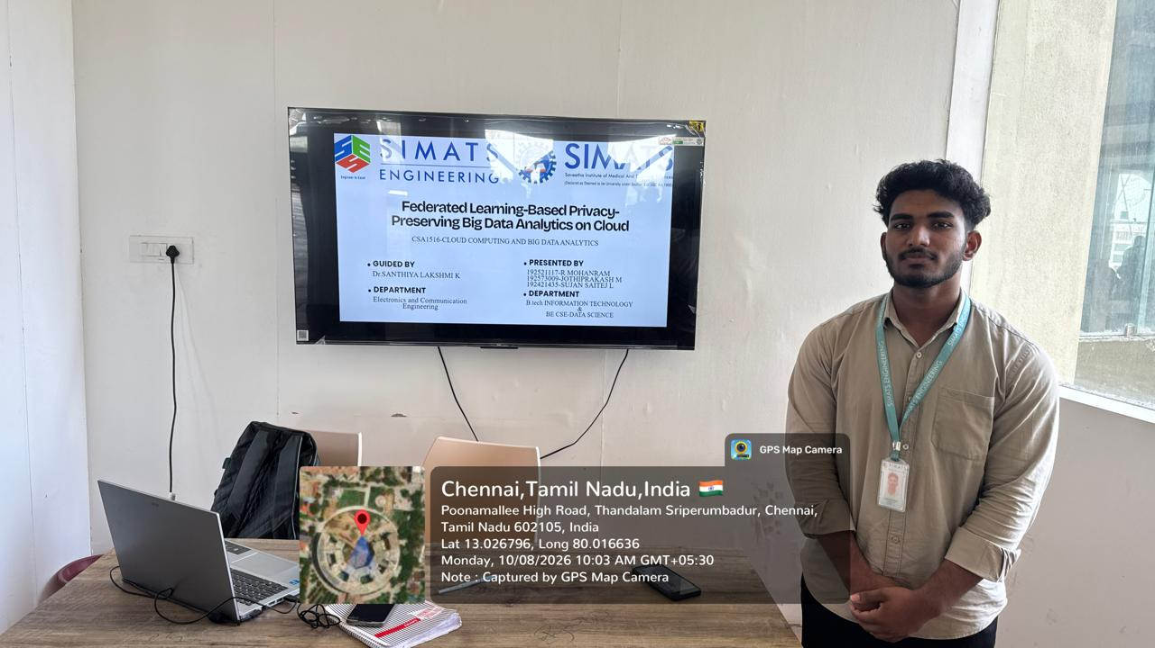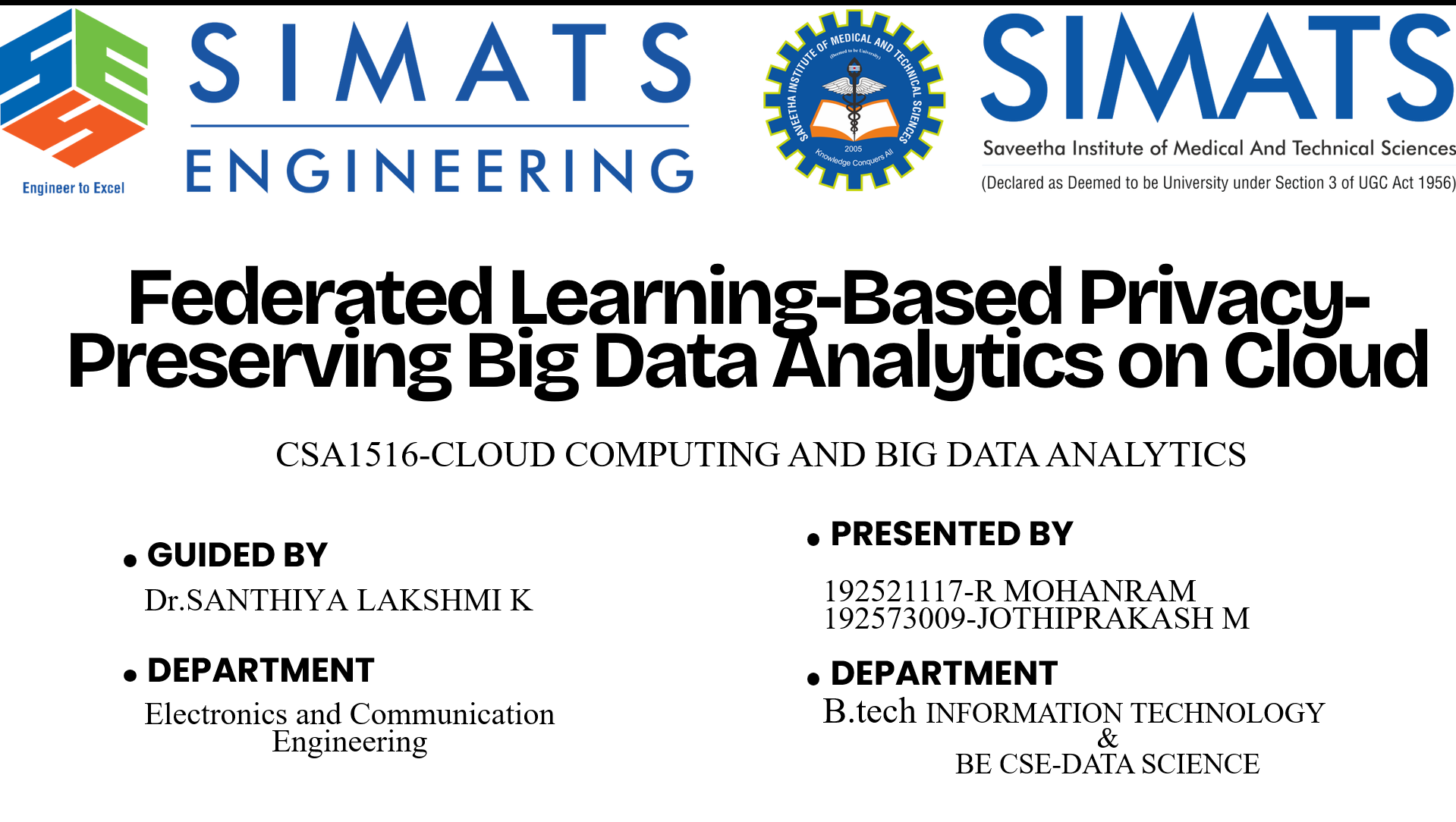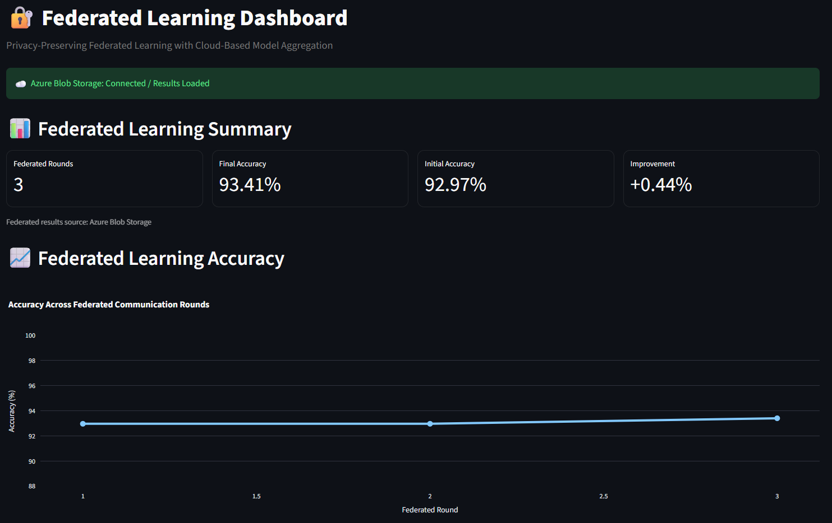
Project Description: Project description and the use of the project are given below
The proposed project develops a Federated Learning-Based Privacy-Preserving Big Data Analytics system on Cloud that enables multiple clients to collaboratively train a machine learning model without directly sharing their raw datasets. The main objective is to combine the benefits of Federated Learning, Big Data Analytics, Cloud Computing, and Privacy Preservation into a single integrated system. In the proposed system, two distributed clients possess their own local datasets containing 30 features. Instead of transferring these raw datasets to a central server, each client performs model training locally using PyTorch. After local training, only the trained model parameters or model updates are communicated to the Federated Server. The server applies Federated Averaging (FedAvg) to aggregate the client models and generate an improved global model. This global model is then used for subsequent federated communication rounds. The implemented system performs 3 federated communication rounds involving 2 clients. The system processes 455 training samples, 228 test samples, and 30 input features across the federated clients. For cloud integration, Microsoft Azure Blob Storage is used to store and manage the federated learning outputs. The global model is stored as models/global_model.pth, while the prediction results are stored as predictions/azure_prediction_results.json. This provides a cloud-based mechanism for storing and retrieving the trained federated model and its results. A Streamlit-based interactive dashboard is developed to provide a user-friendly interface for monitoring the complete federated learning workflow. The dashboard displays federated round accuracy, Big Data analytics, client-wise dataset information, global class distribution, Azure model prediction results, model information, model integrity verification, and live prediction using 30 feature inputs. The project demonstrates that federated learning can support collaborative machine learning while keeping raw client datasets at their respective locations. Only model updates are exchanged during the federated training process, reducing the need for centralized raw-data collection. The integration of Python, PyTorch, Flower, Microsoft Azure Blob Storage, and Streamlit provides a complete prototype for privacy-preserving federated analytics in a cloud environment. Overall, the implemented system successfully demonstrates.

Student Signature Guide Signature

