SIMATS ENGINEERING
ASSESSMENT TOOL 1: Experiments

COURSE NAME: | Cloud Computing and Big Data Analytics | COURSE CODE: | CSA15

COURSE OUTCOME COVERED
CO3: Implement cloud-based solutions using cloud storage, web APIs, and platform services for real-world applications. (BL3)
Assessment Tool Weightage: 40%

Dave's Taxonomy: Precision (Level 3)  Question Count: 5 | Total Marks: 40

Code of Conduct
I _R.MOHANRAM/192521117_ (Name / Reg No) certify that this submission is my original work and that I have adhered to the guidelines specified for this assessment.
I understand that any violation of academic integrity rules will result in disciplinary action.
Signature of the student: _mohanaram_

Assessment Tasks
Experiments
- Experiment 1: Create and document a cloud storage comparison between object, block, and file storage. Select the best storage model for backups, VM disks, and shared enterprise documents.

Experiment 1: Cloud Storage Comparison — Object, Block, and File Storage
1. Objective
To study and compare Object Storage, Block Storage, and File Storage based on architecture, access method, scalability, performance, and use cases, and to select the most suitable storage model for:
Cloud backups
Virtual machine (VM) disks
Shared enterprise documents

2. Storage Models
A. Object Storage
Object storage stores data as objects containing the data, metadata, and a unique identifier.
Examples: Amazon S3, Azure Blob Storage, Google Cloud Storage.
Characteristics:
Highly scalable
Suitable for large volumes of unstructured data
Accessed using HTTP/REST APIs
High durability
Suitable for backups and archives
B. Block Storage
Block storage divides data into fixed-size blocks and presents them as a virtual disk to a VM.
Examples: Amazon EBS, Azure Managed Disks, Google Persistent Disk.
Characteristics:
Low latency
High I/O performance
Suitable for operating systems and databases
Usually attached to a VM
Supports random read/write operations
C. File Storage
File storage organizes data into files and directories and allows multiple systems to access the same file system.
Examples: Amazon EFS, Azure Files, Google Filestore.
Characteristics:
Shared file access
Hierarchical directory structure
Supports common file protocols
Suitable for shared documents and collaborative applications

3. Architecture
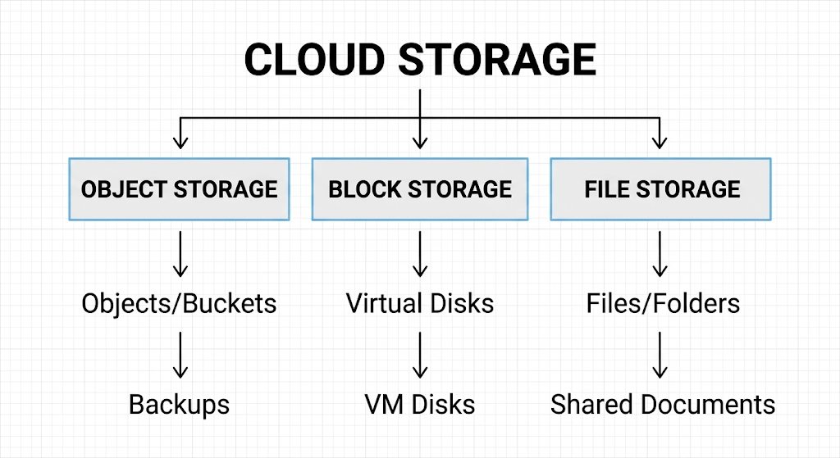

4. Procedure
Step 1: Create Object Storage
Create a cloud storage bucket.
Upload sample backup files such as:
database_backup.sql
student_records.zip
application_backup.tar
Observe how the files are stored as objects.
Check storage capacity and access through the cloud console/API.
Step 2: Create Block Storage
Create a virtual machine.
Attach a block storage volume to the VM.
Format the volume with a file system.
Store application or database files on the volume.
Measure read/write performance and observe VM disk behavior.
Step 3: Create File Storage
Create a managed cloud file system.
Mount it to one or more VMs.
Create directories and files.
Access the same files from multiple VMs.
Verify that changes made by one VM are visible to other connected VMs.
Step 4: Compare the Three Models
Compare them using:
Access method
Performance
Scalability
Sharing capability
Cost
Durability
Typical applications
5. Comparison Table
Feature | Object Storage | Block Storage | File Storage
Data organization | Objects | Blocks | Files/directories
Access | REST/API | Attached disk | File system
Performance | Moderate | High | Moderate
Scalability | Very high | High | High
Sharing | API-based | Usually VM-attached | Multiple systems
Best use | Backups | VM disks | Shared documents
Example | Amazon S3 | Amazon EBS | Amazon EFS
Cost | Low for large-scale storage | Higher | Moderate
Main advantage | Scalability & durability | High performance | Shared access

6. Selection of Best Storage Model
A. Backups → Object Storage
Reason:
Handles very large amounts of backup data.
Highly durable and scalable.
Supports versioning and lifecycle policies.
Older backups can be moved to cheaper archive tiers.
Example: Amazon S3.
Best choice: Object Storage

B. VM Disks → Block Storage
Reason:
Provides low-latency disk access.
Supports high IOPS.
Works directly as a VM's virtual disk.
Suitable for operating systems, applications, and databases.
Example: Amazon EBS.
Best choice: Block Storage

C. Shared Enterprise Documents → File Storage
Reason:
Provides a familiar folder/file structure.
Multiple users or VMs can access the same files.
Suitable for shared documents and departmental data.
Example: Amazon EFS or Azure Files.
Best choice: File Storage
7. Expected Output
The experiment should produce a comparison similar to:
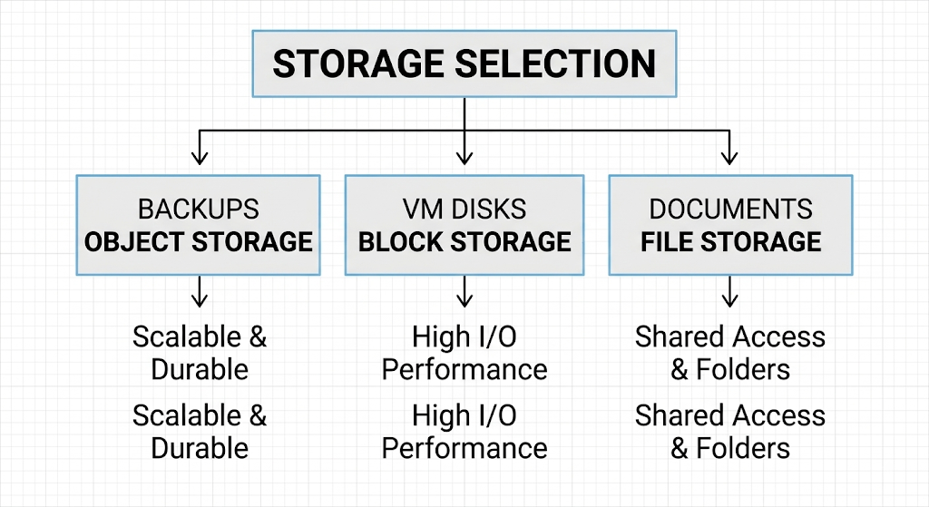Expected observations:
Object storage provides excellent scalability and is most suitable for backups.
Block storage provides better performance for VM operating systems and databases.
File storage provides convenient shared access to enterprise documents.

8. Analysis
The three storage models are designed for different requirements rather than being direct replacements for one another.
Object storage is best when scalability and durability are more important than very low latency. Therefore, it is appropriate for large backup repositories.
Block storage behaves like a physical disk and provides high I/O performance. Therefore, it is appropriate for VM boot volumes and transactional databases.
File storage provides a shared file system that can be accessed by multiple machines. Therefore, it is appropriate for shared enterprise documents and collaborative applications.

9. Conclusion
The experiment demonstrates that cloud storage should be selected according to the workload requirement.
Object Storage → Backups because of its scalability, durability, and cost efficiency.
Block Storage → VM Disks because of its high performance and low-latency access.
File Storage → Shared Enterprise Documents because it supports shared access through a hierarchical file system.
Thus, using the appropriate storage model improves performance, scalability, availability, and cost efficiency in cloud-based applications.

- Experiment 2: Develop a simple REST API workflow for a cloud-based student portal. Show request, response, authentication, and deployment flow.

Experiment 2: REST API Workflow for a Cloud-Based Student Portal
1. Objective
To develop and demonstrate a simple REST API workflow for a cloud-based student portal and understand the flow of:
Client request
API authentication
Server-side processing
Database interaction
JSON response
Cloud deployment

2. Aim
To implement RESTful API endpoints that allow students to view student details and marks using HTTP requests and JSON responses.

3. Software / Tools Required
Python 3.x
Flask
Postman or web browser
SQLite/MySQL database
VS Code
Cloud platform such as Render, AWS, Azure, or Google Cloud

4. Architecture

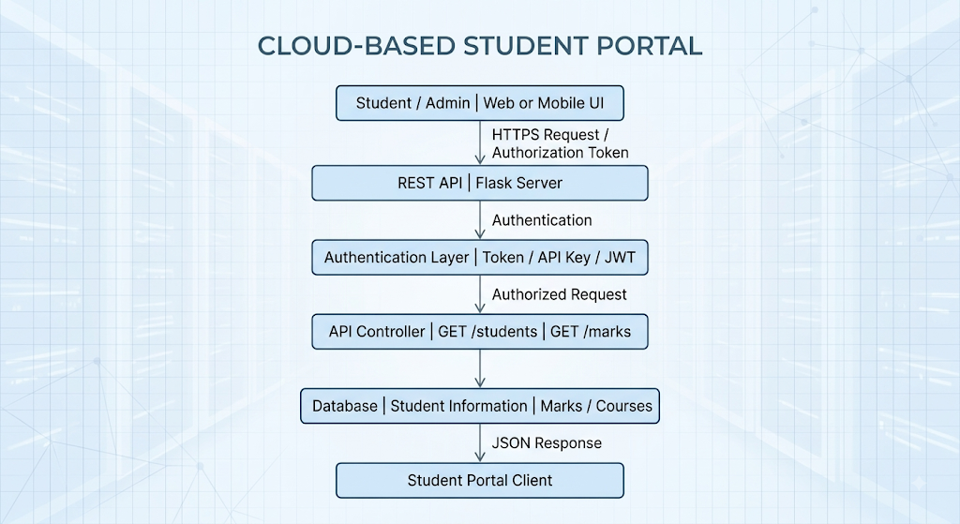
5. REST API Concepts Used
HTTP Method | Purpose | Example
GET | Retrieve data | Get student details
POST | Create data | Add student
PUT | Update data | Update student details
DELETE | Delete data | Delete student
For this experiment, GET and POST are sufficient to demonstrate the workflow.

6. API Endpoints
Endpoint 1: Authentication
POST /login
Used to authenticate a student and generate an access token.
Endpoint 2: Student Details
GET /students/101
Returns details of student ID 101.
Endpoint 3: Student Marks
GET /students/101/marks
Returns the marks of student 101.

7. Procedure
Step 1: Install Flask
Open the terminal and execute:
pip install flask

Step 2: Create the API Program
Create a file named:
app.py
Use the following code:
from flask import Flask, request, jsonify

app = Flask(__name__)

# Sample student data
students = {
"101": {
"name": "Arun",
"department": "CSE",
"year": 3,
"marks": {
"Cloud Computing": 85,
"Big Data": 90,
"Computer Networks": 82
}
}
}

# Simple authentication
USERNAME = "student"
PASSWORD = "12345"
TOKEN = "STUDENT_TOKEN_101"

@app.route("/login", methods=["POST"])
def login():

data = request.get_json()

if data.get("username") == USERNAME and data.get("password") == PASSWORD:
return jsonify({
"message": "Login successful",
"token": TOKEN
}), 200

return jsonify({
"message": "Invalid username or password"
}), 401

@app.route("/students/<student_id>", methods=["GET"])
def get_student(student_id):

token = request.headers.get("Authorization")

if token != "Bearer " + TOKEN:
return jsonify({
"message": "Unauthorized access"
}), 401

student = students.get(student_id)

if student:
return jsonify({
"student_id": student_id,
"name": student["name"],
"department": student["department"],
"year": student["year"]
}), 200

return jsonify({
"message": "Student not found"
}), 404

@app.route("/students/<student_id>/marks", methods=["GET"])
def get_marks(student_id):

token = request.headers.get("Authorization")

if token != "Bearer " + TOKEN:
return jsonify({
"message": "Unauthorized access"
}), 401

student = students.get(student_id)

if student:
return jsonify({
"student_id": student_id,
"marks": student["marks"]
}), 200

return jsonify({
"message": "Student not found"
}), 404

if __name__ == "__main__":
app.run(host="0.0.0.0", port=5000, debug=True)

8. Run the API
Execute:
python app.py
Expected output:
* Running on http://127.0.0.1:5000
* Running on http://192.168.x.x:5000
The API is now running locally.

9. Test Authentication
Use Postman.
Request
POST http://127.0.0.1:5000/login
Body → raw → JSON:
{
"username": "student",
"password": "12345"
}
Expected Response
{
"message": "Login successful",
"token": "STUDENT_TOKEN_101"
}
The client stores the returned token and uses it for subsequent requests.

10. Request Student Details
Request
GET http://127.0.0.1:5000/students/101
Add the following HTTP header:
Authorization: Bearer STUDENT_TOKEN_101
Expected Response
{
"department": "CSE",
"name": "Arun",
"student_id": "101",
"year": 3
}

11. Request Student Marks
Request
GET http://127.0.0.1:5000/students/101/marks
Header:
Authorization: Bearer STUDENT_TOKEN_101
Expected Response
{
"marks": {
"Big Data": 90,
"Cloud Computing": 85,
"Computer Networks": 82
},
"student_id": "101"
}

12. Unauthorized Request
If the token is missing or incorrect:
GET /students/101
without authentication.
Expected Response
{
"message": "Unauthorized access"
}
HTTP status:
401 Unauthorized
This demonstrates how authentication protects student information.

13. REST API Request–Response Flow
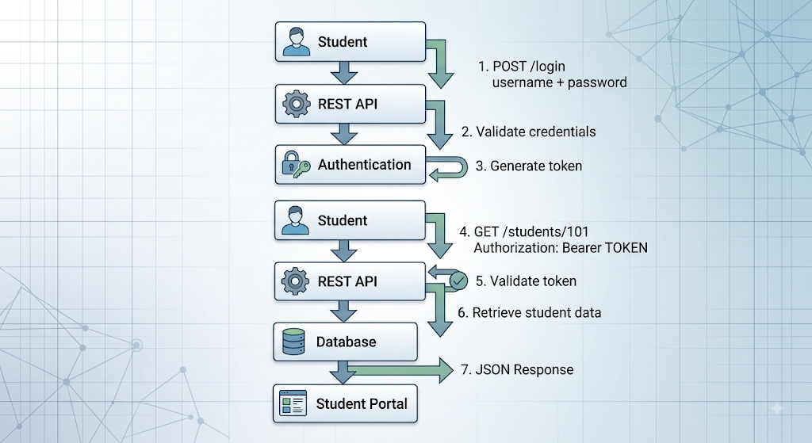
14. Cloud Deployment Flow
The application can be deployed to a cloud platform.
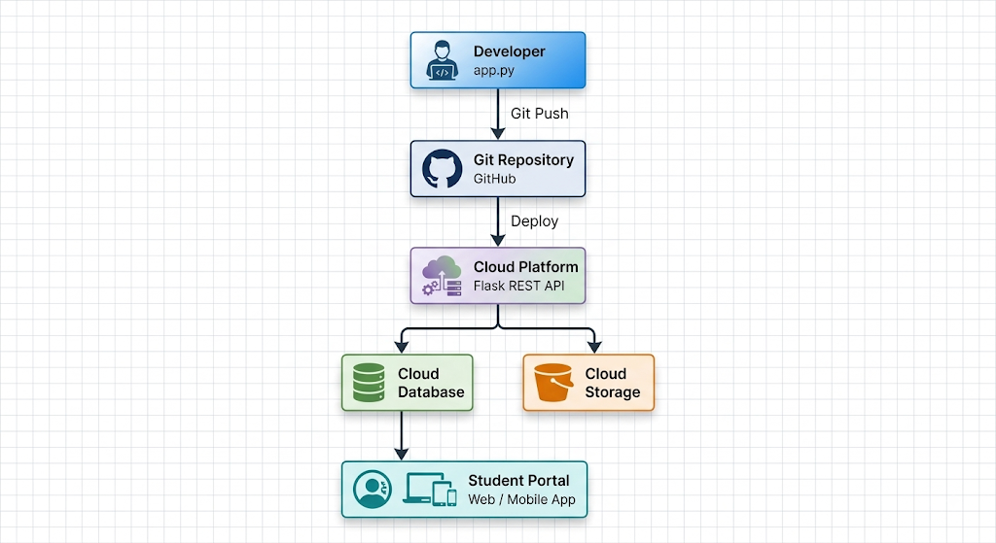Deployment Steps
Create the Flask REST API.
Test all endpoints locally.
Store the application in a Git repository.
Create a cloud application/service.
Connect the Git repository to the cloud platform.
Configure environment variables and database credentials.
Deploy the application.
Obtain the public API URL.
Test the API using Postman.
Enable HTTPS for secure communication.

15. Expected Output
Login
POST /login

Status: 200 OK

{
"message": "Login successful",
"token": "STUDENT_TOKEN_101"
}
Student Details
GET /students/101

Status: 200 OK

{
"student_id": "101",
"name": "Arun",
"department": "CSE",
"year": 3
}
Marks
GET /students/101/marks

Status: 200 OK

{
"student_id": "101",
"marks": {
"Cloud Computing": 85,
"Big Data": 90,
"Computer Networks": 82
}
}
Invalid Authentication
Status: 401 Unauthorized

{
"message": "Unauthorized access"
}

16. Analysis
The experiment demonstrates that a REST API provides a standard method for communication between a student portal and cloud-based backend services.
The GET method retrieves student information, while POST is used for authentication. JSON provides a lightweight format for exchanging information between the client and server.
Authentication prevents unauthorized users from accessing student information. In a production system, the simple token used in this experiment should be replaced with a stronger mechanism such as OAuth 2.0 or JWT, together with HTTPS and secure password storage.
Cloud deployment allows the API to be accessed from different locations and enables the application to scale according to user demand.

17. Conclusion
The REST API workflow was successfully designed for a cloud-based student portal. The experiment demonstrated request handling, authentication, JSON response generation, and cloud deployment flow.
REST APIs provide a simple and scalable way for web and mobile applications to communicate with cloud services. With proper authentication, HTTPS, access control, monitoring, and cloud scalability, the same architecture can be extended to a real-world student management system.

- Experiment 3: Design a serverless event flow for image upload processing using object storage, function-as-a-service, and notification service.

Experiment 3: Serverless Event Flow for Image Upload Processing
1. Objective
To design and demonstrate a serverless image-processing workflow using:
Object Storage for storing uploaded images
Function-as-a-Service (FaaS) for automatic image processing
Notification Service for informing users about processing completion
The experiment demonstrates how an event-driven cloud architecture can process images without continuously running servers.

2. Aim
To implement an event-driven workflow in which an image uploaded to cloud object storage automatically triggers a serverless function, processes the image, stores the output, and sends a notification to the user.

3. Cloud Services Used
A cloud provider such as AWS can be used.
Component | AWS Example | Purpose
Object Storage | Amazon S3 | Stores original and processed images
FaaS | AWS Lambda | Processes uploaded images
Notification | Amazon SNS | Sends processing notification
IAM | AWS IAM | Controls service permissions
Monitoring | Amazon CloudWatch | Monitors function execution

4. Architecture 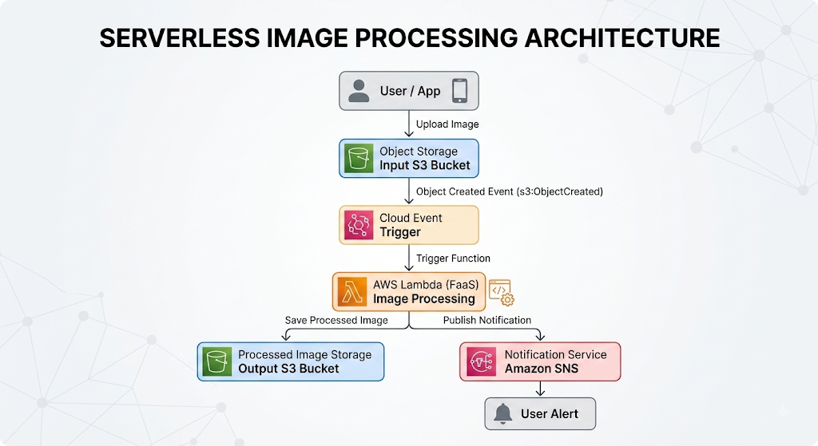
5. Working Principle
The workflow is event-driven.
When a user uploads an image:
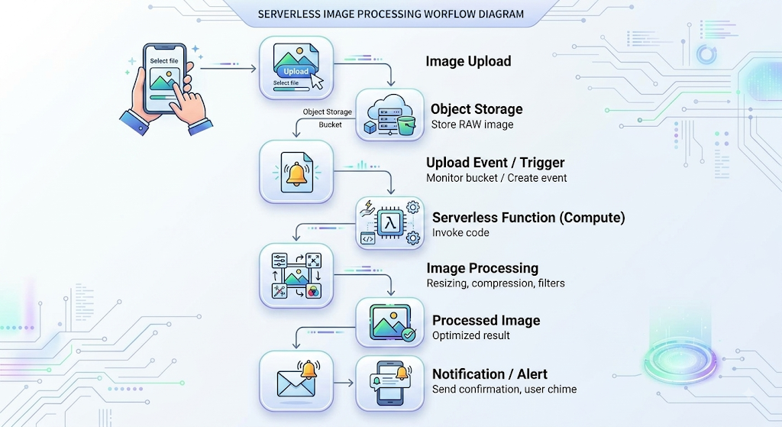No dedicated server needs to remain running continuously.

6. Procedure
Step 1: Create an Object Storage Bucket
Create an S3 bucket:
image-processing-input
Create another bucket/folder for processed images:
image-processing-output
The input bucket stores original images.

Step 2: Upload a Test Image
Upload an image such as:
student.jpg
to:
image-processing-input
Example:
S3 Bucket
│
└── uploads/
└── student.jpg

Step 3: Configure an Event Trigger
Configure the object storage bucket to generate an event whenever a new image is uploaded.
Example event:
ObjectCreated
The event invokes the serverless function.
S3 Upload
↓
ObjectCreated Event
↓
Lambda Function

7. Serverless Function
The Lambda function receives information about the uploaded file.
A simplified Python implementation is:
import json

def lambda_handler(event, context):

bucket = event["bucket"]
filename = event["filename"]

print("Image uploaded successfully")
print("Bucket:", bucket)
print("File:", filename)

# Image processing operation
print("Processing image...")

processed_file = "processed_" + filename

print("Processed file:", processed_file)

return {
"statusCode": 200,
"message": "Image processed successfully",
"output": processed_file
}
In an actual AWS implementation, the Lambda function would use the AWS SDK (boto3) to read the image from S3, process it, and write the output back to S3.

8. Image Processing Operation
The Lambda function can perform operations such as:
Resize image
Compress image
Convert image format
Generate thumbnail
Add watermark
Extract image metadata
For example:
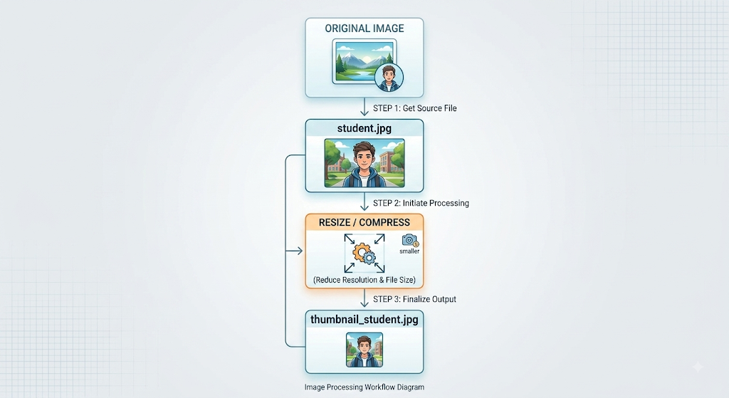
9. Store the Processed Image
After processing, the function stores the result in the output bucket.
image-processing-output
│
└── processed/
└── processed_student.jpg
Therefore:
Input Bucket
│
│ Lambda
▼
Output Bucket

10. Notification Service
After successful processing, the Lambda function publishes a message to a notification service such as Amazon SNS.
Example notification:
Subject:
Image Processing Completed

Message:
Your image student.jpg has been successfully
processed and is available in cloud storage.
Flow:
Lambda
│
▼
SNS Topic
│
├── Email
├── SMS
└── Application Notification

11. Complete Event Flow
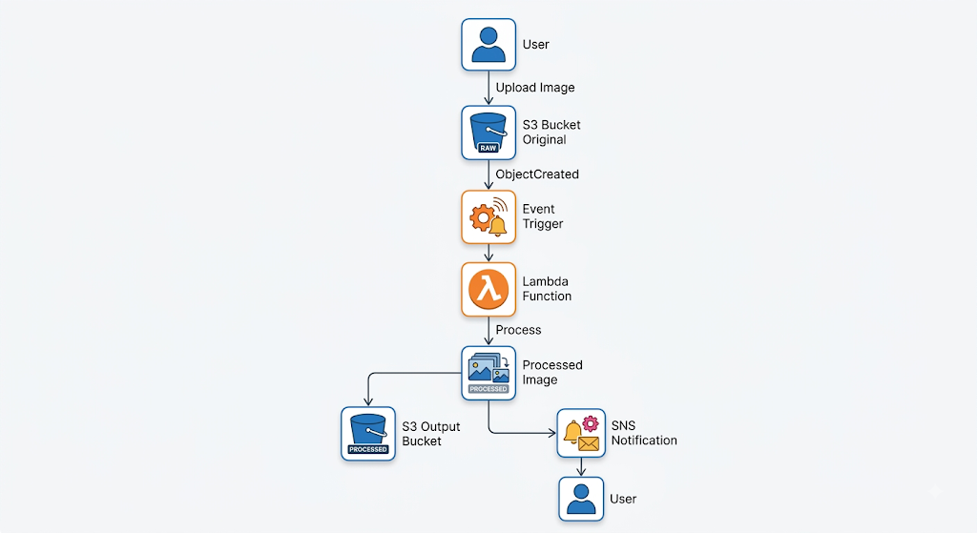

12. Authentication and Security
The architecture should use IAM roles to provide the Lambda function only the permissions it needs.
For example:
Lambda
│
├── Read → Input Bucket
│
├── Write → Output Bucket
│
└── Publish → SNS Topic
Security measures
Enable encryption for stored images.
Use HTTPS/TLS for data transfer.
Apply least-privilege IAM permissions.
Block unauthorized public access to buckets.
Enable logging and monitoring.
Keep sensitive credentials out of source code.

13. Monitoring
Use a monitoring service such as CloudWatch to monitor:
Number of Lambda invocations
Function execution time
Errors
Failed image processing
Memory usage
Notification failures
Example:
Image Upload
↓
Lambda
↓
CloudWatch
│
├── Success
├── Error
└── Performance Metrics
If repeated failures occur, an alert can be generated for the administrator.

14. Expected Output
Input
Uploaded file:
student.jpg
Lambda Output
Image uploaded successfully
Bucket: image-processing-input
File: student.jpg

Processing image...

Processed file:
processed_student.jpg
Output Storage
image-processing-output/
└── processed_student.jpg
Notification
Image Processing Completed

student.jpg has been successfully processed.

15. Analysis
The experiment demonstrates the serverless event-driven architecture of cloud computing.
The object storage service acts as the source of the event. When an image is uploaded, the event automatically invokes the FaaS function. The function processes the image without requiring a permanently running VM or server.
This architecture can automatically handle multiple image uploads because serverless functions can execute independently and scale according to incoming events.

16. Advantages
Feature | Benefit
Serverless | No server management
Event-driven | Automatic processing
Auto-scaling | Handles multiple uploads
Object storage | Highly scalable storage
Notification | Immediate user feedback
IAM | Secure service access
Monitoring | Detects errors and failures
Pay-per-use | Cost-effective for irregular workloads

17. Real-World Applications
The same architecture can be used for:
Social media image processing
E-commerce product image resizing
Student document/image processing
News website thumbnail generation
Medical image preprocessing
Mobile application photo uploads

18. Conclusion
The experiment successfully designs a serverless image upload processing workflow using object storage, FaaS, and a notification service.
When an image is uploaded, the storage event automatically triggers a serverless function. The function processes the image, stores the result, and sends a notification to the user.
Thus, the architecture provides automatic execution, scalability, reduced infrastructure management, event-driven processing, and cost efficiency, making it suitable for modern cloud-based applications.

- Experiment 4: Compare edge computing and fog computing for a smart traffic management system. Include architecture, latency considerations, and deployment location.

Experiment 4: Edge Computing vs Fog Computing for Smart Traffic Management
1. Objective
To compare Edge Computing and Fog Computing for a smart traffic management system based on:
Architecture
Processing location
Latency
Network communication
Scalability
Deployment location
Suitability for real-time traffic management

2. Aim
To design and analyze Edge and Fog computing architectures for processing traffic data from cameras, sensors, and connected vehicles, and determine which approach is more suitable for different traffic-management tasks.

3. Smart Traffic Management Scenario
A smart city uses:
Traffic cameras
Roadside sensors
Traffic lights
Vehicle sensors
GPS data
Pollution sensors
to monitor traffic conditions and automatically control signals.
The system must respond quickly to events such as:
Traffic congestion
Accidents
Emergency vehicles
Abnormal traffic density
Because these applications are time-sensitive, sending every piece of data to a distant cloud can introduce unnecessary latency.

4. Edge Computing Architecture
In Edge Computing, data processing occurs very close to the data source, such as directly on a camera, traffic controller, or roadside edge device.

Architecture
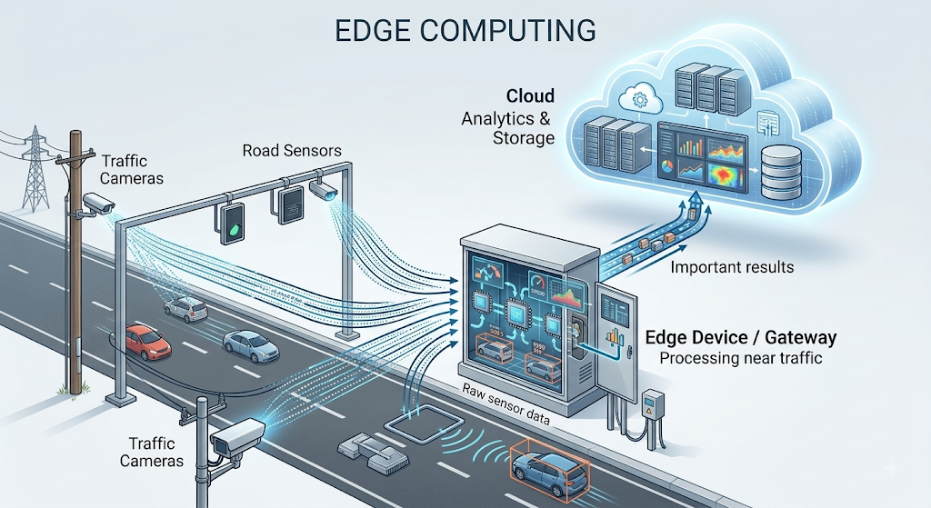Example
A roadside camera detects that traffic density has crossed a threshold.
Camera
↓
Edge Device
↓
Detect congestion
↓
Change Traffic Signal
The decision is made locally rather than waiting for a cloud server.

5. Fog Computing Architecture
Fog Computing places an additional distributed computing layer between edge devices and the central cloud.
Processing can occur at:
Roadside gateways
Local traffic-control servers
Network routers
City-level micro-datacenters

Architecture

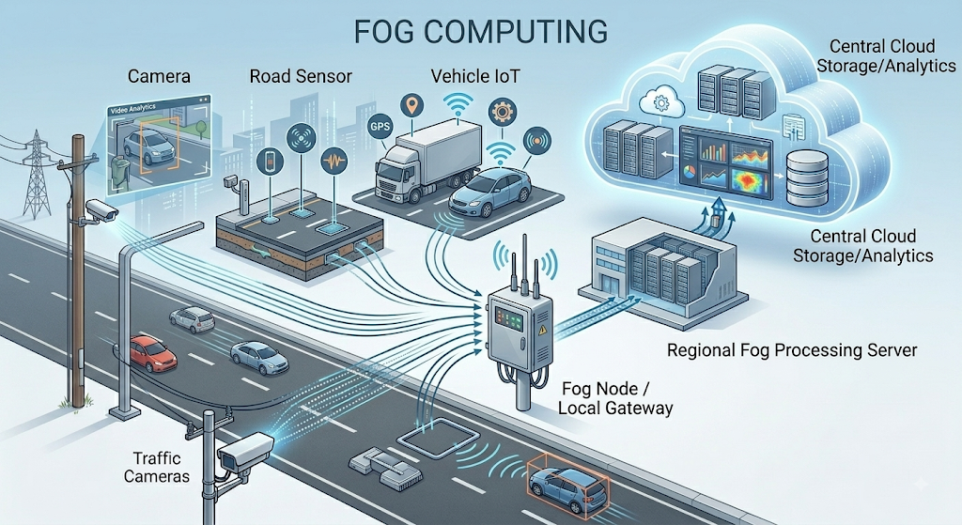
6. Edge vs Fog Architecture
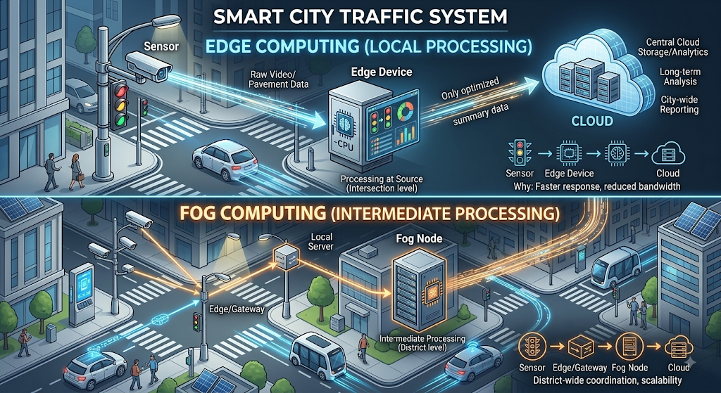The major difference is the location and hierarchy of processing.

7. Latency Comparison
Latency is the time required to collect data, process it, and return a decision.

Edge Computing
Data is processed immediately near the sensor.
Sensor → Edge → Decision
Therefore, communication distance is very small and latency is generally very low.
Fog Computing
Data may travel from the sensor to a nearby fog node before processing.
Sensor → Gateway → Fog Node → Decision
This introduces more processing/network layers than pure edge computing, but it can still provide much lower latency than sending every request to a remote cloud.
Cloud-only approach
Sensor → Internet → Cloud → Internet → Traffic Signal
This generally creates greater network delay and dependence on connectivity.

8. Latency Analysis
Parameter | Edge Computing | Fog Computing
Processing location | At/very near device | Local/regional network
Network distance | Very low | Low
Latency | Very low | Low
Real-time decisions | Excellent | Excellent
Local coordination | Limited | Strong
Cloud dependency | Low | Moderate
Suitable for | Individual intersections | Multiple intersections/areas
Actual latency depends on hardware, network conditions, workload, and architecture; these categories describe the relative design characteristics rather than fixed numerical limits.

9. Deployment Location
Edge Computing
Deployed directly at:
Traffic cameras
Smart traffic lights
Roadside units
IoT gateways
Example:
Intersection A
├── Camera
├── Sensors
└── Edge Processor
Fog Computing
Deployed at a broader local or regional level:
Traffic-control rooms
Roadside micro-datacenters
Network gateways
City-zone servers
Example:
City Zone
├── Intersection 1
├── Intersection 2
├── Intersection 3
└── Fog Node

10. Traffic Management Example
Suppose an intersection suddenly becomes congested.
Edge Processing
Traffic Camera
↓
Edge Processor
↓
Detect congestion
↓
Extend green-light duration
The decision is made at the intersection.
Fog Processing
Intersection 1 ─┐
Intersection 2 ─┼→ Fog Node
Intersection 3 ─┘
↓
Analyze zone traffic
↓
Coordinate signals
The fog node can consider traffic information from multiple intersections and coordinate them.

11. Advantages of Edge Computing
Very low latency
Processing occurs extremely close to the sensors.
Reduced bandwidth usage
Raw camera streams do not need to be continuously sent to the cloud.
Operation during connectivity problems
Local traffic-control functions can continue even when cloud connectivity is temporarily unavailable.
Faster emergency response
Accident or emergency-vehicle detection can trigger immediate local actions.

12. Advantages of Fog Computing
Regional coordination
A fog node can combine information from many edge devices.
Better resource utilization
Complex processing can be moved from small edge devices to more capable fog nodes.
Reduced cloud traffic
Only aggregated or important data needs to reach the cloud.
Suitable for city-level decisions
Fog computing can analyze traffic patterns across several intersections.

13. Limitations
Edge Computing | Fog Computing
Limited computing resources | More infrastructure to manage
Device management can become difficult | More complex architecture
Difficult to coordinate many locations directly | Requires secure communication between layers
Higher number of distributed devices | Higher deployment and maintenance requirements

14. Recommended Hybrid Design
For a real smart-city deployment, combining both approaches is effective.
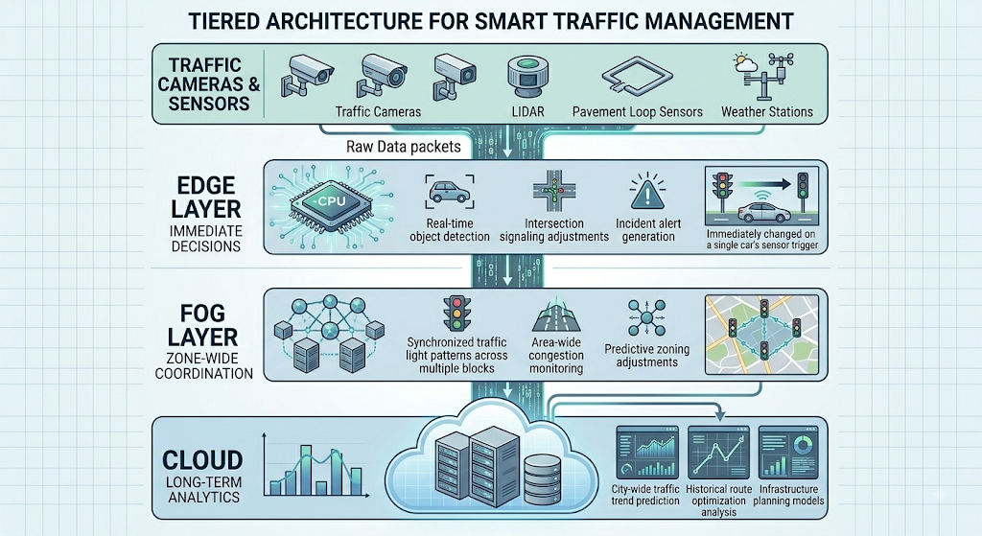Processing Allocation
Edge:
Immediate traffic-light control and accident detection.
Fog:
Coordination between nearby intersections and local traffic analysis.
Cloud:
Historical analysis, machine-learning model training, reporting, and city-wide planning.

15. Expected Output
The experiment should produce the following comparison:
Factor | Edge | Fog
Processing | Near sensor | Local/regional node
Latency | Very low | Low
Deployment | Roadside/device | Network/local datacenter
Bandwidth usage | Very low | Low
Area covered | Individual device/location | Multiple devices/locations
Best application | Immediate signal control | Regional traffic coordination

16. Analysis
Edge computing is more suitable when a decision must be made immediately at a specific location. For example, an edge device can detect congestion and modify a traffic signal without sending the complete camera feed to a remote cloud.
Fog computing is more suitable when information from multiple edge devices must be combined. A fog node can receive data from several intersections and coordinate signal timings across an entire traffic zone.
Therefore, Edge provides the lowest possible processing latency, while Fog provides a useful intermediate layer for regional coordination and distributed analytics.

17. Conclusion
The experiment demonstrates that both Edge Computing and Fog Computing can improve a smart traffic management system by moving computation closer to traffic data sources.
Edge Computing is best for ultra-fast local decisions, such as traffic-light control and accident detection.
Fog Computing is best for regional coordination, such as analyzing traffic across multiple intersections.
A hybrid Edge–Fog–Cloud architecture provides the best overall solution: Edge handles immediate decisions, Fog performs local coordination, and Cloud performs large-scale storage, historical analysis, and long-term optimization.

- Experiment 5: Demonstrate a cloud application deployment workflow showing client access, browser interaction, web API call, storage access, and monitoring.

Experiment 5: Cloud Application Deployment Workflow
1. Objective
To demonstrate a complete cloud application deployment workflow showing how a client interacts with a cloud-hosted application through a browser, how the application communicates with a web API, accesses cloud storage, and is monitored using cloud monitoring services.

2. Aim
To understand the end-to-end flow of a cloud application from client access to cloud deployment, API communication, storage access, and monitoring.

3. Scenario
Consider a simple Student Document Portal.
A student uses a browser to:
Open the cloud application.
View student information.
Upload a document.
The web application calls a REST API.
The API stores the document in cloud storage.
Monitoring services record application activity and errors.

4. Architecture Diagram
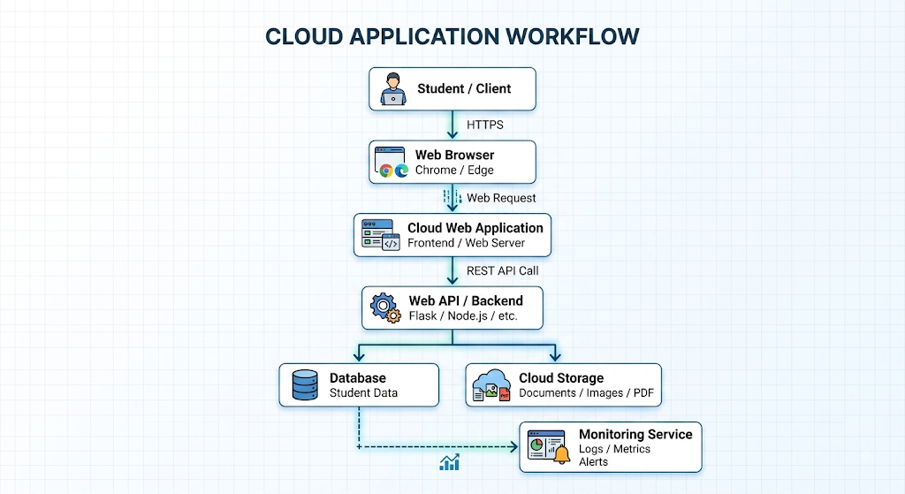
5. Cloud Deployment Flow
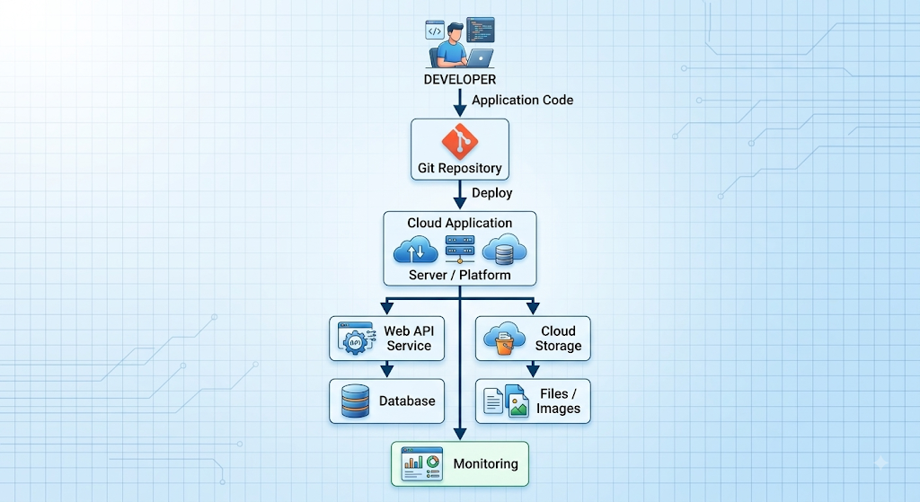
6. Tools / Technologies
The experiment can be implemented using:
Component | Example
Client | Laptop / Smartphone
Browser | Chrome / Edge
Frontend | HTML, CSS, JavaScript
Backend | Python Flask
API | REST API
Database | SQLite / MySQL / Cloud DB
Cloud Storage | Amazon S3 / Azure Blob
Deployment | AWS / Azure / Google Cloud / Render
Monitoring | CloudWatch / Azure Monitor / Cloud Monitoring
Source Control | GitHub

7. Procedure
Step 1: Develop the Application
Create a simple web application containing:
Student Portal
-----------------------
Student ID: 101
Name: Arun
Department: CSE

[View Details]
[Upload Document]
The frontend sends requests to the backend API.

Step 2: Create the Web API
Example REST endpoints:
GET /api/student/101
POST /api/upload
GET /api/health
Purpose
Endpoint | Function
/api/student/101 | Retrieves student details
/api/upload | Uploads a document
/api/health | Checks application availability

8. Browser Interaction
The student enters the cloud application's URL in the browser.
Example:
https://student-portal.example.com
The browser sends:
GET /
The cloud web server responds with the application webpage.
Browser
|
| GET /
▼
Cloud Web Server
|
| HTML + CSS + JavaScript
▼
Browser

9. Web API Call
When the student clicks View Details, the frontend calls:
GET /api/student/101
The backend processes the request and retrieves information from the database.
Request
GET /api/student/101
Response
{
"student_id": "101",
"name": "Arun",
"department": "CSE",
"year": 3
}
The browser displays this information to the student.

10. Storage Access
Suppose the student uploads:
assignment.pdf
The browser sends the file to:
POST /api/upload
The backend receives the file and stores it in cloud object storage.
Flow
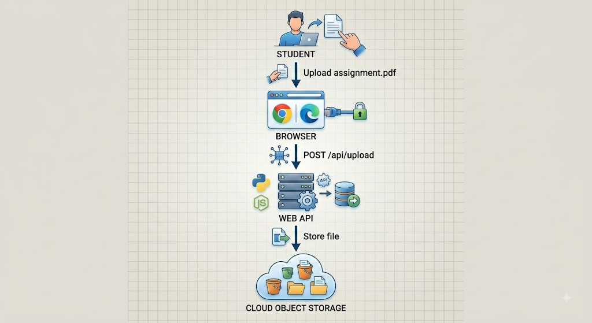Example storage structure:
student-documents/
└── 101/
├── assignment.pdf
├── project.pdf
└── certificate.pdf

11. Example Backend Workflow
A simplified Flask API could look like:
from flask import Flask, request, jsonify

app = Flask(__name__)

@app.route("/api/student/<student_id>", methods=["GET"])
def get_student(student_id):

return jsonify({
"student_id": student_id,
"name": "Arun",
"department": "CSE",
"year": 3
})

@app.route("/api/upload", methods=["POST"])
def upload_file():

file = request.files.get("file")

if not file:
return jsonify({"error": "No file uploaded"}), 400

# In a real cloud deployment:
# Upload the file to cloud object storage.

return jsonify({
"message": "File uploaded successfully",
"filename": file.filename
})

@app.route("/api/health", methods=["GET"])
def health():

return jsonify({
"status": "healthy"
})

if __name__ == "__main__":
app.run()

12. Cloud Deployment
After testing locally:
Step 1
Push the source code to GitHub.
GitHub
|
▼
Source Code
Step 2
Create a cloud application/service.
Step 3
Connect the cloud service to the Git repository.
Step 4
Configure:
Runtime
Environment variables
Database connection
Storage credentials
Security settings
Step 5
Deploy the application.
The cloud platform provides a public URL.
https://student-portal.cloudprovider.com

13. Monitoring Workflow
The cloud application should be continuously monitored.
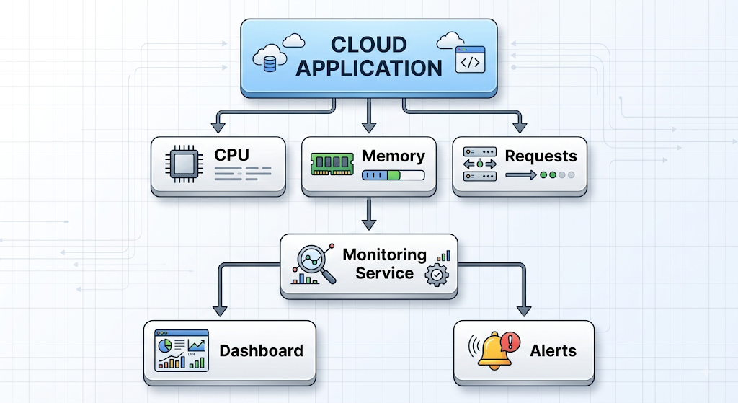Monitoring Parameters
Monitor:
CPU utilization
Memory usage
API response time
Number of requests
HTTP errors
Storage operations
Application logs
Server availability

14. Example Monitoring Output
Application Status : Healthy
CPU Usage : 42%
Memory Usage : 55%
API Requests : 1,250
Average Latency : 120 ms
HTTP Errors : 3
Storage Requests : 420
If API errors suddenly increase:
High Error Rate
↓
Monitoring System
↓
Alert Administrator
↓
Investigate Application

15. Complete End-to-End Workflow
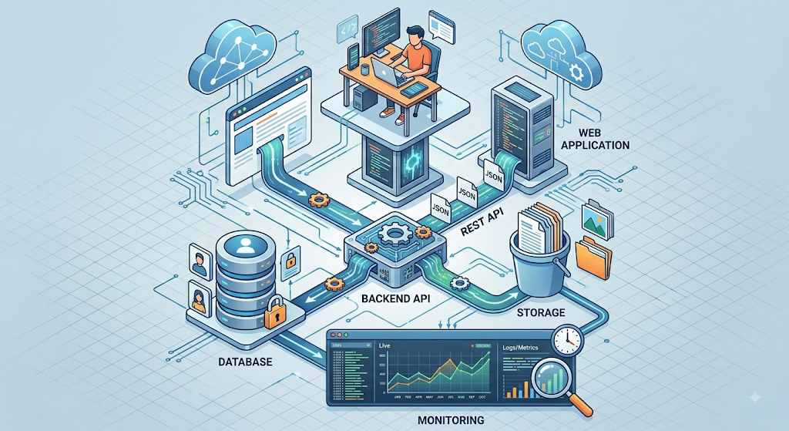

16. Expected Output
Output 1: Application Access
Student Portal Loaded Successfully
Output 2: API Response
{
"student_id": "101",
"name": "Arun",
"department": "CSE",
"year": 3
}
Output 3: File Upload
File uploaded successfully:
assignment.pdf
Output 4: Health Check
{
"status": "healthy"
}
Output 5: Monitoring
Application: Running
API Status: Healthy
Storage: Available
Errors: Low

17. Security Considerations
The deployment should include:
HTTPS
All browser-to-cloud communication should use HTTPS.
Authentication
Only authorized users should access student information.
Access Control
Use IAM/RBAC to control access to cloud resources.
Storage Security
Cloud storage should not be publicly accessible unless explicitly required.
Encryption
Sensitive student documents should be encrypted at rest and in transit.
Logging
API calls, authentication events, and errors should be logged for auditing.

18. Analysis
The experiment demonstrates how different cloud services work together as a single application.
The browser provides the client interface, while the web application handles user interaction. The REST API acts as the communication layer between the frontend and backend. The backend accesses databases and cloud storage to retrieve or save information.
The monitoring service provides visibility into application health, performance, and failures. This enables administrators to detect problems before they significantly affect users.

19. Expected Architecture Behavior
Stage | Operation | Result
1 | Client opens URL | Web page displayed
2 | Browser sends API request | Backend receives request
3 | API accesses database | Student details retrieved
4 | User uploads document | API receives file
5 | API accesses cloud storage | File stored securely
6 | Monitoring collects metrics | Application health visible
7 | Error detected | Alert generated

20. Conclusion
The experiment demonstrates a complete cloud application deployment workflow from client access to monitoring.
The browser communicates with the cloud-hosted web application, which uses REST APIs to process requests and access databases and cloud storage. Monitoring services continuously collect logs and performance metrics and generate alerts when problems occur.
Thus, integrating web applications, APIs, cloud storage, databases, and monitoring provides a scalable, secure, and manageable cloud-based application architecture suitable for real-world systems such as student portals, e-commerce platforms, and enterprise applications.

For each experiment, include objective, architecture sketch, procedure, expected output, and conclusion.

Experiments Rubric
Criteria | Weightage | Level 4 - Exemplary | Level 3 - Proficient | Level 2 - Developing | Level 1 - Beginning
Experimental Design | 25% | Design is systematic and technically strong | Mostly correct design | Basic design with gaps | Poorly designed activity
Use of Tools / Platforms | 20% | Appropriate and effective use of cloud tools | Good tool usage with minor issues | Limited tool usage | Incorrect or missing tool usage
Application of Concepts | 20% | Concepts are applied accurately to practical tasks | Mostly accurate application | Partial application | Weak application
Analysis and Output | 20% | Strong analysis and meaningful outcome interpretation | Good analysis with minor gaps | Basic analysis | Little or no analysis
Documentation | 15% | Clear, structured, and complete documentation | Mostly complete documentation | Partially complete | Poor documentation

