SIMATS ENGINEERING
ASSESSMENT TOOL 2: Case Study

COURSE NAME: | Cloud Computing and Big Data Analytics | COURSE CODE: | CSA15

COURSE OUTCOME COVERED
CO3: Implement cloud-based solutions using cloud storage, web APIs, and platform services for real-world applications. (BL3)
Assessment Tool Weightage: 20%

Dave's Taxonomy: Precision (Level 3)  Question Count: 3 | Total Marks: 30

Code of Conduct
I _R.MOHANRAM/192521117__ (Name / Reg No) certify that this submission is my original work and that I have adhered to the guidelines specified for this assessment.
I understand that any violation of academic integrity rules will result in disciplinary action.
Signature of the student: _mohanram_

Assessment Tasks
Case Study
- Case 1: A food delivery company wants to deploy a cloud-native backend with web APIs, browser clients, and shared cloud storage for receipts and delivery images. Propose the architecture and explain the role of each component.
Case Study 1: Cloud-Native Backend for a Food Delivery Company
1. Proposed Architecture
The food delivery company can use a cloud-native three-tier architecture consisting of browser/mobile clients, REST APIs, cloud database, and shared object storage.
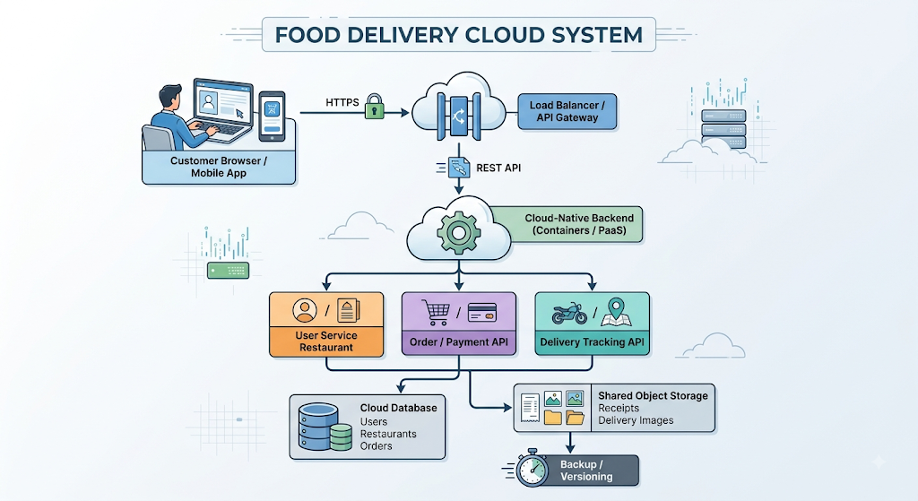
2. Role of Each Component
A. Browser / Mobile Client
The customer uses a web browser or mobile application to:
Browse restaurants
View menus
Place orders
Make payments
Track deliveries
View receipts
Communication with the backend should use HTTPS.
Example request:
GET /api/restaurants
The API returns restaurant information in JSON format.

B. API Gateway / Load Balancer
The API gateway or load balancer acts as the entry point for client requests.
Its functions include:
Routing API requests
Distributing traffic among backend instances
Authentication and access control
Rate limiting
Health checks
Protecting backend services from direct exposure
Example:
Customer
↓
API Gateway
↓
Available Backend Instance
During a large lunch-time traffic spike, requests can be distributed across several backend instances.

C. Cloud-Native Backend
The backend contains the business logic of the food delivery application.
It can be implemented using:
Containers
Kubernetes
Serverless functions
A managed PaaS
The backend can be divided into microservices such as:
User Service
Restaurant Service
Order Service
Payment Service
Delivery Service
Notification Service
This allows individual services to scale independently.

D. Web APIs
REST APIs provide communication between the client and backend.
Example endpoints:
API | Function
GET /restaurants | Display restaurants
GET /restaurants/{id}/menu | Display menu
POST /orders | Place an order
GET /orders/{id} | Check order status
POST /payments | Process payment
POST /delivery/image | Upload delivery image
GET /receipts/{id} | Retrieve receipt
The API generally exchanges data using JSON.
Example:
{
"order_id": "ORD1001",
"customer": "C101",
"restaurant": "Food Palace",
"amount": 450,
"status": "Out for Delivery"
}

3. Cloud Database
The database stores structured application information such as:
Customer details
Restaurant information
Menu items
Orders
Payment status
Delivery status
A managed cloud database can be used to reduce database administration work.
Example:
Customer → Order → Restaurant
|
→ Delivery Status
The database should not be directly accessible from the public internet. It should be accessed through the backend services.

4. Shared Cloud Storage
For receipts and delivery images, object storage is appropriate.
Examples include:
Amazon S3
Azure Blob Storage
Google Cloud Storage
Example structure:
food-delivery-storage/
│
├── receipts/
│ ├── ORD1001.pdf
│ ├── ORD1002.pdf
│ └── ORD1003.pdf
│
└── delivery-images/
├── ORD1001/
│ ├── pickup.jpg
│ └── delivered.jpg
│
└── ORD1002/
└── delivered.jpg

Why object storage?
It provides:
High scalability
High durability
Easy API-based access
Versioning
Lifecycle management
Suitable storage for images and documents

5. Receipt Generation and Image Upload Flow
Receipt Flow
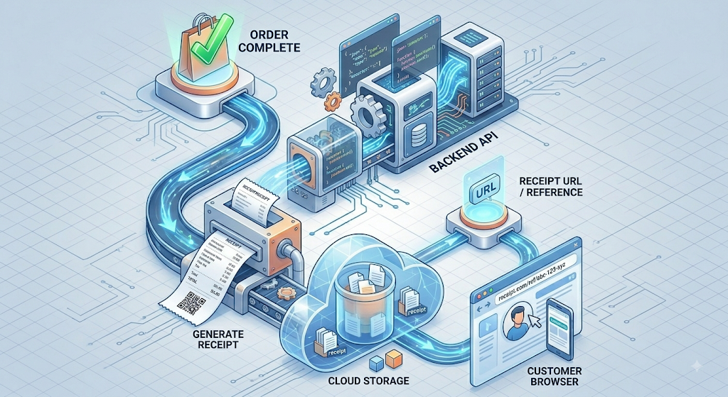

Delivery Image Flow
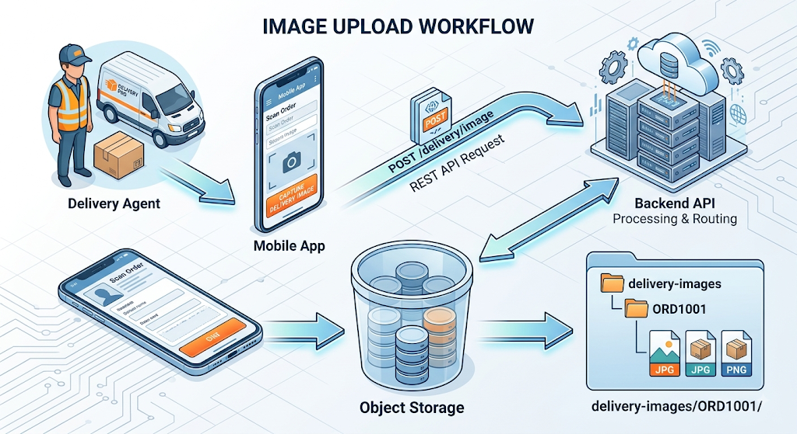The application stores the object URL/key in the database rather than putting the actual image inside the transactional database.

6. Security
Because the system handles customer, payment, receipt, and delivery information, security should be built into the architecture.
Authentication
Users authenticate using mechanisms such as:
OAuth 2.0
OpenID Connect
JWT-based sessions
Authorization
Use role-based access control:
Customer → Own orders/receipts
Restaurant → Restaurant orders
Delivery Agent → Assigned deliveries/images
Admin → Authorized management functions
Encryption
HTTPS/TLS for data in transit
Encryption at rest for database and object storage
Managed keys/KMS for encryption key control
Storage Access
Object storage should remain private. Temporary access can be provided using pre-signed URLs or equivalent controlled access mechanisms.

7. Scalability and Availability
The backend should be deployed across multiple instances or availability zones.
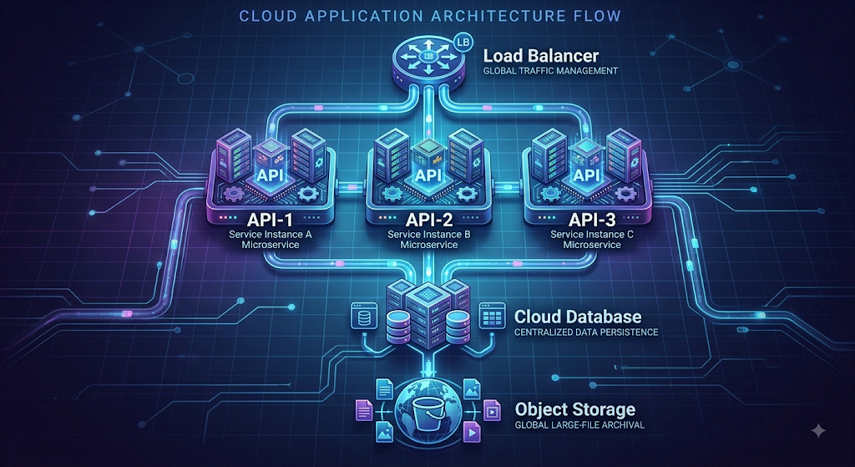Auto-scaling
During peak periods such as:
Lunch
Dinner
Weekends
Festivals
the cloud platform can automatically add backend instances.
During low demand, instances can be reduced.
This provides scalability while avoiding unnecessary infrastructure costs.

8. Example User Workflow
Suppose a customer orders biryani.
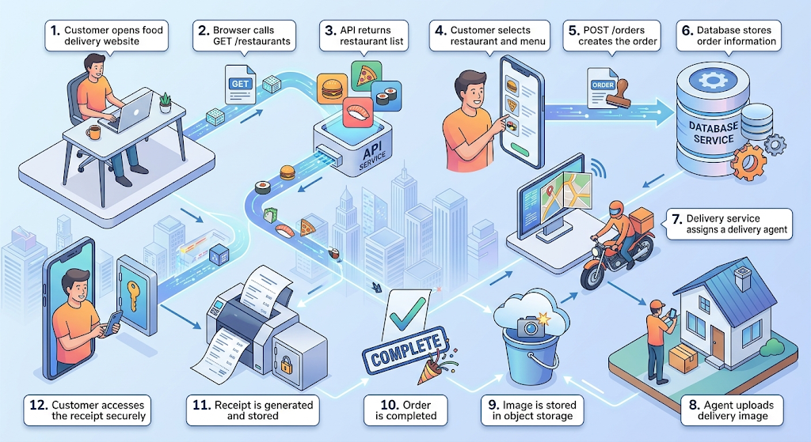
9. Benefits of the Proposed Architecture
Component | Main Benefit
Browser/Mobile App | Easy customer interaction
API Gateway | Secure request routing
REST APIs | Standard communication
Cloud Backend | Scalable business logic
Cloud Database | Reliable structured data storage
Object Storage | Scalable receipt/image storage
Load Balancer | High availability
Auto-scaling | Handles traffic spikes
Monitoring | Detects failures and performance issues

10. Conclusion
The proposed cloud-native architecture uses browser/mobile clients, REST APIs, scalable backend services, a managed cloud database, and object storage to support the food delivery company's operations.
The web APIs handle customer, restaurant, order, payment, and delivery operations, while shared cloud object storage stores receipts and delivery images securely and at scale. Load balancing, auto-scaling, encryption, and access control improve availability, performance, and security.
This architecture can therefore support a real-world food delivery platform while providing scalability, reliability, secure data storage, and efficient cloud resource usage.

- Case 2: A media startup must decide between SAN-backed storage, object storage, and serverless processing for video upload workflows. Analyze the case and recommend a deployment model.

Case Study 2: Storage and Serverless Model for a Media Startup
1. Problem Analysis
A media startup needs to handle a video upload workflow involving large files, processing, storage, and delivery.
The three alternatives are:
SAN-backed storage – high-performance shared block storage.
Object storage – scalable storage for large unstructured files.
Serverless processing – event-driven compute that processes videos without permanently running servers.
For a media startup, the main requirements are high scalability, cost efficiency, durability, and automatic processing.

2. Comparison of the Three Options
Feature | SAN-backed Storage | Object Storage | Serverless Processing
Primary purpose | High-performance shared storage | Large-scale file/object storage | Event-driven computation
Best for | High-I/O applications | Videos, images, backups | Video processing workflow
Scalability | Requires infrastructure planning | Very high | Automatically scales
Access | Block-level | API/HTTP | Trigger/API based
Cost | Relatively high | Cost-efficient for large volumes | Pay for execution
Management | Higher | Low | Very low
Video suitability | Good but expensive | Excellent | Excellent for processing
Startup overhead | Infrastructure dependent | Low | Function startup possible
Recommended | Limited use | Yes | Yes

3. SAN-Backed Storage
SAN (Storage Area Network) provides high-performance block storage to servers.
Architecture
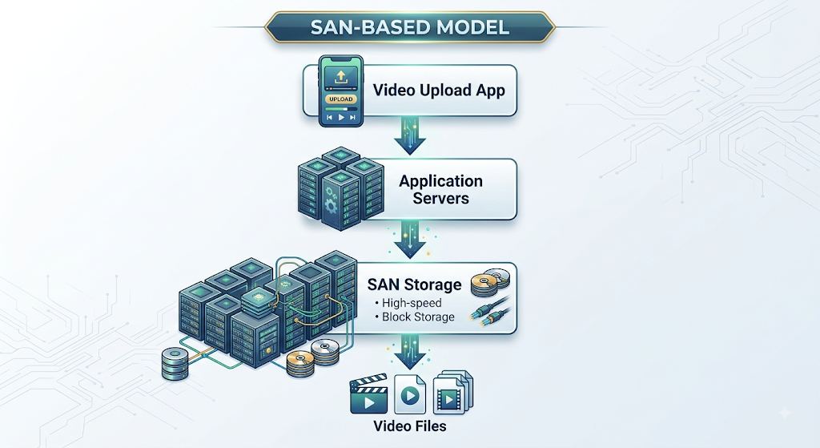Advantages
High throughput and low latency
Suitable for intensive random I/O
Centralized enterprise storage
Good for applications requiring traditional file systems
Limitations
Higher infrastructure and management cost
Scaling may require additional storage infrastructure
Less cloud-native than object storage
Potentially excessive for simply storing large video files
Assessment: Useful when the startup has specialized high-performance processing requirements, but not the best primary storage choice for a cloud-native video platform.

4. Object Storage
Object storage stores videos as independent objects with metadata and unique keys.
Examples include:
Amazon S3
Azure Blob Storage
Google Cloud Storage

Architecture

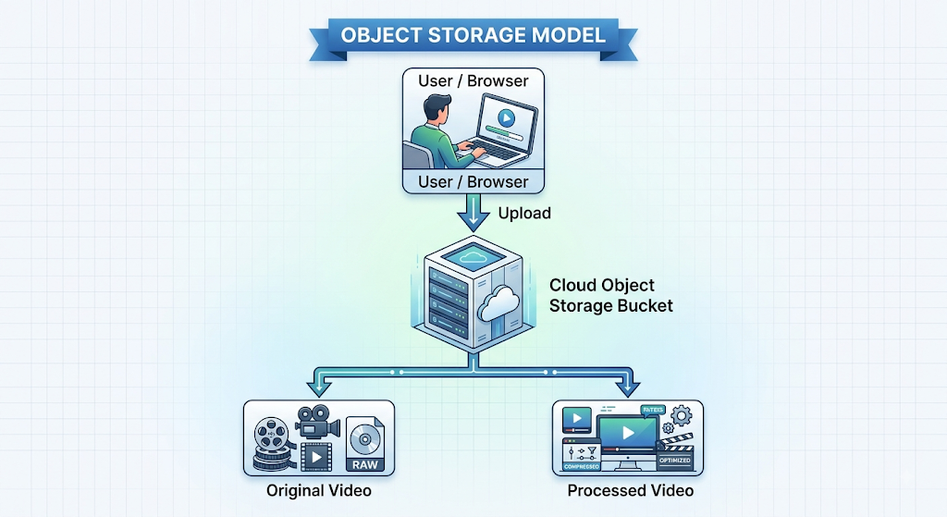Advantages
Designed for very large data volumes
Highly scalable
High durability
API-based access
Lifecycle policies can move old videos to cheaper storage classes
Easy integration with CDNs and serverless services
Limitations
Not a traditional block device
Some workloads requiring very low-latency random writes may be better suited to block storage
Assessment: Best choice for primary video storage.

5. Serverless Processing
Serverless computing can automatically process a video after upload.
Examples:
AWS Lambda
Azure Functions
Google Cloud Functions
For large video transcoding jobs, the actual processing may use a managed media/transcoding service rather than a single short-lived function.

Architecture
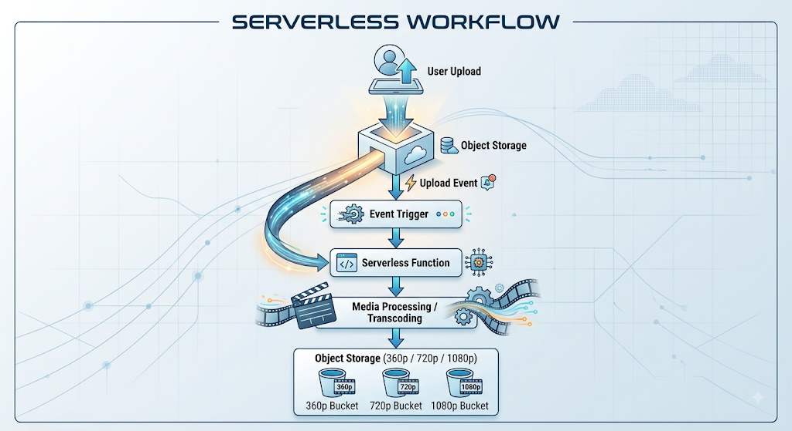Advantages
No always-on processing servers
Automatically responds to uploads
Scales with demand
Pay-per-use
Reduces infrastructure administration
Limitations
Execution duration/resource limits may make a basic function unsuitable for long video transcoding jobs
Large workloads may require managed media-processing services
Assessment: Recommended for workflow orchestration and event handling, combined with a managed video-transcoding service when required.

6. Recommended Deployment Model
The best solution is not to choose only one of the three. A cloud-native architecture should use them according to their strengths.
Recommended Model:
Object Storage + Serverless Event Processing + Managed Transcoding + CDN
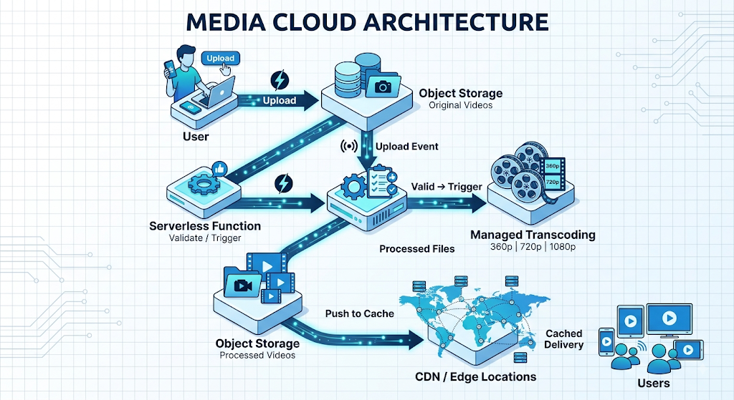
7. Video Upload Workflow
Step 1: Upload
The creator uploads:
movie.mp4
to an object-storage bucket.
Step 2: Event Generation
The storage service generates an object-created event.
Step 3: Serverless Trigger
The event activates a serverless function.
The function can:
Validate the file type
Check metadata
Create a processing job
Record the upload status
Step 4: Transcoding
A managed media service creates multiple versions:
movie.mp4
|
+----> 360p
+----> 720p
+----> 1080p
Step 5: Store Results
The processed videos are stored in another object-storage location.
Step 6: Delivery
A CDN caches frequently accessed videos near users.

8. Why Not Use SAN as the Main Storage?
A SAN is excellent for high-performance block workloads, but a startup storing potentially millions of large video objects benefits more from the scalability and operational simplicity of object storage.
A SAN-based architecture would require more infrastructure management and may create unnecessary cost for a workload primarily characterized by large, durable objects.
SAN/block storage can still be useful for temporary high-performance processing volumes when a transcoding workload specifically requires filesystem/block-level I/O.

9. Cost Optimization
The proposed model reduces cost through:
Object Storage
Use storage tiers:
Frequently accessed → Standard
Less frequently used → Infrequent Access
Old archive videos → Archive
Serverless
Pay for processing execution rather than maintaining idle servers.
Auto-scaling
Processing capacity automatically follows upload volume.
CDN
Frequently watched content can be served from edge caches, reducing repeated origin requests.
Lifecycle Policies
Automatically move old or unused video files to cheaper storage classes.

10. Security
The deployment should include:
IAM/RBAC for access control
Encryption at rest
HTTPS/TLS for data in transit
Private storage buckets
Signed URLs for controlled video access
Logging and monitoring
Malware/content validation before processing

11. Final Recommendation
Recommended Architecture
Requirement | Recommended Technology
Original video storage | Object Storage
Event handling | Serverless Functions
Video transcoding | Managed media/transcoding service
Temporary high-I/O processing | Block/SAN storage when justified
Global delivery | CDN
Monitoring | Cloud monitoring/logging
Security | IAM + encryption + HTTPS
Conclusion
The media startup should adopt a cloud-native, object-storage-first architecture rather than using SAN as the primary video repository. Videos should be uploaded directly to object storage, where an event automatically triggers serverless processing and a managed transcoding service. The resulting versions should be stored back in object storage and delivered through a CDN.
This model provides high scalability, automatic processing, lower operational overhead, strong durability, and pay-as-you-use economics, while SAN/block storage can be retained selectively for specialized high-performance processing workloads.

- Case 3: A smart city platform needs low-latency decision making near sensors while still using the cloud for analytics. Analyze the use of edge computing and fog computing in this environment.

Case Study 3: Edge and Fog Computing for a Smart City
1. Problem Analysis
A smart city generates data continuously from:
Traffic cameras
Smart traffic lights
Pollution sensors
Parking sensors
CCTV systems
Connected vehicles
Weather sensors
The system needs very fast local decisions, such as changing traffic signals when congestion is detected. At the same time, the city wants to use the cloud for large-scale analytics, historical storage, and planning.
A combination of Edge + Fog + Cloud Computing is therefore appropriate.

2. Proposed Architecture
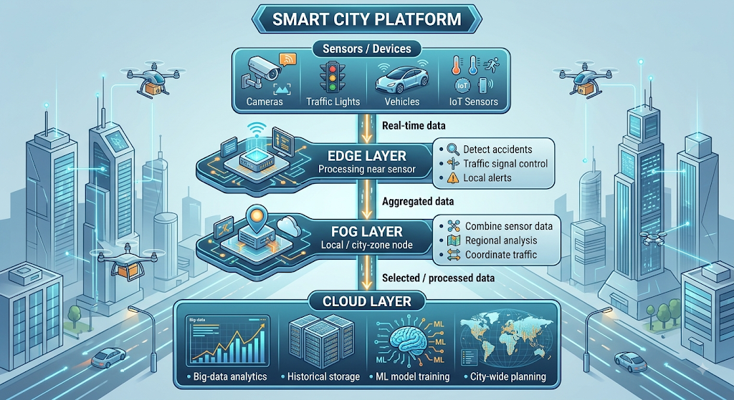
3. Role of Edge Computing
Edge computing processes information as close as possible to where it is generated.
For example, a traffic camera can connect to an edge computing device located at the intersection.
Example
Traffic Camera
↓
Edge Processor
↓
Detect congestion
↓
Change traffic signal
The video does not need to travel to a distant cloud before the traffic signal is changed.
Edge is suitable for:
Accident detection
Emergency vehicle detection
Traffic-light control
Local parking availability
Immediate safety alerts
Main advantage
Very low latency because processing occurs close to the sensor.

4. Role of Fog Computing
Fog computing provides an intermediate computing layer between edge devices and the central cloud.
A fog node can be located at:
Traffic-control centers
Roadside micro-datacenters
City network gateways
Regional data centers
Instead of analyzing only one intersection, the fog layer can combine information from many nearby intersections.
Example
Intersection A ─┐
Intersection B ─┼──> Fog Node
Intersection C ─┘
↓
Regional Analysis
↓
Coordinate Signals
For example, if three nearby roads are experiencing congestion, the fog node can coordinate traffic signals across the entire zone.

5. Role of Cloud Computing
The cloud should handle tasks that do not require immediate local decisions.
Examples:
Long-term data storage
City-wide traffic analysis
Historical reporting
Machine-learning model training
Predictive traffic forecasting
Infrastructure planning
Example:
Fog Nodes
↓
Cloud Data Lake
↓
Big Data Analytics
↓
Traffic Prediction Model
↓
City Planning Dashboard

6. Latency Considerations
Layer | Processing Location | Latency | Suitable Tasks
Edge | At/near sensor | Very low | Immediate decisions
Fog | Local/regional network | Low | Multi-device coordination
Cloud | Central/remote data center | Higher | Large-scale analytics
Why Edge is important
Suppose an accident is detected.
Sensor → Cloud → Decision
requires more network communication.
Instead:
Sensor → Edge → Emergency Signal
allows a faster response.

7. Deployment Location
Edge
Installed directly at or near the data source:
Camera
Sensor
Traffic Controller
Roadside Unit
Fog
Installed at a local aggregation point:
Roadside Gateway
City Zone Server
Traffic Control Center
Cloud
Installed in centralized cloud regions:
Cloud Data Center
Cloud Storage
Analytics Platform
ML Platform

8. Example: Smart Traffic Management
Consider a city with 500 traffic intersections.
Edge layer
Each intersection processes its own camera feeds.
Camera
↓
Edge AI
↓
Vehicle count = High
↓
Extend green signal
This response happens locally.
Fog layer
A fog node receives information from 20 nearby intersections.
20 Intersections
↓
Fog Node
↓
Regional congestion analysis
↓
Coordinate traffic signals
Cloud layer
Data from all city zones is sent to the cloud.
Fog Nodes
↓
Cloud
↓
Historical Analytics
↓
Predict congestion
↓
Improve future traffic planning

9. Edge vs Fog Analysis
Factor | Edge Computing | Fog Computing
Location | Near individual sensor | Between edge and cloud
Coverage | Local device/location | Multiple nearby devices
Latency | Lowest | Low
Processing | Immediate local processing | Regional processing
Network bandwidth | Reduces raw data transfer | Aggregates local data
Best use | Real-time control | Regional coordination
Management | Many distributed devices | Centralized within local zones

10. Advantages of the Combined Approach
Low Latency
Critical decisions are made at the edge rather than waiting for the cloud.
Reduced Bandwidth
Only useful or processed information needs to be transmitted to the cloud.
For example, instead of continuously sending raw camera footage:
Raw video → Edge processing → "Heavy traffic detected"
The summarized information can be sent upstream.
Better Reliability
If cloud connectivity is temporarily unavailable, local edge systems can continue performing critical operations.
Scalability
Fog nodes can aggregate thousands of edge devices before forwarding information to the cloud.
Powerful Analytics
The cloud provides large-scale computing resources for historical and predictive analysis.

11. Challenges
Edge Challenges
Large number of distributed devices
Limited computing resources
Physical security concerns
Device management and software updates
Fog Challenges
More infrastructure layers
Security between edge and fog nodes
Network management complexity
Additional operational cost
Cloud Challenges
Network dependency for cloud analytics
Data transfer costs
Privacy and data governance

12. Recommended Deployment Model
For the smart city, a three-layer Edge–Fog–Cloud architecture is recommended.
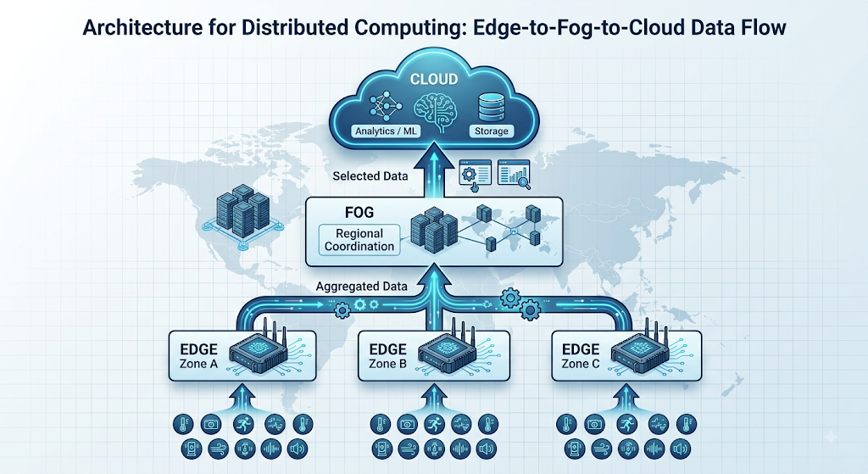Task allocation
Edge: immediate decisions.
Fog: local/regional coordination.
Cloud: large-scale analytics and long-term storage.

13. Expected Outcome
The proposed architecture provides:
Very low latency for critical sensor decisions
Reduced bandwidth consumption
Regional coordination through fog nodes
Large-scale analytics in the cloud
Improved reliability during network interruptions
Scalable smart-city infrastructure

14. Conclusion
For a smart city, using only cloud computing may introduce unnecessary latency for time-sensitive applications. Edge computing solves this by processing critical data near sensors, while fog computing provides an intermediate layer for coordinating multiple edge devices.
The cloud remains important for big-data analytics, historical storage, machine-learning, and city-wide planning.
Therefore, the most suitable solution is a hybrid Edge–Fog–Cloud architecture, where each layer performs the tasks best suited to its processing location and latency requirements.

Case Study Rubric
Criteria | Weightage | Level 4 - Exemplary | Level 3 - Proficient | Level 2 - Developing | Level 1 - Beginning
Understanding of Case | 25% | Clearly identifies all technical and business requirements | Identifies most requirements | Basic understanding only | Poor understanding of case
Application of Concepts | 25% | Applies suitable cloud concepts and tools effectively | Good application with minor issues | Partial application | Weak or incorrect application
Analysis | 20% | Strong analysis with clear trade-off reasoning | Reasonable analysis | Limited analysis | Minimal analysis
Solution Design | 20% | Solution is feasible, practical, and well justified | Reasonable solution with minor gaps | Basic solution | Unclear solution
Clarity | 10% | Well-structured and easy to follow | Mostly clear | Somewhat unclear | Poorly organized

