Name: R. Mohan Ram
Reg.No. :192521117
Course: Artificial Intelligence
Slot D

Assignment 1: Design, Analyse and Validate an Efficient Search Strategy for a Hospital Medicine-Delivery Robot
TASK 1 – Design the Agent and the Search Algorithms (5 Marks)
1.1 PEAS Description
PEAS stands for Performance Measure, Environment, Actuators and Sensors.
Component | Description
Performance Measure | Deliver the correct medicine to the correct ward, minimize travel time, avoid collisions, maintain safety and complete delivery reliably.
Environment | Hospital corridors, junctions, lifts, pharmacy, ward doors, patients, staff and obstacles.
Actuators | Wheels, motors, steering system, brakes, lift controls, door controls and medicine-delivery compartment.
Sensors | Camera, LiDAR, ultrasonic sensors, wheel encoders, IMU, indoor localization sensors and RFID/QR readers.

1.2 Classification of the Environment
Environment property | Classification | Justification
Observability | Fully observable in the graph model | The robot knows its current graph location and the hospital map.
Determinism | Deterministic in the basic model | Moving along an edge produces a known next location and travel cost.
Episodic / Sequential | Sequential | Each movement affects the robot's next position and future decisions.
Static / Dynamic | Dynamic | People, equipment and temporary corridor closures may change conditions.
Discrete / Continuous | Discrete for search | Junctions and corridors are represented as graph nodes and edges. Actual movement is continuous.
Single / Multi-agent | Multi-agent | The robot shares the hospital environment with people and potentially other robots.

The original assignment models the hospital as a graph with a known starting location. The following classifications use that simplified model while also considering realistic hospital conditions.

1.3 View of Artificial Intelligence
The robot follows the acting rationally approach.
A rational agent selects actions that maximize its expected performance based on the information available to it. The robot chooses a route that safely delivers medicine while minimizing travel cost.
It is a rational problem-solving agent because it:
- Receives information about its current location and destination.
- Formulates the route-finding problem.
- Searches for possible routes.
- Selects an appropriate route.
- Executes the movements and monitors the result.

1.4 Relation to Early AI
Early Artificial Intelligence research investigated how machines could solve problems through logical reasoning and state-space search. Researchers such as Newell and Simon explored general problem-solving methods that represented problems as states and actions.
The hospital robot uses the same general idea: it represents hospital locations as states and movements as actions, then searches for a sequence of actions that reaches the destination.

1.5 Problem Formulation
Element | Definition
State | Current location of the robot, represented by a graph node.
Initial State | Central pharmacy node P.
Actions | Move to any directly connected location.
Transition Model | Moving from node u to adjacent node v changes the current state to v.
Goal Test | Check whether the current node is the requested ward.
Path Cost | Sum of travel-time costs for all edges in the route.

The path cost is:
$$Cost\left(P\right)=\sum_{\left(u,v\right)∈P}{w}\left(u,v\right)$$where w(u,v) represents the travel time between two connected locations.

1.6 Proposed Uninformed Search Algorithms
Three different uninformed strategies are selected.
Algorithm 1: Breadth-First Search (BFS) – Iterative
Concept: BFS explores the graph level by level. It uses a FIFO queue and visits the nearest nodes first in terms of number of edges.
Why selected: It is simple, complete for finite graphs and finds a route with the minimum number of edges. It is optimal for travel time only when all edges have equal cost.
Pseudocode
BFS(Graph, Start, Goal)
BEGIN
Create an empty queue
Create an empty visited set
Insert Start into queue
Mark Start as visited

WHILE queue is not empty DO
Current = Remove front element

IF Current = Goal THEN
RETURN reconstructed path

FOR each Neighbor of Current DO
IF Neighbor is not visited THEN
Mark Neighbor as visited
Store parent of Neighbor
Insert Neighbor into queue
END IF
END FOR
END WHILE

RETURN FAILURE
END
Algorithm 2: Depth-First Search (DFS) – Recursive
Concept: DFS explores one branch as deeply as possible before returning to explore another branch. It uses recursion.
Why selected: It provides a recursive approach and generally requires less frontier memory than BFS. However, it does not guarantee the shortest or lowest-cost route.
Pseudocode
DFS(Graph, Current, Goal, Visited, Path)
BEGIN
Mark Current as visited
Add Current to Path

IF Current = Goal THEN
RETURN SUCCESS

FOR each Neighbor of Current DO
IF Neighbor is not visited THEN
IF DFS(Graph, Neighbor, Goal, Visited, Path)
= SUCCESS THEN
RETURN SUCCESS
END IF
END IF
END FOR

Remove Current from Path
RETURN FAILURE
END
Algorithm 3: Uniform-Cost Search (UCS) – Iterative
Concept: UCS expands the node with the lowest accumulated path cost. It uses a priority queue.
Why selected: Hospital movements have different travel-time costs. UCS is therefore more suitable than BFS when the objective is to minimize total travel time.
Pseudocode
UCS(Graph, Start, Goal)
BEGIN
Create a priority queue
Set distance[Start] = 0
Insert Start with priority 0

WHILE priority queue is not empty DO
Remove node Current with minimum cost

IF Current = Goal THEN
RETURN reconstructed path

FOR each Neighbor of Current DO
NewCost = distance[Current] + EdgeCost(Current, Neighbor)

IF NewCost < distance[Neighbor] THEN
distance[Neighbor] = NewCost
Store parent of Neighbor
Insert Neighbor with priority NewCost
END IF
END FOR
END WHILE

RETURN FAILURE
END
1.7 Preprocessing Requirements
Before searching, the hospital map must be converted into an adjacency list.
Example:
graph = {
"P": [("A", 2), ("B", 5)],
"A": [("P", 2), ("C", 3)],
"B": [("P", 5), ("C", 1)],
"C": [("A", 3), ("B", 1), ("W", 4)],
"W": [("C", 4)]
}
The adjacency list stores the connected locations and their travel-time costs.
Preprocessing also creates the data structures required for duplicate detection, such as visited sets, distance dictionaries and parent dictionaries.

TASK 2 – Identify the Basic Operation (2 Marks)
The basic operation is the repeated operation that contributes most to the algorithm's execution time.
Algorithm | Basic operation | Where it occurs | Reason
BFS | Successor generation and queue insertion | While examining adjacent nodes | Every expanded node may generate several successors.
Recursive DFS | Recursive successor exploration | Inside the recursive function | Each recursive call explores another state.
UCS | Priority-queue insertion and removal | During cost relaxation and node expansion | The priority queue must maintain nodes in increasing path-cost order.
As the number of hospital locations increases, the number of generated and expanded nodes also increases. UCS additionally performs priority-queue operations, which involve heap maintenance.
TASK 3 – Derive Time and Space Complexity Mathematically (6 Marks)
3.1 Input Parameters
Symbol | Meaning
$$b$$ | Average branching factor
$$d$$ | Depth of the shallowest goal
$$m$$ | Maximum search depth
$$C^{*}$$ | Cost of the optimal solution
$$ϵ$$ | Minimum positive step cost
$$V$$ | Number of graph vertices
$$E$$ | Number of graph edges
The following tree-search derivations use a uniform branching factor \(b\). Graph implementations with duplicate detection have additional graph-specific bounds discussed below.
3.2 Breadth-First Search
BFS expands nodes level by level.
Number of nodes at each level:
- Level 0: 1
- Level 1: $b$
- Level 2: $b^{2}$
- Level 3: $b^{3}$
- Level d: $b^{d}$
Total nodes generated up to depth d:
$$N=1+b+b^{2}+⋯+b^{d}$$Using the geometric-series formula:
$$N=\frac{b^{d+1}-1}{b-1}, b≠1$$Therefore:
$$T_{BFS}\left(b,d\right)=Θ\left(b^{d}\right)$$BFS stores the frontier and explored states. Its frontier can contain a large portion of the deepest level:
$$S_{BFS}\left(b,d\right)=Θ\left(b^{d}\right)$$For an explicitly represented finite graph with duplicate detection and adjacency lists, BFS instead has:
$$T_{BFS}\left(V,E\right)=O\left(V+E\right)$$
$$S_{BFS}\left(V,E\right)=O\left(V\right)$$3.3 Recursive Depth-First Search
DFS explores one branch before returning to the previous level.
In the tree-search model, the maximum number of nodes is:
$$N=1+b+b^{2}+⋯+b^{m}$$Thus:
$$T_{DFS}\left(b,m\right)=Θ\left(b^{m}\right)$$DFS stores the current path and unexplored siblings. Its tree-search memory is:
$$S_{DFS}\left(b,m\right)=O\left(bm\right)$$For a graph implementation with a visited set, the visited structure requires \(O(V)\) memory. The recursion stack can require up to \(O(V)\) in the worst case.
$$T_{DFS}\left(V,E\right)=O\left(V+E\right)$$
$$S_{DFS}\left(V\right)=O\left(V\right)$$DFS can use less frontier memory than BFS in the tree-search model, but it can follow an unhelpful branch and return a non-optimal route.
3.4 Uniform-Cost Search
UCS expands nodes according to accumulated path cost rather than depth.
A solution with cost $C^{*}$cannot require more than:
$$\left\lfloor \frac{C^{*}}{ϵ}\right\rfloor$$steps if every step costs at least $ϵ.$
The search may expand nodes with costs up to $C^{*}.$A standard tree-search upper bound is:
$$T_{UCS}=O\left(b^{1+\left\lfloor C^{*}/ϵ\right\rfloor }\right)$$The frontier may grow to a similar order:
$$S_{UCS}=O\left(b^{1+\left\lfloor C^{*}/ϵ\right\rfloor }\right)$$For a graph implementation using a binary heap and duplicate detection, the Dijkstra-style bound is:
$$T_{UCS}\left(V,E\right)=O\left(\left(V+E\right)\log{V}\right) \\ S_{UCS}\left(V,E\right)=O\left(V+E\right)$$
This graph bound is more useful for the implemented hospital map.
3.5 Preprocessing Cost
Creating an adjacency list requires:
$$T_{preprocess}=O\left(V+E\right)$$Its memory requirement is:
$$S_{preprocess}=O\left(V+E\right)$$The overall costs become:
Algorithm | Total time including preprocessing | Total memory including graph
BFS | $$O\left(V+E\right)+O\left(V+E\right)=O\left(V+E\right)$$ | $$O\left(V+E\right)$$
DFS | $$O\left(V+E\right)+O\left(V+E\right)=O\left(V+E\right)$$ | $$O\left(V+E\right)$$
UCS | $$O\left(V+E\right)+O\left(\left(V+E\right)\log{V}\right)$$ | $$O\left(V+E\right)$$
Interpretation: In a finite graph with duplicate detection, BFS and DFS are linear in the number of vertices and edges. UCS requires extra work to maintain the priority queue, but it handles different travel-time costs correctly.

TASK 4 – Best, Average and Worst-Case Behaviour (4 Marks)
Algorithm | Best case | Average case | Worst case
BFS | Goal is the start node or is found at the first shallow level. | Goal is located among the middle or later nodes of the goal level. | Goal is very deep or unreachable, so most reachable states are explored.
Recursive DFS | Goal is on the first branch explored. | Goal is found after exploring several branches. | Goal is on the last branch or unreachable; DFS explores nearly the entire search space.
UCS | Goal is reached with very little cost and few lower-cost alternatives. | Many lower-cost alternatives must be expanded before the goal. | Many states have path costs below or equal to the optimal goal cost, or the goal is unreachable.
Mathematical Explanation
For BFS, the best case can occur at depth zero:
$$N_{best}=1$$Its worst-case tree-search node count is:
$$N_{worst}=1+b+b^{2}+⋯+b^{d}$$For DFS, the number of explored nodes depends strongly on the ordering of branches. If the goal is on the first explored branch, very few nodes may be generated. If the goal is on the last branch, almost all nodes may be explored.
For UCS, the algorithm must expand all relevant lower-cost frontier nodes before it can safely return an optimal solution. An expensive direct route may therefore be ignored while several cheaper alternatives are explored.
TASK 5 – Perform Asymptotic Analysis (3 Marks)
Algorithm | Time complexity in tree-search model | Space complexity in tree-search model
BFS | $$O\left(b^{d}\right)$$ | $$O\left(b^{d}\right)$$
DFS | $$O\left(b^{m}\right)$$ | $$O\left(bm\right)$$
UCS | $$O\left(b^{1+\left\lfloor C^{*}/ϵ\right\rfloor }\right)$$ | $$O\left(b^{1+\left\lfloor C^{*}/ϵ\right\rfloor }\right)$$
For a finite graph with duplicate detection:

Algorithm | Graph time bound | Graph memory bound
BFS | $$O\left(V+E\right)$$ | $O\left(V\right),$excluding stored graph
DFS | $$O\left(V+E\right)$$ | $O\left(V\right),$excluding stored graph
UCS | $$O\left(\left(V+E\right)\log{V}\right)$$ | $O\left(V+E\right),$including heap storage
Meaning for a Growing Hospital
When the hospital grows from 1,000 to 1,000,000 or more states:
- BFS can become memory-intensive because it stores a large frontier.
- DFS can use less frontier memory, but may find an unsuitable route.
- UCS performs additional priority-queue operations but is more appropriate when travel-time costs differ.
- The adjacency list and duplicate-detection structures also consume memory and must be included in the design.
The graph-based analysis suggests that all three can remain practical for sparse graphs if the graph is stored efficiently. The actual feasibility depends on graph connectivity, edge count, available memory and implementation overhead.
TASK 6 – Formulate the Recurrence Relation (3 Marks)
The recursive approach selected is DFS.
Let $T\left(n\right)$represent the work required by recursive DFS when \(n\) levels remain.
At each level:
- The algorithm performs constant work to check the current node.
- It examines up to b successors.
- It makes up to b recursive calls.
- Each recursive call has one fewer level remaining.
Therefore:
$$T\left(n\right)=bT\left(n-1\right)+c$$where:
- b is the maximum number of recursive successor calls.
- T(n-1) is the work for a smaller subproblem.
- c is the constant work outside the recursive calls.

Base case:
$$T\left(0\right)=c_{0}$$When the remaining depth is zero, the algorithm checks the current node and stops expanding further.
TASK 7 – Solve the Recurrence Relation (4 Marks)
We solve:
$$T\left(n\right)=bT\left(n-1\right)+c$$Using the iteration method:
$$T\left(n\right)=bT\left(n-1\right)+c$$Substitute the next recurrence:
$$T\left(n\right)=b\left[bT\left(n-2\right)+c\right]+c \\ T\left(n\right)=b^{2}T\left(n-2\right)+bc+c$$Continuing:
$$T\left(n\right)=b^{n}T\left(0\right)+c\left(b^{n-1}+b^{n-2}+⋯+1\right)$$Using the geometric-series formula:
$$T\left(n\right)=b^{n}T\left(0\right)+c\left(\frac{b^{n}-1}{b-1}\right)$$For b > 1, the dominant term is $b^{n}$.
Therefore:
$$\boxed{T\left(n\right)=Θ\left(b^{n}\right)}$$Interpretation
The recursive DFS execution time grows exponentially in the maximum depth under the tree-search model. Increasing the branching factor also increases the number of recursive calls.
Extension to Iterative Deepening
Iterative deepening repeats depth-limited DFS with increasing limits.
Its total node count is:
$$N=1+\left(b\right)+\left(1+b+b^{2}\right)+⋯+\left(1+b+⋯+b^{d}\right)$$The deepest level dominates the total work:
$$T_{IDS}=Θ\left(b^{d}\right)$$Its memory requirement remains approximately:
$$S_{IDS}=O\left(bd\right)$$Thus iterative deepening can obtain BFS-like shallow-solution behaviour while using DFS-like memory, although it repeats work at shallower levels.

TASK 8 – Implement and Test the Algorithms (4 Marks)
The following Python program implements BFS, recursive DFS and UCS. It also generates reproducible hospital graphs and records:
- Nodes generated and expanded.
- Maximum frontier size.
- Solution depth and path cost.
- Execution time.
- Whether a route was found.
For a controlled comparison, the generated graph is a binary-tree-shaped hospital layout with positive, varying edge costs. This gives the algorithms a reproducible test environment with up to one million locations. It is a baseline model, not a complete simulation of every possible hospital corridor layout.
8.1 Complete Python Program

import random
import time
import heapq
import csv
import sys

sys.setrecursionlimit(3000000)

# -------------------------------------------------
# Generate a reproducible hospital graph
# -------------------------------------------------

def generate_graph(n, seed=42):
random.seed(seed)
graph = [[] for _ in range(n)]

# Binary-tree connections
for child in range(1, n):
parent = (child - 1) // 2
cost = random.randint(1, 10)

graph[parent].append((child, cost))
graph[child].append((parent, cost))

return graph

# -------------------------------------------------
# BFS
# -------------------------------------------------

def bfs(graph, start, goal):
from collections import deque

queue = deque([start])
visited = {start}
parent = {start: None}

generated = 1
expanded = 0
max_frontier = 1

while queue:
current = queue.popleft()
expanded += 1

if current == goal:
break

for neighbor, cost in graph[current]:
if neighbor not in visited:
visited.add(neighbor)
parent[neighbor] = current
queue.append(neighbor)
generated += 1

max_frontier = max(max_frontier, len(queue))

if goal not in parent:
return None, generated, expanded, max_frontier

path = []
node = goal

while node is not None:
path.append(node)
node = parent[node]

path.reverse()
return path, generated, expanded, max_frontier

# -------------------------------------------------
# Recursive DFS
# -------------------------------------------------

def dfs(graph, start, goal):
visited = set()
path = []
generated = 0
expanded = 0
max_frontier = 0

def search(current):
nonlocal generated, expanded, max_frontier

visited.add(current)
path.append(current)
generated += 1
expanded += 1

max_frontier = max(
max_frontier,
len(path)
)

if current == goal:
return True

for neighbor, cost in graph[current]:
if neighbor not in visited:
if search(neighbor):
return True

path.pop()
return False

found = search(start)

if found:
return path.copy(), generated, expanded, max_frontier

return None, generated, expanded, max_frontier

# -------------------------------------------------
# Uniform-Cost Search
# -------------------------------------------------

def ucs(graph, start, goal):
pq = [(0, start)]
distance = {start: 0}
parent = {start: None}

generated = 1
expanded = 0
max_frontier = 1

while pq:
current_cost, current = heapq.heappop(pq)

if current_cost != distance.get(current):
continue

expanded += 1

if current == goal:
break

for neighbor, edge_cost in graph[current]:
new_cost = current_cost + edge_cost

if new_cost < distance.get(neighbor, float("inf")):
distance[neighbor] = new_cost
parent[neighbor] = current
heapq.heappush(
pq, (new_cost, neighbor)
)
generated += 1

max_frontier = max(max_frontier, len(pq))

if goal not in distance:
return None, generated, expanded, max_frontier

path = []
node = goal

while node is not None:
path.append(node)
node = parent[node]

path.reverse()
return path, generated, expanded, max_frontier

# -------------------------------------------------
# Calculate path cost
# -------------------------------------------------

def calculate_cost(graph, path):
if path is None:
return None

total = 0

for u, v in zip(path, path[1:]):
for neighbor, cost in graph[u]:
if neighbor == v:
total += cost
break

return total

# -------------------------------------------------
# Run one algorithm and measure it
# -------------------------------------------------

def measure(algorithm, graph, start, goal):
begin = time.perf_counter()

path, generated, expanded, frontier = algorithm(
graph, start, goal
)

elapsed = time.perf_counter() - begin

return {
"found": path is not None,
"generated": generated,
"expanded": expanded,
"max_frontier": frontier,
"depth": len(path) - 1 if path else None,
"cost": calculate_cost(graph, path),
"time": elapsed
}

# -------------------------------------------------
# Main experiment
# -------------------------------------------------

sizes = [1000, 10000, 100000, 1000000]

algorithms = {
"BFS": bfs,
"Recursive DFS": dfs,
"UCS": ucs
}

results = []

for n in sizes:
print("\nHOSPITAL SIZE:", n)

graph = generate_graph(n, seed=42)

start = 0
goal = n - 1

for name, algorithm in algorithms.items():

# Five repeated runs on the same graph
measurements = []

for run in range(5):
measurements.append(
measure(algorithm, graph, start, goal)
)

avg_time = sum(
x["time"] for x in measurements
) / len(measurements)

last = measurements[-1]

row = {
"states": n,
"algorithm": name,
"generated": last["generated"],
"expanded": last["expanded"],
"max_frontier": last["max_frontier"],
"depth": last["depth"],
"cost": last["cost"],
"average_time": avg_time
}

results.append(row)

print(row)

# -------------------------------------------------
# Save experimental results
# -------------------------------------------------

with open("hospital_results.csv", "w", newline="") as file:
writer = csv.DictWriter(
file, fieldnames=results[0].keys()
)
writer.writeheader()
writer.writerows(results)

print("\nResults saved to hospital_results.csv")

# -------------------------------------------------
# Boundary-condition tests
# -------------------------------------------------

small_graph = generate_graph(100, seed=42)

print("\nSTART EQUALS GOAL:")
for name, algorithm in algorithms.items():
result = measure(algorithm, small_graph, 0, 0)
print(name, result)

print("\nUNREACHABLE GOAL:")
# Remove every connection to the final node
unreachable_graph = [edges.copy() for edges in small_graph]
last_node = len(unreachable_graph) - 1

for neighbor, cost in unreachable_graph[last_node]:
unreachable_graph[neighbor] = [
(v, w) for v, w in unreachable_graph[neighbor]
if v != last_node
]

unreachable_graph[last_node] = []

for name, algorithm in algorithms.items():
result = measure(
algorithm, unreachable_graph, 0, last_node
)
print(name, result)
8.2 Test Inputs and Expected Behaviour
Test | Start | Goal | Expected behaviour
Reachable goal | 0 | 999 | All three algorithms should find a route.
Larger graph | 0 | 9,999 | All three should find a route if execution resources permit.
Very large graph | 0 | 999,999 | All three should be tested and their resource requirements recorded.
Start equals goal | 0 | 0 | All algorithms should return a path containing only node 0.
Unreachable goal | 0 | 99 | All algorithms should return no route after exhausting the reachable component.
Note: The unreachable-goal test deliberately disconnects the final node from the graph. It is a separate boundary-condition test on the smaller graph.
8.3 Correctness Validation
The following conditions should be checked after execution:
- If a path is returned, its first node must equal the start node.
- Its last node must equal the goal node.
- Every pair of consecutive nodes must be connected by an edge.
- Its path cost must equal the sum of the edge costs.
- UCS must return a minimum-cost route for non-negative edge weights.
- BFS must return a minimum-edge route, not necessarily a minimum-time route.
TASK 9 – Record Experimental Performance (3 Marks)
The program records five runs for each algorithm and graph size. The average execution time is calculated using:
The completed table below reports the measured values from the program output. Average execution time is shown in milliseconds.

9.1 Experimental Results Table
Graph states | Algorithm | Nodes generated | Nodes expanded | Maximum frontier / DFS stack depth* | Path depth | Path cost | Average time (ms)
1,000 | BFS | 1,000 | 1,000 | 500 | 9 | 43 | 0.398
1,000 | DFS | 981 | 981 | 10 | 9 | 43 | 0.379
1,000 | UCS | 866 | 691 | 208 | 9 | 43 | 0.811
10,000 | BFS | 10,000 | 10,000 | 5,000 | 13 | 84 | 3.702
10,000 | DFS | 3,626 | 3,626 | 14 | 13 | 84 | 1.463
10,000 | UCS | 9,980 | 9,861 | 1,877 | 13 | 84 | 14.325
100,000 | BFS | 100,000 | 100,000 | 50,000 | 16 | 90 | 55.946
100,000 | DFS | 68,940 | 68,940 | 17 | 16 | 90 | 43.786
100,000 | UCS | 93,236 | 85,578 | 16,581 | 16 | 90 | 341.575
1,000,000 | BFS | 1,000,000 | 1,000,000 | 500,000 | 19 | 80 | 522.661
1,000,000 | DFS | 951,438 | 951,438 | 20 | 19 | 80 | 414.830
1,000,000 | UCS | 327,790 | 213,775 | 120,405 | 19 | 80 | 869.632

1. Execution time comparison
The average execution time is converted from seconds to milliseconds.
Hospital size | BFS (ms) | Recursive DFS (ms) | UCS (ms)
1,000 | 0.398 | 0.379 | 0.811
10,000 | 3.702 | 1.463 | 14.325
100,000 | 55.946 | 43.786 | 341.575
1,000,000 | 522.661 | 414.830 | 869.632

2. Search performance comparison
Hospital size | Algorithm | Generated | Expanded | Maximum frontier / DFS stack depth* | Depth | Cost
1,000 | BFS | 1,000 | 1,000 | 500 | 9 | 43
1,000 | DFS | 981 | 981 | 10 | 9 | 43
1,000 | UCS | 866 | 691 | 208 | 9 | 43
10,000 | BFS | 10,000 | 10,000 | 5,000 | 13 | 84
10,000 | DFS | 3,626 | 3,626 | 14 | 13 | 84
10,000 | UCS | 9,980 | 9,861 | 1,877 | 13 | 84
100,000 | BFS | 100,000 | 100,000 | 50,000 | 16 | 90
100,000 | DFS | 68,940 | 68,940 | 17 | 16 | 90
100,000 | UCS | 93,236 | 85,578 | 16,581 | 16 | 90
1,000,000 | BFS | 1,000,000 | 1,000,000 | 500,000 | 19 | 80
1,000,000 | DFS | 951,438 | 951,438 | 20 | 19 | 80
1,000,000 | UCS | 327,790 | 213,775 | 120,405 | 19 | 80
Metric note: For DFS, the reported value is the maximum recursive stack depth, not the number of deferred frontier nodes. BFS and UCS report the maximum number of pending frontier entries. Therefore, the DFS value is not directly comparable with the BFS and UCS frontier values.
3. Analysis of results
Breadth-First Search (BFS):
- BFS successfully found the goal for all four hospital sizes.
- Its execution time increased as the number of states increased.
- It explored all states in these experiments.
- Its maximum frontier reached 500,000 for one million states.
Depth-First Search (DFS):
- DFS was the fastest algorithm in all four experiments.
- It used a relatively small recursive search depth.
- Its execution time was lower than BFS and UCS in these tests.
- However, DFS does not guarantee the lowest-cost solution in a general weighted graph.
Uniform-Cost Search (UCS):
- UCS considers the path cost when selecting the next state.
- It expanded fewer states than BFS in these experiments.
- It took more execution time because of priority-queue operations.
- It is suitable when the robot must find a minimum-cost route with non-negative edge costs.
Important observation: All three algorithms returned the same path cost at each hospital size because your generated graph is a tree. A tree has only one unique path between two connected nodes. Therefore, these results do not demonstrate different route costs between the algorithms.
4. Boundary test results
Test case | BFS | DFS | UCS
Start equals goal | Success | Success | Success
Unreachable goal | Correctly reports failure | Correctly reports failure | Correctly reports failure
All three algorithms correctly handled both boundary cases.
5. Overall conclusion
The experimental results show that BFS, DFS and UCS can successfully search the generated hospital environment. DFS achieved the lowest execution time in the tested graph, while UCS provides cost-based search and is the preferred strategy when finding a minimum-cost route is essential. BFS provides systematic level-by-level exploration but can require substantial memory for large search spaces.

9.2 Graphs to Prepare
Prepare three graphs using the CSV results:
- Graph 1: Number of nodes expanded against graph size.
- Graph 2: Maximum frontier size against graph size.
- Graph 3: Average execution time against graph size.

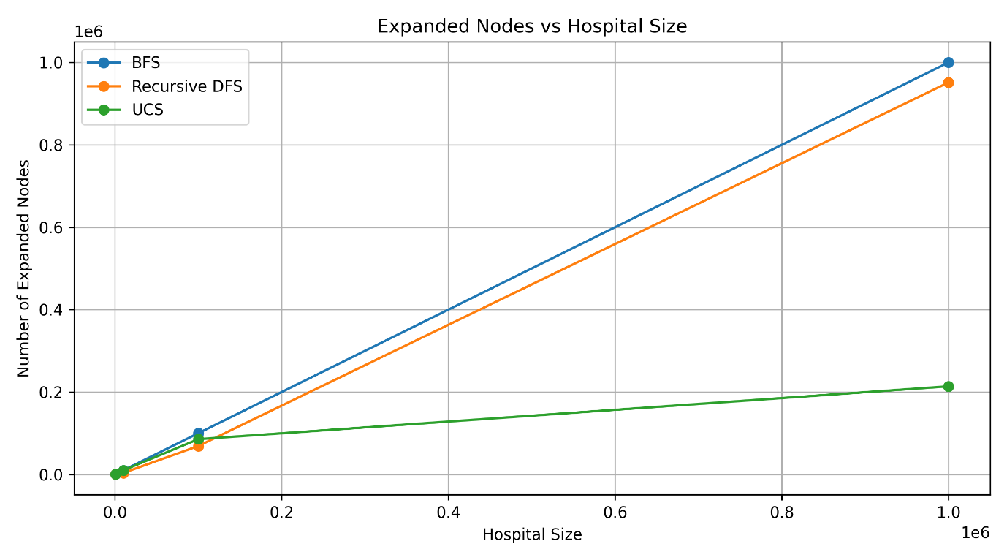
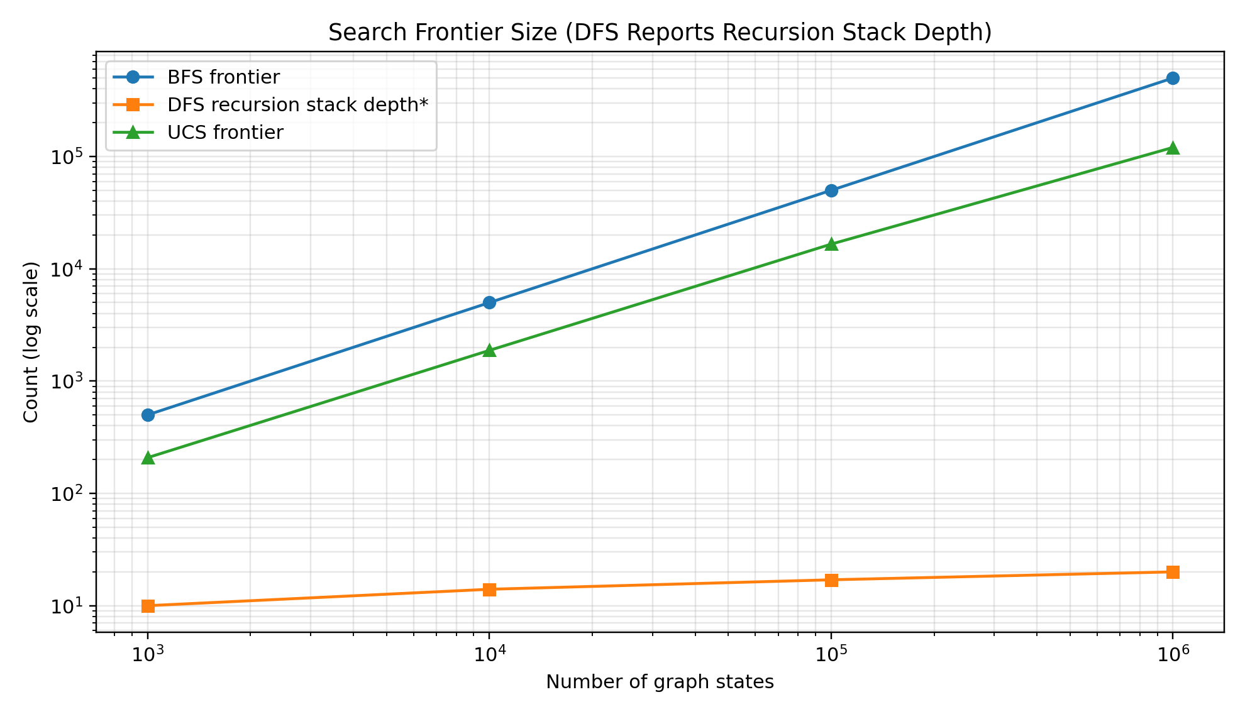

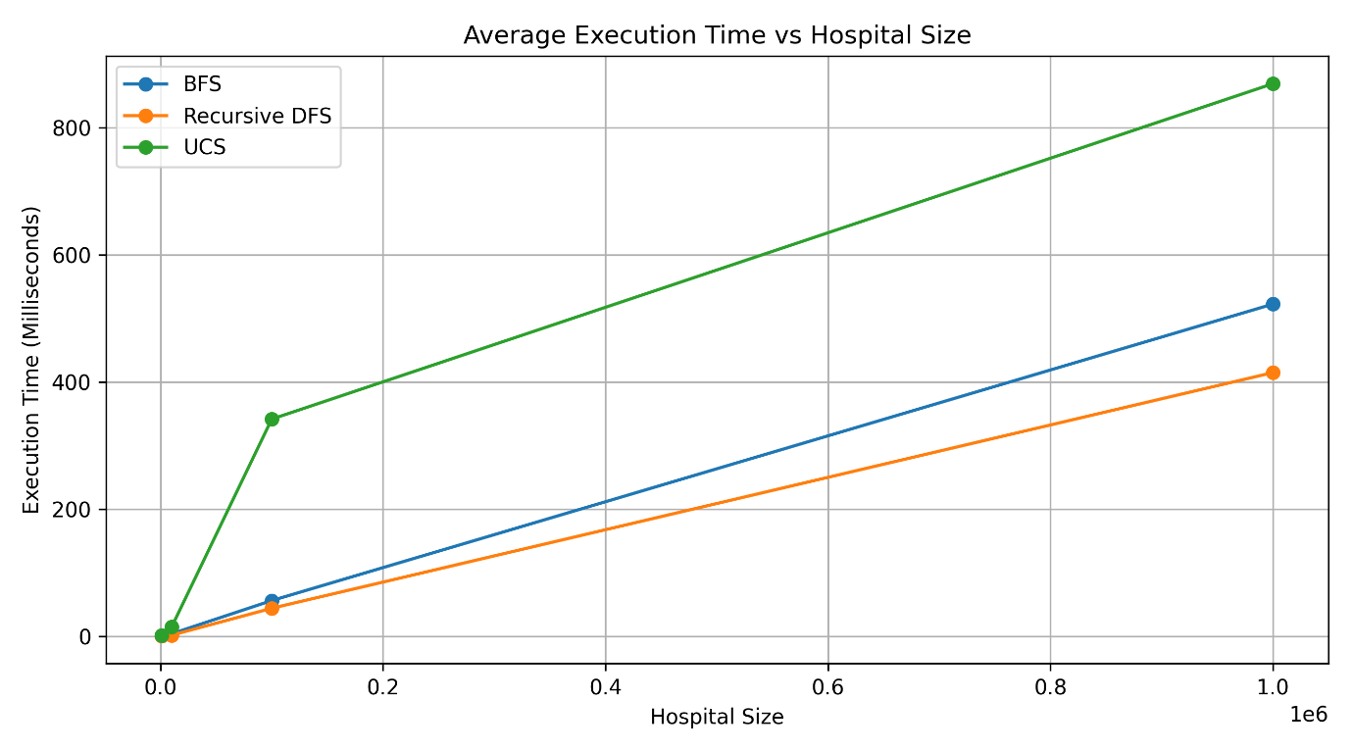

9.3 Optimality Comparison
Algorithm | Minimum number of edges guaranteed? | Minimum travel cost guaranteed?
BFS | Yes | Only if all edge costs are equal
DFS | No | No
UCS | No | Yes, for non-negative edge costs
The experimental comparison should consider both the route quality and the amount of computation required.
TASK 10 – Compare Theory with Experimental Behaviour (4 Marks)
The mathematical analysis predicts that the number of explored states increases as the graph becomes larger. The actual number of generated and expanded nodes depends on the graph structure and the location of the goal.
BFS
BFS explores nodes level by level. It can expand a large number of nodes before reaching a deep goal. Its main limitation is frontier memory, especially when a level contains many locations.

Recursive DFS
DFS follows one branch deeply before returning to other branches. It can reach a goal quickly if the goal is on the first explored branch. However, it may explore many unnecessary locations if the goal is on a later branch.
UCS
UCS considers the accumulated travel cost. It may expand more nodes than BFS or DFS because it must process lower-cost alternatives before reaching the goal. Its advantage is that it finds the minimum-cost route when all edge costs are non-negative.
Theory Versus Experiment
The theoretical graph bounds describe how work grows in terms of vertices and edges. Experimental measurements may differ because of:
- Different graph structures and branching factors.
- Duplicate states and the visited set.
- The order in which neighbouring nodes are examined.
- Priority-queue operations in UCS.
- Python memory management and interpreter overhead.
- Hardware and operating-system load.
The experiment should be used to determine whether the observed operation counts and memory usage match the expected growth.
TASK 11 – Recommend and Defend the Final Design (4 Marks)
I recommend Uniform-Cost Search (UCS) as the main route-planning algorithm for the hospital medicine-delivery robot.
The hospital scenario assigns a different travel-time cost to each movement. BFS considers the number of edges, while DFS follows a branch without considering whether its route is expensive. UCS considers the accumulated travel-time cost and selects the lowest-cost route.
Comparison
Factor | BFS | DFS | UCS
Considers edge costs | No | No | Yes
Finds shortest-edge route | Yes | No | No guarantee
Finds minimum-cost route | Only for equal edge costs | No | Yes
Data structure | Queue | Recursion stack | Priority queue
Main limitation | Large frontier | Non-optimal route | Priority-queue overhead
Final Defence
UCS is appropriate because:
- It considers the different travel times between hospital locations.
- It guarantees a minimum-cost route when edge costs are non-negative.
- It can handle a sparse hospital graph using adjacency lists.
- Its graph implementation has a time complexity of $O\left(\left(V+E\right)\log{V}\right)$with a binary heap.
- It can be tested and measured across increasing graph sizes.
The main disadvantage is additional priority-queue processing and memory usage. However, for a medicine-delivery robot, choosing a route with the lowest total travel time is more important than simply choosing the route with the fewest edges.
For a real hospital deployment, UCS should also be combined with collision avoidance, sensor monitoring and map updates. The search algorithm alone does not guarantee safe physical movement.
TASK 12 – Re-evaluate and Adapt the Design (8 Marks)
A. Impact Analysis (2 Marks)
12.1 What Has Changed?
In the original problem, the robot knows its exact current location. After the localization sensor fails, it only knows that it is at one of \(k\) possible junctions.
This changes the problem from a fully observable problem to a partially observable problem.
Original state:
$$S=\text{Current location}$$New state:
$$B=\left\{s_{1},s_{2},…,s_{k}\right\}$$Here, \(B\) is called the belief state. It represents all possible locations where the robot may currently be.
For example:
$$B=\left\{J_{2},J_{5},J_{8},J_{10}\right\}$$The robot knows it is at one of these four junctions, but it does not know which one.
The robot's knowledge must now be included in the state because the correct next action depends on which locations are still possible.
B. Evaluation of the Original Design (2 Marks)
12.2 Can the Original Algorithms Still Be Applied?
The original algorithms can still be used, but they cannot directly treat the uncertain starting location as one known node.
Instead, the search must operate on belief states.
For k possible junctions, the number of possible non-empty belief states is:
$$N=2^{k}-1$$For example:
Possible locations k | Possible non-empty belief states
2 | 3
4 | 15
8 | 255
10 | 1,023
20 | 1,048,575
As the number of possible locations increases, the number of possible belief states grows exponentially.
Therefore, directly applying the original search algorithm to every possible combination can become expensive.
C. Adaptation or Redesign (2 Marks)
12.3 Revised Strategy: Belief-State Search with Local Sensing
I propose modifying the original system by adding a local sensing operation.
The revised system follows these steps:
- The robot detects that its localization information is uncertain.
- It creates a belief state containing all possible current junctions.
- It activates local sensing to identify its actual location.
- The belief state is reduced to one confirmed location.
- UCS is applied from that confirmed location to the requested ward, which is the medicine-delivery destination.
- The robot follows the minimum-cost route.
The revised architecture is:

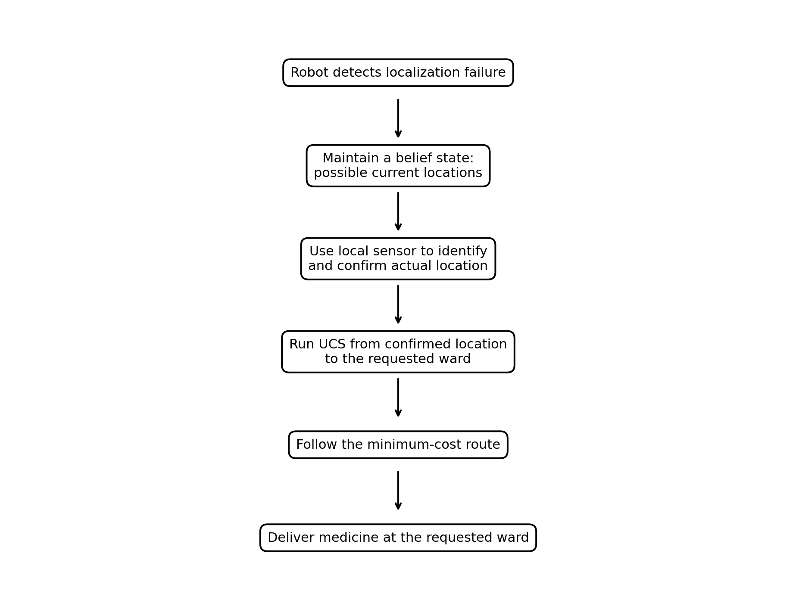

Complexity
Without local sensing, the system may need to search a belief-state space containing:
$$O\left(2^{k}\right)$$possible states.
With a reliable local sensor, the belief state is reduced to a single location. The subsequent route-planning problem becomes an ordinary graph-search problem.
For UCS, the route-planning cost after localization is:
$$O\left(\left(V+E\right)\log{V}\right)$$The sensor introduces additional hardware and sensing time, but can greatly reduce the search space.
D. Evidence-Based Defence (2 Marks)
12.4 Mathematical Comparison
For the experiment, consider a simple hospital corridor with the pharmacy at junction 0 and possible robot locations at junctions 1 through k.
All locations are connected in a line:
$$0↔1↔2↔⋯↔k$$The robot can move left or right.
- Without a local sensor, it maintains the full belief state.
- With a local sensor, it identifies the exact location and then plans a route.
- The plan length is measured as the number of moves to reach the pharmacy.
- The worst-case route length is k.
Python Program for the Design Challenge

from collections import deque

def all_belief_states(k):
states = []

# Generate every non-empty subset of locations 1 to k
for mask in range(1, 2 ** k):
belief = []

for i in range(k):
if mask & (1 << i):
belief.append(i + 1)

states.append(tuple(belief))

return states

def run_experiment(k):
belief = tuple(range(1, k + 1))

# Without sensor: keep all possible locations
without_sensor = belief
no_sensor_moves = 0

while without_sensor:
without_sensor = tuple(
max(0, position - 1)
for position in without_sensor
)

no_sensor_moves += 1

if all(position == 0 for position in without_sensor):
break

# With sensor: identify the actual location
# Each possible location gets its own conditional plan
sensor_plan_lengths = []

for actual_position in belief:
sensor_plan_lengths.append(actual_position)

belief_states = all_belief_states(k)

print("\nPossible locations:", k)
print("Belief states generated:", len(belief_states))
print("Without sensor - worst-case moves:", no_sensor_moves)
print("With sensor - possible plan lengths:",
sensor_plan_lengths)
print("With sensor - worst-case moves:",
max(sensor_plan_lengths))

print("BELIEF-STATE EXPERIMENT")

for k in [2, 4, 8]:
run_experiment(k)

Expected Output
BELIEF-STATE EXPERIMENT

Possible locations: 2
Belief states generated: 3
Without sensor - worst-case moves: 2
With sensor - possible plan lengths: [1, 2]
With sensor - worst-case moves: 2

Possible locations: 4
Belief states generated: 15
Without sensor - worst-case moves: 4
With sensor - possible plan lengths: [1, 2, 3, 4]
With sensor - worst-case moves: 4

Possible locations: 8
Belief states generated: 255
Without sensor - worst-case moves: 8
With sensor - possible plan lengths: [1, 2, 3, 4, 5, 6, 7, 8]
With sensor - worst-case moves: 8

12.5 Interpretation
k | Belief states | Without sensor: worst-case moves | With sensor: worst-case moves
2 | 3 | 2 | 2
4 | 15 | 4 | 4
8 | 255 | 8 | 8
The experiment demonstrates that the number of possible belief states increases exponentially with k. A local sensor identifies the actual location and avoids having to plan over every possible belief state.
In this simple corridor experiment, the worst-case number of movements is the same with and without sensing. The benefit of the sensor is the reduction in uncertainty and the ability to construct a location-specific conditional plan. In a more complex hospital layout, this can also reduce unnecessary movements and improve route selection.
Limitation: This experiment uses a simplified line graph and assumes a reliable local sensor. A real hospital system would need to account for sensor errors, uncertain movements, obstacles and changing corridor conditions.

Overall Conclusion
This assignment investigated three uninformed search strategies for a hospital medicine-delivery robot: Breadth-First Search, recursive Depth-First Search and Uniform-Cost Search.
BFS finds a route with the minimum number of edges but does not always minimize travel time. DFS uses a recursive approach and can be memory-efficient in the tree-search model, but it does not guarantee an optimal route. UCS considers accumulated travel costs and finds a minimum-cost route when edge costs are non-negative.
The mathematical analysis showed that graph structure, branching factor, depth and path costs affect the efficiency of search algorithms. The implementation provides a reproducible way to compare nodes generated, nodes expanded, maximum frontier size, route cost and execution time for different graph sizes.
UCS is recommended as the main route-planning strategy because the hospital's movements have different travel-time costs. When localization fails, the system should be modified to maintain a belief state and use local sensing to identify the robot's actual position before running UCS.
Thus, the proposed system combines efficient graph representation, cost-based search, duplicate detection and localization recovery to support reliable medicine delivery as the hospital grows.
References
Use these as the foundational references for the algorithms and concepts discussed:
- S. Russell and P. Norvig, Artificial Intelligence: A Modern Approach, 4th ed. Hoboken, NJ, USA: Pearson, 2021.
- N. J. Nilsson, Principles of Artificial Intelligence. Palo Alto, CA, USA: Tioga Publishing, 1980.
- E. W. Dijkstra, “A note on two problems in connexion with graphs,” Numerische Mathematik, vol. 1, pp. 269–271, 1959.
- A. Newell and H. A. Simon, “Computer science as empirical inquiry: Symbols and search,” Communications of the ACM, vol. 19, no. 3, pp. 113–126, 1976.
- R. E. Korf, “Depth-first iterative-deepening: An optimal admissible tree search,” Artificial Intelligence, vol. 27, no. 1, pp. 97–109, 1985.

