BL4 – IMAGE / WORKFLOW BASED PRACTICE QUESTIONS
DEVSECOPS • CO1–CO5 • 5 QUESTIONS PER CO • 25 QUESTIONS
CO1: DevSecOps lifecycle, DevOps vs DevSecOps, security risk analysis
CO2: Threat propagation, attack surface, Shift-Left security
CO3: SAST, DAST, SCA, vulnerability trends
CO4: Infrastructure, deployment, IAM, GitOps, Kubernetes security
CO5: Security logs, incident timelines, anomalies, monitoring

Q1. CO1 — DevSecOps Lifecycle
The workflow contains two missing stages. Which pair correctly completes the flow after BUILD and before the final monitoring stage?
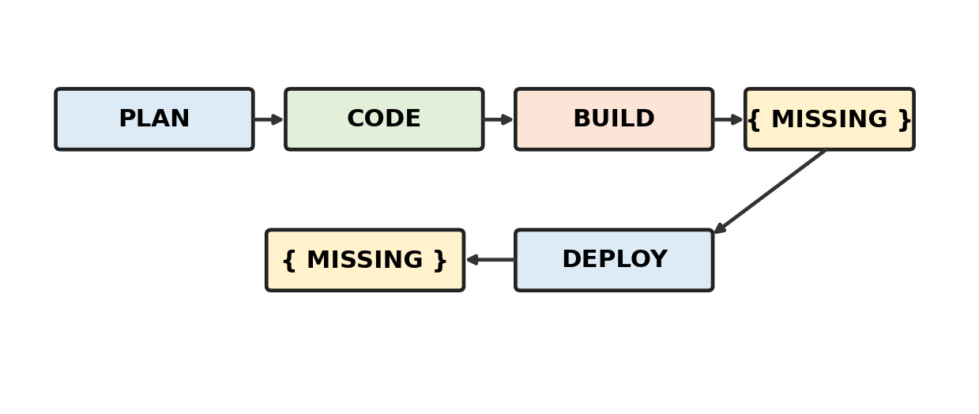
A. TEST → MONITOR
B. MONITOR → TEST
C. SCAN → OPERATE
D. OPERATE → TEST
Practice: Analyse the diagram and select the best answer.

Q2. CO1 — DevOps vs DevSecOps
The workflow adds a security activity to the development pipeline. Which missing block best represents the main DevSecOps distinction?
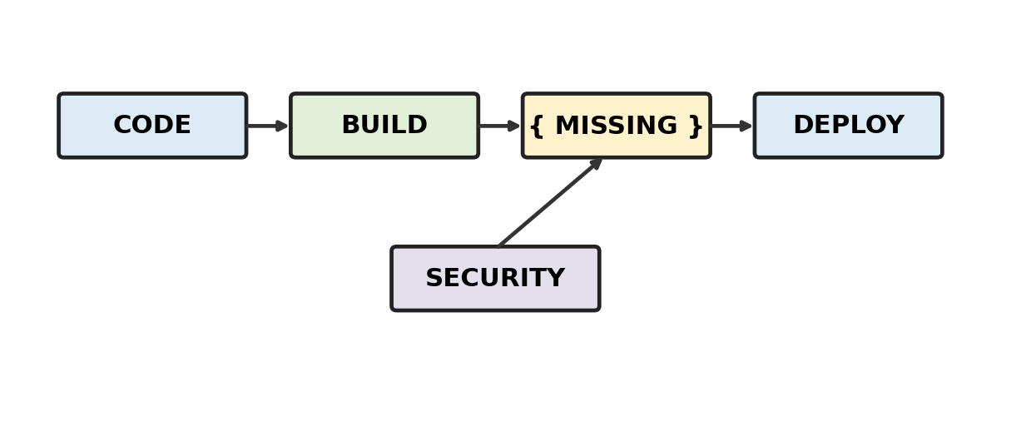
A. Security scanning
B. Release packaging
C. User training
D. Business approval
Practice: Analyse the diagram and select the best answer.

Q3. CO1 — Security Risk Analysis
A risk workflow moves from a threat to a control decision. What should be inserted before the final treatment decision?
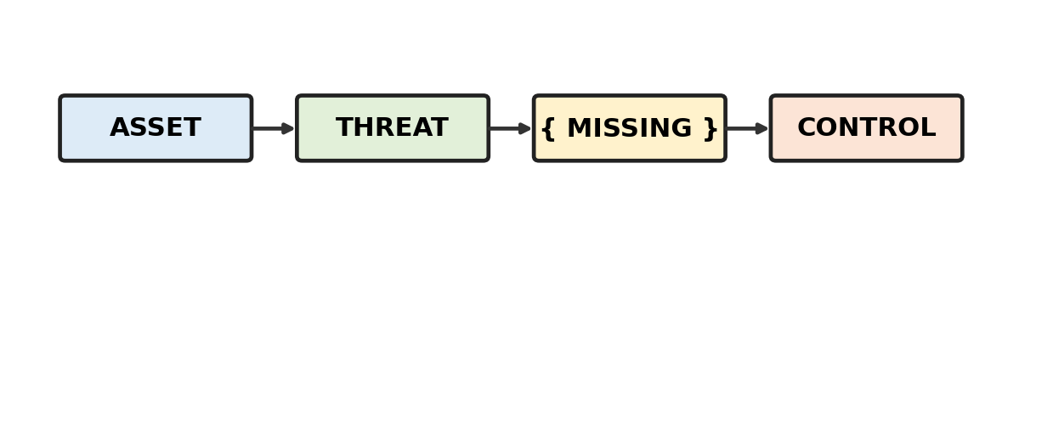
A. Likelihood / impact assessment
B. Source compilation
C. Application deployment
D. Account creation
Practice: Analyse the diagram and select the best answer.

Q4. CO1 — Secure Development
The diagram moves security toward the beginning of the SDLC. Which missing activity is most consistent with early security analysis?
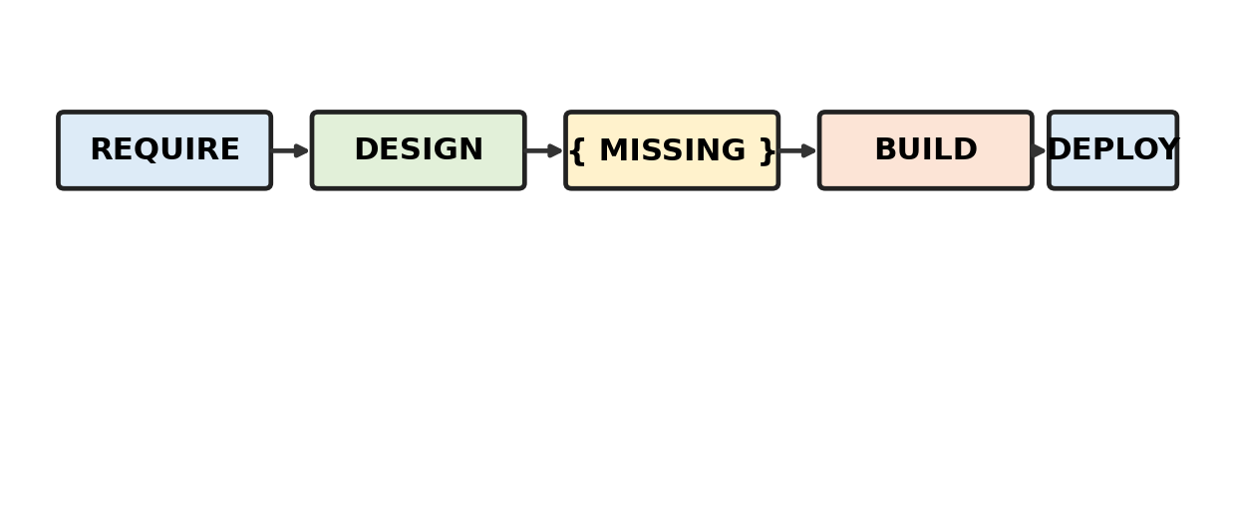
A. Threat modelling
B. Post-release audit
C. Backup verification
D. Log deletion
Practice: Analyse the diagram and select the best answer.

Q5. CO1 — Risk Prioritization
A finding is identified and linked to an important asset. Which missing factor should be considered before assigning remediation priority?
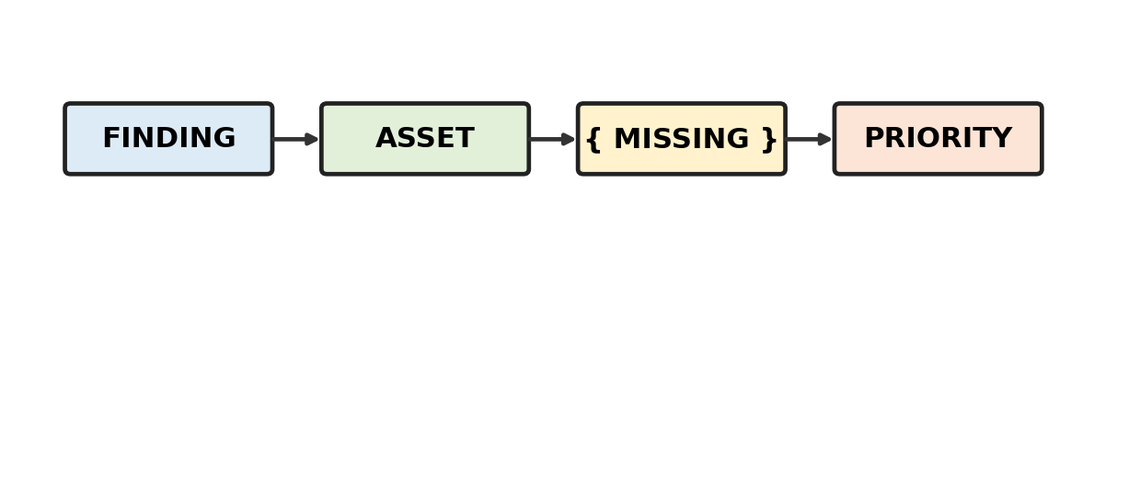
A. Likelihood
B. Logo design
C. Code formatting
D. Team size
Practice: Analyse the diagram and select the best answer.

Q6. CO2 — Threat Propagation
A compromised public service can reach Service B and then Service D. Which missing control would most directly reduce this propagation path?
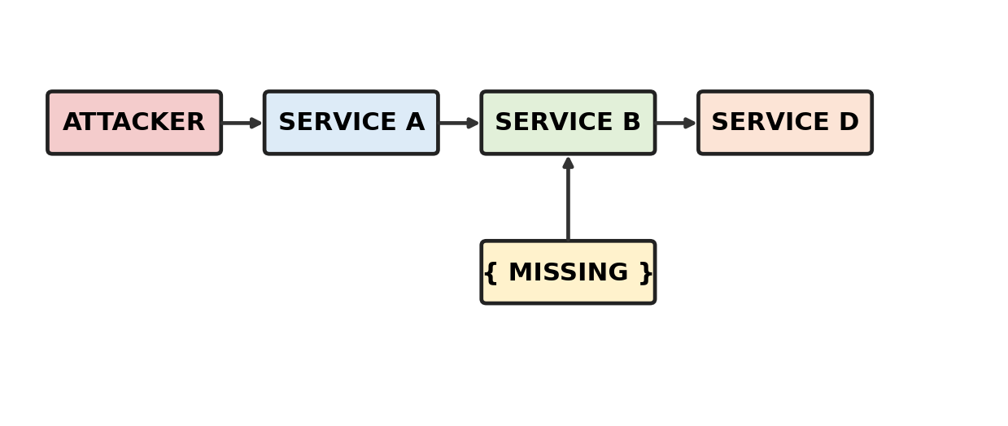
A. Trust boundary / validation
B. UI redesign
C. Build caching
D. Release tagging
Practice: Analyse the diagram and select the best answer.

Q7. CO2 — Attack Surface Analysis
Several externally reachable interfaces are shown. Which missing analysis would help identify unnecessary exposure?
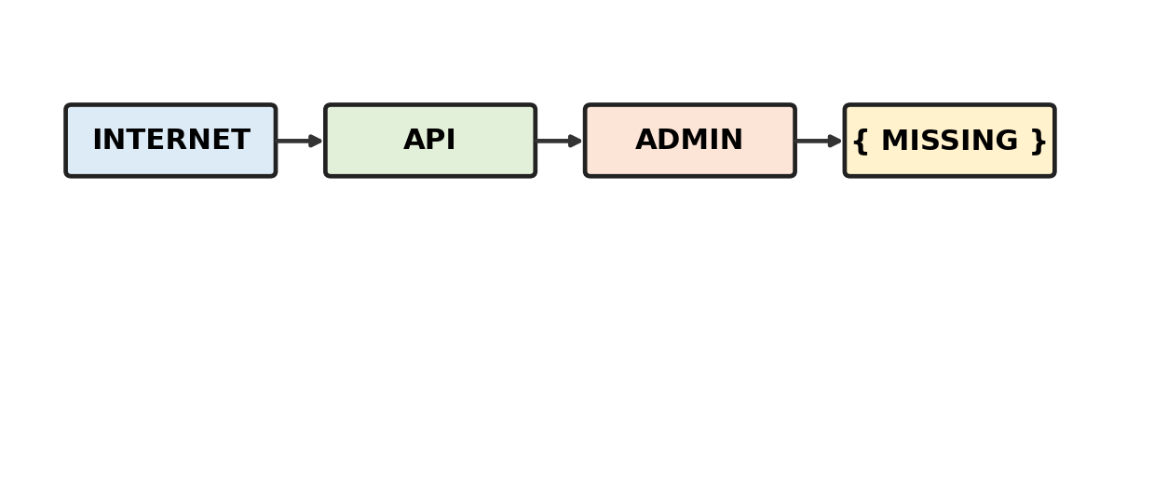
A. Exposure inventory
B. Version tagging
C. Unit testing
D. Artifact signing
Practice: Analyse the diagram and select the best answer.

Q8. CO2 — Shift-Left Security
The workflow moves security checks earlier. Which missing activity best represents shift-left security?
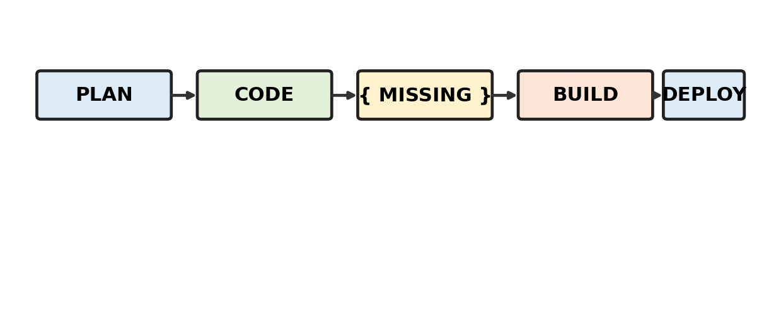
A. Threat modelling during design
B. Post-release audit
C. Incident reporting
D. Backup verification
Practice: Analyse the diagram and select the best answer.

Q9. CO2 — Threat Boundary
An untrusted component sends input toward a trusted service. What missing control belongs at the boundary?
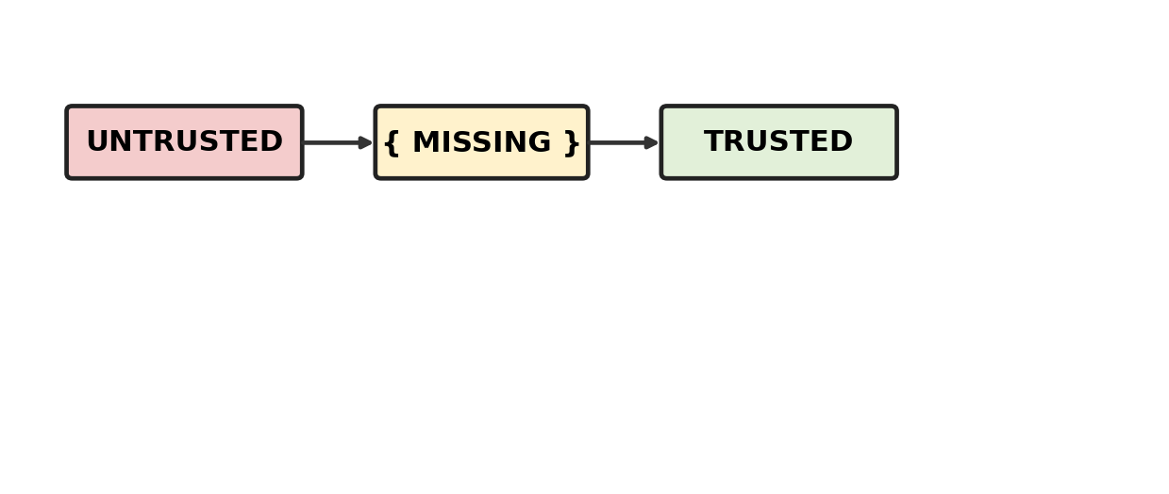
A. Validation / authorization
B. UI theme
C. Code comments
D. Release notes
Practice: Analyse the diagram and select the best answer.

Q10. CO2 — Attack Surface Reduction
A public endpoint is removed and traffic is routed through a controlled gateway. Which missing outcome indicates reduced attack surface?
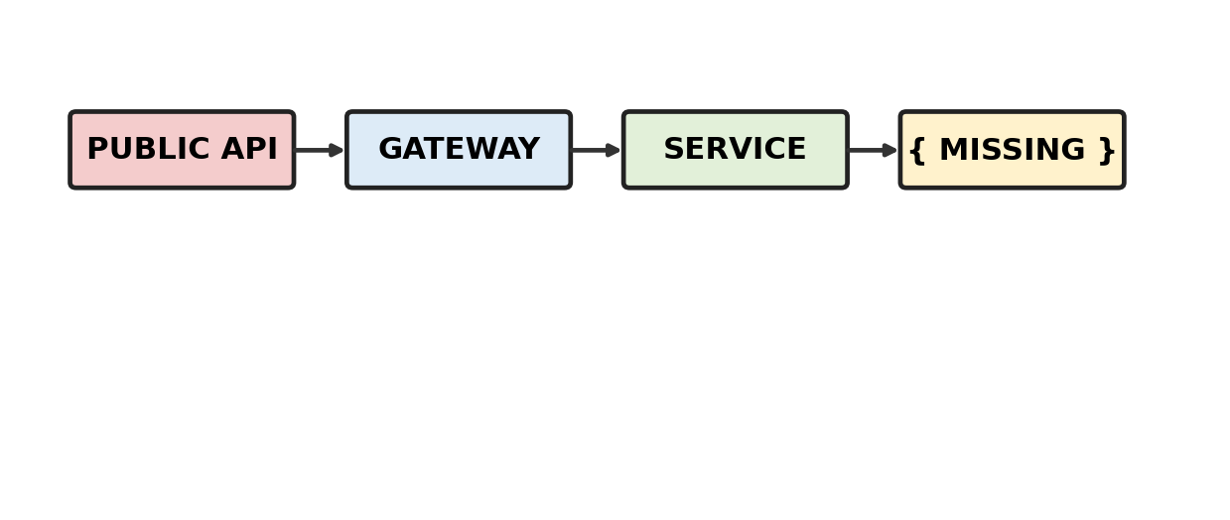
A. Fewer reachable entry points
B. More public endpoints
C. More privileged accounts
D. More deployment stages
Practice: Analyse the diagram and select the best answer.

Q11. CO3 — SAST / DAST / SCA
The workflow starts from source code. Which missing technique belongs at the source-code analysis stage?
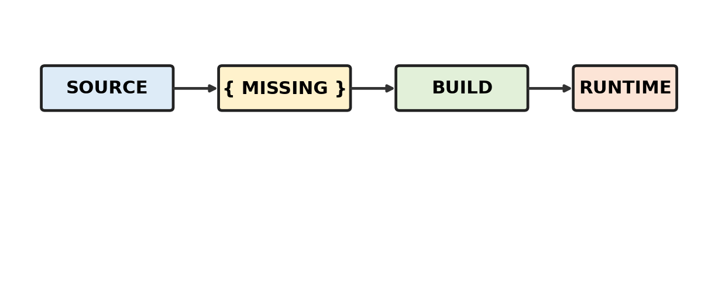
A. SAST
B. DAST
C. SCA
D. IAM
Practice: Analyse the diagram and select the best answer.

Q12. CO3 — DAST Placement
A security test is performed against a running application. Which missing label identifies the technique?
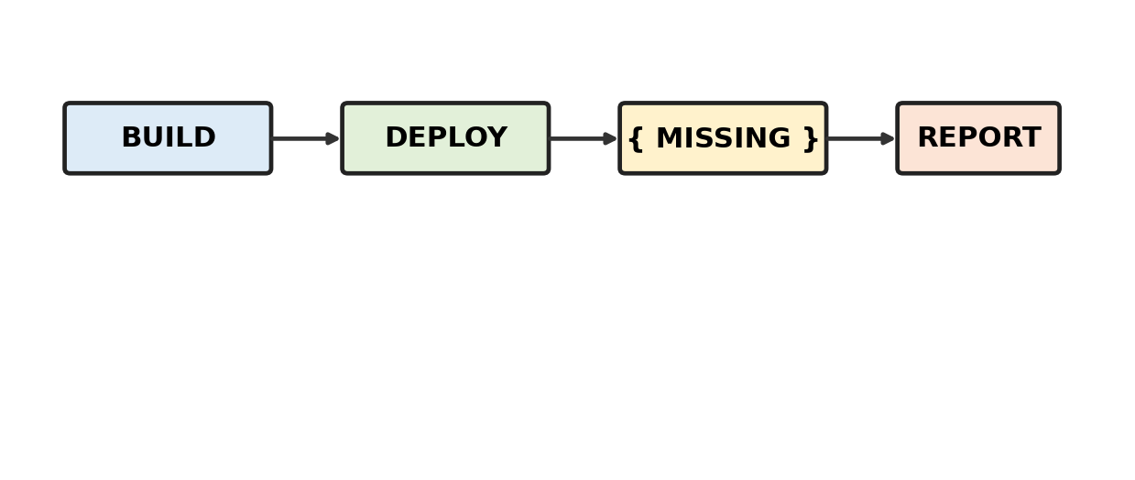
A. DAST
B. SAST
C. SCA
D. IaC scanning
Practice: Analyse the diagram and select the best answer.

Q13. CO3 — SCA Workflow
A project scans third-party libraries before packaging. What missing finding is most directly associated with SCA?
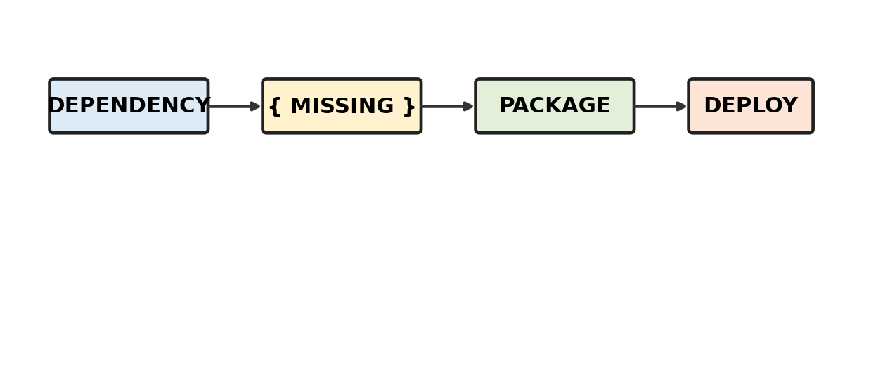
A. Known vulnerable component
B. UI defect
C. Network outage
D. User credential
Practice: Analyse the diagram and select the best answer.

Q14. CO3 — Vulnerability Trend
Findings are grouped across releases. Which missing step is needed before deciding whether the vulnerability trend improved?
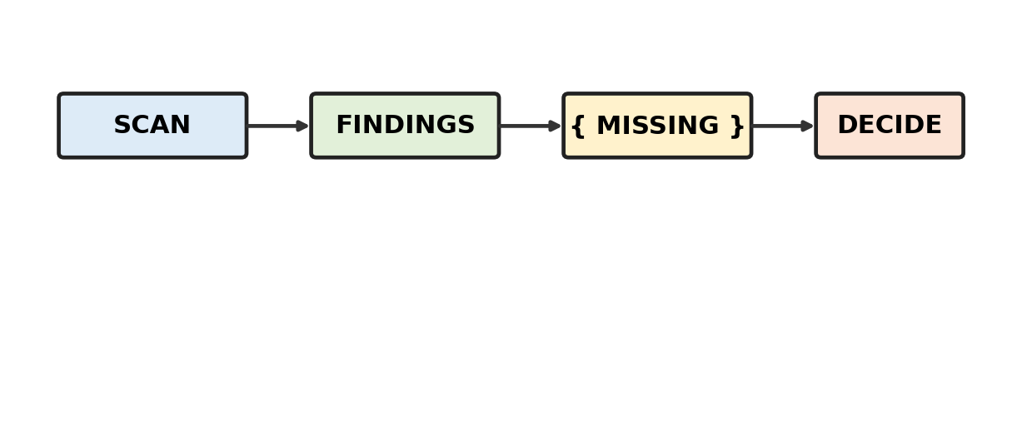
A. Compare across releases
B. Delete old data
C. Rename repositories
D. Skip severity
Practice: Analyse the diagram and select the best answer.

Q15. CO3 — Layered Verification
The workflow combines static, dynamic and dependency checks. Which missing technique belongs between CODE and RUN?
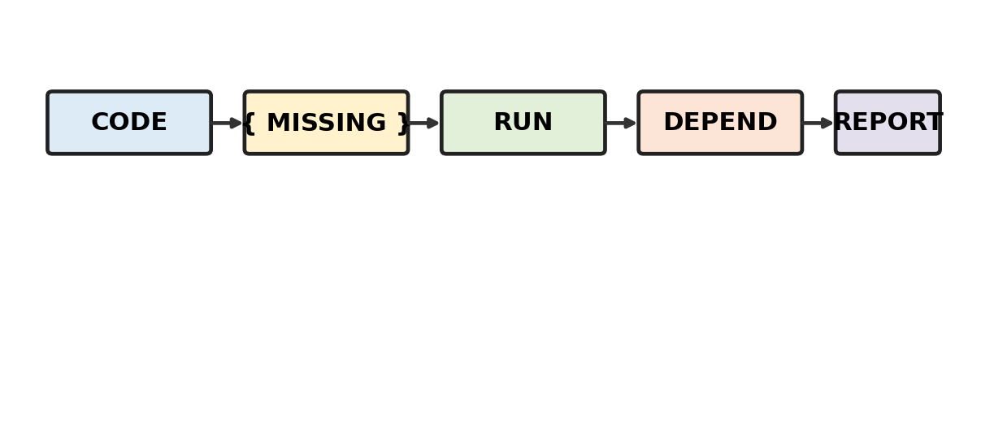
A. SAST
B. DAST
C. SCA
D. IAM
Practice: Analyse the diagram and select the best answer.

Q16. CO4 — Secure Infrastructure
The architecture moves infrastructure code toward a cloud environment through a security gate. Which missing component represents infrastructure policy validation?
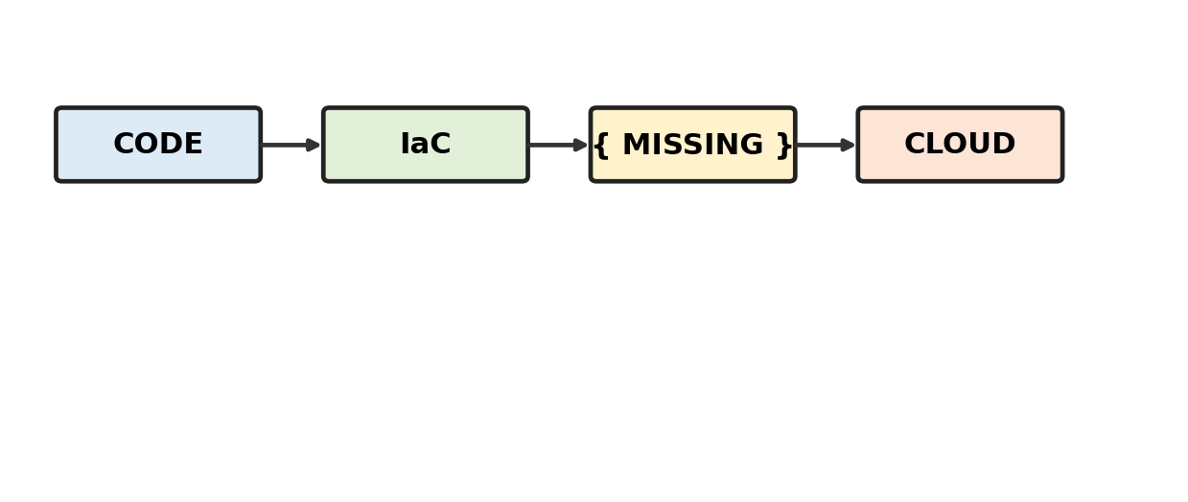
A. Policy-as-code check
B. UI test
C. Log archive
D. Email notification
Practice: Analyse the diagram and select the best answer.

Q17. CO4 — Deployment Workflow
A repository and controller update the target environment. Which missing stage best represents controlled deployment?
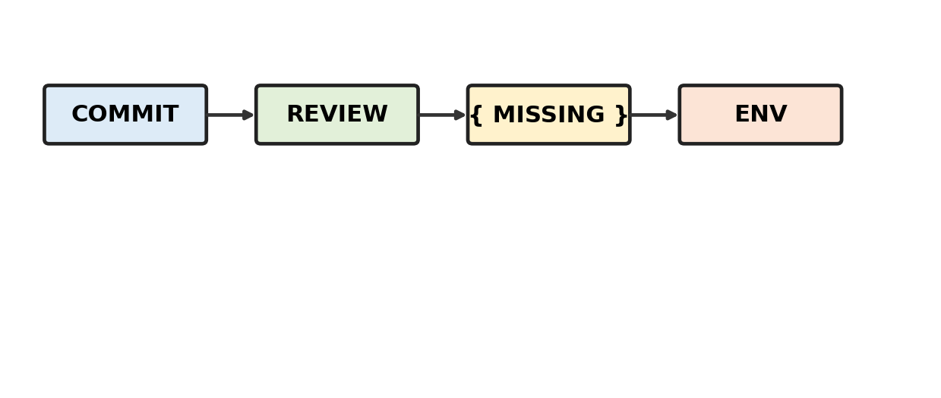
A. Deploy through controller
B. Delete branch
C. Edit binary
D. Disable checks
Practice: Analyse the diagram and select the best answer.

Q18. CO4 — IAM Relationship
A workload requests access to a protected resource. Which missing relationship determines whether the request is allowed?
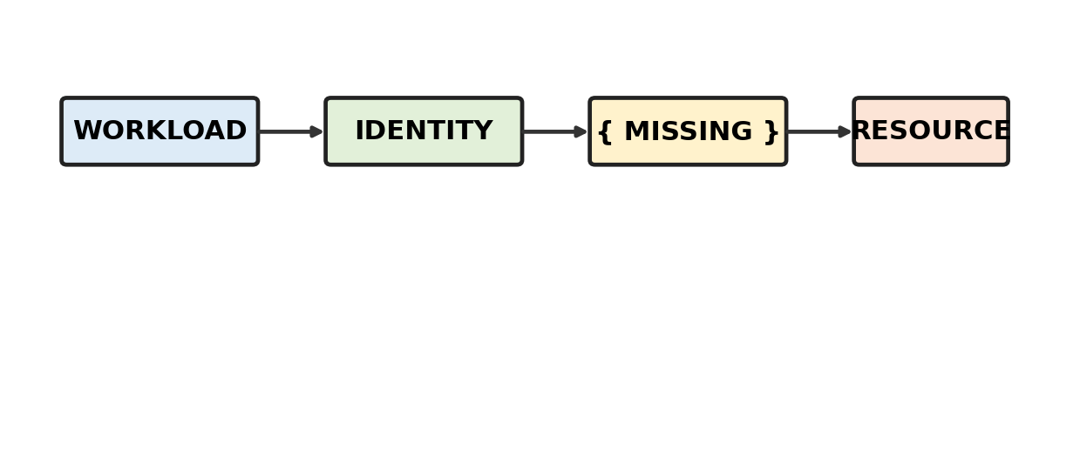
A. ROLE / POLICY
B. Container image
C. Build cache
D. Monitoring chart
Practice: Analyse the diagram and select the best answer.

Q19. CO4 — GitOps Workflow
Desired state is stored in Git and a controller acts on the cluster. Which missing action maintains the declared state?
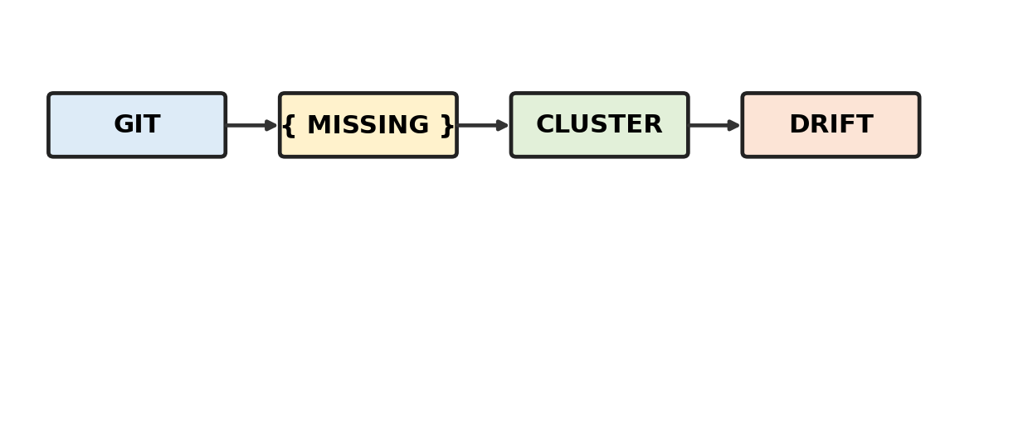
A. Reconcile desired state
B. Compile source
C. Encrypt logs
D. Create image
Practice: Analyse the diagram and select the best answer.

Q20. CO4 — Kubernetes Security
A Kubernetes workload is blocked before admission. Which missing check best fits this control point?
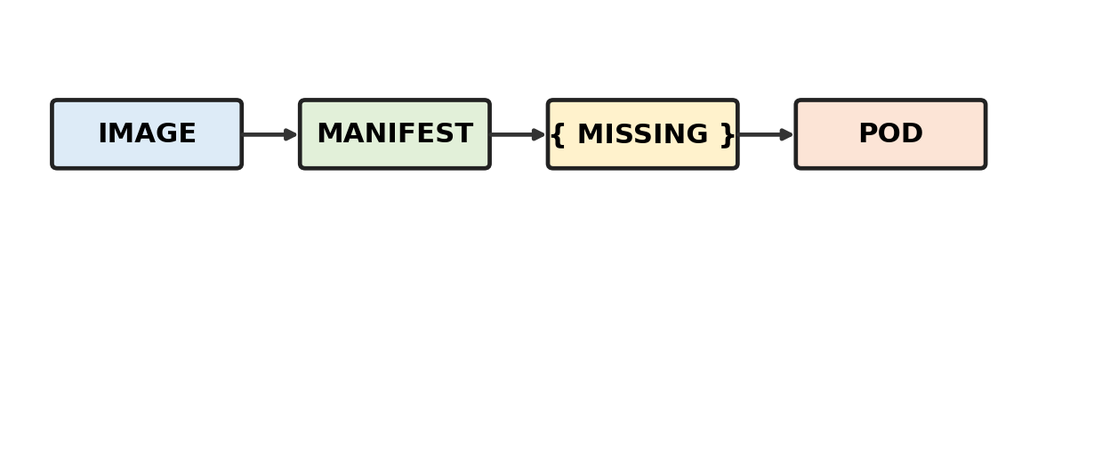
A. Admission policy validation
B. UI rendering
C. Backup scheduling
D. Repository merge
Practice: Analyse the diagram and select the best answer.

Q21. CO5 — Security Log Analysis
Logs are normalized and combined. Which missing stage should occur before concluding that an incident exists?
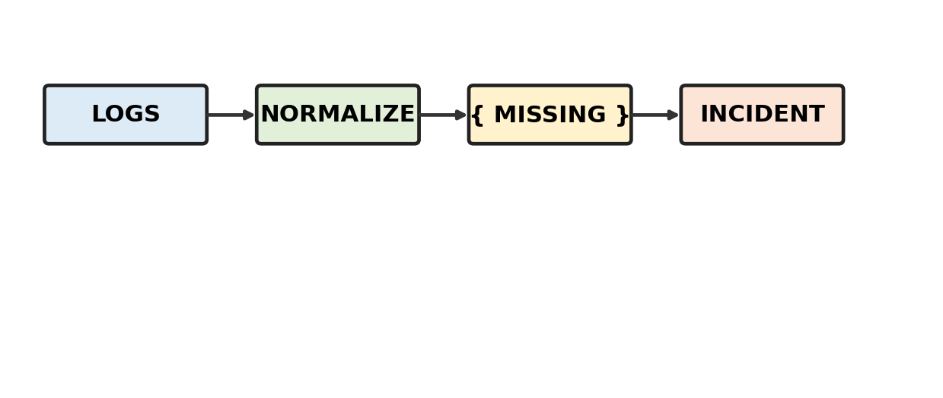
A. Correlate events
B. Delete duplicates
C. Deploy software
D. Rotate images
Practice: Analyse the diagram and select the best answer.

Q22. CO5 — Incident Timeline
Failed logins are followed by a successful login and privileged activity. Which missing event strengthens the incident correlation?
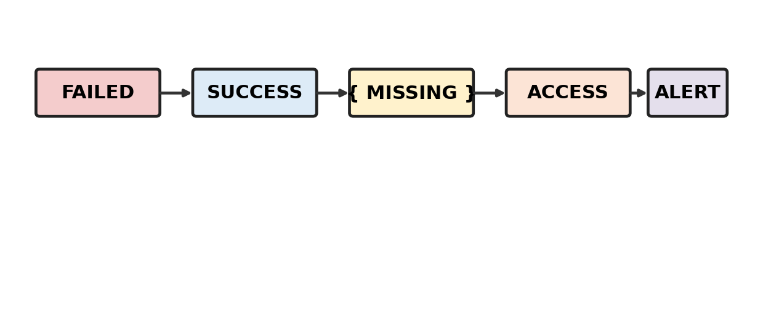
A. Privilege escalation
B. Password reset notice
C. Build completion
D. Version tag
Practice: Analyse the diagram and select the best answer.

Q23. CO5 — Anomaly Detection
The workflow compares a user baseline with current activity. Which missing condition should trigger investigation?
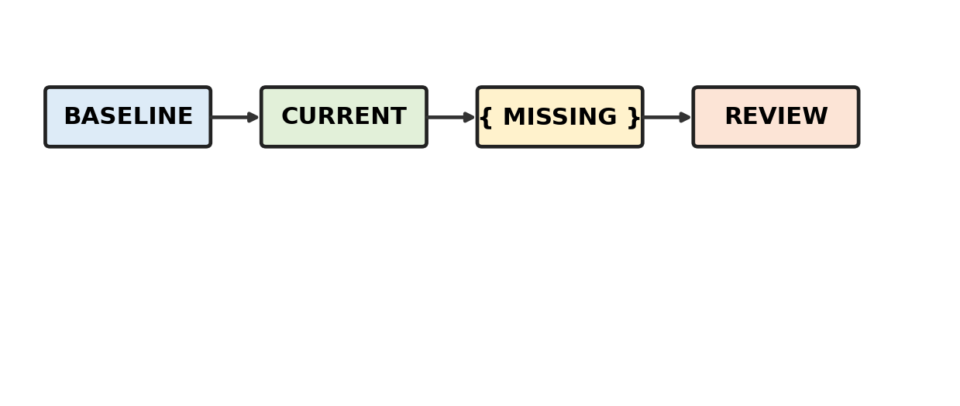
A. Threshold exceeded
B. Code compiled
C. Image signed
D. User logged out
Practice: Analyse the diagram and select the best answer.

Q24. CO5 — Monitoring Dashboard
A dashboard combines logs, alerts and trends. Which missing element helps an analyst prioritize an active event?
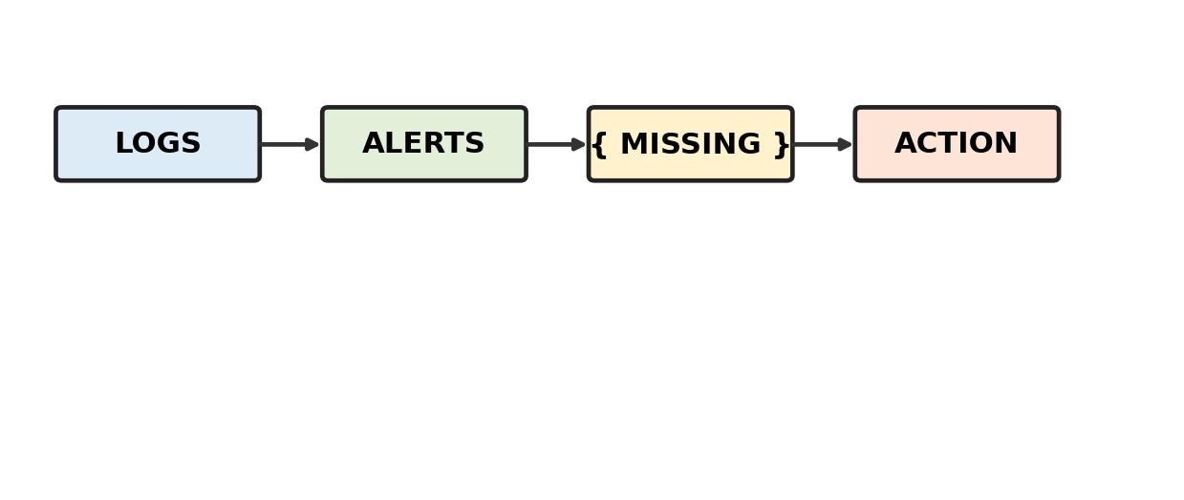
A. Severity / context
B. Font size
C. Source-code length
D. Build duration
Practice: Analyse the diagram and select the best answer.

Q25. CO5 — Incident Response
Detection and triage are complete. Which missing step should connect evidence analysis to the response decision?
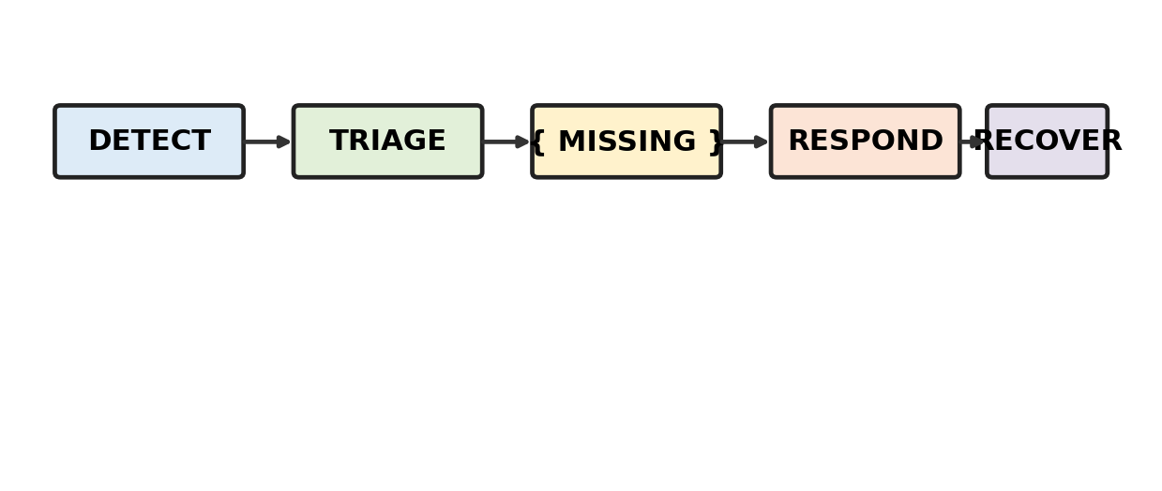
A. Investigate / confirm
B. Build artifact
C. Edit dashboard
D. Deploy feature
Practice: Analyse the diagram and select the best answer.

