

SIMATS ENGINEERING

Saveetha Institute of Medical and Technical Sciences
Chennai- 602105

Student Name: R. Mohanram Reg. No.: 192521117
Course Code: CSA5801 Slot: A
Course Name: DevSecOps Engineering and Application Security
Course Faculty: Dr. Vincent Gnanaraj T
Project Title: GATEKEEPERX: QUEUEING SIMULATION FOR INTELLIGENT DEVSECOPS SECURITY GATES
Module Photographs: 3 photographs - student presentation image, student contribution to the project
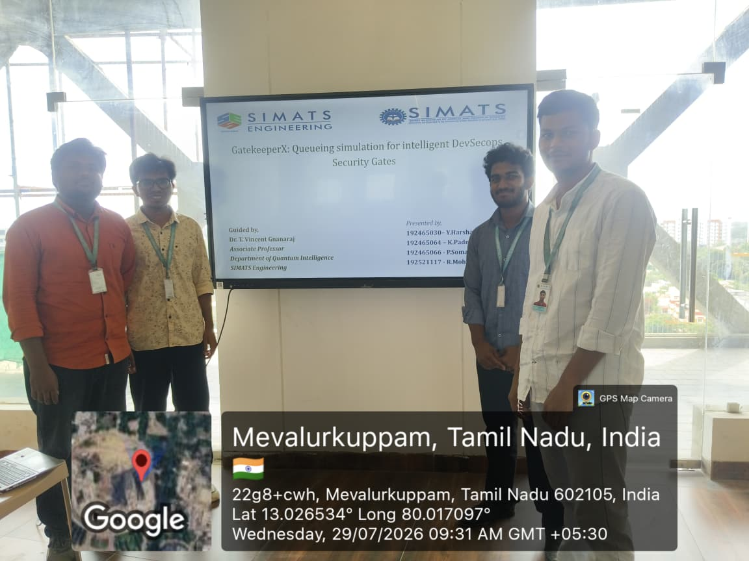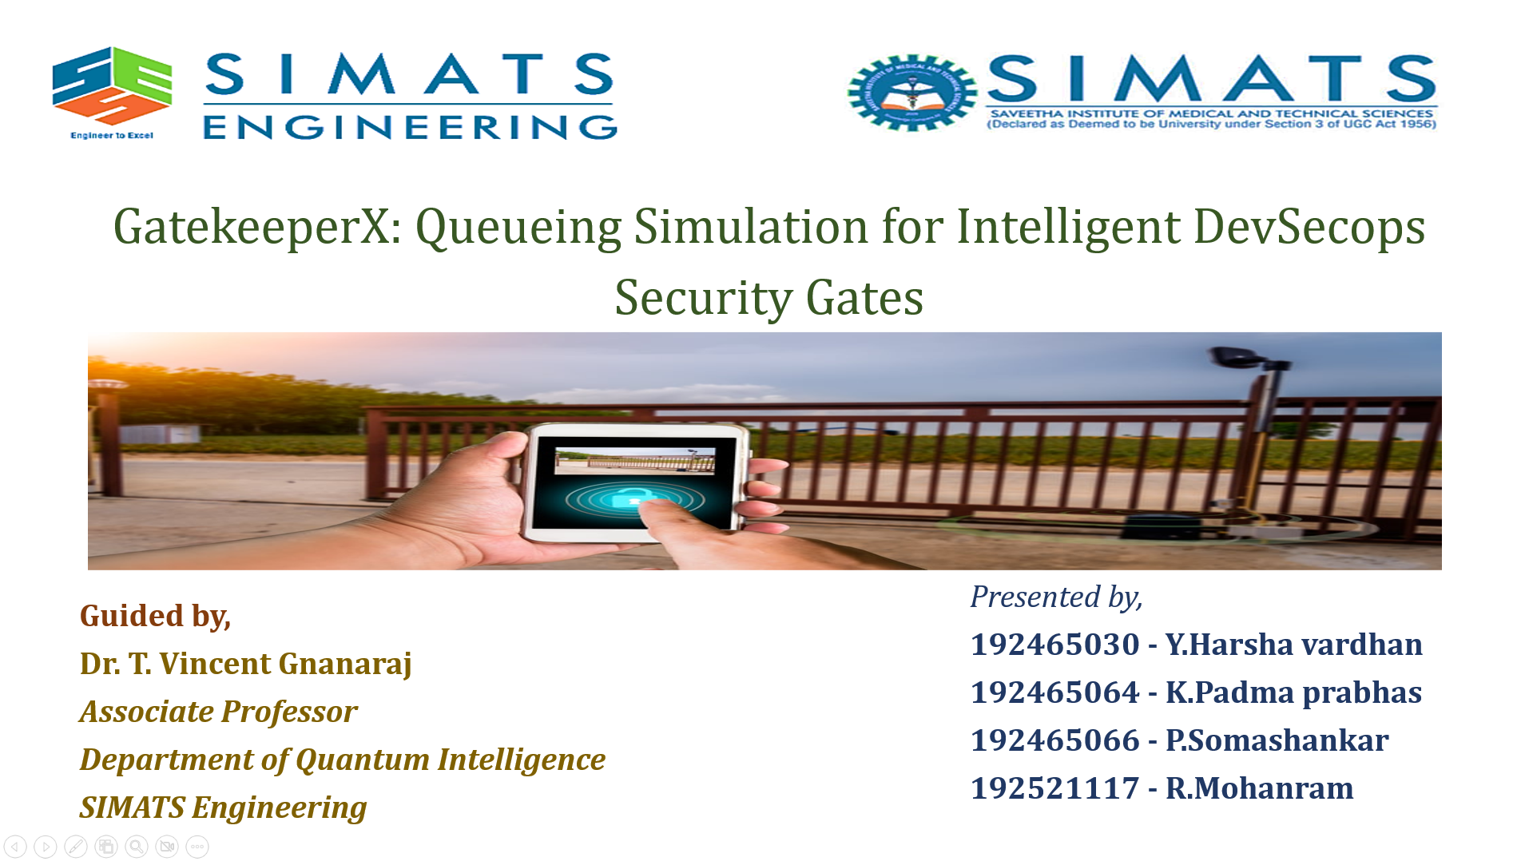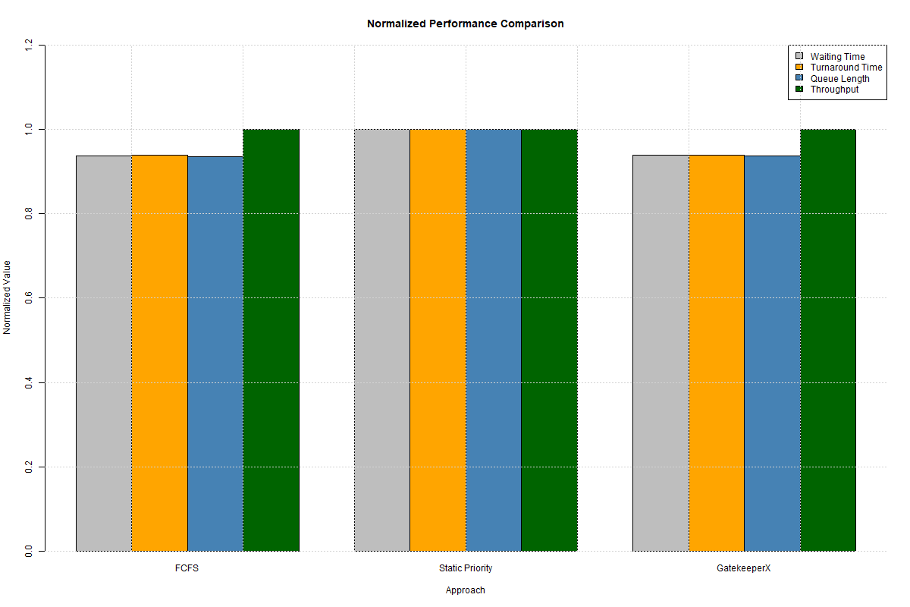
Project Description: Project description and the use of the project are given below
The project GatekeeperX proposes an intelligent queueing simulation system for improving the efficiency of security gates in modern DevSecOps and CI/CD pipelines. Traditional security gates generally use fixed scheduling strategies such as First-Come-First-Served (FCFS) or Static Priority Queueing, which can result in increased waiting time, pipeline bottlenecks, and starvation of lower-priority security tasks. GatekeeperX addresses these limitations by combining risk-based priority scoring, dynamic aging, queueing theory, and anomaly detection. Synthetic DevSecOps security jobs are generated using parameters such as severity, vulnerability count, dependency risk, business impact, developer priority, code complexity, arrival time, and service time. A priority score is calculated for each job, while dynamic aging gradually increases the priority of waiting jobs to improve fairness and prevent starvation. The system models SAST, Dependency, and DAST security checks as a tandem queueing network and simulates their operation using RStudio and the simmer package. An Isolation-Forest anomaly detection layer is also incorporated to identify irregular builds before deployment. The system evaluates waiting time, turnaround time, queue length, throughput, utilization, and anomaly scores, and compares GatekeeperX with FCFS and Static Priority Queueing approaches. The simulation results demonstrate that GatekeeperX provides risk-aware task prioritization and reduces starvation of lower-priority jobs. The DAST gate was identified as the primary pipeline bottleneck, operating at approximately 99% utilization with an average queue length of about 31 jobs, while the SAST and Dependency gates retained additional capacity. The anomaly-detection layer also identified approximately 6% of builds as anomalous. Overall, GatekeeperX provides a practical simulation-based framework for analyzing security-gate performance, identifying bottlenecks, and supporting faster, more reliable, and secure continuous software delivery.

Student Signature Guide Signature

