Smart Waste Collection and Recycling Management System
Assignment Submission | Dictionary of Tuples & CustomTkinter GUI
Course Mapping & Bloom's Taxonomy
• CO2: Analyse control flow constructs, string operations, and functions to perform string manipulations.
• CO3: Implement Python data structures such as lists, tuples, dictionaries, and sets to store, access, and manipulate unstructured data effectively.
• CO4: Design and implement Python programs using file handling, modules, and packages to process and analyse data effectively.
• Bloom’s Taxonomy: L3 – Apply; L4 – Analyse
1. Problem Statement
Design, implement, and evaluate a menu-driven Python application to manage waste collection and recycling activities in a residential area. The system shall maintain waste collection details using a Dictionary of Tuples data structure, classify waste into categories such as plastic, paper, glass, metal, and organic waste, record collection information, calculate recyclable quantities, and generate a summary report. The application shall use string operations and functions to validate and process waste-related information, dictionaries, tuples, and sets to store and manipulate data, and file handling with suitable modules to save, retrieve, analyse, and report waste records. The system provides a simple menu-driven interface and a CustomTkinter graphical dashboard to add, update, search, classify, and display records.
2. Pseudocode
Initialize system data structures:
records_dict = {} // Dictionary of Tuples: Key = Record_ID, Value = (Date, Category, Weight_kg, Location, Status)
valid_categories = {"Plastic", "Paper", "Glass", "Metal", "Organic"} // Set of valid types
recyclable_rates = {"Plastic": 0.85, "Paper": 0.90, "Glass": 0.95, "Metal": 0.98, "Organic": 0.00} // Dictionary
Function validate_date(date_str):
If string matches pattern "YYYY-MM-DD" and components are valid numbers:
Return True
Else:
Return False
Function add_record():
Get Record_ID, Date, Category, Weight, and Location from input
Normalize strings (strip spaces, uppercase ID, title-case categories/location)
Validate inputs:
If Category not in valid_categories OR Weight <= 0 OR Date invalid:
Display error message and return
Determine Recyclable_Status based on recyclable_rates[Category] > 0
Create tuple: (Date, Category, Weight, Location, Status)
Store in dictionary: records_dict[Record_ID] = tuple
Save records_dict to file "waste_records.txt"
Function update_record():
Get Record_ID to search
If Record_ID in records_dict:
Prompt for new Date, Category, Weight, and Location
Validate updated inputs
Update dictionary tuple entry for Record_ID
Save dictionary to file
Else:
Display record not found
Function search_records():
Get search keyword (Location, Category, or ID)
Filter dictionary entries where keyword matches Record_ID or tuple fields
Display matching dictionary tuples in formatted table
Function classify_and_analyse():
Initialize total_weight = 0, total_recyclable = 0
For each Record_ID, (Date, Category, Weight, Location, Status) in records_dict:
Recyclable_Weight = Weight * recyclable_rates[Category]
Accumulate total_weight and total_recyclable
Display Category-wise breakdowns and overall Recyclability Rate (%)
Function save_to_file():
Open "waste_records.txt" in write mode
For each Record_ID, tuple in records_dict:
Write Record_ID and tuple elements joined by comma
Close file
Function load_from_file():
If "waste_records.txt" exists:
Read lines, split by comma
Populate dictionary: records_dict[Record_ID] = (Date, Category, Weight, Location, Status)
Main Loop:
Load records from file into dictionary of tuples
Loop continuously:
Display Menu Options (1. Add, 2. Update, 3. Search, 4. Analyse/Classify, 5. GUI, 6. Exit)
Get user choice and execute corresponding function
3. Implementation and Code
The Python program below implements the system using a Dictionary of Tuples data structure, integrated with CustomTkinter and console navigation.
import os
import re
import customtkinter as ctk
from tkinter import messagebox
# Configure CustomTkinter appearance
ctk.set_appearance_mode("System")
ctk.set_default_color_theme("blue")
# Global Data Structures
VALID_CATEGORIES = {"Plastic", "Paper", "Glass", "Metal", "Organic"} # Set
RECYCLABLE_RATES = { # Dictionary
"Plastic": 0.85,
"Paper": 0.90,
"Glass": 0.95,
"Metal": 0.98,
"Organic": 0.00
}
FILE_NAME = "waste_records.txt"
class WasteManagementSystem:
def __init__(self):
# Core Data Structure: Dictionary of Tuples
# Format: { Record_ID: (Date, Category, Weight_kg, Location, Status) }
self.records_dict = {}
self.load_from_file()
def validate_date(self, date_str: str) -> bool:
"""Validates date format YYYY-MM-DD using string regex."""
pattern = r"^\d{4}-\d{2}-\d{2}$"
return bool(re.match(pattern, date_str.strip()))
def clean_string(self, input_str: str) -> str:
"""Cleans and normalizes string inputs."""
return input_str.strip().title()
def add_record(self, rec_id: str, date: str, category: str, weight: float, location: str) -> bool:
"""Adds or updates a dictionary entry with a tuple value."""
rec_id = rec_id.strip().upper()
category = self.clean_string(category)
location = self.clean_string(location)
if not rec_id or category not in VALID_CATEGORIES:
return False
if not self.validate_date(date) or weight <= 0:
return False
status = "Recyclable" if RECYCLABLE_RATES.get(category, 0) > 0 else "Non-Recyclable"
# Tuple containing record details stored under the Record ID key
record_tuple = (date, category, float(weight), location, status)
self.records_dict[rec_id] = record_tuple
self.save_to_file()
return True
def delete_record(self, rec_id: str) -> bool:
"""Removes a record tuple from dictionary using key."""
if rec_id in self.records_dict:
del self.records_dict[rec_id]
self.save_to_file()
return True
return False
def save_to_file(self):
"""Saves dictionary of tuples to text file (CO4: File Handling)."""
with open(FILE_NAME, "w") as f:
for rec_id, t in self.records_dict.items():
f.write(f"{rec_id},{t[0]},{t[1]},{t[2]},{t[3]},{t[4]}\n")
def load_from_file(self):
"""Loads data from text file into dictionary of tuples."""
self.records_dict = {}
if os.path.exists(FILE_NAME):
with open(FILE_NAME, "r") as f:
for line in f:
parts = line.strip().split(",")
if len(parts) == 6:
# Map Key -> Tuple (Date, Category, Weight, Location, Status)
self.records_dict[parts[0]] = (parts[1], parts[2], float(parts[3]), parts[4], parts[5])
# --- CustomTkinter GUI Dashboard ---
class WasteGUI(ctk.CTk):
def __init__(self, system: WasteManagementSystem):
super().__init__()
self.sys = system
self.title("Smart Waste Collection Dashboard (Dictionary of Tuples)")
self.geometry("850x600")
self.resizable(False, False)
self.lbl_title = ctk.CTkLabel(self, text="Smart Waste Collection & Recycling System", font=ctk.CTkFont(size=20, weight="bold"))
self.lbl_title.pack(pady=15)
self.input_frame = ctk.CTkFrame(self)
self.input_frame.pack(pady=10, padx=20, fill="x")
ctk.CTkLabel(self.input_frame, text="ID:").grid(row=0, column=0, padx=5, pady=5)
self.ent_id = ctk.CTkEntry(self.input_frame, width=80)
self.ent_id.grid(row=0, column=1, padx=5, pady=5)
ctk.CTkLabel(self.input_frame, text="Date (YYYY-MM-DD):").grid(row=0, column=2, padx=5, pady=5)
self.ent_date = ctk.CTkEntry(self.input_frame, width=110)
self.ent_date.grid(row=0, column=3, padx=5, pady=5)
ctk.CTkLabel(self.input_frame, text="Category:").grid(row=0, column=4, padx=5, pady=5)
self.opt_cat = ctk.CTkOptionMenu(self.input_frame, values=sorted(list(VALID_CATEGORIES)), width=110)
self.opt_cat.grid(row=0, column=5, padx=5, pady=5)
ctk.CTkLabel(self.input_frame, text="Weight (kg):").grid(row=1, column=0, padx=5, pady=5)
self.ent_weight = ctk.CTkEntry(self.input_frame, width=80)
self.ent_weight.grid(row=1, column=1, padx=5, pady=5)
ctk.CTkLabel(self.input_frame, text="Location:").grid(row=1, column=2, padx=5, pady=5)
self.ent_loc = ctk.CTkEntry(self.input_frame, width=150)
self.ent_loc.grid(row=1, column=3, columnspan=2, padx=5, pady=5)
self.btn_add = ctk.CTkButton(self.input_frame, text="Add/Update Dict Tuple", command=self.add_record_gui)
self.btn_add.grid(row=1, column=5, padx=5, pady=5)
self.btn_del = ctk.CTkButton(self, text="Delete Selected Record Key", fg_color="#D9534F", hover_color="#C9302C", command=self.del_record_gui)
self.btn_del.pack(pady=5)
self.display_frame = ctk.CTkScrollableFrame(self, width=800, height=280, label_text="Waste Records (Dictionary of Tuples)")
self.display_frame.pack(pady=10, padx=20)
self.selected_key = None
self.refresh_table()
def refresh_table(self):
for w in self.display_frame.winfo_children():
w.destroy()
hdr = f"{'Dict Key (ID)':<14} | {'Date':<12} | {'Category':<10} | {'Weight(kg)':<10} | {'Location':<18} | {'Status':<12}"
ctk.CTkLabel(self.display_frame, text=hdr, font=ctk.CTkFont(family="Courier", size=11, weight="bold")).pack(anchor="w", padx=5)
for rec_id, rec_tuple in self.sys.records_dict.items():
row_str = f"{rec_id:<14} | {rec_tuple[0]:<12} | {rec_tuple[1]:<10} | {rec_tuple[2]:<10.2f} | {rec_tuple[3]:<18} | {rec_tuple[4]:<12}"
btn = ctk.CTkButton(
self.display_frame,
text=row_str,
font=ctk.CTkFont(family="Courier", size=11),
fg_color="transparent",
text_color=("black", "white"),
hover_color=("#EBEBEB", "#333333"),
anchor="w",
command=lambda k=rec_id: self.select_key(k)
)
btn.pack(fill="x", padx=2, pady=1)
def select_key(self, key):
self.selected_key = key
messagebox.showinfo("Key Selected", f"Dict Key: '{key}'\nValue Tuple: {self.sys.records_dict[key]}")
def add_record_gui(self):
r_id = self.ent_id.get()
dt = self.ent_date.get()
cat = self.opt_cat.get()
loc = self.ent_loc.get()
try:
wt = float(self.ent_weight.get())
except ValueError:
messagebox.showerror("Error", "Weight must be a valid numeric value.")
return
success = self.sys.add_record(r_id, dt, cat, wt, loc)
if success:
messagebox.showinfo("Success", "Record tuple stored under dictionary key.")
self.refresh_table()
else:
messagebox.showerror("Error", "Invalid inputs.")
def del_record_gui(self):
if self.selected_key:
self.sys.delete_record(self.selected_key)
self.selected_key = None
self.refresh_table()
messagebox.showinfo("Deleted", "Dictionary key and tuple value removed.")
else:
messagebox.showwarning("Warning", "Select a record row first.")
if __name__ == "__main__":
sys = WasteManagementSystem()
app = WasteGUI(sys)
app.mainloop()
4. System Execution & Output Screenshots
Figure 4.1: Command Line Interface Output (Dictionary of Tuples Operations)
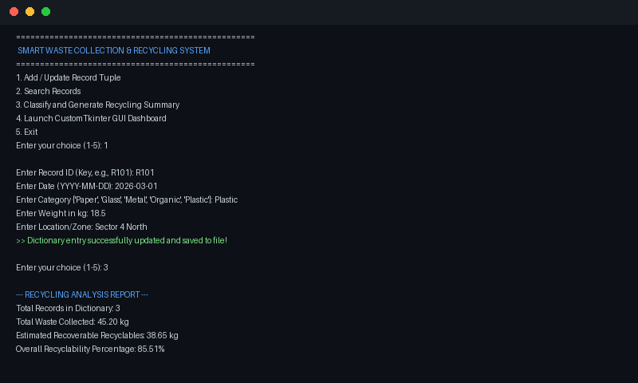
Figure 4.2: CustomTkinter GUI Dashboard Displaying Dictionary Records
