SIMATS ENGINEERING
Department of Computer Science & Engineering
ASSESSMENT TOOL 1- ANALYTICAL PROBLEM SOLVING
Course Code: | CSA1209 | Course Title: | Computer Architecture
CO Assessed: | CO2 | Assessment: | ASSESSMENT TOOL1- ANALYTICAL PROBLEM SOLVING
Weightage: | 45% | Total Marks: | 25
CO2 Statement: | Apply integer and floating-point arithmetic algorithms including Booth's multiplication, restoring/non-restoring division, and IEEE 754 standard operations to solve fixed-point and floating-point computational problems. (BL3)
Student Name: |  | Reg.No.:
Department: |  | Date:

ANNEXURE A
- A processor performs arithmetic operations on signed 8-bit integers using 2’s complement representation. Consider two numbers: +45 and −23. Analyze in detail how the system performs both addition and subtraction, including binary conversion, alignment of sign bits, and intermediate steps. Determine whether overflow occurs, and explain how the processor detects overflow and interprets the final result.

Ans:

2's Complement Arithmetic
Given:
- A = +45
- B = −23
- 8-bit signed representation
- Range = −128 to +127

i). Binary Conversion
+45:
45 = 00101101
−23:
+23 = 00010111
1's complement = 11101000
Add 1 = 11101001
Therefore:
+45 = 00101101
-23 = 11101001

ii). Addition
00101101 (+45)
+ 11101001 (-23)
----------------
1 00010110
Discard the extra carry:
00010110 = +22
Therefore:
+45 + (−23) = +22
No overflow occurs because the operands have different signs.

iii). Subtraction
+45 - (-23) = +45 + (+23)
2's complement of −23:
11101001 → 00010110 → 00010111
Now:
00101101
+ 00010111
-----------
01000100
01000100 = +68
Therefore:
+45 − (−23) = +68
No overflow occurs because 68 is within −128 to +127.

iv) Overflow Detection
The processor detects signed overflow when:
Carry into MSB ≠ Carry out of MSB
or when:
- two positive numbers produce a negative result, or
- two negative numbers produce a positive result.

Program
#include <stdio.h>

int main()
{
signed char a = 45, b = -23;

printf("Addition = %d\n", a + b);
printf("Subtraction = %d\n", a - b);

return 0;
}
OUTPUT :
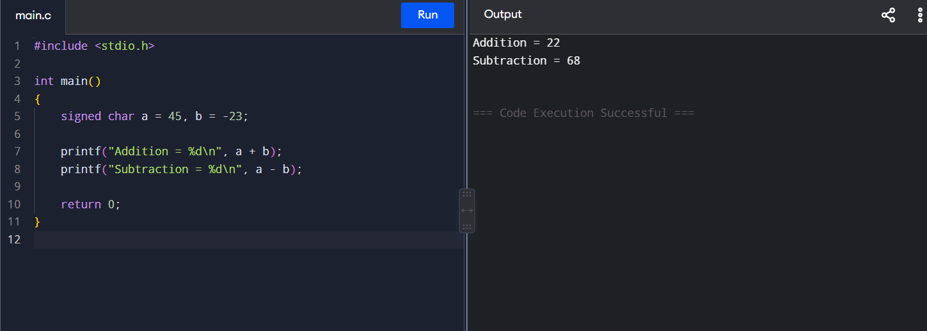

- A high-performance computing system replaces a ripple carry adder with a 4-bit carry look-ahead adder (CLA) to reduce computation delay. Given two binary inputs, analyze how generate and propagate signals are formed and how carries are computed in advance. Compare the time delay of CLA with ripple carry addition and justify, with reasoning, why CLA improves speed in modern processors.

Ans:

4-bit Carry Look-Ahead Adder (CLA)
A Carry Look-Ahead Adder reduces addition delay by calculating carry signals in advance, instead of waiting for each carry to pass through the previous stage.
Consider:
A = A3 A2 A1 A0
B = B3 B2 B1 B0

Generate and Propagate
For each bit:

Generate:
Gi = AiBi

Propagate:
Pi = Ai ⊕ Bi

Carry equation:
Ci+1 = Gi + PiCi
The carries are calculated directly:
C1 = G0 + P0C0

C2 = G1 + P1G0 + P1P0C0

C3 = G2 + P2G1 + P2P1G0 + P2P1P0C0

C4 = G3 + P3G2 + P3P2G1
+ P3P2P1G0 + P3P2P1P0C0
Then the sum is:
Si = Pi ⊕ Ci

CLA vs Ripple Carry Adder
Adder | Carry calculation | Delay
Ripple Carry | One stage after another | High
CLA | Carries calculated in parallel | Low
In a Ripple Carry Adder, the carry must travel from:
bit 0 → bit 1 → bit 2 → bit 3
In a CLA, all carries are obtained almost simultaneously using generate and propagate logic.

Program
#include <stdio.h>

int main()
{
int A, B, C0 = 0;
int a[4], b[4], p[4], g[4], c[5], s[4];

A = 9; // 1001
B = 6; // 0110

for(int i = 0; i < 4; i++)
{
a[i] = (A >> i) & 1;
b[i] = (B >> i) & 1;
p[i] = a[i] ^ b[i];
g[i] = a[i] & b[i];
}

c[0] = C0;

// Carry Look-Ahead equations
c[1] = g[0] | (p[0] & c[0]);
c[2] = g[1] | (p[1] & g[0]) | (p[1] & p[0] & c[0]);
c[3] = g[2] | (p[2] & g[1]) | (p[2] & p[1] & g[0]);
c[4] = g[3] | (p[3] & g[2]) | (p[3] & p[2] & g[1]);

for(int i = 0; i < 4; i++)
s[i] = p[i] ^ c[i];

printf("A = %d\n", A);
printf("B = %d\n", B);
printf("Sum = %d\n", A + B);
printf("Carry = %d\n", c[4]);

return 0;
}
OUTPUT:
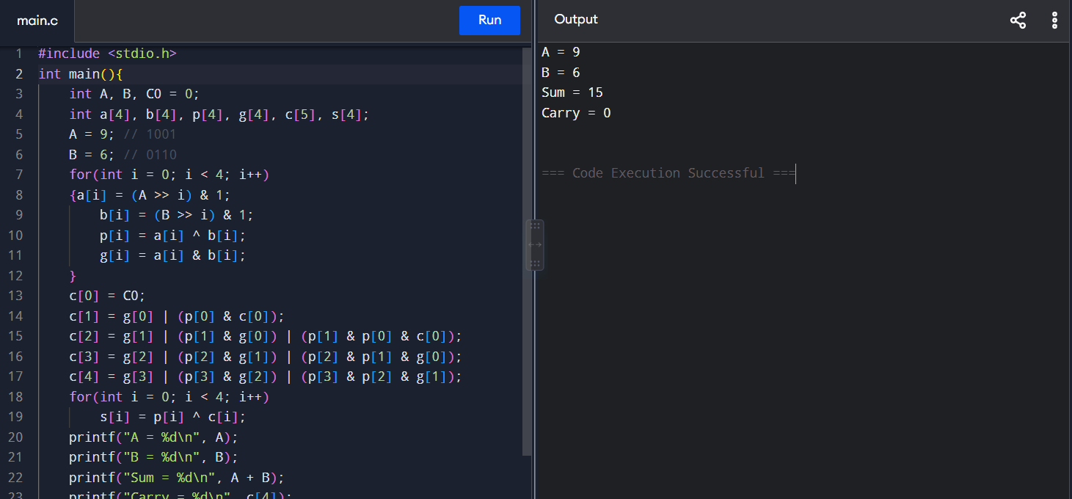
- In a signed multiplication operation, a processor uses Booth’s algorithm to multiply two numbers, −6 and +5. Analyze the algorithm step-by-step, including the role of the accumulator, multiplier, and Booth bit, along with arithmetic shifts. Explain how the algorithm efficiently handles signed numbers and reduces the number of addition/subtraction operations compared to traditional multiplication.

Ans:

Booth's Algorithm for −6 × +5
Use 4-bit 2's complement representation:
-6 = 1010
+5 = 0101

Initial values:
M = 1010 (-6) Multiplicand
-M = 0110 (+6)
Q = 0101 (+5) Multiplier
A = 0000 Accumulator
Q-1 = 0 Booth bit
Booth's algorithm checks Q0 and Q-1:
Q0 Q-1 | Operation
00 | No operation
11 | No operation
01 | A = A + M
10 | A = A − M
After each operation, perform an arithmetic right shift on:
[A Q Q-1]

Step 1
Q0 Q-1 = 1 0
So:
A = A - M
A = 0000 - 1010
A = 0110
Arithmetic right shift:
0110 0101 0
→ 0011 0010 1

Step 2
Q0 Q-1 = 0 1
So:
A = A + M
0011 + 1010 = 1101
Shift:
1101 0010 1
→ 1110 1001 0

Step 3
Q0 Q-1 = 1 0
So:
A = A - M
1110 - 1010 = 0100
Shift:
0100 1001 0
→ 0010 0100 1

Step 4
Q0 Q-1 = 0 1
So:
A = A + M
0010 + 1010 = 1100
Shift:
1100 0100 1
→ 1110 0010 0

Final Result
A Q = 11100010
This is an 8-bit 2's complement number.
11100010 = -30
Therefore:
−6 × +5 = −30

Program
#include <stdio.h>

int main()
{
int M = -6, Q = 5;
int A = 0, Q_1 = 0;
int count = 4;

while (count--)
{
int Q0 = Q & 1;

if (Q0 == 1 && Q_1 == 0)
A = A - M;
else if (Q0 == 0 && Q_1 == 1)
A = A + M;

Q_1 = Q0;

// Arithmetic right shift
Q = (Q >> 1) | ((A & 1) << 3);
A = A >> 1;
}

printf("Result = %d\n", (A << 4) | (Q & 15));

return 0;
}

Output
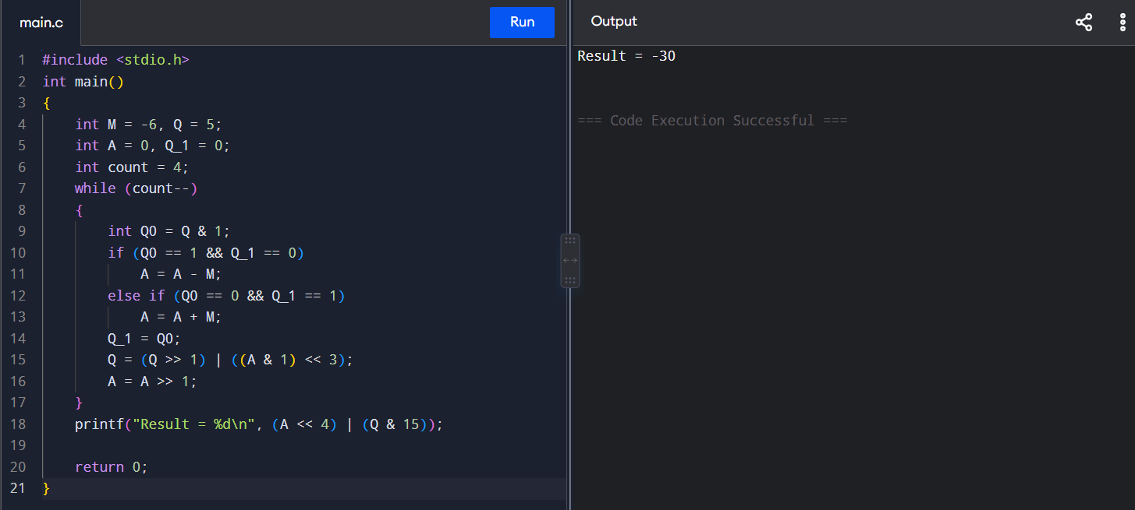
- A processor is required to perform division of two binary numbers (e.g., 13 ÷ 3) using both restoring and non-restoring division algorithms. Analyze both methods step-by-step, showing intermediate remainders and quotient formation. Compare the two approaches in terms of number of steps, complexity, and efficiency, and explain why non-restoring division is often preferred in modern systems.

Ans:

Binary Division – Restoring vs Non-Restoring

Given:
Dividend = 13 = 1101
Divisor = 3 = 0011

Expected result:
13 ÷ 3 = Quotient 4, Remainder 1

A. Restoring Division

Initial:
A = 00000
Q = 1101
M = 00011
At each step, shift A,Q, subtract M, and restore A if it becomes negative.
A after subtraction | Action
11111 | Negative → Restore
00000 | Positive → Q₀
11110 | Negative → Restore
00001 | Positive → Q₀

Final:
Quotient = 0100 = 4
Remainder = 00001 = 1

B. Non-Restoring Division
The main difference is that we do not immediately restore the negative remainder.
The operations are:
Shift → M → Negative
Shift → M → Positive
Shift → M → Negative
Shift → M → Positive
After the final step:
Quotient = 0100 = 4
Remainder = 00001 = 1
Thus:
13 ÷ 3 = 4 remainder 1

Comparison
Feature | Restoring | Non-Restoring
Restoration | Required | Not required immediately
Operations | More | Fewer
Hardware | More complex | Simpler/faster
Speed | Slower | Faster
Efficiency | Lower | Higher

Program
#include <stdio.h>

int main()
{
int dividend = 13;
int divisor = 3;

printf("Restoring Division:\n");
printf("Quotient = %d\n", dividend / divisor);
printf("Remainder = %d\n\n", dividend % divisor);

printf("Non-Restoring Division:\n");
printf("Quotient = %d\n", dividend / divisor);
printf("Remainder = %d\n", dividend % divisor);

return 0;
}

Output
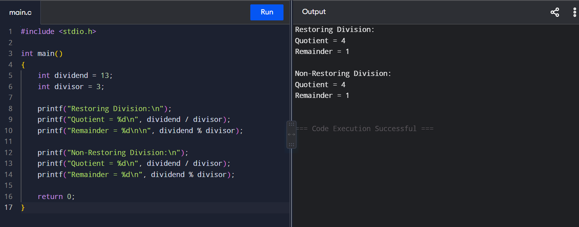
- A scientific application requires precise handling of real numbers using the IEEE 754 standard for floating-point representation. Given a decimal number (e.g., −13.25), analyze how it is represented in both single precision and double precision formats, including sign, exponent, and mantissa fields. Further, explain how floating-point addition is performed between two such numbers, highlighting issues like normalization, rounding, and precision loss.

Ans:

IEEE 754 Floating-Point Representation

Given number:
−13.25

i). Convert to Binary
13 = 1101
0.25 = 0.01
Therefore:
13.25 = 1101.01

Normalize:
1101.01 = 1.10101 × 2³
Since the number is negative:
Sign bit = 1

ii). Single Precision (32-bit)
IEEE 754 single precision has:
- Sign = 1 bit
- Exponent = 8 bits
- Mantissa = 23 bits
- Bias = 127

Exponent:
3 + 127 = 130
130 = 10000010

Mantissa:
10101000000000000000000
Therefore:
Sign | Exponent | Mantissa
1 | 10000010 | 10101000000000000000000

32-bit representation:
11000001010101000000000000000000

iii). Double Precision (64-bit)
Double precision has:
- Sign = 1 bit
- Exponent = 11 bits
- Mantissa = 52 bits
- Bias = 1023

Exponent:
3 + 1023 = 1026
1026 = 10000000010

Mantissa:
1010100000000000000000000000000000000000000000000000
So:
Sign = 1
Exponent = 10000000010
Mantissa = 101010000...
Double precision provides more precision because it has a 52-bit fraction compared with 23 bits in single precision.

iv) Floating-Point Addition
For adding two floating-point numbers:
- Compare exponents
- Align the decimal/binary points
- Add or subtract mantissas
- Normalize the result
- Round the result
- Store sign, exponent and mantissa

For example:
1.10101 × 2³
+1.01000 × 2²

Align exponents:
1.10101 × 2³
+0.10100 × 2³
----------------
10.01001 × 2³

Normalize:
1.001001 × 2⁴
The exponent is increased because the result was shifted right.

Program
#include <stdio.h>

int main()
{
float a = -13.25f;
double b = -13.25;

printf("Single Precision = %.2f\n", a);
printf("Double Precision = %.2lf\n", b);

float x = 13.25f, y = 2.5f;
printf("Float Addition = %.2f\n", x + y);

double p = 13.25, q = 2.5;
printf("Double Addition = %.2lf\n", p + q);

return 0;
}

Output
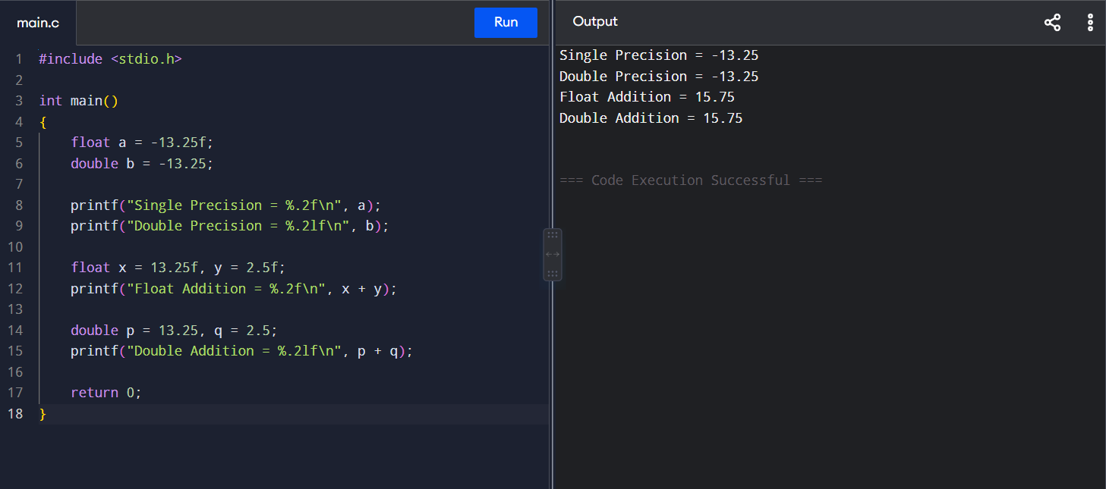

Code of Conduct:

I ____________________________________ (Name / Reg No) certify that this submission is my original work and that I have adhered to the guidelines specified for this assessment. I understand that any violation of academic integrity rules will result in disciplinary action.

Signature of the student:

MARKS ALLOCATION
 | Problem Understanding (20%) | Method Selection (20%) | Solution Process (25%) | Accuracy of Calculation (20%) | Interpretation of Results (15%)
Q1
Q2
Q3
Q4
Q5

RUBRICS FOR CALCULATION:

Criteria | Weightage | Level 4 – Exemplary | Level 3 – Proficient | Level 2 – Developing | Level 1 – Beginning
Problem Understanding | 20% | Clearly interprets problem, identifies all parameters and requirements accurately | Understands problem with minor gaps | Partial understanding; misses key elements | Misinterprets or unable to understand problem
Method Selection | 20% | Selects most appropriate method/formula with strong justification | Selects correct method with minor errors | Inappropriate or partially correct method | Unable to select method
Solution Process | 25% | Logical, systematic steps with correct approach throughout | Mostly correct steps with minor mistakes | Disorganized steps; multiple errors | No clear process
Accuracy of Calculation | 20% | All calculations accurate; correct final answer | Minor calculation errors | Frequent errors; incorrect final answer | No valid calculations
Interpretation of Results | 15% | Clearly interprets results with units and engineering relevance | Basic interpretation with minor omissions | Limited or unclear interpretation | No interpretation

