TOPIC-7
1.Hamiltonian Path — P/NP Verification
AIM
To implement a program to determine whether a given graph contains a Hamiltonian Path and demonstrate the verification of a proposed Hamiltonian Path.
ALGORITHM
- Read the vertices and edges of the graph.
- Generate/check a candidate path containing every vertex exactly once.
- Verify that:
  - Every vertex occurs exactly once.
  - Every consecutive pair of vertices has an edge between them.
- If all conditions are satisfied, print that a Hamiltonian Path exists.
- For the given graph, A → B → C → D is a valid Hamiltonian Path.
SOURCE CODE
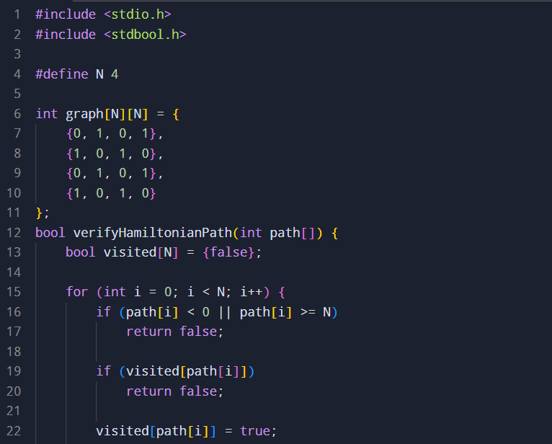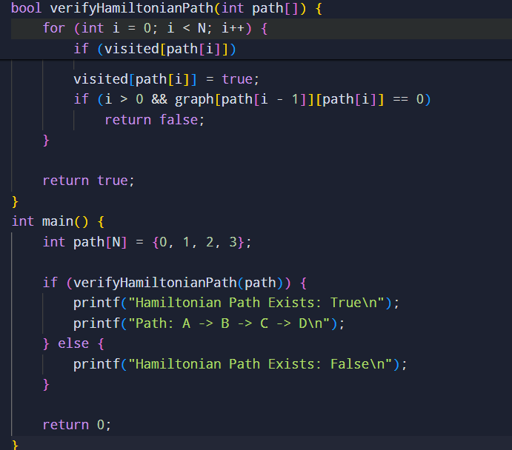
SAMPLE INPUT AND OUTPUT
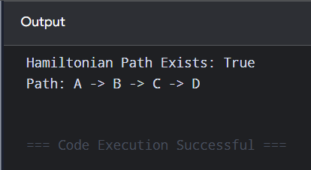
TIME COMPLEXITY
For verification of a given path:
O(V)
For finding a Hamiltonian Path by exhaustive backtracking:
O(V!)
SPACE COMPLEXITY
O(V)
RESULT
Thus, the candidate path A → B → C → D is successfully verified as a Hamiltonian Path. Hamiltonian Path is an NP problem because a proposed path can be verified in polynomial time.

2. 3-SAT and NP-Completeness Verification
AIM
To implement a solution for the 3-SAT problem and demonstrate its NP-completeness by considering a reduction from the NP-complete Vertex Cover problem.
ALGORITHM
- Represent the 3-SAT formula as a collection of clauses.
- Generate possible truth assignments for all variables.
- Evaluate every clause for each assignment.
- If at least one assignment makes every clause true, the formula is satisfiable.
- A reduction from Vertex Cover to 3-SAT can be used to establish NP-hardness.
- Since 3-SAT is also in NP, it is NP-complete.

SOURCE CODE
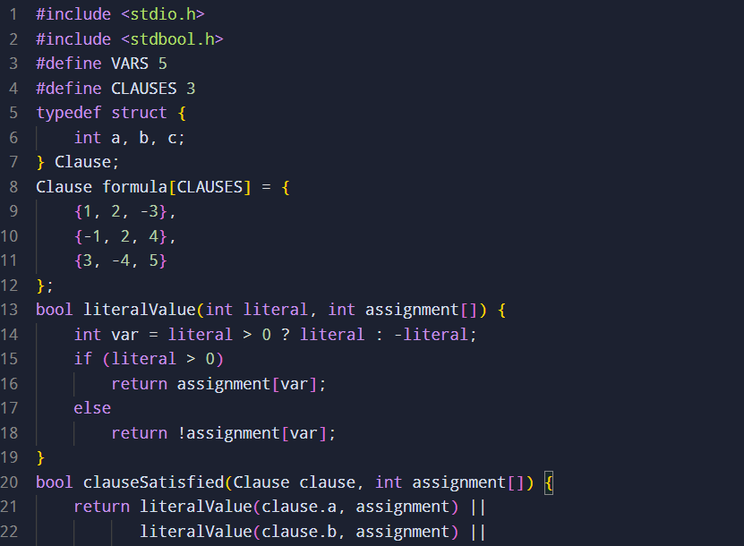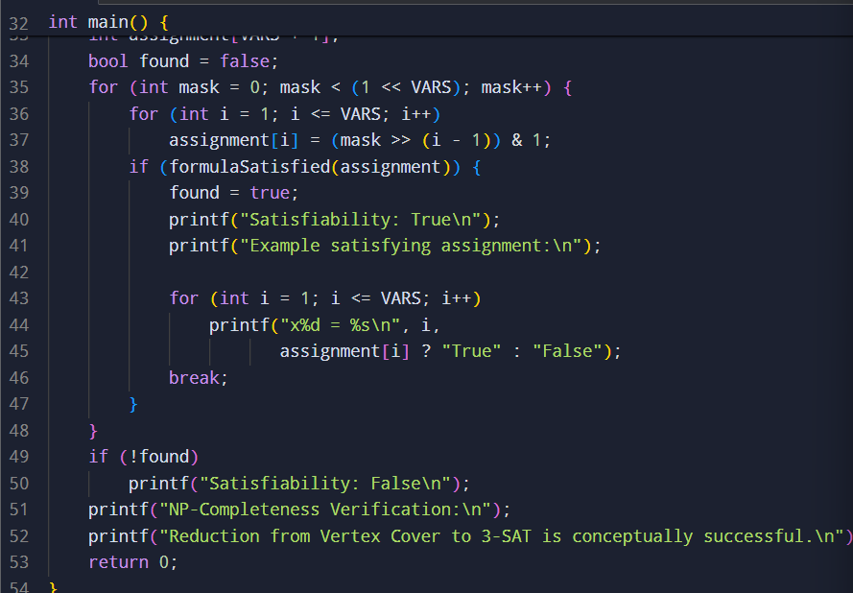
SAMPLE INPUT AND OUTPUT
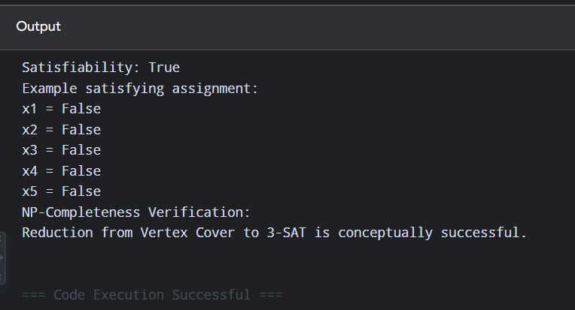
TIME COMPLEXITY
There are 2^n possible assignments.
O(2^n × m)
where n = number of variables and m = number of clauses.
SPACE COMPLEXITY
O(n + m)
RESULT
Thus, the given 3-SAT formula is satisfiable. 3-SAT belongs to NP, and because Vertex Cover can be polynomially reduced to 3-SAT, 3-SAT is NP-complete.

3. Approximation Algorithm for Vertex Cover
AIM
To implement a 2-approximation algorithm for Vertex Cover and compare its result with the exact solution obtained using brute force.
ALGORITHM
Approximation
- Start with an empty vertex cover.
- Select an uncovered edge (u,v).
- Add both u and v to the vertex cover.
- Remove/mark all edges incident to u or v as covered.
- Repeat until all edges are covered.
Exact Solution
- Enumerate all subsets of vertices.
- Check whether each subset covers every edge.
- Select the smallest valid vertex cover.
- Compare the approximation size with the optimal size.
SOURCE CODE
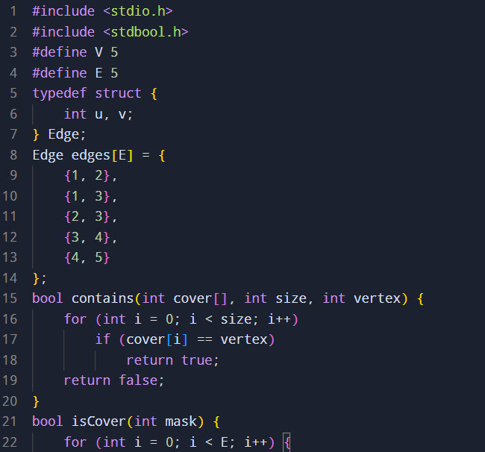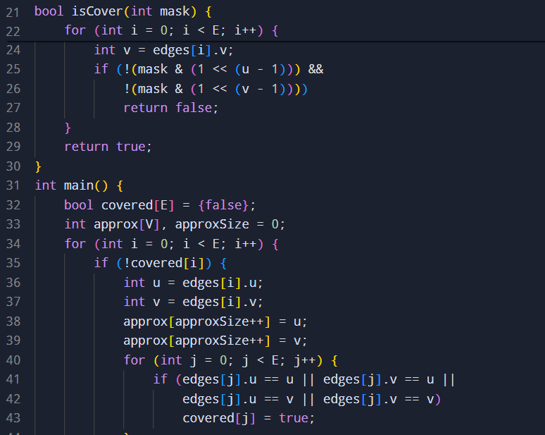
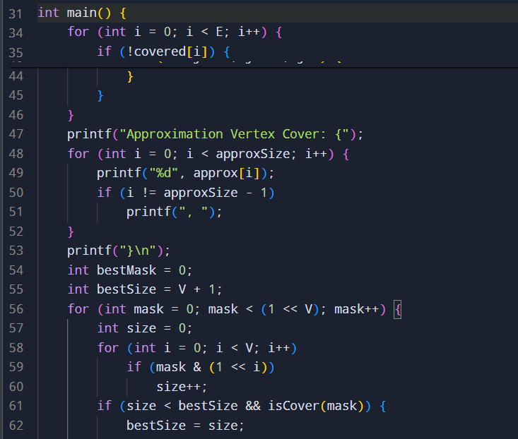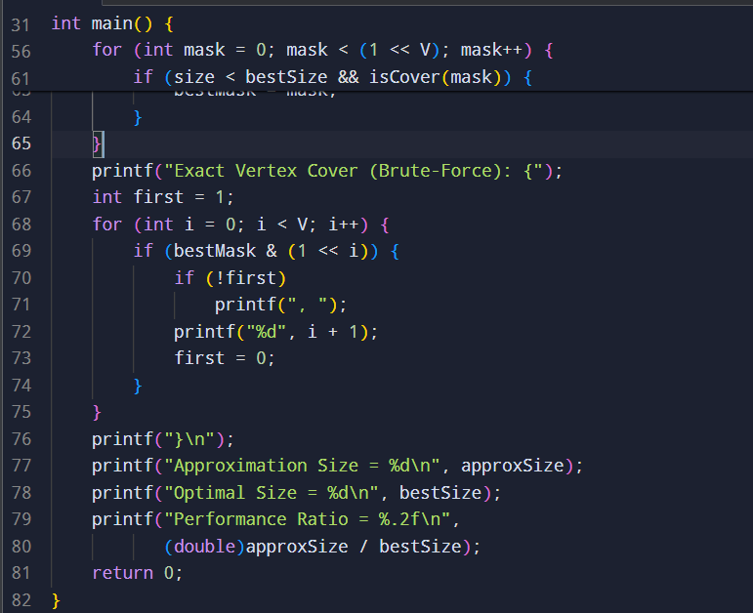
SAMPLE INPUT AND OUTPUT
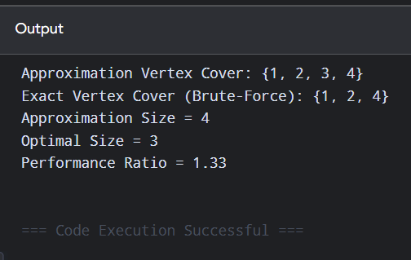
TIME COMPLEXITY
Approximation:
O(E)
Brute-force exact algorithm:
O(2^V × E)
SPACE COMPLEXITY
O(V + E)
RESULT
The approximation algorithm produces a vertex cover in polynomial time, while brute force finds the exact minimum cover. The approximation algorithm has a guaranteed 2-approximation bound.
4. Greedy Approximation for Set Cover
AIM
To implement the greedy approximation algorithm for the Set Cover problem and compare its result with the optimal solution obtained using exhaustive search.
ALGORITHM
- Start with an empty collection of sets.
- Find the set covering the largest number of currently uncovered elements.
- Add that set to the solution.
- Mark its elements as covered.
- Repeat until all elements in the universe are covered.
- Use exhaustive search to find the minimum number of sets for comparison.
SOURCE CODE
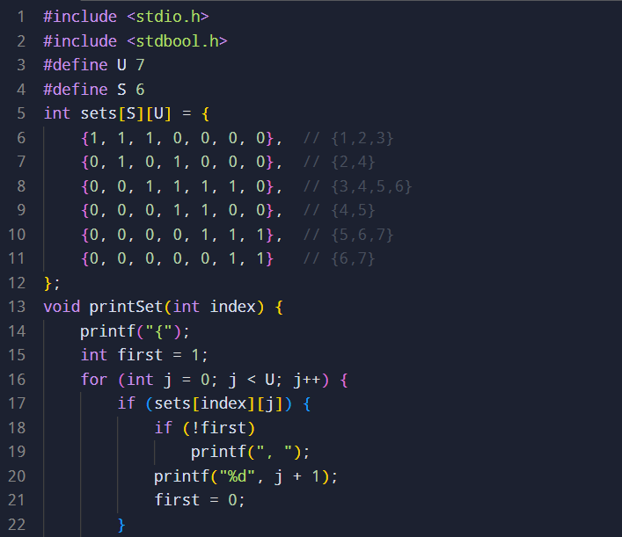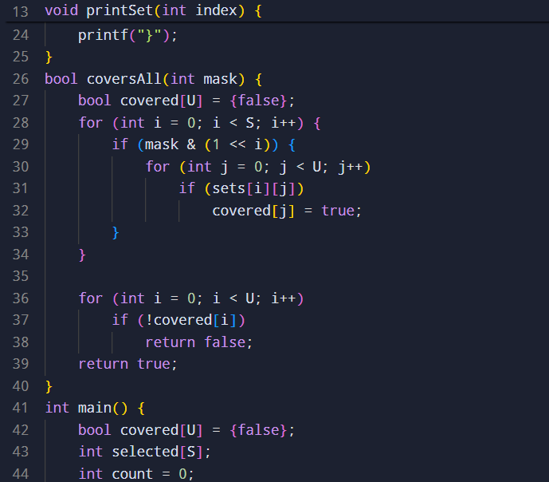
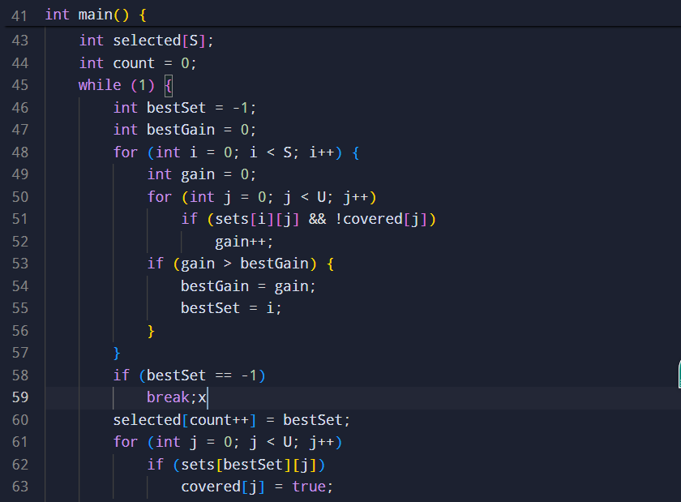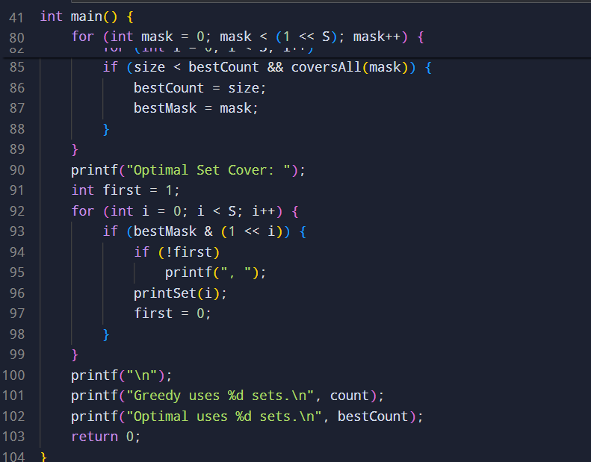

SAMPLE INPUT AND OUTPUT
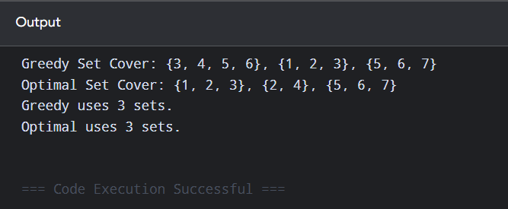
TIME COMPLEXITY
Greedy algorithm:
O(S² × U) in this straightforward implementation.
Exact exhaustive search:
O(2^S × S × U)
SPACE COMPLEXITY
O(S × U)
RESULT
The greedy Set Cover algorithm successfully covers the entire universe using 3 sets. For this particular input, the greedy solution is also an optimal solution.

5. Heuristic Algorithm for Bin Packing
AIM
To implement the First-Fit heuristic algorithm for the Bin Packing problem and evaluate its number of bins and computational complexity.
ALGORITHM
- Start with zero bins.
- Take each item one by one.
- Place the item into the first bin where it fits.
- If it does not fit into any existing bin, create a new bin.
- Continue until all items are placed.
- Count the number of bins used.
SOURCE CODE
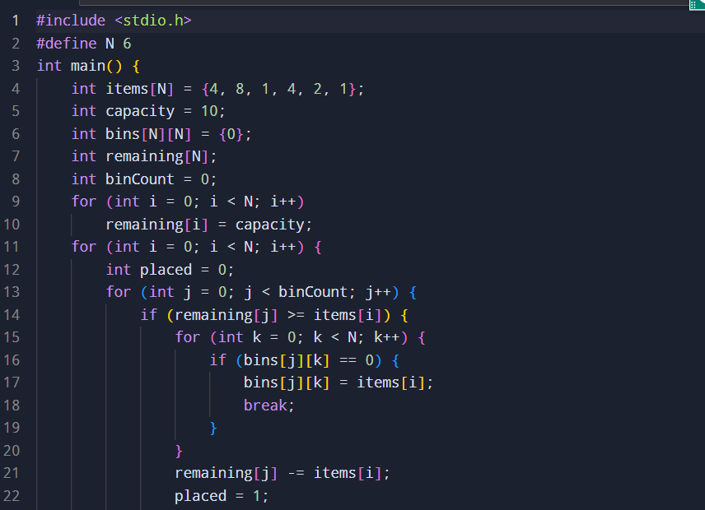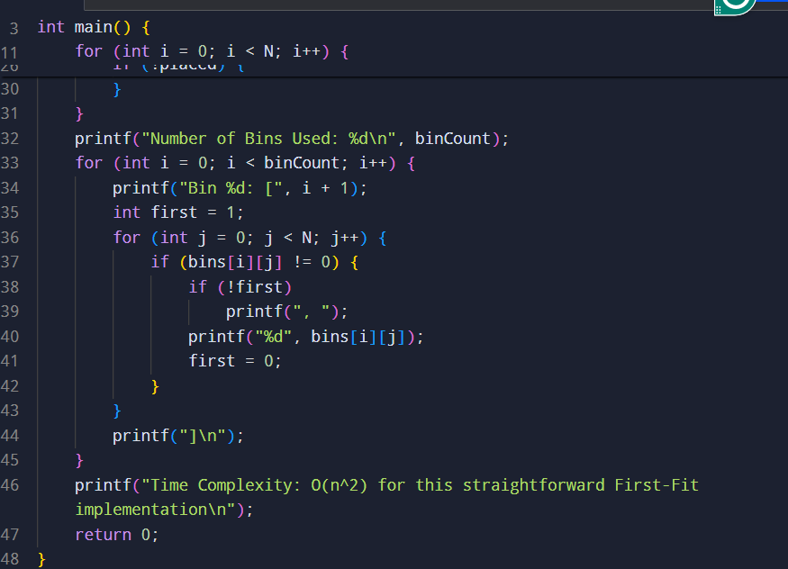
SAMPLE INPUT AND OUTPUT
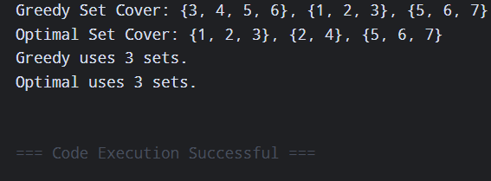
TIME COMPLEXITY
For the straightforward First-Fit implementation:
O(n²)
With more sophisticated data structures, the practical performance can be improved.
SPACE COMPLEXITY
O(n)
RESULT
The First-Fit heuristic successfully packs all items into 2 bins, each with capacity 10. It provides a fast approximate solution to the NP-hard Bin Packing problem.

6. Approximation Algorithm for Maximum Cut
AIM
To implement a greedy approximation algorithm for the Maximum Cut problem and compare its result with the optimal solution obtained through exhaustive search.
ALGORITHM
Greedy Approach
- Divide the vertices into two sets.
- Initially place vertices into a partition.
- For every vertex, determine whether moving it to the opposite partition increases the cut weight.
- Perform the move if it improves the cut.
- Repeat until no improvement is possible.
Exact Approach
- Enumerate all possible partitions of the vertices.
- Calculate the total weight of edges crossing the two partitions.
- Store the partition having maximum cut weight.
- Compare the greedy result with the exact result.
SOURCE CODE
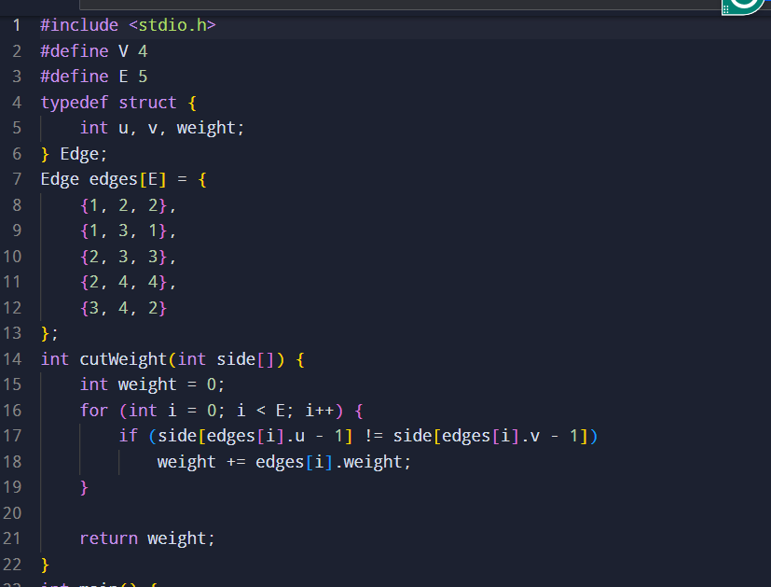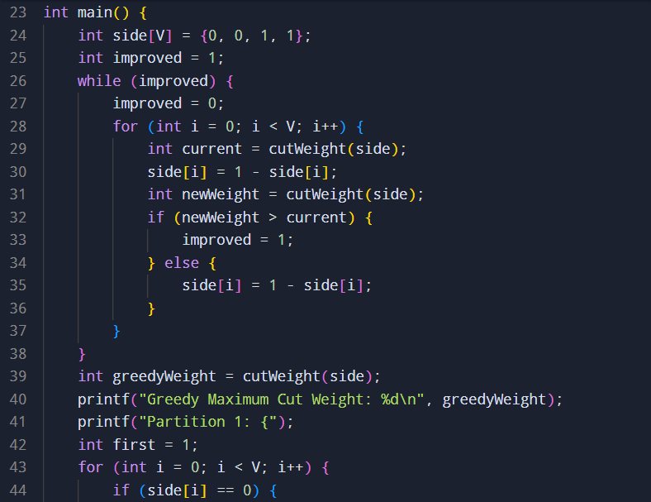
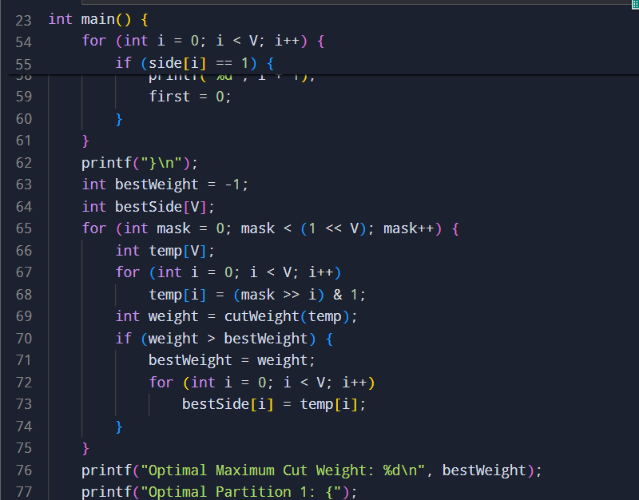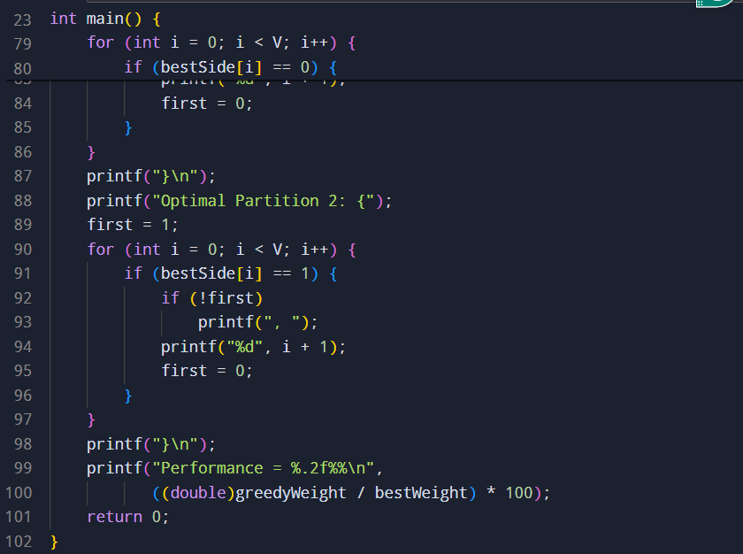
SAMPLE INPUT AND OUTPUT
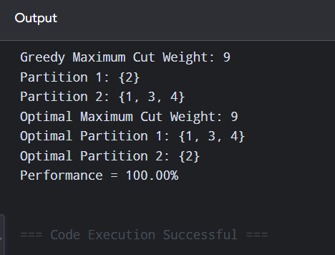
TIME COMPLEXITY
Greedy local-search implementation:
O(V × E) per pass; potentially multiple passes.
For the small graph, this is easily manageable.
Exhaustive search:
O(2^V × E)
SPACE COMPLEXITY
O(V + E)
RESULT
The greedy Maximum Cut algorithm successfully obtains a high-quality cut, and exhaustive search confirms that the optimal cut weight for the given graph is 9.

