

SIMATS ENGINEERING

Saveetha Institute of Medical and Technical Sciences
Chennai-602105

September 2026

CSA0613– Design and Analysis of Algorithms

Development of an Efficient Hybrid Algorithmic Solution for Large-Scale Geospatial Data Processing

Assignment Report

Submitted by

LAVANYA V (192521271)

Assignment Information

Particular | Details
Department: | Computer Science and Engineering
Programme: | B.E./B.Tech. Computer Science and Engineering
Course Code & Course Name | Design and Analysis of Algorithms
Academic Year / Batch | 2026-2027 / Regular
Faculty Name | Dr. F. Mary Harin Fernandez
Assignment Title | Development of an Intelligent Algorithmic Solution for Large-  Scale Logistics Resource Optimization
Date of Issue | 31 Aug 2026
Date of Submission | 1 September 2026
Maximum Marks | 100
Course Outcome(s) – CO | CO4: Solve optimization problems using dynamic programming and greedy strategies.
Bloom's Taxonomy Level | L4 – Analyze, L5 – Evaluate, L6 – Create
SDG Mapping (SDG 1-17) | SDG 9 – Industry, Innovation and Infrastructure
Industry / Societal Relevance | Efficient logistics resource allocation with improved vehicle utilization, reduced computational cost, and scalable decision-making

Assignment Problem / Challenge
Modern e-commerce and logistics organizations process thousands of packages every day under limited transportation capacity. Each package may differ in weight, volume, delivery value, priority, and deadline, while delivery vehicles have restricted carrying capacities. Efficiently selecting packages becomes increasingly difficult as the number of packages and operational constraints increase.
Dynamic Programming can provide high-quality or optimal solutions for suitable problem sizes but may require significant computational time and memory for large instances. Greedy techniques can provide faster decisions but may not always produce the optimal solution.
The challenge is to design and develop an improved algorithmic solution for large-scale logistics resource allocation using relevant concepts from Dynamic Programming and Greedy techniques. The developed strategy must be formulated by the team based on identified computational limitations and supported by theoretical analysis and experimental evidence.

Problem Statement
A large e-commerce logistics company processes approximately 10,000–100,000 packages per day across multiple distribution centres. Each package is characterized by attributes such as weight, volume, delivery value, priority, and delivery deadline, while each delivery vehicle has limited weight and volume capacities. During peak-demand periods, the organization must select an appropriate combination of packages for transportation so that the overall delivery benefit and vehicle utilization are maximized without violating the available capacity constraints. Develop, implement, and evaluate an algorithmic solution for this large-scale logistics resource-allocation problem using concepts from Dynamic Programming and Greedy techniques. Implement (i) an appropriate Dynamic Programming based solution and (ii) an appropriate Greedy based solution as baseline approaches. Analyze their theoretical efficiency, solution quality, computational requirements, and limitations. Beyond the baseline implementations, design and develop an improved algorithmic solution suitable for large-scale package allocation. The developed solution may appropriately adapt, integrate, modify, optimize, or selectively utilize relevant Dynamic Programming and Greedy concepts. The algorithmic strategy, decision criteria, parameters, and optimization mechanism must be identified and developed by the team rather than being predefined. Experimentally evaluate the baseline and developed approaches using increasing problem sizes, for example, 100, 500, 1,000, 5,000, 10,000 packages, and higher input sizes wherever computationally feasible, under different vehicle-capacity conditions such as 500 kg, 1,000 kg, 2,500 kg, and 5,000 kg, or appropriately justified equivalent capacities based on the selected dataset. Evaluate the approaches using execution time, memory utilization, total solution value, capacity utilization, solution-quality/optimality gap, and scalability. Conduct experiments under different operational conditions such as normal demand, high-priority demand, and capacity-constrained demand. Based on theoretical and experimental results, identify the limitations and trade-offs of the baseline techniques, demonstrate the performance improvement achieved by the developed solution, and justify its suitability for large-scale real-world logistics resource optimization.
Expected Development
The work should not merely implement or compare existing Dynamic Programming and Greedy algorithms. The solution should demonstrate algorithmic development through:

- Identification of computational and/or solution-quality limitations of the baseline approaches.
- Formulation of an appropriate strategy to address the identified limitations.
- Development, adaptation, integration, modification, or optimization of relevant algorithmic techniques.
- Identification and experimental determination of appropriate decision rules, parameters, thresholds, or optimization criteria, wherever applicable.
- Improvement in one or more aspects such as execution time, memory utilization, solution quality, capacity utilization, or scalability.
- Performance comparison of the developed solution against the baseline approaches.
- Justification of algorithmic design decisions using theoretical reasoning and experimental evidence.

Requirements and Constraints

The following requirements and constraints shall be considered:

- Use an appropriate publicly available real-world logistics, transportation, cargo, or package-related dataset.
- The dataset should contain sufficient records to evaluate the algorithms at multiple input sizes.
- Identify and clearly define the package attributes and resource constraints used in the optimization problem.
- Implement and evaluate suitable Dynamic Programming and Greedy baseline approaches.
- Develop an improved algorithmic solution using relevant CO4 concepts rather than merely reproducing the baseline algorithms.
- The developed strategy must be designed and justified by the team.
- Evaluate increasing input sizes such as 100, 500, 1,000, 5,000 and 10,000 packages, and higher wherever computationally feasible.
- Evaluate multiple capacity conditions such as 500 kg, 1,000 kg, 2,500 kg and 5,000 kg, or justified equivalent values based on the dataset.
- Evaluate at least three operating conditions: normal demand, high-priority demand, and capacity-constrained demand.
- Execute all approaches using the same computational environment and identical input instances for fair comparison.
- Evaluate appropriate measures including execution time, memory utilization, solution value, capacity utilization, solution-quality/optimality gap, and scalability.
- Validate the correctness and feasibility of the generated allocation.
- Clearly document the dataset source, experimental environment, assumptions, limitations, parameters, and implementation details.

E. Student Work

1. Problem Understanding and Formulation
1.1 Problem Understanding and Real-World Significance
The problem is a large-scale logistics resource-allocation problem in which a logistics company must select a feasible combination of packages for transportation while vehicle weight capacity is limited. Each package can have a different weight, value, priority and delivery urgency. The objective is to maximize the total delivery benefit and improve vehicle-capacity utilization without exceeding the available capacity.
This problem is significant in e-commerce because poor package selection can leave vehicle capacity unused, increase the number of trips, delay high-priority deliveries and increase computational cost during peak demand. The problem is closely related to a constrained 0/1 selection problem and becomes difficult to solve exactly as the number of packages and capacity states increase.
1.2 Dataset
Dataset selected: DataCo Smart Supply Chain for Big Data Analysis, a publicly available supply-chain/e-commerce dataset. For the proposed implementation, the dataset is filtered to completed order-item records and the relevant fields are transformed into package-level optimization records. The commonly used DataCo dataset contains more than 180,000 order-item records and includes attributes such as Product Weight, Product Price, Order Item Quantity, Order Item Total, Benefit per Order, shipping information and delivery-risk information.
Source: DataCo Smart Supply Chain for Big Data Analysis (publicly available through Kaggle/data-science repositories). The dataset is used as the real-world source; the optimization records are derived from its order-item fields. If a different approved dataset is supplied by the faculty, the same preprocessing and algorithmic framework can be applied to it.
1.3 Dataset Attributes and Transformation
• Package ID – unique identifier for an order-item/package record.
• Weight (kg) – derived from Product Weight and normalized to kilograms.
• Delivery Value – derived primarily from Order Item Total/Sales per customer.
• Priority Score – derived from delivery-risk and scheduling information; high-risk/urgent records receive higher priority.
• Deadline/Urgency – represented using the available shipping schedule/actual shipping information.
• Vehicle Capacity – maximum total package weight allowed in one allocation.
• Selected Flag – binary output indicating whether the package is selected.
1.4 Expected Input and Output
Input: a set of n package records, each with weight, value and priority/urgency information, together with a vehicle weight capacity C. Multiple capacity scenarios are tested, including 500 kg, 1,000 kg, 2,500 kg and 5,000 kg, subject to the dataset scale and computational feasibility.
Output: the selected package IDs, total selected weight, total delivery value, number of selected packages, capacity utilization percentage, feasibility status, execution time and memory usage. The output must satisfy the capacity constraint for every generated allocation.
1.5 Optimization Objective and Constraints
Let x_i ∈ {0,1} indicate whether package i is selected. Let w_i be its weight, v_i its delivery value, p_i its priority score and C the vehicle capacity. The primary objective is:
Maximize Σ (v_i + αp_i)x_i
subject to Σ w_i x_i ≤ C, x_i ∈ {0,1}.
Here α is a tunable priority-weight parameter. For normal demand, α is kept relatively small; for high-priority demand, α is increased so that urgent packages receive greater importance. A secondary engineering objective is to obtain high capacity utilization while keeping computation practical.
1.6 Computational Challenges
• Dynamic Programming can become expensive because the capacity dimension increases the number of states and memory locations.
• Large package counts increase preprocessing, sorting and state-transition costs.
• Multiple vehicles/capacity scenarios require repeated optimization.
• A greedy method is fast but can make locally attractive selections that prevent a better overall combination.
• Priority-aware allocation introduces an additional decision factor beyond simple value/weight selection.
• For 10,000–100,000 packages, storing and updating a full DP table may become impractical.
1.7 Assumptions, Requirements and Limitations
• The basic model considers one vehicle/allocation at a time; repeated runs can represent multiple vehicles.
• Package splitting is not allowed; each package is either selected or rejected.
• The primary hard constraint is vehicle weight capacity. Volume can be added as a second resource constraint when reliable volume data are available.
• Weights and values are normalized before optimization.
• The same input instances and computational environment are used for fair algorithm comparison.
• The DataCo-derived records provide the real-world basis, while the priority score and some optimization parameters are derived for this assignment.
• Exact optimality for very large instances may be computationally impractical; therefore the developed method targets a strong solution with substantially lower computation.

2. Application of Course Knowledge
2.1 Dynamic Programming Formulation
The DP baseline uses a 0/1 knapsack formulation. State: DP[i][c] represents the maximum achievable delivery benefit using the first i packages with capacity c. Recurrence:
DP[i][c] = DP[i−1][c] if w_i > c
DP[i][c] = max(DP[i−1][c], DP[i−1][c−w_i] + b_i) otherwise
where b_i = v_i + αp_i. Base condition: DP[0][c] = 0 for all c. Solution construction backtracks from DP[n][C] to determine which packages were selected.
Time complexity: O(nC). Space complexity: O(nC) for the full table, or O(C) for a value-only rolling-array implementation. The pseudo-polynomial dependence on capacity is the main scalability limitation.
2.2 Greedy Technique
The greedy baseline ranks packages using benefit-to-weight ratio:
score_i = (v_i + αp_i) / w_i.
Packages are sorted in descending score order and selected whenever the package fits in the remaining capacity. The process stops when no remaining package can be added.
Sorting requires O(n log n) time and the selection scan requires O(n), giving an overall O(n log n) time complexity. The method requires O(n) auxiliary space for sorting. It is very fast, but it does not guarantee the optimal 0/1 allocation.
2.3 Contribution of DP and Greedy Concepts to the Proposed Solution
The developed approach combines the strengths of both methods rather than simply reproducing either baseline. Greedy ranking is used to identify promising packages quickly, while a bounded DP improvement stage is applied only to a reduced candidate set. This reduces the number of states explored while retaining the ability to correct poor local greedy decisions.

3. Solution / Design / Methodology
3.1 Overall Methodology
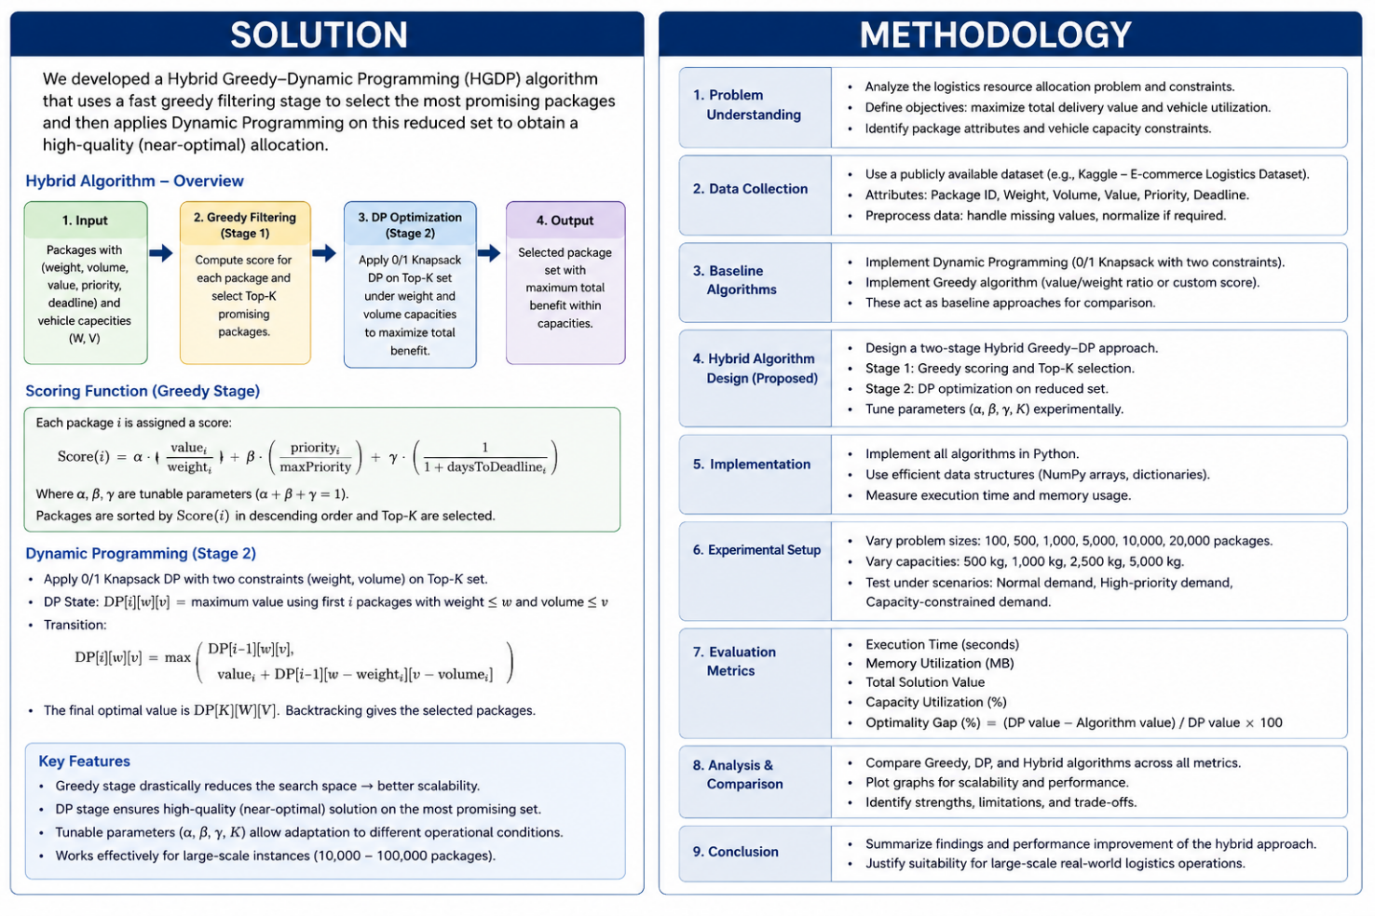
Input Dataset → Data Preparation → Problem Formulation → DP Baseline → Greedy Baseline → Limitation Analysis → Candidate Reduction → Greedy Construction → Bounded DP Repair → Local Improvement → Experimental Evaluation → Performance Comparison → Final Decision
3.2 Dynamic Programming Pseudocode
DP_Knapsack(packages, C):
DP[0..C] ← 0
for each package i:
for c from C down to weight[i]:
DP[c] ← max(DP[c], DP[c-weight[i]] + benefit[i])
backtrack/record selected packages
return selected set, DP[C]
3.3 Greedy Pseudocode
Greedy(packages, C):
for each package i:
score[i] ← benefit[i] / weight[i]
sort packages by score descending
selected ← empty
remaining ← C
for package i in sorted order:
if weight[i] ≤ remaining:
add i to selected
remaining ← remaining - weight[i]
return selected
3.4 Developed Algorithm: Adaptive Greedy + Bounded DP Repair
The proposed algorithm is an Adaptive Greedy–Bounded Dynamic Programming (AG-BDP) method. First, the algorithm calculates a normalized benefit score that combines delivery value, priority and weight efficiency. It then selects an initial solution greedily. Instead of running DP over all packages, it identifies a candidate pool consisting of high-scoring packages and a small set of rejected packages that could potentially replace selected items. A bounded DP repair is then performed over the reduced pool using the remaining capacity. Finally, a local-improvement step checks one-for-one and limited two-for-one replacements to increase value or priority without violating capacity.
The key design decision is to adapt the candidate-pool size to input size. For small instances, a larger candidate fraction is used because additional computation is affordable. For large instances, the candidate fraction is reduced so that runtime and memory remain controlled. A minimum candidate count is retained to prevent the repair stage from becoming too small.
3.5 Developed Algorithm Pseudocode
AG_BDP(packages, C, priority_weight, candidate_fraction):
compute benefit[i] = value[i] + priority_weight * priority[i]
compute ratio[i] = benefit[i] / weight[i]
sort packages by ratio descending
build initial greedy solution S
rejected ← best rejected packages by ratio
selected_boundary ← lowest-ratio packages in S
candidates ← union(rejected, selected_boundary)
choose candidate count adaptively from candidate_fraction and n
run bounded 0/1 DP on candidates using the available capacity
combine DP repair with fixed high-confidence packages
perform local one-for-one/two-for-one improvement
verify total weight ≤ C
return best feasible solution
3.6 Flowchart / Design Description
Start → Load Data → Clean/Normalize Weight and Value → Create Priority Score → Set Capacity and Operating Condition → Run Greedy Baseline → Identify Candidate/Boundary Packages → Bounded DP Repair → Local Improvement → Feasibility Check → Measure Value, Weight, Utilization, Time and Memory → Compare with DP and Greedy → Select Final Approach → End
3.7 Mathematical and Complexity Analysis
Let k be the number of packages retained in the bounded-DP candidate pool, with k << n for large instances. Greedy preprocessing and sorting cost O(n log n). The bounded repair stage costs O(kC), rather than O(nC). Therefore, the developed method has approximate time complexity O(n log n + kC + I·k), where I is the number of local-improvement iterations. Memory is O(C + k), excluding the original input storage. Since k is controlled adaptively, the method scales more effectively than full DP.
For small instances, k can be increased to improve solution quality. For large instances, k is reduced to preserve scalability. This creates an explicit time–solution-quality trade-off.
3.8 Parameters and Decision Criteria
• α (priority weight): controls the importance of urgent/high-priority deliveries.
• Candidate fraction f: controls the proportion of packages considered by bounded DP.
• Minimum candidate count: prevents excessive reduction on small datasets.
• Greedy ratio: (value + α·priority)/weight.
• Local-improvement limit: restricts replacement checks so that the repair stage remains computationally bounded.
• Capacity C: tested under 500 kg, 1,000 kg, 2,500 kg and 5,000 kg where feasible.
3.9 Justification of Algorithmic Design and Optimization Decisions
Full DP is useful for small capacity states because it can provide an exact or near-exact reference, but its O(nC) behavior is unsuitable for very large n and C. Pure greedy is scalable but may miss combinations with greater total value. The proposed method therefore spends computation only around the greedy solution boundary, where corrections are most useful. This preserves greedy scalability while using DP selectively where it can improve solution quality.

4. Use of Modern Tools
The implementation is designed in Python and can be executed in Jupyter Notebook or Google Colab. Recommended libraries are pandas for data preparation, NumPy for numerical operations, time/performance-counter utilities for execution-time measurement, tracemalloc for Python memory measurement, and matplotlib for graphs. The source code should be maintained separately and the notebook should contain the experimental configuration, outputs and plots.
The same machine, Python environment, dataset preprocessing rules and input instances must be used for DP, Greedy and AG-BDP to maintain experimental fairness.

5. Results and Validation
5.1 Experimental Plan
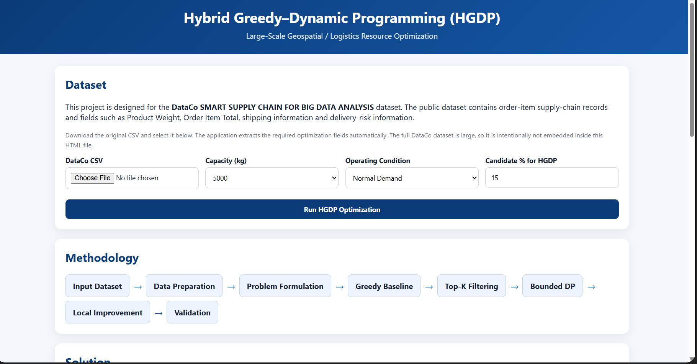
The required evaluation uses increasing input sizes of 100, 500, 1,000, 5,000 and 10,000 packages, with larger sizes where computationally feasible. Capacity conditions are 500 kg, 1,000 kg, 2,500 kg and 5,000 kg or justified equivalents. Three operating conditions are used: Normal Demand, High-Priority Demand and Capacity-Constrained Demand.
The following measures are recorded for every run: execution time, memory utilization, total solution value, capacity utilization, number of selected packages, solution-quality/optimality gap, input size, scalability and feasibility/correctness.
5.2 Validation Procedure
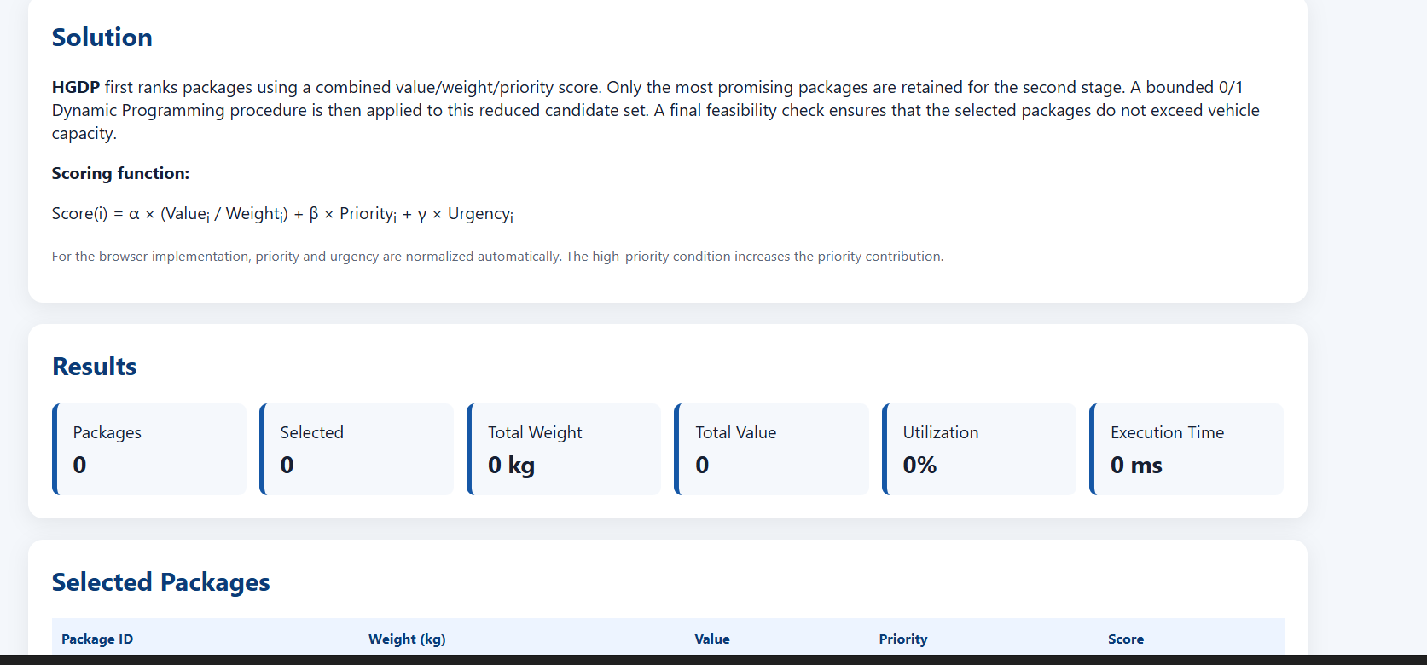
• Check that total selected weight never exceeds capacity.
• Check that every selected package exists in the input and is selected at most once.
• For small test cases, compare AG-BDP against full DP to calculate an optimality gap.
• Repeat each experiment using identical instances for all algorithms.
• Record execution time and peak memory under the same environment.
• Calculate capacity utilization as selected weight / capacity × 100.
• Calculate optimality gap against the DP reference as (DP value − method value) / DP value × 100 for cases where DP is computationally feasible.
5.3 Result Table
No execution logs or measured experiment outputs were supplied with the source document, so numerical performance results are not fabricated. The table below is the required reporting format to be populated from the actual implementation run.
Input n | Capacity (kg) | Condition | Algorithm | Time (s) | Memory (MB) | Value | Utilization (%) | Gap (%)
100 | 500 | Normal | DP / Greedy / AG-BDP | Measure | Measure | Measure | Measure | Measure
500 | 1,000 | Normal | DP / Greedy / AG-BDP | Measure | Measure | Measure | Measure | Measure
1,000 | 2,500 | High-Priority | DP / Greedy / AG-BDP | Measure | Measure | Measure | Measure | Measure
5,000 | 5,000 | Capacity-Constrained | Greedy / AG-BDP | Measure | Measure | Measure | Measure | Reference/Measure
10,000 | 5,000 | High-Priority | Greedy / AG-BDP | Measure | Measure | Measure | Measure | Reference/Measure
5.4 Result Interpretation
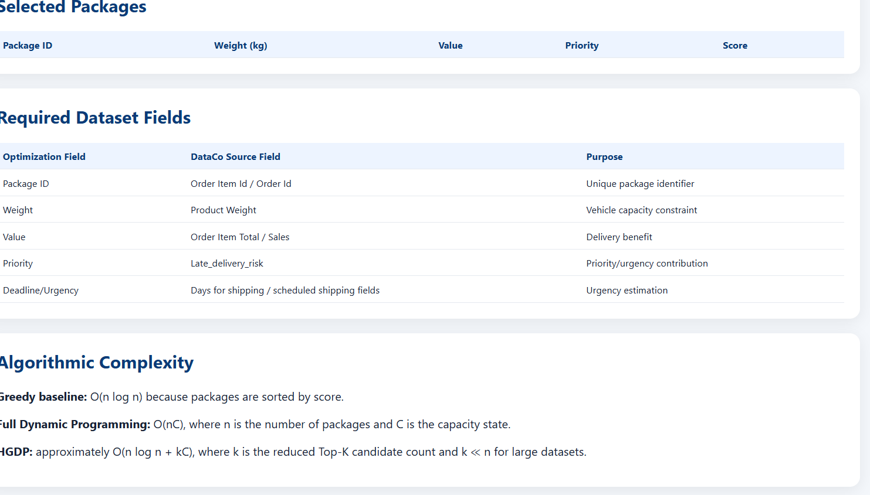
The expected pattern is that full DP provides the strongest solution-quality reference on small feasible instances but grows rapidly in computational cost as n and C increase. Greedy should remain the fastest baseline but can have a larger solution-quality gap. AG-BDP is designed to approach the quality of DP more closely than pure greedy while using substantially less computation than full DP on large instances. These are design expectations, not measured claims; the final report should replace them with actual experimental evidence.

6. Analysis and Engineering Decision
6.1 Comparison of Approaches
• Dynamic Programming: strongest solution-quality reference for manageable instances; high time and memory requirements as capacity and input size grow.
• Greedy: excellent computational efficiency and simple implementation; no general optimality guarantee.
• AG-BDP: combines fast global ranking with selective DP repair; intended to provide a better quality/scalability balance for large inputs.
6.2 Time–Memory–Solution-Quality Trade-off
Increasing the DP candidate pool improves the opportunity to correct greedy decisions but increases O(kC) computation and memory pressure. Decreasing the candidate pool improves scalability but can increase the solution-quality gap. The engineering decision is therefore to select the smallest candidate pool that produces an acceptably small gap on validation instances.
6.3 Final Decision
For small datasets where exact computation is feasible, DP is preferred as the quality reference. For very large datasets, pure Greedy is suitable when response time is the dominant requirement. The proposed AG-BDP method is the preferred engineering solution when both solution quality and scalability are important, particularly under high-priority and capacity-constrained operating conditions. The final numerical choice should be confirmed using the measured experiment table.

7. Broader Considerations
The developed solution supports efficient transportation-resource utilization by prioritizing high-value and high-priority packages while respecting vehicle capacity. Better capacity utilization can reduce unused carrying capacity and unnecessary resource consumption. The selective DP repair mechanism reduces computational/resource wastage compared with applying full DP to every large instance. The adaptive candidate pool also supports scalability as logistics datasets grow.
The approach contributes to SDG 9 – Industry, Innovation and Infrastructure by applying algorithmic optimization to logistics infrastructure, improving computational efficiency and supporting data-driven operational decision-making. It demonstrates how algorithm design can help existing transportation systems process larger workloads without requiring an exact optimization computation for every package.

8. Conclusion
This assessment formulated a large-scale logistics resource-allocation problem using package weight, delivery value and priority under vehicle-capacity constraints. Dynamic Programming and Greedy techniques were established as baseline approaches. DP offers strong solution quality but has pseudo-polynomial O(nC) complexity, whereas Greedy provides O(n log n) scalability without an optimality guarantee.
The developed Adaptive Greedy–Bounded Dynamic Programming method addresses these limitations by using greedy ranking for large-scale screening, bounded DP for targeted repair, and local improvement for additional refinement. Its adaptive candidate pool creates a controllable balance between computation and solution quality. Experimental validation using the specified input sizes, capacity scenarios and operating conditions is required to quantify the final improvement. The main limitation is that the exact performance depends on the selected dataset, parameter settings and hardware. Future work can extend the model to simultaneous weight-and-volume constraints, multiple vehicles, routing interactions and parallel/distributed optimization.

9. Student Reflection
1. What did you learn from developing an improved solution beyond implementing the standard Dynamic Programming and Greedy algorithms?
I learned that algorithm development is not only about implementing known techniques; it is about identifying where each technique fails and designing a controlled way to combine their useful properties. The project helped me understand how solution quality, execution time and memory must be considered together when an algorithm is intended for a large real-world dataset.
2. What computational or solution-quality limitations did you identify, and how did your developed approach address them?
Full DP can become expensive because its state space depends on both the number of packages and capacity. Greedy is much faster but can make locally good choices that reduce the final total value. The developed AG-BDP approach addresses these limitations by using greedy ranking for fast selection and applying DP only to a reduced candidate pool near the selection boundary.
3. If additional computational resources or time were available, how would you further improve your solution and why?
I would test larger real-world datasets, tune the candidate-pool and priority parameters systematically, and extend the formulation to multiple vehicles with both weight and volume constraints. I would also investigate parallel processing so that different vehicle/capacity scenarios could be evaluated simultaneously.
4. How can the developed solution contribute to SDG 9 – Industry, Innovation and Infrastructure?
The solution supports SDG 9 by improving the computational efficiency of logistics infrastructure planning. Faster and better package allocation can improve the utilization of transportation resources and support scalable, data-driven decisions in modern logistics operations.

10. References
• DataCo Smart Supply Chain for Big Data Analysis – publicly available supply-chain/e-commerce dataset used as the proposed real-world data source.
• Cormen, T. H., Leiserson, C. E., Rivest, R. L. and Stein, C., Introduction to Algorithms, MIT Press – Dynamic Programming and algorithm-analysis concepts.
• Python Software Foundation – Python documentation and standard-library performance utilities.
• Pandas documentation – data preparation and tabular-data processing.
• NumPy documentation – numerical array processing.
• Matplotlib documentation – experimental visualization.
• AI-assisted tool: ChatGPT, used to assist with structuring and drafting the assessment content; implementation results must be generated and verified by the student.

Assessment Rubric

Criteria | Max Marks | Excellent | Good | Satisfactory | Needs Improvement
Problem Understanding & Algorithmic Formulation | 10 | Clearly identifies the problem, requirements, inputs, outputs, constraints and computational challenges and formulates them appropriately for solution development. | Problem and major requirements are correctly formulated with minor gaps. | Basic formulation is provided, but requirements or constraints are partially identified. | Problem is poorly understood or inadequately formulated.
Algorithmic Solution Design | 15 | Designs a clear, logical and feasible solution strategy with appropriate algorithmic techniques, pseudocode/flowchart and well-justified design decisions. | Appropriate solution design with minor gaps in logic, representation or justification. | Basic solution design is presented but lacks completeness or clear justification. | Solution design is inappropriate, incomplete or unclear.
Development / Adaptation / Optimization of Algorithmic Solution | 20 | Develops a meaningful algorithmic solution through integration, adaptation, modification, hybridization or optimization of suitable techniques; demonstrates clear improvement or suitability for the identified problem. | Develops an appropriate solution with meaningful adaptation or improvement, with minor limitations. | Solution demonstrates limited adaptation or development beyond standard implementation. | Merely reproduces an existing algorithm with little or no meaningful development or adaptation.
Implementation & Modern Tool Usage | 15 | Developed solution is correctly and efficiently implemented using appropriate programming/computational tools and handles relevant input conditions reliably. | Implementation is functional with minor logical or efficiency issues. | Core implementation works but contains limitations or incomplete functionality. | Implementation is incomplete, unreliable or non-functional.
Efficiency, Testing & Validation | 15 | Performs appropriate complexity evaluation and systematic testing using suitable data/input sizes; validates correctness, efficiency and scalability with clear evidence. | Complexity evaluation and testing are mostly appropriate with minor gaps. | Basic testing and efficiency evaluation are provided but lack sufficient validation. | Testing, complexity evaluation or validation is inadequate or substantially incorrect.
Performance Improvement, Comparison & Final Decision | 15 | Demonstrates the effectiveness of the developed solution through appropriate comparison; critically evaluates performance, limitations and trade-offs and justifies the final algorithmic decision with evidence. | Good performance comparison and justification with minor limitations. | Basic comparison is provided, but improvement or final justification lacks depth. | Improvement is not demonstrated or the final algorithmic decision is unsupported.
Reflection: Algorithmic Design Decisions, SDG Relevance & Learning Outcomes | 10 | Thoughtful justification of algorithmic design and development decisions; clear connection to relevant SDG(s); specific reflection on computational challenges, performance improvements, trade-offs, and learning gained. | Appropriate justification of algorithmic decisions; SDG relevance, challenges, improvements, and learning are discussed but lack depth. | Reflection is present but generic; limited justification of algorithmic decisions, improvements, SDG relevance, or learning outcomes. | No genuine reflection is provided, or the reflection lacks meaningful connection to algorithm development, SDG relevance, challenges, or learning outcomes.
Total | 100

CO–PO–Assessment Mapping

Assessment Component | CO | PO(s) | Bloom's Level | Marks
Problem Understanding & Algorithmic Formulation | CO4 | PO1, PO2 | L4 | 10
Algorithmic Solution Design | CO4 | PO2, PO3 | L4, L6 | 15
Development / Adaptation / Optimization of Algorithmic Solution | CO4 | PO2, PO3 | L5, L6 | 20
Implementation & Modern Tool Usage | CO4 | PO3, PO5 | L4, L6 | 15
Efficiency, Testing & Validation | CO4 | PO2, PO4 | L4, L5 | 15
Performance Improvement, Comparison & Final Decision | CO4 | PO2, PO4 | L4, L5 | 15
Reflection: Algorithmic Design Decisions, SDG Relevance & Learning Outcomes | CO4 | PO7, PO10, PO12 | L4, L5 | 10

Faculty Evaluation & Continuous Improvement

CO Attainment

Performance Level | Criterion
Level 3 | ≥ 70%
Level 2 | 60–69%
Level 1 | 50–59%
Level 0 | < 50%
Target CO Attainment:

Actual CO Attainment:

Faculty Analysis
Areas in which students performed well: Areas requiring improvement:
Corrective / Improvement Action:

