SIMATS ENGINEERING
ASSESSMENT TOOL 2: Concept Mapping

COURSE NAME: | Cloud Computing and Big Data Analytics | COURSE CODE: | CSA15

COURSE OUTCOME COVERED
CO1: Apply cloud computing technologies including hardware-software evolution, virtualization, web services, and service models to develop cloud-based solutions. (BL2)
Assessment Tool Weightage: 20%

Dave's Taxonomy: Imitation (Level 1)  Question Count: 4 | Total Marks: 20

Code of Conduct
I ___________________HEMANTH R 192521327________________________________ (Name / Reg No) certify that this submission is my original work and that I have adhered to the guidelines specified for this assessment.
I understand that any violation of academic integrity rules will result in disciplinary action.

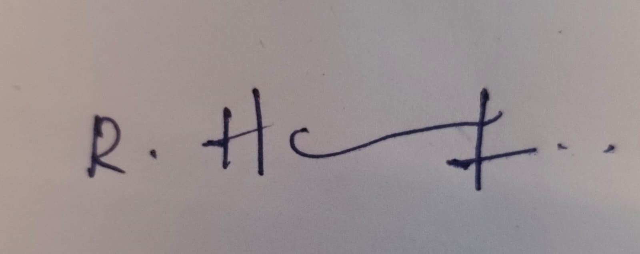

Signature of the student:

Assessment Tasks
Concept Mapping Tasks
Create concept maps for the following tasks. Each map must show key nodes, link labels, and a logical hierarchy.
- Concept Map 1: Cloud Computing Fundamentals. Include definition, characteristics, benefits, and limitations.
- Concept Map 2: Evolution of Cloud Computing. Connect hardware evolution, internet software evolution, distributed systems, and service delivery.
- Concept Map 3: Service Models. Map IaaS, PaaS, SaaS, and XaaS with provider responsibilities and user responsibilities.
- Concept Map 4: Virtualization and Web Services as Enablers of Cloud. Show how these two concepts support cloud deployment and scalability.
Expected concept nodes:
- Elasticity, scalability, resource pooling, on-demand access, measured service
- Virtual machine, hypervisor, abstraction, API, SOAP, REST, provider, consumer
- Infrastructure layer, platform layer, application layer, shared responsibility

Concept Mapping Rubric
Criteria | Weightage | Level 4 - Exemplary | Level 3 - Proficient | Level 2 - Developing | Level 1 - Beginning
Concept Identification | 25% | All major concepts are accurately identified | Most concepts are identified correctly | Limited concepts are identified | Essential concepts are missing
Relationship Mapping | 25% | Links between concepts are accurate and meaningful | Most links are correct | Some links are weak or unclear | Relationships are mostly incorrect
Hierarchy and Organization | 20% | Excellent structure with clear hierarchy | Mostly organized with minor issues | Basic structure with weak hierarchy | No logical organization
Technical Relevance | 20% | Map strongly reflects cloud course content | Mostly aligned to topic | Partially aligned to topic | Weak alignment to topic
Visual Clarity | 10% | Neat, readable, and easy to interpret | Generally readable | Somewhat cluttered | Poorly presented

Question 1: Cloud Computing Fundamentals
Task: Create a concept map on Cloud Computing Fundamentals. Include definition, characteristics, benefits, and limitations.
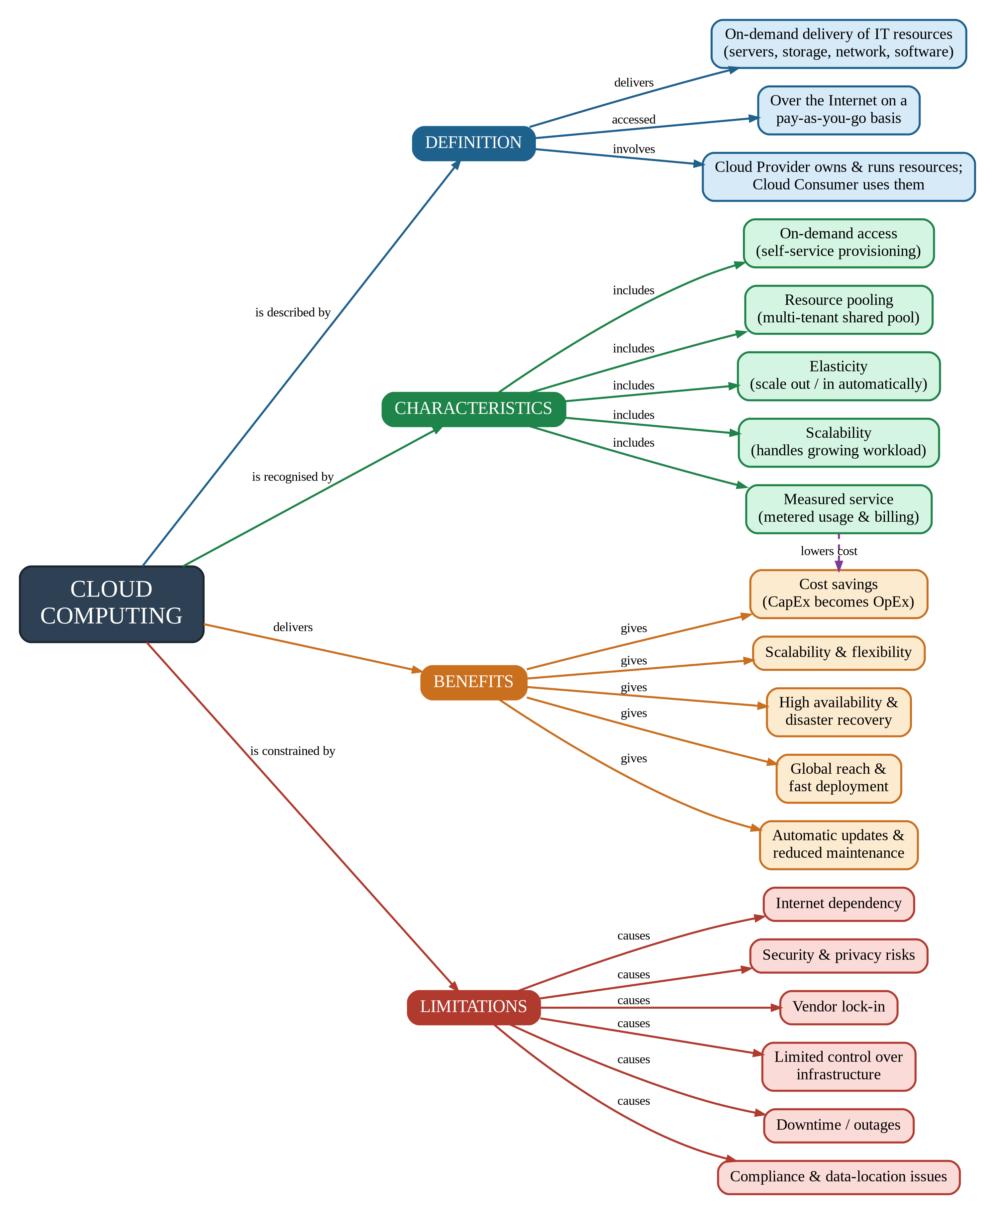

Explanation of Concept Map 1
The map places Cloud Computing at the root and divides it into four main branches that match the four required areas: definition, characteristics, benefits, and limitations. Each arrow carries a link label (for example, "is described by", "delivers", "is constrained by") so that every connection reads as a complete statement. The dashed purple arrow from Measured service to Cost savings is a cross-link: metered, pay-per-use billing is the reason cloud adoption lowers cost.

1. Definition
Cloud computing is the on-demand delivery of IT resources such as servers, storage, networks, databases and software over the Internet, usually on a pay-as-you-go basis. Two parties are involved: the Cloud Provider, who owns and operates the resources, and the Cloud Consumer, who uses them as a service instead of buying and maintaining hardware.

2. Characteristics
Characteristic | Meaning
On-demand access | Users provision computing resources themselves, whenever needed, without human interaction with the provider.
Resource pooling | The provider's resources are pooled and shared by many consumers (multi-tenancy) and assigned dynamically.
Elasticity | Resources are automatically increased or released as the workload rises or falls.
Scalability | The system can grow (scale up or scale out) to handle increasing workload without redesign.
Measured service | Usage is monitored and metered, so consumers are billed only for what they use.

3. Benefits
- Cost savings: capital expenditure on hardware becomes operational expenditure (pay for use).
- Scalability and flexibility: capacity can be adjusted quickly to match demand.
- High availability and disaster recovery: data and services are replicated across multiple locations.
- Global reach and fast deployment: applications can be launched in minutes in many regions.
- Automatic updates: the provider handles patching and maintenance.

4. Limitations
- Internet dependency: services are unavailable without reliable connectivity.
- Security and privacy risks: data is stored and processed on shared, third-party infrastructure.
- Vendor lock-in: moving to another provider can be difficult and costly.
- Limited control: users cannot customise the underlying hardware and platform.
- Downtime and outages: provider failures affect all dependent customers.
- Compliance and data location: legal rules may restrict where data can be stored.

Question 2: Evolution of Cloud Computing
Task: Create a concept map on the Evolution of Cloud Computing. Connect hardware evolution, internet software evolution, distributed systems, and service delivery.
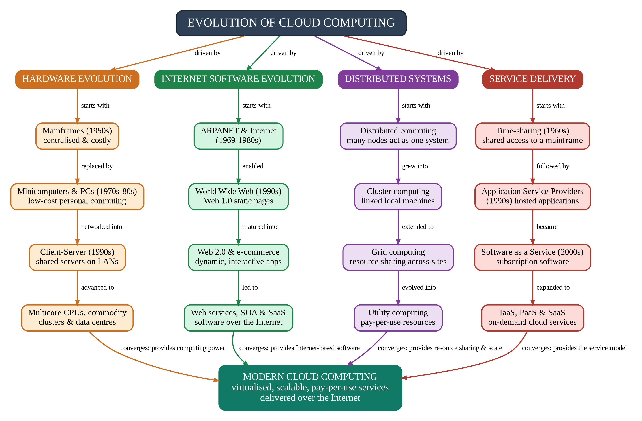

Explanation of Concept Map 2
Cloud computing did not appear suddenly; it is the result of four parallel developments that converged. The map shows each strand as a top-to-bottom chain in chronological order, with link labels such as "replaced by" and "evolved into", and all four chains merge into Modern Cloud Computing at the bottom.
Strand | Progression | Contribution to the cloud
Hardware evolution | Mainframes, then minicomputers and PCs, then client-server systems, then multicore CPUs and commodity clusters in data centres. | Cheap, powerful, standardised hardware made it economical to build huge data centres and virtualise them.
Internet software evolution | ARPANET and the Internet, then the World Wide Web (Web 1.0), then Web 2.0 and e-commerce, then web services, SOA and SaaS. | Ubiquitous Internet access and web standards allow software and services to be delivered remotely through a browser or API.
Distributed systems | Distributed computing, then cluster computing, then grid computing, then utility computing. | Showed how many networked machines can work as one system, share resources and be billed like a utility.
Service delivery | Time-sharing, then Application Service Providers, then SaaS, then IaaS, PaaS and SaaS. | Established the business model of renting computing as a service instead of owning it.

Hierarchy and links: the root node branches into four strands (driven by), each strand is a chain of dated stages, and the four final stages converge into Modern Cloud Computing. The result is virtualised, scalable, pay-per-use services delivered over the Internet.

Question 3: Service Models
Task: Create a concept map on Service Models. Map IaaS, PaaS, SaaS, and XaaS with provider responsibilities and user responsibilities.
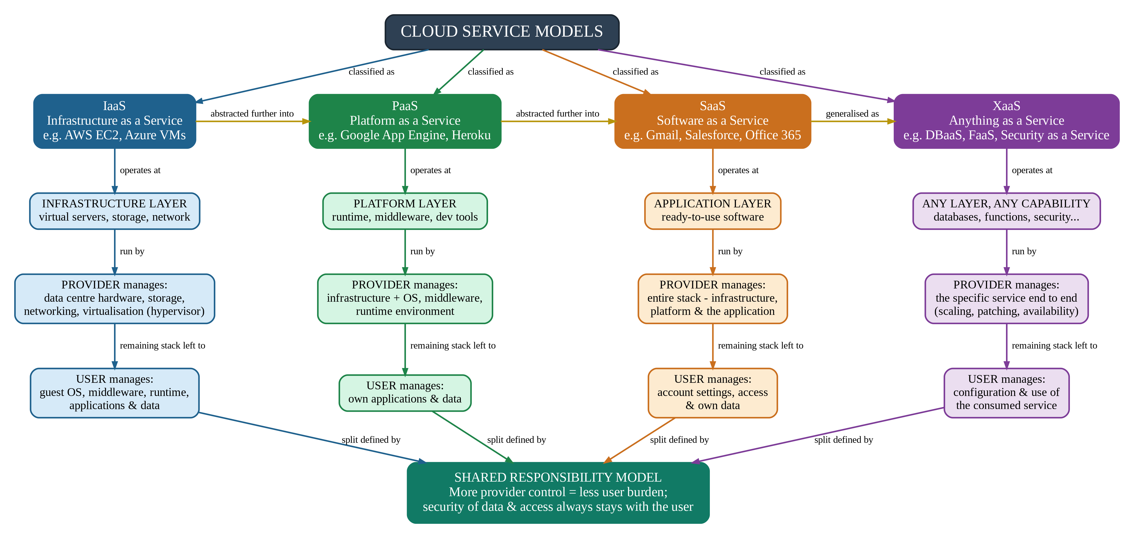

Explanation of Concept Map 3
The root node, Cloud Service Models, is classified into four models. For each model the map follows the same chain: the model operates at a layer (infrastructure, platform or application), that layer is run by the provider, and the remaining part of the stack is left to the user. All four chains end at the Shared Responsibility Model. The gold arrows between the models show that each model abstracts more of the stack than the one before it.
Model | Layer | Provider responsibility | User responsibility | Examples
IaaS | Infrastructure layer | Data centre hardware, storage, networking and virtualisation (hypervisor). | Guest operating system, middleware, runtime, applications and data. | AWS EC2, Azure Virtual Machines, Google Compute Engine
PaaS | Platform layer | Everything in IaaS plus operating system, middleware and runtime environment. | Own application code and data. | Google App Engine, Azure App Service, Heroku
SaaS | Application layer | The entire stack, including the application itself. | Account settings, access control and own data. | Gmail, Salesforce, Microsoft 365
XaaS | Any layer | The chosen service delivered end to end (scaling, patching, availability). | Configuring and using the consumed service. | DBaaS, FaaS (AWS Lambda), Security as a Service

Shared responsibility
Moving from IaaS to PaaS to SaaS, the provider takes over more layers and the user manages fewer. XaaS generalises the idea to any capability delivered as a service. Whatever the model, the user remains responsible for their own data, identities and access, which is why the final node states that security of data and access always stays with the user.

Question 4: Virtualization and Web Services as Enablers of Cloud
Task: Create a concept map on Virtualization and Web Services as enablers of cloud. Show how these two concepts support cloud deployment and scalability.
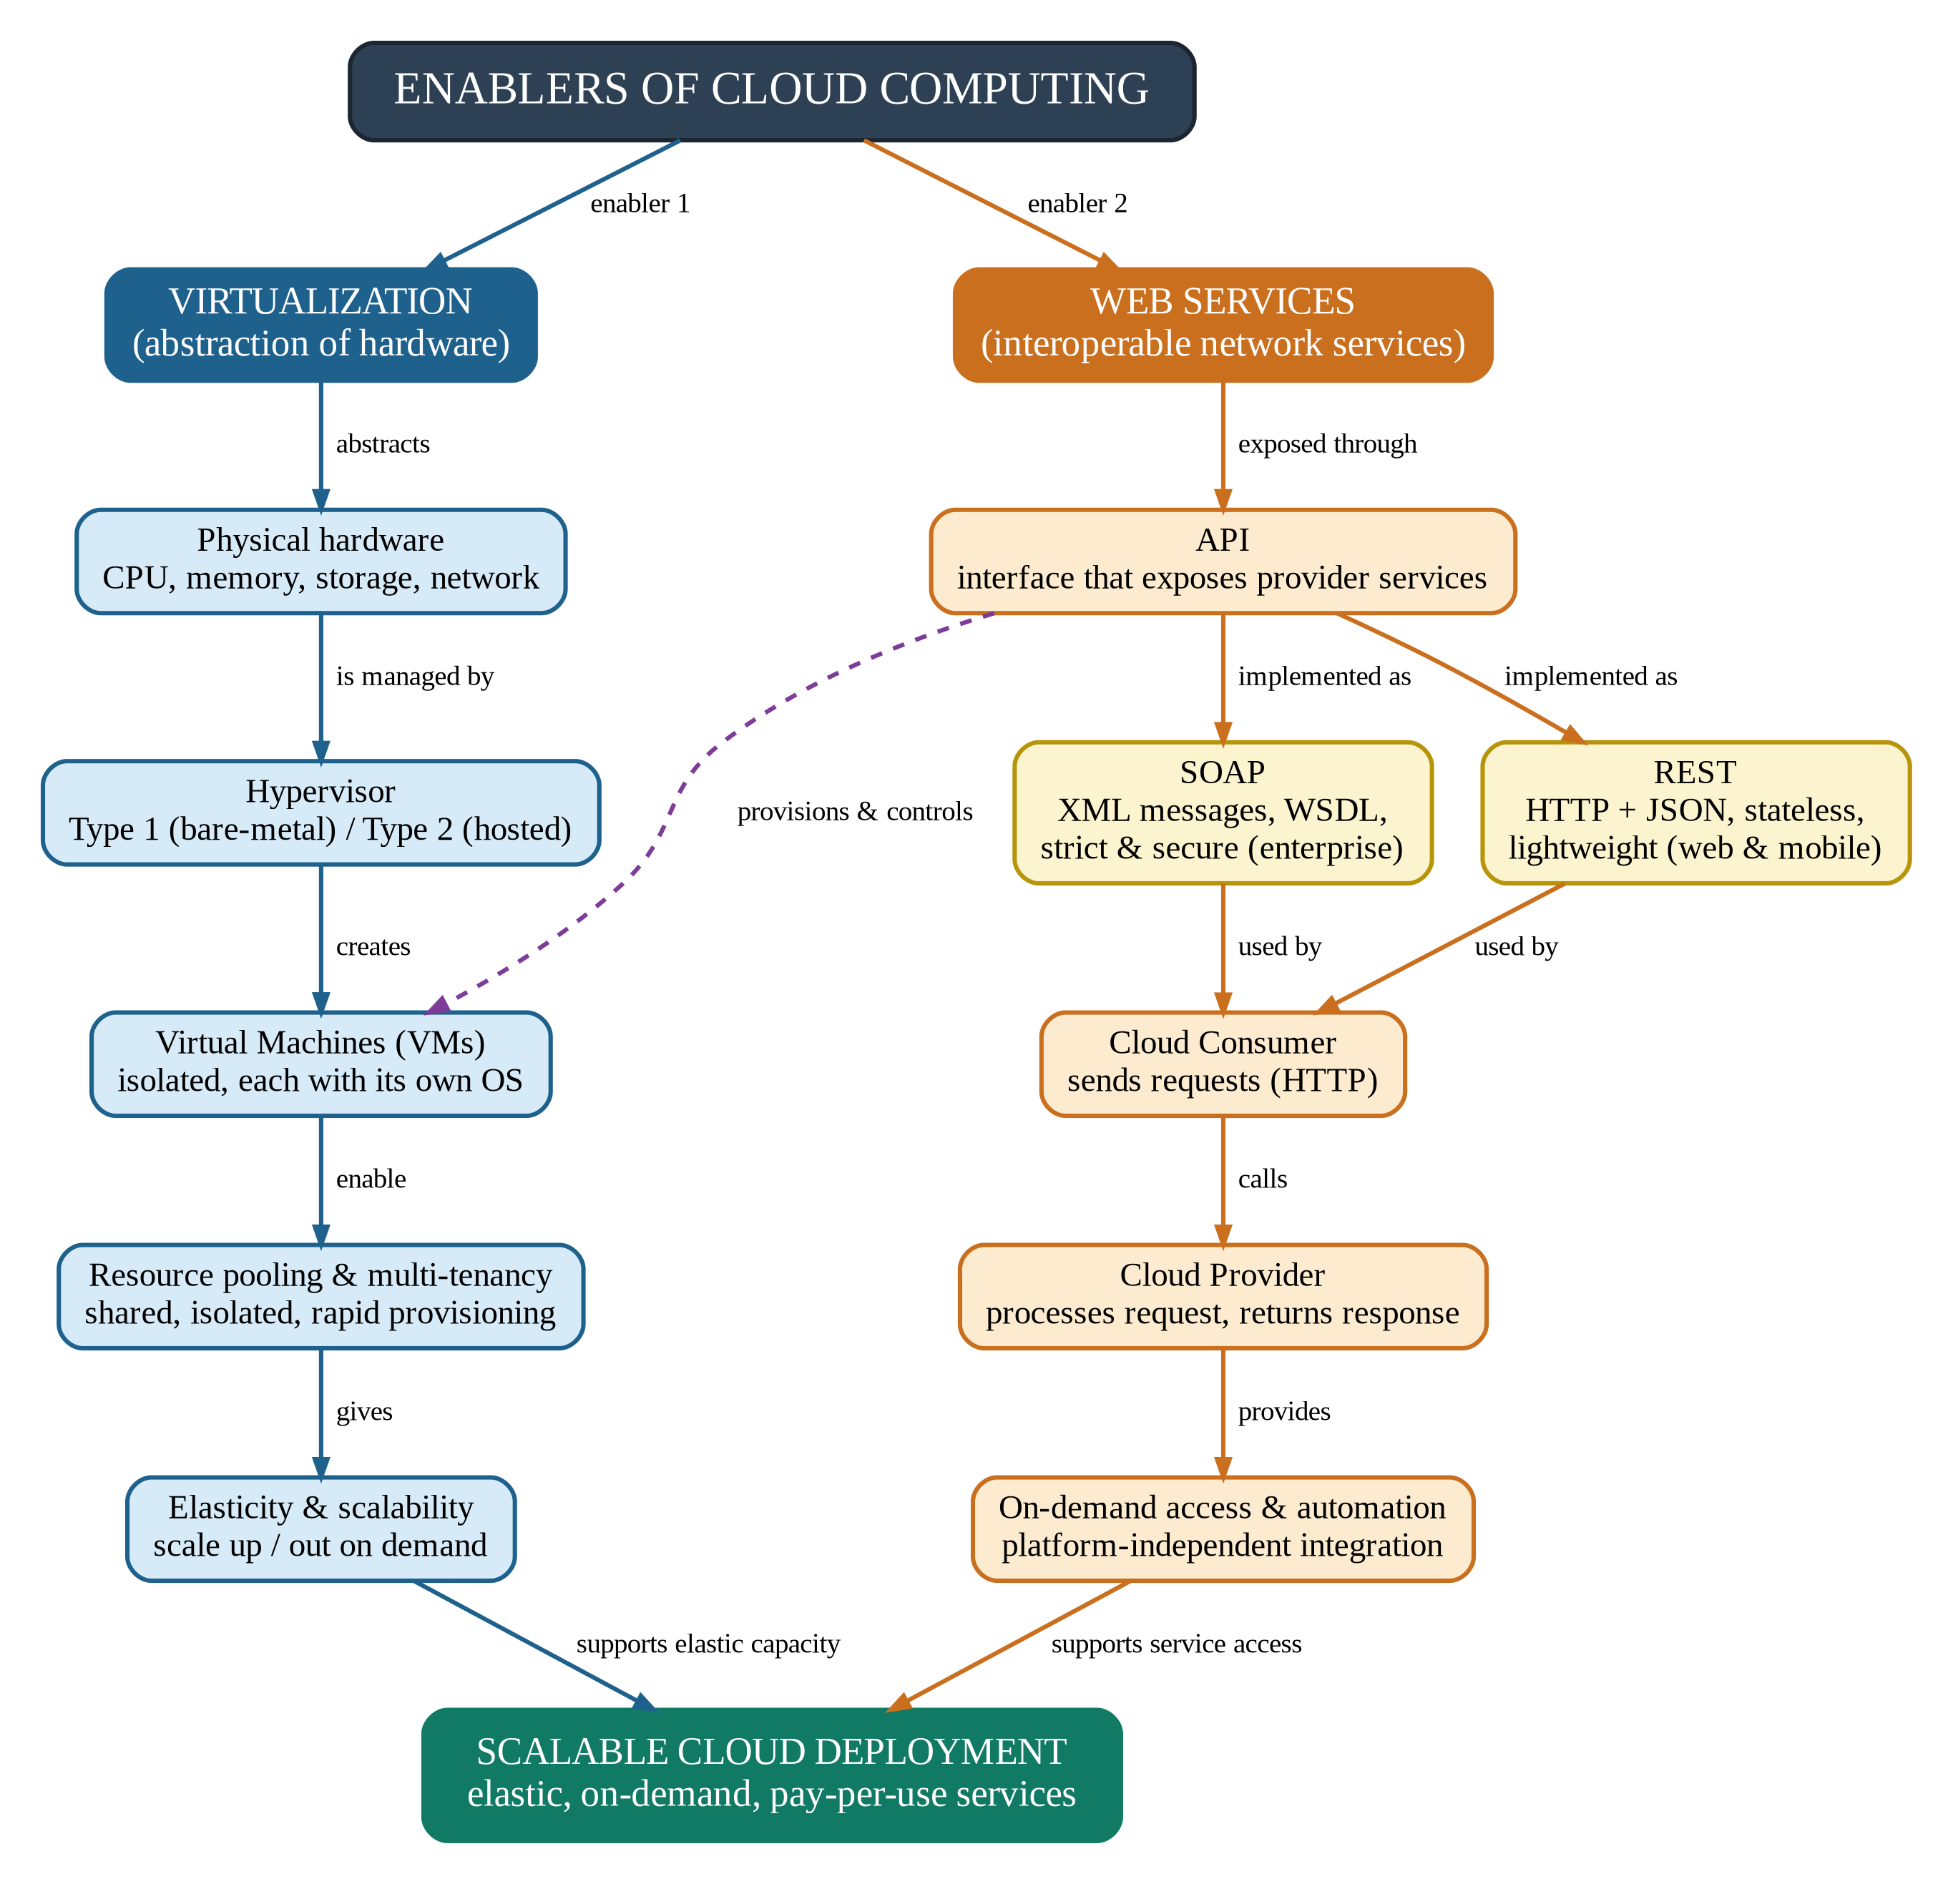

Explanation of Concept Map 4
The root node splits into two enablers. The left (blue) branch shows how virtualization creates flexible, shareable resources; the right (orange) branch shows how web services let consumers reach those resources over the network. Both branches meet at Scalable Cloud Deployment.

1. Virtualization (left branch)
- Abstraction: virtualization hides the physical hardware (CPU, memory, storage, network) behind logical resources.
- Hypervisor: software that manages the hardware and creates virtual machines. Type 1 runs directly on the hardware (bare-metal); Type 2 runs on top of a host operating system.
- Virtual machines: isolated computers, each with its own operating system, running on the same physical server.
- Resource pooling and multi-tenancy: many consumers safely share one pool of resources, and new VMs can be provisioned within minutes.
- Elasticity and scalability: VMs can be added, removed or resized on demand, so capacity follows the workload.

2. Web Services (right branch)
- API: the interface through which the provider exposes its services, so consumers can request and control resources programmatically.
- SOAP: an XML-based protocol with WSDL descriptions and strict standards; suited to secure enterprise integration.
- REST: an architectural style using HTTP and usually JSON; lightweight, stateless and widely used for web and mobile applications.
- Consumer and provider: the Cloud Consumer sends a request through the API and the Cloud Provider processes it and returns a response.
- On-demand access and automation: standard, platform-independent calls allow self-service access and automated management of cloud resources.

3. How they work together
The dashed purple arrow from API to Virtual Machines shows the connection between the two enablers: when a consumer calls the provider's API, the provider uses virtualization to create, resize or release virtual machines. Virtualization therefore supplies the elastic, shared capacity (scalability), while web services supply the standard access method (on-demand deployment). Together they make pay-per-use, scalable cloud deployment possible.
Aspect | SOAP | REST
Data format | XML only | JSON, XML or others
Transport | HTTP, SMTP and others | HTTP
Style | Strict protocol with WSDL contract | Lightweight architectural style
Typical use | Enterprise, high-security integration | Web and mobile cloud applications

