SIMATS ENGINEERING

ASSESSMENT TOOL 1

COURSE NAME: Cryptography and Network Security COURSE CODE: CSA5117

COURSE OUTCOME COVERED

CO1: Apply classical encryption techniques using symmetric and asymmetric ciphers to encrypt and decrypt data for the ensuring data security. (BL3, BL4)

Assessment Tool Weightage: 40%

QUESTIONS: 5 Total Marks:50

Annexure A

APPLICATION- BASED QUESTIONS

Code of Conduct:

I HEMANTH R 192521327 (Name / Reg No) certify that this submission is my original work and that I have adhered to the guidelines specified for this assessment.
I understand that any violation of academic integrity rules will result in disciplinary action.

Signature of the student:
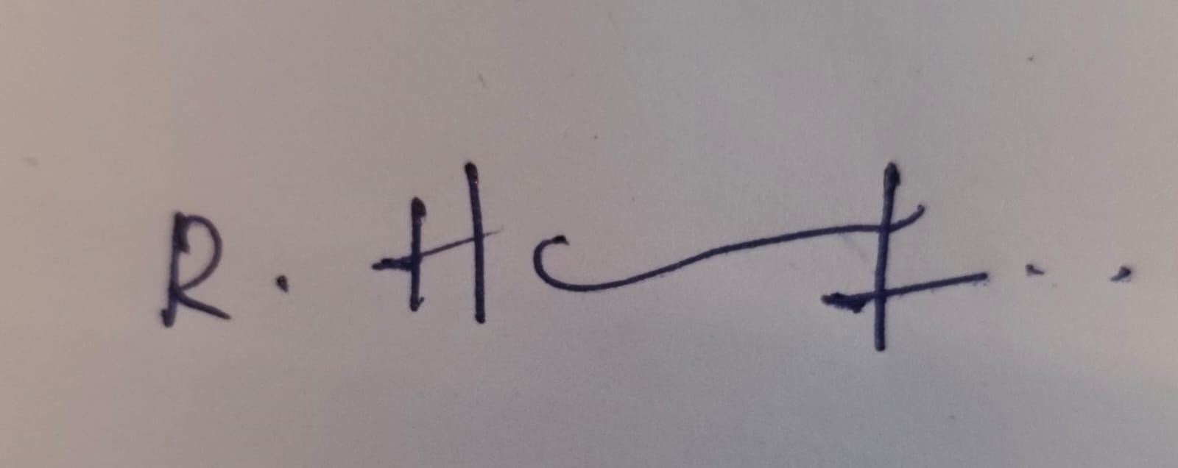

Annexure A

APPLICATION- BASED QUESTIONS

- Scenario: Event Communication Security
A student organization is preparing to share confidential event details with its core members using a simple classical encryption method. During testing, a message “MEET AT NOON” is transformed into an encoded version using a fixed shift pattern.
  - Reconstruct how the encrypted message might appear if a shift of 4 positions is applied.
  - Explain how an authorized member, aware of the encoding rule, would retrieve the original message.

- Scenario: Intercepted Suspicious Message
A cybersecurity intern intercepts the coded message: “GSRH RH Z HVXIVG” during network monitoring. The structure of the text suggests a simple substitution mechanism rather than complex encryption.
  - Deduce the most likely original message.
  - Justify your answer by analyzing repeating patterns, letter structures, or known cipher characteristics.

- Scenario: Secure Messaging System
A company deploys a keyword-based encryption technique for internal communication. An employee sends the word “HELLO” using the keyword “KEY” to ensure confidentiality.
  - Demonstrate how the encryption process transforms the message step-by-step.
  - Explain how the repeating keyword influences each character of the ciphertext.

- Scenario: Suspicious Digital Asset Investigation
During a digital forensic audit, investigators suspect that a company logo file may contain hidden confidential information embedded within it. The file appears normal upon casual inspection.
  - Analyze how investigators could detect the presence of hidden data within the image.
  - Recommend two techniques that could strengthen the security of such hidden communications against detection or extraction.

- Scenario: Legacy Encryption in Corporate Communication
A legacy system in a company still uses a transposition-based encryption method with three levels of arrangement. A received message appears as: “WECRLTEERDSOEEFEAOCAIVDEN”.
  - Determine the most probable original message by reversing the encryption process.
  - Critically evaluate why such a method is vulnerable in modern communication systems.
  - Propose one practical enhancement to improve the confidentiality of messages in this scenario.

RUBRICS FOR CALCULATION:

Criteria | Weightage | Level 4 –  Exemplary | Level 3 –  Proficient | Level 2 –  Developing | Level 1 –  Beginning
Understanding of Concepts | 25 | Demonstrates thorough understanding and effectively integrates multiple concepts/technologies | Good understanding with proper integration of most  concepts | Basic understanding; limited or partial integration | Poor understanding; unable to integrate concepts
Experiment al Design | 30 | Well-planned, systematic implementation with optimal  solution | Correct implementation with minor issues | Basic implementation with errors or  inefficiencies | Incorrect or incomplete implementation
Use of Tools | 20 | Effective and advanced use of tools/technologies with proper  configuration | Appropriate use of tools with correct execution | Limited or inconsistent use of tools | Incorrect or minimal use of tools
Analysis of Results | 15 | Insightful analysis with accurate interpretation and validation of results | Good analysis with reasonable interpretation | Basic analysis with limited insights | Poor or incorrect analysis of results
Documentation | 10 | Clear, well-structured documentation with diagrams,  code, and results | Organized documentation with necessary  details | Basic documentation with missing  details | Poor or incomplete documentation

Question 2: Intercepted Suspicious Message
Intercepted ciphertext: “GSRH RH Z HVXIVG”
(a) Most Likely Original Message
Plaintext: “THIS IS A SECRET”
The message is encrypted with the Atbash cipher, a simple monoalphabetic substitution cipher in which the alphabet is reversed (A ↔ Z, B ↔ Y, C ↔ X, and so on). Each ciphertext letter is replaced by its mirror letter. The substitution rule is:
Plain: A B C D E F G H I J K L M N O P Q R S T U V W X Y Z
Cipher: Z Y X W V U T S R Q P O N M L K J I H G F E D C B A
The formula used is: P = 27 − C (positions A = 1 … Z = 26), i.e. the plaintext position equals 27 minus the ciphertext position.
Cipher word | Letter-by-letter decoding | Plain word
GSRH | G→T, S→H, R→I, H→S | THIS
RH | R→I, H→S | IS
Z | Z→A | A
HVXIVG | H→S, V→E, X→C, I→R, V→E, G→T | SECRET

(b) Justification by Pattern and Structure Analysis
1. Single-letter word: The ciphertext contains one isolated letter, “Z”. In English, the only single-letter words are “A” and “I”. Since “Z” is the first letter of the reversed alphabet, mapping Z → A is the most natural guess, and it immediately suggests the Atbash (reversed alphabet) rule.
2. Repeated word: The two-letter group “RH” appears on its own and also as the ending of “GSRH”. This matches the English pattern “IS” and “THIS”, where “IS” is both a word and the ending of “THIS”. Hence R → I and H → S, which fits the Atbash mapping exactly.
3. Letter-repetition pattern: The word “HVXIVG” has the letter V repeated in positions 2 and 5. The pattern _E__E_ fits “SECRET” (E in positions 2 and 5). Also, V is the mirror of E, the most frequent letter in English, which agrees with frequency analysis.
4. Word-length and sentence structure: The word lengths 4-2-1-6 follow the structure of an ordinary English sentence (demonstrative + verb + article + noun). Spaces are preserved, which is a typical sign of a simple substitution cipher and not a block cipher.
5. Consistency check: Every letter pair obeys the same fixed rule (the sum of the positions of plaintext and ciphertext letters is always 27, e.g. G(7) + T(20) = 27; S(19) + H(8) = 27). A single consistent reversal confirms the Atbash cipher and rules out a Caesar shift (where the shift would be constant, not reversed).
6. Weakness observed: Because there is no key, Atbash provides no real security; anyone who recognises it can decode the message instantly.
Conclusion: The intercepted message “GSRH RH Z HVXIVG” decodes to “THIS IS A

SECRET”.
Question 3: Secure Messaging System
Plaintext: HELLO Keyword: KEY Technique: Vigenère cipher (polyalphabetic, keyword-based)
(a) Step-by-Step Encryption Process
Encryption formula: Ci = (Pi + Ki) mod 26, with A = 0, B = 1, … Z = 25.
Step 1 – Convert letters to numbers.
H = 7, E = 4, L = 11, L = 11, O = 14. K = 10, E = 4, Y = 24.
Step 2 – Repeat the keyword to match the message length (5 letters).
Message | H | E | L | L | O
Key | K | E | Y | K | E

Step 3 – Add the numbers and take the result modulo 26.
No. | Plain letter (Pi) | Key letter (Ki) | Pi + Ki | mod 26 | Cipher letter
1 | H = 7 | K = 10 | 7 + 10 = 17 | 17 | R
2 | E = 4 | E = 4 | 4 + 4 = 8 | 8 | I
3 | L = 11 | Y = 24 | 11 + 24 = 35 | 35 − 26 = 9 | J
4 | L = 11 | K = 10 | 11 + 10 = 21 | 21 | V
5 | O = 14 | E = 4 | 14 + 4 = 18 | 18 | S

Step 4 – Write the ciphertext.
Ciphertext: “RIJVS”
Verification (decryption): Pi = (Ci − Ki) mod 26. R(17) − K(10) = 7 = H; I(8) − E(4) = 4 = E; J(9) − Y(24) = −15 → +26 = 11 = L; V(21) − K(10) = 11 = L; S(18) − E(4) = 14 = O. This returns “HELLO”, so the result is correct.
(b) Influence of the Repeating Keyword on Each Character
1. Different shift for each letter: Each key letter decides the Caesar shift used for the matching plaintext letter. K shifts by 10, E by 4 and Y by 24. So H moves 10 places to R, E moves 4 places to I, and the third letter L moves 24 places to J.
2. Repetition of the keyword: Since the key “KEY” is only three letters long, it repeats cyclically (K-E-Y-K-E). The 4th and 5th plaintext letters therefore reuse the shifts of K and E.
3. Same plaintext letter, different ciphertext: The double letter “LL” in HELLO is encrypted as J and V, because the two L’s meet different key letters (Y and K). This hides the repeated-letter pattern, which a simple substitution cipher would reveal.

4. Flattened letter frequencies: As one plaintext letter can map to several ciphertext letters, and one ciphertext letter can come from several plaintext letters, simple frequency analysis becomes much harder than with a Caesar or Atbash cipher.
5. Security depends on the key: The key length defines the period of the cipher. A short key such as “KEY” can be broken by Kasiski examination or the index of coincidence. A longer, random and non-repeating key greatly improves confidentiality.
Conclusion: “HELLO” encrypted with the keyword “KEY” using the Vigenère cipher gives the ciphertext “RIJVS”.

