SIMATS ENGINEERING
ASSESSMENT TOOL 2

COURSE NAME: OBJECT ORIENTED ANALYSIS AND DESIGN
COURSE CODE:CSA1105

COURSE OUTCOME COVERED

CO2: Design UML diagrams to represent system requirements and architecture. (BL3)

Assessment Tool Weightage: 30%

QUESTIONS: 6 Total Marks:60

Annexure A

Application Based Questions

Code of Conduct:

I __HEMANTH R 192521327__________________ (Name / Reg No) certify that this submission is my original work and that I have adhered to the guidelines specified for this assessment.
I understand that any violation of academic integrity rules will result in disciplinary action.

Signature of the student:

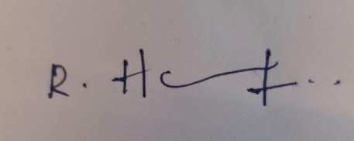

Annexure A

Application Based Questions

1. Use Case Diagram Analysis
A Smart Pharmacy Management System allows customers to search medicines, upload prescriptions, place medicine orders, and make online payments. Pharmacists verify prescriptions and dispense medicines, while administrators manage inventory and user accounts. The current system design does not clearly define actor responsibilities and interactions.
Analyze the system requirements, identify all actors and missing use cases, and design an optimized Use Case Diagram showing appropriate relationships (include, extend, and generalization) to improve system functionality.
(10 Marks)

2. Class Diagram Design
A Smart Library Management System consists of entities such as Book, Member, Librarian, Reservation, Fine, and BorrowRecord. The existing system does not clearly specify class attributes, operations, or relationships among these entities.
Analyze the system, identify relevant classes with appropriate attributes and methods, define relationships (association, aggregation, composition, and inheritance), specify multiplicity, and construct a well-structured Class Diagram.
(10 Marks)

3. Sequence Diagram Evaluation
An Online Examination System enables students to log in, select an examination, answer questions, submit responses, and receive results. The communication among the student, examination module, evaluation module, and database is incomplete.
Analyze the interaction process, identify all participating objects and missing message exchanges, and design a detailed Sequence Diagram representing the complete interaction flow with activation bars and lifelines.
(10 Marks)

4. Activity Diagram Construction
A Loan Approval System allows customers to submit loan applications, upload supporting documents, complete eligibility verification, receive loan approval or rejection, and complete loan disbursement. The workflow lacks proper decision points and parallel activities.
Analyze the business process, identify all workflow activities, include decision nodes for approval and rejection, represent parallel processing where applicable, and construct an optimized Activity Diagram.
(10 Marks)

5. Component Diagram Design
A Smart E-Commerce Platform consists of modules such as User Management, Product Catalog, Shopping Cart, Order Management, Payment Gateway, Inventory Management, and Notification Service. The existing architecture does not clearly define interfaces and dependencies among modules.
Analyze the software architecture, identify major components and their provided/required interfaces, define dependencies among components, and design a comprehensive Component Diagram representing the overall system architecture.
(10 Marks)

6. Deployment Diagram Design
A Smart Agriculture Monitoring System uses IoT soil sensors, weather stations, irrigation controllers, cloud servers, mobile applications, and farmer dashboards to monitor crop health and automate irrigation. The deployment architecture lacks proper representation of hardware nodes and communication links.
Analyze the deployment environment, identify hardware nodes and deployed software artifacts, specify communication protocols between nodes, and construct a detailed Deployment Diagram representing the complete physical system architecture.
(10 Marks)

RUBRICS FOR CALCULATION

Application Based Questions

Criteria | Weightage | Level 4 – Exemplary (5 Marks) | Level 3 – Proficient (4 Marks) | Level 2 – Developing (2–3 Marks) | Level 1 – Beginning (0–1 Mark)
Understanding of Problem Context | 20 | Clearly understands the problem and accurately identifies all requirements | Good understanding with minor gaps | Basic understanding; some requirements unclear | Poor understanding or misinterpretation of the problem
Application of Concepts | 30 | Accurately applies appropriate concepts to solve complex problems | Applies relevant concepts correctly with minor errors | Applies basic concepts with limited accuracy | Fails to apply appropriate concepts
Problem-Solving Approach | 20 | Logical, well-structured, and efficient approach | Mostly logical approach with minor gaps | Basic approach with some inconsistencies | Illogical or unclear approach
Accuracy of Solution | 20 | Completely correct solution with proper justification | Mostly correct with minor errors | Partially correct solution | Incorrect or incomplete solution
Clarity | 10 | Clear, well-organized, and properly explained solution | Understandable with minor clarity issues | Limited clarity and explanation | Poorly presented and difficult to understand

1. Use Case Diagram Analysis (Smart Pharmacy Management System)
Analysis of the system requirements
The problem statement describes customers who search, upload, order and pay, pharmacists who verify and dispense, and administrators who manage inventory and accounts. The existing design does not separate these responsibilities and omits supporting functions such as login, stock checking, refunds and notifications. The actors and their responsibilities are identified below.
Actor | Type | Responsibilities
Customer | Primary | Registers, searches medicines, uploads prescriptions, places and tracks orders, makes online payments and cancels orders.
Pharmacist | Primary | Verifies or rejects uploaded prescriptions and dispenses the ordered medicines.
Administrator | Primary | Manages medicine inventory and user accounts, and generates reports.
User (abstract) | Generalised actor | Common parent of the three primary actors, who all log in to the system.
Payment Gateway | External, secondary | Authorises payments and refunds.
Notification Service | External, secondary | Sends SMS or e-mail alerts about order and prescription status.

Missing use cases identified
Login / Authenticate, Register Account, View Medicine Details, Check Stock Availability, Apply Coupon / Discount, Track Order, Cancel Order, Process Refund, Reject Prescription, Update Inventory, Raise Low-Stock Alert, Generate Reports and Send Notification were not defined in the existing design and are added.
Optimised Use Case Diagram
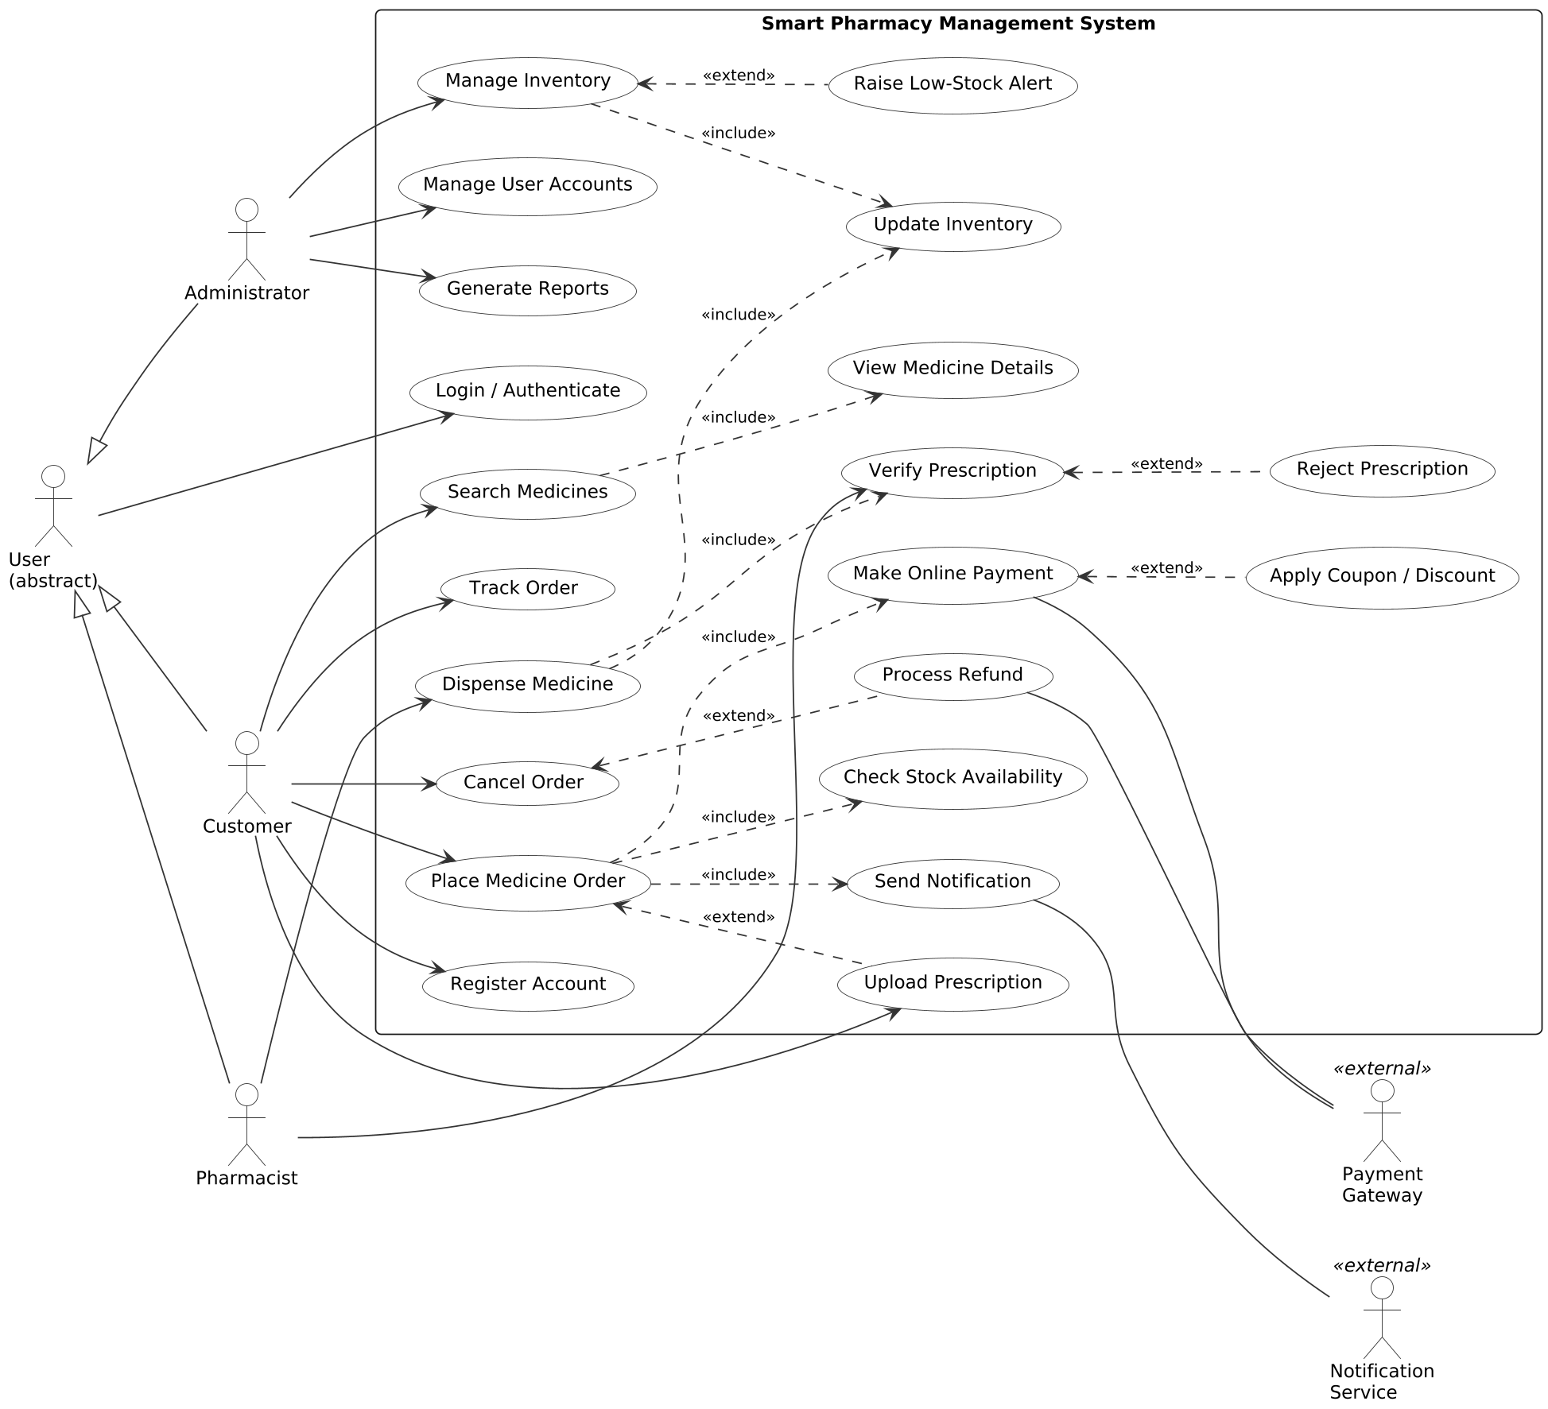
Figure 1: Use Case Diagram of the Smart Pharmacy Management System
Relationships and justification
- Generalization: Customer, Pharmacist and Administrator inherit from the abstract actor User, so Login / Authenticate is shown once instead of three times.
- Include (mandatory sub-behaviour): Place Medicine Order includes Check Stock Availability, Make Online Payment and Send Notification. Search Medicines includes View Medicine Details. Dispense Medicine includes Verify Prescription and Update Inventory. Manage Inventory includes Update Inventory.
- Extend (optional or conditional behaviour): Upload Prescription extends Place Medicine Order, because it is needed only for prescription-only medicines. Apply Coupon extends Make Online Payment, Process Refund extends Cancel Order, Reject Prescription extends Verify Prescription, and Raise Low-Stock Alert extends Manage Inventory when stock falls below the threshold.
- External actors: The Payment Gateway and Notification Service are shown outside the system boundary, which makes the interfaces with third-party systems explicit.
The optimised diagram gives every actor a clear set of responsibilities, removes duplicated functions through generalization and include relationships, and covers the full order-to-dispense lifecycle.
2. Class Diagram Design (Smart Library Management System)
Analysis of the system
The entities Book, Member, Librarian, Reservation, Fine and BorrowRecord are given. Member and Librarian share personal details, so an abstract class Person is introduced as their parent. A Library class is added to hold the collections of books and members, which allows aggregation to be shown. The classes, attributes and operations are summarised below and shown in the diagram.
Class | Key attributes | Key operations
Person (abstract) | personId, name, email, phone | login(), updateProfile()
Member | membershipType, joinDate, status | searchBook(), borrowBook(), returnBook(), reserveBook(), payFine()
Librarian | employeeId, shift | issueBook(), receiveReturn(), addBook(), removeBook(), collectFine()
Book | bookId, isbn, title, author, category, availableCopies | checkAvailability(), updateStatus()
BorrowRecord | recordId, issueDate, dueDate, returnDate | calculateDueDate(), markReturned(), isOverdue()
Reservation | reservationId, reservationDate, expiryDate, status | confirm(), cancel(), notifyMember()
Fine | fineId, amount, paidStatus | calculateFine(), markPaid()
Library | name, address | addBook(), registerMember()

Class Diagram
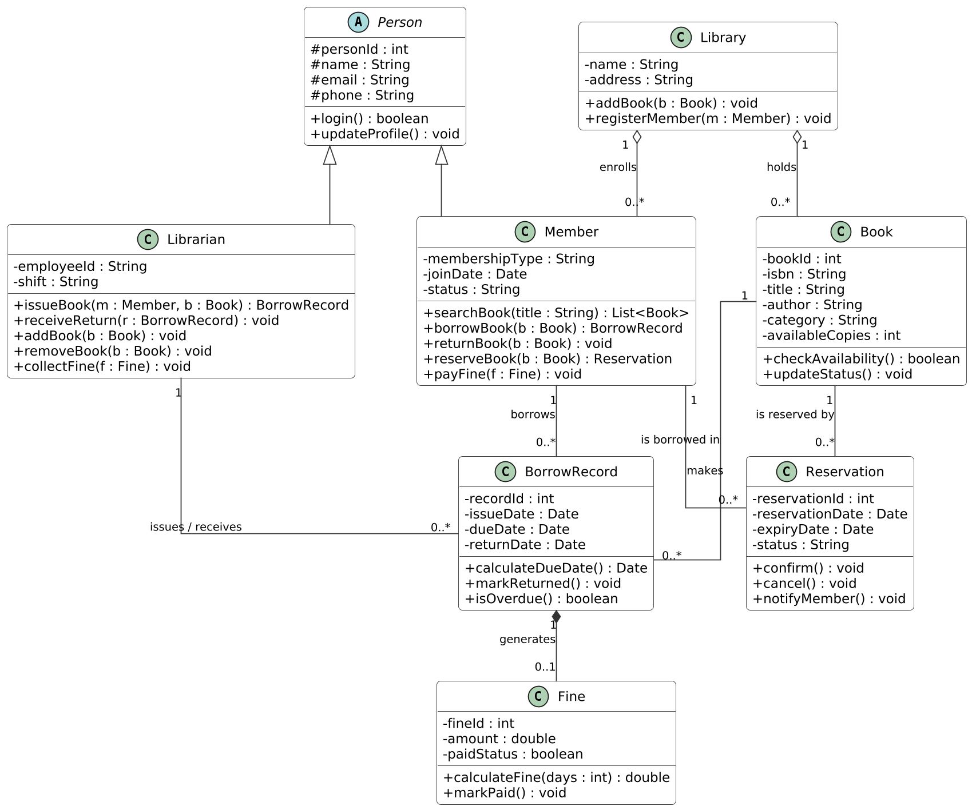
Figure 2: Class Diagram of the Smart Library Management System
Relationships and multiplicity
Relationship | Type | Multiplicity | Reason
Person - Member / Librarian | Inheritance | - | Both are kinds of Person and reuse its attributes.
Library - Book | Aggregation | 1 to 0..* | A library holds books, but books can exist without the library object.
Library - Member | Aggregation | 1 to 0..* | A library enrols members.
Member - BorrowRecord | Association | 1 to 0..* | A member can have many borrow records; each record belongs to one member.
Book - BorrowRecord | Association | 1 to 0..* | A book can be borrowed many times over its life.
Librarian - BorrowRecord | Association | 1 to 0..* | A librarian issues and receives many books.
BorrowRecord - Fine | Composition | 1 to 0..1 | A fine exists only because of an overdue record and is deleted with it.
Member - Reservation | Association | 1 to 0..* | A member can make many reservations.
Book - Reservation | Association | 1 to 0..* | A book can have many pending reservations.

The design follows encapsulation (private attributes, public operations), reuses common data through inheritance, and uses composition only where the part cannot live without the whole (Fine in BorrowRecord). The multiplicities capture the real business rules of the library.
3. Sequence Diagram Evaluation (Online Examination System)
Analysis of the interaction process
The participating objects are the Student (actor), the Examination Module, the Evaluation Module and the Database. The incomplete design lacks credential validation, eligibility checks, saving of each answer, and the interaction between the evaluation module and the database. These missing message exchanges are identified below.
Missing interaction | Added messages
Authentication | login(), validateCredentials(), loginSuccess / loginFailed
Exam selection and eligibility | selectExam(), getExamDetails(), displayInstructions / examNotAvailable
Answer storage | submitAnswer(), saveAnswer(), saved, nextQuestion (repeated in a loop)
Submission | submitExam(), markExamSubmitted(), confirmation
Evaluation | evaluateExam(), fetchAnswers(), fetchAnswerKey(), calculateScore(), storeResult()
Result display | result(score, grade), displayResult()

Sequence Diagram
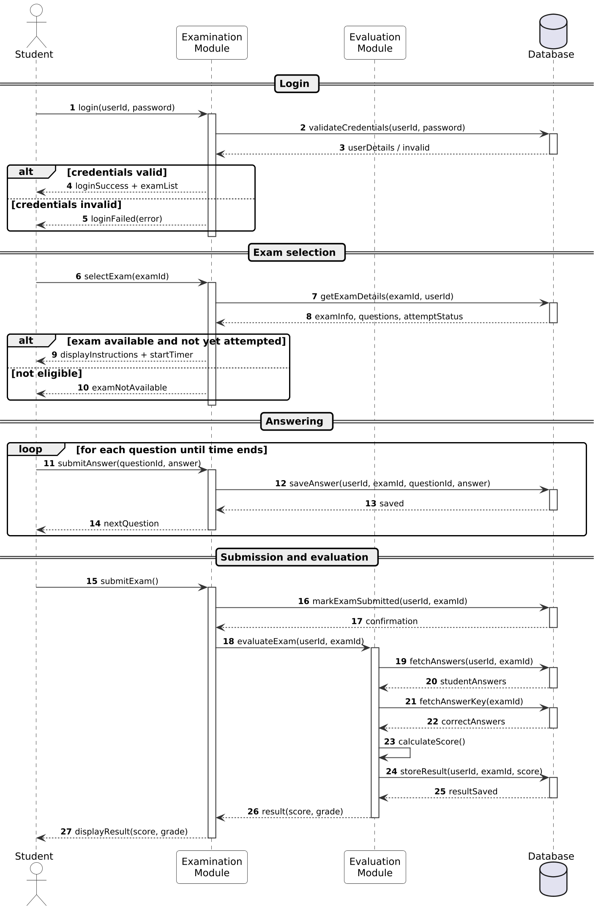
Figure 3: Sequence Diagram of the Online Examination System
Explanation
- Lifelines and activation bars: Each participant has a dashed lifeline. The narrow rectangles are activation bars that show when an object is processing a request, for example the Examination Module stays active from login() until the final reply.
- Combined fragments: The alt fragments model the valid / invalid login and the available / not-available exam. The loop fragment models repeated answering until all questions are done or the time ends.
- Synchronous and return messages: Solid arrows are calls and dashed arrows are replies, so the order of the whole flow can be traced from top to bottom.
- Separation of responsibility: The Examination Module controls the session, the Evaluation Module only scores, and the Database is accessed by both, which keeps the design modular.
The diagram now describes the complete flow from login to result display, with 27 numbered messages and no missing exchanges.
4. Activity Diagram Construction (Loan Approval System)
Analysis of the business process
The workflow lacks decision points and parallel activities. The process activities are identified first, followed by the decisions and the parallel (concurrent) activities.
Element | Details
Main activities | Submit application, validate data, upload documents, check completeness, eligibility verification, calculate risk score, officer review, generate sanction letter, accept offer, sign agreement, disburse loan, update account.
Decision nodes | Documents complete? (loops back to request missing documents); Eligible?; Loan approved?; Offer accepted?
Parallel activities (fork 1) | Verify identity (KYC), check credit score, and verify income and employment run at the same time and join before the risk score is calculated.
Parallel activities (fork 2) | After the agreement is signed, loan disbursement, repayment schedule creation and the confirmation notification run concurrently.
Final nodes | Funds received, application closed, or rejection notified.

Optimised Activity Diagram
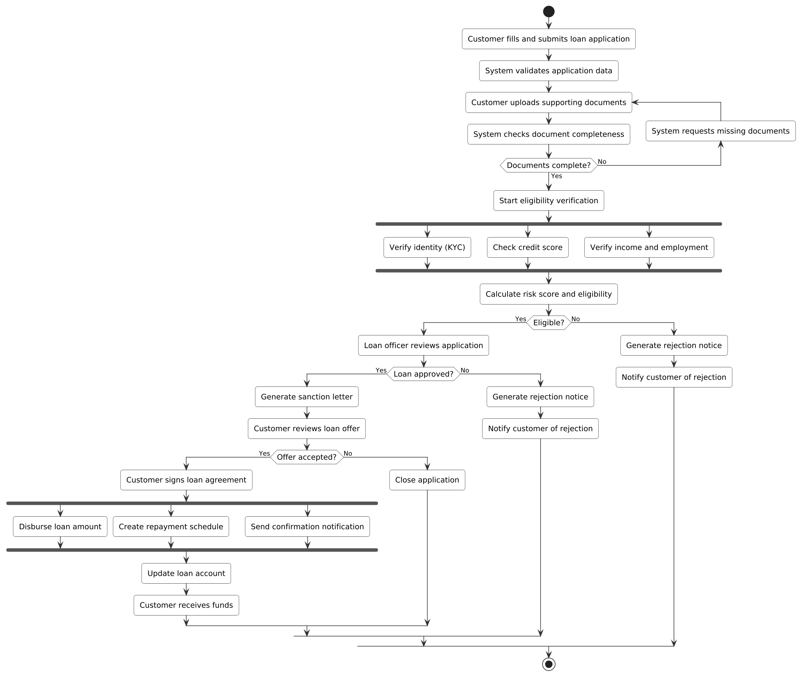
Figure 4: Activity Diagram of the Loan Approval System
Justification
- Decision nodes separate the approval path from the rejection paths and include a loop for incomplete documents, so no case ends without a defined outcome.
- Fork and join bars represent true concurrency. Running the three verification checks in parallel shortens the approval time compared with a sequential process.
- Rejection handling: Both ineligible and rejected applications produce a rejection notice with the reason and notify the customer, which is required for transparency.
The diagram has a single start node, a single stop node, and every branch converges, so the workflow is complete, correct and easy to follow.
5. Component Diagram Design (Smart E-Commerce Platform)
Analysis of the software architecture
Seven modules are given. Each is modelled as a component that provides a well-defined interface, and other components depend on it only through that interface. A web / mobile client is added as the consumer of the user-facing services, and two external providers are added for payment and messaging.
Component | Provided interface | Required interfaces (dependencies)
User Management | IUserAuth | None; used by the client for login and registration.
Product Catalog | IProductInfo | IStock (to display availability).
Shopping Cart | ICart | IProductInfo (price and details).
Order Management | IOrder | ICart, IStock, IPayment, INotify.
Inventory Management | IStock | INotify (low-stock alerts).
Payment Gateway | IPayment | INotify; external payment provider.
Notification Service | INotify | External e-mail / SMS provider.

Component Diagram
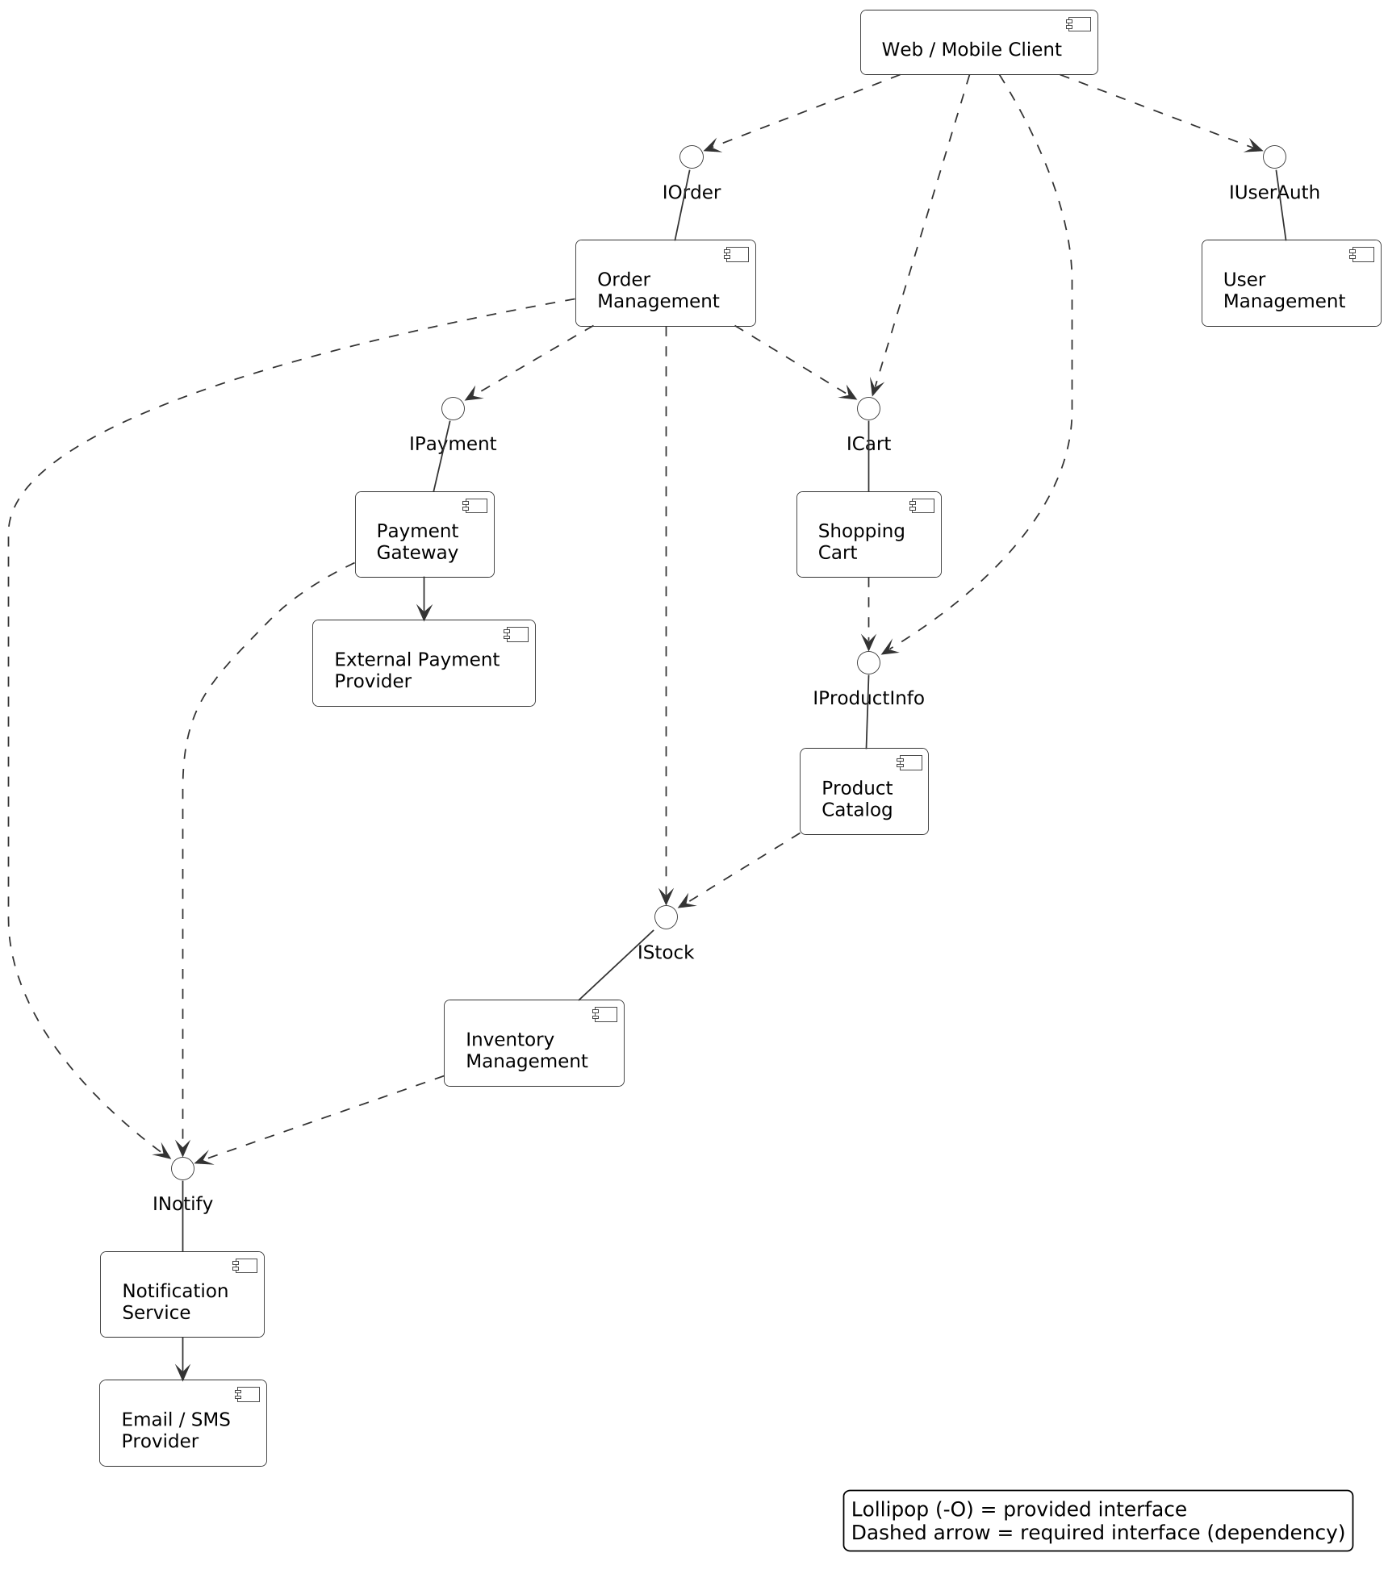
Figure 5: Component Diagram of the Smart E-Commerce Platform
Justification
- Provided interfaces (lollipop symbols) show what each component offers; the dashed arrows show which interface another component requires.
- Loose coupling: Components communicate only through interfaces such as IStock and IPayment, so an implementation (for example the payment provider) can be replaced without changing Order Management.
- Layered dependencies: Order Management is the orchestrator, depending on cart, stock, payment and notification, while lower-level components such as User Management have no dependencies, which avoids circular dependencies.
- Shared service: Notification Service is required by several components, so it is a separate reusable component
6. Deployment Diagram Design (Smart Agriculture Monitoring System)
Analysis of the deployment environment
The system has three tiers: field devices that sense and act, an edge gateway that connects them to the internet, and cloud servers with client devices that process data and present it to the farmer. The nodes, artifacts and communication links are listed below.
Node | Deployed artifacts | Role
Soil Sensor Node (ESP32) | soil-sensor-firmware | Measures soil moisture and temperature.
Weather Station | weather-firmware | Measures rainfall, humidity, wind and temperature.
IoT Gateway (Raspberry Pi) | gateway-agent, local-cache | Collects sensor data, buffers it during outages and forwards it to the cloud.
Irrigation Controller (PLC) | irrigation-control-firmware | Opens and closes valves and runs pumps on command.
MQTT Broker (cloud) | mqtt-broker | Receives sensor messages and routes commands.
Application Server (cloud) | rest-api-service, decision-engine, alert-service | Runs the irrigation logic, APIs and alerts.
Database Server (cloud) | Time-series sensor database | Stores sensor readings and history.
Farmer's Smartphone | farmer-mobile-app | Shows live data and receives push alerts.
Farmer's PC / Browser | farmer-dashboard | Shows charts and lets the farmer control irrigation.

Communication link | Protocol and reason
Soil Sensor / Weather Station to Gateway | LoRaWAN (and RS-485 for the weather station): low power and long range across fields.
Gateway to Irrigation Controller | Modbus RTU or Zigbee: standard industrial control protocols for valve commands.
Gateway to MQTT Broker | MQTT over TLS (port 8883) on 4G or Wi-Fi: lightweight and encrypted publish / subscribe.
MQTT Broker to Application Server | MQTT over TCP inside the cloud.
Application Server to Database Server | JDBC over TCP for storing and reading readings.
Application Server to Smartphone and PC | HTTPS (REST) and WebSocket for live data; push notification (FCM) for alerts.

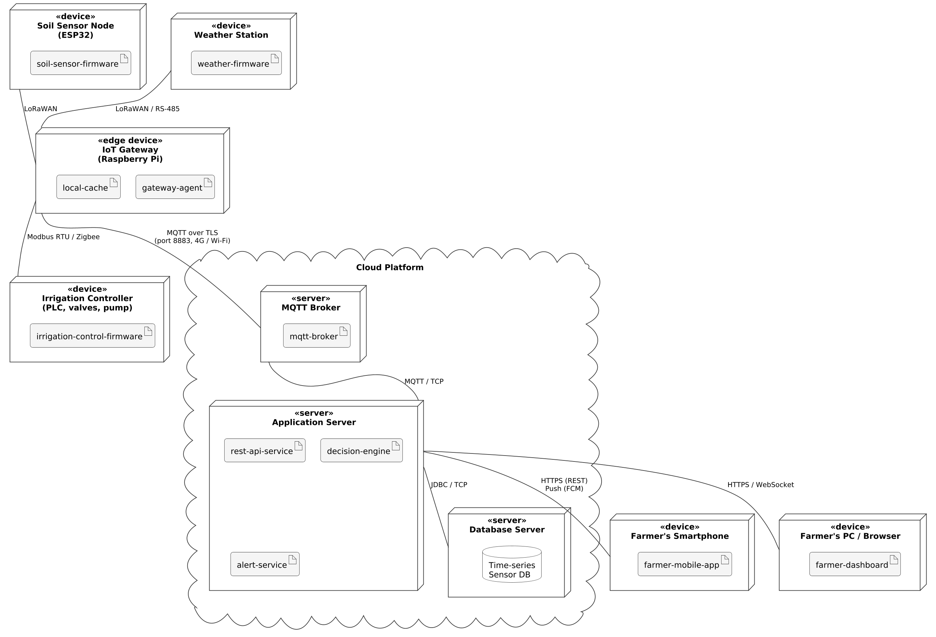
Figure 6: Deployment Diagram of the Smart Agriculture Monitoring System
Justification
- Edge gateway: Placing a gateway in the field lets low-power sensor protocols (LoRaWAN) be converted to internet protocols, and the local cache keeps data safe when the network is down.
- Closed-loop automation: Sensor data flows up to the decision engine, and irrigation commands flow back down through the broker and gateway to the controller, so irrigation is automated.
- Security and scalability: TLS and HTTPS protect data in transit, and the cloud tier can be scaled by adding servers without changing the field devices.

