SIMATS ENGINEERING
ASSESSMENT TOOL 3

COURSE NAME: OBJECT ORIENTED ANALYSIS AND DESIGN
COURSE CODE:CSA1105

COURSE OUTCOME COVERED

CO2: Design UML diagrams to represent system requirements and architecture. (BL3)

Assessment Tool Weightage: 30%

QUESTIONS: 6 Total Marks:30

Annexure A

Scenario-Based

Code of Conduct:

I _________HEMANTH R 192521327___________ (Name / Reg No) certify that this submission is my original work and that I have adhered to the guidelines specified for this assessment.
I understand that any violation of academic integrity rules will result in disciplinary action.

Signature of the student:
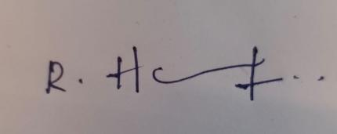

Annexure A

Scenario-Based

1. Use Case Diagram Scenario
A Smart Cinema Ticket Booking System allows customers to search movies, select seats, book tickets, cancel bookings, and make online payments. Theater managers update movie schedules and seat availability, while administrators manage users and system settings. The interactions between actors and system functions are not clearly defined.
Based on this scenario, analyze the system requirements, identify all actors and use cases, and design a Use Case Diagram showing appropriate relationships (include, extend, and generalization) to ensure complete system functionality.
(5 Marks)

2. Class Diagram Scenario
A Smart College Management System consists of entities such as Student, Faculty, Department, Course, Attendance, and Examination. The existing design does not clearly define class attributes, operations, or relationships among these entities.
Based on this scenario, identify the required classes, define suitable attributes and methods, establish relationships (association, aggregation, composition, and inheritance), specify multiplicity, and construct a detailed Class Diagram.
(5 Marks)

3. Sequence Diagram Scenario
In an Online Railway Reservation System, a passenger searches for trains, selects a seat, books a ticket, makes payment, and receives an e-ticket. The communication among the passenger, reservation system, payment gateway, and database is incomplete.
Based on this scenario, analyze the sequence of operations, identify participating objects and message flows, and design a Sequence Diagram representing the complete interaction process.
(5 Marks)

4. Activity Diagram Scenario
A Smart Insurance Claim Processing System allows customers to submit insurance claims, upload supporting documents, verify claim details, approve or reject claims, and receive compensation. The workflow does not clearly represent decision-making or concurrent activities.
Based on this scenario, analyze the workflow, identify decision points and parallel activities, and design an optimized Activity Diagram using decision nodes, forks, and joins.
(5 Marks)

5. State Diagram Scenario
A Smart Washing Machine System operates through states such as Idle, Water Filling, Washing, Rinsing, Spinning, Paused, and Completed. The transitions between these operational states are not clearly specified.
Based on this scenario, identify all possible states, triggering events, and transitions, and construct a State Transition Diagram that accurately represents the washing machine's behavior.
(5 Marks)

6. Deployment Diagram Scenario
A Smart Energy Management System uses smart electricity meters, edge gateways, cloud servers, utility monitoring dashboards, and mobile applications to monitor energy consumption and control power distribution. The deployment architecture does not clearly illustrate hardware nodes, deployed software artifacts, or communication links.
Based on this scenario, analyze the deployment environment, identify all hardware nodes and software artifacts, and design a Deployment Diagram showing the physical architecture and communication links.
(5 Marks)

RUBRICS FOR CALCULATION

Scenario-Based

Criteria | Weightage | Level 4 (Exemplary) | Level 3 (Proficient) | Level 2 (Developing) | Level 1 (Beginning)
Understanding of Scenario | 20% | Demonstrates clear and complete understanding of the scenario and context | Shows good understanding with minor gaps | Partial understanding; misses key aspects | Misinterprets or fails to understand the scenario
Identification of Key Issues | 20% | Accurately identifies all relevant issues and factors involved | Identifies most key issues with minor omissions | Identifies limited issues; some irrelevant points | Unable to identify key issues
Application of Concepts | 25% | Applies appropriate concepts effectively to address the scenario | Applies concepts with minor errors | Limited or partially correct application | Unable to apply relevant concepts
Decision Making | 20% | Makes well-reasoned, logical decisions with strong rationale | Makes reasonable decisions with some justification | Makes weak decisions with limited justification | No clear decisions made or rationale provided
Clarity of Response | 15% | Response is clear, structured, and logically presented | Generally clear with minor issues | Somewhat unclear or poorly structured | Disorganized and difficult to understand

1. Use Case Diagram Scenario (Smart Cinema Ticket Booking System)
Understanding of the scenario
Customers search movies, select seats, book tickets, cancel bookings and pay online. Theater managers maintain movie schedules and seat availability, and administrators manage users and system settings. The payment is completed by an external bank or gateway, and booking confirmations are delivered through an external messaging service.
Key issues identified
Actor | Type | Responsibilities
Customer | Primary | Registers, searches movies, selects seats, books and cancels tickets, pays, and views booking history.
Theater Manager | Primary | Updates movie schedules and seat availability.
Administrator | Primary | Manages users, configures system settings and generates reports.
User (abstract) | Generalised | Parent of the three actors, who all log in.
Payment Gateway | External | Authorises payments and refunds.
Notification Service | External | Sends booking confirmation by SMS / e-mail.

Missing or unclear functions: Login, Register Account, View Movie Details and Showtimes, View Seat Availability, Apply Promo Code, Process Refund, View Booking History, Send Booking Confirmation and Generate Reports were not defined in the scenario but are required for complete functionality.
Application of concepts: Use Case Diagram
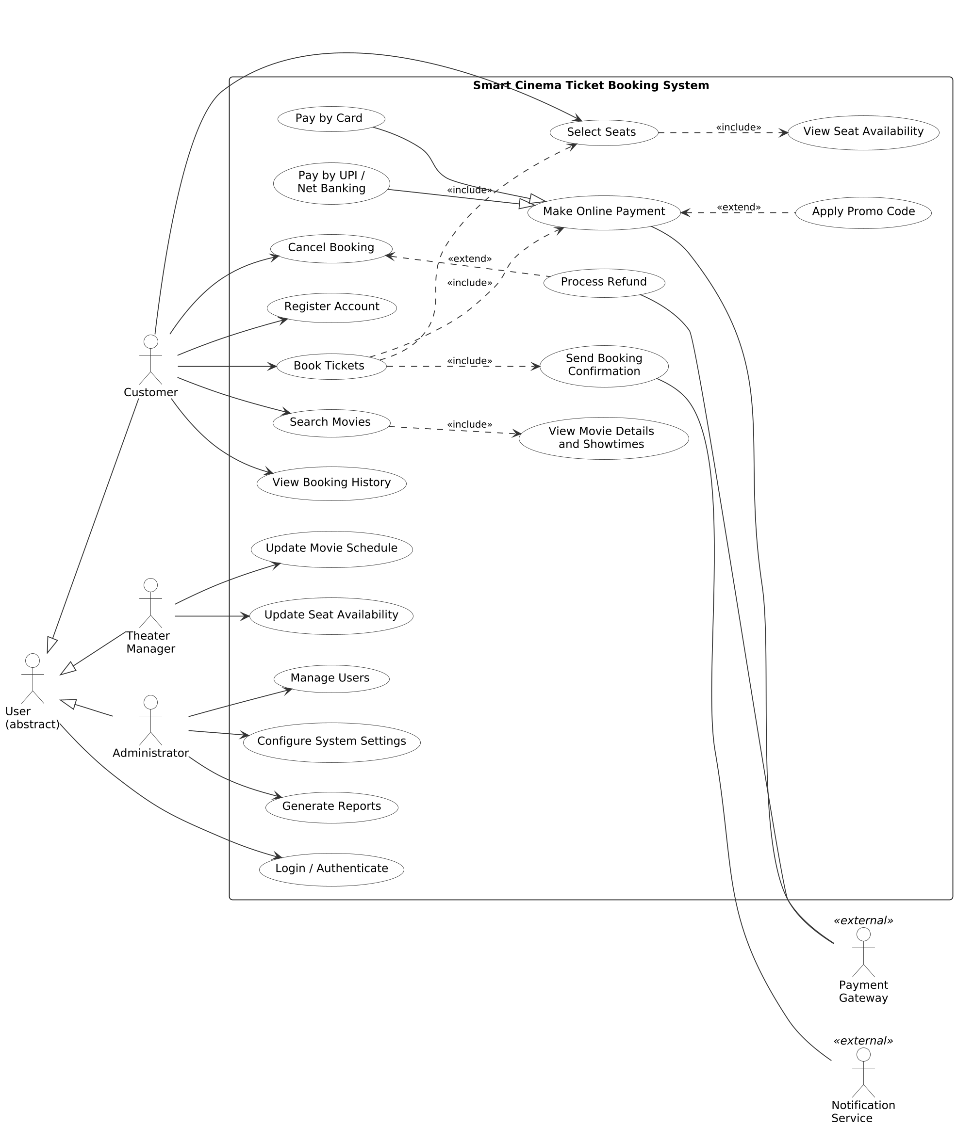
Figure 1: Use Case Diagram of the Smart Cinema Ticket Booking System
Design decisions and justification
- Generalization: Customer, Theater Manager and Administrator inherit from User so that Login is defined once. Pay by Card and Pay by UPI / Net Banking specialise Make Online Payment, so new payment methods can be added without changing the booking flow.
- Include: Book Tickets always includes Select Seats, Make Online Payment and Send Booking Confirmation; Select Seats includes View Seat Availability; Search Movies includes View Movie Details and Showtimes. These steps are mandatory, so they are included.
- Extend: Apply Promo Code extends Make Online Payment and Process Refund extends Cancel Booking, because both happen only under a condition (a promo code is entered, or a paid booking is cancelled).
- External actors are drawn outside the system boundary to show the interfaces with third-party systems.
2. Class Diagram Scenario (Smart College Management System)
Understanding of the scenario
The college has students and faculty who belong to departments. Departments offer courses; students enrol in courses, attendance is recorded for each student per course, and examinations are conducted for courses and produce marks for students.
Key issues identified
Class | Attributes | Methods
Person (abstract) | personId, name, email, phone | login(), updateProfile()
Student | rollNo, semester, admissionYear | enrollCourse(), viewAttendance(), viewResult()
Faculty | employeeId, designation, qualification | markAttendance(), conductExam(), enterMarks()
Department | deptId, name, hodName | addFaculty(), addCourse()
Course | courseCode, title, credits, semester | getSyllabus(), getEnrolledCount()
Attendance | attendanceId, date, status | markPresent(), markAbsent()
Examination | examId, examType, examDate, maxMarks | schedule(), publishResult()
Result (association class) | marksObtained, grade | calculateGrade()

Issues in the existing design: Student and Faculty duplicate personal data, the many-to-many links (Student-Course and Faculty-Course) are not shown, and the marks of a student in an examination have no place to be stored. These are solved with the Person parent class and the Result association class.
Application of concepts: Class Diagram
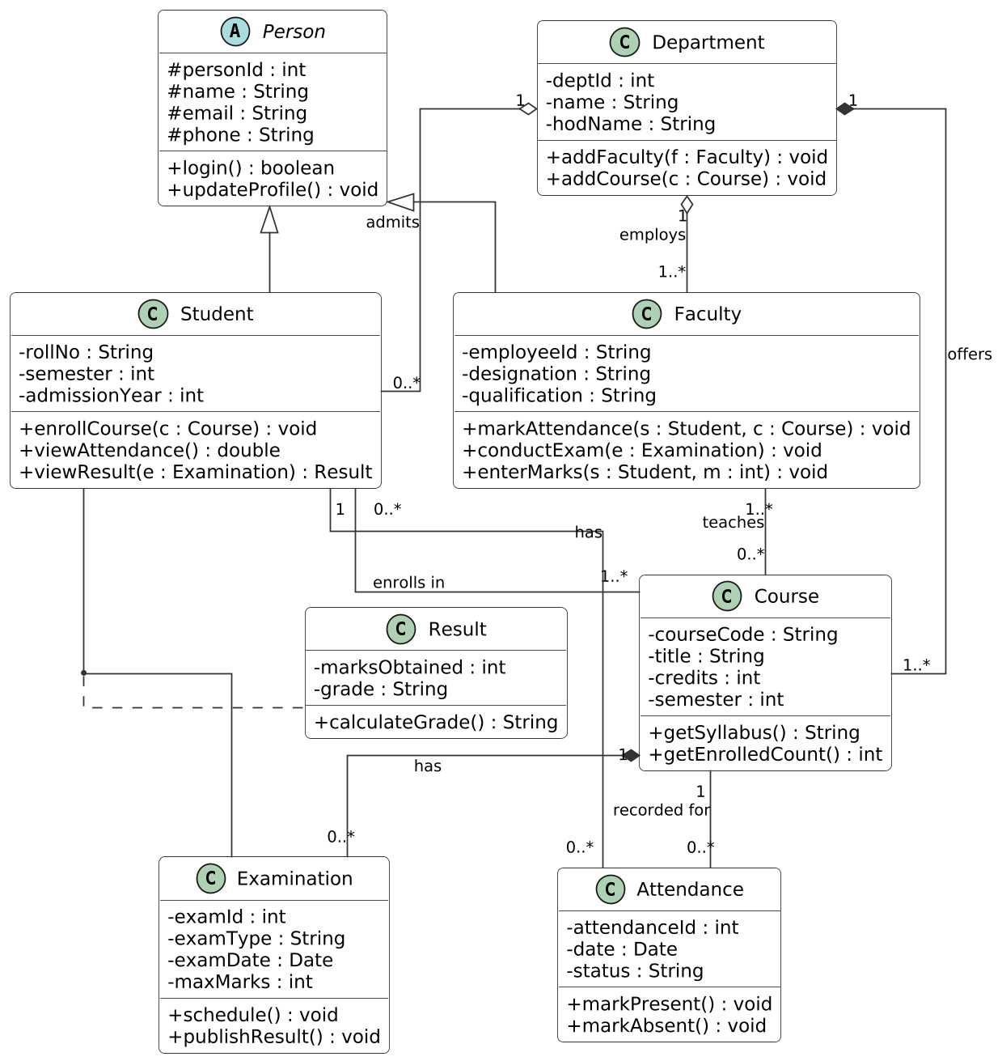
Figure 2: Class Diagram of the Smart College Management System
Design decisions and justification
Relationship | Type | Multiplicity | Rationale
Person - Student / Faculty | Inheritance | - | Shared personal attributes and operations are reused.
Department - Faculty | Aggregation | 1 to 1..* | Faculty belong to a department but continue to exist if it is reorganised.
Department - Student | Aggregation | 1 to 0..* | Students are admitted to a department.
Department - Course | Composition | 1 to 1..* | A course is created and owned by a department.
Student - Course | Association | 0..* to 1..* | Many-to-many enrolment.
Faculty - Course | Association | 1..* to 0..* | A course can be taught by several faculty, and a faculty teaches several courses.
Student - Attendance | Association | 1 to 0..* | Each student has many attendance entries.
Course - Attendance | Association | 1 to 0..* | Attendance is recorded for a course session.
Course - Examination | Composition | 1 to 0..* | An examination belongs to one course.
Student, Examination - Result | Association class | - | Marks depend on both a student and an examination.
3. Sequence Diagram Scenario (Online Railway Reservation System)
Understanding of the scenario
A passenger searches trains, selects a seat, books the ticket, pays and receives an e-ticket. The Reservation System controls the process, the Database stores trains, seats and bookings, and the Payment Gateway handles the payment.
Key issues identified
Missing interaction | Messages added
Train search | searchTrains(), queryTrains(), trainList, displayTrains()
Availability check | selectTrain(), checkSeatAvailability(), availableSeats
Seat holding | selectSeat(), holdSeat(), seatHeld (prevents double booking)
Pending booking | bookTicket(), createBooking(status = pending), bookingId
Payment | makePayment(), processPayment(), paymentSuccess / paymentFailed
Confirmation and e-ticket | confirmBooking(), PNR generated, generateETicket(), sendETicket()
Failure handling | releaseSeat(), paymentFailedMessage, showWaitingListOption
Application of concepts: Sequence Diagram
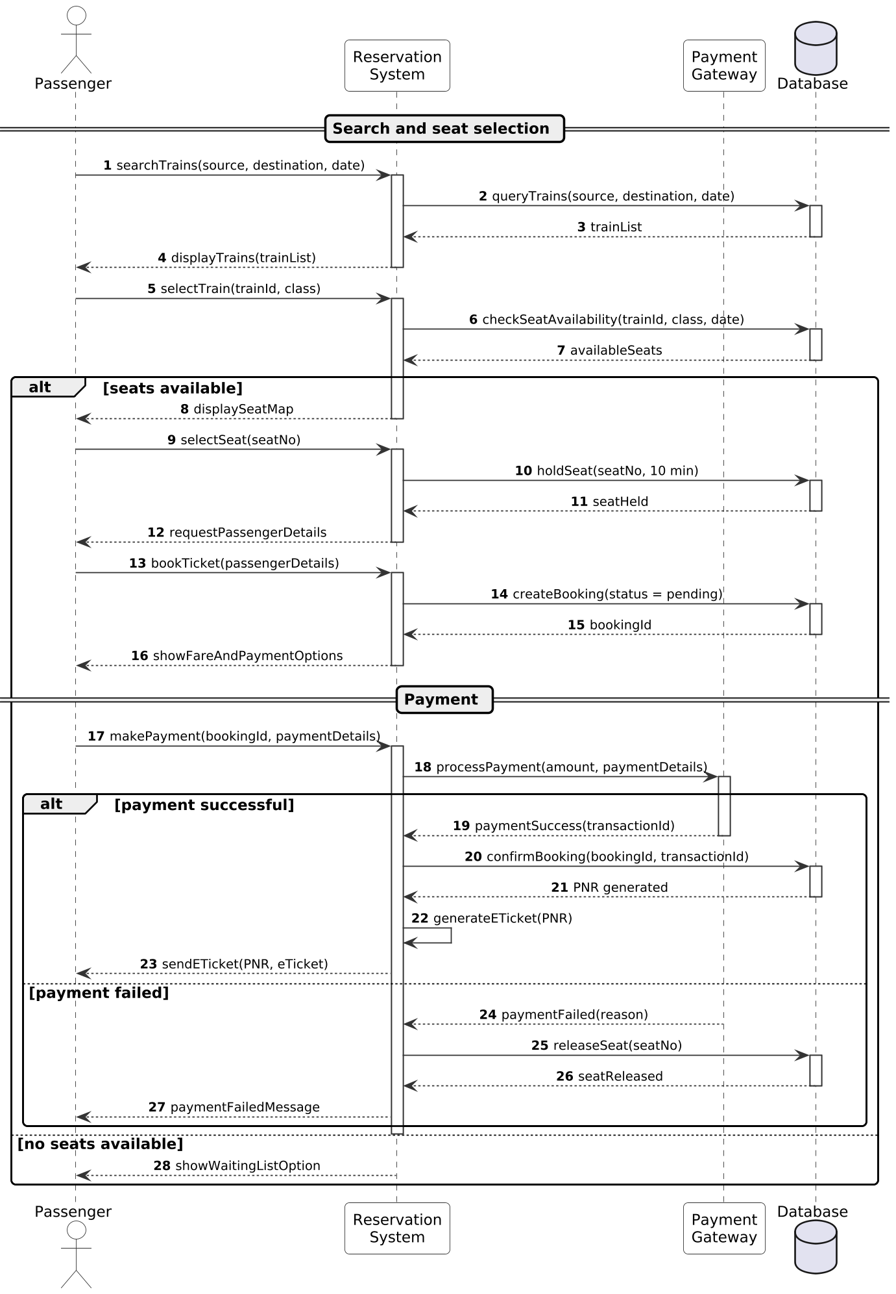
Figure 3: Sequence Diagram of the Online Railway Reservation System
Design decisions and justification
- Seat hold before payment: The seat is held for 10 minutes before payment, so two passengers cannot pay for the same seat. It is released if the payment fails.
- Pending then confirmed booking: The booking is created as pending and confirmed only after the Payment Gateway returns success, so no ticket is issued without payment.
- alt fragments: They show the alternative flows for seat availability and for payment success or failure, which makes the diagram complete.
- Activation bars and lifelines: The Reservation System coordinates all messages, the Payment Gateway is active only during payment, and the Database is active only during each query, which reflects their real responsibilities.

4. Activity Diagram Scenario (Smart Insurance Claim Processing System)
Understanding of the scenario
A customer submits a claim and supporting documents. The claim is then verified, approved or rejected, and approved claims are paid. The existing workflow does not show where decisions are taken or which checks can run at the same time.
Key issues identified
Element | Details
Main activities | Submit claim, register claim, upload documents, check completeness, verification, consolidate results, officer evaluation, calculate compensation, notify customer.
Decision points | Documents complete? (loop back for missing documents); Verification passed?; Officer approves claim?
Parallel activities (fork 1) | Policy validity check, document authenticity check, fraud detection and surveyor damage assessment are independent, so they run at the same time and join before evaluation.
Parallel activities (fork 2) | After approval, the approval letter, the compensation transfer and the record update run concurrently.
Application of concepts: Activity Diagram
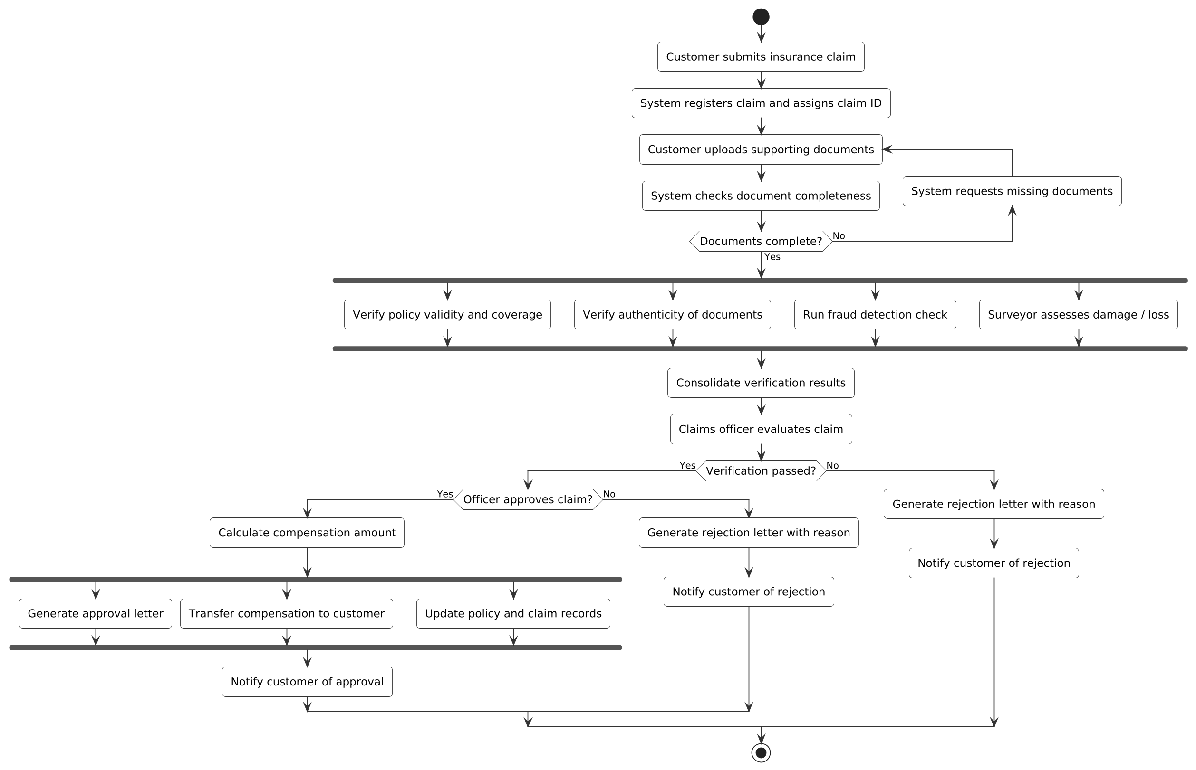
Figure 4: Activity Diagram of the Smart Insurance Claim Processing System
Design decisions and justification
- Decision nodes separate failed verification and officer rejection from the approval path, and both rejection paths produce a reasoned rejection letter. The document loop prevents incomplete claims from entering verification.
- First fork and join: The four checks do not depend on each other, so running them in parallel shortens claim processing time compared with a sequence.
- Second fork and join: Payment, letter generation and record update are independent after approval; the join ensures the customer is notified only when all three are complete.
- Structure: The diagram has one start node and one final node, and every branch merges, so there are no dead ends.

5. State Diagram Scenario (Smart Washing Machine System)
Understanding of the scenario
The washing machine passes through the states Idle, Water Filling, Washing, Rinsing, Spinning, Paused and Completed. A wash cycle moves forward automatically using timers and sensors, and the user can pause, resume or cancel it.
Key issues identified
From state | Event [guard] | To state | Action
Idle | start pressed [door closed, load detected] | Water Filling | Lock door, open inlet valve
Water Filling | water level reached | Washing | Close valve, start drum
Washing | wash timer expired | Rinsing | Drain, refill
Rinsing | rinse cycle done | Spinning | Drain, high-speed spin
Spinning | spin timer expired | Completed | Beep, unlock door
Completed | door opened | Idle | Clothes removed
Any running state | pause pressed or door opened | Paused | Stop drum, remember state
Paused | resume pressed [door closed] | Previous running state | Continue cycle
Paused / running | cancel pressed | Idle | Drain water
Idle | power off | Final | -

Unclear points in the scenario: how the machine resumes after a pause, and how a cycle is stopped. These are resolved with a history state and a cancel transition.
Application of concepts: State Transition Diagram
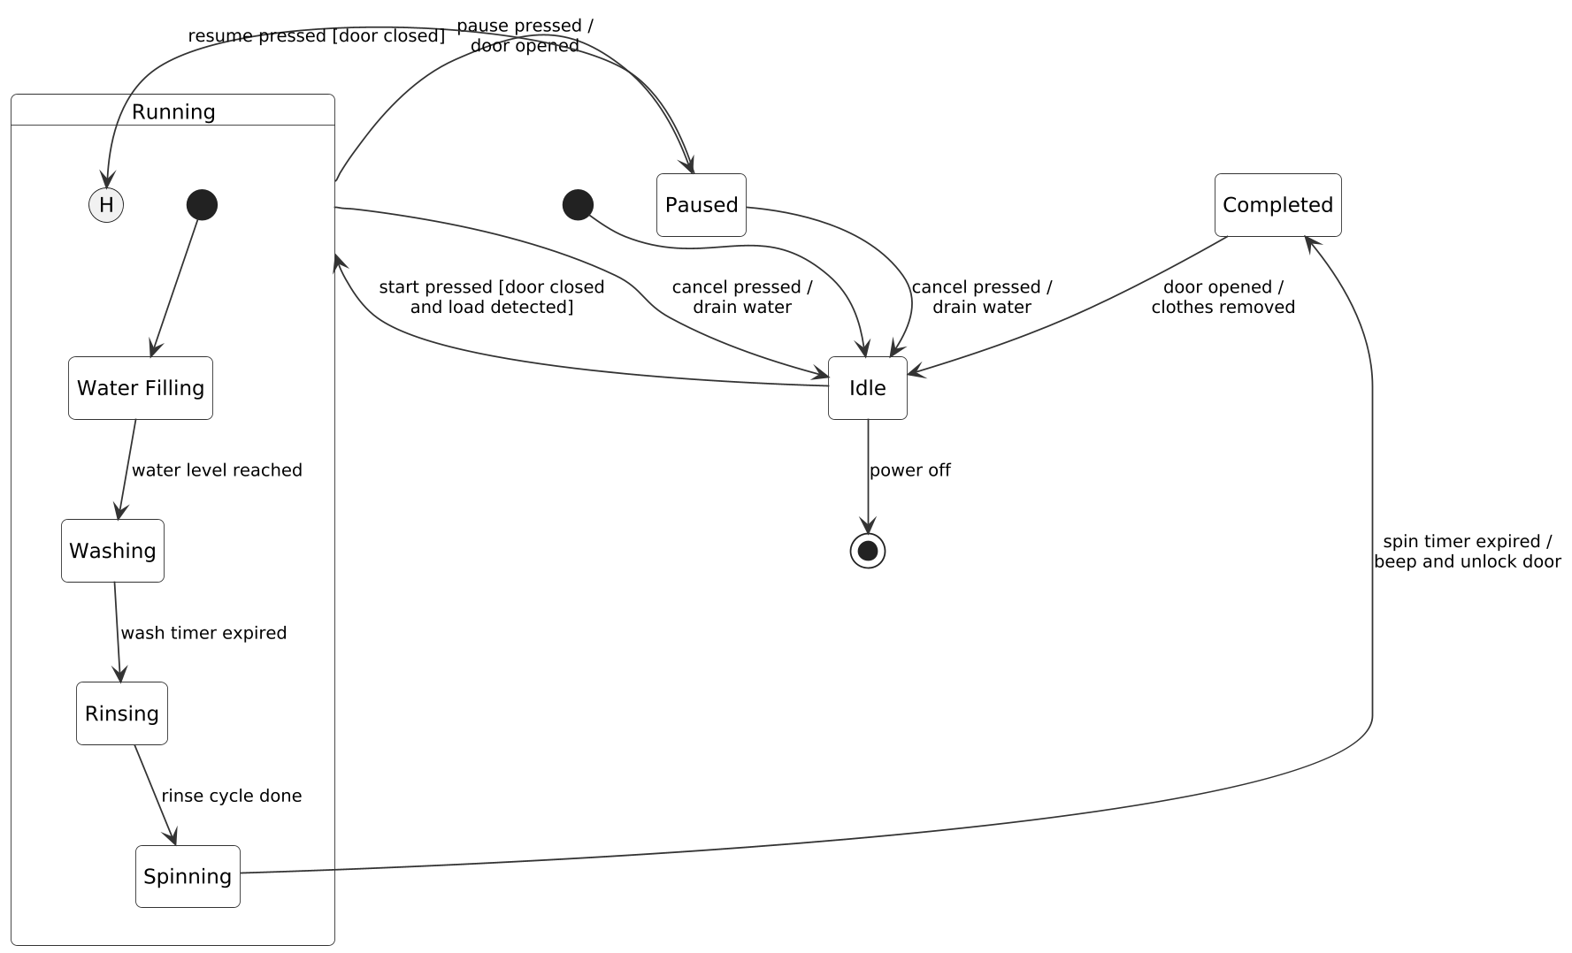
Figure 5: State Transition Diagram of the Smart Washing Machine
Design decisions and justification
- Composite state Running: Water Filling, Washing, Rinsing and Spinning are grouped, so pause and cancel are drawn once instead of four times.
- History state (H): Resume returns to the exact sub-state where the machine was paused (for example in the middle of rinsing), rather than restarting the cycle.
- Guards: Conditions such as [door closed] prevent unsafe operation, and the door is unlocked only in Completed or after a cancel.
- Completeness: Every state has at least one outgoing transition, so the machine can never get stuck.

6. Deployment Diagram Scenario (Smart Energy Management System)
Understanding of the scenario
Smart meters measure consumption at each premises. Edge gateways collect and pre-process the readings and forward them to the cloud, where servers analyse the data. Utility staff use dashboards and consumers use mobile apps, while power distribution is controlled through relays.
Key issues identified
Node | Deployed artifacts | Role
Smart Electricity Meter | metering-firmware, comm-module | Measures energy and sends readings.
Edge Gateway | data-aggregator, local-analytics, load-control-agent | Aggregates meter data, filters it locally and relays control commands.
Switchgear / Load Control Relay | relay-controller-firmware | Switches power on or off for load control.
IoT / MQTT Hub (cloud) | mqtt-broker | Receives gateway messages.
Application Server (cloud) | energy-analytics-service, demand-response-engine, rest-api-service | Analyses consumption and decides on load control.
Database Server (cloud) | Time-series energy database | Stores readings and history.
Utility Control Room PC | monitoring-dashboard (web) | Lets utility staff monitor and control distribution.
Consumer Smartphone | energy-mobile-app | Shows consumption and sends alerts to the consumer.

Communication link | Protocol and reason
Meter to Edge Gateway | RF Mesh / Zigbee / RS-485 with DLMS/COSEM: low-power metering standards.
Edge Gateway to Relay | Modbus TCP: standard protocol for industrial switching commands.
Edge Gateway to Cloud Hub | MQTT over TLS on 4G or fibre: lightweight and encrypted.
Hub to Application Server | MQTT over TCP inside the cloud.
Application Server to Database | JDBC over TCP for storing and reading readings.
Server to Dashboard and Mobile App | HTTPS / WebSocket for live data; HTTPS REST and push (FCM) for the mobile app.
Application of concepts: Deployment Diagram
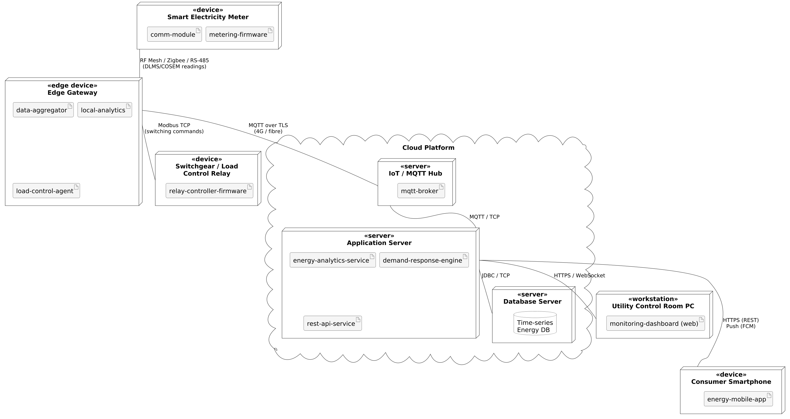
Figure 6: Deployment Diagram of the Smart Energy Management System
Design decisions and justification
- Edge gateway: Processing data near the meters reduces cloud traffic and latency, and allows load control to continue if the internet link fails.
- Separate control path: Switching commands travel from the cloud decision engine through the gateway to the relay, which keeps the physical grid equipment isolated from the public internet.
- Security: TLS and HTTPS encrypt all external links, and each tier can be scaled independently.

