SIMATS ENGINEERING
ASSESSMENT TOOL 2

COURSE NAME: CSA04 COURSE CODE: Operating Systems

COURSE OUTCOME COVERED

CO1: Apply the concepts of Operating System types, structures, and system calls to demonstrate their functions in various computing environments. (BL2, BL3)

QUESTIONS: 1 Total Marks:100

Annexure A

Concept Mapping

Code of Conduct:

I _________HEMANTH R 192521327___________ (Name / Reg No) certify that this submission is my original work and that I have adhered to the guidelines specified for this assessment.
I understand that any violation of academic integrity rules will result in disciplinary action.

Signature of the student:

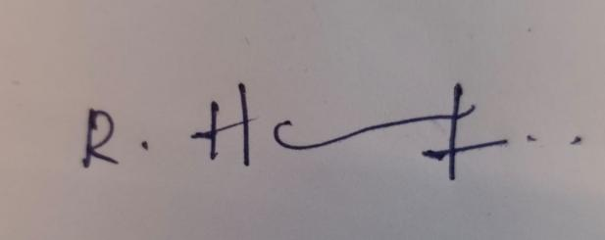

Annexure A

Concept Mapping

Question 1
Show a multi-level concept map integrating:
Operating System Types → OS Structures → System Calls → OS Functions.
Your map must show cross-links (e.g., how OS structure influences system call implementation). (BL2)

Question 2
Construct a comprehensive concept map representing:
Process Management, Memory Management, File System, and I/O System.
Include interdependencies and indicate where system calls interact with each component. (BL3)

Question 3
Sketch a comparative concept map for:
Batch OS, Time-Sharing OS, Distributed OS, and Real-Time OS.
Highlight differences, similarities, advantages, and limitations using linking phrases. (BL2)

Question 4
Illustrate a dynamic concept map showing the execution flow:
User Program → API → System Call Interface → Kernel → Hardware → Response back to User.
Include feedback loops and control flow paths. (BL3)

Question 5
Sketch a hierarchical + functional concept map for system calls:
Process, File, Device, and Information system calls.
Also show how they relate to OS services like scheduling, memory allocation, and device handling. (BL3)

RUBRICS FOR CALCULATION

Concept Mapping
Criteria | Weightage | Level 4 (Exemplary) | Level 3 (Proficient) | Level 2 (Developing) | Level 1 (Beginning)
Concept Identification | 25% | Identifies all key concepts from literature accurately and comprehensively | Identifies most key concepts with minor omissions | Identifies limited concepts; some are irrelevant or missing | Fails to identify essential concepts
Linkages | 25% | Establishes clear, meaningful, and accurate relationships between concepts | Shows correct relationships with minor gaps | Relationships are weak, unclear, or partially incorrect | No meaningful relationships established
Organization | 20% | Concepts are well-structured hierarchically with logical flow and grouping | Mostly organized with minor structural issues | Some organization but lacks clear hierarchy | No logical organization or structure
Integration of Literature | 20% | Integrates multiple studies effectively to show connections and comparisons | Shows some integration of literature | Limited integration; mostly isolated concepts | No integration of literature evidence
Clarity | 10% | Concept map is clear, neat, visually structured, and easy to interpret | Generally clear with minor readability issues | Clarity is reduced; difficult to interpret in parts | Poorly presented and hard to understand

Question 1
Show a multi-level concept map integrating: Operating System Types → OS Structures → System Calls → OS Functions. Show cross-links (e.g., how OS structure influences system call implementation). (BL2)
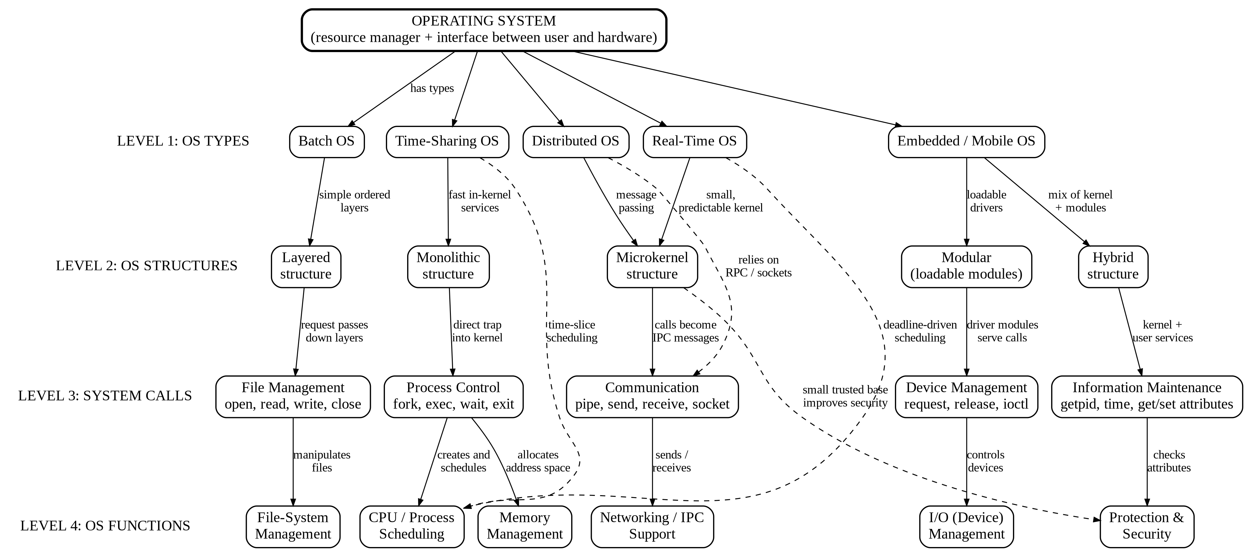

Explanation of the Concept Map (Question 1)
- Level 1 – OS Types: Batch, Time-Sharing, Distributed, Real-Time and Embedded/Mobile systems. The type is decided by the computing environment and its goals (throughput, response time, resource sharing, deadlines).
- Level 2 – OS Structures: Layered, Monolithic, Microkernel, Modular and Hybrid. The structure is the way the kernel is organised to meet the needs of the chosen type.
- Level 3 – System Calls: Process control, file management, device management, information maintenance and communication. These form the interface through which programs request kernel services.
- Level 4 – OS Functions: CPU scheduling, memory management, file-system management, I/O management, protection and security, and networking/IPC support.
Cross-links (dashed arrows and structure-to-call links):
- Monolithic structure: a system call is a direct trap into one large kernel, so it is fast, but a fault in any service can affect the whole system.
- Layered structure: a request passes down the layers one by one, which makes debugging easy but adds overhead to every call.
- Microkernel structure: communication system calls become IPC messages to user-space servers, which improves security and reliability but costs extra context switches.
- Modular and hybrid structures: drivers and services are loaded as modules, so device-management calls are served by dynamically loaded code.
- Distributed OS depends on communication calls (RPC, sockets); Real-Time OS demands deadline-driven scheduling; Time-Sharing OS depends on time-slice scheduling; a small microkernel gives a small trusted base for protection.

Question 2
Construct a comprehensive concept map representing Process Management, Memory Management, File System, and I/O System. Include interdependencies and indicate where system calls interact with each component. (BL3)
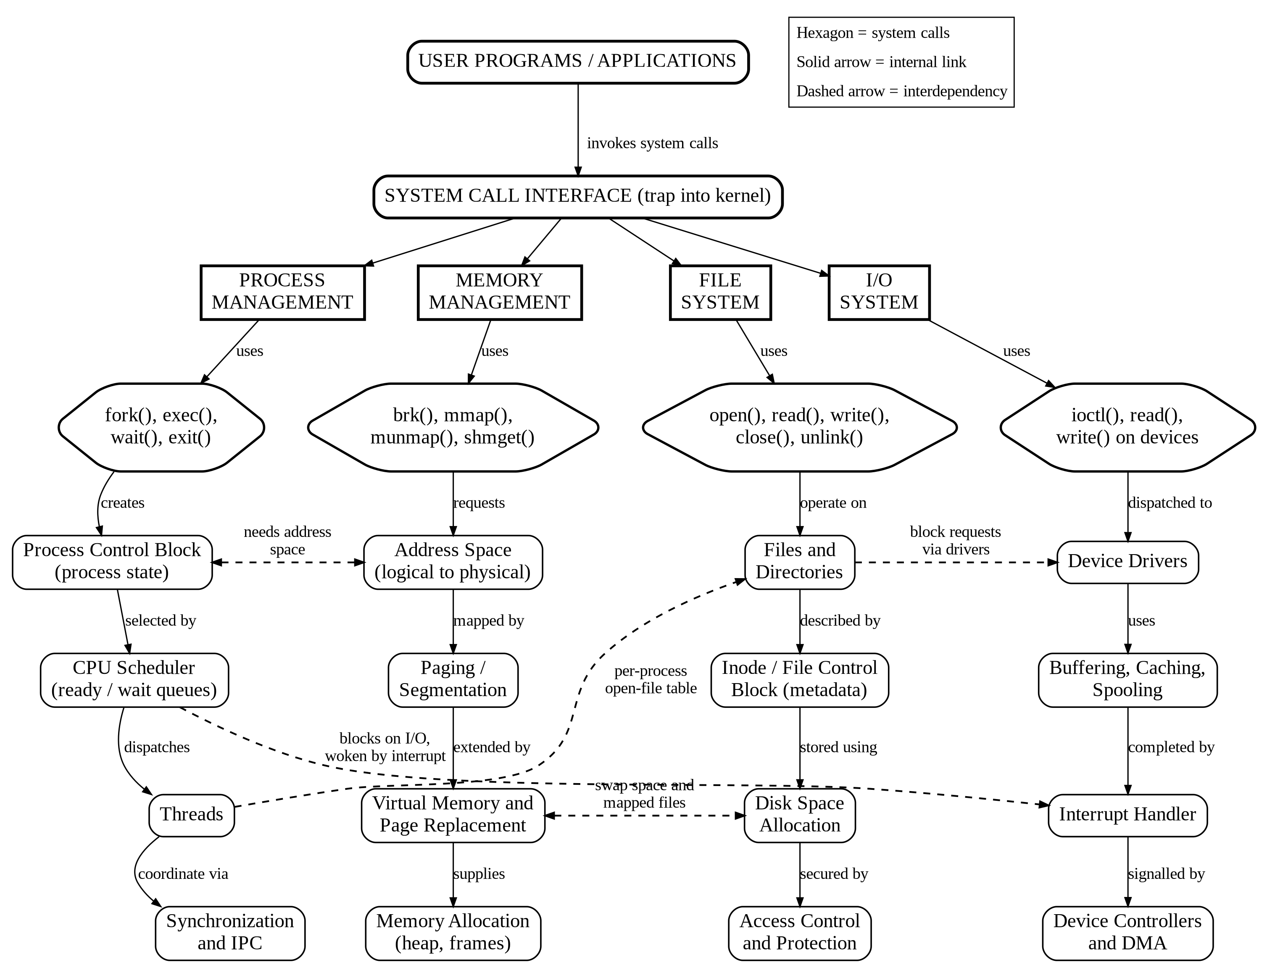

Explanation of the Concept Map (Question 2)
- Process Management: The Process Control Block stores process state; the CPU scheduler picks the next process; threads are dispatched; synchronization and IPC coordinate processes. System calls: fork(), exec(), wait(), exit().
- Memory Management: Address space with logical-to-physical mapping, paging/segmentation, virtual memory with page replacement, and memory allocation. System calls: brk(), mmap(), munmap(), shmget().
- File System: Files and directories described by inodes (file control blocks), stored through disk-space allocation and secured by access control. System calls: open(), read(), write(), close(), unlink().
- I/O System: Device drivers, buffering/caching/spooling, the interrupt handler, and device controllers with DMA. System calls: ioctl(), read(), write() on devices.
Interdependencies (dashed arrows):
- Process ↔ Memory: every process needs an address space, and a page fault makes the process wait until the page is loaded.
- Process → File: each process keeps a per-process open-file table that refers to the system-wide file table.
- Process → I/O: a process blocks on slow I/O and is woken by the interrupt handler.
- Memory ↔ File: swap space and memory-mapped files connect virtual memory to disk space.
- File → I/O: every block request of the file system goes through the device driver.
- System-call interaction: User programs call the System Call Interface, which routes each call to the matching component (hexagon nodes), so system calls are the single entry point to all four components.

Question 3
Sketch a comparative concept map for Batch OS, Time-Sharing OS, Distributed OS, and Real-Time OS. Highlight differences, similarities, advantages, and limitations using linking phrases. (BL2)
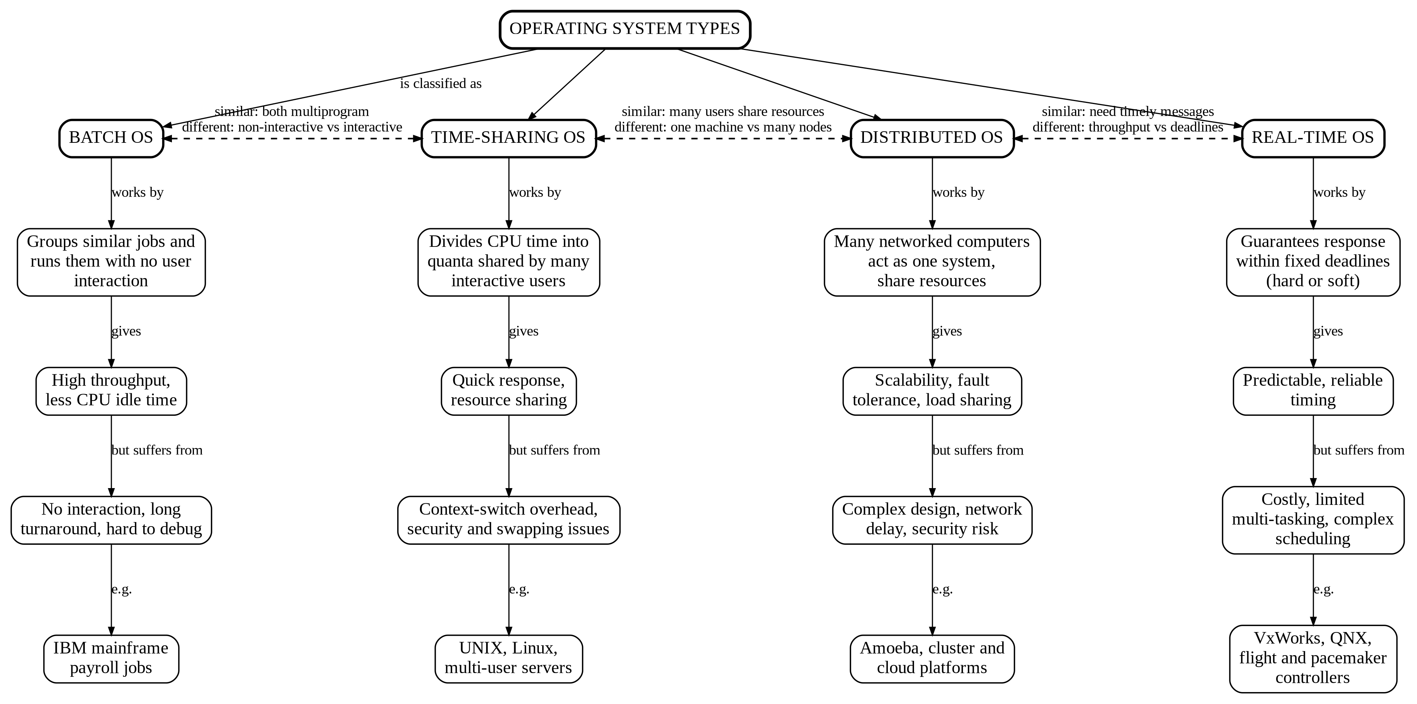

Comparison Summary (Question 3)
Aspect | Batch OS | Time-Sharing OS | Distributed OS | Real-Time OS
Basic idea | Similar jobs are grouped and run one after another | CPU time is divided into quanta among many users | Networked computers work as one system | Tasks must finish within fixed deadlines
User interaction | None during execution | Interactive | Interactive, over a network | Limited; event/sensor driven
Main goal | Maximum throughput | Fast response time | Resource sharing and scalability | Predictable timing
Advantages | Less CPU idle time; efficient for repetitive jobs | Quick response; many users share one machine | Fault tolerance, load sharing, scalability | Reliable, deterministic behaviour
Limitations | Long turnaround; hard to debug | Context-switch overhead; security issues | Complex design; network delay | Costly; limited multitasking
Examples | IBM mainframe jobs | UNIX, Linux | Amoeba, cluster / cloud systems | VxWorks, QNX

- Similarities: Batch and Time-Sharing both use multiprogramming; Time-Sharing and Distributed both let many users share resources; Distributed and Real-Time both need timely communication.
- Differences: Batch is non-interactive and aims for throughput, Time-Sharing is interactive and aims for response time, Distributed spreads work across many nodes, and Real-Time is judged by meeting deadlines.

Question 4
Illustrate a dynamic concept map showing the execution flow: User Program → API → System Call Interface → Kernel → Hardware → Response back to User. Include feedback loops and control flow paths. (BL3)
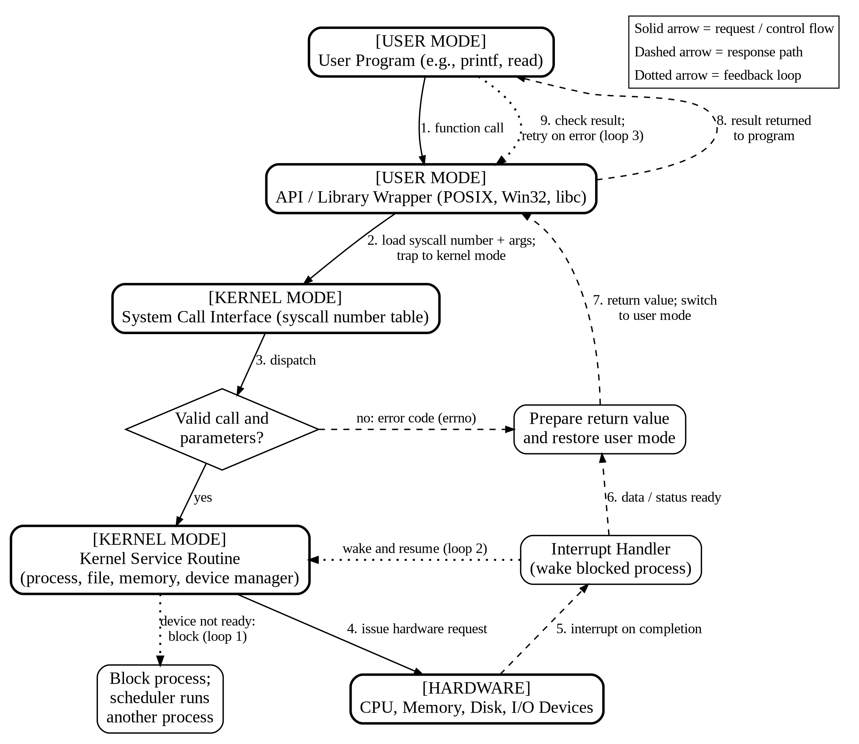

Explanation of the Execution Flow (Question 4)
- Function call: the user program calls an API function such as printf() or read().
- Trap: the library wrapper loads the system-call number and arguments, then executes a trap that switches the CPU to kernel mode.
- Dispatch and validation: the System Call Interface uses the call number to find the handler and checks that the call and its parameters are valid. If not, an error code (errno) is prepared and returned.
- Kernel service: the service routine (process, file, memory or device manager) runs and sends a request to the hardware.
- Interrupt: the hardware signals completion through an interrupt, which the interrupt handler processes.
- Result ready: data and status are collected and the return value is prepared.
- Return to user mode: the kernel restores user mode and returns the value to the API wrapper.
- Response: the API passes the result back to the user program.
- Result check: the program checks the result and may retry on an error.
Feedback loops and control-flow paths:
- Loop 1 (blocking): if the device is not ready, the process is blocked and the scheduler runs another process.
- Loop 2 (wake-up): the interrupt handler wakes the blocked process and the service routine resumes.
- Loop 3 (retry): the user program examines the returned value and re-issues the call on an error such as EINTR or EAGAIN.
- Decision path: the validity check separates the normal path (yes) from the error path (no).

Question 5
Sketch a hierarchical and functional concept map for system calls: Process, File, Device, and Information system calls. Also show how they relate to OS services like scheduling, memory allocation, and device handling. (BL3)
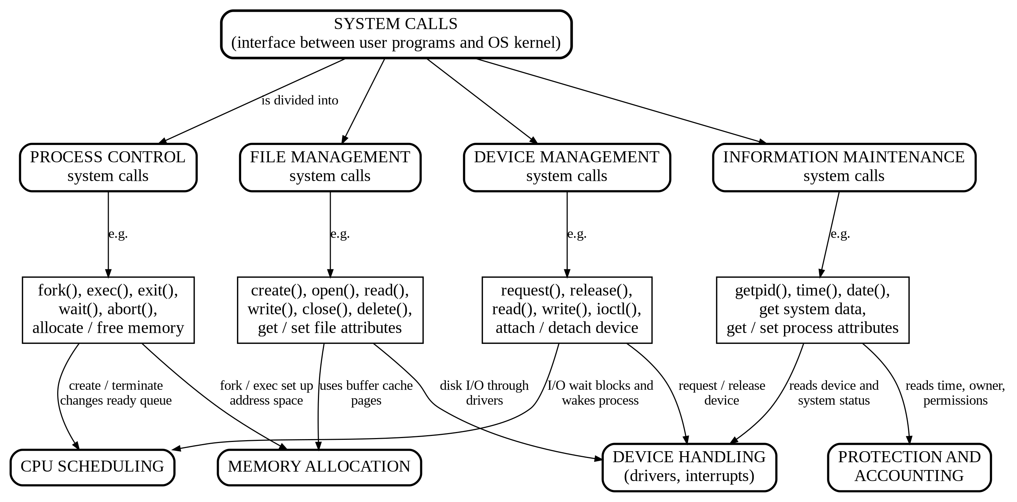

Explanation of the Concept Map (Question 5)
- Hierarchy: System calls are divided into four categories, each with representative calls.
- Process control: fork(), exec(), exit(), wait(), abort() and memory allocate/free calls.
- File management: create(), open(), read(), write(), close(), delete() and get/set file attributes.
- Device management: request(), release(), read(), write(), ioctl() and attach/detach device.
- Information maintenance: getpid(), time(), date(), get system data and get/set process attributes.
Functional links to OS services:
- Process calls → CPU Scheduling: creating, terminating or waiting changes the ready queue; they also → Memory Allocation, because fork() and exec() set up the address space.
- File calls → Memory Allocation: file data uses buffer-cache pages; they also → Device Handling, because disk I/O goes through device drivers.
- Device calls → Device Handling: request and release control the device; they also → CPU Scheduling, because an I/O wait blocks and later wakes the process.
- Information calls → Device Handling and Protection and Accounting: they read device and system status, and read time, owner and permissions.

