SIMATS ENGINEERING
ASSESSMENT TOOL 3

COURSE NAME: CSA04 COURSE CODE: Operating Systems

COURSE OUTCOME COVERED

CO1: Apply the concepts of Operating System types, structures, and system calls to demonstrate their functions in various computing environments. (BL2, BL3)

Assessment Tool Weightage: 30%

QUESTIONS: 5 Total Marks:25

Annexure A

Technical Presentation

Code of Conduct:

I ________HEMANTH R 192521327____________ (Name / Reg No) certify that this submission is my original work and that I have adhered to the guidelines specified for this assessment.
I understand that any violation of academic integrity rules will result in disciplinary action.

Signature of the student:
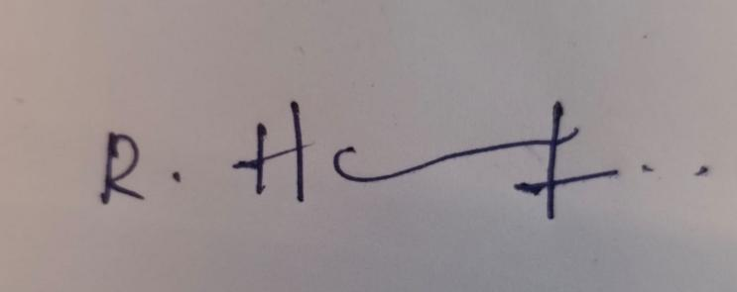

Annexure A

Technical Presentation

Question 1 (5 Marks)
Suppose an Operating System is used in a banking system handling thousands of transactions simultaneously.
Prepare a technical presentation explaining:
Types of OS suitable for this scenario
OS structure used
Role of system calls in transaction processing

Question 2 (5 Marks)
Consider a multi-user Linux-based server environment supporting file sharing and device access.
Prepare a technical presentation covering:
OS functions involved in resource management
File and device system calls
Interaction between user processes and kernel

Question 3 (5 Marks)
Assume a real-time embedded system used in traffic signal control.
Prepare a technical presentation explaining:
Type of OS used and justification
OS structure and components
System calls used for process control and timing

Question 4 (5 Marks)
A company uses a distributed computing system across multiple locations.
Prepare a technical presentation discussing:
Type of OS and its characteristics
Architecture of distributed OS
System calls used for communication and coordination

Question 5 (5 Marks)
Consider an OS managing process scheduling, memory allocation, and I/O operations in a modern computer.
Prepare a technical presentation including:
Key OS functions and their importance
Interaction between OS components
Examples of system calls for each function

RUBRICS FOR CALCULATION

Technical Presentation
Criteria | Weightage | Level 4 – Exemplary | Level 3 – Proficient | Level 2 – Developing | Level 1 – Beginning
Technical Content Accuracy | 30 | Highly accurate, in-depth, and insightful technical explanation | Technically correct content with adequate depth and clarity | Basic concepts presented with limited accuracy and depth | Content contains major technical errors; concepts poorly understood
Problem Identification | 25 | Problem rigorously analyzed using appropriate and advanced methods | Problem clearly defined with a logical engineering approach | Problem identified but analysis or methodology is weak | Problem statement unclear or incorrect; no logical approach
Use of Tools | 20 | Advanced tools, well-analyzed data, and highly effective visuals | Appropriate tools and data used effectively with clear visuals | Limited use of tools and basic data interpretation | Minimal or incorrect use of tools and data; poor visuals
Communication | 15 | Highly engaging, confident, and audience-focused delivery | Clear, organized, and professional communication | Understandable but lacks clarity, structure, or confidence | Poor organization, unclear speech, ineffective slides
Professionalism | 10 | Exemplary professionalism, leadership, and ethical awareness | Professional conduct with effective team collaboration | Basic professionalism; uneven team participation | Lacks professionalism; minimal contribution or ethical awareness

Real-Time Embedded System for Traffic Signal Control

CSA04 Operating Systems | Technical Presentation

Presented by
NAME : HEMANTH R REG NO : 192521327
COURSE : OPERATING SYSTEM

Introduction: Real-Time Embedded System for Traffic Signal Control

- A real-time embedded system is a small computer built into a device to do one job
on time
- A traffic signal controller reads sensors and buttons and changes the lights on a fixed schedule
- Correct timing is as important as a correct result
- The operating system manages the tasks so every deadline is met

Type of OS Used and Justification

- A Hard Real-Time Operating System (RTOS) is used
- It responds within a fixed time, every time; a missed deadline is a failure
- Lights must change exactly on schedule and button presses must be answered at
once
- It is small and reliable, which suits embedded hardware, for example FreeRTOS or VxWorks

OS Structure and Components

- Structure: a small kernel (microkernel style) with only the essential services
- Scheduler: decides which task runs next, by priority
- Timer and interrupt handler: keep time and react to sensors and buttons
- IPC and memory manager: let tasks share data and give them fixed memory

Conclusion

- A traffic signal controller is a real-time embedded system where correct timing matters as much as correct results
- A hard RTOS is used because it guarantees response times, and a missed deadline can
cause accidents
- Its small kernel, with scheduler, timer, interrupt handler, IPC and memory manager, keeps tasks fast and in order
- System calls for process control and timing start, stop and schedule tasks, so signals
change on time, every time

