Factorial

Aim
To calculate the factorial of a given number using RAPTOR.

Apparatus Required
- Computer/Laptop
- RAPTOR Software
- Windows Operating System

Procedure
- Open RAPTOR.
- Input a number.
- Initialize the factorial value to 1.
- Use a loop to multiply numbers from 1 to the given number.
- Store the factorial.
- Display the factorial.
- Execute the flowchart.
Flowchart
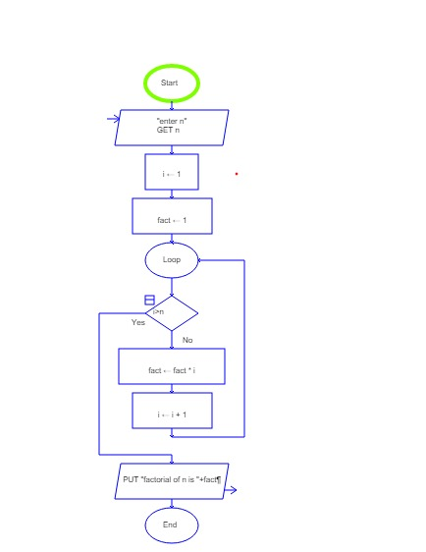

Input
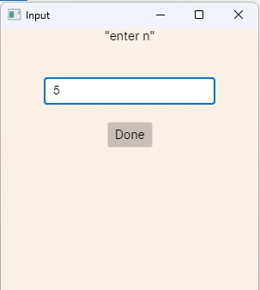

Output
