LCM

Aim
To calculate the Least Common Multiple (LCM) of two numbers using RAPTOR.

Apparatus Required
- Computer/Laptop
- RAPTOR Software
- Windows Operating System

Procedure
- Open RAPTOR.
- Input two numbers.
- Find the GCD of the numbers.
- Calculate the LCM using the formula:
LCM = (First Number × Second Number) ÷ GCD
- Display the LCM.
- Execute the flowchart.
Flowchart
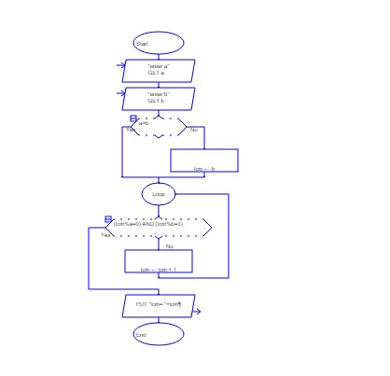
Input
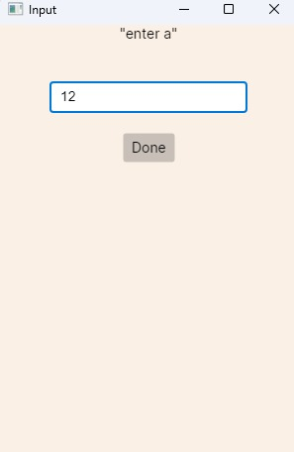
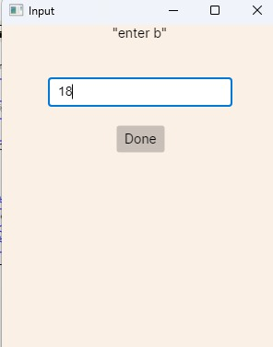
Output
