Palindrome

Aim
To check whether a given string is a palindrome using RAPTOR.

Apparatus Required
- Computer/Laptop
- RAPTOR Software
- Windows Operating System

Procedure
- Open RAPTOR.
- Input a string.
- Reverse the string.
- Compare the original and reversed strings.
- Display whether the string is a palindrome or not.
- Execute the flowchart.
Flowchart
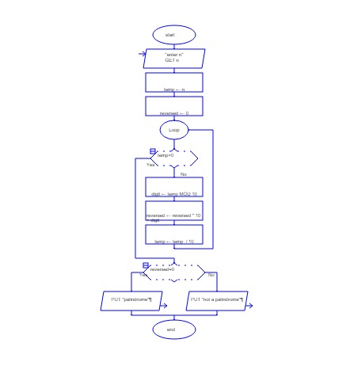
Input
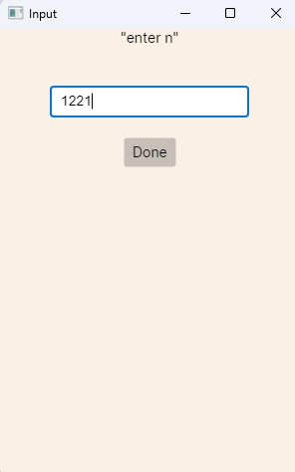
Output
