7. GCD

Aim
To find the Greatest Common Divisor (GCD) of two numbers using RAPTOR.

Apparatus Required
- Computer/Laptop
- RAPTOR Software
- Windows Operating System

Procedure
- Open RAPTOR.
- Input two numbers.
- Apply the Euclidean algorithm using a loop.
- Continue until the remainder becomes 0.
- Display the GCD.
- Execute and verify the result.
Flowchart
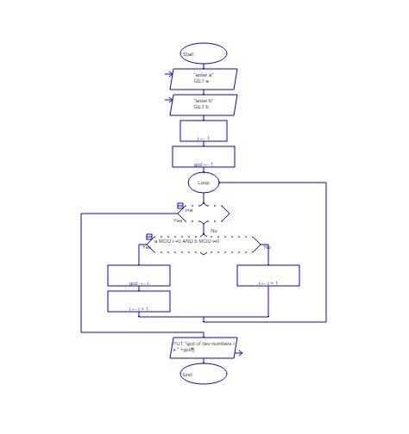
Input
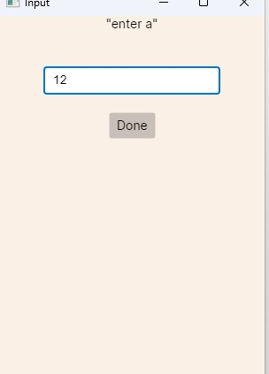
Output
