SIMATS ENGINEERING
ASSESSMENT TOOL 1

COURSE NAME: COMPUTER NETWORKS
COURSE CODE: CSA07

COURSE OUTCOME COVERED

CO5:
Design network topologies star, mesh, bus, and hybrid using networking devices, transmission media, and cabling standards
(BL2,BL5)

Assessment Tool Weightage: 40%

QUESTIONS: 3 Total Marks:30

Annexure A

Constraint-Based Problem Solving

Code of Conduct:

I Harish Kumar / 192521340 (Name / Reg No) certify that this submission is my original work and that I have adhered to the guidelines specified for this assessment.
I understand that any violation of academic integrity rules will result in disciplinary action.

Signature of the student:

Annexure A

Constraint-Based Problem Solving
- A multinational company is opening a new branch office in a remote rural location where high-speed wired internet is unavailable. The office must support cloud-based applications, video conferencing, and secure communication with the headquarters. The company has a limited budget for connectivity but requires uninterrupted business operations. As a network engineer, recommend a suitable internet connection, networking devices, and security mechanisms. Justify your recommendations by considering bandwidth limitations, reliability, cost, and future scalability
Answer — Question 1: Rural Branch Office Connectivity
Constraint Analysis
• No wired broadband available: rules out fiber/DSL/leased-line options entirely at this location.
• Must support cloud applications and video conferencing: needs sufficient bandwidth and, critically, low and stable latency/jitter, not just raw throughput.
• Secure communication with headquarters: all traffic between branch and HQ must be encrypted and authenticated.
• Limited budget: rules out expensive dedicated leased lines or traditional enterprise VSAT-only solutions as the sole connection.
• Uninterrupted business operations: a single point of failure in the internet connection is unacceptable — redundancy is required.
Recommended Internet Connectivity
The primary WAN link should be 4G/5G Fixed Wireless Access (FWA) using a cellular router, since rural areas increasingly have cellular tower coverage even where wired broadband has never been deployed, and 4G/5G FWA is substantially cheaper to deploy and operate than a traditional leased line or VSAT-only setup, while offering far lower latency than satellite — an important factor for real-time video conferencing. As a backup WAN link, a satellite internet service (e.g. a modern LEO satellite service) should be provisioned; although satellite has higher latency than cellular, it provides coverage independent of local cell-tower reliability, giving true physical-path diversity for the redundancy this scenario demands.
Recommended Networking Devices

Device | Recommendation | Purpose
SD-WAN Router/Firewall | Dual-WAN capable (e.g. Peplink Balance, Cisco Meraki MX, or pfSense with 2 WAN NICs) | Combines both WAN links, automatically fails over if the primary drops, and terminates the site-to-site VPN
Managed Switch | 8–16 port Gigabit managed switch | Connects office PCs, VoIP/video endpoints, and the Wi-Fi AP
Wireless Access Point | WPA3-capable business AP | Wireless connectivity for laptops/mobile devices in the office

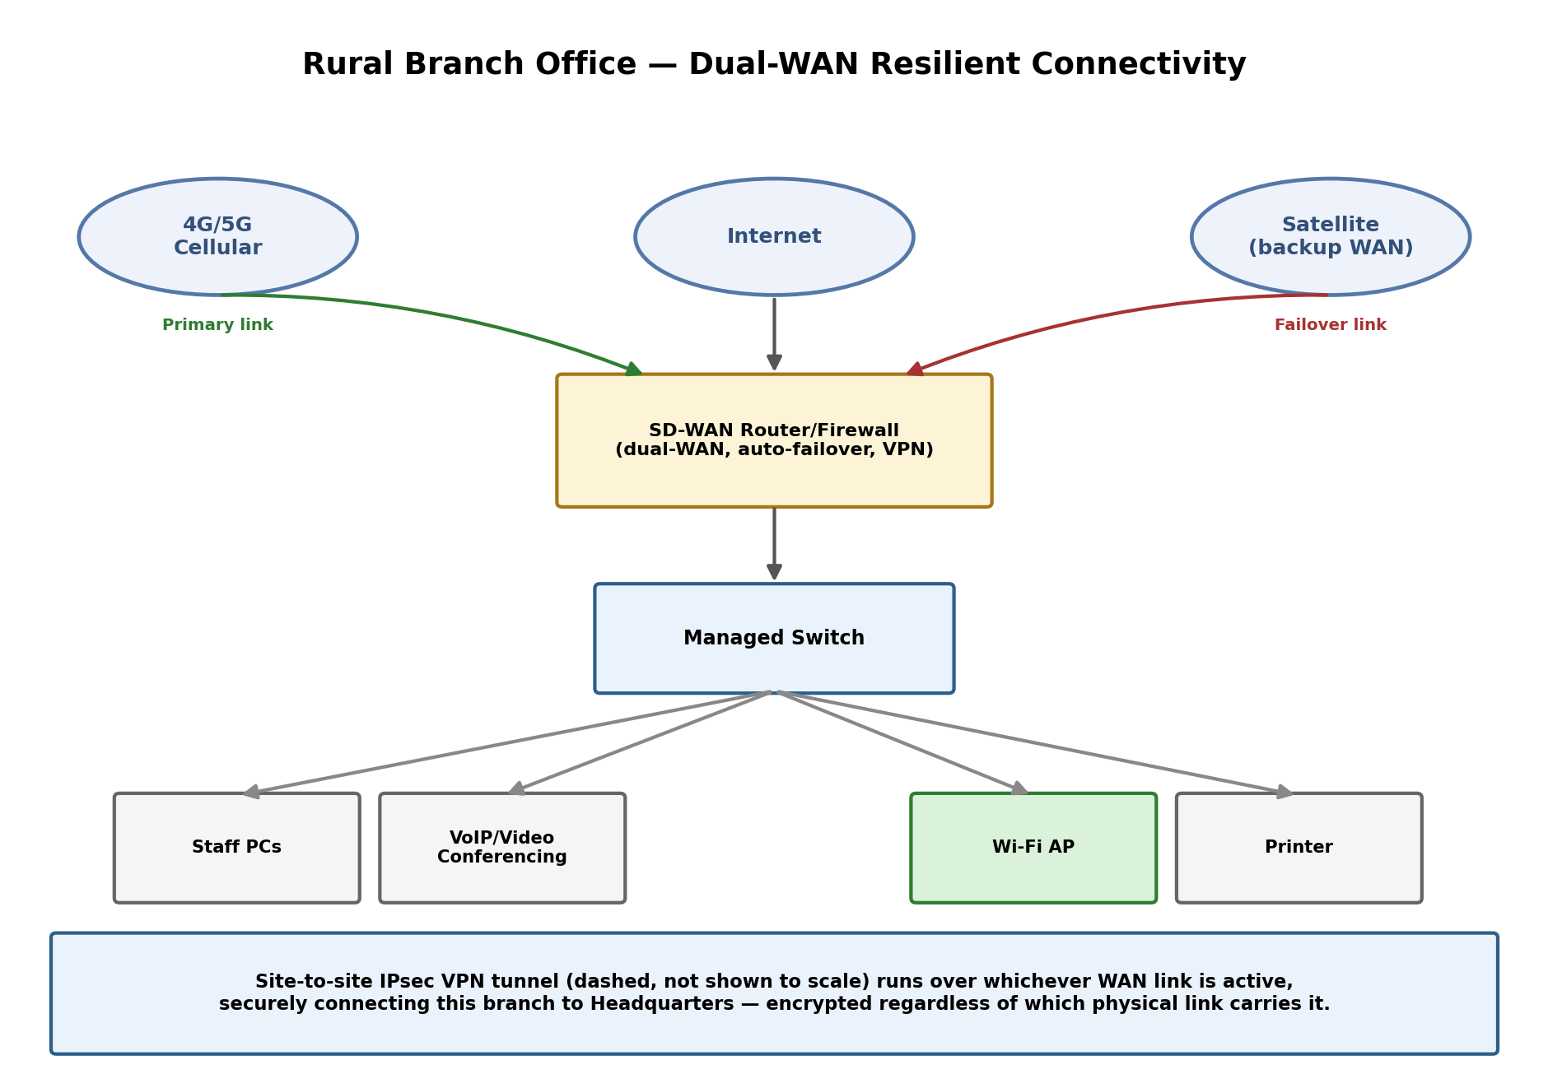
Figure 1.1 – Rural branch office with dual-WAN (4G/5G primary + satellite backup) and a VPN back to HQ.
Security Mechanisms
• Site-to-site IPsec VPN: establishes an encrypted tunnel between the branch's SD-WAN router and HQ's router, protecting all inter-site traffic regardless of which physical WAN link (cellular or satellite) is currently active.
• Integrated UTM/firewall features: since a standalone next-generation firewall would strain the budget, an all-in-one SD-WAN router with built-in firewall, intrusion prevention, and content filtering keeps security strong without adding separate hardware costs.
• WPA3-Enterprise or WPA3-Personal Wi-Fi security: protects the internal wireless network from unauthorized access.
• QoS (Quality of Service) prioritization: tags and prioritizes video-conferencing and VoIP traffic ahead of routine bulk data, so limited bandwidth is used where it matters most for real-time communication quality.
Justification Against Each Constraint
Bandwidth: a 4G/5G connection typically provides tens of megabits per second — comfortably enough for cloud applications and several concurrent HD video-conferencing streams (each needing roughly 2–4 Mbps), especially once QoS ensures that video/voice traffic is never starved by background downloads. Reliability: the dual-WAN design means the office keeps operating even if one link fails entirely — automatic failover typically completes within seconds, satisfying the requirement for uninterrupted business operations without needing a much more expensive fully-redundant wired solution. Cost: 4G/5G FWA plans are dramatically cheaper than leased lines or enterprise-grade VSAT contracts, and consolidating firewall/VPN/routing functions into one SD-WAN appliance avoids the cost of multiple separate security appliances. Future scalability: because the design is centered on an SD-WAN device, adding a third WAN link, onboarding more branch offices under the same centrally-managed SD-WAN fabric, or upgrading to a wired connection later (if one becomes available) requires no redesign — only configuration changes.
- A university plans to provide campus-wide wireless internet access for more than 3,000 students across classrooms, laboratories, libraries, and hostels. The network must support a large number of simultaneous users while minimizing signal interference and ensuring secure access. Due to budget constraints, only a limited number of wireless access points can be deployed. Analyze the requirements and propose an efficient wireless network design, including access point placement, frequency band selection, and authentication methods. Explain how your solution balances coverage, performance, security, and cost.
Answer — Question 2: Campus-Wide Wireless Network Design
Constraint Analysis
• Very large user base: 3,000+ students across varied building types with very different usage density (packed lecture halls vs. sparse hostel corridors).
• Limited number of access points: the AP budget cannot simply be scaled to match total headcount — placement and configuration must be intelligent, not brute-force.
• Minimizing signal interference: crowding many APs into a small area on the same channels causes co-channel interference that can hurt performance more than it helps.
• Secure access: thousands of individual students need controlled, auditable access without relying on an insecure single shared password.
• Balancing coverage, performance, security, and cost simultaneously.
AP Placement Strategy — Density-Based Deployment
Rather than distributing APs evenly across the whole campus, they should be concentrated where concurrent usage is highest. A rough capacity estimate: assuming perhaps 30–40% of 3,000 students are actively connected at any given moment (roughly 900–1,200 concurrent users), and that a well-configured enterprise AP can comfortably serve about 50–60 clients with good throughput, high-density zones need noticeably more APs at lower transmit power (creating smaller “cells” that can reuse channels more tightly and serve more users per square meter), while low-density zones (hostel corridors, administrative areas) can rely on fewer APs at higher transmit power for wide, economical coverage.
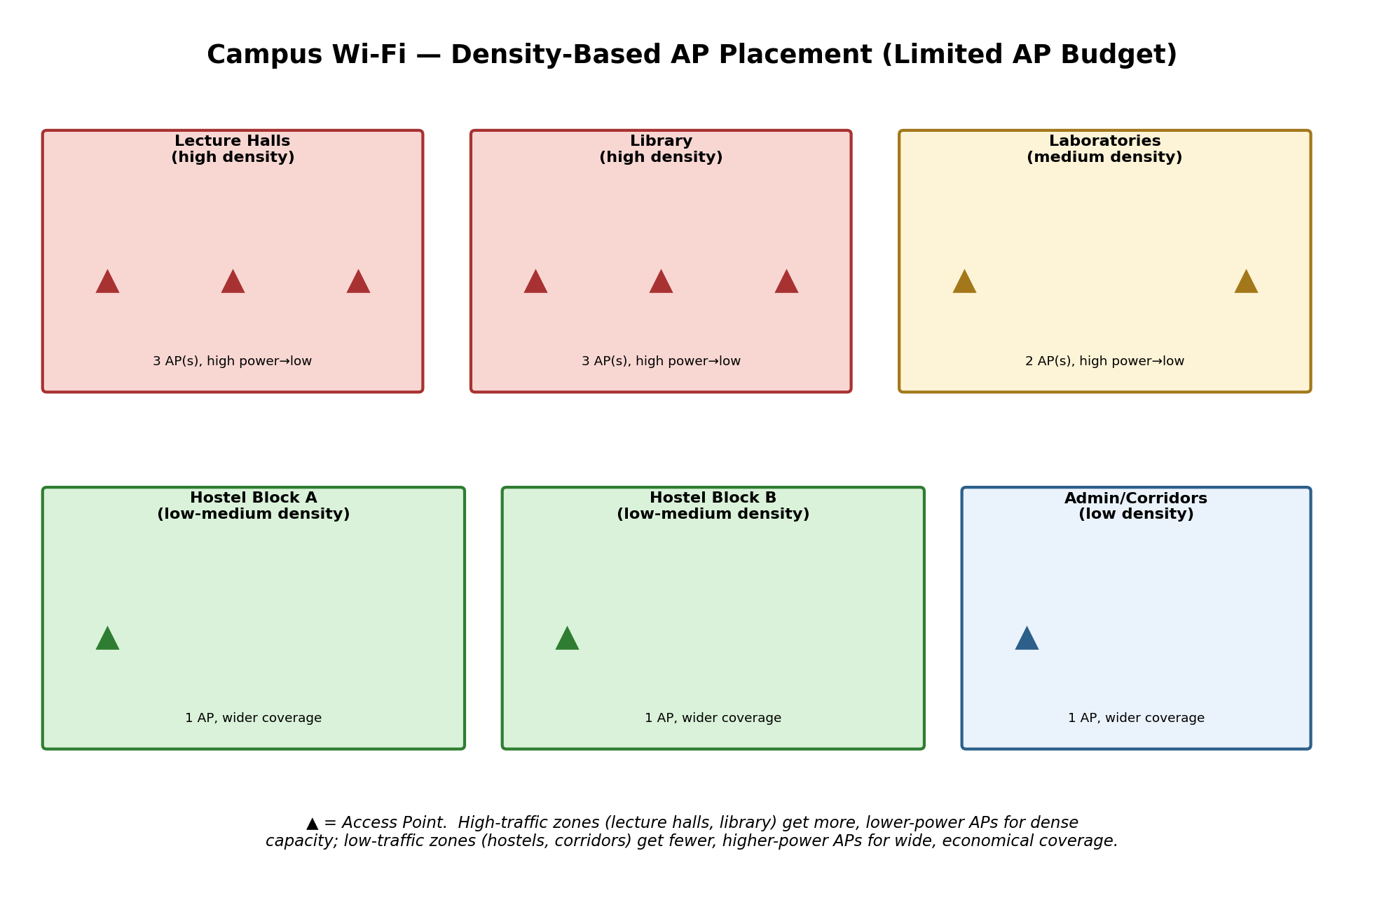
Figure 2.1 – Density-based AP placement: more, lower-power APs in high-traffic zones; fewer, higher-power APs elsewhere.
Frequency Band Selection & Interference Minimization
The 2.4 GHz band offers only 3 non-overlapping channels, making it prone to severe interference once more than a handful of APs are deployed close together — entirely unsuitable as the primary band for a dense, 3,000-student deployment. The 5 GHz band (and, on newer Wi-Fi 6E-capable hardware, the 6 GHz band) offers roughly 24 non-overlapping channels, allowing many more APs to be packed into the same area while still avoiding co-channel interference between neighboring cells. Dual-band APs should therefore be deployed with band steering enabled, actively pushing capable devices onto 5 GHz/6 GHz and reserving 2.4 GHz mainly for legacy devices and the sparser, wide-coverage zones. A cellular-style channel-reuse pattern (assigning different non-overlapping channels to adjacent AP cells, and only repeating a channel once cells are far enough apart) further minimizes interference in the high-density zones.
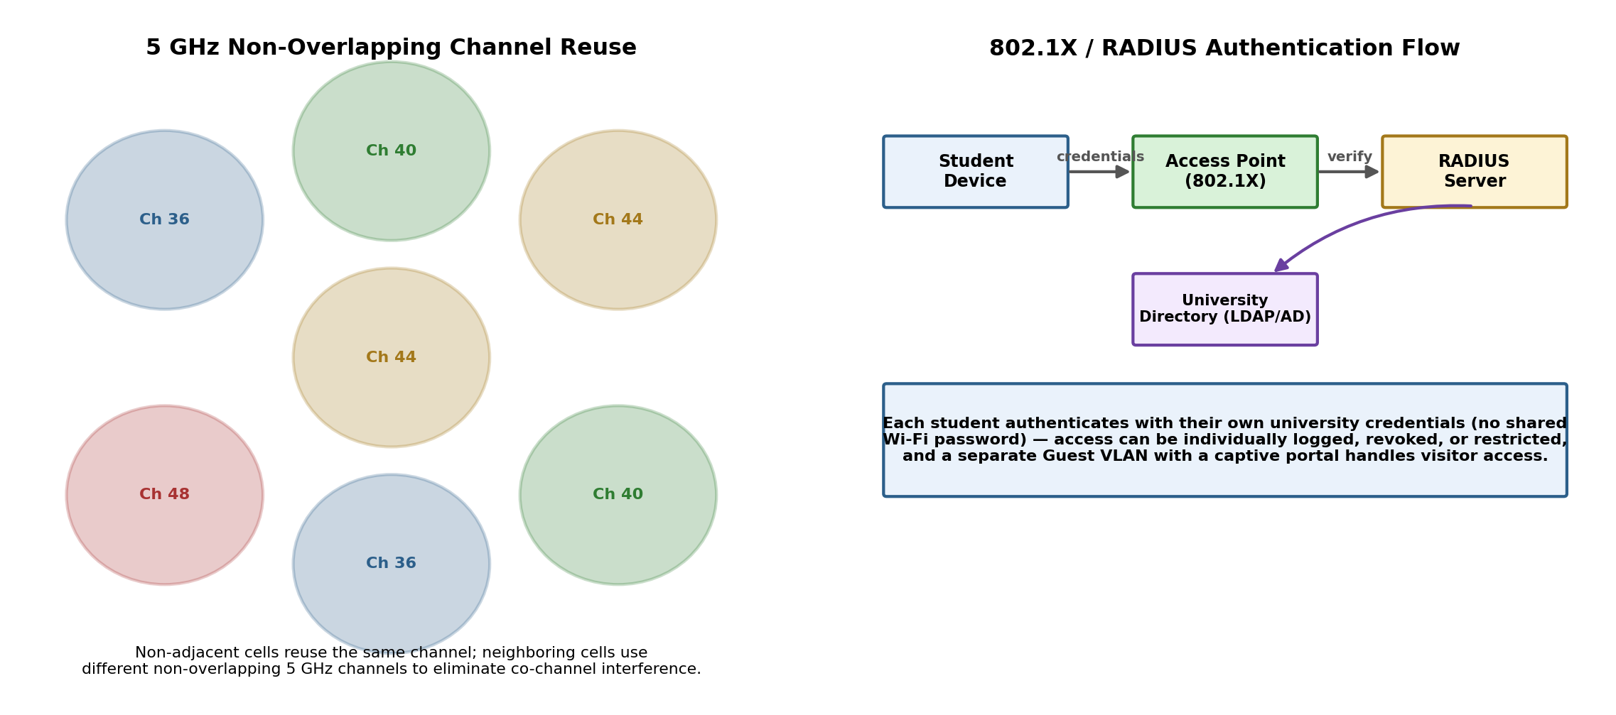
Figure 2.2 – Non-overlapping 5 GHz channel reuse pattern, and the 802.1X/RADIUS authentication flow.
Authentication Method
Rather than a single shared Wi-Fi password (which cannot be revoked per-user and offers no accountability), the network should use WPA2/WPA3-Enterprise with 802.1X authentication against a RADIUS server tied to the university's existing student directory (LDAP/Active Directory) — the same model used by real-world federated academic Wi-Fi (e.g. eduroam). Each student authenticates with their own university credentials, so access can be individually logged, and a single compromised or graduated account can be revoked without affecting anyone else. A separate Guest VLAN with a captive-portal login handles visitors without exposing them to the main academic network.
How This Balances the Four Constraints
Coverage and performance are balanced through density-based placement (concentrating limited APs where they are needed most) combined with 5/6 GHz band steering and channel reuse (letting a limited number of APs serve far more concurrent users than a naive 2.4 GHz-only deployment could, without interference collapsing throughput). Security is addressed through per-user 802.1X/RADIUS authentication rather than a shared password, giving both stronger protection and individual accountability. Cost is controlled because the AP budget is spent where it delivers the most value (high-density zones) rather than uniformly, and because a centralized Wireless LAN Controller manages all APs' channel/power settings automatically, minimizing the ongoing administrative burden that would otherwise come with manually tuning a large number of individual devices.
- A financial institution is upgrading its internal computer network to improve cybersecurity while allowing employees to access sensitive customer information and online banking services. The organization must comply with strict security policies without significantly affecting network performance or increasing operational costs. Design a secure network architecture by selecting appropriate network segmentation techniques, firewall deployment, authentication methods, and intrusion detection mechanisms. Justify your design by considering the constraints of security, performance, compliance, and budget.
Answer — Question 3: Secure Network Architecture for a Financial Institution
Constraint Analysis
• Strong cybersecurity: must protect highly sensitive customer and financial data from both external attackers and internal threats.
• Employee access to sensitive systems: staff still need functional, timely access to customer data and online banking systems to do their jobs.
• Strict compliance requirements: financial institutions are typically subject to standards such as PCI-DSS for any systems handling payment card data.
• Performance must not be significantly affected: security controls cannot introduce unacceptable latency into day-to-day operations.
• Operational cost must be controlled: the design should reuse existing capable infrastructure wherever possible rather than requiring an entirely new security stack.
Network Segmentation Design
The network is divided into function-based VLANs enforcing the principle of least privilege: a Teller/Customer-Service VLAN, a Back-Office/Admin VLAN, a highly restricted Sensitive Customer Database VLAN (protected by its own dedicated firewall rules and IDS sensor, since this segment holds the institution's most valuable data), and an isolated Guest Wi-Fi VLAN with no path to any internal segment. Inter-VLAN traffic is routed through the core Layer 3 switch, where Access Control Lists (ACLs) tightly restrict exactly which VLANs may communicate with which, and on what ports/protocols — for example, only specific back-office application servers may query the sensitive database VLAN, and Teller workstations may reach only the particular banking application ports they need, nothing more.
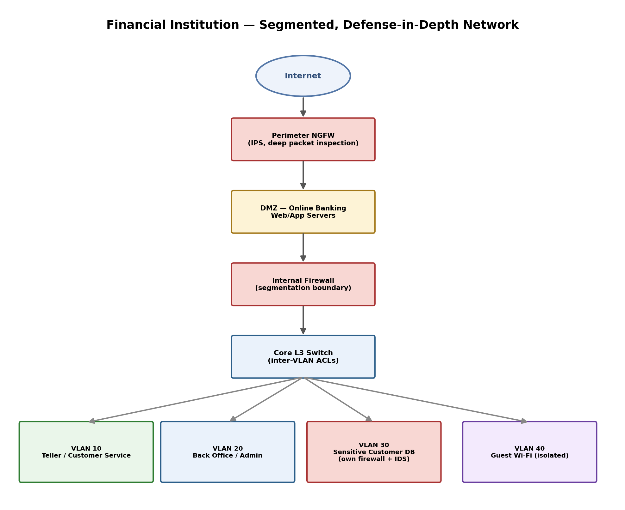
Figure 3.1 – Layered, segmented financial network: perimeter NGFW, DMZ, internal firewall, and function-based VLANs.
Firewall Deployment
A perimeter Next-Generation Firewall (NGFW) sits at the internet edge, performing deep packet inspection and blocking malicious traffic before it ever reaches internal systems. Public-facing online banking web/application servers are placed in a DMZ (demilitarized zone) between two firewall boundaries — isolated from both the raw internet and the internal network — so that even if a public-facing server were compromised, the attacker would still have to breach a second firewall boundary to reach any internal segment. An additional internal firewall sits between the DMZ/core network and the internal VLANs, and the most sensitive database VLAN is protected by its own dedicated firewall ruleset on top of the shared core ACLs — a defense-in-depth approach where no single control failure exposes the whole network.
Authentication Methods
All employee access to sensitive systems requires Multi-Factor Authentication (MFA) — a password combined with a one-time code or hardware token — so that a stolen password alone is not sufficient to gain access. Centralized identity management (Active Directory, paired with RADIUS or TACACS+ for authenticating administrative access to network devices themselves) enforces Role-Based Access Control (RBAC), ensuring employees can only reach the specific systems and data relevant to their job function, directly supporting the segmentation design above.
Intrusion Detection & Prevention
An Intrusion Detection/Prevention System (IDS/IPS) is deployed at the network perimeter and specifically around the sensitive customer database segment, monitoring for known attack signatures and anomalous traffic patterns in real time. Because this sits alongside (rather than fully in-line with) most internal traffic, and only the smaller, high-value database segment requires full in-line IPS enforcement, the performance overhead is concentrated only where the security payoff is highest.
Justification Against Security, Performance, Compliance, and Budget
Security is achieved through defense-in-depth: multiple independent layers (perimeter NGFW, DMZ isolation, internal firewall, per-VLAN segmentation, MFA, and IDS/IPS) mean a single failure or breach at any one layer does not automatically compromise the entire network. Performance is protected because segmentation and ACL enforcement are handled by the core L3 switch's existing hardware-accelerated forwarding, and dedicated deep inspection (the more computationally expensive control) is concentrated only at the perimeter and around the highest-value database segment rather than applied uniformly everywhere. Compliance is directly supported because network segmentation is a core, explicitly recommended control under frameworks such as PCI-DSS — isolating the systems that actually handle sensitive payment/customer data into their own tightly controlled segment substantially reduces the scope of what must be audited in full compliance detail. Budget is respected because the design reuses the organization's existing core switch for VLAN/ACL-based internal segmentation instead of purchasing a separate physical firewall for every segment boundary, reserving the cost of dedicated NGFW/IDS hardware for only the perimeter and the single most sensitive segment where the investment matters most.

