CSA:0714
COMPUTER NETWORKS
LAB PRACTICALS

By
B S Reshma
192521342

- Design and Configuration of Star Topologies using Packet Tracer.

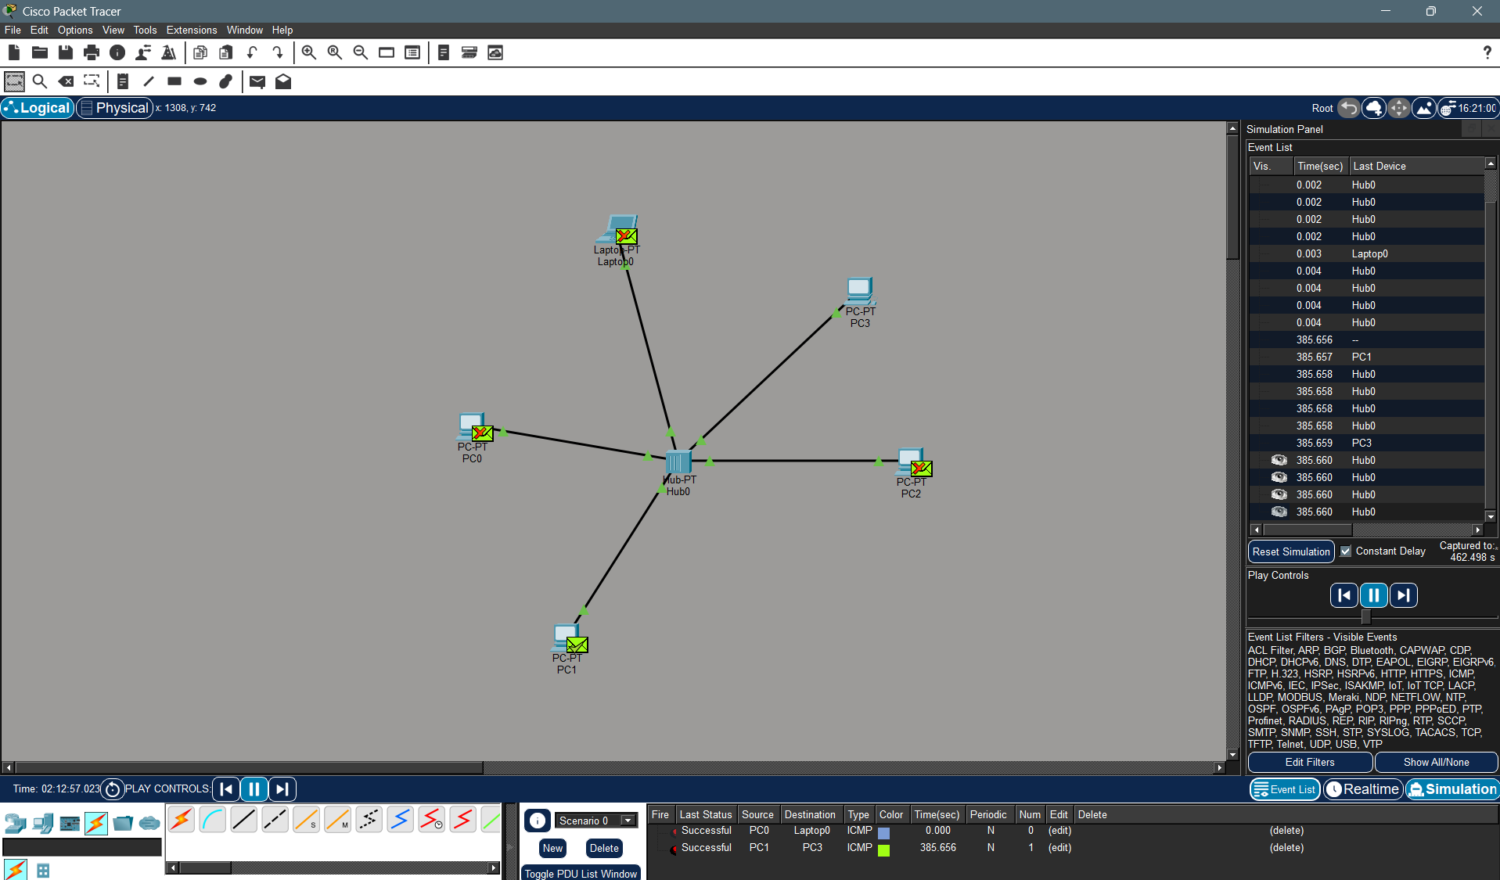

- Design and Configuration of BUS Topologies using Packet Tracer.
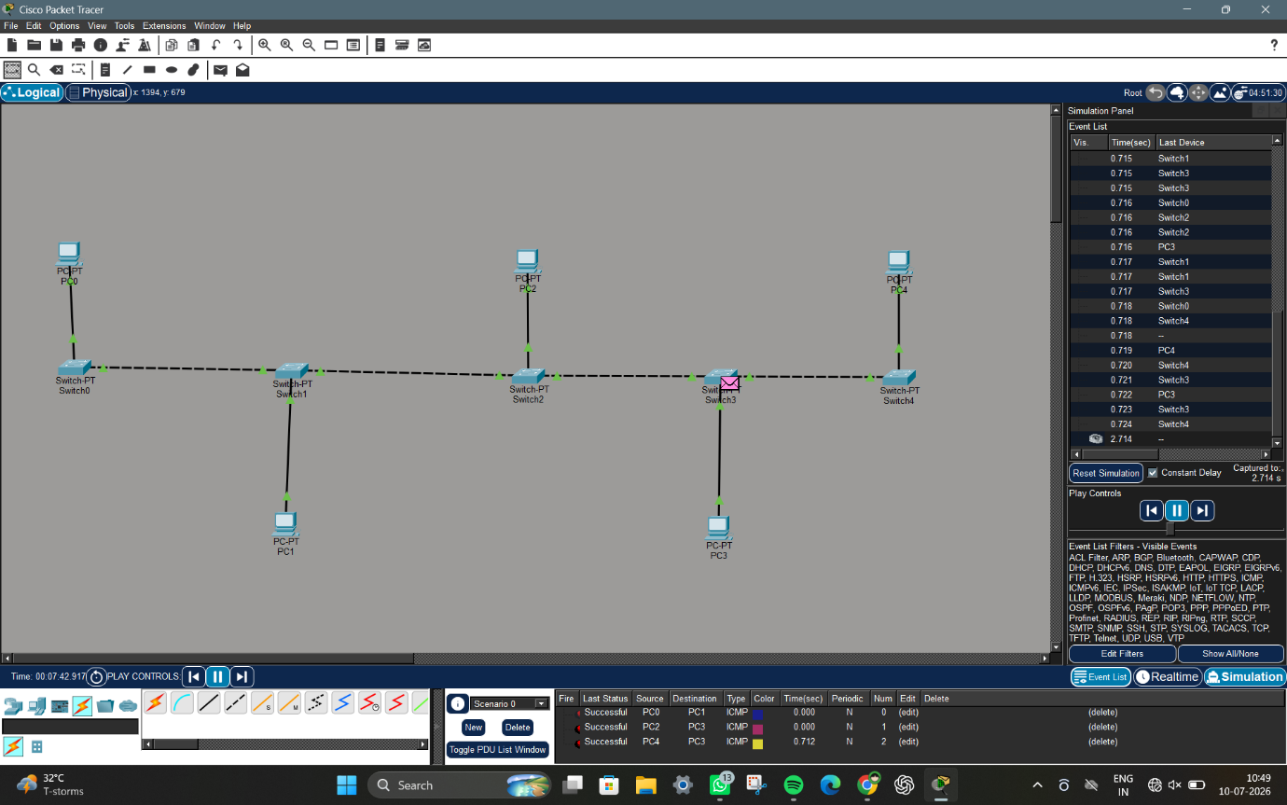

- Design and Configuration of RING Topologies using Packet Tracer.
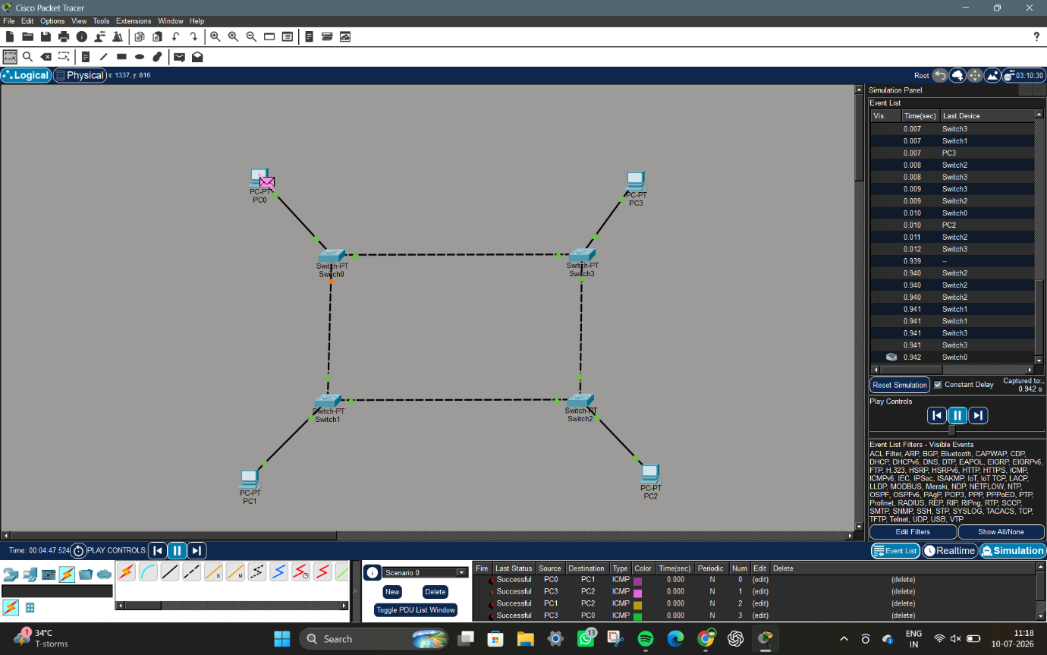

- Design and Configuration of RING Topologies using Packet Tracer. 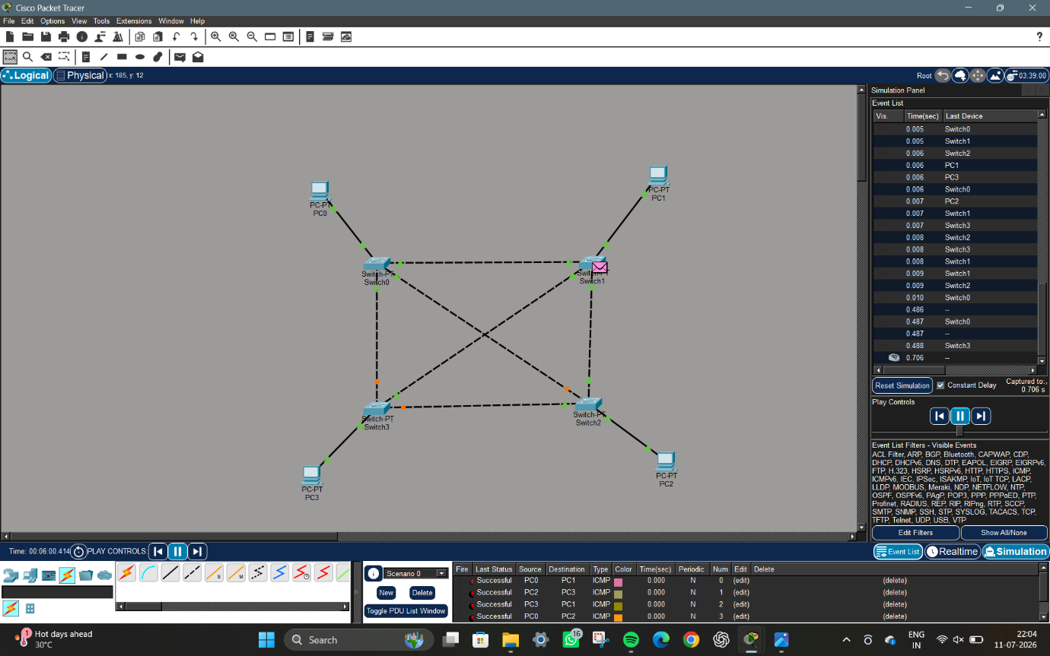

- Design and Configuration of Tree Topologies using Packet Tracer. 