SIMATS ENGINEERING
Department of Computer Science and Engineering
CSA10 – SOFTWARE ENGINEERING
ASSIGNMENT 1 – CO1
Design, Simulate and Validate an Agile Delivery Strategy
for the Omnichannel Order Fulfilment Platform
CO1: Apply agile methodologies and project management techniques such as scale and lean to effectively manage software projects using industry-standard tools like Jira.
Student Name | B S Reshma | Register Number | 192521432
Department / Section | IT | Academic Year / Semester | II/I
Faculty Name | Dr S Nanthini | Nature of Assignment | Individual
Duration | 1 Week | Total Marks | 50
Date of Submission |  | Date of Evaluation

MARK SHEET (Rubric-based Evaluation)
Task | Task Title | Max | Marks Awarded | Remarks
1 | Problem Investigation and Delivery Outcomes | 5
2 | Agile and Lean Operating Model | 6
3 | Prioritized Product Backlog (Jira / Selected Tool) | 8
4 | Capacity-Based Release Plan and Workflow | 7
5 | Delivery Simulation and Design Validation | 7
6 | Scaled Delivery Redesign and Validation (Day-4) | 12
7 | Individual Technical Reflection | 5
 | TOTAL | 50

OVERALL REMARKS

Student Signature | Faculty Signature | Program Director
B S Reshma

MANDATORY SUBMISSION EVIDENCE CHECK
Task | Evidence Expected | Status | Note
1 | Investigation questions, stakeholder findings / simulated responses, problem statement, scope boundaries, feasibility, measurable success criteria
2 | Comparison of two approaches, justified selection, operating model with Lean practices, tool investigation & selection
3 | ≥4 epics, ≥12 user stories with AC, priorities, estimates, dependencies, DoR, DoD, stakeholder conflict decisions, tool screenshots/export
4 | Capacity assumptions, 4 sprint goals, selected work, estimation method, dependencies (gateway/scanner), workflow + WIP limits, urgent/unfinished rules
5 | Bottleneck prediction, ≥10 simulated events (labelled), tool updates, ≥3 delivery indicators, interpretation + improvement for next sprint
6 | Impact diagnosis, redesign objectives, revised backlog/roles/sequencing, scaled Agile practices, ≥5 further events, comparative indicators, defence
7 | Significant decision, evidence-driven change, remaining vulnerability, ethical concern addressed, next investigation linked to own artefacts

SUBMISSION CHECKLIST (not separately marked)
Requirement | Status
All tasks (1–7) answered with required evidence | ☐ Yes ☐ Partly ☐ No
Investigation questions + stakeholder / simulated findings present (Task 1) | ☐ Yes ☐ Partly ☐ No
Two delivery approaches compared and operating model justified (Task 2) | ☐ Yes ☐ Partly ☐ No
≥4 epics + ≥12 stories with AC, priorities, estimates, DoR/DoD (Task 3) | ☐ Yes ☐ Partly ☐ No
Capacity plan, sprint goals, workflow with WIP limits shown (Task 4) | ☐ Yes ☐ Partly ☐ No
Sprint-1 simulation: prediction, ≥10 events, indicators, improvement (Task 5) | ☐ Yes ☐ Partly ☐ No
Day-4 redesign: impact, objectives, revised strategy, validation, defence (Task 6) | ☐ Yes ☐ Partly ☐ No
Individual reflection covering decision, change, vulnerability, ethics, next step (Task 7) | ☐ Yes ☐ Partly ☐ No
Tool screenshots / export (backlog, board, workflow) included and labelled | ☐ Yes ☐ Partly ☐ No
All simulated data clearly labelled as simulated (not presented as real delivery) | ☐ Yes ☐ Partly ☐ No
No unfilled template placeholders; work consistent throughout | ☐ Yes ☐ Partly ☐ No
Viva readiness (able to defend prioritization, capacity, WIP, indicators) | ☐ Yes ☐ No

SIMATS ENGINEERING
CSA10 – SOFTWARE ENGINEERING
ASSIGNMENT 1
CO1: Apply agile methodologies and project management techniques such as scale and lean to effectively manage software projects using industry-standard tools like Jira.

Assignment Title: Design, Simulate and Validate an Agile Delivery Strategy for the Omnichannel Order Fulfilment Platform

Nature of Assignment: Individual
Duration: One week
Total Marks: 50
Submission Date: __________________

Scenario – Agile Delivery Planning for the Order Fulfilment Platform
A retailer sells through a website, a mobile app and twelve physical stores. It plans an integrated order fulfilment platform to reduce failed orders, slow refunds and unclear order ownership. Warehouse pickers prioritize accurate stock reservation and pick lists, support agents prioritize order visibility and fast return handling, and finance reviewers require auditable refunds and payment reconciliation. A seven-member team must select a feasible eight-week release before a fixed festival-sale date despite uncertain capacity, limited stakeholder time and delayed payment-gateway access. Create and validate an Agile delivery strategy connecting these priorities to a justified backlog, team responsibilities, Lean flow controls and sprint goals. Revise the strategy when regions, staffing and coordination needs change, while protecting a complete order-to-delivery-to-refund journey.
Planning conditions for the representative release are stated below.
Observation | Scenario planning condition
Operational scope | Checkout, stock reservation, payment, picking, dispatch, tracking, returns, refunds and support lookup
Users | Customer, warehouse picker, support agent, store manager, finance reviewer and administrator
Reference data | Synthetic products, synthetic orders and simulated stock movements; no real customer or card data
Integration constraint | Payment gateway sandbox may be unavailable; preserve local order records and retry payment requests safely without double charging
Validation need | Verify stock, order status, price, authorization, persistence and refund audit behaviour

The retailer proposes an omnichannel order fulfilment platform. Its intended modules are a storefront catalogue, cart and checkout, payment integration, inventory synchronization, order tracking, a warehouse picking dashboard, returns and refunds, a support console and sales analytics. The system should connect a customer order to stock reservation, payment confirmation, picking, dispatch, tracking, delivery and, where needed, an authorized return and refund.
A seven-member cross-functional team plans an initial release within eight weeks using four two-week sprints. There is no established velocity. Test access to the payment gateway sandbox begins in week four, and a barcode-scanner test device arrives in week five. Warehouse and finance stakeholders can attend clarification and review meetings for ninety minutes per week. These are assignment planning assumptions.
Principal users are customers, warehouse pickers, support agents, store managers, finance reviewers and administrators. They need different permissions. Pickers require accurate pick lists; support agents require readable order and return status; finance reviewers require auditable refund approvals; engineers require traceable links between orders, payments and releases. Automation must preserve human responsibility for refund approval and stock corrections.
Define workload, service-level policies and acceptance thresholds as explicit planning assumptions. Dashboard values, stock counts and screenshots are illustrative evidence of displayed behaviour, not proof of production accuracy, performance, live inventory control or secure payment handling. Verify claims through repeatable checks. Distinguish deterministic rules, such as fixed low-stock thresholds, from trained machine-learning forecasting, and label simulations and proposed extensions accurately.

Design Challenge:
Management requests all nine modules in the initial release. Pickers prioritize stock reservation, pick lists and dispatch; support agents prioritize order tracking and return handling; finance reviewers prioritize refund approval and payment reconciliation. Gateway access and limited review time constrain delivery. A broad release may leave every workflow incomplete, while a storefront-only release may fail to reduce failed or delayed orders.
Design, simulate and validate an Agile project delivery strategy using a project-management tool of your choice that produces a coherent and achievable first release under these conditions.
Develop alternative delivery approaches and create a justified strategy connecting backlog priorities to the identified operational problems. Establish team responsibilities, capacity assumptions, dependency sequencing, stakeholder review arrangements and Lean practices for controlling waiting, rework and work in progress.
Investigate at least two suitable project-management tools, such as Jira, Trello, Azure DevOps or GitHub Projects. Select one and justify its suitability for your strategy, considering planning, workflow management, collaboration, reporting, accessibility and cost. Explain any limitations and how you will address them.
Before simulation, predict the principal delivery bottleneck and define measurable criteria for judging the strategy. Use the resulting evidence to revise your plan and defend the features retained, deferred or resequenced. Your final design must explain how the team will deliver, why the selected release should improve fulfilment, and how the chosen tool supports the strategy.

TASK 1 – INVESTIGATE THE PROBLEM AND DEFINE DELIVERY OUTCOMES
Investigate the platform from the perspectives of customers, warehouse pickers, support agents, finance reviewers and the development team.
- Formulate at least three questions to investigate about priorities, workflow problems or delivery constraints.
- Obtain initial evidence through a small stakeholder discussion, questionnaire or documented review of the existing process. If access is unavailable, use clearly identified simulated stakeholder responses.
- Define the product goal, first-release scope and exclusions.
- Establish at least three measurable delivery-success criteria.
- Examine technical, operational and financial feasibility at a level appropriate to project planning.
Evidence Expected
Investigation questions, stakeholder findings or labelled simulated responses, a problem statement, scope boundaries, feasibility observations and measurable success criteria.
Ans:

1.1 Problem statement
The retailer sells through a website, a mobile application and twelve physical stores. Its current fulfilment process has three connected problems: orders may fail because stock information is inaccurate, refunds may be delayed because approval and payment status are unclear, and customers or support agents may not know who owns an order at each stage. The platform must connect checkout, stock reservation, payment, picking, dispatch, tracking, returns and authorized refunds. The first release must be achievable in eight weeks by a seven-member team, even though gateway sandbox access is delayed until week four and the barcode-scanner test device arrives in week five.

1.2 Investigation questions
- 1. What causes the difference between stock shown as available at checkout and stock physically available to warehouse pickers?
- 2. Which order milestones do customers and support agents need to see to answer delivery and return enquiries without exposing internal notes?
- 3. What approval rules, amount limits and audit details must finance reviewers use before a refund can be issued?
- 4. What should happen when the payment gateway is unavailable, times out or receives the same payment request more than once?
- 5. How much time can warehouse and finance representatives commit to clarification and sprint reviews, given the shared limit of ninety minutes per week?

1.3 Stakeholder findings
The following are simulated responses for assignment planning; they are not actual interviews or verified observations.
Stakeholder | Simulated finding | Implication for the product
Customer | Tracking remains at “processing” without a clear milestone. | Show permitted milestones such as paid, picked, dispatched and delivered.
Warehouse picker | A pick list may contain an item already sold through another channel. | Reserve stock atomically and show only valid reserved orders on pick lists.
Support agent | Customers contact support repeatedly because return and refund status is not visible. | Provide a single order lookup with readable return and refund status.
Finance reviewer | Refund approval is sometimes communicated informally and is difficult to audit. | Use role-based approval, amount limits and an immutable decision record.
Store manager | Store and warehouse stock movements need a consistent record. | Record stock adjustments with an authorized user and reason.
Development team | Gateway access is delayed and the team has no established velocity. | Build a local payment adapter and use a conservative initial sprint commitment.

1.4 Product goal, first-release scope and exclusions
Product goal: deliver a reliable and traceable order journey from checkout to delivery and, when required, to an authorized refund, while preserving stock integrity and clear ownership across customer, warehouse, support and finance roles.
First-release scope:
- Authenticated customer access and order placement using synthetic product and order data.
- Stock reservation with expiry and rejection of out-of-stock orders.
- Payment request handling with an idempotency key, a local adapter/stub and safe retry behaviour.
- Warehouse pick list for reserved and eligible paid orders, followed by dispatch status updates.
- Customer tracking page showing permitted order milestones.
- Return request and role/amount-based refund approval with an audit record.
- Support order lookup and a fixed-threshold low-stock alert, subject to capacity and release-gate review.
Exclusions from the first release: production payment processing or real card data, demand forecasting, product recommendations, multi-currency pricing, loyalty features, advanced sales analytics and full promotional campaign management. The nine proposed modules remain on the longer-term product roadmap; inclusion in a roadmap does not mean that every module is complete in this release.

1.5 Measurable delivery-success criteria
Criterion | Target / acceptance threshold | How it will be verified
End-to-end journey | At least one synthetic order completes Paid → Picked → Dispatched → Delivered, and a valid return reaches Refunded with an audit entry. | Repeatable integration test using synthetic data; inspect persisted order and refund history.
Stock integrity | For 100 concurrent test attempts against 10 units, no more than 10 reservations succeed and stock never becomes negative. | Automated concurrency test and database assertions.
Payment idempotency | Ten retries with the same payment key create one payment intent and one associated order; failed gateway attempts remain recoverable. | Automated retry test against the local adapter and sandbox when available.
Authorization and audit | A support agent cannot approve a refund; an authorized finance reviewer can approve within configured limits, and each decision records actor, time, amount and reason. | Role-based negative and positive tests; audit-record inspection.
Release reproducibility | A clean checkout/build and documented setup reproduce the core synthetic journey, with records preserved after application restart. | Fresh-environment build, smoke test and persistence check.
These are proposed acceptance targets, not claims that the system has already achieved them.

1.6 Feasibility analysis
Feasibility area | Observation and decision
Technical | A web application, relational persistence, synthetic data, local payment adapter and automated tests are feasible for a limited first release. Gateway sandbox access begins in week four and scanner hardware in week five, so interfaces and simulated adapters must be developed first. Real payment processing is excluded.
Operational | The proposed workflow matches the responsibilities of customers, pickers, support agents and finance reviewers. Warehouse staff must agree stock-reservation expiry and pick eligibility; finance must approve refund limits. Stakeholder time is restricted to ninety minutes weekly, so questions should be batched and reviewed against prepared examples.
Financial | Planning assumes existing development computers and available test accounts. No paid hosting or commercial integration cost is assumed. Any hosting, messaging or gateway charges must be separately estimated and approved before production use.
Task 1 conclusion: the feasible first release is not a broad collection of disconnected screens. It is a narrow but complete order-to-delivery-to-refund journey supported by stock integrity, safe payment retries, role-based authorization and auditable records.

TASK 2 – DESIGN AND JUSTIFY THE PROJECT MANAGEMENT APPROACH
Develop two meaningfully different delivery approaches for the scenario. Consider Scrum, Lean flow management, XP practices or a justified combination.

For each approach, explain how work would be selected, coordinated and reviewed.

Identify its suitability for changing requirements and cross-functional work.

Examine likely limitations, overheads and delivery risks.

Select an approach and create a tailored operating model defining responsibilities, planning activities, review points, escalation procedures and stakeholder participation.

Explain how Lean principles will help reduce waiting, unnecessary handovers, rework or excessive work in progress.

Evidence Expected

Comparison of two approaches, a justified selection and an original operating model with explicit Lean practices.

Ans:

2.1 Comparison of delivery approaches
Dimension | Approach A: Scrum with Lean flow controls | Approach B: Continuous Kanban with release milestones
Work selection | Select an ordered set of ready stories against a sprint goal and available capacity. | Pull the highest-value ready story when WIP permits; reprioritize continuously.
Coordination | Product lead, daily coordination, refinement, sprint planning and cross-role dependency discussion. | Flow manager/service owner, replenishment meetings and frequent coordination around blocked work.
Review | Two-week sprint review and retrospective with warehouse and finance representatives. | Weekly service review and flow review; release milestone demo.
Changing requirements | Negotiate changes against the sprint goal; urgent work replaces equivalent planned scope. | Reorder the queue continuously; expedite only under an explicit policy.
Cross-functional suitability | Clear timeboxes help a small team coordinate frontend, API, inventory, payments, QA and DevOps work. | Useful when work arrives unpredictably and specialists need to pull tasks across functions.
Limitations and risks | Without historical velocity, the team may overcommit; sprint boundaries can delay urgent changes if poorly governed. | Without firm milestone discipline, payment integration or end-to-end testing may be postponed; constant reprioritization can fragment focus.
Selected approach: Scrum with Lean flow controls. Four two-week sprints provide predictable review points for the limited-time warehouse and finance stakeholders. Lean WIP limits, blocked-item visibility and pull-based completion prevent the sprint structure from hiding queues. This combination supports both a fixed eight-week release and controlled change.

2.2 Tailored operating model and responsibilities
Role (seven-person team) | Primary responsibility | Decision / evidence owned
Product and analysis lead | Maintains product goal, backlog order, stakeholder questions and scope decisions. | Accepts/rejects scope trade-offs; escalates unresolved business decisions.
Frontend engineer | Checkout, tracking, support lookup and accessible user interface. | UI behaviour, keyboard navigation and readable status labels.
Order API engineer | Order lifecycle, order persistence and status transition rules. | Order API contract, validation and transition tests.
Inventory and data engineer | Stock reservation, expiry, stock movement and pick-list data. | Concurrency tests and stock audit evidence.
Payments and security engineer | Payment adapter, idempotency, authorization and refund security. | Payment contract, safe retry and authorization controls.
QA engineer | Acceptance tests, integration tests, regression and release evidence. | Test results; may reject stories that do not meet acceptance criteria.
DevOps engineer | Build, deployment configuration, environment and monitoring checks. | Reproducible build, deployment notes and smoke-test evidence.

2.3 Cadence, stakeholder participation and escalation
- Daily: 15-minute team coordination focused on progress toward the sprint goal, today's plan and blockers.
- Weekly: one 90-minute stakeholder window shared by warehouse and finance. The product lead batches clarification questions and uses examples rather than open-ended discussion.
- At each sprint start: planning, capacity review, dependency check and a sprint goal.
- During each sprint: backlog refinement and a short cross-role design discussion when an API or data contract changes.
- At each sprint end: working increment review, acceptance evidence and retrospective.
- Escalation: an item blocked for more than one working day is raised to the product lead and relevant stakeholder. A decision affecting security, refund authority or stock integrity cannot be bypassed to protect a date.

2.4 Lean practices
Lean control | How it is applied | Waste reduced / evidence
Limit WIP | Maximum four development items, two review items and two test items; blocked work remains visible and counted. | Reduces multitasking; board shows queue size and ageing.
Finish before starting | When QA or review reaches its limit, engineers help resolve existing work instead of starting more stories. | Reduces waiting and hand-offs; compare queue age and cycle time.
Reduce waiting | Create a payment contract and local adapter before week-four sandbox access; prepare scanner interface before week-five device arrival. | Avoids idle integration work; inspect blocked days.
Prevent rework | Agree acceptance examples, including negative cases, before a story enters Ready. | Track reopened stories and clarification-related rework.
Single source of truth | Use one Jira board for ownership, status, blockers and evidence links. | Avoids duplicate status reporting and conflicting task lists.

2.5 Project-management tool comparison and selection
Criterion | Jira | Trello
Planning | Supports epics, stories, backlog ordering, sprint planning, estimates and issue links. | Simple cards and lists; more manual structure is needed for complex dependencies.
Workflow | Configurable statuses, transitions, board views and WIP-related controls depending on configuration. | Easy visual columns; advanced workflow enforcement may require power-ups or conventions.
Collaboration | Comments, assignees, labels, links and notifications support cross-functional work. | Comments, members, labels and attachments support lightweight collaboration.
Reporting | Sprint and issue reports can support planned-versus-completed and flow review; availability depends on plan and configuration. | Basic visual tracking; detailed metrics may require manual export or extensions.
Accessibility | Browser-based access; permissions and accessibility should be checked for the actual account and users. | Browser-based and straightforward; permissions and accessibility still need verification.
Cost and limitation | Selected for structured backlog and sprint traceability. Actual free/paid limits must be checked; do not assume every report is included. | Lower setup overhead for a small board, but dependency and reporting detail may be less convenient.
Jira is selected because this assignment needs traceable epics, user stories, dependencies, sprint planning and review evidence. Trello is a credible simpler alternative, particularly if Jira access or cost is restrictive. The team should confirm account permissions, plan limits and available reports before relying on them. If a report is unavailable, export issue data and calculate the indicator in a spreadsheet.
Task 2 conclusion: Scrum provides the release rhythm; Lean controls waiting, handovers, rework and WIP; Jira provides the shared planning and evidence record.

TASK 3 – CONSTRUCT A PRIORITIZED PRODUCT BACKLOG IN THE SELECTED TOOL
Ans:

3.1 Backlog structure and prioritization method
Create four Jira epics: E1 Order and Stock Core; E2 Payments and Refund Governance; E3 Warehouse Fulfilment and Tracking; E4 Reproducible Delivery and Support. Prioritize using MoSCoW (Must, Should, Could) with a dependency and risk check. A Must item is required to make the order journey safe and usable; Should items improve operations but may be deferred if capacity is insufficient; Could items are optional. Story points are relative size and uncertainty, not hours.

3.2 Jira-ready user stories
ID / Epic | User story and acceptance criteria | Priority / points | Dependency | Responsible role
S01 / E1 | As a user, I want to sign in so that I can access only the functions assigned to my role. AC: valid credentials create a session; invalid credentials are rejected; customer, picker, support and finance permissions are checked server-side. | Must / 3 | None | Security / API
S02 / E1 | As a customer, I want to place an order so that stock is reserved accurately. AC: available stock is reserved atomically with expiry; out-of-stock orders are rejected; stock cannot become negative under concurrent requests. | Must / 5 | S01 | Order API
S03a / E2 | As the platform, I want an idempotency key and local payment stub so that retries do not create duplicate payment intents. AC: same key returns the same intent; failure leaves an order recoverable; no real card data is stored. | Must / 2 | S02 | Payments engineer
S03b / E2 | As the platform, I want to connect the gateway sandbox so that payment outcomes can be reconciled. AC: success, failure and timeout responses are mapped; retries are safe; request/response identifiers are logged without sensitive data. | Must / 3 | S03a; sandbox from week 4 | Payments engineer
S04 / E3 | As a picker, I want a pick list containing eligible reserved and paid items so that I do not pick stock assigned elsewhere. AC: only assigned eligible orders appear; quantities match reservations; corrections require an authorized reason. | Must / 3 | S02 | Inventory engineer
S05 / E3 | As a warehouse user, I want to dispatch an order and update its status so that downstream users can track fulfilment. AC: only valid transitions are accepted; actor and timestamp are recorded; invalid transitions are rejected. | Must / 5 | S03a, S04 | Order API
S06 / E3 | As a customer, I want to see permitted tracking milestones so that I understand order progress. AC: paid, picked, dispatched and delivered milestones display; internal notes are hidden; labels are screen-reader readable. | Must / 3 | S05 | Frontend engineer
S07 / E2 | As a customer, I want to request a return so that an eligible purchase can be reviewed. AC: only the order owner can request; return window is checked; request status is persisted. | Must / 3 | S05 | Order API
S08 / E2 | As a finance reviewer, I want to approve or reject a refund within my authority so that refunds are controlled and auditable. AC: support role cannot approve; amount limit is enforced; actor, time, amount and reason are recorded. | Must / 5 | S03a, S07 | Payments / Security
S09a / E4 | As a developer, I want a repeatable local build and smoke check so that the core application can be verified. AC: documented setup succeeds; health check passes; synthetic journey can be run. | Must / 3 | S01, S02 | DevOps
S09b / E4 | As a developer, I want a tagged deployment pipeline so that releases are traceable. AC: tagged build is reproducible; deployment notes and rollback instructions are available. | Should / 2 | S09a | DevOps
S10 / E4 | As a support agent, I want to look up an order and see return/refund status so that I can answer customer questions. AC: permitted search finds an order; unauthorized records are hidden; status and timestamps are readable. | Should / 3 | S05, S07, S08 | Frontend engineer
S11 / E1 | As a store manager, I want a fixed-threshold low-stock alert so that replenishment can be considered. AC: configured threshold triggers one alert per item; threshold and alert event are recorded. | Should / 3 | S04 | Inventory engineer
S12 / E3 | As a picker, I want barcode confirmation so that the picked item is checked against the pick list. AC: correct scan confirms the item; wrong item is rejected; scan records are retained. | Should / 3 | S04; device from week 5 | Inventory engineer
S13 / E4 | As a manager, I want sales analytics so that I can review order totals. AC: totals reconcile with synthetic order records. | Could / 3 | S05 | Frontend / Data
The backlog contains four epics and fifteen refined story slices. The split of S03 and S09 is deliberate: sandbox integration cannot be completed before week four, and a local build is useful before full pipeline hardening.
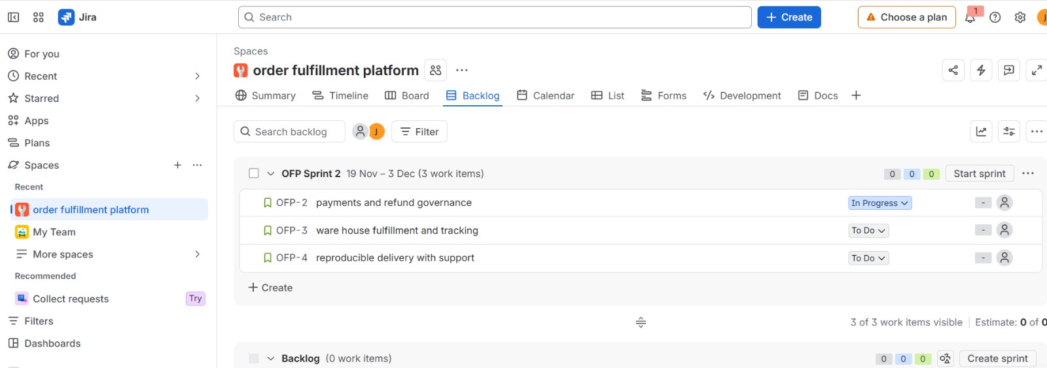
Figure 3.1: Jira Project Board Showing the Four Product Epics

3.3 Essential and deferred modules
Decision | Modules / capabilities | Reason
Retain in first release | Order placement, stock reservation, payment idempotency, pick list, dispatch, tracking, return request, refund approval, support lookup and reproducible build. | Together they form a complete order-to-delivery-to-refund journey and address the principal operational failures.
Conditional / Should | Low-stock alert, barcode confirmation, pipeline hardening. | Useful operational improvements, but must not compromise the core journey or release validation.
Defer | Sales analytics, demand forecasting, recommendations, multi-currency, loyalty and promotions. | They add breadth without fixing stock integrity, payment recovery or refund authorization; analytics also depends on trustworthy underlying records.

3.4 Definition of Ready and Definition of Done
Definition of Ready (DoR):
- The user, business outcome and affected role are identified.
- Acceptance criteria include at least one positive and one negative example.
- Dependencies, owner and priority are recorded; required stakeholder decision is available.
- Privacy and authorization questions are resolved before implementation.
- The story is small enough to complete and verify within one sprint.
Definition of Done (DoD):
- Code is peer-reviewed and relevant unit, integration and regression tests pass.
- Persistent state, validation and server-side authorization are verified.
- No real customer or card data appears in test fixtures, logs, screenshots or exports.
- User-facing screens have readable labels, keyboard access and screen-reader-compatible status information.
- Build/deployment instructions are updated and the evidence link is attached to the Jira issue.
- The product owner accepts the story against its criteria; UI completion alone is not sufficient.

3.5 Stakeholder trade-off decisions
Decision 1 – Stock reservation versus analytics: picker concerns about overselling take priority over management's request for a broad dashboard. A dashboard cannot repair a failed pick caused by inaccurate stock. Therefore S02 and S04 are Must, while S13 is Could and deferred.
Decision 2 – Refund governance versus promotional features: finance's need for authorized, auditable refunds takes priority over promotional breadth. An unauthorized refund creates direct financial exposure and weakens traceability. Therefore S08 is Must, while loyalty and promotions are excluded from the first release.
Jira artefact specification: create the four epics, enter S01–S13 (including the split slices S03a/S03b and S09a/S09b), set priority and story points, assign the listed roles, and link the stated dependencies. The table above is a Jira-ready export specification; it is not a screenshot or evidence of an already-created Jira project.

TASK 4 – CREATE A CAPACITY-BASED RELEASE PLAN AND DELIVERY WORKFLOW
Design the four-sprint release plan using explicit assumptions about team availability and capacity.
- Define a goal for each sprint.
- Select work that fits the assumed capacity.
- Explain your estimation method and avoid treating story points as fixed hours.
- Represent dependencies and cross-functional responsibilities, including the week-four gateway and week-five scanner constraints.
- Create a development workflow in the selected tool with statuses, transition rules and completion checks. Distinguish this workflow from the operational order lifecycle.
- Set and justify work-in-progress limits where applicable.
- Define how blocked work, urgent requests and unfinished stories will be handled.
- Show how the selected features collectively achieve the product goal.
Evidence Expected
Release plan, capacity assumptions, sprint goals, selected-tool board or workflow, work-in-progress policies and dependency-management decisions.
Ans:

4.1 Capacity assumptions and estimation
Planning assumption: seven team members are available for ten working days per sprint, with six focused hours per person per day. Nominal capacity is 7 × 10 × 6 = 420 hours. Reserve 20% (84 hours) for stakeholder reviews, unplanned defects, integration and support, leaving 336 focused hours. Story points represent relative effort, complexity and uncertainty; they are not fixed hours and are not converted into person-hours. Because there is no established velocity, the initial 16-point sprint ceiling is provisional.

4.2 Four-sprint release plan
Sprint / weeks | Sprint goal | Selected stories | Points | Dependency / constraint
Sprint 1 / Weeks 1–2 | Secure ordering foundation and prove local build. | S01, S02, S03a, S04, S09a | 16 | Use synthetic data and local payment stub; agree reservation expiry.
Sprint 2 / Weeks 3–4 | Deliver dispatch, tracking and stock visibility; harden build. | S05, S06, S11, S09b | 13 | Sandbox opens in week 4; prepare contract and adapter before access.
Sprint 3 / Weeks 5–6 | Integrate sandbox, controlled returns/refunds and scanner where feasible. | S03b, S07, S08, S12 | 14 | Gateway access from week 4; scanner device arrives in week 5.
Sprint 4 / Weeks 7–8 | Complete support visibility, regression and release rehearsal. | S10 | 3 | Reserve remaining capacity for carryover, security checks, regression and release rehearsal.
The initial unsliced Sprint 1 proposal would have been 21 points and exceeded the provisional 16-point ceiling. S03 is split into S03a (local idempotency and stub) and S03b (sandbox integration); S09 is split into S09a (local build and smoke check) and S09b (pipeline hardening). This moves gateway-dependent work to Sprint 3 and balances the plan at 16, 13, 14 and 3 points. S13 is deferred.

4.3 Dependency sequencing and cross-functional responsibility
- S01 establishes identity and role permissions before order and refund functions are exposed.
- S02 establishes reservation integrity before pick lists and payment processing rely on reserved stock.
- S03a is completed against a local adapter; S03b waits for sandbox availability in week four.
- S04 supplies eligible reserved items to the warehouse; S05 requires payment and picking readiness before dispatch.
- S06 depends on S05 so customer-visible milestones reflect valid operational transitions.
- S07 depends on a delivered/eligible order; S08 depends on the return request and payment record.
- S12 is tested only after the barcode device arrives in week five; a simulated scanner interface can be prepared earlier.
- QA owns repeatable acceptance and integration checks; engineers remain responsible for fixing defects in their components.

4.4 Development workflow and transition rules
Status | Entry / exit rule
Ready | DoR satisfied; priority, estimate, owner, acceptance criteria and dependencies recorded.
In Progress | A developer pulls the item only when WIP permits; work and evidence are linked to the issue.
Review | Implementation complete and peer review requested; reviewer checks design, security and maintainability.
Test | Review passed and acceptance evidence is available; QA runs positive, negative and relevant regression tests.
Blocked | A dependency or defect prevents progress; blocker reason, owner and next action are recorded. Blocked items remain visible and count toward WIP.
Done | DoD met, tests pass, evidence attached and product owner acceptance recorded.
Permitted flow: Ready → In Progress → Review → Test → Done. Any active state may move to Blocked with a reason and owner; after resolution it returns to the appropriate prior working state. Failed review returns to In Progress. Failed testing returns to In Progress with a defect link. The workflow above is the software-development workflow. It is distinct from the operational order lifecycle (Placed → Reserved → Paid → Picking → Dispatched → Delivered → Return Requested → Refund Approved/Rejected → Refunded).

4.5 WIP, blocked work, urgent requests and unfinished stories
Set WIP limits at four In Progress development items, two Review items and two Test items. The single QA engineer makes the test queue a likely constraint, so the test limit is intentionally tight. When a limit is reached, the team finishes or helps unblock existing work instead of pulling another item. A blocked item remains counted and must show an owner and next action. Permit at most one expedite item only when the product lead removes equivalent planned work and records the trade-off. Unfinished stories return to the ordered backlog for re-estimation and replanning; partial work is not marked Done or counted as completed.
Task 4 conclusion: the release plan sequences the minimum capabilities needed for a complete journey, protects capacity for uncertainty and makes the delayed gateway and scanner explicit dependencies.

TASK 5 – SIMULATE DELIVERY AND VALIDATE THE DESIGN
Simulate the first sprint using a documented sequence of at least ten work events, such as starting a story, identifying a dependency, encountering a defect, receiving clarification or completing a review.
- Before simulation, predict where a bottleneck is most likely to occur.
- Identify which planning or workflow rule should help control it and what evidence would indicate that the rule is effective.
- Update the selected management tool to reflect the simulated events.
- Record suitable indicators such as completed versus planned work, blocked time, cycle time, work in progress or reopened stories.
- Use the results to identify a limitation in your original plan and create an improvement for the next sprint.
Evidence Expected
Prediction, event log, management-tool updates, at least three delivery indicators, interpretation of results and a revised planning or workflow decision.
All simulated results must be clearly labelled. Do not present simulated activity as actual team delivery.
Ans:

5.1 Bottleneck prediction and control rule
Prediction before simulation: the main bottleneck is likely to occur at testing and at the order-to-payment hand-off. Stock reservation, persistence and payment idempotency converge in this area, while one QA engineer validates the integrated behaviour. The two-item Test WIP limit, explicit dependency links and finish-before-start rule should make the queue visible. Evidence of effectiveness would include lower test queue age, fewer blocked story-days and fewer reopened stories. The simulation below is illustrative and does not represent actual team delivery.

5.2 Sprint 1 simulated event log
Event | Simulated event | Jira-style update / effect
1 | Start S01 and S02. | Move S01 and S02 from Ready to In Progress; development WIP = 2.
2 | Warehouse clarification confirms reservation expiry rule. | Add acceptance example and expiry rule to S02; retain in In Progress.
3 | S01 implementation completed. | Move S01 to Review.
4 | Review identifies missing expired-session test. | Return S01 to In Progress; link review finding.
5 | Start S04 against agreed stock stub. | Move S04 to In Progress; development WIP = 3.
6 | S02 implementation completed. | Move S02 to Review.
7 | S01 repaired; permission tests pass. | Move S01 through Test to Done; attach test evidence.
8 | Concurrency test finds two orders reserving the last unit. | Move S02 to Blocked; create defect and link it to S02.
9 | S04 review and acceptance checks pass. | Move S04 through Review and Test to Done.
10 | S03a payment-key slice cannot proceed until S02 reservation defect is fixed. | Move S03a to Blocked; record S02 dependency and owner.
11 | Reservation lock repaired; concurrency test passes. | Return S02 to Test and then Done; attach test evidence; unblock S03a.
12 | S09a local build passes smoke check, but deployment notes are missing. | Keep S09a in Review / not Done until the DoD documentation check is satisfied.

5.3 Simulated indicators
Indicator | Simulated result | Interpretation
Planned versus completed | 16 points planned; 11 completed = 68.8%. | Three stories/slices completed; five points carried over. This is a planning signal, not a productivity benchmark.
Blocked effort | S03a blocked for two story-days while waiting for the S02 reservation fix. | The dependency was real and visible; earlier integration of the reservation and payment contract could reduce waiting.
Test queue | Maximum two items; simulated wait reduced from two days to one day after the team focused on finishing existing work. | The WIP limit exposes congestion, but this small simulation cannot establish that the rule caused the reduction.
Reopened stories | Two stories were reopened during review/testing. | DoR should include stronger negative-case examples and test expectations.

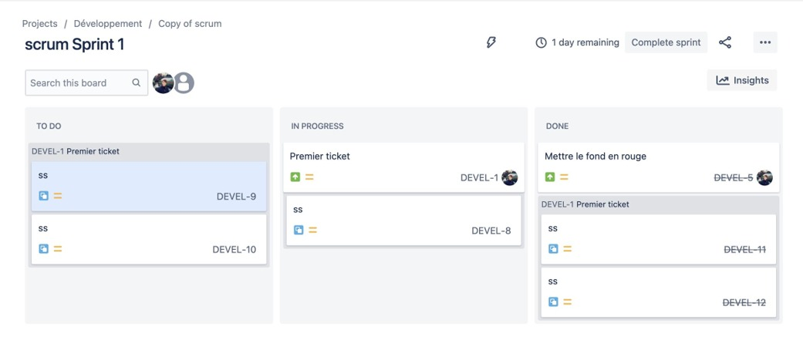fig 5.1 scrum sprint 1

5.4 Interpretation and next-sprint improvement
The simulation supports the original bottleneck prediction: the reservation defect delayed the payment-key slice, and review/testing exposed missing negative cases. The board rules made the blocker visible rather than allowing dependent work to appear active without progress. However, the initial Sprint 1 plan still carried five points and showed that a provisional commitment can be optimistic when there is no velocity history.
Sprint 2 improvement: plan no more than ten new points plus the five-point carryover until actual capacity and flow are better understood. Split S05 into a three-point status API slice and a two-point notification slice; move S11 to Sprint 3 if required. Schedule a daily API/QA pairing slot for reservation, payment and status integration. Carryover remains visible and is not counted again as new velocity. Update Jira by retaining unfinished items in the backlog, linking the defect, recording blocked time and revising the Sprint 2 commitment.
Task 5 conclusion: the simulation validates the usefulness of visible dependencies and WIP controls, while revealing that the original plan needs a more conservative commitment and earlier integration testing.

TASK 6 – REDESIGN DELIVERY UNDER CHANGED CONDITIONS
Changed Requirement

At the end of the first simulated sprint, the organization introduces the following changes:

Two additional regional warehouses must use the platform.

A second seven-member development team joins the project.

The payments engineer from the original team becomes unavailable for the remaining period.

Region-specific tax, shipping and refund-approval rules are now required.

The festival-sale release deadline remains unchanged.

Create a revised strategy that coordinates both teams, preserves a useful first release and manages the new constraints.
Component | Required Work | Marks
A. Diagnose the impact | Identify affected assumptions, capacity, scope, dependencies and risks using evidence from your original plan. | 2
B. Define redesign objectives | Establish measurable objectives for the revised strategy, including achievable scope and coordination expectations. | 2
C. Create the revised strategy | Redesign backlog priorities, team responsibilities, release sequencing and dependency coordination. Incorporate justified scaled Agile and Lean practices. | 4
D. Validate the redesign | Simulate at least five additional events and compare the revised strategy with the original using equivalent indicators. | 2
E. Defend the decision | Explain benefits, limitations and trade-offs. Show why the revised strategy remains feasible under the unchanged deadline. | 2

You may use selected SAFe-inspired coordination practices or another justified scaled Agile approach. Explain what you adopt and why it fits this project.

Evidence Expected

Impact analysis, measurable redesign objectives, revised management-tool artefacts, cross-team coordination design, comparative simulation evidence and an evidence-based defence.

Ans:

6.1 A. Diagnose the impact
Changed condition | Affected original assumption | Impact and risk
Two additional regional warehouses | Initial operational model assumed one common warehouse context. | Tax, shipping, stock and refund policies may differ by region; configuration and regional test coverage are needed.
Second seven-member team joins | Original plan assumed one seven-person team and one coordination path. | Onboarding and cross-team dependencies reduce the immediate capacity benefit; duplicate work and integration conflicts become possible.
Original payments engineer unavailable | Original plan assigned payment adapter and refund security to one specialist. | Knowledge concentration threatens idempotency, gateway integration and refund controls.
Region-specific tax, shipping and refund approval rules | Original rules were treated as common across the release. | Order totals and refund authorization must become region-aware; hard-coded rules create financial and compliance risk.
Festival deadline unchanged | Original eight-week release window remains fixed. | Scope must be narrowed and sequencing protected; simply adding people cannot guarantee the date.
Capacity recalculation for the next sprint: Team A has six available people after the payments engineer becomes unavailable: 6 × 10 × 6 = 360 nominal hours. Team B has seven people but is assumed to be 60% available during its first sprint because of onboarding: 7 × 10 × 6 × 0.60 = 252 nominal hours. Combined nominal capacity is 612 hours. Apply a 25% reserve for coordination, integration and unplanned work: 612 × 0.75 = 459 focused hours. This is approximately 1.4 times the original 336 focused hours, not twice the throughput. These are explicit planning assumptions, not measured capacity.
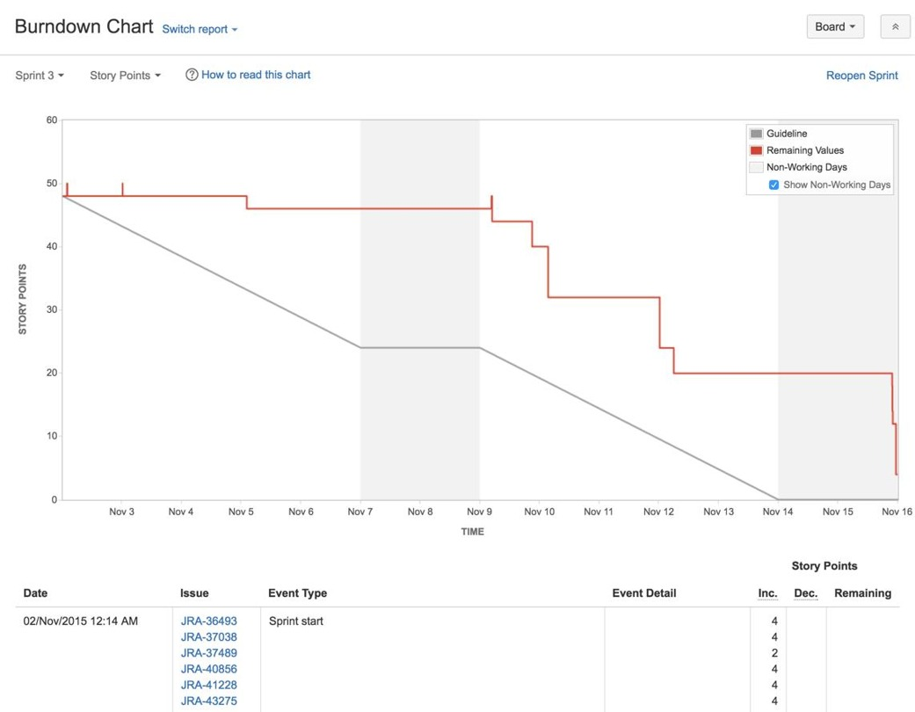
Fig.6.1 Burndown chart

6.2 B. Measurable redesign objectives
- Deliver a demonstrable end-to-end order, dispatch, tracking and controlled-refund journey for at least two configured regions before the unchanged festival deadline.
- Maintain one versioned order, payment and refund API contract shared by both teams; contract changes require review before implementation.
- Keep no more than two cross-team dependencies in active implementation at any one time.
- Complete a paired payment-engineer handover and pass idempotency, timeout and refund-authorization regression tests before release.
- Represent tax, shipping and refund-approval differences as region configuration/policy data rather than duplicated order-processing code.
- Hold one integrated demonstration at the end of each sprint and resolve critical integration blockers within one working day.

6.3 C. Revised backlog, roles and sequencing
Revised priorities: protect S01, S02, S03a/S03b, S04, S05, S06, S07 and S08 as the core journey. Add region-policy stories for configurable tax, shipping and refund limits, plus contract and integration tests. Retain S10 support lookup if the core path is stable. Defer S13 analytics and promotional work; S11 low-stock alerts and S12 barcode confirmation become conditional and may be deferred if regional policy or payment recovery threatens the deadline.
Workstream | Team A – six members | Team B – seven members (onboarding-adjusted)
Ownership | Order, stock, tracking and shared order lifecycle. | Regional policy configuration, refund workflow, UI/support and delivery support.
Core responsibilities | Maintain order API, reservation concurrency, pick/dispatch transitions and tracking events. | Implement regional tax/shipping/refund policy tables, approval configuration and region-aware screens.
Payments continuity | Provide API pairing and integration support; nominate an integration owner. | Assign one engineer to pair on payment API and take over adapter knowledge from the unavailable engineer.
Quality | Own order/stock integration tests and shared contract compliance. | Own regional policy tests, refund authorization tests and UI accessibility checks.
Shared responsibility | Both teams review contract changes, participate in integrated demos and fix cross-team defects. | Both teams maintain one backlog, one definition of done and one release gate.

6.4 Scaled Agile and Lean coordination
Use selected SAFe-inspired practices without adopting a full enterprise framework: one shared product backlog and release goal; a short joint planning session at each sprint boundary; named owners for shared interfaces; twice-weekly dependency reviews; one integrated demonstration; and a shared risk/impediment list. This is proportionate to two teams and the short remaining schedule.
Lean controls are retained and strengthened: one shared integration lane with WIP limit two; reserve 40% of Team B's first sprint capacity for learning, pairing and integration; keep cross-team dependencies visible; use contract-first API changes; and resolve duplicate work before sprint commitment. The coordinator or product lead resolves ownership conflicts before work begins. A single integrated release candidate is tested against the same DoD.

6.5 Revised release sequencing
Remaining release stage | Priority work | Release decision
Immediate / next sprint | Payment-engineer handover; shared API contracts; region policy model; order and stock regression; tax/shipping/refund acceptance examples. | Do not start parallel regional implementation until contracts and policy ownership are agreed.
Following sprint | Integrate two regional configurations; complete region-aware refund authorization; run end-to-end tests across both regions. | Protect the full core journey; defer optional operational enhancements if integration is late.
Final sprint / release hardening | Combined regression, authorization audit, payment retry tests, accessible tracking/support views, deployment rehearsal and rollback check. | Release only when critical security, stock, payment and refund acceptance checks pass.

6.6 D. Five-event redesign simulation and comparison
The following additional events are simulated to test the revised coordination model; they are not actual team activity.
Event | Simulated change / issue | Revised response
1 | A new region requests a different tax and shipping rule. | Extend the region policy table and add tests; do not duplicate order-processing code.
2 | Team B proposes an address field name that conflicts with Team A's API payload. | Joint contract review resolves the field name and version before implementation proceeds.
3 | Original payments engineer becomes unavailable. | A paired handover transfers adapter knowledge; the replacement engineer runs idempotency and timeout tests.
4 | Gateway sandbox access is delayed again. | Continue against the local adapter and replay tests; keep sandbox integration blocked and visible rather than pretending it is complete.
5 | Integrated demo finds a support agent can approve a refund. | Release gate blocks refund completion; server-side role authorization is repaired and regression-tested.
6 | Midpoint capacity review shows regional policy work is larger than expected. | Keep analytics and promotional scope deferred; make S11 and S12 conditional on core release readiness.
Equivalent indicator | Original simulated Sprint 1 | Revised simulated sprint
Planned / completed points | 16 planned; 11 completed | 22 planned; 18 completed across both teams
Completion ratio | 68.8% | 81.8%
Blocked story-days | 2 | 1
Reopened stories per completed story | 2 / 3 = 0.67 | 2 / 6 = 0.33
The revised indicator values are simulated and use comparable definitions, but the team size and work mix differ. They do not prove that adding a team caused better performance. They show how the revised design intends to make handover, contract and integration risks more visible.

6.7 E. Defence, benefits and trade-offs
The redesign is feasible only as a focused release. It benefits from clearer team ownership, region configuration instead of duplicated code, explicit payment knowledge transfer and an integration lane that prevents parallel work from overwhelming the shared interfaces. It protects the business-critical order-to-refund journey while accommodating two regional warehouses.
The limitations are onboarding time, increased communication overhead, payment-specialist knowledge loss and the possibility that regional policy requirements are more complex than assumed. The 459 focused-hour estimate is a planning model, not a guarantee. The deadline remains credible only if analytics (S13), promotions and, if the midpoint review indicates a shortfall, low-stock alert (S11) and barcode confirmation (S12) remain deferred. No release should bypass critical stock, payment, privacy or refund-authorization checks to meet the date.
Task 6 conclusion: scaling is achieved through shared contracts, clear ownership, controlled WIP and integrated validation—not by assuming that doubling headcount doubles throughput.

TASK 7 – INDIVIDUAL TECHNICAL REFLECTION
Explain:
- Which project-management decision you consider most significant and why.
- How your evidence influenced a change to the original strategy.
- Where your final design remains vulnerable.
- How you addressed an ethical concern involving privacy, workload, accessibility or transparency.
- What you would investigate next before using the strategy with a real development team.
Evidence Expected
A concise individual reflection demonstrating understanding of the created strategy and its limitations. Refer to your own artefacts and findings.
Ans:
The most significant decision in my strategy is to prioritize a complete order-to-refund journey instead of attempting to deliver every proposed module at once. This decision connects the three main operational problems: inaccurate stock can cause failed orders, unclear tracking increases support work, and weak refund controls create financial and audit risk. The backlog reflects this by making stock reservation, payment idempotency, picking, dispatch, tracking and refund approval Must items, while analytics is deferred.
The simulated Sprint 1 event log influenced a change to the original plan. The concurrency defect in S02 blocked the dependent payment slice S03a, and review/testing reopened work when negative cases were missing. I therefore reduced the next-sprint commitment, made carryover visible, strengthened the Definition of Ready and scheduled API/QA pairing. The redesigned two-team plan adds contract reviews and a shared integration lane because the second team and regional rules increase coordination risk.
The final design remains vulnerable to gateway behaviour that differs from the local adapter, incomplete knowledge transfer after the payments engineer leaves, and regional tax/refund rules that may be more complex than the assumptions.
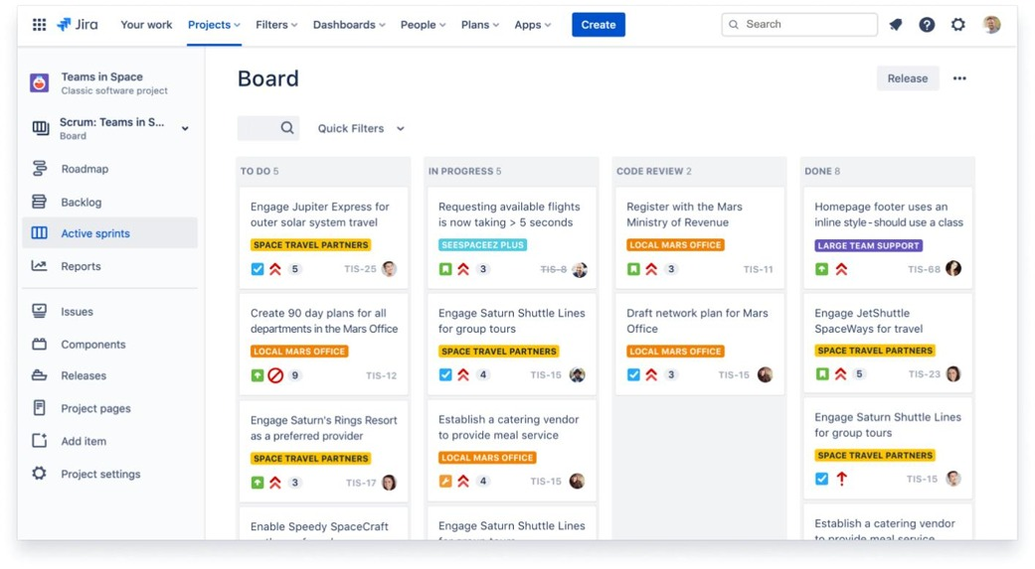
Fig.7.1 Jira
The main ethical concern addressed is privacy and appropriate access. The plan uses synthetic orders and no real card or customer data in test evidence. Server-side role checks restrict who can view order details and approve refunds; customer-facing tracking excludes internal notes. Workload transparency is also supported by visible WIP, blockers and carryover rather than hiding unfinished work or treating story points as hours.
Before using this strategy with a real team, I would investigate actual order volumes and concurrency, warehouse reservation and correction practices, region-specific tax and refund policies, gateway latency and failure rates, stakeholder availability, accessibility needs and the real cost of hosting/integration. I would also run a pilot with representative warehouse and finance users and replace all simulated findings and indicators with measured evidence.
Task 7 conclusion: the strategy is a reasoned plan for a constrained release, not proof of a production-ready system. Its value depends on validating assumptions with real stakeholders and repeatable tests.

FINAL RUBRIC-ALIGNMENT CHECK
Task | Rubric coverage included in this report
1 – 5 marks | Investigation questions; labelled simulated stakeholder evidence; problem statement; goal, scope and exclusions; measurable criteria; technical, operational and financial feasibility.
2 – 6 marks | Two different approaches compared; selection justified; roles, cadence, stakeholder participation and escalation; Lean controls; Jira compared with Trello.
3 – 8 marks | Four epics; more than twelve story slices; acceptance criteria, priorities, points, dependencies and owners; MoSCoW rationale; retained/deferred scope; DoR, DoD, privacy/accessibility; stakeholder trade-offs; Jira-ready artefact specification.
4 – 7 marks | Capacity arithmetic and reserve; four sprint goals; story-point explanation; gateway/scanner sequencing; development statuses and transition rules; WIP; blocked, urgent and unfinished-work policies; complete journey.
5 – 7 marks | Pre-simulation bottleneck prediction; control rule; twelve simulated events; board updates; four indicators; interpretation and next-sprint improvement.
6 – 12 marks | Impact diagnosis; measurable redesign objectives; revised priorities, team roles, sequencing, scaled Agile and Lean practices; six simulated events; equivalent comparative indicators; trade-off defence under fixed deadline.
7 – 5 marks | Significant decision; evidence-driven change; vulnerabilities; privacy/workload ethics; next investigation linked to the report's artefacts.

MARK DISTRIBUTION
Task | Assessed Area | Marks
Task 1 | Problem investigation and measurable delivery outcomes | 5
Task 2 | Original Agile and Lean operating model | 6
Task 3 | Prioritized Jira backlog and acceptance criteria | 8
Task 4 | Capacity-based release plan and workflow | 7
Task 5 | Delivery simulation and evidence-based improvement | 7
Task 6 | Day-4 Design Challenge – scaled delivery redesign and validation | 12
Task 7 | Individual technical reflection | 5
TOTAL |  | 50

