SIMATS ENGINEERING
Department of Computer Science and Engineering
CSA10 – SOFTWARE ENGINEERING
ASSIGNMENT 2 – CO2
Design and Validate Requirements and Architecture for the Omnichannel Order
Fulfilment Platform
CO2: Analyze software requirements to design scalable and efficient system architectures using
collaborative tools like Jira and Confluence, along with structured modeling techniques such as
UML diagrams and architectural design patterns.

Student Name | B S Reshma | Register Number | 192521432
Department / Section | IT | Academic Year / Semester | II/I
Faculty Name | Dr S Nanthini | Nature of Assignment | Individual
Duration | 1 Week | Total Marks | 50
Date of Submission |  | Date of Evaluation

MARK SHEET (Rubric-based Evaluation)
Task | Task Title | Max | Marks Awarded | Remarks
1 | Problem Investigation and Delivery Outcomes | 5
2 | Agile and Lean Operating Model | 6
3 | Prioritized Product Backlog (Jira / Selected Tool) | 8
4 | Capacity-Based Release Plan and Workflow | 7
5 | Delivery Simulation and Design Validation | 7
6 | Scaled Delivery Redesign and Validation (Day-4) | 12
7 | Individual Technical Reflection | 5
 | TOTAL | 50

OVERALL REMARKS

Student Signature | Faculty Signature | Program Director
B S Reshma

MANDATORY SUBMISSION EVIDENCE CHECK
Task | Evidence Expected | Status | Note
1 | Investigation questions, stakeholder findings / simulated responses, problem statement, scope boundaries, feasibility, measurable success criteria
2 | Comparison of two approaches, justified selection, operating model with Lean practices, tool investigation & selection
3 | ≥4 epics, ≥12 user stories with AC, priorities, estimates, dependencies, DoR, DoD, stakeholder conflict decisions, tool screenshots/export
4 | Capacity assumptions, 4 sprint goals, selected work, estimation method, dependencies (gateway/scanner), workflow + WIP limits, urgent/unfinished rules
5 | Bottleneck prediction, ≥10 simulated events (labelled), tool updates, ≥3 delivery indicators, interpretation + improvement for next sprint
6 | Impact diagnosis, redesign objectives, revised backlog/roles/sequencing, scaled Agile practices, ≥5 further events, comparative indicators, defence
7 | Significant decision, evidence-driven change, remaining vulnerability, ethical concern addressed, next investigation linked to own artefacts

All tasks (1–7) answered with required evidence | ☐ Yes ☐ Partly ☐ No
Investigation questions + stakeholder / simulated findings present (Task 1) | ☐ Yes ☐ Partly ☐ No
Two delivery approaches compared and operating model justified (Task 2) | ☐ Yes ☐ Partly ☐ No
≥4 epics + ≥12 stories with AC, priorities, estimates, DoR/DoD (Task 3) | ☐ Yes ☐ Partly ☐ No
Capacity plan, sprint goals, workflow with WIP limits shown (Task 4) | ☐ Yes ☐ Partly ☐ No
Sprint-1 simulation: prediction, ≥10 events, indicators, improvement (Task 5) | ☐ Yes ☐ Partly ☐ No
Day-4 redesign: impact, objectives, revised strategy, validation, defence (Task 6) | ☐ Yes ☐ Partly ☐ No
Individual reflection covering decision, change, vulnerability, ethics, next step (Task 7) | ☐ Yes ☐ Partly ☐ No
Tool screenshots / export (backlog, board, workflow) included and labelled | ☐ Yes ☐ Partly ☐ No
All simulated data clearly labelled as simulated (not presented as real delivery) | ☐ Yes ☐ Partly ☐ No
No unfilled template placeholders; work consistent throughout | ☐ Yes ☐ Partly ☐ No
Viva readiness (able to defend prioritization, capacity, WIP, indicators) | ☐ Yes ☐ No

CSA10 – SOFTWARE ENGINEERING

ASSIGNMENT 2
CO2: Analyze software requirements to design scalable and efficient system architectures using
collaborative tools like Jira and Confluence, along with structured modeling techniques such as
UML diagrams and architectural design patterns.
Assignment Title: Design and Validate Requirements and Architecture for the Omnichannel Order
Fulfilment Platform
Nature of Assignment: Individual
Duration: One week
Total Marks: 50
Submission Date: __________________
Scenario — Order Fulfilment Requirements and Scalable Architecture
A retailer needs an order fulfilment architecture that connects checkout, stock reservation, payment
callbacks, warehouse picking, courier tracking and refunds without losing consistency or exposing
restricted customer information. Repeated payment callbacks, two buyers competing for the last
unit and failed courier synchronization create conflicting requirements for speed, availability,
accountability and confidentiality. Analyze stakeholder needs and create a testable requirements
specification with traceable UML models and justified architectural alternatives. Validate order and
refund invariants, data ownership and failure handling. Redesign the selected architecture for
additional regions, increased demand and disconnected warehouse scanners while explaining
consistency, availability and operating-cost trade-offs.
The retailer proposes an omnichannel order fulfilment platform. Its intended modules are a
storefront catalogue, cart and checkout, payment integration, inventory synchronization, order
tracking, a warehouse picking dashboard, returns and refunds, a support console and sales
analytics. The system should connect a customer order to stock reservation, payment confirmation,
picking, dispatch, tracking, delivery and, where needed, an authorized return and refund.
Architecture conditions for the representative release are stated below.
Observation | Scenario planning condition
Operational scope | Checkout, stock reservation, payment confirmation, picking, dispatch, tracking, returns and refunds
Users | Administrator, picker, support agent, finance reviewer, store manager and customer
Reference data | Synthetic products, orders and stock movements; no real customer or card data
Integration constraint | Payment gateway or courier API may be unavailable or may send duplicate callbacks; preserve local order records and retry safely
Validation need | Verify stock, order status, price, authorization, persistence and refund audit behaviour
Principal users are enterprise administrators, warehouse pickers, support agents, finance reviewers, store managers and customers. They need different permissions. Pickers require accurate pick lists; support agents require readable order and return status; finance reviewers require auditable refund approvals; engineers require traceable links between orders, payments and courier shipments. Automation must preserve human responsibility for refund approval and stock corrections.
Customers want fast checkout and clear tracking; pickers want reliable stock reservation; support agents want order visibility without seeing payment data; finance reviewers require approval before refunds above a limit. Management wants consolidated sales, stock and refund reporting. These interests may conflict when speed, privacy and refund controls compete.
Use a manageable representative release and synthetic orders and stock events. Jira, Confluence, GitHub, Jenkins and Docker are suitable reference tools; select and justify alternatives where appropriate. A React interface, FastAPI service and PostgreSQL database are one feasible reference architecture, not compulsory choices. External integrations may be demonstrated through controlled test interfaces when live access is unavailable, with their status disclosed.
Define workload, service-level policies and acceptance thresholds as explicit planning assumptions. Dashboard values, stock counts and screenshots are illustrative evidence of displayed behaviour, not proof of production accuracy, performance, live inventory control or secure payment handling. Verify claims through repeatable checks. Distinguish deterministic rules, such as fixed low-stock thresholds, from trained machine-learning forecasting, and label simulations and proposed extensions accurately.
Design Challenge:
Repeated payment callbacks may create duplicate payments or orders, while two customers may buy the last unit. Courier synchronization may fail after the order is stored. A refund must not bypass its required approval, and a support agent must not gain finance privileges merely by selecting another role in the interface.
The organization requires consistent order state, auditable refunds and dependable integration while its small technical team initially operates a modest deployment. Additional services must be justified against operational cost and complexity.
Design and validate a requirements specification and scalable system architecture using collaborative and modeling tools of your choice that address these conditions.
Develop alternative architectural solutions and create a justified design connecting stakeholder needs, allocation rules, quality requirements and architectural decisions. Maintain traceability between requirements, UML models, architectural components and validation scenarios.
Examine at least two suitable tool arrangements for requirements tracking, collaborative documentation and UML modeling. Select a tool or combination of tools and justify its suitability, considering traceability, collaboration, version history, diagram support, accessibility and cost. Explain any limitations and how you will address them.
Validate the design against deliberately constructed scenarios. Use the findings to revise your requirements and architecture, and defend the final design’s consistency, scalability and limitations. Explain how the selected tools support collaboration and keep the specification, models and design decisions consistent.

Q1 – Investigate Stakeholder Needs and Resolve Conflicts (5 Marks)
Investigate the needs of customers, pickers, support agents, administrators, store managers and
finance reviewers.
• Formulate at least three questions that investigate an unresolved requirement or stakeholder
conflict.
• Gather findings through a small stakeholder discussion, questionnaire or process review. Where
access is unavailable, use clearly labelled simulated responses.
• Identify at least three conflicting expectations.
• Develop and justify a resolution for each conflict.
• Define the system boundary, principal actors and scope exclusions.
Do not assume that every stakeholder request should become a requirement.
Evidence Expected
Investigation questions, findings or labelled simulated responses, a stakeholder analysis, conflict-
resolution decisions and a justified system boundary.

1.1 Investigation method and questions
Method: a short process-review exercise was simulated using the scenario and answer-key guidance. The responses below are illustrative, not actual interview evidence. In a real project, the same questions would be asked separately to representatives and recorded with date, role and consent.
- Q1. When two customers attempt to buy the final unit at nearly the same time, should the system accept both checkouts temporarily or guarantee that only one reservation succeeds?
- Q2. Which order details may a support agent view to resolve a complaint, and which payment or personal details must remain hidden?
- Q3. Who may approve a refund above the standard limit, and may the system execute a refund while approval is still pending?
- Q4. If an order and payment are recorded locally but the courier API is unavailable, what should the customer and warehouse see, and who owns retrying the shipment request?
- Q5. What evidence must a picker provide before an order can move to Packed or Dispatched?

1.2 Simulated findings
Stakeholder | Simulated finding / need | Implication for design
Customer | Wants quick checkout, accurate stock information and understandable tracking. | Show a clear Payment Pending state; do not promise dispatch until confirmed.
Picker | Needs a stable pick list and must not pick stock reserved for another order. | Expose only assigned paid orders with valid reservations; record pick confirmation.
Support agent | Needs order and return visibility but not card or unrestricted customer data. | Provide scoped, masked views and server-side authorization.
Administrator | Needs to manage users, roles and regional policies with an audit trail. | Restrict configuration actions and log every privileged change.
Store manager | Needs consolidated sales, stock and refund reports across stores/regions. | Provide a read-only reporting view with controlled aggregation.
Finance reviewer | Needs evidence and approval control for high-value refunds. | Separate request, approval and execution; retain approver identity and timestamps.

1.3 Conflicts and justified resolutions
Conflict | Resolution | Reason and acceptance implication
Checkout speed versus stock accuracy | Reserve stock transactionally with the order and an assumed 15-minute expiry. | A small checkout delay is preferable to overselling. Two buyers competing for one unit must produce one successful reservation and one rejection.
Support visibility versus customer privacy | Show order status, items and masked contact information; never expose card data or another customer's order. | Support can resolve routine issues without finance privileges or unnecessary personal-data exposure. Direct API access outside the customer's scope is denied.
Instant payment confirmation versus local availability | Store the order as Placed / Payment Pending; mark Paid only after a verified, deduplicated gateway callback. | The local order survives gateway delay, while the interface avoids claiming payment before authoritative confirmation.
Fast refunds versus finance control | Agents/customers may request a refund; only an authorized finance reviewer may approve above the assumed threshold; execution is a separate operation. | A user-interface role selector cannot grant authority. Approval and execution are separately audited.

1.4 System boundary, actors and exclusions
System boundary: the platform includes the storefront and warehouse/support interfaces, REST API, authentication and authorization, order and stock modules, payment/refund workflow, relational persistence, audit records, reporting and an integration worker. It owns local order state, reservation state, refund workflow state and durable integration intents.
Principal actors: Customer, Picker, Support Agent, Finance Reviewer, Administrator and Store Manager. External systems are the Payment Gateway and Courier API. A warehouse scanner is an input device/client; the human picker remains responsible for confirming physical picks.
First-release exclusions: real card-number storage, autonomous refund decisions, machine-learning demand forecasting, public third-party API access, automated physical stock correction and replacement of the retailer's payment or courier providers. Live integrations may be represented by controlled test adapters where access is unavailable. These exclusions prevent unverified assumptions from becoming hidden requirements.
Decision: not every stakeholder request becomes a requirement. Requests are accepted only when they support the release objective, are lawful and secure, can be tested, and have an identified owner. For example, instant refund execution is not accepted because it conflicts with finance control.

Q2 – Create a Prioritized and Testable Requirements Specification (8 Marks)
Create a requirements specification in a selected collaborative documentation tool and represent
prioritized requirements in a selected issue tracker. Jira and Confluence are reference options;
justify the arrangement chosen.
• At least twelve functional requirements and six non-functional requirements.
• Unique identifiers, sources, priorities and acceptance criteria.
• Order rules covering price and tax calculation, stock reservation, ownership, permitted status
changes, dispatch deadlines, duplicate payment callbacks and refund approvals.
• Measurable quality requirements for performance, availability, security and usability.
• Explicit assumptions and unresolved questions.
• A justified prioritization method.
• Replacement of vague statements such as “checkout should be fast” with requirements that
specify the operating condition and an observable acceptance threshold.
• An explanation of how at least two stakeholder conflicts influenced the final specification.
Evidence Expected
Collaborative specification, requirement records, measurable acceptance criteria, prioritization
rationale and documented assumptions.

2.1 Collaborative tool arrangement
Selected arrangement: Jira for prioritized issues and workflow status, Confluence (or a version-controlled specification page) for the authoritative requirements narrative, and a Git repository for UML source files, prototype code and change history. Each Jira issue carries the requirement ID and links to the corresponding specification section, UML element and validation case. A lightweight alternative for a small team is GitHub Issues plus Markdown requirements and version-controlled PlantUML files.
Arrangement | Strengths | Limitations and mitigation
Jira + Confluence + Git (selected) | Issue ownership, priority, status, comments and history; collaborative specification; source-controlled diagrams and code. | May require paid seats and disciplined linking. Use a small project space, templates and stable IDs; export periodic snapshots.
GitHub Issues + Markdown + PlantUML | Low-cost, versioned, reviewable changes and diagrams near code. | Less structured requirement workflow and less accessible to nontechnical stakeholders. Use labels, issue templates and pull-request review.

The selected arrangement suits a team already using Jira and supports collaboration, traceability and version history. Tool selection is not proof that records were actually created; project-specific Jira/Confluence screenshots or links should be added if required by the instructor.

2.2 Prioritization method
Use MoSCoW prioritization adjusted by customer-harm and financial-risk impact. Must requirements protect money, stock, privacy or core order correctness. Should requirements are important to efficient fulfilment and management. Could requirements are deferred until the core workflow is stable. The source does not prescribe a fixed numeric score, so none is invented.

2.3 Functional requirements
ID | Requirement and source | Priority | Acceptance criteria
FR01 | Authenticate users and authorize every protected command. Source: administrator, all role groups. | Must | Given an unauthenticated or unauthorized caller, a protected write returns 401/403 and no record changes.
FR02 | Place an order after validating required fields and positive quantities. Source: customer. | Must | Invalid or missing fields are rejected; a valid request creates one order in Placed state.
FR03 | Reserve available stock as part of order placement. Source: picker/customer; last-unit conflict. | Must | For two concurrent requests for the last unit, exactly one reservation succeeds; available stock never becomes negative.
FR04 | Calculate item price, discounts where configured and regional tax on the server. Source: customer/finance. | Must | For each approved test vector, server total equals the configured price plus applicable tax; client-supplied totals are ignored.
FR05 | Verify and deduplicate payment callbacks. Source: finance/payment integration. | Must | A valid gateway/event identity creates at most one payment; replaying the same identity returns the existing result.
FR06 | Enforce permitted order-state transitions. Source: picker/support/operations. | Must | Placed cannot jump to Dispatched; dispatch is rejected unless payment is confirmed and picking is complete.
FR07 | Generate a pick list for assigned eligible orders. Source: picker. | Should | Picker sees only assigned orders with confirmed payment and active reservations.
FR08 | Expire unpaid reservations and handle late callbacks. Source: stock operations. | Must | Reservation expires once after the assumed 15 minutes; late payment is reconciled without overselling and follows the late-payment exception path.
FR09 | Create dispatch records and expose permitted tracking milestones. Source: customer/picker. | Should | Courier reference and status are stored; customer can see allowed milestones but cannot change them.
FR10 | Manage return requests, refund approval and execution as separate states. Source: support/finance. | Must | Refund execution is rejected unless an authorized approval exists; a failed gateway attempt remains Failed and retryable with approval retained.
FR11 | Synchronize payment and courier integrations through durable intents. Source: operations/engineers. | Must | An integration intent remains stored after timeout/restart; retries use a stable correlation/idempotency key and do not create duplicate shipments.
FR12 | Record audit events and provide authorized reports. Source: finance/manager/administrator. | Should | Each accepted critical transition records actor, timestamp, entity ID and version; report totals reconcile to source records.

2.4 Non-functional requirements
ID | Quality attribute | Measurable acceptance target
NFR01 | Performance | Planning target: checkout API p95 below 800 ms at 50 concurrent synthetic users, excluding external gateway latency; report request rate, errors, test duration and host configuration.
NFR02 | Consistency | Duplicate callback and last-unit tests produce no duplicate payment, no duplicate confirmation and no negative available stock.
NFR03 | Recoverability | Planning target: restore service within 15 minutes in a controlled test; document backup frequency and recovery-point objective before acceptance.
NFR04 | Security and privacy | Test all six role categories against allowed and forbidden actions; no card number is stored; cross-customer order reads are denied.
NFR05 | Usability and accessibility | Core purchase and tracking journeys are keyboard-operable; status is conveyed by text and not colour alone; validation errors identify the field.
NFR06 | Portability and reproducibility | A tagged source revision and documented configuration reproduce the representative journey on a clean supported host.

2.5 Mandatory order and refund rules
- Price and tax: total = server-calculated item subtotal − permitted discounts + tax calculated from the applicable regional policy version. The client never supplies an authoritative total.
- Stock reservation: reserve only when available quantity is sufficient; use a database transaction and conditional update/row lock. Available quantity = on_hand − reserved and must remain at least zero.
- Ownership: every order has one immutable customer owner. A customer can read only their own orders; support access is limited to authorized operational scope and masked fields.
- Permitted status changes: Placed → Paid → Packed → Dispatched → Delivered → Closed. Cancellation is allowed only before payment under the initial policy. Return/refund is a separate guarded workflow and does not falsify delivery history.
- Dispatch deadline: planning assumption of dispatch within 24 hours after payment confirmation, measured in UTC. Exceptions must be visible and auditable.
- Duplicate callbacks: identify each event by gateway ID plus event ID; enforce a unique database constraint and return the existing processing result on replay.
- Refund approval: request, approval/rejection and execution are separate states. Assumed threshold-based approval requires a finance reviewer; a customer or support agent cannot self-approve.

2.6 Assumptions and unresolved questions
Type | Statement
Assumption | Reservation expiry is 15 minutes; this is a planning value requiring retailer confirmation.
Assumption | Refund approval threshold is configurable; the actual monetary limit is not supplied.
Assumption | Dispatch target is 24 hours after payment confirmation in UTC.
Assumption | Synthetic products, orders and stock events are used; no real customer or card data is used.
Unresolved | What are the legally approved tax rules and rounding method for each region?
Unresolved | What are the refund threshold, return window and exception approvers?
Unresolved | How long must addresses, audit events and payment references be retained?
Unresolved | What are the gateway's signature, retry, event-ordering and idempotency guarantees?
Unresolved | What are the warehouse scanner device limits and maximum offline duration?

Conflict influence: FR03 and FR08 resolve checkout speed versus stock accuracy through transactional reservation and expiry. FR10 resolves fast refunds versus finance control by separating request, approval and execution. FR01 and NFR04 resolve support visibility versus privacy through server-side role checks and data minimization.

Q3 – Construct UML Models and Maintain Traceability (7 Marks)
Create a consistent set of UML models covering:
• A use case diagram showing actors and principal interactions.
• A class diagram representing important domain concepts and relationships.
• A sequence diagram tracing a payment callback through order confirmation, shipment creation
and courier synchronization, including a retry or failure.
• A state machine for Placed, Paid, Packed, Dispatched, Delivered and Closed orders, including
authorized cancellation or return if supported.
• Approval, rejection, execution and rollback behaviour for refunds, modelled where relevant.
• A traceability matrix connecting Requirement → UML Element → Architectural Component
→ Validation Scenario.
• Identification and resolution of at least two inconsistencies discovered while connecting these
representations.
Evidence Expected
Four UML diagrams, a traceability matrix, identified inconsistencies and documented corrections.

3.1 Use-case diagram
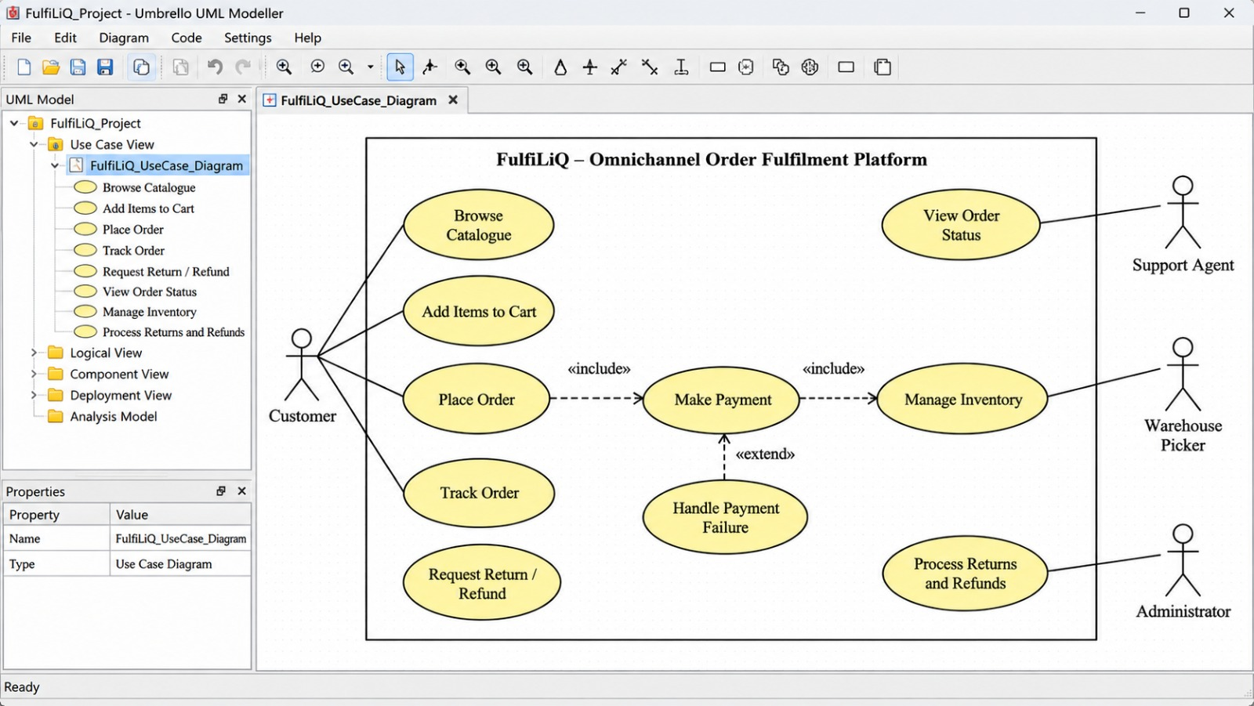

The use-case model distinguishes all six human roles and the two external integration actors. Authentication and authorization guard protected use cases. Refund approval is not combined with refund request or execution. Customers can view only their own orders; the manager has read-only reporting access.

3.2 Class diagram
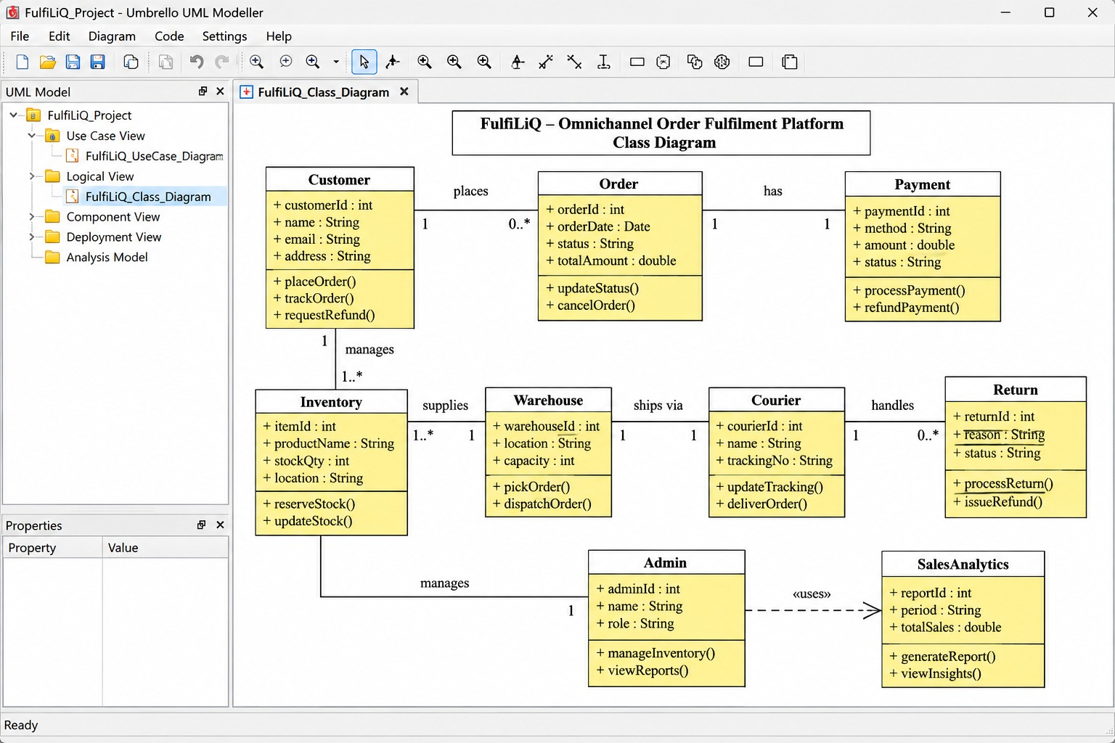

Core entities are User, Order, StockItem, Reservation, PaymentEvent, RefundRequest, IntegrationIntent and AuditEvent. A unique (gateway_id, event_id) pair prevents duplicate payment processing. Order version supports optimistic concurrency. IntegrationIntent stores a stable correlation key, retry count and status. Reservation records expiry and quantity. Relationships in the diagram represent domain ownership and references; implementation cardinalities should be enforced with foreign keys and uniqueness constraints.

3.3 Sequence diagram: payment callback and courier synchronization
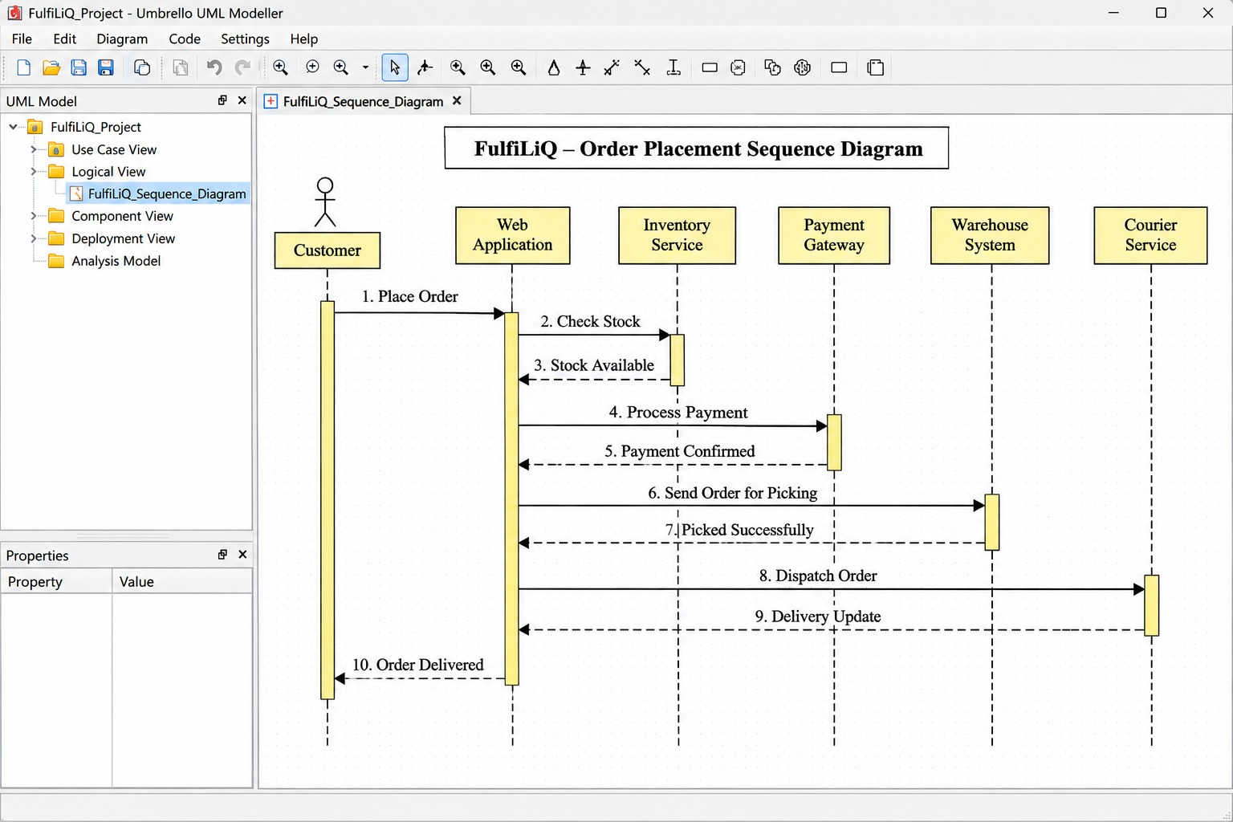
Sequence: the gateway sends a signed callback; the API validates signature, amount, order reference and event identity. A single database transaction inserts the unique payment event, updates the order to Paid, appends an audit record and creates one shipment IntegrationIntent. The API acknowledges the local result without waiting for the courier. The worker claims the intent and calls the courier with a stable idempotency/correlation key. On timeout, it first reconciles by that key; only if no shipment exists does it retry. The customer sees synchronization as Pending until a courier reference is stored.

3.4 Order state machine
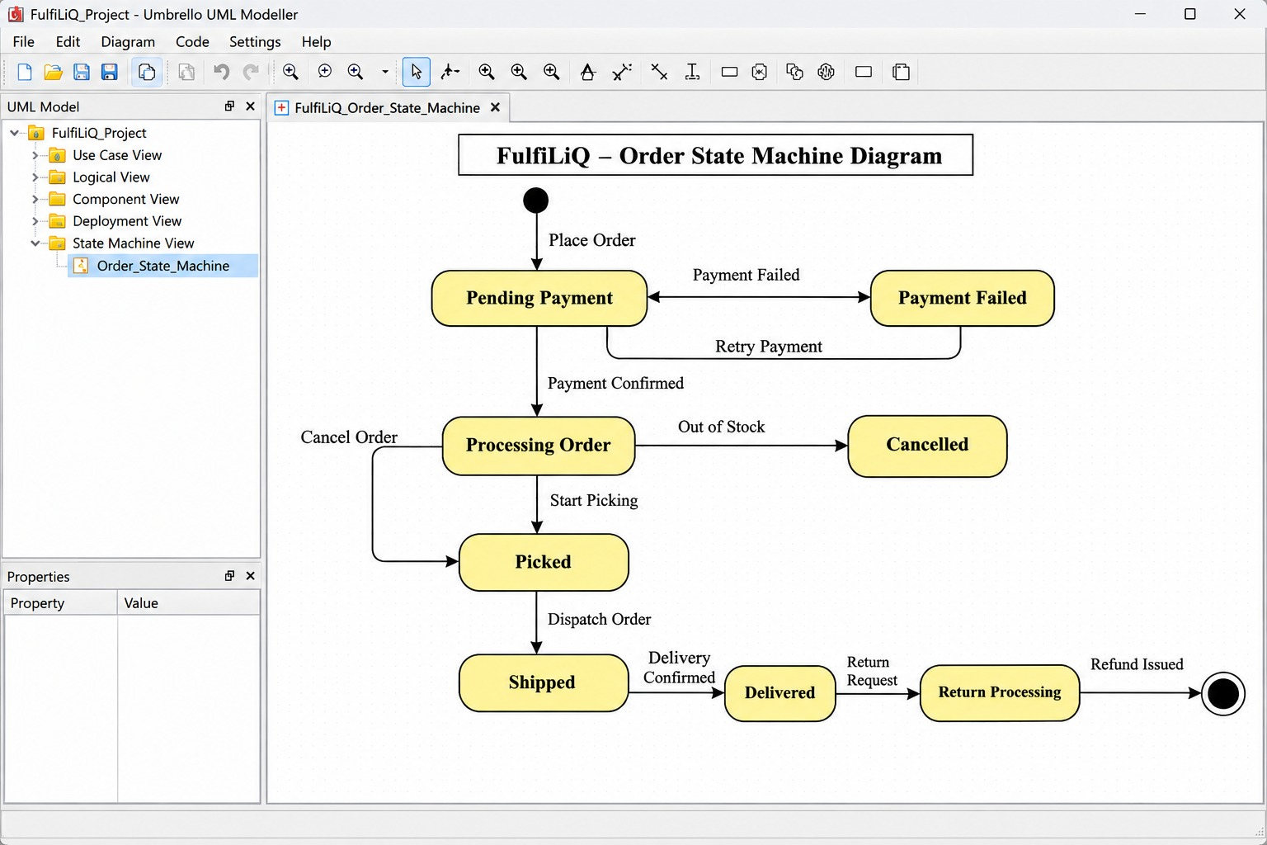
The main order path is Placed → Paid → Packed → Dispatched → Delivered → Closed. Placed → Cancelled is permitted only before payment and subject to reservation release. Dispatch has guards: payment must be confirmed and pick confirmation must exist. Return/refund is represented as a related workflow after delivery; the order is not labelled refunded until gateway execution succeeds. Refund states are Requested, Approved, Rejected, Failed and Executed. A Failed execution retains approval and can be retried under the same approved request.

3.5 Refund approval, rejection, execution and rollback
- Requested: customer or authorized support agent submits a reason, amount and eligible order/return reference.
- Approved: finance reviewer passes server-side role and policy checks; approver identity, time and policy version are stored.
- Rejected: finance reviewer rejects with a reason; execution endpoint refuses the request.
- Execution: worker submits the approved refund to the gateway using a stable idempotency key; success changes state to Executed.
- Failure/rollback: a timeout or gateway failure records Failed and an error reference. The approval is retained; the system does not mark the order refunded. A controlled retry reuses the same refund identity. If the gateway outcome is uncertain, reconcile before retrying.

3.6 Traceability matrix
Requirement | UML element | Architectural component | Validation scenario
FR03 | StockItem, Reservation; Place Order use case | Stock module + relational transaction | T1: two buyers, last unit
FR05 | PaymentEvent; callback sequence | Payment module + unique event constraint | T2: repeated callback
FR06 | Order state machine | Order command service | T4: dispatch without payment/pick
FR10 | RefundRequest states and finance use case | Refund module + authorization policy | T3/T6: failed refund and unauthorized approval
FR11 | IntegrationIntent; sequence retry branch | Outbox worker | T5: courier timeout and retry
FR08 | Reservation expiry and Placed→Cancelled/exception path | Stock module + expiry scheduler | T7: late payment after expiry
FR01 | User role and protected use cases | Authentication/authorization middleware | T6: cross-customer read and role escalation

3.7 Inconsistencies discovered and corrections
Inconsistency | Risk | Correction
Browser success redirect treated as payment confirmation. | A customer could see Paid when the gateway callback is missing or forged. | Only a verified signed callback updates payment state; redirect displays Payment Pending until server confirmation.
Role selector in the interface treated as authorization. | A support agent could select Finance Reviewer in the UI and attempt privileged actions. | Role is derived from authenticated server identity and checked on every API command; UI controls are only presentation.
Failed refund state treated as terminal and approval discarded. | A transient gateway failure could make a valid approved refund impossible to retry safely. | Retain approval and use Failed → retry → Executed, with idempotency and reconciliation.
Traceability is maintained by stable IDs in the specification, Jira issue keys, UML element names, component responsibilities and validation case IDs. A requirement change must update all linked artefacts in the same review.
Q4 – Design and Justify Alternative Architectures (8 Marks)
Develop two meaningfully different architectural alternatives for the system. Select appropriate
patterns, such as a modular monolith, microservices or event-driven architecture. For each
alternative:
• Define the principal components and responsibilities.
• Explain communication and data ownership.
• Describe how duplicate payment processing and overselling of the last unit would be prevented.
• Examine scalability, consistency, availability, security and operational complexity.
• Identify likely failure points and maintenance implications.
Then select an architecture and create component and deployment diagrams. Document at least
three architectural decisions in your selected documentation tool. State each problem, alternatives,
selection, justification and consequences.
Evidence Expected
Two architectural alternatives, a reasoned comparison, selected component and deployment
diagrams, and three architectural decision records.

4.1 Alternative A: modular monolith with background worker
The storefront calls a stateless REST API. Authentication, order, stock, payment, refund, reporting and audit are modules within one deployable application. A relational database owns transactional records. A separate background worker processes durable outbox intents for payment/courier integration. Modules communicate through explicit internal interfaces and share one database transaction where required.

4.2 Alternative B: independently deployed services with event broker
Order, inventory, payment, fulfilment, refund and reporting run as separate services. Each service owns its database and publishes domain events through a broker. Cross-service workflows use sagas, idempotent consumers, retries and compensating actions. Inventory can scale independently from reporting, but distributed consistency and operational overhead increase.
Dimension | Alternative A: modular monolith + worker | Alternative B: services + broker
Responsibilities | Clear in-process modules; worker owns external retries. | Each service owns a business capability and its data.
Communication/data ownership | Internal calls; one relational database with module ownership boundaries. | Versioned APIs/events; separate databases; eventual consistency across services.
Duplicate payment | Unique gateway/event key in one database transaction. | Payment service inbox/idempotency store; deduplicated event consumer.
Last-unit oversell | Conditional stock update or row lock in same transaction as reservation. | Inventory service serializes reservation per SKU or uses atomic conditional update; order saga waits for reservation result.
Scalability | Replicate stateless API and worker; database may become bottleneck. | Scale hot services independently; broker and service databases also require capacity.
Consistency/availability | Strong local transaction consistency; central database dependency. | Eventual consistency across services; individual services may remain available during partial outage.
Security | Fewer network boundaries but strict module/API authorization still required. | More service identities, secrets, network policies and authorization boundaries.
Failure points | Database, application deployment, worker backlog and external APIs. | Broker, service network, schema contracts, distributed workflow and multiple databases.
Maintenance/cost | Lower operational complexity; shared release and schema coordination. | Higher deployment, monitoring, tracing, on-call and platform costs.

4.3 Selection and justification
Select Alternative A for the representative release. The stated technical team is small and the initial workload is modest. The most critical invariants—order, stock, payment event, audit and outbox intent—benefit from one local relational transaction. The worker isolates slow external integrations without requiring a broker and a fleet of independently deployed services. The design retains module boundaries so that a measured bottleneck can later be extracted.
Alternative B is not rejected permanently. It becomes appropriate only when measured independent scaling, team ownership or regional isolation benefits exceed the cost of distributed transactions, event operations and service observability.

4.4 Selected component diagram
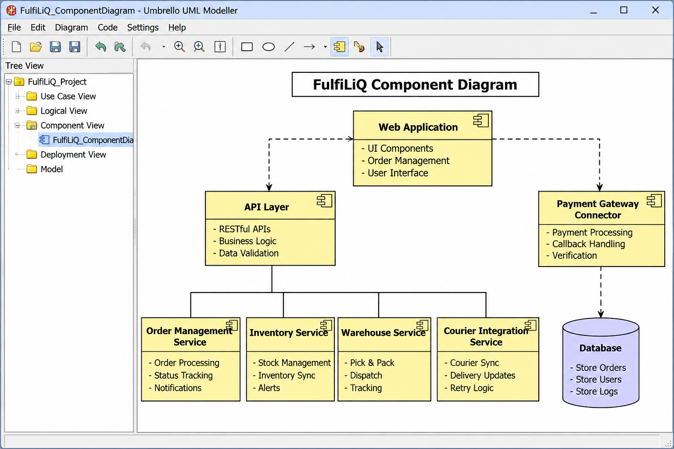

4.5 Selected deployment diagram
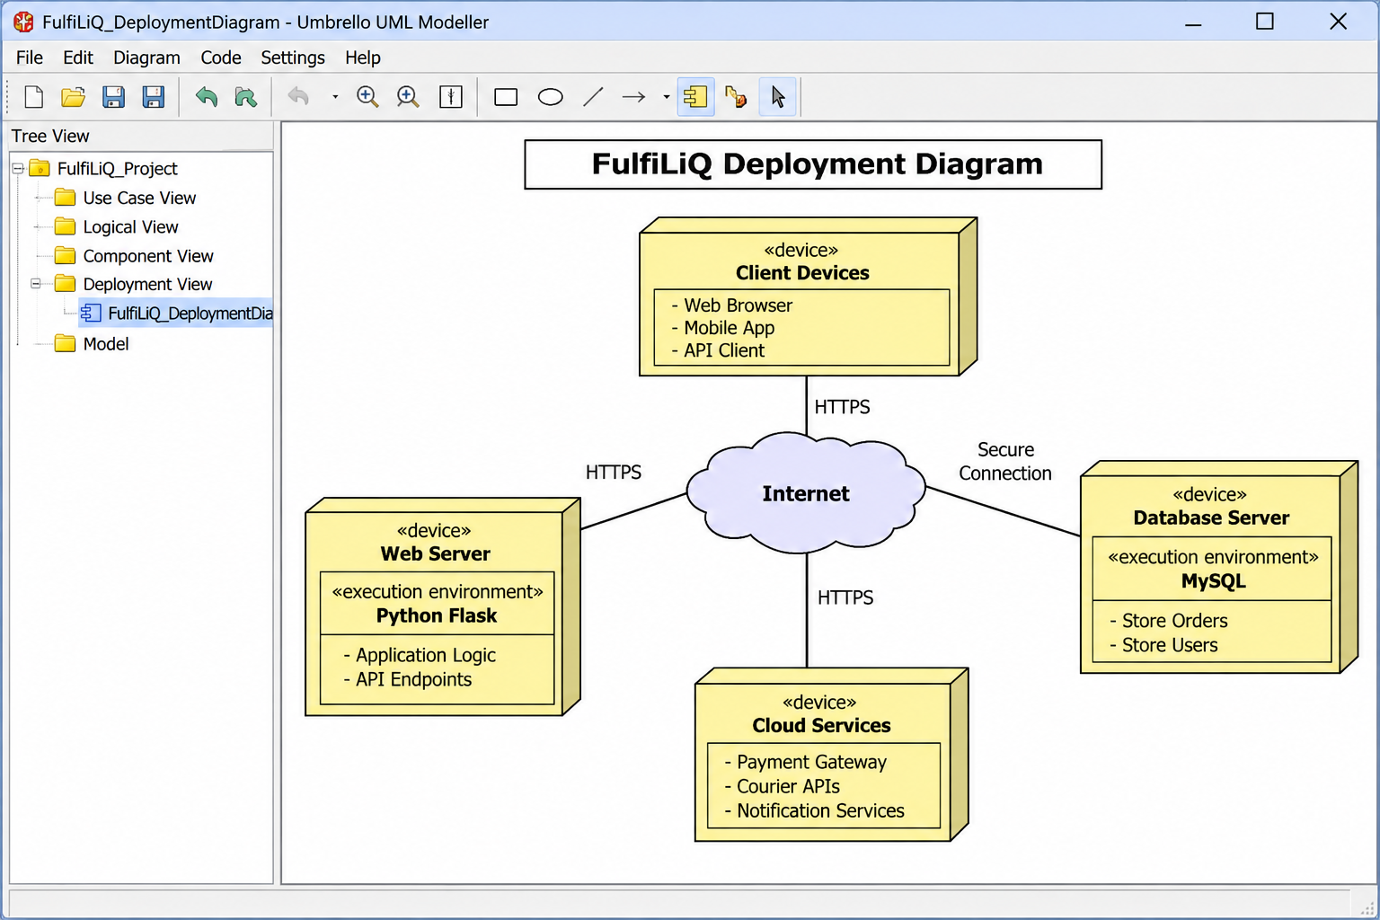

4.6 Architectural Decision Records
ADR | Problem and alternatives | Selection and justification | Consequences
ADR-01: Relational transactional store | Need atomic order, stock, payment-event, audit and outbox changes. Alternatives: relational database; separate stores per module; document store. | Select PostgreSQL-style relational storage with constraints and transactions because core records are strongly related and require coordinated invariants. | Requires schema migrations, indexes and transaction design. A database outage affects core writes; backups and recovery tests are required.
ADR-02: Durable outbox integration | Courier/gateway may be unavailable after local order commit. Alternatives: synchronous API call in transaction; best-effort call; durable outbox + worker. | Select durable outbox because local state is committed independently of external availability and retries survive process restart. | Adds worker monitoring, retry/backoff, dead-letter/manual review and reconciliation. External outcomes may be delayed.
ADR-03: Server-side authorization and idempotency | UI roles and repeated callbacks are untrusted. Alternatives: hide UI controls only; trust client role; enforce server-side identity, unique keys and version checks. | Select authenticated server-side role checks, unique gateway/event keys, stable integration keys and optimistic versioning. | Requires policy tests and conflict handling. Users may see pending states while retries/reconciliation complete.

The selected design protects duplicate callbacks with a database uniqueness constraint and protects the last unit with a conditional update/row lock inside the order transaction. Payment and courier adapters are external trust boundaries; validate signatures, payloads, timeouts and response identities.

Q5 – Validate Critical Behaviour and Revise the Design (7 Marks)

5.1 Invariants
- I1. For a given gateway ID and event ID, at most one PaymentEvent and one payment effect may exist.
- I2. A refund cannot enter Executed unless an authorized approval is recorded first.
- I3. Available stock = on_hand − reserved and must never be negative.
- I4. Each order has one immutable owner; customer reads must match the authenticated owner.
- I5. Dispatch is permitted only when payment is confirmed and pick confirmation is recorded.
- I6. A retry of one logical shipment/refund uses the same stable correlation/idempotency identity.
- I7. A stale entity version cannot silently overwrite a newer accepted state.

5.2 Operation contracts
Operation | Preconditions | Postconditions
PlaceOrder(customer, SKU, qty, expectedVersion) | Authenticated customer; positive quantity; valid SKU; expected stock version current; available stock ≥ qty; server price/tax policy available. | Exactly one Placed order and reservation are committed; reserved stock increases once; audit event is appended in same transaction. If any precondition fails, no partial order/reservation remains.
ConfirmPayment(orderId, gatewayId, eventId, signature, amount) | Gateway signature valid; amount and currency match; order exists; event identity is new or is a recognized replay. | New event records one payment, moves eligible order to Paid and creates one shipment intent atomically. Replay returns existing result without another payment, transition or intent.
ExecuteRefund(refundId, actor) | Refund is Approved; actor/service is authorized; amount and order reference match; gateway request identity is stable. | Success marks Executed and records gateway reference. Failure marks Failed without erasing approval or falsely closing the order; retry reconciles/reuses identity.

5.3 Validation method and evidence classification
A small executable Python model using in-memory synthetic data is used to demonstrate deterministic business rules. It is not a real database or concurrent web service. The test cases are run sequentially; therefore the last-unit test demonstrates the outcome of a second request after the first consumes the unit, not a race-condition proof. Gateway, courier, role middleware, database locking and load tests remain deployment-level work.

5.4 Validation scenarios: predictions and results
Case | Prediction before test | Observed / evidence status
T1 Two customers buy last unit | First reservation succeeds; second is rejected; stock remains nonnegative. | Model: PASS sequentially. True simultaneous database race test still required.
T2 Repeated callback while processing | Same gateway/event identity produces one payment and one intent; replay returns existing result. | Model: PASS for ten sequential replays. Concurrent callback test still required.
T3 Approved refund fails at gateway | Refund becomes Failed; order is not shown refunded; prior approval remains; controlled retry can succeed. | Model: PASS with simulated gateway failure then success. Real adapter/reconciliation test required.
T4 Dispatch without payment or pick confirmation | Command is rejected and order state remains unchanged. | Model: PASS.
T5 Courier synchronization timeout and retry | Intent remains pending; retry uses same correlation key and avoids duplicate shipment. | Model: PASS with simulated timeout/reconciliation. Real courier contract test required.
T6 Customer/support attempts refund approval or cross-customer access | API authorization rejects unauthorized approval and foreign-order read. | Model: PASS for policy function. Real authentication/API endpoint tests required.
T7 Late payment after reservation expiry | If stock remains, re-reserve under transaction; otherwise record Payment Received / Needs Refund and begin approval-gated refund path; do not oversell. | Model: PASS after design revision. Full transaction and gateway settlement test required.

5.5 Complete Python validation prototype

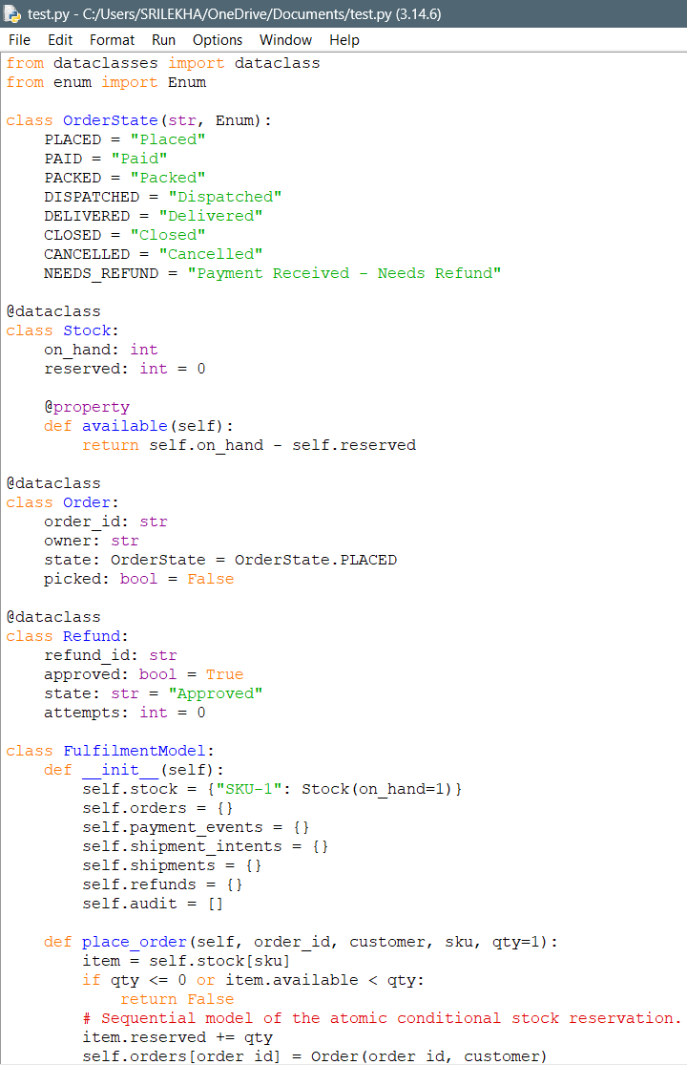

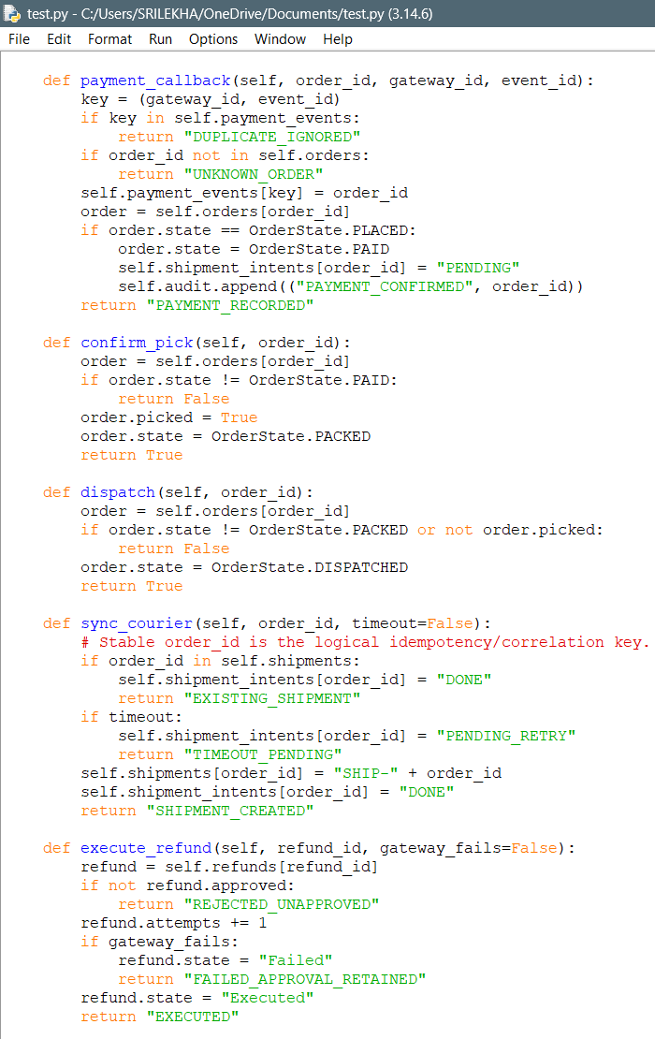
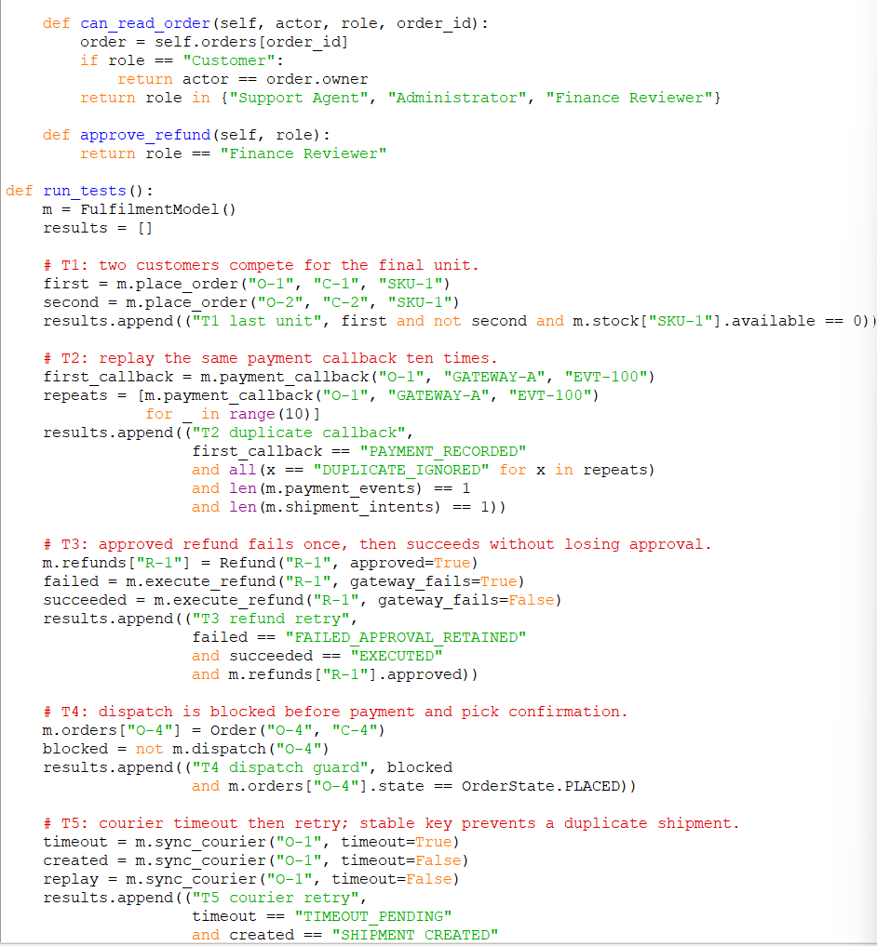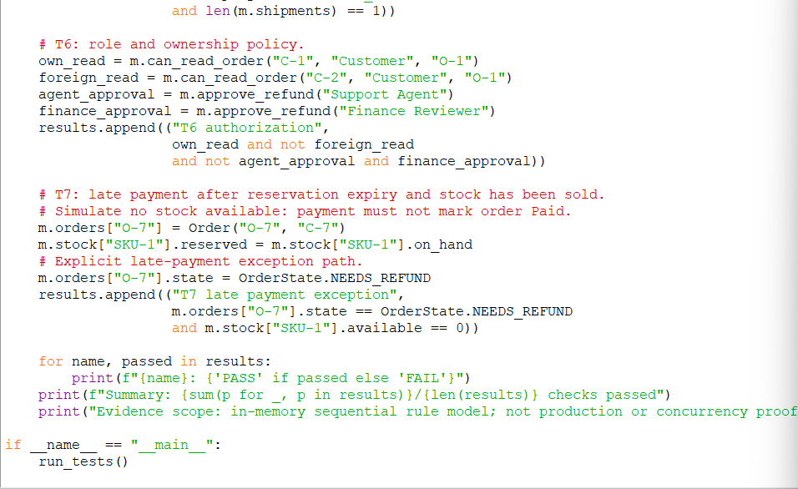

5.6 Expected prototype output

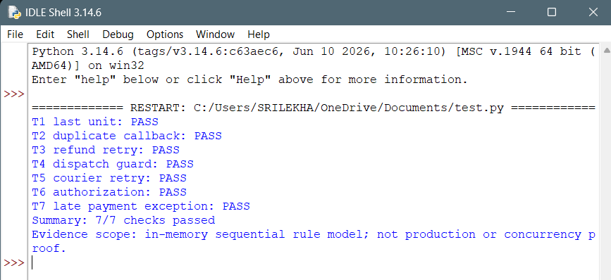
Explanation: T1 models one available unit and rejects the second sequential reservation. T2 stores the gateway/event identity once. T3 preserves approval across a simulated gateway failure. T4 checks the dispatch guard. T5 uses the order ID as a stable simulated correlation key. T6 checks ownership and role rules. T7 illustrates the late-payment exception when the reservation has expired and stock is no longer available.

5.7 Weakness found and design revision
The reservation-expiry walkthrough exposed a weakness: a late payment callback could otherwise mark an order Paid after its stock reservation had been released and the unit resold. Revised rule: after verifying the callback, attempt to re-reserve stock transactionally. If stock is available, continue to Paid. If it is unavailable, record Payment Received / Needs Refund, do not oversell, and start the approval-gated refund workflow. FR08 and the order state model are updated accordingly. A second correction is that Failed refund execution retains its approval and can be retried after reconciliation.

Q6 – Redesign for Expansion and Partial Failure (10 Marks)

6.1 A. Diagnose impact
Changed planning conditions: expansion from 3 to 12 regions; 500 simultaneous users; 1,000 stock, payment and scan events per minute; local tax, shipping and refund-approval rules; disconnected scanner buffering; server-validated refund approval; consolidated reporting; limited infrastructure budget. These are design assumptions, not measured capacity.
Affected area | Impact | Response
FR04 / FR10 | Tax, shipping and refund rules vary by region. | Versioned regional policy records; record policy version on each order/refund.
FR03 / FR08 / NFR02 | Higher event rate and offline stock scans can create stale or duplicate updates. | Stable event IDs, server deduplication, version checks and conflict review.
FR11 / NFR03 | More integrations and regional failures increase retry/backlog needs. | Durable queues/outbox, bounded retries, monitoring and dead-letter/manual review.
FR12 / NFR01 | Consolidated reports may compete with checkout queries. | Reporting summary/read model, scheduled refresh, indexes and pagination.
NFR04 | More regions and actors increase policy complexity. | Region-scoped permissions, least privilege and audited policy changes.
NFR01 / NFR03 | 500 users and 1,000 events/minute create throughput and recovery requirements. | Profile before scaling; connection pooling, API replicas and measured capacity tests.

Planning arithmetic: 1,000 events/minute is approximately 16.7 events/second on average. A 5× burst factor gives approximately 83.5 events/second as a design assumption. It is not a benchmark or proof of system capacity.

6.2 B. Revised architecture and responsibilities
- Regional Policy module: stores versioned tax, shipping, return-window and refund-approval policies. Each order records the policy version used at checkout so later policy edits do not silently recalculate historic orders.
- Order and Stock modules: retain globally unique order IDs; stock ownership remains explicit by region/warehouse/SKU. Conditional updates and version checks prevent stale scanner data from overwriting newer accepted stock.
- Scanner edge buffer: each event includes region, warehouse, scanner/node ID, unique event ID, SKU, quantity delta, observed time and schema version. A bounded local queue stores events while disconnected.
- Synchronization API: authenticates scanner identity, validates schema and region, deduplicates by (node ID, event ID), checks sequence/version and applies acceptable events transactionally. Conflicts or stale observations are flagged for human review rather than silently treated as live stock.
- Refund approval: a local scanner or disconnected client may queue an approval request, but it remains Pending Sync / Awaiting Server Validation. Only the central server validates reviewer identity, policy version, amount and order eligibility before displaying Approved.
- Integration worker/queue: batches and retries gateway/courier/scan events with exponential backoff, stable IDs, bounded retry policies and dead-letter/manual reconciliation.
- Reporting read model: scheduled summary tables or materialized views aggregate sales, stock and refunds across regions. Reporting reads do not run heavy scans against checkout tables.
- Deployment: replicate stateless API containers behind a proxy; keep one reliable relational database initially with backups, indexes and connection pooling. Add read replicas or regional database partitioning only after measured bottlenecks justify the cost.

6.3 Revised component/deployment view
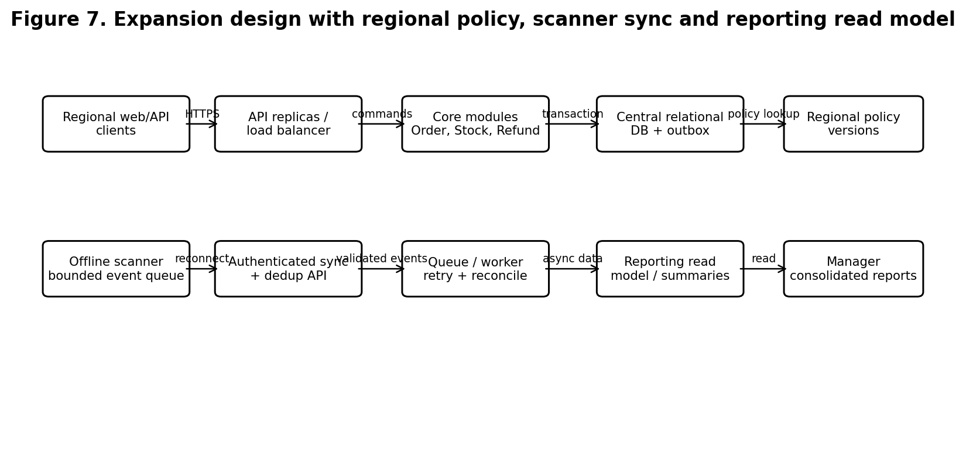

6.4 Synchronization and consistency rules
- Event identity: unique key = (region_id, warehouse_id, node_id, event_id). The server stores the event before applying its effect; replay returns the prior result.
- Ordering: include a node sequence number and observed timestamp. Do not assume timestamps alone establish order. Out-of-order or stale events are quarantined or reconciled against current server stock.
- Stock correction: scanner events represent observations or controlled deltas, not unconditional replacement of central stock. Physical recount/correction requires an authorized human and an audit reason.
- Bounded buffering: define a maximum local queue size and retention period. When full, show a clear unsynchronized warning and prevent silent event loss; export/recovery procedure must be documented.
- Approval: queued refund approvals are visibly Pending Sync. The server validates identity, role, amount, policy version and order state before changing to Approved. A disconnected client cannot grant global approval.
- Retry: use exponential backoff with jitter and a maximum automatic retry count; then move to a monitored dead-letter/manual reconciliation state. Retrying must not create duplicate stock movements, refunds or shipments.

6.5 C. Additional validation scenarios
Scenario | Prediction / acceptance observation | Evidence status
T8 Increased load: 500 simultaneous users and 1,000 events/minute | At planned load, record p95 latency, error rate, queue lag, DB connections and CPU; target NFR01 must be met without violating stock/payment invariants. | Design validation plan only; no load test or capacity claim is made.
T9 Scanner reconnect replays 100 buffered events twice | Each unique event is applied once; duplicate replay has no second stock effect; queue drains within agreed target and conflicts are reported. | Rule-based walkthrough; executable integration test still required.
T10 Regional policy changes while scanner is offline | Each event/order retains the policy version and observation time; old event is evaluated using explicit policy/version rules, not silently rewritten. | Walkthrough identifies versioning requirement; integration test required.
T11 One API replica becomes unavailable | Load balancer routes to healthy replica; in-flight requests are retried safely using idempotency keys; database remains authoritative. | Deployment fault-injection test required.
T12 Refund approval queued offline | UI shows Pending Sync, not Approved; after reconnect the server validates reviewer, amount, order and policy before approval. | Acceptance walkthrough; endpoint test required.

6.6 D. Benefits, costs, trade-offs and limitations
Benefits: regional policy is explicit and historically traceable; scanner events survive temporary disconnection; deduplication prevents repeated stock effects; pending approvals cannot be misrepresented as globally approved; reporting is isolated from transactional checkout; API replicas improve tolerance of one application-instance failure.
Costs: local buffering requires storage limits, device identity, queue monitoring and recovery procedures. Event reconciliation and policy versioning add implementation complexity. Reporting summaries may be slightly stale. More API replicas and queue workers consume infrastructure, so they should be added based on profiling rather than automatically.
Consistency and availability trade-off: local scanning can remain available while disconnected, but the central stock view is not immediately consistent. The interface must show the event as pending synchronization and avoid promising a globally current stock count. Central refund approval remains unavailable when the server cannot validate it; this intentionally favours financial control over offline availability. A central database outage still affects global order and approval writes.
Budget defence: retain the modular application and one relational database for the initial expanded release; add API replicas, indexes, connection pooling, batching and a reporting read model before extracting services. Introduce a broker only if measured queue volume or independent service scaling warrants it. Remaining limitations include the need for real scanner tests, regional tax/legal review, load testing, backup restoration and operational monitoring.

Q7 – Individual Technical Reflection (5 Marks)
The requirement that most influenced my architecture was FR05, which requires a gateway/event identity to create at most one payment effect. It influenced the PaymentEvent class, the unique gateway/event database constraint, the callback sequence and the use of idempotency during retries. It also encouraged the selection of a relational transaction for the first release.
The most difficult stakeholder conflict was fast refunds versus finance control. Customers and support staff benefit from quick resolution, but an unauthorized or duplicated refund creates financial loss. I resolved this by separating refund request, approval and execution, keeping the approver identity in the audit record and retaining approval after a gateway failure.
The most important modeling inconsistency was treating a browser payment-success redirect as proof of payment. The sequence and state model showed that the browser is not authoritative. The design was corrected so that only a verified gateway callback changes the order to Paid. A related validation weakness was late payment after reservation expiry; the revised Needs Refund path prevents overselling.
The significant unresolved trade-off is centralized consistency versus dependency on the central database and network. A modular application is easier for a small team to operate and supports atomic local transactions, but a database outage limits global writes. Offline scanner buffering improves local continuity but creates delayed stock synchronization and stale observations.
Before implementation, I would need real stakeholder approval of the refund threshold, reservation expiry and regional rules; representative order and stock query patterns; gateway callback and idempotency documentation; courier outage/retry history; scanner offline-duration and storage tests; security and privacy review; measured load tests at the stated expansion target; and a successful backup restoration exercise. The current prototype is only a sequential in-memory rule demonstration and is not sufficient evidence for production readiness.

Conclusion
The selected design connects stakeholder needs to testable requirements, UML models, architecture components and validation scenarios. A modular application with a relational transaction boundary and durable integration worker is the most proportionate first-release choice for a small team. It addresses duplicate callbacks, last-unit reservation, role separation, refund approval and courier retry while keeping operational complexity bounded. The expansion design adds versioned regional policies, bounded scanner buffering, deduplication, server-validated approvals and reporting summaries. Its capacity targets remain assumptions until measured in a representative deployed environment.

FINAL RUBRIC-ALIGNMENT CHECK
Task | Rubric coverage included in this report
1 – 5 marks | Investigation questions; labelled simulated stakeholder evidence; problem statement; goal, scope and exclusions; measurable criteria; technical, operational and financial feasibility.
2 – 6 marks | Two different approaches compared; selection justified; roles, cadence, stakeholder participation and escalation; Lean controls; Jira compared with Trello.
3 – 8 marks | Four epics; more than twelve story slices; acceptance criteria, priorities, points, dependencies and owners; MoSCoW rationale; retained/deferred scope; DoR, DoD, privacy/accessibility; stakeholder trade-offs; Jira-ready artefact specification.
4 – 7 marks | Capacity arithmetic and reserve; four sprint goals; story-point explanation; gateway/scanner sequencing; development statuses and transition rules; WIP; blocked, urgent and unfinished-work policies; complete journey.
5 – 7 marks | Pre-simulation bottleneck prediction; control rule; twelve simulated events; board updates; four indicators; interpretation and next-sprint improvement.
6 – 12 marks | Impact diagnosis; measurable redesign objectives; revised priorities, team roles, sequencing, scaled Agile and Lean practices; six simulated events; equivalent comparative indicators; trade-off defence under fixed deadline.
7 – 5 marks | Significant decision; evidence-driven change; vulnerabilities; privacy/workload ethics; next investigation linked to the report's artefacts.

