SIMATS ENGINEERING
ASSESSMENT TOOL 2: Scenario-Based Questions
COURSE NAME: COMPUTER VISION COURSE CODE: ITA05

COURSE OUTCOME COVERED
CO2: Apply image enhancement and segmentation techniques for extracting meaningful regions from images. (BTL 3)

QUESTIONS: 5 Max Marks50 Duration :60 Minutes
Annexure A
Scenario-Based Questions

Code of Conduct:
I B S Reshma (192521342) (Name / Reg No) certify that this submission is my original work and that I have adhered to the guidelines specified for this assessment.I understand that any violation of academic integrity rules will result in disciplinary action.
Signature of the student:
B S Reshma

Annexure A
Scenario-Based Questions

1. Dental X-Ray Enhancement and Cavity Region Extraction
A dental clinic uses a digital radiography system to help dentists locate early-stage cavities (caries) in teeth. The X-ray images are dark and low in contrast, with quantum noise and overlapping tooth structures, so small cavity regions blend into the surrounding enamel and dentine.
Question: Apply suitable grey-level transformations (such as negative, log or power-law transformation) and histogram equalization to improve the visibility of the cavity regions. Select an appropriate spatial smoothing filter to suppress noise without blurring the cavity boundaries. Subsequently, apply thresholding or region growing to extract the suspected cavity region, and use edge detection to outline it. Explain the sequence of processing steps and justify the choice of each technique.
Ans:
Processing sequence and justification
1. Image preparation. Load the radiograph and keep an unchanged copy for comparison. If the input is colour, convert it to grayscale because conventional X-ray information is mainly represented by intensity. Normalize grey levels to a consistent range such as 0–255 or 0–1. Do not crop away tooth margins too early: surrounding anatomy helps distinguish a genuine cavity from an artifact.
2. Grey-level transformation. Use a power-law transformation, s = c r^γ. A gamma value below 1 brightens darker pixels and can reveal low-intensity regions. A logarithmic transformation, s = c log(1+r), is another option because it expands low intensities and compresses high intensities. Choose moderate parameters; excessive brightening can amplify quantum noise and make normal anatomical variations look suspicious.
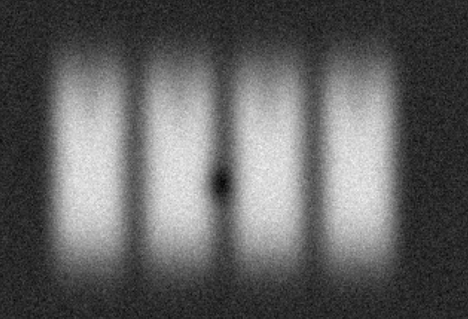
Figure 1. Illustrative input image showing the problem conditions.
3. Histogram processing. Inspect the histogram to determine whether most pixels occupy a narrow intensity range. Global histogram equalization redistributes intensity values, but may over-enhance noise across the image. Contrast-Limited Adaptive Histogram Equalization (CLAHE) is usually more suitable because it enhances local contrast and clips extreme histogram peaks. This can reveal a small cavity beside brighter enamel without making every noisy pixel equally prominent.
4. Noise reduction. Apply a small 3 × 3 median filter to remove isolated impulse-like specks. If quantum noise is approximately Gaussian, a mild Gaussian filter may be suitable. A bilateral filter is useful when edge preservation is important because it smooths similar intensities while reducing smoothing across strong edges. Keep the kernel small: heavy smoothing can erase an early cavity or soften its margin.
5. Thresholding or region growing. Thresholding assigns pixels to cavity and non-cavity classes based on intensity. A global threshold is simple but can fail when tooth thickness and brightness vary. Adaptive thresholding uses local thresholds and can handle local variation. Alternatively, seeded region growing starts from a suspected cavity and adds neighbouring pixels with similar intensity or texture. Stop growth at strong intensity changes and anatomical limits to avoid leakage into adjacent structures. The output is only a candidate region, not a confirmed diagnosis.
6. Boundary detection and validation. Apply Canny edge detection to the denoised image or extract contours from the binary mask. Canny uses gradients and hysteresis to produce thin, connected edges. Morphological closing can bridge small gaps, while size filtering can remove isolated noise. Compare the outline with the original X-ray and check its anatomical location. Restorations, overlaps and artifacts can resemble caries, so a dentist must verify the result.
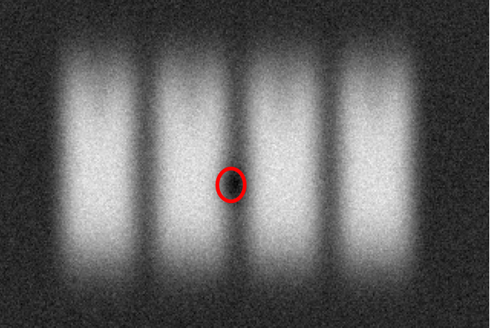
Figure 2. Illustrative enhanced or segmented result.

2. Night-Time Vehicle Number Plate Region Extraction
A traffic police department installs CCTV cameras at a toll gate to capture vehicles at night. The images suffer from very low brightness, headlight glare, sensor noise, and motion blur. The system must locate and extract the number-plate region so that the characters can be read in a later stage.
Question: Apply suitable grey-level transformations and histogram processing to enhance the dark regions while controlling glare. Use appropriate smoothing and sharpening filters (for example, median filtering followed by Laplacian or unsharp masking) to reduce noise and restore character edges. Apply edge detection, line detection and edge linking to locate the rectangular plate boundary, and use thresholding to separate the characters from the plate background. Present the complete processing pipeline and explain how each step contributes to extracting the number-plate region.
Ans:
Processing sequence and justification
1. Grayscale conversion and normalization. Convert the frame to grayscale for intensity-based processing, but preserve the colour original if colour may help identify the vehicle later. Normalize the intensity range and inspect the histogram. Night images often contain many dark pixels, while headlight glare creates a small group of very bright pixels. A single global stretch may brighten the glare without adequately improving the plate.
2. Grey-level transformation and glare control. Apply gamma correction with γ below 1 to lift dark plate regions. Use local tone mapping or a high-intensity glare mask so saturated headlights do not dominate enhancement. CLAHE can increase local contrast between the plate and characters. Use a conservative clip limit because strong equalization may amplify sensor noise and glare halos. Avoid indiscriminately increasing all intensities.
3. Denoising before sharpening. Apply a small median filter, typically 3 × 3, to suppress isolated bright and dark sensor specks. A mild bilateral filter can reduce fine grain while preserving character edges. Motion blur differs from random noise: smoothing cannot recover details already smeared across pixels. If video is available, select a sharper neighbouring frame when possible; otherwise use deblurring cautiously. Excessive denoising may merge adjacent characters.

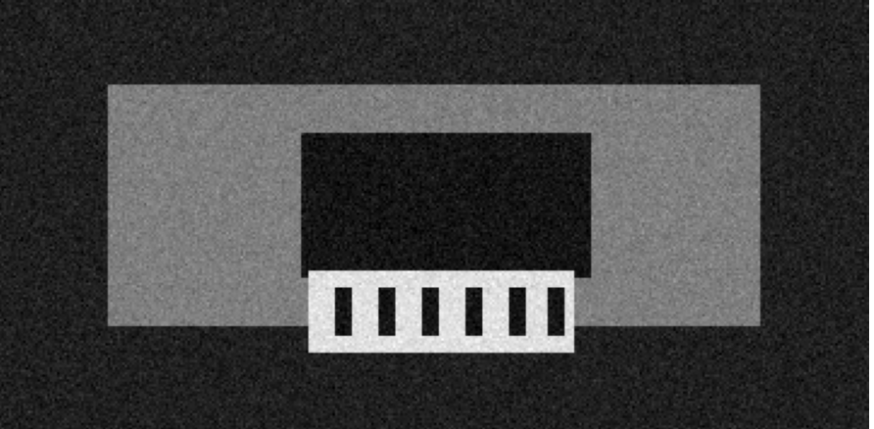
Figure 1. Illustrative input image showing the problem conditions.
4. Sharpening and edge restoration. After denoising, apply unsharp masking or mild Laplacian sharpening. Unsharp masking creates a detail mask by subtracting a blurred version from the image, then adds that mask back with controlled gain. This increases the contrast of character strokes and plate borders. Strong sharpening can create halos around headlights, exaggerate noise and introduce false edges.
5. Detect the plate rectangle. Use Canny edge detection to find strong intensity transitions. Apply a Hough line transform or another line detector to identify long horizontal and vertical segments. Pair plausible lines into rectangular candidates. Edge linking or morphological closing can connect broken border segments. Rank candidates using rectangularity, expected aspect ratio, edge density and local contrast; reject irregular candidates or those dominated by glare.
6. Crop and threshold characters. Crop the selected plate and correct perspective if needed. Apply Otsu thresholding when the plate has uniform illumination; use adaptive thresholding when shadows or reflections cause local variation. Check whether characters are darker or lighter than the plate and choose foreground polarity accordingly. Morphological opening removes isolated specks, while careful closing can reconnect broken strokes. The character mask can then be sent to OCR or automatic number-plate recognition.
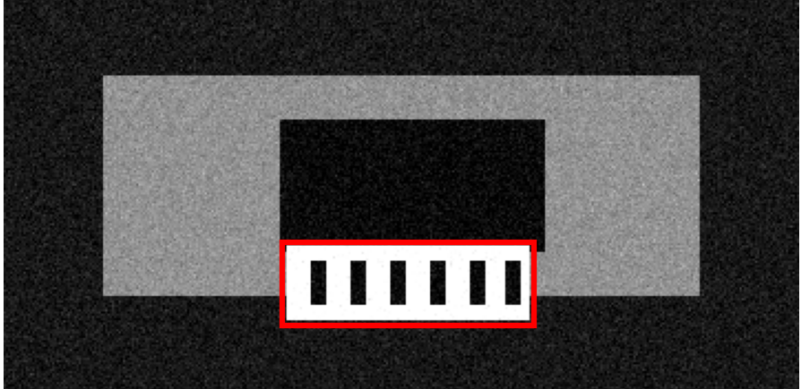
Figure 2. Illustrative enhanced or segmented result.
Overall justification: The correct order is enhancement, denoising, sharpening, geometric localization and character segmentation. Sharpening before denoising would exaggerate noise. Detecting the plate before thresholding restricts binarization to the relevant crop and reduces interference from the road, headlights and vehicle body.
Conclusion: The pipeline produces an enhanced image and candidate regions for further analysis. Filter sizes and thresholds must be tuned using representative data and checked against the original. Clinical or operational deployment requires validation by an appropriate expert.
3. Textile Fabric Defect Detection Using Frequency-Domain Processing
A textile mill inspects woven fabric rolls using a line-scan camera. The fabric has a regular, repeating weave pattern, and defects such as holes, broken threads, oil stains and knots disturb this pattern. The captured images also contain periodic noise from the machine lighting and uneven illumination across the width of the roll.
Question: Apply suitable frequency-domain filtering techniques (low-pass, high-pass, or notch/band-reject filtering) to suppress the periodic noise and the regular weave texture, so that the defects stand out. Use histogram processing to correct the uneven illumination. Subsequently, apply thresholding and boundary detection to segment and outline the defective regions. Explain the order of operations and justify why frequency-domain processing is preferred over spatial-domain processing in this scenario.
Ans:
Processing sequence and justification
1. Normalize illumination. Load the grayscale fabric image and preserve the original. Estimate slowly varying brightness using a large Gaussian blur or morphological opening. Subtract the estimated background, or divide by it when illumination is multiplicative. This flat-field correction reduces brightness changes across the roll and makes local defects easier to compare.
2. Inspect the Fourier spectrum. Compute the two-dimensional Fourier transform (FFT) and display the log-magnitude spectrum. The centre represents low spatial frequencies; positions farther from the centre represent higher frequencies. A regular weave creates repeated frequency components, while periodic lighting interference often appears as distinct symmetric peaks. These peaks indicate which frequencies can be selectively suppressed.
3. Choose a frequency filter. Use a notch-reject filter centred on identified periodic-noise peaks. This is the preferred starting point when the interference is localized in the spectrum. A band-reject filter can remove a known frequency range. Low-pass filtering suppresses high-frequency noise but can blur tiny holes and broken threads. High-pass filtering emphasizes abrupt defects but can also strengthen the weave, so targeted notch filtering is usually safer.
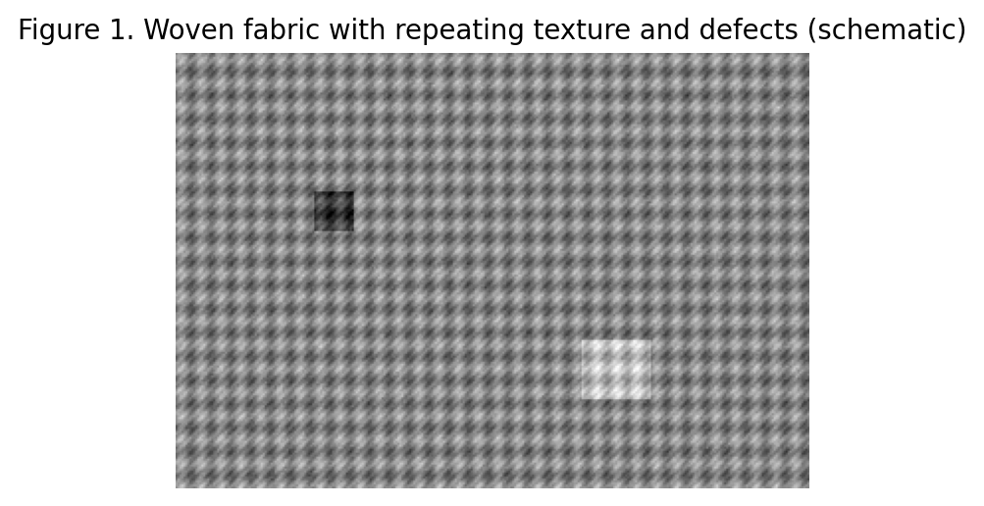
Figure 1. Illustrative input image showing the problem conditions.
4. Inverse transform and inspect. Apply the inverse Fourier transform to return to the spatial image. Inspect for ringing, halos or lost thread detail. Abrupt spectral cut-offs can create ringing near edges, so smooth filter transitions are often safer. Compare the filtered result with the original and confirm that actual defects remain visible. A visually smooth result is not enough; the distinction between normal texture and defects must improve.
5. Histogram enhancement and segmentation. After frequency filtering, use CLAHE if defect contrast remains weak. Segment dark defects such as holes and oil marks with an appropriate dark-region threshold. Bright knots or broken fibres may need a separate bright-region mask. One threshold may miss defects of opposite polarity. Threshold the corrected image or a residual image representing deviations from the expected weave.
6. Boundary detection and inspection. Use connected-component labeling to identify candidate regions, then Canny edge detection or contour tracing to outline them. Morphological closing can connect short gaps; size and shape criteria can remove tiny noise components. Record each defect's centroid, area and bounding box for quality control. Validate settings on examples of holes, stains, knots and normal fabric because different defect classes may require different thresholds.
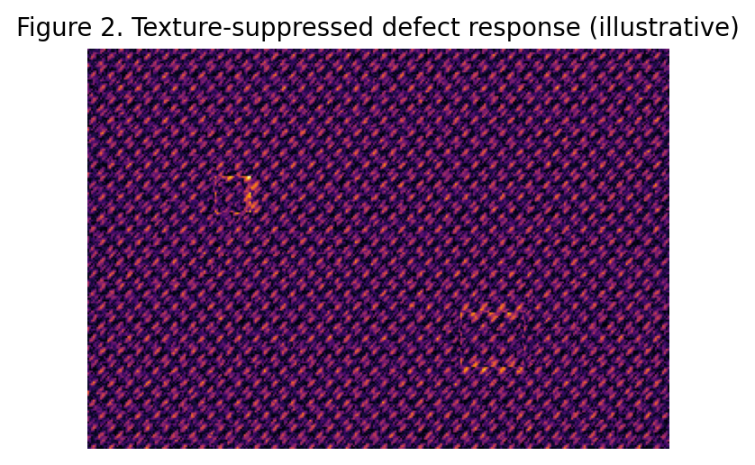
Figure 2. Illustrative enhanced or segmented result.
Overall justification: Frequency-domain processing is advantageous because periodic weave and lighting noise concentrate energy at identifiable frequencies. Spatial filters act locally and may blur defects along with the weave. Targeted notch filtering can suppress selected periodic components while preserving more of the irregular changes caused by defects.
Conclusion: The pipeline produces an enhanced image and candidate regions for further analysis. Filter sizes and thresholds must be tuned using representative data and checked against the original. Clinical or operational deployment requires validation by an appropriate expert.
4. Blood Cell Segmentation in Microscopic Images
A pathology laboratory uses an automated microscope to capture images of stained blood smears for counting red and white blood cells. The images show uneven staining, poor contrast between cells and background, touching or overlapping cells, and noise from dust particles on the slide.
Question: Apply suitable contrast enhancement and histogram processing techniques to improve the separation between cells and background. Use an appropriate spatial filter to remove small noise particles while preserving cell boundaries. Apply global or adaptive thresholding to separate cells from the background, and use region-based segmentation (region growing or region splitting and merging) to separate touching cells. Finally, apply edge detection and boundary detection to outline individual cells. Explain the processing sequence and the role of each technique in obtaining accurate cell regions.
Ans:
Processing sequence and justification
1. Select a useful channel. Retain the colour image because stain colour may distinguish cells from the background. If intensity processing is needed, convert to grayscale or use a colour space such as Lab or HSV and select the channel with the strongest separation. Normalize the channel and preserve the original. The best channel depends on the stain and microscope settings, so inspect representative images.
2. Enhance contrast and correct background. Apply CLAHE to improve local contrast without excessive global amplification. Correct uneven staining and illumination by estimating a smooth background and subtracting or dividing by it. This reduces gradual intensity variation across the field. Global histogram equalization may help a uniformly low-contrast image, but can exaggerate dust and stains; conservative CLAHE is often more robust.
3. Remove noise carefully. Use a small median filter to remove isolated dust specks and impulse noise. A mild Gaussian filter reduces fine noise, while an edge-preserving bilateral filter may help when cell membranes are faint. Use a small kernel because heavy smoothing can merge adjacent cells or erase small details. If dust overlaps a cell, size filtering alone may fail; colour, shape and location should also be considered.
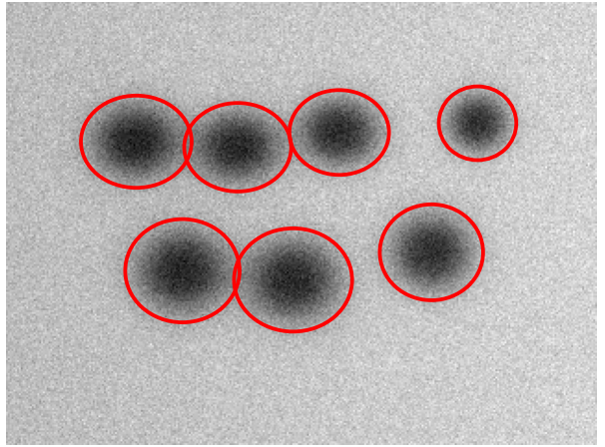
Figure 1. Illustrative input image showing the problem conditions.
4. Threshold cells from background. Use Otsu's method when the corrected histogram separates into two classes. With uneven staining, adaptive thresholding is generally more suitable because it calculates a threshold within local neighbourhoods. Invert the binary mask if necessary so cells form the foreground. Remove only components clearly too small to be cells; a strict size limit might remove small white cells or cell fragments.
5. Separate touching cells. Thresholding often merges touching cells into one connected component. Compute a distance transform inside the cell mask; central pixels have larger distance values. Detect local maxima as markers and apply marker-controlled watershed to split clumps along narrow contact regions. Seeded region growing is an alternative, using intensity or colour similarity and a stopping rule. Region splitting and merging can also help with heterogeneous cells. True overlaps may remain ambiguous and should be flagged.
6. Outline and count cells. Apply Canny edge detection or extract contours from the final masks. Label each separated component and calculate area, perimeter, centroid and bounding box. These measurements support counting and quality checks. Use size and shape as supporting evidence only, because red cells, white cells and damaged cells vary. Compare results against manually annotated images and record errors such as merged cells, split cells and missed faint cells.
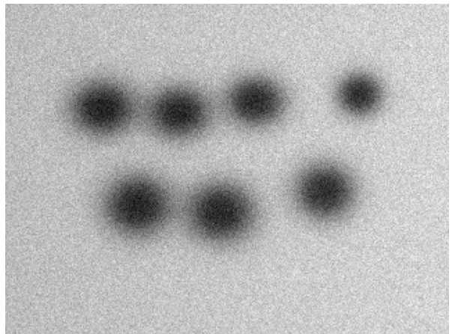
Figure 2. Illustrative enhanced or segmented result.
Overall justification: Contrast enhancement and background correction address uneven staining, while thresholding creates the initial mask. Region-based methods such as marker-controlled watershed solve the separate problem of touching cells. Boundary extraction follows separation so each outline corresponds as closely as possible to one cell rather than a whole cluster.
Conclusion: The pipeline produces an enhanced image and candidate regions for further analysis. Filter sizes and thresholds must be tuned using representative data and checked against the original. Clinical or operational deployment requires validation by an appropriate expert.
5. Text Extraction from Degraded Historical Documents
A state archive is digitising old handwritten manuscripts. The scanned pages contain yellowed paper, ink bleed-through from the reverse side, stains, faded strokes and uneven lighting across the page. The archive requires clean extraction of text regions before handwriting recognition.
Question: Apply suitable grey-level transformations and histogram processing to improve the contrast between faded ink and the background. Select appropriate smoothing and sharpening filters to remove stains and noise while strengthening the pen strokes. Compare global thresholding (such as Otsu's method) with local (adaptive) thresholding for this scenario and apply the more suitable one to separate text from the background. Use edge detection and boundary detection to identify text lines and word regions. Explain the sequence of operations and justify each decision.
Ans:
Processing sequence and justification
1. Grayscale and background estimation. Keep the colour image if paper or ink colour helps distinguish stains and bleed-through; otherwise convert to grayscale. Estimate slow background variation with a large Gaussian or median filter, or morphological opening. Normalize the image using the estimated background to reduce yellowing and uneven illumination. The background window should be much larger than a pen stroke; otherwise the correction may treat writing as background.
2. Grey-level and histogram enhancement. A gamma or logarithmic transformation can expand intensity differences associated with faint ink. Inspect the histogram before and after enhancement to confirm improved separation. CLAHE improves local contrast where some lines are more faded than others. Global equalization may over-enhance stains and paper grain, so use conservative settings and inspect thin strokes, punctuation and diacritic marks.
3. Reduce stains and bleed-through. A small median filter can remove isolated specks, while background normalization reduces broad stains. If colour is available, channel differences may help separate ink from yellowing. Reverse-side bleed-through is difficult when it has similar intensity to front-side writing; directional or layout cues may help, but complete removal is not guaranteed. Avoid strong blur or aggressive opening because these can erase thin strokes and disconnect letters.

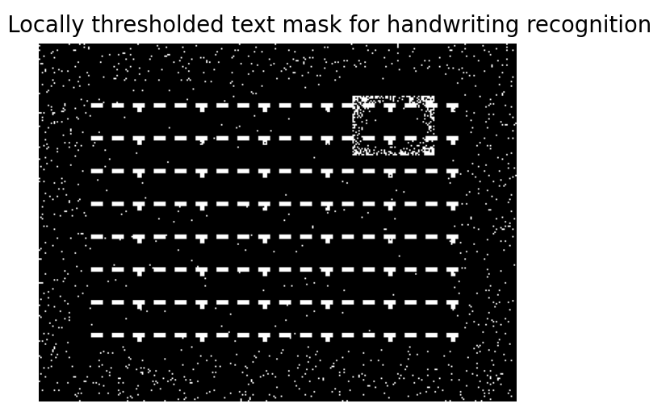
Figure 1. Illustrative input image showing the problem conditions.
4. Sharpen faint strokes. After denoising, apply mild unsharp masking to strengthen pen strokes. It adds a controlled detail mask derived from the difference between the image and a blurred version. Use low sharpening gain to avoid halos and prevent paper grain from becoming dark specks. Inspect cursive letters before and after sharpening because recognition depends on connected joins and realistic stroke width.
5. Compare global and adaptive thresholding. Otsu's method selects one global threshold by separating the histogram into two classes and minimizing within-class variance. It works well when ink and paper intensities are fairly uniform. In historical pages, stains, faded ink and uneven lighting make one threshold unreliable: it may erase pale writing in one area and turn stains into foreground in another. Adaptive thresholding calculates a local threshold, so it is generally more suitable here. Choose a window large enough to cover local paper texture but small enough to follow illumination changes.
6. Extract text lines and words. Create a binary mask with ink as foreground and apply restrained cleanup. Use horizontal projection profiles or horizontal dilation to group components into text lines. Connected-component analysis can identify word candidates, and gaps between components help estimate word boundaries; cursive writing may join letters and words. Canny edges can locate page borders or text blocks, but projection profiles and connected components are usually more useful for line grouping. Crop each line for recognition after checking that strokes remain intact.

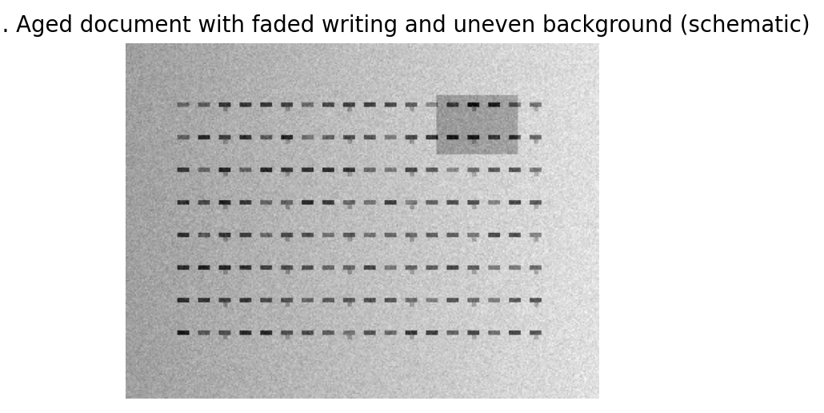
Figure 2. Illustrative enhanced or segmented result.
Overall justification: Background correction should precede binarization because thresholding cannot fix illumination variation after pixels are classified. Adaptive thresholding is preferred for this degraded page. Text-line grouping follows binarization, and visual checks are essential because removing bleed-through too aggressively may erase genuine handwriting.
Conclusion: The pipeline produces an enhanced image and candidate regions for further analysis. Filter sizes and thresholds must be tuned using representative data and checked against the original. Clinical or operational deployment requires validation by an appropriate expert.
RUBRICS FOR CALCULATION:
Criteria | Weightage | Level 4 (Exemplary) | Level 3 (Proficient) | Level 2 (Developing) | Level 1 (Beginning)
Understanding of Scenario | 20% | Demonstrates clear and complete understanding of the scenario and context | Shows good understanding with minor gaps | Partial understanding; misses key aspects | Misinterprets or fails to understand the scenario
Identification of Key Issues | 20% | Accurately identifies all relevant issues and factors involved | Identifies most key issues with minor omissions | Identifies limited issues; some irrelevant points | Unable to identify key issues
Application of Concepts | 25% | Applies appropriate concepts effectively to address the scenario | Applies concepts with minor errors | Limited or partially correct application | Unable to apply relevant concepts
Decision Making | 20% | Makes well-reasoned, logical decisions with strong rationale | Makes reasonable decisions with some justification | Makes weak decisions with limited justification | No clear decisions made or rationale provided
Clarity of Response | 15% | Response is clear, structured, and logically presented | Generally clear with minor issues | Somewhat unclear or poorly structured | Disorganized and difficult to understand

