ITA0501
Computer Vision
Lab Observation

B S Reshma
192521342

1.Perform basic Image Handling and processing operations on the image is to read an image in python and convert an Image to Gray-scale.
Aim:
To read an image using Python and OpenCV and convert the image from RGB/color format to grayscale.
Procedure:
- Import the OpenCV library using import cv2.
- Specify the path of the input image.
- Read the image using the cv2.imread() function.
- Check whether the image has been loaded successfully.
- Convert the color image into a grayscale image using cv2.cvtColor() with cv2.COLOR_BGR2GRAY.
- Display the original image using cv2.imshow().
- Display the grayscale image using cv2.imshow().
- Use cv2.waitKey(0) to keep the images displayed until a key is pressed.
- Close all image windows using cv2.destroyAllWindows().
Code:
import cv2
image = cv2.imread("image.jpg")
if image is None:
print("Error: Image not found!")
else:
gray_image = cv2.cvtColor(image, cv2.COLOR_BGR2GRAY)

cv2.imshow("Original Image", image)
cv2.imshow("Grayscale Image", gray_image)
cv2.imwrite("gray_image.jpg", gray_image)
print("Image read successfully.")
print("Image converted to grayscale successfully.")
print("Grayscale image saved as gray_image.jpg")
cv2.waitKey(0)
cv2.destroyAllWindows()
Sample input:
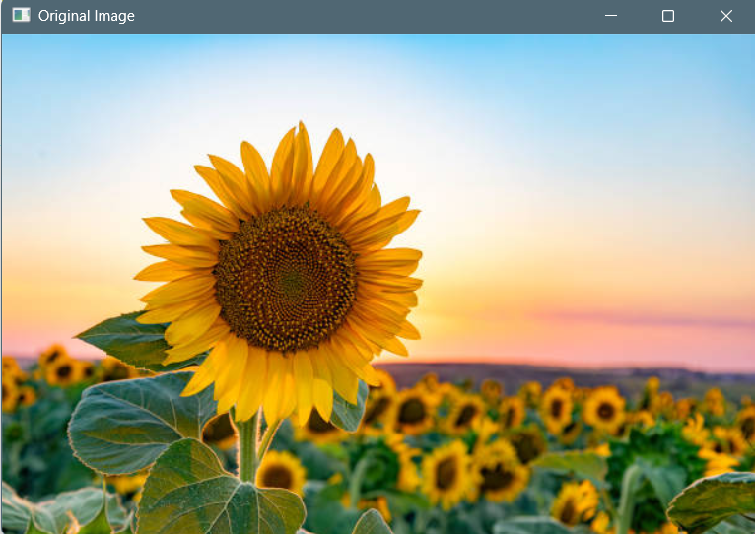

Sample output:
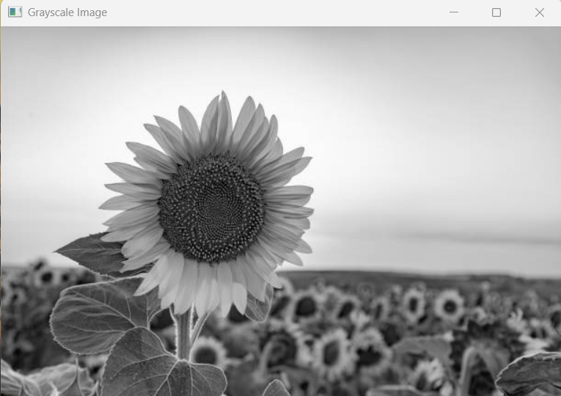
Result:
Thus, the given image was successfully read and converted from a color image to a grayscale image using OpenCV.
2. Perform basic Image Handling and processing operations on the image is to read an image in python and Convert an Image to Blur using Gaussian Blur.
Aim:
To read an image using Python and OpenCV and convert the image into a blurred image using Gaussian Blur.
Procedure:
- Import the OpenCV library using import cv2.
- Specify the path of the input image.
- Read the image using the cv2.imread() function.
- Check whether the image has been loaded successfully.
- Apply Gaussian Blur to the image using cv2.GaussianBlur().
- Specify the kernel size, such as (5,5), to control the amount of blur.
- Display the original image using cv2.imshow().
- Display the blurred image using cv2.imshow().
- Use cv2.waitKey(0) to keep the images displayed until a key is pressed.
10. Close all image windows using cv2.destroyAllWindows().
Code:
import cv2
image = cv2.imread("image.jpg")
if image is None:
print("Error: Image not found!")
else:
gray_image = cv2.cvtColor(image, cv2.COLOR_BGR2GRAY)
cv2.imshow("Original Image", image)
cv2.imshow("Grayscale Image", gray_image)
cv2.imwrite("gray_image.jpg", gray_image)
print("Image read successfully.")
print("Image converted to grayscale successfully.")
print("Grayscale image saved as gray_image.jpg")
cv2.waitKey(0)
cv2.destroyAllWindows()
Sample input:
Sample output:
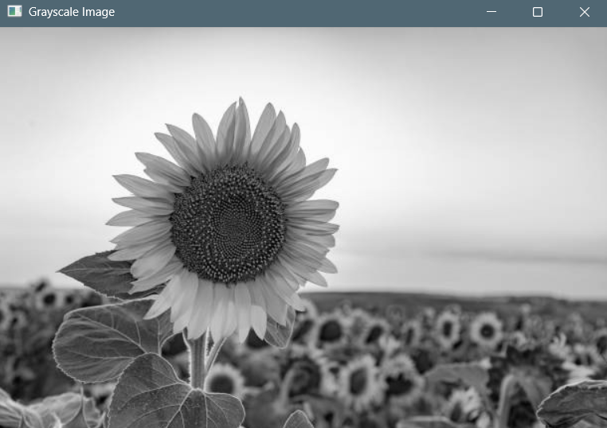
Result:
Thus, the given image was successfully read and blurred using the Gaussian Blur function in OpenCV, reducing noise and fine details.
3.Perform basic Image Handling and processing operations on the image is to read an image in python and Convert an Image to show outline using Canny function.
Aim:
To read an image using Python and OpenCV and detect the outline or edges of the image using the Canny function.
Procedure:
- Import the OpenCV library using import cv2.
- Specify the path of the input image.
- Read the image using the cv2.imread() function.
- Check whether the image has been loaded successfully.
- Convert the image into grayscale using cv2.cvtColor().
- Apply the Canny edge detection function using cv2.Canny().
- Specify suitable lower and upper threshold values for detecting edges.
- Display the original image using cv2.imshow().
- Display the detected outline/edges using cv2.imshow().
10. Use cv2.waitKey(0) to keep the images displayed until a key is pressed.
11. Close all image windows using cv2.destroyAllWindows().
Code:
import cv2
image = cv2.imread("image.jpg")
if image is None:

print("Error: Image not found!")
else:
gray_image = cv2.cvtColor(image, cv2.COLOR_BGR2GRAY)
edges = cv2.Canny(gray_image, 100, 200)
cv2.imshow("Original Image", image)
cv2.imshow("Canny Outline", edges)
cv2.imwrite("canny_image.jpg", edges)
print("Image read successfully.")
print("Image outline detected using Canny successfully.")
print("Canny image saved as canny_image.jpg")
cv2.waitKey(0)
cv2.destroyAllWindows()
Sample input:
Sample output:
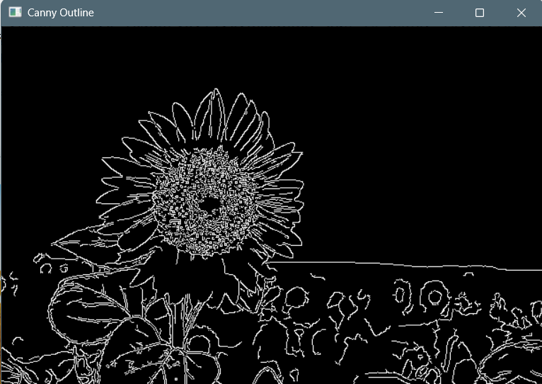
Result:
Thus, the given image was successfully read and its outline/edges were detected using the Canny edge detection function in OpenCV.
4.Implement histogram equalization on the given image and compare it with the original image using Open CV.
Aim
To implement histogram equalization on a given image and compare the equalized image with the original image using OpenCV.
Procedure
- Import the required OpenCV library.
- Read the input image using cv2.imread().
- Convert the image from BGR to grayscale.
- Apply histogram equalization using cv2.equalizeHist().
- Display the original grayscale image and the equalized image.
Code:
import cv2
image = cv2.imread("image.jpg")
if image is None:
print("Error: Image not found!")
else:
gray_image = cv2.cvtColor(image, cv2.COLOR_BGR2GRAY)

equalized_image = cv2.equalizeHist(gray_image)
cv2.imshow("Original Image", gray_image)
cv2.imshow("Equalized Image", equalized_image)
cv2.imwrite("equalized_image.jpg", equalized_image)
cv2.waitKey(0)
cv2.destroyAllWindows()
Input image:
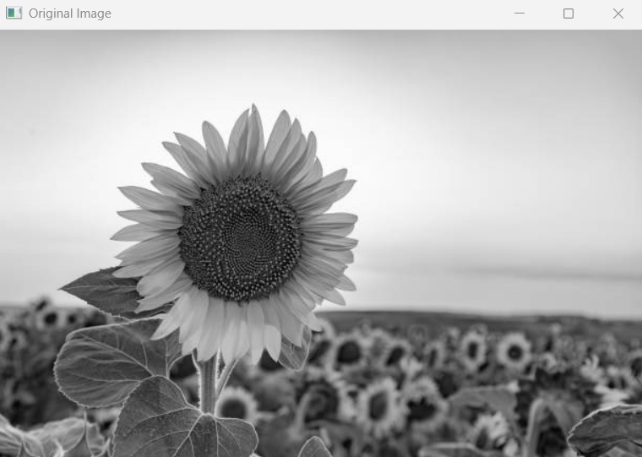
Output image:
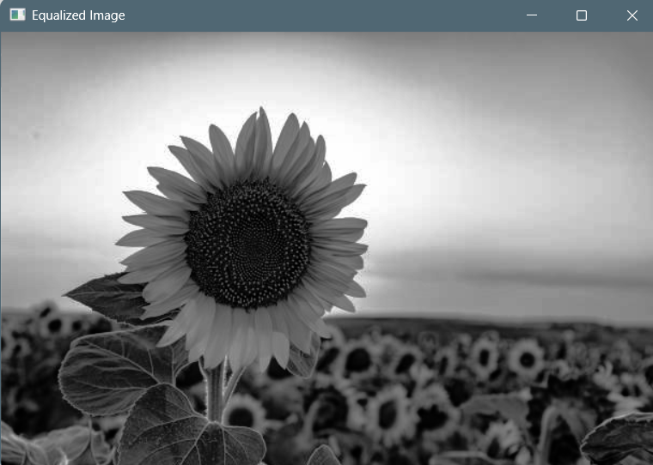
Result:
Thus, histogram equalization was successfully performed. The equalized image showed improved contrast compared with the original grayscale image.
5.Write a Python function to analyze the histogram of the given input image based on color levels using Open CV.
Aim:
To write a Python function to analyze the histogram of a given input image based on its color levels using OpenCV.
Procedure:
- Import OpenCV.
- Read the input image.
- Separate the image into Blue, Green, and Red channels.
- Calculate the histogram for each color channel using cv2.calcHist().
- Display the histograms of the three color channels.
- Analyze the distribution of different intensity levels.
Code
import cv2
def analyze_histogram(image):
colors = ['Blue', 'Green', 'Red']
channels = [0, 1, 2]
for channel in channels:
histogram = cv2.calcHist([image], [channel], None, [256], [0, 256])
print(colors[channel], "Channel")
print("Minimum intensity:", histogram.argmin())
print("Maximum intensity:", histogram.argmax())
cv2.imshow("Input Image", image)
image = cv2.imread("image.jpg")
if image is None:
print("Error: Image not found!")
else:
analyze_histogram(image)
cv2.waitKey(0)
cv2.destroyAllWindows()

Input Image:
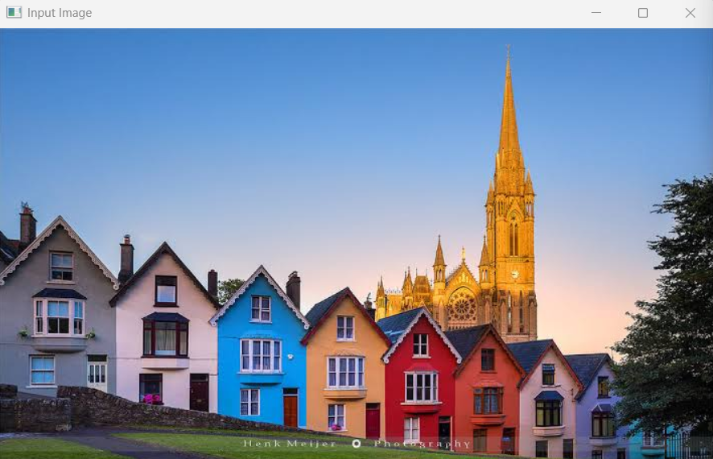
Output image:
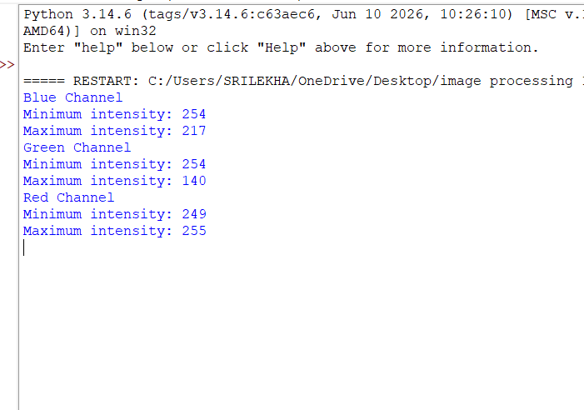
Result
Thus, the histogram of the input image was successfully analyzed based on the Blue, Green, and Red color levels.
6.Perform basic Image Handling and processing operations on the image is to read an image in python and Convert an Image to erode using Erode function.
Aim
To perform basic image processing by reading an image in Python and applying erosion using the OpenCV erode() function.
Procedure
- Import OpenCV.
- Read the input image.
- Convert the image to grayscale.
- Create a kernel using cv2.getStructuringElement().
- Apply erosion using cv2.erode().
- Display the original and eroded images.
- Save the resulting image.
Code
import cv2

image = cv2.imread("image.jpg")
if image is None:
print("Error: Image not found!")
else:
gray_image = cv2.cvtColor(image, cv2.COLOR_BGR2GRAY)
kernel = cv2.getStructuringElement(cv2.MORPH_RECT, (5, 5))
eroded_image = cv2.erode(gray_image, kernel, iterations=1)
cv2.imshow("Original Image", gray_image)
cv2.imshow("Eroded Image", eroded_image)
cv2.imwrite("eroded_image.jpg", eroded_image)
cv2.waitKey(0)
cv2.destroyAllWindows()
Sample input:
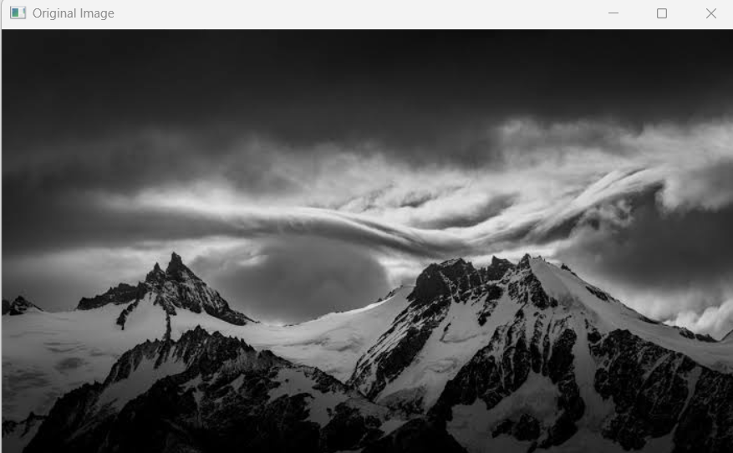

Sample output:
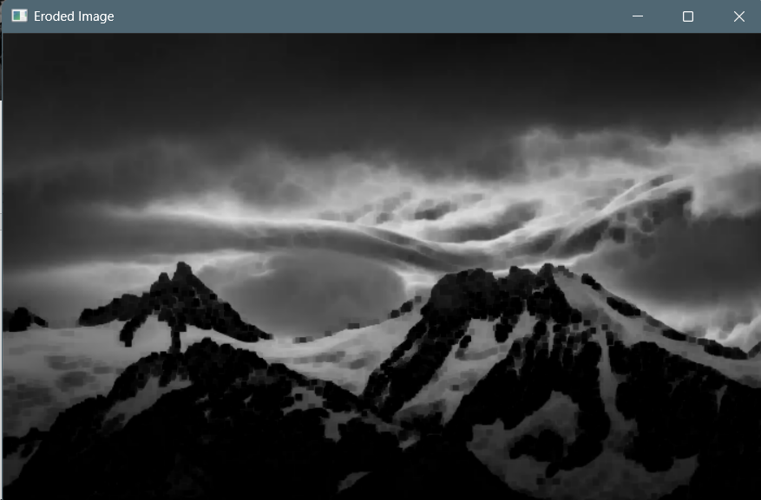
Result
Thus, erosion was successfully performed on the input image. The eroded image showed reduced boundaries and smaller foreground regions.
7.Perform basic video processing operations on the captured video. Read captured video in python and display the video, in slow motion and in fast motion.
Aim
To perform basic video processing by reading a captured video in Python and displaying it in slow motion and fast motion using OpenCV.
Procedure
- Import OpenCV.
- Open the captured video using cv2.VideoCapture().
- Read the video frame by frame.
- Display the video normally.
- Increase the delay between frames to produce slow motion.
- Skip frames or reduce the delay to produce fast motion.
- Release the video and close all windows.
Code
import cv2

video = cv2.VideoCapture("video.mp4")

if not video.isOpened():
print("Error: Video not found!")
else:
while True:
ret, frame = video.read()

if not ret:
break

cv2.imshow("Video", frame)

key = cv2.waitKey(100)

if key == ord('q'):
break

video.release()
cv2.destroyAllWindows()
For Slow Motion
Change:
key = cv2.waitKey(100)
to:
key = cv2.waitKey(200)
For Fast Motion
Use:
key = cv2.waitKey(30)
Result
Thus, the captured video was successfully read and displayed using OpenCV. The playback speed was changed to obtain slow-motion and fast-motion effects.
8.Perform basic Image Handling and processing operations on the image is to read an image in python and Dilate an Image using Dilate function
Aim
To perform basic image processing by reading an image in Python and applying dilation using the OpenCV dilate() function.
Procedure
- Import OpenCV.
- Read the input image.
- Convert the image to grayscale.
- Create a structuring kernel.
- Apply dilation using cv2.dilate().
- Display the original and dilated images.
- Save the resulting image.
Code
import cv2
image = cv2.imread("image.jpg")

if image is None:
print("Error: Image not found!")
else:
gray_image = cv2.cvtColor(image, cv2.COLOR_BGR2GRAY)
kernel = cv2.getStructuringElement(cv2.MORPH_RECT, (5, 5))
dilated_image = cv2.dilate(gray_image, kernel, iterations=1)
cv2.imshow("Original Image", gray_image)
cv2.imshow("Dilated Image", dilated_image)
cv2.imwrite("dilated_image.jpg", dilated_image)
cv2.waitKey(0)
cv2.destroyAllWindows()
Sample input:
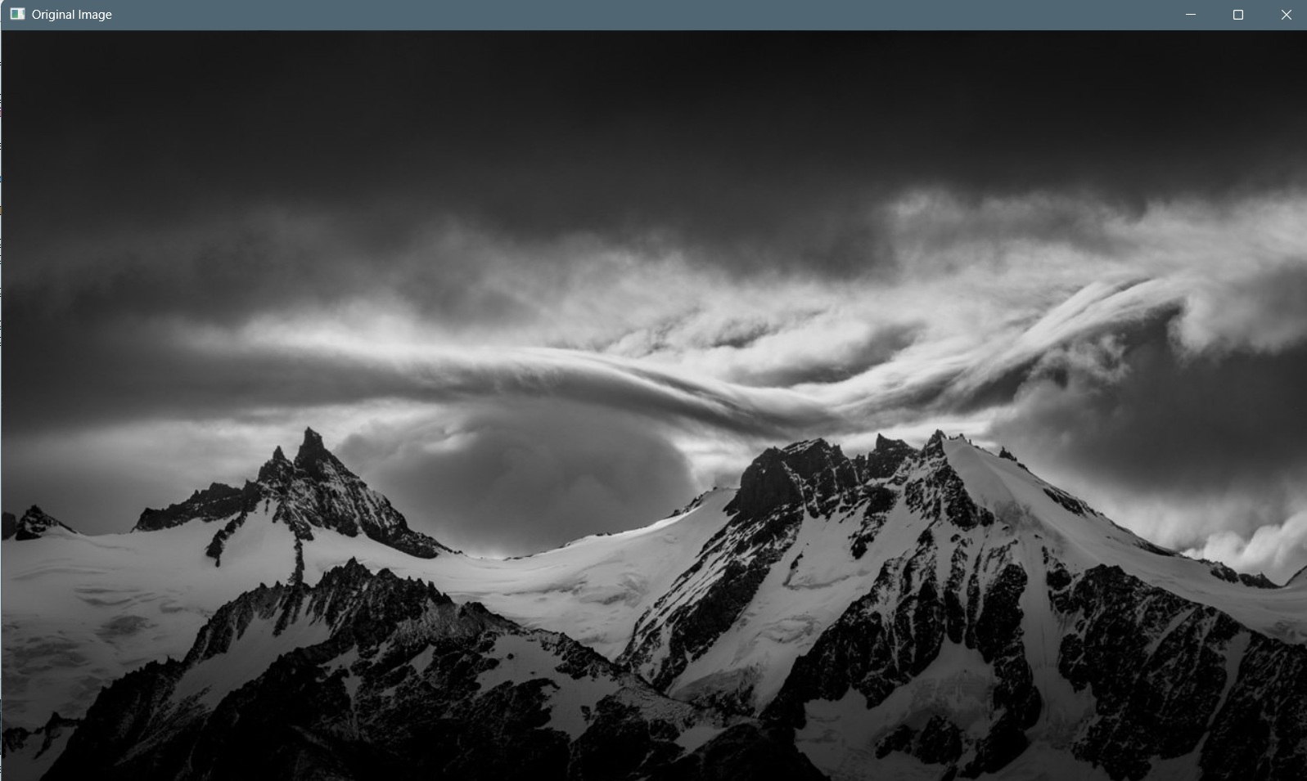

Sample output:
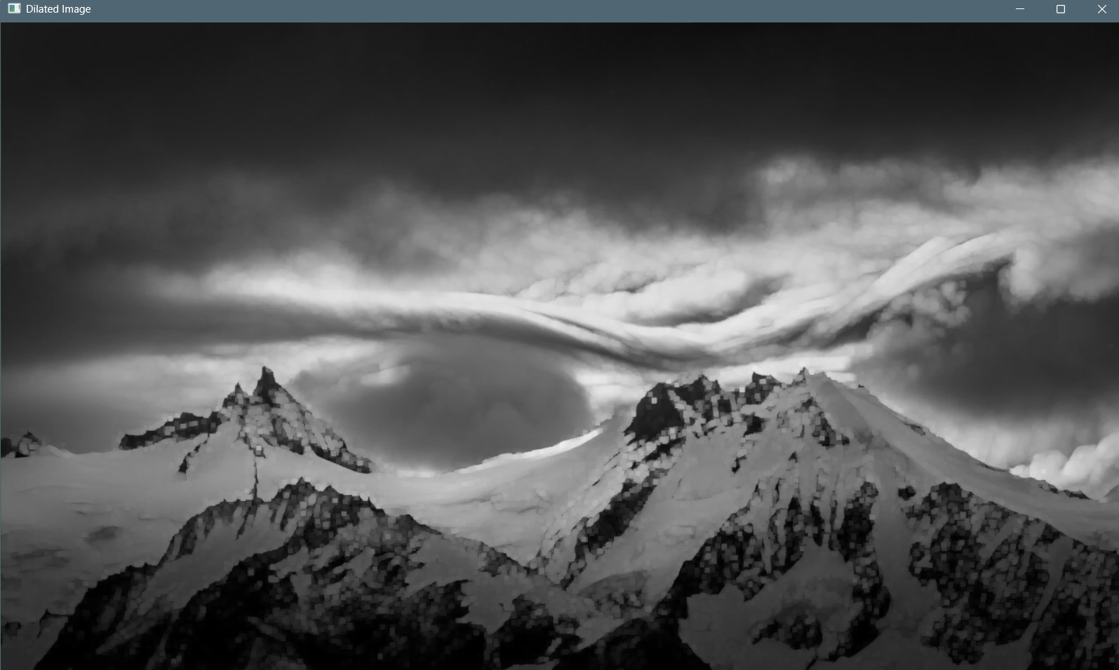
Result
Thus, dilation was successfully performed on the input image. The dilated image showed enlarged foreground regions and thicker boundaries.
9.Implement the image scaling techniques to resize the images to both bigger and small sizes
Aim
To implement image scaling techniques by resizing an image to both bigger and smaller sizes using OpenCV.
Procedure
- Import OpenCV.
- Read the input image.
- Obtain the original dimensions of the image.
- Increase the dimensions to create a larger image.
- Decrease the dimensions to create a smaller image.
- Use cv2.resize() for scaling.
- Display the original, enlarged, and reduced images.
Code
import cv2
image = cv2.imread("image.jpg")
if image is None:
print("Error: Image not found!")
else:
height, width = image.shape[:2]
bigger_image = cv2.resize(image, (width * 2, height * 2))
smaller_image = cv2.resize(image, (width // 2, height // 2))
cv2.imshow("Original Image", image)
cv2.imshow("Bigger Image", bigger_image)
cv2.imshow("Smaller Image", smaller_image)
cv2.imwrite("bigger_image.jpg", bigger_image)
cv2.imwrite("smaller_image.jpg", smaller_image)
cv2.waitKey(0)
cv2.destroyAllWindows()
Sample input:
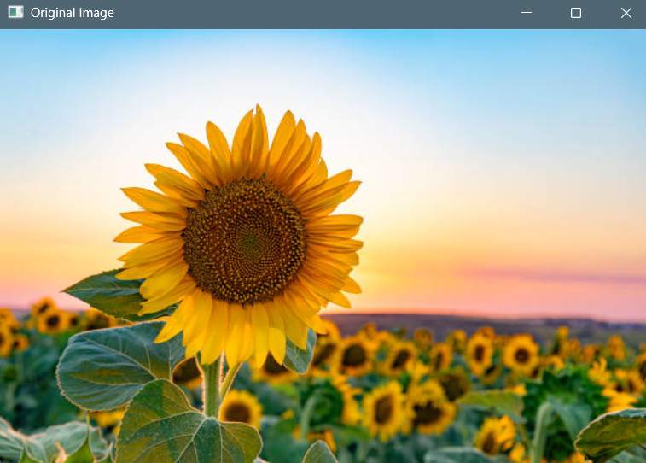
Sample output:
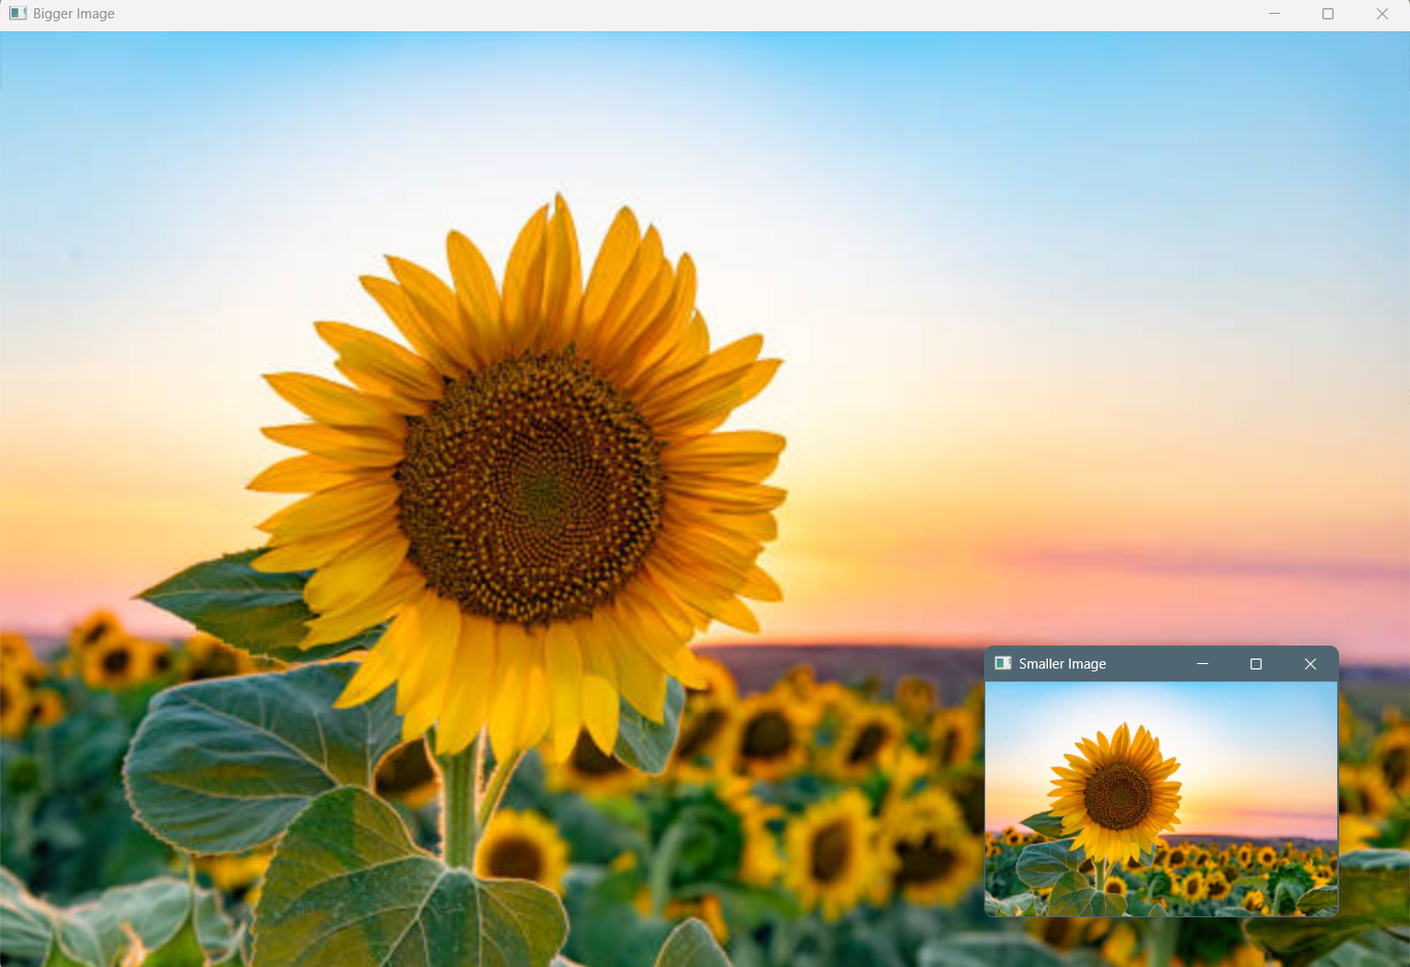
Result
Thus, the given image was successfully resized into both larger and smaller dimensions using OpenCV.
10.Perform a 90-degree rotation clockwise along the y-axis for the given image.
Aim
To perform a 90-degree clockwise rotation of a given image using OpenCV.
Procedure
- Import OpenCV.
- Read the input image.
- Apply a 90-degree clockwise rotation using cv2.rotate().
- Display the original and rotated images.
- Save the rotated image.
Code
import cv2
image = cv2.imread("image.jpg")
if image is None:
print("Error: Image not found!")
else:
rotated_image = cv2.rotate(image, cv2.ROTATE_90_CLOCKWISE)
cv2.imshow("Original Image", image)
cv2.imshow("90 Degree Clockwise Image", rotated_image)
cv2.imwrite("rotated_image.jpg", rotated_image)
cv2.waitKey(0)
cv2.destroyAllWindows()
Sample input:
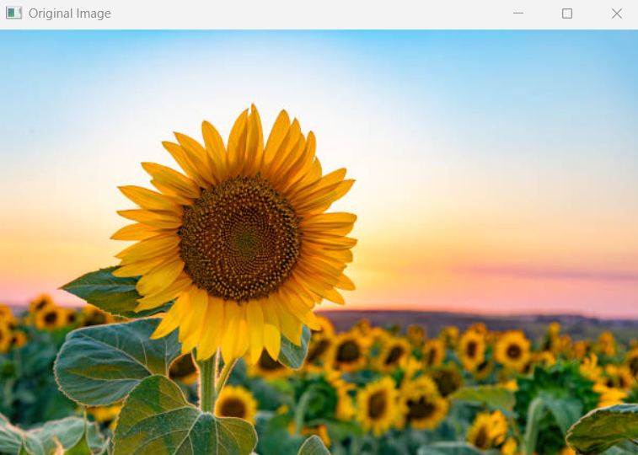

Sample output:
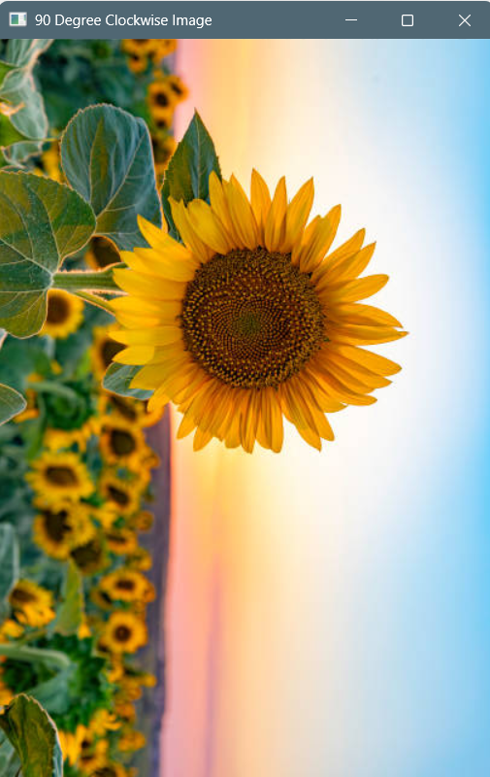
Result
Thus, the given image was successfully rotated by 90 degrees in the clockwise direction using OpenCV.

