COMPUTER NETWORKS ASSIGNMENT
Design and Performance Evaluation of a Next-Gen Smart Campus Network Architecture

Name: MUKESH M
Register No.: 192521368
Course Code: CSA0712
Course: COMPUTER NETWORKS
Faculty: Dr.S.Salini

Assignment Submission

1. Understanding of the Given Assignment
The supplied assignment sheet is for CSA0712 – Computer Networks. Its title is “Design and Performance Evaluation of a Next-Gen Smart Campus Network Architecture.” The task requires a scalable multi-tier Smart Campus network, simulation with network tools, comparison of two routing/design alternatives, and evaluation using throughput, packet delivery ratio and end-to-end delay. It also requires topology, IP addressing/subnetting, routing configuration, screenshots/results, QoS and congestion analysis, failure-mode analysis and GitHub documentation.
This document is intentionally prepared as an assignment solution, not as a capstone-project report. The practical implementation is designed for Cisco Packet Tracer and the screenshot checklist identifies the actual screenshots that should be captured from the student's Packet Tracer file.

2. Problem Solution
The proposed solution divides the campus into logical VLANs and IP subnets. Academic users, laboratories, library users, VoIP, CCTV/security, IoT, servers and network management are separated. A multilayer/core layer performs Layer-3 forwarding, while two core routers provide a more reliable routed backbone. OSPF is selected for the improved alternative because it can dynamically learn routes and adapt after a path change. QoS is used to protect delay-sensitive voice traffic from ordinary bulk data.
Main objectives:
- Build the Smart Campus topology in Cisco Packet Tracer.
- Create separate subnets/VLANs and assign correct gateways.
- Demonstrate communication between different subnets.
- Implement and compare two routing/design alternatives.
- Measure throughput, packet delivery ratio, delay and packet loss using repeatable tests.
- Apply QoS concepts for congestion management and real-time traffic.
- Test link/device failures and explain reliability and scalability.

3. Network Architecture and Topology
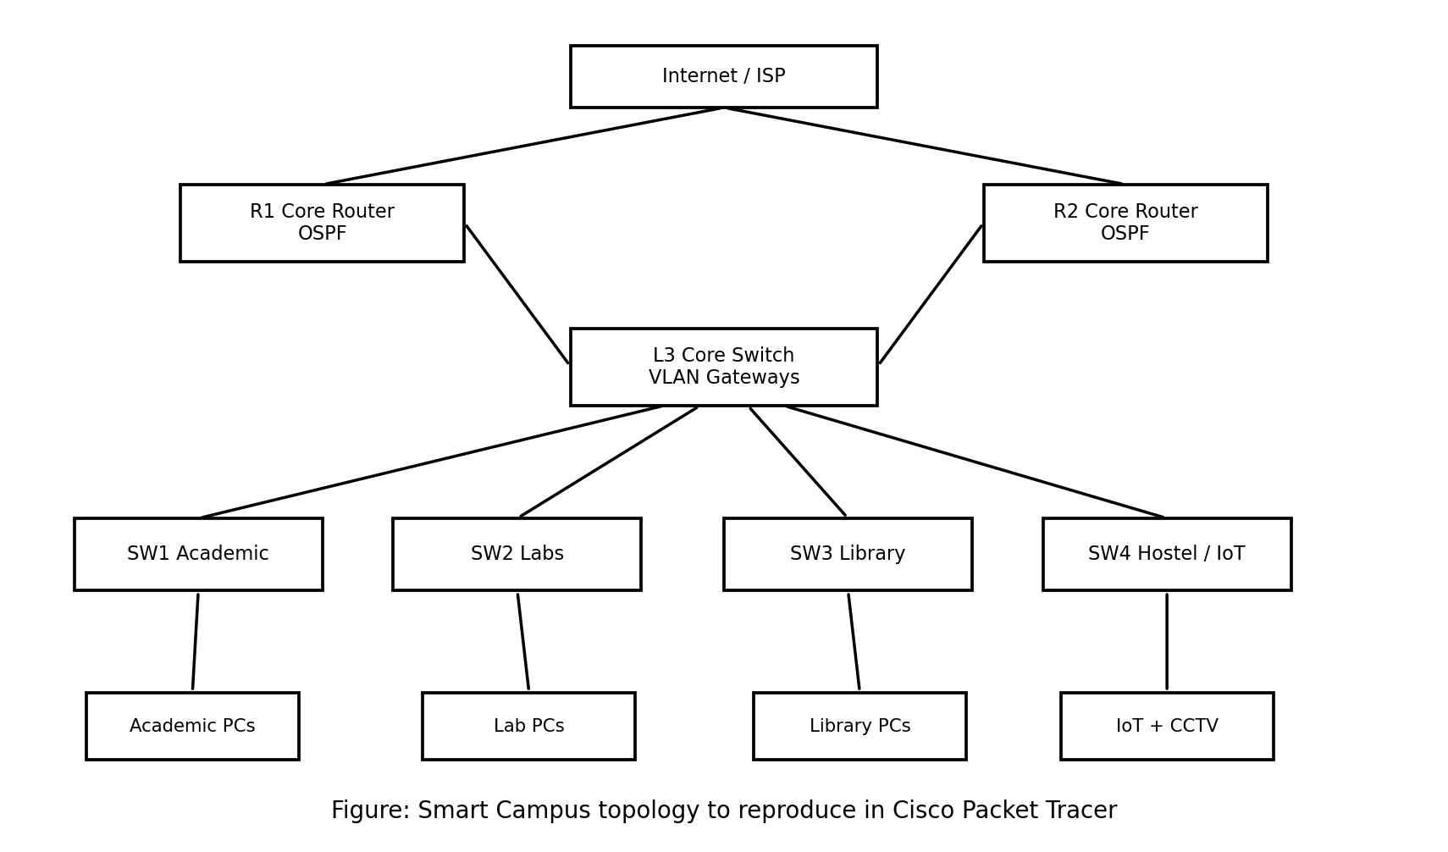
Figure 1. Logical topology for the Cisco Packet Tracer implementation.
Layer/Device | Packet Tracer Device | Role
Internet/Edge | Cloud or generic router | External network representation
Core | 2 × Cisco 2911 routers | Inter-network routing and OSPF
Core/Distribution | 1 × Cisco 3560 multilayer switch | VLAN gateways and aggregation
Access | 4 × Cisco 2960 switches | Connect campus users/devices
End devices | PCs, server, IP phone/IoT/CCTV | Generate application traffic

Communication is primarily unicast for host-to-host traffic. Broadcasts remain within VLANs, reducing unnecessary campus-wide traffic. Ethernet is used for the wired links. The hierarchical design makes the network easier to manage and expand.

4. IP Addressing and Subnetting Plan
VLAN | Purpose | Network | Gateway | Example Host
10 | Academic | 10.10.10.0/24 | 10.10.10.1 | 10.10.10.10
20 | Computer Labs | 10.10.20.0/24 | 10.10.20.1 | 10.10.20.10
30 | Library | 10.10.30.0/24 | 10.10.30.1 | 10.10.30.10
40 | VoIP | 10.10.40.0/24 | 10.10.40.1 | 10.10.40.10
50 | CCTV/Security | 10.10.50.0/24 | 10.10.50.1 | 10.10.50.10
60 | IoT | 10.10.60.0/24 | 10.10.60.1 | 10.10.60.10
70 | Servers | 10.10.70.0/24 | 10.10.70.1 | 10.10.70.10
99 | Management | 10.10.99.0/24 | 10.10.99.1 | 10.10.99.10

A /24 is used in the simulation for simple configuration and future growth. In a production campus, VLSM could allocate smaller prefixes to small groups and larger prefixes to high-density areas.

5. Alternative 1 — Centralized Router-on-a-Stick
In Alternative 1, one router performs inter-VLAN routing through 802.1Q subinterfaces. Access switches connect users through VLANs. This is inexpensive and easy to configure, but the central router and its uplink can become bottlenecks or single points of failure.
enable
configure terminal
interface g0/0
no shutdown
interface g0/0.10
encapsulation dot1Q 10
ip address 10.10.10.1 255.255.255.0
interface g0/0.20
encapsulation dot1Q 20
ip address 10.10.20.1 255.255.255.0
interface g0/0.30
encapsulation dot1Q 30
ip address 10.10.30.1 255.255.255.0
interface g0/0.40
encapsulation dot1Q 40
ip address 10.10.40.1 255.255.255.0
end
write memory

6. Alternative 2 — OSPF Multi-Tier Design
Alternative 2 introduces two core routers and dynamic OSPF routing. OSPF advertises reachable networks and can recalculate routes after a topology change. The design reduces dependence on one routing device and is more appropriate for a growing smart campus.
! R1
enable
configure terminal
router ospf 10
router-id 1.1.1.1
network 10.10.10.0 0.0.0.255 area 0
network 10.10.20.0 0.0.0.255 area 0
network 10.10.30.0 0.0.0.255 area 0
network 10.10.40.0 0.0.0.255 area 0
end
! R2
enable
configure terminal
router ospf 10
router-id 2.2.2.2
network 10.10.50.0 0.0.0.255 area 0
network 10.10.60.0 0.0.0.255 area 0
network 10.10.70.0 0.0.0.255 area 0
network 10.10.99.0 0.0.0.255 area 0
end
write memory
Important: the exact interface IPs and OSPF network statements must match the topology actually built in Packet Tracer. After configuration, verify using show ip interface brief, show ip route and show ip ospf neighbor.

7. Alternative Comparison
Criterion | Alternative 1 | Alternative 2
Routing | Static/router-on-a-stick | Dynamic OSPF
Complexity | Low | Moderate
Scalability | Moderate | High
Fault tolerance | Low | Higher
Congestion risk | Higher at central point | Lower with hierarchical design
Route adaptation | Manual/static changes | Dynamic reconvergence
Best use | Small/simple network | Smart campus with growth
Recommendation | Baseline | Preferred

8. Cisco Packet Tracer Configuration Steps
- Place the routers, multilayer switch, access switches and end devices shown in Figure 1.
- Connect devices using appropriate copper/optical links available in Packet Tracer.
- Create VLANs 10, 20, 30, 40, 50, 60, 70 and 99.
- Assign end-device switch ports to the correct VLANs.
- Configure inter-switch links as trunks where VLANs must cross the link.
- Assign gateway addresses to the Layer-3 interfaces/subinterfaces.
- Configure Alternative 1 and test connectivity.
- Save a separate Packet Tracer file for Alternative 2 and configure OSPF.
- Verify OSPF neighbours and routes.
- Use ping/traceroute and Simulation Mode to demonstrate packet movement.
- Apply the QoS policy supported by the selected Packet Tracer IOS image.
- Repeat the same traffic tests for both alternatives and record measured results.

9. Verification Commands
show ip interface brief
show vlan brief
show interfaces trunk
show ip route
show ip ospf neighbor
show ip ospf interface
show policy-map interface
ping 10.10.20.10
ping 10.10.70.10
traceroute 10.10.70.10

10. QoS and Congestion Management
QoS separates important real-time traffic from ordinary data. VoIP is treated as delay-sensitive, CCTV as sustained high-bandwidth traffic, and normal academic/web traffic as best-effort. A Cisco MQC policy can classify traffic and give priority service to real-time packets. Packet Tracer IOS feature support varies, so the commands must be checked on the selected router.
class-map match-any REALTIME
match access-group 110
!
access-list 110 permit udp any any range 16384 32767
!
policy-map CAMPUS-QOS
class REALTIME
priority percent 20
class class-default
fair-queue
!
interface g0/0
service-policy output CAMPUS-QOS
The purpose of the policy is to reduce queueing delay for real-time traffic when congestion occurs. Verification should be performed with show policy-map interface.

11. Performance Evaluation
Both alternatives must be tested under the same conditions. Use the same source/destination pairs, device count and traffic pattern. The final numerical values below must be replaced with the actual values observed in the student's Cisco Packet Tracer simulation; this prevents fabricated experimental data.
Metric | How to evaluate | Expected interpretation
Throughput | Delivered data over a fixed interval | Higher is better for bulk traffic
Packet Delivery Ratio | Received packets / sent packets × 100 | Closer to 100% is better
End-to-End Delay | Source-to-destination packet time | Lower is better for VoIP/interactive traffic
Packet Loss | Sent minus received packets | Lower is better
Congestion | Queue/load behaviour under high traffic | Less persistent queueing is better
QoS effectiveness | Compare real-time traffic before/after policy | Priority traffic should improve

12. Results Table — Enter Packet Tracer Measurements
Metric | Alternative 1 | Alternative 2 | Better
Throughput | ________ | ________ | ________
Packet Delivery Ratio | ________ | ________ | ________
Average Delay | ________ | ________ | ________
Packet Loss | ________ | ________ | ________
Congestion observation | ________ | ________ | ________
QoS observation | ________ | ________ | ________

13. Required Cisco Packet Tracer Screenshots
- Screenshot 1: Complete topology with all routers, switches and end devices.
- Screenshot 2: VLAN configuration (show vlan brief) and trunk configuration.
- Screenshot 3: IP interface status (show ip interface brief).
- Screenshot 4: Routing table (show ip route).
- Screenshot 5: OSPF neighbour relationship (show ip ospf neighbor).
- Screenshot 6: Successful inter-subnet ping.
- Screenshot 7: Simulation Mode showing packet movement from one subnet to another.
- Screenshot 8: QoS configuration and show policy-map interface output.
- Screenshot 9: Performance/congestion test evidence.
- Screenshot 10: Failure test with a routed link disconnected and the resulting path/routing change.
These are screenshot instructions, not fabricated screenshots. Capture them directly from your own Cisco Packet Tracer window after the topology and configurations are working.

14. Failure Mode, Reliability and Scalability Analysis
Failure/Condition | Effect in Alternative 1 | Effect in Alternative 2 | Mitigation
Central router failure | Major outage | Other core path may remain available | Redundant core
Core link failure | Connectivity may be lost | OSPF can reconverge if an alternate path exists | Redundant routed links
Access switch failure | Local group affected | Local group affected; core remains operational | Spare switch/redundant access
Peak traffic | Central bottleneck likely | QoS and distributed routing reduce impact | QoS, capacity planning
New building | Manual expansion is harder | New VLAN/subnet can be advertised through OSPF | Hierarchical scaling
QoS policy error | Priority service may fail | Same risk, but can be isolated to policy interface | Test and verify policy

The reliability advantage of Alternative 2 depends on actually providing physically/logically redundant paths. OSPF alone cannot recover from a failure if no alternate path exists. Scalability is improved by VLAN segmentation, hierarchical access/distribution/core design and dynamic routing.

15. Final Discussion
Alternative 1 is suitable as a baseline because it is straightforward and has low configuration overhead. However, its centralized routing arrangement is less suitable for a smart campus with many concurrent users and mixed traffic classes. Alternative 2 provides a stronger engineering solution because it separates campus traffic into subnets, supports dynamic routing and provides a basis for redundant paths and QoS.
The proposed design directly addresses the assignment conditions: network topology and device selection, IP addressing and subnetting, inter-subnet routing, comparison of two alternatives, performance evaluation, QoS and congestion management, and failure/reliability/scalability analysis. The empirical performance conclusion should be finalized only after the Packet Tracer tests are executed and the measured values are entered in the results table.

16. Conclusion
A multi-tier Smart Campus network is a practical solution for supporting academic, laboratory, library, VoIP, CCTV, server and IoT services. VLAN-based segmentation controls broadcast domains and improves organization, while OSPF provides dynamic route management. QoS can protect delay-sensitive traffic during congestion. Based on the design characteristics, Alternative 2 is recommended for the final implementation, provided that the required redundant links and QoS policies are configured and verified in Cisco Packet Tracer.

17. GitHub Submission Checklist
- Upload the final .pkt Packet Tracer file.
- Upload this assignment document or PDF if required by faculty.
- Upload topology image and Packet Tracer screenshots.
- Upload a README explaining how to open and test the .pkt file.
- Upload configuration notes/commands and measured results.
- Add the final GitHub repository link in the submission portal.
GitHub Repository: ______________________________________________

18. Submission Details
Field | Details
Student Name | MUKESH M
Register Number | 192521368
Course Code | CSA0712
Course | COMPUTER NETWORKS
Faculty | Dr.S.Salini
Assignment | Design and Performance Evaluation of a Next-Gen Smart Campus Network Architecture
Simulation Tool | Cisco Packet Tracer

