ASSIGNMENT 3
OBJECT-ORIENTED ANALYSIS AND DESIGN
Online Shopping System

Submission Details | Information
Student A | MUKESH M.
Student B | KISHORE KUMAR V
Programme / Department | B.Tech – Information Technology
Course Outcome | CO3 – Analyze system requirements using object-oriented techniques
Mode | Pair Work – 2 Students
Total Marks | 50

Selected System: Online Shopping System
The Online Shopping System allows customers to discover products, maintain a shopping cart, place orders, make payments, and track deliveries. Administrators maintain product information and review system reports. External services support payment processing and delivery updates.

Overall Design Workflow
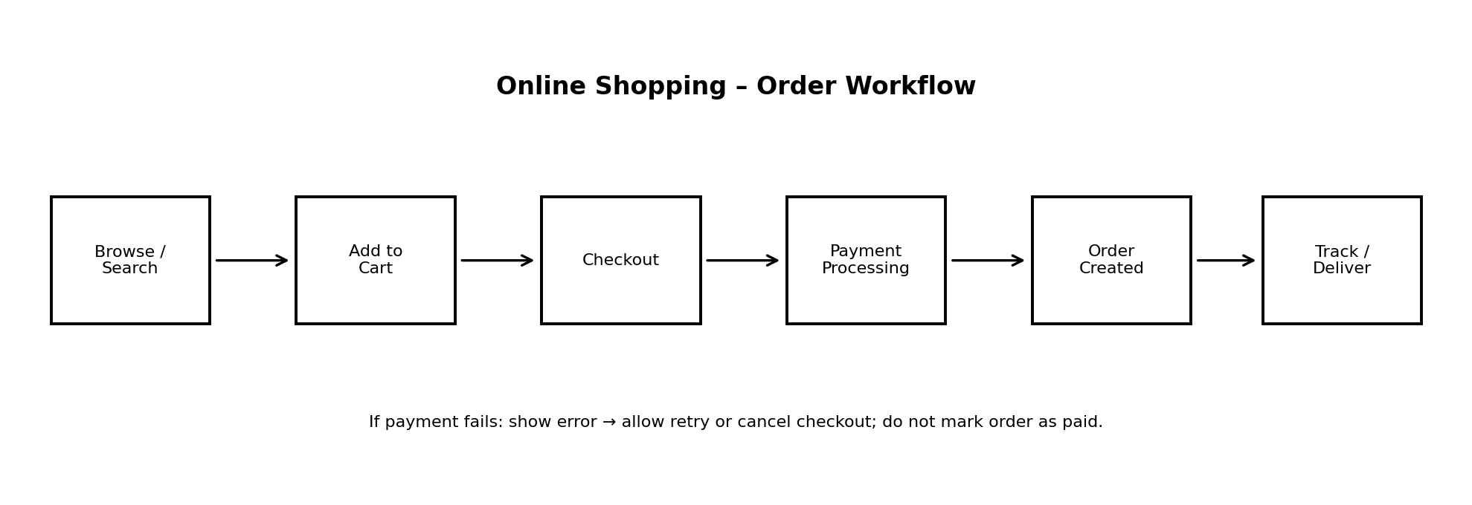
Figure 1. Main workflow for placing and fulfilling an online order.

Contents
- Q1 – System Requirement Analysis and Object Identification
- Q2 – Identification of Classes and Attributes
- Q3 – Relationship Identification and UML Class Diagram
- Q4 – Use Case Identification and Use Case Diagram
- Q5 – Detailed Use Case Specifications
- Q6 – Integrating Requirements, Classes and Use Cases
- Q7 – Complete OOAD Analysis and Design Challenge
- Contribution Record and Final Submission Checklist

Q1 – System Requirement Analysis and Object Identification (7 Marks)

1.1 Purpose, Problem Statement and Scope
Problem statement: Customers need a convenient way to find products, place orders and pay without visiting a physical store. Without a centralized online system, product availability, order records, payment status and delivery tracking may be handled separately, causing delays and inconsistent information.
Purpose: To provide a single platform for customers to browse products, manage a cart, place orders, complete or retry payments, and track deliveries, while allowing administrators to maintain the product catalogue.
System boundary: The system includes customer registration and login, product catalogue, search, cart, checkout, order management, payment coordination, delivery tracking and administration. The external payment gateway and delivery partner are outside the system boundary and communicate through defined interfaces.

1.2 Major Stakeholders
Stakeholder | Interest / Responsibility
Customer | Registers, searches products, manages cart, places/cancels orders and tracks delivery.
Administrator | Adds or updates products, manages stock and views reports.
Payment Gateway | Authorizes or rejects online payment transactions.
Delivery Partner | Receives shipment details and provides delivery/tracking updates.
Store / Business Owner | Uses sales and order reports to monitor business operations.

1.3 Functional Requirements
Requirement ID | Requirement | Type | Stakeholder
FR1 | The system shall allow a customer to register and log in. | Functional | Customer
FR2 | The system shall allow customers to search and view products. | Functional | Customer
FR3 | The system shall display product price and availability. | Functional | Customer
FR4 | The system shall allow customers to add, update and remove cart items. | Functional | Customer
FR5 | The system shall calculate the cart total before checkout. | Functional | Customer
FR6 | The system shall allow a customer to place an order using a valid cart. | Functional | Customer
FR7 | The system shall send payment details to the payment gateway and record the result. | Functional | Customer / Payment Gateway
FR8 | The system shall allow customers to view order status and tracking details. | Functional | Customer / Delivery Partner
FR9 | The system shall allow customers to request cancellation when order rules permit. | Functional | Customer
FR10 | The system shall allow administrators to add, edit and deactivate products. | Functional | Administrator
FR11 | The system shall allow administrators to view order and sales reports. | Functional | Administrator
FR12 | The system shall update order delivery status from delivery-partner updates. | Functional | Delivery Partner

1.4 Non-Functional Requirements
Requirement ID | Requirement | Type | Stakeholder
NFR1 | The system should respond to common search and browsing requests within 3 seconds under normal load. | Performance | Customer
NFR2 | Passwords and sensitive payment data must be protected using appropriate security controls; raw card data should not be stored by the application. | Security | Customer / Business
NFR3 | The service should be available 99.5% of each month, excluding planned maintenance. | Availability | Customer / Business
NFR4 | The interface should be usable on common desktop and mobile screen sizes. | Usability | Customer
NFR5 | The system should preserve order and payment status consistently when a transaction succeeds or fails. | Reliability | Business / Customer

1.5 Candidate Object Extraction – Student B
Important nouns and noun phrases found in the requirements include customer, account, product, catalogue, cart, cart item, order, payment, payment gateway, delivery, tracking detail, administrator and report.
Candidate | Keep / Remove | Classification | Reason
Customer | Keep | Entity | Has identity and participates in shopping activities.
Product | Keep | Entity | Has product details, price and stock information.
Cart | Keep | Entity | Maintains a customer's selected items before checkout.
CartItem | Keep | Entity | Stores product selection, quantity and price information.
Order | Keep | Entity | Represents a confirmed customer purchase.
Payment | Keep | Entity | Stores amount, method and transaction status.
Delivery | Keep | Entity | Represents shipment and tracking information.
Administrator | Keep | Entity / Actor | Has a distinct role and product-management responsibilities.
Payment Gateway | Keep | Boundary / External Actor | External service boundary used to authorize payments.
Shopping Page | Keep as Boundary concept | Boundary | Represents the user interface through which customers interact.
Checkout Controller | Keep as Control concept | Control | Coordinates checkout, payment and order creation.
Date | Remove as separate class | Attribute | A date is stored as an attribute of an order or delivery.
Login Button | Remove | UI element | A button is an interface control, not a domain class.
Price Label | Remove | UI element | A displayed label is not an independent business object.

1.6 Preliminary Class List
- Customer
- Administrator
- Product
- Cart
- CartItem
- Order
- OrderItem
- Payment
- CardPayment
- UPIPayment
- Delivery
- PaymentGateway

1.7 Joint Analysis: How does requirement analysis help identify classes?
Requirement analysis explains what the system must do and which information it must maintain. By reading each requirement, analysts identify important nouns as candidate objects and identify verbs as possible responsibilities or operations. For example, “customer places an order” suggests Customer and Order classes and a placeOrder responsibility. “The system displays product price and availability” suggests Product attributes such as price and stockQuantity. Analysts then remove interface-only words, duplicate terms and simple values that belong as attributes. This process produces classes that are connected to real system needs instead of arbitrary programming objects.

Q2 – Identification of Classes and Attributes (7 Marks)

2.1 Class Specification Table – Student A
Class | Attributes | Purpose
Customer | customerId (PK), name, email, phone, passwordHash | Stores customer identity and contact details.
Administrator | adminId (PK), name, email, role | Maintains catalogue and views reports.
Product | productId (PK), name, description, price, stockQuantity, activeStatus | Represents an item offered for sale.
Cart | cartId (PK), customerId, createdAt | Holds a customer's selected items before checkout.
CartItem | cartItemId (PK), cartId, productId, quantity, unitPrice | Connects a product to a cart with quantity.
Order | orderId (PK), customerId, orderDate, status, deliveryAddress, totalAmount | Records a purchase after checkout.
OrderItem | orderItemId (PK), orderId, productId, quantity, priceAtPurchase | Stores each product line in an order.
Payment | paymentId (PK), orderId, amount, method, status, transactionReference | Records payment attempt and result.
Delivery | deliveryId (PK), orderId, trackingNumber, carrier, status, estimatedDate | Tracks shipment and delivery progress.
PaymentGateway | gatewayName, endpointReference | External service interface used to process payment.

Derived attribute: Order.totalAmount can be calculated from the sum of each OrderItem line total, with applicable charges or discounts. It may be stored as a snapshot for audit and order-history consistency. CartItem.subTotal is derived as quantity × unitPrice.

2.2 Class Responsibilities – Student B
Class | Main Responsibilities
Customer | Maintain profile and contact information; register/login; manage cart; place and view orders.
Administrator | Create, update or deactivate products; review stock; generate reports.
Product | Maintain product description, price and stock quantity; provide availability information.
Cart | Add, update and remove items; calculate estimated total; initiate checkout.
CartItem | Maintain selected product, quantity and unit price; calculate line subtotal.
Order | Create order record; calculate or preserve total; maintain order status; validate cancellation.
OrderItem | Preserve product, quantity and purchase-time price for each order line.
Payment | Initiate payment, store gateway result, mark success/failure and support refund workflow.
Delivery | Maintain carrier and tracking data; update shipment and delivery status.
PaymentGateway | Authorize or reject a payment request and return a transaction result.

2.3 Attribute Ownership and Cohesion Review
Potential issue | Incorrect design | Improved assignment | Reason
Customer phone stored in Order | Order.phone | Customer.phone; Order stores deliveryAddress or Address reference | Contact information belongs to the customer; order-specific delivery destination is separately preserved.
Product price stored only in Cart | Cart.productPrice | Product.price and CartItem.unitPrice snapshot | Product owns current price; cart item can preserve the price used when added.
Tracking number stored in Customer | Customer.trackingNumber | Delivery.trackingNumber | Tracking belongs to a shipment, not the customer generally.
Payment status stored in Product | Product.paymentStatus | Payment.status | Payment status describes a transaction.
Order line quantity stored in Product | Product.quantityOrdered | OrderItem.quantity | A product may appear in many orders with different quantities.

2.4 Class Cohesion and Improvements
A class has good cohesion when its attributes and operations contribute to one clear responsibility. Product should manage product details and stock; it should not process payments. Payment should manage transaction status; it should not maintain delivery tracking. Separating OrderItem from Product preserves the price and quantity purchased at the time of an order. Separating Delivery from Order keeps shipment information focused and allows delivery status to change independently.

2.5 Joint Question: Problems caused by assigning attributes to the wrong class
- If trackingNumber is placed in Customer, a customer with multiple orders cannot be represented correctly because each order may have a different shipment.
- If paymentStatus is placed in Product, the system cannot distinguish which customer's transaction succeeded or failed.
- If quantityOrdered is placed in Product, simultaneous orders and different quantities per customer may overwrite one another.

Q3 – Relationship Identification and UML Class Diagram (7 Marks)

3.1 Associations and Multiplicity – Student A
Relationship | Multiplicity | Meaning / Justification
Customer — Cart | 1 to 0..1 | A customer may have no active cart or one active cart in this simplified model; each cart belongs to one customer.
Customer — Order | 1 to 0..* | One customer may place zero or many orders; each order belongs to one customer.
Cart — CartItem | 1 to 1..* | A cart contains one or more cart items when it is ready for checkout; each item belongs to one cart.
CartItem — Product | * to 1 | Many cart items across different carts can refer to one product; each cart item refers to one product.
Order — OrderItem | 1 to 1..* | An order contains one or more order lines; each order item belongs to one order.
Order — Payment | 1 to 0..1 | An order may have no successful payment yet or one recorded payment in this simplified model.
Order — Delivery | 1 to 0..1 | An order may not yet be shipped or may have one delivery record.

Multiplicity examples: 1..1 means exactly one; 0..1 means optional one; 0..* means zero or many; 1..* means one or many.

3.2 Generalization, Aggregation and Composition – Student B
- Generalization: Payment is the superclass. CardPayment and UPIPayment are specialized payment types. They inherit common payment information and provide method-specific authorization behavior.
- Composition: Cart–CartItem is modeled as composition because a CartItem is meaningful only as part of its cart and is removed when the cart is deleted. Order–OrderItem is also composition because order lines belong to a specific order.
- Aggregation: A Product can be associated with many OrderItems over time, while each OrderItem records a purchase-time snapshot. The product exists independently of any particular order; this is a whole–part-like weak ownership relationship and can be represented as shared aggregation if the modeling convention requires it.
- Dependency: CheckoutController depends on PaymentGateway to request payment authorization. The gateway is external and is not owned by the controller.

3.3 UML Class Diagram
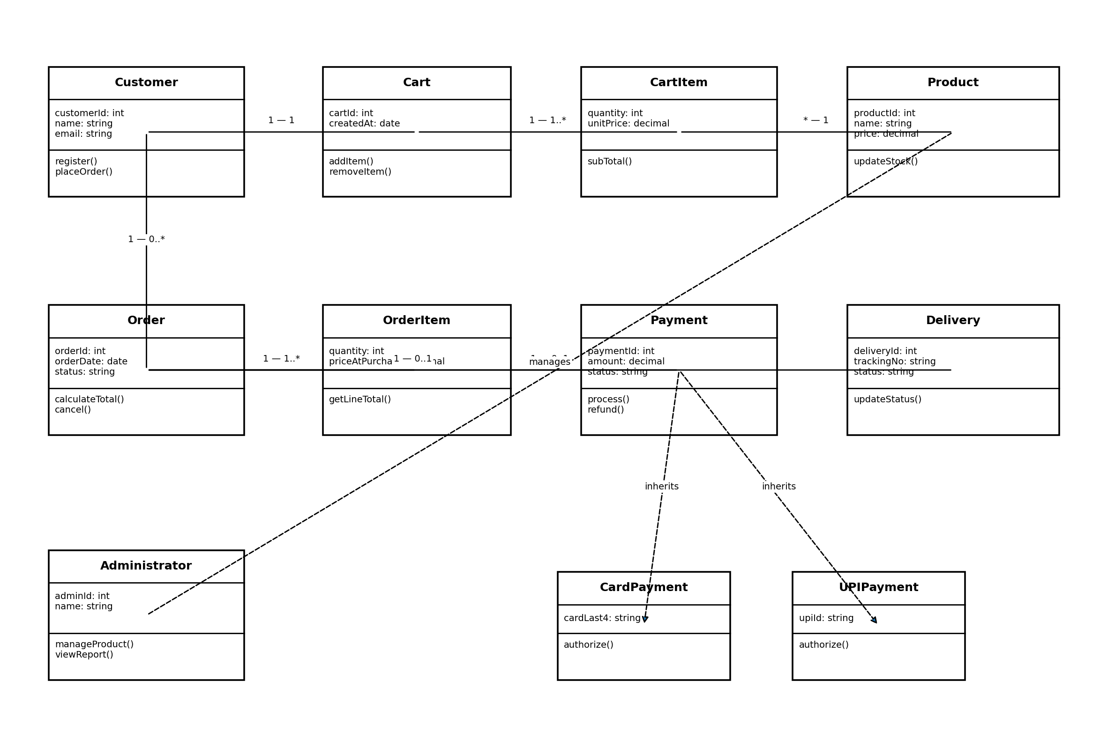
Figure 2. Simplified UML class model showing major classes and selected relationships.
Diagram note: The diagram is a readable overview. The relationship table above provides the precise multiplicities. Payment subclasses inherit from Payment. In a full UML tool, use a hollow triangle pointing to the superclass for generalization, a filled diamond at the whole end for composition, and a hollow diamond for aggregation.

3.4 Joint Evaluation: Effect of incorrect class relationships
Incorrect relationships can cause invalid data, unnecessary dependencies and difficult maintenance. If Order and OrderItem are modeled as unrelated, order lines may remain without a valid order. If Customer–Order is modeled as one-to-one, the design prevents a customer from placing multiple orders. If CardPayment is not modeled as a specialization of Payment, common payment behavior may be duplicated. Incorrect multiplicity can also allow impossible data, such as one order being assigned to several unrelated customers.

Q4 – Use Case Identification and Use Case Diagram (7 Marks)

4.1 Actors and Goals – Student B
Actor | Type | Goal / Interaction
Customer | Primary actor | Uses shopping features to find products, manage cart, purchase and track orders.
Administrator | Primary actor | Maintains product catalogue and reviews reports.
Payment Gateway | Supporting actor | Processes payment authorization and returns success or failure.
Delivery Partner | Supporting actor | Receives shipment information and sends tracking/status updates.

4.2 Major Use Cases
ID | Use Case | Actor(s) | Goal
UC1 | Register / Login | Customer | Create an account or access an existing account.
UC2 | Search Product | Customer | Find products by keyword or category.
UC3 | View Product Details | Customer | Review product description, price and availability.
UC4 | Manage Cart | Customer | Add, update or remove selected products.
UC5 | Place Order | Customer | Confirm cart and create a purchase order.
UC6 | Make Payment | Customer, Payment Gateway | Pay for an order and receive the transaction result.
UC7 | Track Order | Customer, Delivery Partner | View current shipment and delivery status.
UC8 | Cancel Order | Customer | Request cancellation when order status permits.
UC9 | Manage Products | Administrator | Add, edit, deactivate products and update stock.
UC10 | Generate Reports | Administrator | View order and sales summaries.
UC11 | Update Delivery Status | Delivery Partner | Send shipment progress and delivery confirmation.
UC12 | Retry Payment | Customer, Payment Gateway | Attempt payment again after a failed transaction.

4.3 Use Case Relationships – Student A
Relationship | Use case connection | Reason
<<include>> | Place Order includes Validate Cart | Cart validation is a required step before an order can be created.
<<include>> | Place Order includes Calculate Total | The system must calculate the amount before confirming checkout.
<<include>> | Place Order includes Make Payment for prepaid orders | Online prepaid checkout requires a payment attempt. COD can be modeled as a separate conditional path.
<<extend>> | Retry Payment extends Make Payment | Retry is optional and occurs only after a payment failure.
<<extend>> | Cancel Order extends View Order | Cancellation is an optional action available only when the order is eligible.
Actor association | Payment Gateway — Make Payment | The external gateway authorizes or rejects the transaction.
Actor association | Delivery Partner — Update Delivery Status | The delivery partner supplies tracking updates.

4.4 UML Use Case Diagram
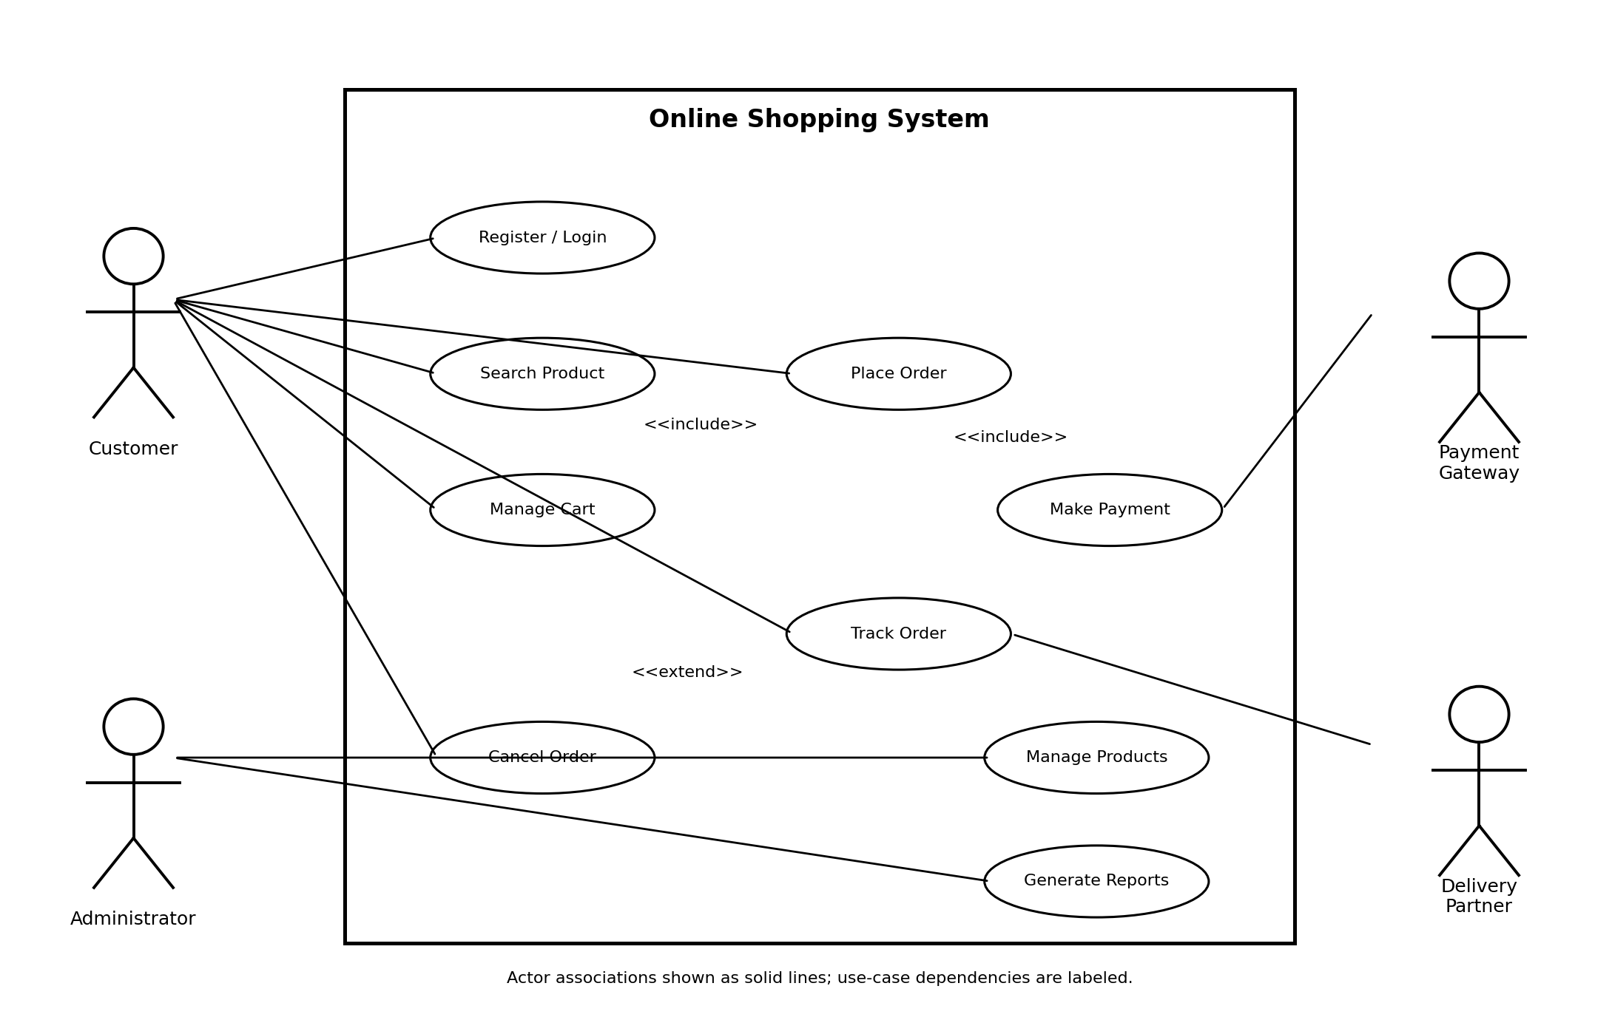
Figure 3. Use case model for the Online Shopping System.
Diagram note: The diagram shows the main actors and use cases inside the system boundary. The use case relationship table defines the intended include and extend semantics. Include is mandatory reused behavior; extend is conditional or optional behavior added at an extension point.

4.5 Joint Question: Difference between <<include>> and <<extend>>
<<include>> represents required behavior that is reused by a base use case. For example, Place Order includes Validate Cart because the system must check that cart items are valid before order creation. <<extend>> represents optional or conditional behavior that occurs only in a particular situation. For example, Retry Payment extends Make Payment because it is needed only when the first payment attempt fails. The include arrow points from the base use case to the included use case; the extend arrow points from the extending use case to the base use case.

Q5 – Detailed Use Case Specifications (6 Marks)

5.1 Use Case 1 – Place Order (Student A)
Field | Specification
Use Case Name | Place Order
Goal | Allow a customer to submit a valid cart as an order.
Primary Actor | Customer
Supporting Actors | Payment Gateway (for prepaid payment); Delivery Partner (after dispatch).
Preconditions | Customer is logged in; cart contains at least one available product; delivery information is available.
Trigger | Customer selects the checkout / Place Order option.
Main Success Scenario | 1. Customer opens the cart. 2. System displays cart items and quantities. 3. Customer confirms or updates the cart. 4. System validates product availability. 5. System calculates the total. 6. Customer confirms delivery address. 7. Customer selects payment method. 8. System sends payment request when prepaid payment is selected. 9. Gateway returns success. 10. System creates the order and order items. 11. System reduces or reserves stock. 12. System displays order confirmation.
Alternative Flows | A1: If the customer chooses cash on delivery, the system records the order with payment pending / due and skips online authorization. A2: If an item becomes unavailable, the system identifies it and asks the customer to update the cart.
Exception Flows | E1: Payment gateway is unavailable; system does not mark payment successful and offers retry. E2: Cart validation fails; checkout stops and the customer is shown the affected item.
Postconditions | A valid order exists with order items and a status. Payment status reflects the actual result; customer receives an order reference.

5.2 Use Case 2 – Make Payment (Student A)
Field | Specification
Use Case Name | Make Payment
Goal | Collect payment for an order through an approved payment method.
Primary Actor | Customer
Supporting Actors | Payment Gateway
Preconditions | Customer has reached checkout; order amount is calculated; selected payment method is supported.
Trigger | Customer confirms the selected online payment method.
Main Success Scenario | 1. System displays amount and payment options. 2. Customer selects a method. 3. System creates a payment attempt reference. 4. System sends the payment request to the gateway. 5. Gateway authenticates and processes the request. 6. Gateway returns success and transaction reference. 7. System records the successful result. 8. System confirms payment to the customer.
Alternative Flows | A1: Customer selects a different supported method before submitting payment. A2: Customer returns to checkout without completing payment; the payment remains pending.
Exception Flows | E1: Gateway declines the payment; system records failure and displays a safe error message. E2: Network timeout; system checks transaction status before allowing a new attempt to avoid duplicate charges.
Postconditions | A successful transaction is recorded as paid; otherwise the order remains unpaid or pending and can be retried.

5.3 Use Case 3 – Track Order (Student B)
Field | Specification
Use Case Name | Track Order
Goal | Allow a customer to view the current status of an order and its shipment.
Primary Actor | Customer
Supporting Actors | Delivery Partner
Preconditions | Customer is authenticated and the selected order belongs to that customer.
Trigger | Customer selects Track Order for an order.
Main Success Scenario | 1. Customer opens order history. 2. Customer selects an order. 3. System verifies order ownership. 4. System retrieves delivery and tracking details. 5. System displays current status and available tracking events.
Alternative Flows | A1: Order has not been dispatched; system displays “Preparing for shipment”. A2: Delivery partner has not supplied a recent update; system displays the latest known status and update time.
Exception Flows | E1: Order ID is invalid or does not belong to the customer; system denies access. E2: Delivery tracking service is unavailable; system displays a temporary-unavailable message.
Postconditions | No order data is changed; customer has viewed the latest available tracking information.

5.4 Alternative and Exception Flow Summary – Student B
Use Case | Alternative / Exception | System Response
Place Order | Product becomes unavailable during checkout | Stop confirmation, identify unavailable item and ask customer to revise cart.
Make Payment | Gateway declines or times out | Record result accurately; do not mark paid; allow safe retry after status check.
Track Order | Tracking provider unavailable | Show last known tracking status and indicate that the latest update could not be retrieved.

5.5 Joint Evaluation: Why are detailed specifications necessary?
A use case diagram shows actors and the functions they interact with, but it does not describe the step-by-step behavior. A detailed specification records preconditions, triggers, normal steps, alternatives, exceptions and postconditions. It helps developers implement the same expected behavior, testers create test cases, and stakeholders agree on what should happen when something goes wrong. For example, the diagram may show Make Payment, while its specification explains what happens after a gateway timeout and prevents the system from incorrectly marking an unpaid order as paid.

Q6 – Integrating Requirements, Classes and Use Cases (6 Marks)

6.1 Requirement-to-Use-Case Traceability – Student A
Requirement | Mapped Use Case(s) | Supporting Classes
FR1 | Register / Login | Customer
FR2 | Search Product; View Product Details | Customer, Product
FR3 | View Product Details | Product
FR4 | Manage Cart | Customer, Cart, CartItem, Product
FR5 | Manage Cart; Place Order | Cart, CartItem, Product, Order
FR6 | Place Order | Customer, Cart, Order, OrderItem
FR7 | Make Payment; Retry Payment | Payment, PaymentGateway
FR8 | Track Order; Update Delivery Status | Customer, Order, Delivery
FR9 | Cancel Order | Customer, Order
FR10 | Manage Products | Administrator, Product
FR11 | Generate Reports | Administrator, Order, Payment
FR12 | Update Delivery Status | DeliveryPartner, Delivery

6.2 Use-Case-to-Class Traceability – Student B
Use Case | Participating Classes | Explanation
Register / Login | Customer | Customer account data is created or authenticated.
Search Product | Product | Product catalogue data is searched and returned.
Manage Cart | Customer, Cart, CartItem, Product | Cart items refer to products and belong to a customer's cart.
Place Order | Customer, Cart, CartItem, Product, Order, OrderItem | The cart is validated and converted into order records.
Make Payment | Order, Payment, PaymentGateway | Payment is associated with the order and processed externally.
Track Order | Customer, Order, Delivery | Customer views the delivery record associated with the order.
Cancel Order | Customer, Order | Order validates whether cancellation is permitted and updates status.
Manage Products | Administrator, Product | Administrator creates and updates product catalogue data.
Generate Reports | Administrator, Order, Payment | Reports summarize order and payment information.
Update Delivery Status | Delivery, DeliveryPartner | Delivery information is updated using partner status events.

6.3 Integrated Traceability Matrix
Requirement | Use Case | Class / Classes | Consistency Check
FR4 – manage cart items | Manage Cart | Cart, CartItem, Product | Cart operations and item data are represented.
FR6 – place order | Place Order | Customer, Cart, Order, OrderItem | Order creation is supported by the class model.
FR7 – process payment | Make Payment | Payment, Order, PaymentGateway | Payment status and gateway interaction are represented.
FR8 – track order | Track Order | Customer, Order, Delivery | Delivery details are linked to the order.
FR10 – manage products | Manage Products | Administrator, Product | Administrator has product-management responsibilities.

6.4 Joint Analysis: Why must class and use case diagrams be consistent?
The use case diagram describes the services the system provides, while the class diagram describes the structural elements that support those services. If Place Order appears as a use case but the model has no Order or OrderItem class, the design is incomplete. If Delivery exists as a class but no requirement or use case uses it, its purpose should be reviewed. Consistency ensures that every important use case has suitable participating classes and that each important class contributes to a required system behavior.

Q7 – Complete OOAD Analysis and Design Challenge (10 Marks)

7.1 Stage 1 – Independent Analysis Proposals
Model Element | Student A – Initial Proposal | Student B – Initial Proposal
Actors | Customer, Administrator, Payment Gateway | Customer, Administrator, Delivery Partner, Payment Gateway
Use Cases | Register/Login, Search Product, Manage Cart, Place Order, Make Payment, Track Order | Register/Login, Search Product, View Product, Place Order, Cancel Order, Manage Products, Generate Reports, Track Order
Candidate Classes | Customer, Product, Cart, CartItem, Order, Payment, Delivery | Customer, Administrator, Product, Cart, Order, OrderItem, Payment, Delivery, PaymentGateway
Important Attributes | Customer.email; Product.price; Order.status; Payment.amount | Product.stockQuantity; CartItem.quantity; OrderItem.priceAtPurchase; Delivery.trackingNumber
Relationships | Customer–Order; Cart–CartItem; Order–Payment | Customer–Cart; Order–OrderItem; Order–Delivery; Payment inheritance

The proposals above are example independent starting points. Each student should retain their own actual first draft in the final submission and revise this table if their original ideas differ.

7.2 Stage 2 – Design Comparison Record
Comparison Point | Observation / Decision
Areas of agreement | Both proposals identify Customer, Product, Cart, Order and Payment as important concepts.
Differences | Student B explicitly identifies Administrator, OrderItem and PaymentGateway; Student A identifies Delivery and the core checkout flow.
Classes added to final model | Administrator, OrderItem and PaymentGateway are retained because they support stated requirements and use cases.
Use cases added | View Product Details, Cancel Order, Manage Products, Generate Reports, Update Delivery Status and Retry Payment are included for requirement coverage.
Potential design risk | Payment handling must not assume every order uses online prepaid payment; cash-on-delivery is an alternative flow.
Final decision | Combine the strongest supported elements and ensure each final class and use case traces to a requirement.

7.3 Stage 3 – Joint Final OOAD Model

A. Requirement Model
The final requirement model is the problem statement, system boundary, 12 functional requirements and 5 non-functional requirements documented in Q1. It covers customer shopping, administration, payment processing and delivery tracking.

B. Use Case Model
The final model contains four actors and twelve use cases. The system boundary is the Online Shopping System. Required reused behavior is modeled using <<include>> and optional or conditional behavior using <<extend>>. Three detailed specifications are provided in Q5.

C. Class Model
The final model contains Customer, Administrator, Product, Cart, CartItem, Order, OrderItem, Payment, Delivery and PaymentGateway, with CardPayment and UPIPayment as specialized payment types. Attributes and responsibilities are listed in Q2; relationships and multiplicities are described in Q3.

D. Requirement → Use Case → Class
Requirement | Use Case | Supporting Class(es)
Customer can manage cart | Manage Cart | Customer, Cart, CartItem, Product
Customer can purchase products | Place Order | Customer, Cart, Order, OrderItem, Product
Customer can make online payment | Make Payment | Order, Payment, PaymentGateway
Customer can track shipment | Track Order | Customer, Order, Delivery
Administrator can update catalogue | Manage Products | Administrator, Product

7.4 Stage 4 – Model Validation

Student A – Use Case Model Validation
- All listed functional requirements are mapped to one or more use cases in Q6.
- Customer and Administrator are primary actors because they initiate system goals.
- Payment Gateway and Delivery Partner are supporting actors because they provide external services.
- Place Order includes mandatory validation and total calculation; optional retry and cancellation behavior is modeled as extension behavior.
- Every major use case has a stated goal and the key use cases have detailed specifications.

Student B – Class Model Validation
- Each class has a focused responsibility and relevant attributes.
- OrderItem separates individual purchased lines from Product and preserves purchase-time price.
- Order–OrderItem and Cart–CartItem use composition because line items belong to their containing aggregate.
- Customer–Order multiplicity allows a customer to create multiple orders.
- Payment specializations share common payment data and behavior through the Payment superclass.
- Delivery stores shipment-specific tracking information rather than placing it in Customer or Product.

7.5 Stage 5 – Cross-Defence
Student A: The class diagram supports Place Order through Customer, Cart, CartItem, Product, Order and OrderItem. Customer owns the shopping activity; Cart and CartItem hold selections; Product supplies price and availability; Order and OrderItem preserve the confirmed purchase. Payment and PaymentGateway support the prepaid payment branch.
Student B: The requirement “the system shall allow customers to track order status” leads to the Track Order use case. Customer initiates it, Order identifies the purchase, and Delivery supplies the tracking number and current shipment status. Delivery Partner is the supporting actor that supplies shipment updates.

7.6 Stage 6 – Joint Evaluation and Change Impact
New / Modified Requirement | Expected Model Change
Customer can save multiple delivery addresses | Add Address class; associate Customer 1 to 0..* Address; Order refers to the chosen delivery address.
Order can be cancelled only before shipment | Add or clarify cancellation eligibility rule in Order; update Cancel Order specification and its extension condition.
Administrator can also shop as a customer | Represent Administrator and Customer as specializations of a shared User superclass if they share identity and authentication attributes.
Cash-on-delivery makes online payment optional | Do not model online Make Payment as mandatory for every Place Order path; show payment method selection and conditional prepaid authorization.
A customer can have several active carts | Change Customer–Cart multiplicity from 1 to 0..1 to 1 to 0..* and define cart status/selection rules.

7.7 Conclusion: Characteristics to check before finalizing an OOAD model
An analyst should confirm that each class represents a meaningful concept in the problem domain, has clear responsibilities, and owns appropriate attributes. Relationships must reflect real business rules and use correct multiplicities. Actors must be external roles that interact with the system, and use cases must represent meaningful goals rather than individual interface clicks. The class and use case models must be traceable to requirements, avoid duplication, handle important alternative and exception flows, and remain understandable when requirements change. The final design should be validated with stakeholders and tested against realistic scenarios.

Contribution Record
Question | Student A – Primary Contribution | Student B – Primary Contribution | Joint Work
Q1 | Requirements analysis | Object identification | System selection and joint analysis
Q2 | Classes and attributes | Responsibilities | Class model review
Q3 | Associations and multiplicity | Inheritance / aggregation / composition | Class diagram
Q4 | Use case relationships | Actors and use cases | Use case diagram
Q5 | Main success scenarios | Alternative and exception flows | Use case specifications
Q6 | Requirement traceability | Class traceability | Integrated model
Q7 | Use case model validation | Class model validation | Final OOAD model and evaluation

This record is a suggested allocation based on the assignment brief. Both students remain responsible for understanding and defending the complete submission. Update the record to match the actual work performed.

Final Submission Checklist
No. | Submission Check | Status
1 | Problem statement and system scope are clearly defined | ☐
2 | Stakeholders are identified | ☐
3 | At least 8 functional requirements are listed | ☐
4 | At least 4 non-functional requirements are listed | ☐
5 | Candidate classes are identified and justified | ☐
6 | At least 8 major classes and their attributes are documented | ☐
7 | Class responsibilities are defined | ☐
8 | Associations and multiplicities are specified | ☐
9 | Inheritance, aggregation and composition are justified where applicable | ☐
10 | Actors and at least 10 use cases are identified | ☐
11 | Use case diagram shows actors, boundary and use cases | ☐
12 | Include and extend relationships are explained | ☐
13 | Three detailed use case specifications are provided | ☐
14 | Class diagram is included | ☐
15 | Requirement-to-use-case-to-class traceability is provided | ☐
16 | Class and use case models are checked for consistency | ☐
17 | Contribution record is included | ☐
18 | Both students can explain the complete OOAD model | ☐

Design Principle
REQUIREMENTS → IDENTIFY OBJECTS → DEFINE CLASSES → ASSIGN ATTRIBUTES → IDENTIFY RELATIONSHIPS → DEVELOP USE CASES → INTEGRATE UML MODELS → VALIDATE → EVALUATE
The objective is not merely to draw UML diagrams. The students must demonstrate the ability to analyze, identify, model, justify and validate the requirements of an object-oriented system.

