SIMATS ENGINEERING
Department of Information Technology
OBJECT-ORIENTED SYSTEMS DEVELOPMENT
ASSIGNMENT 1 – SMARTCYCLE CITY BIKE-SHARE SYSTEM
Original task-wise answers with comparison tables and workflow diagrams
Student detail | Information
Name | Mukesh M
Programme | B.Tech – Information Technology
Institution | SIMATS Engineering College
Course | CSA11 – OOAD
Assignment | Assignment 1 – 50 Marks

.

TASK 1 – Object Identification and Requirements Inquiry

1.1 Object identification test
A candidate is treated as a class if it has an identity, meaningful state, behaviour and belongs within the SmartCycle software boundary. A descriptive value is an attribute; an action is an operation; a physical/external item may be outside the boundary. Unclear candidates are marked for further inquiry.
Candidate | Classification | Reason
Rider | Class | Unique rider ID, KYC/subscription state and rental behaviour.
Bike | Class | Bike ID, condition, lock state and station; can be unlocked or blocked.
Dock Station | Class | Station ID, capacity and available slots; accepts/rejects returns.
Trip | Class | Trip identity, start/end time, rider and bike; lifecycle behaviour.
Payment | Class | Transaction ID, amount and status; authorises/records payment.
Price | Attribute/value object | Monetary value used by fare calculation, not an independent lifecycle entity initially.
Report | Class | Damage report has reporter, bike, time, description and review state.
Battery | Component/attribute | Relevant to e-bikes; model separately only if telemetry/maintenance needs it.
Rider’s Phone | Outside system | Physical phone is external; app session/device token can be represented.
Station Map | View/service | Displays station locations and availability; not a core domain entity.
Maintenance Team | Class/external actor | Represent team and assignment if work allocation is managed in the platform.
Wheel | Outside/component | Physical part; track separately only for part-level inventory.
Return Bike | Operation | Action performed through Trip and DockStation.
Fine | Needs information | Could be a charge entity if late return, damage or misuse penalties exist.
Subscription Plan | Class | Plan ID, validity, benefits, discount and eligibility rules.

1.2 Ambiguity and assumption log
Question to corporation | Temporary assumption | Impact
Who performs bike rebalancing? | Operators receive tasks in dashboard and field staff execute them. | Defines roles and task ownership.
What is a damaged bike? | Rider report/sensor alert moves bike to UNDER_REVIEW; staff confirm. | Unsafe bikes must not be rented.
What if payment fails? | Trip ends; payment becomes PENDING and another rental is blocked until resolved. | Avoids duplicate charges and open trips.
What if return station is full? | App suggests nearby station with free capacity. | Protects station capacity invariant.
Which KYC documents and expiry rules apply? | Use city-approved provider; retain verification reference unless raw files are required. | Privacy and compliance.
Can student and subscription discounts combine? | Support stacking through configurable policy; corporation confirms precedence/cap. | Prevents inconsistent fares.
What happens offline at a dock? | Vendor-confirmed local event queue synchronises after connectivity returns. | Affects lock and trip reliability.

1.3 Encapsulation
Class | Hidden state | Public operations | Two invalid actions and rule location
Bike | ID, lock state, condition, current station | unlock(), lock(), markDamaged(), markAvailable() | Reject unlock if damaged/in-use; reject availability while active trip exists. Rule in Bike domain logic and authorisation service.
Trip | IDs, timestamps, status | start(), finish(), calculateDuration() | Reject finish before start; reject a second finish after CLOSED. Rule in Trip state machine.
DockStation | ID, capacity, occupied slots | hasFreeSlot(), acceptReturn(), releaseBike() | Reject return when full; reject release when no bike exists. Rule in station capacity invariant.

Encapsulation means callers cannot directly edit state. They must use operations that preserve valid business rules.

TASK 2 – Modular Object Design

2.1 Core object model
Class | Responsibility | Relationship
Bike (abstract) | Common ID, condition and lock behaviour | Parent of StandardBike, EBike, CargoBike
StandardBike | Standard lock/rental behaviour | Extends Bike
EBike | Battery and electronic lock | Extends Bike; has BatteryInfo
CargoBike | Cargo capacity and special lock | Extends Bike
Rider | KYC, student status, subscription | Starts Trip
Trip | Start/end state and duration | Uses FarePolicy
FarePolicy interface | calculate(trip,rider) | Implemented by fare strategies
SubscriptionPlan | Validity and benefits | Associated with Rider
Payment | Transaction and settlement status | Settles fare
DockStation | Capacity and dock inventory | Receives Bike

Core relationship sketch: Bike is specialised into three hardware types; Trip delegates price calculation to a FarePolicy object. This keeps hardware variation separate from fare variation.

2.2 Alternative A – inheritance with fare inside bike classes
Each bike subclass overrides calculateFare(). StandardBike uses a time rate, EBike may add an energy surcharge, and CargoBike returns a flat fare. This is initially simple, but bike type and pricing policy become tightly coupled.
- Abstraction: Bike defines common state and operations.
- Inheritance: concrete bike types reuse Bike behaviour.
- Polymorphism: the subclass implementation calculates the fare.
- Weakness: a shared pricing change must be repeated across bike classes.

2.3 Alternative B – composition with replaceable policies
Bike subclasses manage lock and hardware behaviour only. Trip contains a FarePolicy reference and delegates calculation. TimeBasedFare, FlatCargoFare, PeakHourPolicy and DiscountPolicy can be added or combined without modifying bike classes.
- Composition: Trip has a FarePolicy.
- Polymorphism: all fare policies implement calculate().
- Cohesion: bike classes handle bikes; fare objects handle price.
- Reuse: common peak-hour and discount rules can apply to several bike types.

2.4 Change test
Change | Alternative A estimate | Alternative B estimate | Comparison
Cargo Bike, special lock, flat fare | 2 classes modified, 1 added, 1 fare branch. | 1 factory/configuration modified; CargoBike, CargoLockAdapter and FlatCargoFare added; no fare-type branch. | B separates hardware and pricing.
Peak-hour pricing for all bikes | 3 fare classes modified; 3 repeated decisions. | Add PeakHourPolicy/decorator; 0–1 existing class modified; no bike-type branch. | B avoids duplicated rule.
Student discount + subscription | 3 fare methods modified; repeated eligibility/stacking decisions. | Add discount composition/stacking policy; one configuration point changed. | B localises discount rules.

Counts are estimated design-level changes, not measured source-code edits. I choose Alternative B for fares and keep inheritance for hardware behaviour. Pricing is expected to change often and apply across types. Remaining weakness: combining multiple policies can create stacking-order ambiguity; define a central precedence rule and expose a fare breakdown.

TASK 3 – Life Cycle Model Selection

Model | 24-week arrangement | Deliverables, reuse and testing
Waterfall | W1–4 requirements; W5–8 design; W9–16 build; W17–21 test; W22–24 release. | Baselined specification, architecture, code, test report. Reuse planned during design; full testing mainly late.
OO life cycle | W1–4 analysis; W5–7 object design; W8–9 prototype; W10–20 increments; W21–24 integration/acceptance. | Use cases, class models, prototypes and increments. Reuse identified in design; tests per increment.
Spiral | Four six-week risk cycles: discovery/prototype; payment/KYC; dock integration; scale/pilot/release. | Each cycle sets objectives, analyses risk, prototypes/builds, verifies and gets stakeholder review.

3.1 Rework rule and replay
Base rule: reopening one completed phase or iteration costs one rework unit. Five changes: cargo bike/lock/fare, peak pricing, student discount stacking, geofenced return, and revised KYC/payment rule.
Change | Waterfall phases reopened | OO life cycle areas reopened | Spiral response
Cargo bike | Requirements, design, build, test = 4 | Object design + affected increment = 2 | Bike/dock risk cycle = 1
Peak pricing | 4 | Fare design + pricing increment = 2 | Pricing experiment = 1
Student discount | 4 | Fare design + fare increment = 2 | Policy prototype = 1
Geofenced return | 4 | Use case/model + return increment = 2 | Location risk review = 1
KYC/payment change | 4 | Compliance model + payment increment = 2 | Compliance risk cycle = 1
Total | 20 | 10 | 5

Sensitivity: if Waterfall reopen cost doubles to 2, OO iteration cost becomes 1.5 and Spiral response remains 1, totals become 40, 15 and 5. Ranking remains Spiral, OO, Waterfall. If requirements were frozen early, Waterfall rework would fall; the brief explicitly expects change.
Recommendation: Spiral at project level, with OO increments inside each cycle. It gives early attention to payment/KYC, hardware and safety risks. If requirements stabilise and vendor interfaces are proven, a lighter OO iterative model may be more economical.

TASK 4 – Object-Oriented Methodologies
Approach | First artefacts | Full-station return fragment
Rumbaugh OMT | Object model and dynamic model | Objects Rider, Bike, Trip, DockStation, ReturnRequest. Associations show bike/station/trip. State flow: Riding → ReturnRequested → RejectedFull → AlternativeStationSuggested.
Jacobson OOSE | Use-case model and analysis objects | Actor Rider; use case Return Bike; boundary ReturnScreen; control ReturnCoordinator; entities Trip, Bike, DockStation.

Interaction: rider scans station QR; app checks capacity; ReturnCoordinator finds no free slot; system rejects this return and suggests another station; trip closes only after another dock confirms the lock event.
Criterion | OMT | OOSE
Clarity | Strong domain structure and object states. | Strong user goal and alternate interaction.
Completeness | Detailed structure; user goal may need explanation. | User workflow clear; object relationships need later refinement.
Non-technical official | Object diagram may need guidance. | Use-case narrative is generally easier to review.
Geofence change | Update location association and dynamic model: about 2 artefacts. | Update Return Bike use case and analysis/control objects: about 2 artefacts.

Choose OMT for complex domain structure and experienced modelling teams. Choose OOSE when user workflows dominate and customer representatives can review use cases. Booch emphasises iterative object design; the Unified Approach combines use cases, object models and iterative refinement.

TASK 5 – Model-Driven Development
Layer | SmartCycle content
CIM | Business goals/rules: eligible rider rents bike; trip begins after authorised unlock; trip ends after confirmed return; fare follows approved plan; KYC required.
PIM | Platform-neutral Rider, Bike, Trip, FarePolicy, SubscriptionPlan, Payment classes; operations startTrip(), finishTrip(), calculateFare().
Mobile PSM | Android/iOS screens, QR scanner adapter, API DTOs, error/offline states.
Database PSM | RIDER, BIKE, TRIP, FARE_POLICY, SUBSCRIPTION and PAYMENT tables, keys and constraints.
Web PSM | Operator dashboard views, station inventory, damage queue and rebalance commands.

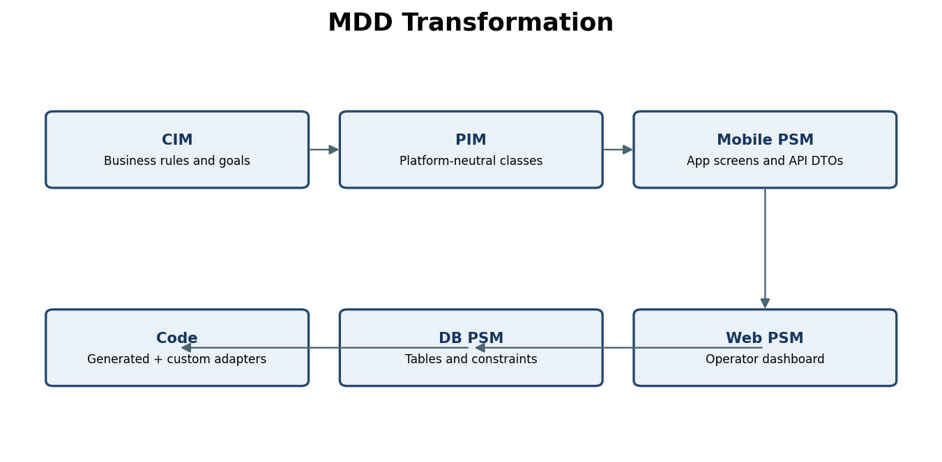

5.1 Transformation rules and example
- PIM class maps to application data type and/or database table.
- PIM attributes map to typed fields; identity maps to primary key.
- Associations map to foreign keys or API identifiers.
- Enums map to database constraints and application enums.
- PIM operations map to service/API operations; platform-specific UI behaviour may remain custom.
Worked example – Trip: tripId becomes primary key; riderId and bikeId become foreign keys; startTime/endTime become timestamp fields; status becomes a constrained enum. start() becomes a service command that checks rider eligibility and bike availability before recording the start.
Approach | Artefacts for “first 30 minutes free for subscribers”
MDD | Edit the authoritative fare rule in the model/mapping and regenerate affected mobile, web and service outputs.
Hand-written code | Update Android, iOS and web fare implementations separately: at least 3 code locations plus tests.

A direct edit to generated code makes model and output inconsistent; regeneration may erase the fix. Use protected extension points, update generator templates/model, and detect manual edits in builds. MDD is not worthwhile for every UI screen in a short project: generator setup and governance can exceed the saved effort. Use it for stable shared domain structures and API/database mappings.

TASK 6 – Agile Sprint Planning and Design Evolution
Sprint | Stories | Points | Classes and engineering work
1 | S1 QR unlock (5), S2 nearby bikes (3) | 8 | Rider, Bike, DockStation, UnlockService, StationQueryService; test eligibility and availability.
2 | S4 damage report (3), S3 payment (5) | 8 | DamageReport, BikeStatus, Payment, FarePolicy, Trip; test reporting and payment outcomes.
3 | S6 monthly subscription (5) | 5 | SubscriptionPlan, Rider and FarePolicy; test expiry and discount calculation.
Later | S5 operator rebalance (8) | 8 | OperatorTask and RebalanceService; scheduled after this three-sprint plan.

Only 21 backlog points are selected across the three sprints. The remaining capacity is reserved for integration, hardening and refactoring; S5 is explicitly not completed.

6.1 Disruption: Sprint 2 velocity drops to 7
Replanned sprint | Scope | Points | Model effect
1 | S1 + S2 | 8 | Initial rider, bike, station and map/unlock services.
2 | S4 (3) + safety integration/testing (2 estimated) | 5 of 7 | Bike gains UNDER_REVIEW/BLOCKED state; UnlockService refuses unlock if a damage report is active.
3 | S3 payment (5) | 5 | Payment/FarePolicy integration; S6 stays in backlog unless additional capacity is confirmed.

The two points for safety integration/testing are an explicit estimate, not supplied backlog points. Continuous integration and automated tests protect the design most. Rushed story acceptance without refactoring time creates design risk. Definition of Done should include review, tests and updated interface notes.

TASK 7 – Agile or Plan-Driven by Subsystem
Scores are 1 (weak fit) to 5 (strong fit). For risk/change-cost criteria, a high score means stronger need for plan-driven controls.
Criterion | Weight | A Rider app | B Certified firmware | C Payment/KYC
Requirement volatility | 25% | 5 | 2 | 3
Safety/compliance exposure | 25% | 2 | 5 | 5
Cost of post-release change | 20% | 3 | 5 | 5
Customer feedback availability | 15% | 5 | 2 | 3
Formal evidence need | 15% | 2 | 5 | 5
Weighted score / 5 | 100% | 3.45 | 3.80 | 4.10

Recommendation: Agile for rider app; plan-driven assurance gates for firmware and payment/KYC. Sensitivity: increase volatility weight to 40% and reduce formal evidence weight to 0% (redistributing the 15%). The rider app remains Agile; firmware and KYC/payment still need control because safety/compliance and post-release change costs remain high.
- Agile app publishes versioned API contracts and acceptance criteria.
- Firmware supplies hardware contracts, simulator results and certified release packages.
- Payment/KYC supplies provider contracts, audit trails and compliance evidence.
- Integration team owns shared architecture, interface versions and end-to-end release tests.

TASK 8 – Incremental Testing and Cost of Defects

8.1 Process A – testing at the end
Origin | Working | Cost
Requirements | 2×3 + 7×10 + 3×30 | 6 + 70 + 90 = 166
Design | 7×10 + 3×30 | 70 + 90 = 160
Code | 4×1 + 10×10 + 4×30 | 4 + 100 + 120 = 224
Total |  | 550

The supplied cost rule is used: requirements defect found in design = 3; same phase = 1; testing = 10; post-release = 30.

8.2 Process B – testing each iteration
Origin | Working | Cost
Requirements | 8×1 + 3×4 + 1×30 | 8 + 12 + 30 = 50
Design | 7×1 + 2×4 + 1×30 | 7 + 8 + 30 = 45
Code | 14×1 + 3×4 + 1×30 | 14 + 12 + 30 = 56
Total |  | 151

Process B is 399 relative cost units lower (550−151), a reduction of approximately 72.5% under the given assumptions.
Process | Highest-cost origin | Reason
A | Code = 224 | More code defects are found during testing or after release, where assumed repair costs are high.
B | Code = 56 | Code has 18 introduced defects; even early detection leaves the largest origin total.

Incremental testing shortens the delay between defect introduction and correction. Prototypes expose requirement errors; suitable reuse can reduce repeated implementation mistakes. The table does not include repeated testing effort, automation/environment cost, defect severity or prove equal defect introduction rates. It compares only the supplied repair-cost model.

TASK 9 – Integrated Development Process and Changed Conditions
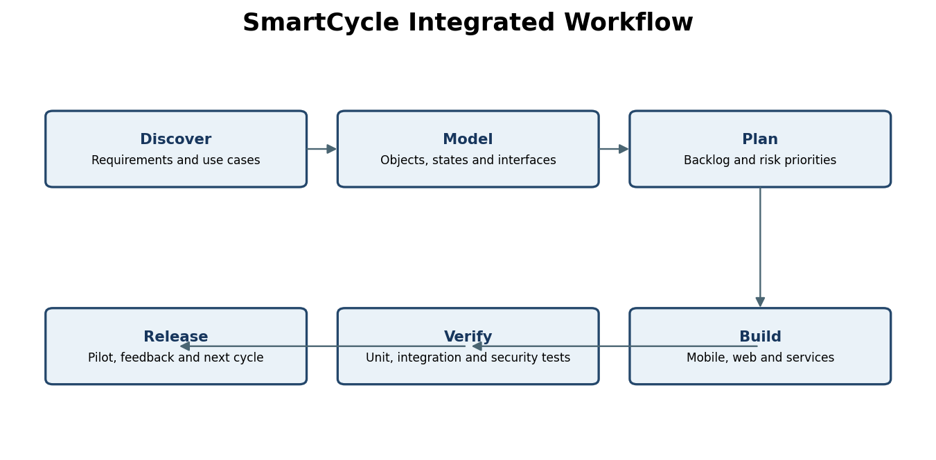
Role | Responsibility | Artefact
Product owner/city | Priorities and acceptance | Backlog, acceptance criteria
Process architect | Boundaries, interfaces and decisions | Domain model, architecture records
OO analyst/designer | Classes, states and interactions | Use cases, class/state/sequence models
App/web developers | Rider and operator increments | UI, API clients, automated tests
Vendor/firmware engineer | Dock and lock integration | Hardware contract, simulator, test evidence
Security/compliance lead | KYC, payments, privacy and audit | Threat model, compliance checklist
QA/integration engineer | Regression and end-to-end tests | Test plan and release report

9.1 Choices linked to earlier tasks
- Task 1: encapsulate Bike, Trip and DockStation invariants.
- Task 2: use composition for fare rules.
- Task 3: use Spiral risk reviews with OO increments.
- Task 4: use OOSE for user workflows and OMT for object states.
- Task 5: use MDD for stable shared structures, not every UI detail.
- Task 6: use short sprints and continuous tests.
- Task 7: Agile app; formal assurance gates for firmware and KYC/payment.
- Task 8: test continuously to reduce late defect discovery.

9.2 Changed conditions
Condition | Response | Trade-off/control
Week 14 KYC/payment rule changes | Log change; impact CIM/PIM, use cases, API and tests; compliance lead reviews before release. | May delay payment release but prevents uncontrolled regulatory change.
Docks arrive six weeks late | Continue against simulator and versioned hardware contract; shift physical integration tests after delivery. | Simulation avoids idle time but cannot prove real lock/radio timing.
Lead developer leaves in week 10 | Use architecture records, pair ownership, reviewed code, reproducible builds and interim technical owner. | Knowledge sharing takes time but reduces dependency on one person.

Single point of failure: lead developer as sole holder of architecture/integration knowledge. Assign two maintainers per critical subsystem and require reviewed architecture decisions. Trade-off: reviews and knowledge sharing consume short-term capacity but reduce delivery risk.

TASK 10 – Cross-Task Review and Final Defence
Finding | Source task | Effect
Core objects own important state rules. | 1 | Keep invariants in domain methods.
Fare variation is independent of bike hardware. | 2 | Use FarePolicy composition.
Requirements expected to change. | 3 | Avoid rigid sequential-only delivery.
Full-station return has alternate flows. | 4 | Model use cases and object states.
Fare rules are shared across platforms. | 5 | Centralise stable rules and transformations.
Damage report must block unlock. | 6 | Add safety acceptance tests.
Firmware/KYC have assurance needs. | 7 | Use formal release gates.
Iteration testing reduces calculated repair cost. | 8 | Test continuously; track test effort separately.
Vendor delay and staff exit threaten integration. | 9 | Use simulators, contracts and shared ownership.

10.1 Conflicting findings and resolution
Conflict 1: MDD benefits from stable models, while Agile expects design to evolve. Resolution: model stable shared rules/interfaces and update the PIM each sprint; do not model every screen in advance.
Conflict 2: Agile favours rapid delivery, while firmware and KYC/payment require formal evidence. Resolution: select process by subsystem. Teams can build increments, but regulated/safety-sensitive releases pass formal gates.
Conflict 3: reuse saves effort, but the vendor simulator may differ from real docks. Resolution: reuse stable adapters/domain logic but isolate hardware-specific behaviour and test on real docks before release.

10.2 Evaluate the official’s claim
“Agile means no documentation or models” is incorrect. Agile values working software but does not prohibit useful diagrams, acceptance criteria, interface notes or architecture records. Tasks 1, 4 and 9 show why models and traceable decisions are useful.
“MDD means no programmers” is also incorrect. Developers must create models and transformations, review generated output, write platform adapters, handle errors and test the result. Task 5 shows that centralised rules help, but round-trip edits and generator limitations still need engineering judgement. Agile and MDD address different concerns and can be combined.

10.3 Final reflection and defence
There is no single best method for every object-oriented project. The process must fit uncertainty, risk, team capability and external dependencies. For SmartCycle, I recommend a risk-driven Spiral structure with short object-oriented increments inside each cycle. This gives the corporation regular demonstrations while examining payment, KYC, hardware and safety risks early. The core domain model should centre on Rider, Bike, Trip and DockStation. Bike and Trip must protect their state rules, while fare calculation should use replaceable policy objects so peak pricing, subscriptions and student discounts can evolve without changing every bike class.
The rider application can follow Agile planning because screens, maps and user feedback are likely to change. Certified dock firmware and payment/KYC need stronger baselines, traceability and formal release checks. MDD should be limited to stable shared structures, API contracts and database mappings; it should not generate every screen or replace programming work. Continuous unit, integration and acceptance testing are essential, especially for damage blocking, payment failure and return capacity.
I would change this recommendation if requirements became stable, the hardware interface was proven and compliance risk was low; a lighter OO iterative process could then reduce overhead. The weakest evidence is the rework estimate because each reopened phase was assigned a simplified unit cost. Next, I would validate estimates with the actual team, confirm city rules, test vendor docks and measure payment/KYC integration risk. The process should be reviewed as evidence changes, not treated as a fixed recipe.

Conclusion
SmartCycle needs modular objects, adaptable fare policies, risk-based life-cycle planning and continuous testing. A hybrid process—Spiral at project level, OO increments for implementation, Agile for the rider app and formal gates for safety/compliance—best balances change and control for the stated scenario.

