ASSIGNMENT – 3
CRYPTOGRAPHY AND NETWORK SECURITY
CO3: Cryptographic Hashes, Digital Signatures,
Kerberos and X.509 Authentication Frameworks

STUDENT DETAILS | INFORMATION
Student Name | MUKESH.M
Register Number | 192521368
Course | CSA51 – Cryptography and Network Security
Assignment | Assignment 3 (Q1–Q7)

SUBMITTED TO
Department of Information Technology
SIMATS

Q1 – WHAT MAKES A HASH FUNCTION TRUSTWORTHY? (6 MARKS)

1.1 Aim and core concepts
A cryptographic hash function maps an input of arbitrary length to a fixed-length digest. SHA-256, for example, always produces 256 output bits. A trustworthy cryptographic hash should make it computationally infeasible to reverse a digest, find a second input matching a given input, or find any two distinct inputs with the same digest.
Property | Meaning | Attack scenario prevented
Pre-image resistance | Given digest h, it is infeasible to find m such that H(m)=h. | An attacker cannot practically recover an unknown message from its digest.
Second pre-image resistance | Given m1, it is infeasible to find m2≠m1 with H(m2)=H(m1). | An attacker cannot replace a known legitimate file with a different file having the same digest.
Collision resistance | It is infeasible to find any distinct m1,m2 with equal digests. | An attacker cannot prepare two different documents with the same digest and exploit one signed version.
Avalanche effect | A one-bit input change should change about half the output bits, unpredictably. | Small input changes should not create predictable or visibly related digests.

1.2 Expected avalanche change
For an ideal n-bit hash, each output bit behaves like an independent fair bit. When one input bit is flipped, the probability that any particular output bit changes is 1/2. If X is the number of changed output bits, X follows a binomial distribution:
X ~ Binomial(n, 1/2); E[X] = n × 1/2 = n/2; Var(X) = n × 1/2 × 1/2 = n/4.
For SHA-256, n=256, so the expected number of changed bits is 128, with standard deviation √64 = 8 bits. This is an average, not a promise that every pair changes exactly 128 bits.

1.3 Why a byte-sum toy hash fails
Define a toy digest T(m) as the sum of all message bytes modulo 256. It has only 8 output bits and is highly structured. If a byte is increased by 1, the digest changes by only 1 rather than behaving randomly. Reordering bytes does not change the sum. Many messages therefore collide trivially.
Second-pre-image example: for message bytes [65,66], the sum is 131. A different message [64,67] also sums to 131. The attacker can construct a different message with the same toy digest without searching a large space. A byte-sum hash also fails avalanche because a one-bit flip in a byte changes the sum by a predictable power of two (modulo 256).

1.4 Why fixed-length digests must have collisions
The set of all possible finite-length messages is vastly larger than the set of n-bit digests, which contains only 2^n values. By the pigeonhole principle, at least two different messages must map to the same digest. Security does not mean collisions do not exist; it means finding one is computationally infeasible.

1.5 Experiment design and workflow
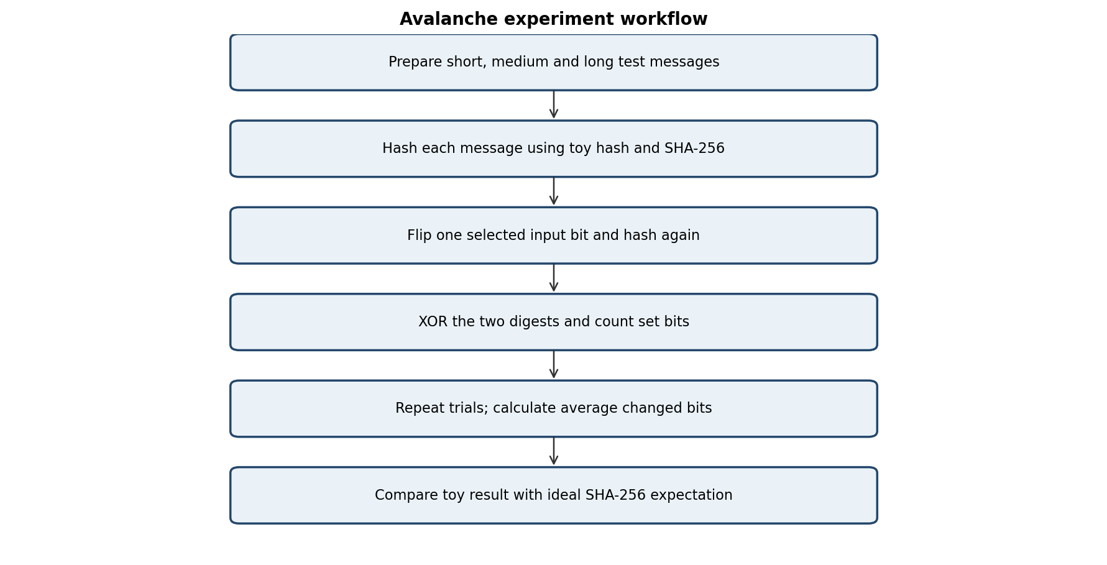
Recommended test sizes: 16 bytes, 128 bytes and 1,024 bytes. Use at least 100 trials per size. For each trial, select an input bit, flip it, compute both digests and count differing output bits using popcount(H(m) XOR H(m′)).

1.6 Python implementation
import hashlib, random

def toy_hash(data):
return sum(data) % 256

def changed_bits(a, b):
return (a ^ b).bit_count()

def digest_sha256(data):
return int.from_bytes(hashlib.sha256(data).digest(), "big")

random.seed(7)
for size in (16, 128, 1024):
sha_counts, toy_counts = [], []
for _ in range(100):
msg = bytearray(random.randbytes(size))
bit = random.randrange(size * 8)
changed = bytearray(msg)
changed[bit // 8] ^= 1 << (bit % 8)
sha_counts.append(changed_bits(digest_sha256(msg),
digest_sha256(changed)))
toy_counts.append(changed_bits(toy_hash(msg),
toy_hash(changed)))
print(size, sum(sha_counts)/100, sum(toy_counts)/100)

Illustrative interpretation: SHA-256 averages should be near 128 changed bits for every input size. The toy digest has only 8 bits and its changes are constrained by byte addition; its average is not expected to approach the ideal 4 changed bits consistently. Exact experimental averages depend on the random trials and Python version.
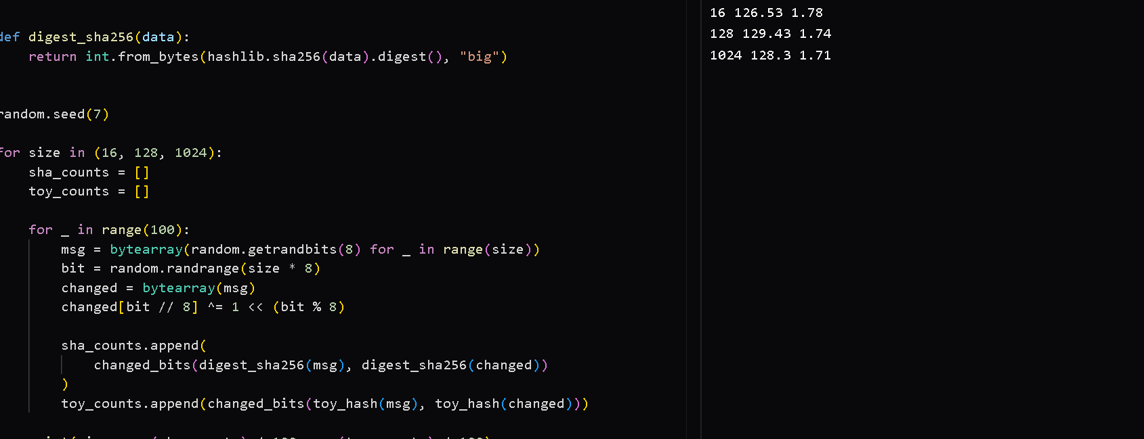

1.7 Birthday bound and collision effort
For a k-bit digest there are N=2^k possible outputs. After q independent random hashes, the approximate probability of at least one collision is p ≈ 1 − exp(−q(q−1)/(2N)). Setting p near 0.5 gives q ≈ √(2N ln 2) ≈ 1.177 × 2^(k/2). Thus the collision effort grows roughly as 2^(k/2), not 2^k.
Truncated bits k | Digest space 2^k | Birthday scale 2^(k/2) | Approx. 50% collision count 1.177×2^(k/2)
16 | 65,536 | 256 | 301
20 | 1,048,576 | 1,024 | 1,206
24 | 16,777,216 | 4,096 | 4,821
28 | 268,435,456 | 16,384 | 19,284
32 | 4,294,967,296 | 65,536 | 77,137

Any-collision search is different from a second-preimage search. In an any-collision attack, the attacker chooses both messages and seeks a matching pair, giving birthday complexity. In a second-preimage attack, one message is fixed in advance; the attacker must find a different message matching its digest, which ideally costs about 2^k work.
The birthday bound explains why digest sizes must be selected with a large security margin. MD5 (128-bit) and SHA-1 (160-bit) have practical collision attacks and must not be used for new collision-resistant signatures or certificates. SHA-256 or stronger modern hashes are preferred.

1.8 Collision-finder code and results interpretation
import hashlib

def truncated_digest(message, k):
value = int.from_bytes(hashlib.sha256(message).digest(), "big")
return value >> (256-k)

def find_collision(k, limit=2_000_000):
seen = {}
for i in range(limit):
msg = f"candidate-{i}".encode()
d = truncated_digest(msg, k)
if d in seen and seen[d] != msg:
return i + 1, seen[d], msg, d
seen[d] = msg
return None

for k in (16, 20, 24, 28, 32):
print(k, find_collision(k))

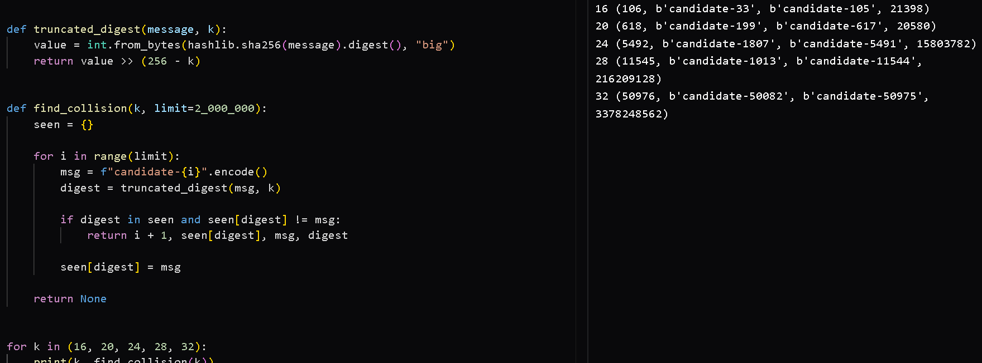
The code is a reproducible search procedure, but this document does not claim measured collision counts for a run that has not been executed here. The number of hashes varies by run and is probabilistic. For k=32, a search may require tens of thousands of hashes on average; record actual run counts in the lab table.

k | Trial 1 hashes | Trial 2 hashes | Trial 3 hashes | Expected scale
16 | Record run | Record run | Record run | ≈256
20 | Record run | Record run | Record run | ≈1,024
24 | Record run | Record run | Record run | ≈4,096
28 | Record run | Record run | Record run | ≈16,384
32 | Record run | Record run | Record run | ≈65,536

Q2 – INTEGRITY IS NOT THE SAME AS AUTHENTICATION: HASH, MAC AND HMAC (7 MARKS)

2.1 Problem analysis
A public SHA-256 digest published beside a downloadable file can detect accidental corruption only when the digest itself is trusted. If an attacker can replace both the file and the digest on the same page, the attacker can calculate a new digest and the recipient has no independent proof of authenticity. A plain hash is unkeyed.

2.2 Hash, MAC and HMAC comparison
Mechanism | Secret key? | Integrity | Source authentication | Non-repudiation
Plain hash H(m) | No | Only if expected digest is obtained through a trusted channel | No | No
Naive MAC H(K || m) | Yes | Yes, for parties sharing K | Yes, to holders of K | No
HMAC(K,m) | Yes | Yes | Yes, to holders of K | No

A MAC cannot provide non-repudiation because both sender and receiver know the same secret key. Either party could have generated a valid tag, so an outside verifier cannot identify which party created it.

2.3 Merkle–Damgård construction and length extension
A Merkle–Damgård hash processes fixed-size message blocks through a compression function. Each block updates a chaining value; padding includes a length encoding. The final chaining value is the digest. In a vulnerable construction H(K || m), the digest exposes the final chaining value. If the attacker knows the length of K || m, the attacker can continue hashing attacker-chosen suffix blocks from that state and calculate a valid tag for m || glue-padding || suffix without knowing K.
What the attacker needs: the original message, its tag, an estimate of the secret-key length, the hash construction and the ability to submit the extended message. What is not needed: the actual secret key. This attack is specific to vulnerable Merkle–Damgård prefix-MAC constructions and is not a general attack against HMAC.
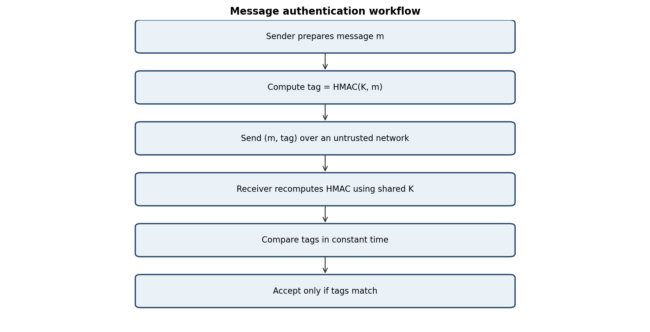

2.4 HMAC structure
HMAC uses a block-sized key K0 (hashed if too long and zero-padded if short), an inner pad ipad and an outer pad opad. The construction is HMAC(K,m)=H((K0 XOR opad) || H((K0 XOR ipad) || m)). The outer hash prevents an attacker from treating the published tag as a reusable internal chaining state for appending data.
The key must be random, high-entropy, stored securely and rotated when exposed. HMAC-SHA-256 is a standard choice for message authentication where both endpoints can share a secret.

2.5 Tamper tests
import hashlib, hmac

key = b"organisation-secret"
message = b"Transfer amount=100"
tag = hmac.new(key, message, hashlib.sha256).digest()

tests = {
"original": message,
"modified": b"Transfer amount=900",
"appended": message + b";approved=true"
}
for name, candidate in tests.items():
candidate_tag = hmac.new(key, candidate, hashlib.sha256).digest()
print(name, hmac.compare_digest(tag, candidate_tag))

Test case | Expected verification | Reason
Original message + original tag | ACCEPT | The computed HMAC matches.
Modified message + old tag | REJECT | Message change produces a different HMAC.
Appended data + old tag | REJECT | The tag covers the complete message.
Modified file + recomputed public SHA-256 | May appear valid | If attacker controls both file and displayed digest, no authenticity is established.
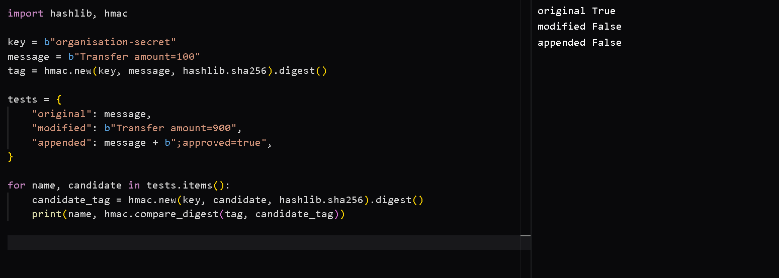

2.6 Engineering decision
For public software downloads, publish a digital signature over a manifest containing the file name, version, size and SHA-256 digest. Distribute the signing public key or certificate through a trusted mechanism. For internal service-to-service messages, use HMAC-SHA-256 with unique, protected shared keys. Keep the signing private key and HMAC keys secret. Residual risks include compromised signing keys, endpoint compromise, weak key storage, rollback to an old but valid release, and implementation errors.

Q3 – DIGITAL SIGNATURES: HASH-THEN-SIGN AND WHAT CAN BREAK THEM (7 MARKS)

3.1 Why hash before signing?
A message can be arbitrarily long, while signature algorithms operate on values of a defined size or encoded structure. Hash-then-sign produces a fixed-length digest and binds the signature to the complete message. Secure signature standards also use defined encodings such as RSA-PSS; raw textbook RSA is not a safe deployment format.

3.2 RSA signature derivation
Choose primes p and q; compute n=pq and φ(n)=(p−1)(q−1). Select public exponent e coprime to φ(n), and private exponent d satisfying ed≡1 (mod φ(n)). Let h=H(m) be encoded appropriately as an integer. Sign: s=h^d mod n. Verify: v=s^e mod n and accept only if v equals the correctly encoded digest.
Correctness: s^e ≡ (h^d)^e ≡ h^(de) (mod n). Since de=1+tφ(n), Euler's theorem gives h^(de) ≡ h (mod n) when h is relatively prime to n; the RSA standard's encoding and verification rules handle practical inputs. Thus verification recovers the signed encoded digest.
Toy calculation: p=11, q=13, n=143, φ(n)=120. Choose e=7; d=103 because 7×103=721≡1 mod 120. For toy digest h=9, s=9^103 mod 143 = 113. Verification gives 113^7 mod 143 = 9. This illustrates RSA arithmetic only; these tiny values are completely insecure.

3.3 DSA/ECDSA verification relation
For DSA, work in a subgroup of order q with generator g. Public key y=g^x mod p. For message digest H(m), signature (r,s) is formed using fresh secret nonce k: r=(g^k mod p) mod q and s=k⁻¹(H(m)+xr) mod q. Verification computes w=s⁻¹ mod q, u1=H(m)w mod q, u2=rw mod q, then v=((g^u1 y^u2 mod p) mod q). Accept if v=r.
Substitution shows g^u1 y^u2 = g^(H(m)/s) × g^(x r/s) = g^((H(m)+xr)/s) = g^k, because s=k⁻¹(H(m)+xr). Therefore v=r. ECDSA uses the corresponding elliptic-curve point operations and verifies that the x-coordinate of u1G+u2Q, reduced modulo q, equals r.

3.4 Nonce reuse attack
For DSA, if the same k signs two different digests, s1=k⁻¹(h1+xr) and s2=k⁻¹(h2+xr). Subtracting gives k=(h1−h2)(s1−s2)⁻¹ mod q. Then x=(s1k−h1)r⁻¹ mod q. This recovers the private key. ECDSA has an analogous nonce-reuse failure. A nonce must be unique and secret; deterministic nonce generation following a standard can reduce dependence on random-number quality.

3.5 Signature test matrix
Test | Expected result | Security meaning
Correct message, signature and public key | ACCEPT | Signature verifies.
Modified message | REJECT | Digest changes.
Modified signature | REJECT | Signature equation fails.
Wrong public key | REJECT | Verification uses a different key.
Same DSA/ECDSA nonce reused | Key may be recovered | A mathematically valid scheme can fail through unsafe nonce handling.

3.6 Textbook RSA multiplicative forgery
Raw RSA is multiplicative: if s1^e≡m1 and s2^e≡m2 (mod n), then (s1s2)^e≡m1m2 (mod n). This can create a signature on the product message without the private key. Hashing and secure encoding prevent this simple algebraic construction from applying to a valid modern RSA signature format.

3.7 Non-repudiation conditions
A valid signature supports attribution to the private-key holder, but does not automatically prove a human personally performed an action. Strong non-repudiation requires exclusive key control, reliable identity proofing, secure key storage, trustworthy time evidence, audit records, certificate status checking and a defensible signing process. A signer may dispute a signature if the key was stolen, malware signed without consent, the certificate was mis-issued, or the time of signing is uncertain. Trusted timestamping and independent evidence help establish when a signature existed.

Q4 – TRUST THROUGH CERTIFICATES: X.509 CHAIN VALIDATION (7 MARKS)

4.1 X.509 v3 certificate structure
An X.509 certificate binds a subject identity to a public key. Important fields include version, serial number, signature algorithm, issuer, validity period (notBefore/notAfter), subject, subject public-key information, issuer signature and extensions. Extensions include Basic Constraints (CA flag and path length), Key Usage, Extended Key Usage, Subject Alternative Name (SAN), and certificate policies.
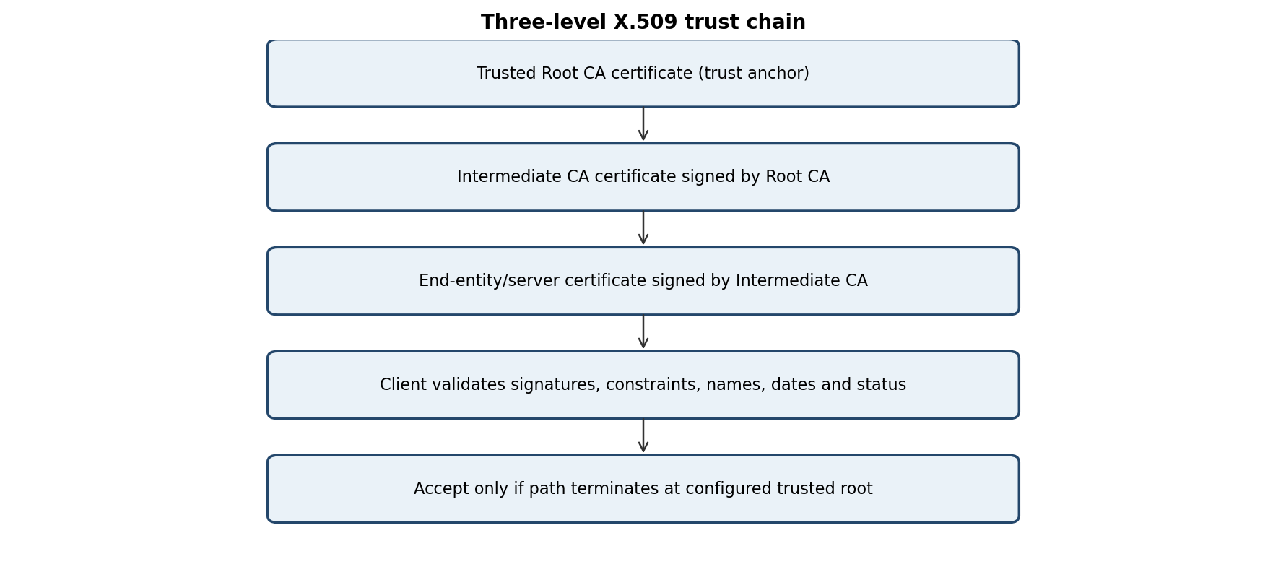

4.2 Chain-validation pseudocode
validate_chain(leaf, intermediates, trusted_roots, hostname, now):
path = build_path(leaf, intermediates)
if path cannot be built: REJECT
if final certificate is not a configured trust anchor: REJECT
for cert in path:
if now < cert.notBefore or now > cert.notAfter: REJECT
if certificate signature is invalid under issuer public key: REJECT
if issuer name does not match issuer certificate subject: REJECT
if certificate is a CA certificate:
require BasicConstraints.ca == TRUE
require KeyUsage.keyCertSign == TRUE
else:
require intended KeyUsage / ExtendedKeyUsage
require hostname matches a permitted SAN entry
check revocation using current CRL or OCSP policy
enforce path length, name constraints and algorithm policy
ACCEPT

4.3 What each validation step prevents
Validation check | Threat limited
Issuer–subject linkage and signature | Forged or substituted certificate in the chain.
Validity period | Use outside the certificate's authorized time window.
Basic Constraints CA=TRUE | A normal end-entity certificate being used to issue certificates.
Key Usage / Extended Key Usage | Using a certificate for an unauthorized purpose.
Hostname/SAN matching | A valid certificate for another domain being accepted.
CRL or OCSP revocation | Continued acceptance of a compromised or withdrawn certificate.
Trusted-root anchoring | Trusting a chain that does not end at a locally trusted authority.

The root's trust cannot be proven by its own signature. A self-signature proves internal consistency, not identity or legitimacy. The root must be installed or accepted through an out-of-band trust decision, such as operating-system trust-store governance.

4.4 Failure-case test table
Failure case | Validation step that rejects it | Expected outcome
Expired certificate | Validity-period check | REJECT
Not-yet-valid certificate | notBefore check | REJECT
Wrong issuer | Issuer/subject linkage or signature check | REJECT
Tampered certificate field | Certificate signature check | REJECT
Hostname mismatch | SAN/name matching | REJECT
End-entity certificate used as CA | Basic Constraints / keyCertSign | REJECT
Revoked certificate | CRL/OCSP status check | REJECT when checked and status is known

4.5 CRL versus OCSP
Factor | CRL | OCSP
Method | CA publishes a signed list of revoked serial numbers. | Client asks a responder for status of a certificate.
Freshness | Depends on CRL issue/update interval; list can be stale. | Can provide fresher status, depending on responder and response validity.
Size | Can become large as revocations accumulate. | Small per-certificate response; responder handles lookup load.
Privacy | Downloading a broad list reveals less about a specific browsing request. | Responder may learn which certificate a client is checking.
Availability | Client can use a cached CRL until its nextUpdate limit, subject to policy. | Online responder availability can affect validation.
Failure policy | Fail-open may accept when status cannot be checked. | Fail-open may accept when responder is unreachable.

A fail-open policy means the client accepts a certificate when revocation status cannot be obtained. This improves availability but can allow a revoked certificate to remain usable. A deployment should define freshness limits, use stapled OCSP where appropriate, monitor CA compromise, rapidly distribute emergency revocation information and maintain short-lived certificates.

4.6 Limiting damage from CA compromise
A compromised intermediate can be revoked by its parent or removed from trust, and short certificate lifetimes reduce the exposure window. Root keys should be offline and protected by hardware security modules and multi-person controls. Use constrained intermediates, name constraints, certificate transparency monitoring where applicable, rapid incident response and key rotation. A compromised root is especially serious because clients may trust certificates issued under it until trust stores are updated.

Q5 – KERBEROS: AUTHENTICATION WITHOUT SENDING PASSWORDS (6 MARKS)

5.1 Components and keys
Kerberos uses a Key Distribution Center (KDC), consisting logically of an Authentication Server (AS) and Ticket-Granting Server (TGS). The client has a long-term secret derived from its password; the KDC shares a long-term key with each service. Kerberos issues tickets and temporary session keys so that the user's password is not sent over the network.
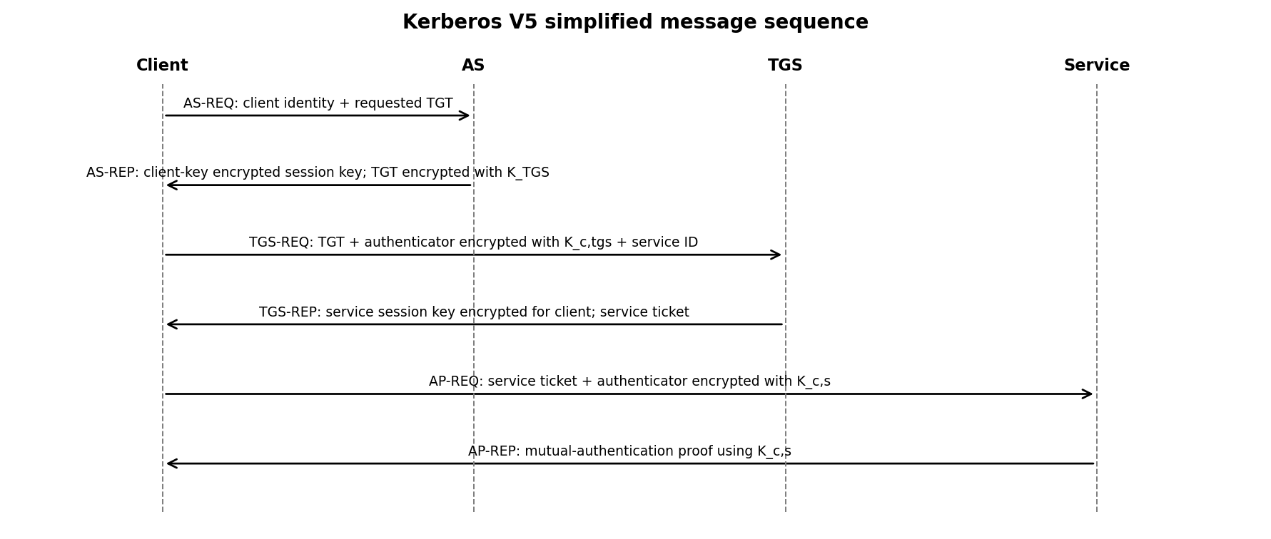

5.2 Ticket and authenticator
The Ticket-Granting Ticket (TGT) allows the client to request service tickets without repeatedly entering the password or contacting the AS for every service. The TGT is encrypted with the TGS secret key, so the client cannot alter its protected contents. The authenticator contains client identity and a timestamp and is encrypted with the relevant session key. The service checks the timestamp and replay cache to prevent reuse.
The user's long-term key is used to protect the initial AS reply, allowing the client to recover a session key. Subsequent exchanges use temporary session keys. The password itself is never transmitted.

5.3 Who can read which information?
Data | Readable by | Protection
AS reply's client portion | Client (using password-derived key) | Encrypted under client long-term key.
TGT | TGS | Encrypted under K_TGS; client carries it but cannot read/modify it.
TGS reply's client portion | Client | Encrypted under client–TGS session key.
Service ticket | Target service | Encrypted under service's long-term key.
Authenticator | TGS or service, depending on exchange | Encrypted under the corresponding session key.

5.4 Replay, expiry and clock-skew experiments
Scenario | Without protection | With Kerberos protection
Captured authenticator replayed | May be accepted by a naïve service. | Timestamp and replay cache reject duplicate or stale authenticator.
Expired ticket | A service ignoring ticket times may accept it. | Ticket start/end time checks reject it.
Clock skew | Timestamp checks may fail or allow replay if too loose. | Configured clock-skew tolerance bounds accepted time difference.
KDC unavailable | New tickets and renewals cannot be obtained. | Existing unexpired tickets may continue to work; new authentication is disrupted.
Stolen ticket | Attacker may attempt use during ticket lifetime. | Authenticator, session-key protection, short lifetimes and endpoint protection limit but do not eliminate risk.

An offline password-guessing attack may be possible if an attacker captures an AS reply protected by a password-derived key and can test guesses offline. Strong passwords, pre-authentication, salted/iterated password-based key derivation where supported, and account monitoring reduce this risk.
A service learns the authenticated principal identity and receives proof that the client possesses the session key associated with the ticket. A ticket can authenticate a client to a service, but it does not provide third-party non-repudiation: the KDC and service operate in a shared-secret trust model, and the service cannot later prove independently that only the user created the request.

5.5 Kerberos acceptance workflow
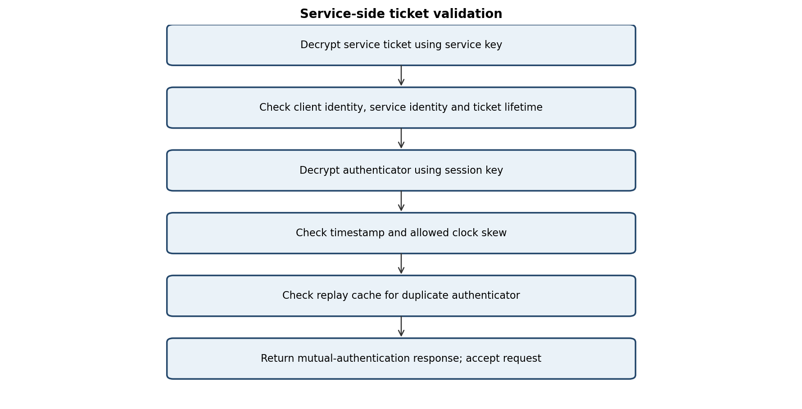

Q6 – ADVANCED SECURITY MINI-INVESTIGATIONS (7 MARKS)

6.1 Collision versus second pre-image
A collision attack lets the attacker choose both messages and find H(m1)=H(m2). A second-preimage attack starts with a fixed legitimate m1 and seeks a different m2 with the same digest. Collision attacks against weak hashes can threaten signatures because an attacker may prepare a harmless document and a malicious document with the same digest, obtain a signature on the harmless one, and transfer that signature to the malicious one.
This requires both candidate documents to be prepared before the legitimate document is signed. Historical MD5 and SHA-1 collision weaknesses have enabled demonstrations of forged certificate structures. Certificate authorities must use collision-resistant modern hashes and strict algorithm policy.

6.2 Collision-to-signature risk
If a signature scheme signs only a weak truncated digest, two preselected messages with the same digest can share the same signature verification result. A toy collision finder can demonstrate this concept, but it must not be used to forge real certificates. Modern signature standards hash with secure digest sizes and use carefully defined encoding.

6.3 Kerberos versus X.509/PKI
Dimension | Kerberos | X.509 / PKI
Key type | Symmetric long-term keys and session keys. | Public/private key pairs; certificates bind public keys to identities.
Trusted third party | KDC (AS and TGS). | Certificate authorities and configured trust anchors.
Online/offline dependence | KDC normally needed to obtain/renew tickets; existing tickets may work temporarily offline. | Certificate signatures can be checked offline; revocation and freshness may require online or cached status.
Scalability | Centralized KDC avoids every user maintaining pairwise secrets. | CA hierarchy supports large, distributed populations.
Revocation | Ticket expiry, key rotation and account disabling at KDC. | CRL, OCSP, short-lived certificates and trust-store changes.
Typical environment | Enterprise/campus single sign-on and internal services. | TLS, device identity, code signing and document signatures.
Non-repudiation | No strong third-party non-repudiation from shared secrets. | Digital signatures can support non-repudiation if key control and evidence are trustworthy.

6.4 Key relationship count for n users
Architecture | Approximate key relationships | Reason
Pairwise shared keys | n(n−1)/2 | Every pair of users needs a distinct shared secret.
Kerberos with KDC | n long-term client/KDC relationships, plus service/KDC keys | Each principal shares a key with the KDC; session keys are issued as needed.
PKI | One key pair and certificate per entity; trust paths through CA hierarchy | Users verify public keys using certificates rather than pre-sharing pairwise secrets.

For n=1,000 users, pairwise design requires 1,000×999/2 = 499,500 pairwise relationships. A centralized Kerberos design requires approximately one long-term client-to-KDC relationship per user (plus service accounts), making administration far more scalable.
Recommendation: use Kerberos for campus single sign-on and internal service authentication. Use a properly governed PKI digital-signature system for legally binding electronic contracts, with identity proofing, secure private-key control, timestamping and audit evidence.

6.5 RSA, DSA/DSS, ECDSA, ElGamal and Schnorr comparison
Scheme | Key material | Randomness / nonce | Verification concept | Security cautions
RSA | Integer modulus n; public e; private d. | RSA-PSS uses secure salt randomness (or configured deterministic options); never use raw RSA. | Check encoded digest using public exponent. | Use modern padding/encoding and adequate key size; textbook RSA is malleable.
DSA/DSS | Finite-field subgroup parameters; public y=g^x; private x. | Fresh secret k for every signature. | Recompute v from u1,u2 and compare v=r. | Nonce reuse can reveal k and private x; legacy DSA is not preferred for new systems.
ECDSA | Elliptic-curve group; public Q=xG; private x. | Unique secret per-signature nonce k. | Compute u1G+u2Q and compare x-coordinate to r. | Nonce reuse or bias can expose private key.
ElGamal | Prime p, generator g; public y=g^x; private x. | Choose fresh k coprime to p−1. | Check g^H(m) ≡ y^r r^s (mod p). | Weak/reused k can expose private key; parameter and encoding choices matter.
Schnorr | Group generator g; public y=g^x; private x. | Fresh secret nonce k; challenge must bind message and commitment. | Verify g^s = R·y^e (convention dependent). | Nonce reuse can expose x; challenge must be unpredictable or securely derived.

6.6 Schnorr commitment–challenge–response
Prover selects nonce k and sends commitment R=g^k. Verifier (or Fiat–Shamir hash) provides challenge e bound to the message and commitment. Prover responds s=k+ex mod q. Verification checks g^s=R·y^e, where y=g^x. Derivation: g^s=g^(k+ex)=g^k(g^x)^e=R·y^e. Reusing k across challenges gives s1−s2=(e1−e2)x mod q, revealing x.

6.7 ElGamal toy example
Use p=23, g=5, private x=6, so public y=5^6 mod 23=8. Let message digest h=13 and nonce k=7; gcd(7,22)=1. Then r=g^k mod p=5^7 mod 23=17. The inverse of 7 modulo 22 is 19. Compute s= k⁻¹(h−xr) mod 22 = 19(13−6×17) mod 22 = 19×(−89) mod 22 = 7. Signature is (17,7). Verification: y^r r^s mod 23 = 8^17 × 17^7 mod 23 = 5^13 mod 23 = 21. A modified message digest or modified signature should fail this equality.

6.8 Why a weak hash weakens an unchanged signature algorithm
The signature authenticates the digest, not the human meaning of the full message. If an attacker can create two different messages with the same digest, a valid signature over one digest may verify for the other message. Strong RSA mathematics cannot compensate for a collision-broken hash function.

Q7 – DESIGN A SECURE AUTHENTICATION AND INTEGRITY SCHEME FROM FIRST PRINCIPLES (10 MARKS)

7.1 Problem and threat model
A manufacturer distributes firmware updates to thousands of hospital infusion pumps. Each pump must verify that an update is unchanged, came from the manufacturer and cannot later be plausibly denied by the manufacturer. Pumps have limited memory, may be offline and may have unreliable clocks. They also need to authenticate to a hospital server for service sessions.
Threat actors may intercept, modify, replace, replay or delay firmware; distribute an old but valid version; steal a device; compromise a signing key; exploit a compromised CA; or disrupt network access. The design assumes the pump's boot ROM or secure bootloader and its manufacturer trust anchor are initially trustworthy.

7.2 Independent proposals – design record
Student A initial proposal | Student B initial proposal
Use SHA-256 to check firmware integrity; use a manufacturer RSA signature; store the public key in each pump; use a timestamp to reject old updates. | Use an X.509 certificate to authenticate the manufacturer's signing key; sign a manifest containing hash, version and device family; use HMAC or Kerberos for hospital service sessions.

Comparison: both proposals use a digital signature for manufacturer authenticity. Student B adds certificate governance and a manifest; Student A emphasizes a trusted public key and anti-rollback version check. The final design combines a signed manifest, pinned manufacturer trust anchor, certificate policy, secure version counter and separate service-session authentication.

7.3 Security goals and mechanisms
Goal | Mechanism | What it contributes
Integrity | SHA-256 digest inside signed manifest | Detects firmware modification.
Manufacturer authentication | Digital signature verified using certified/pinned public key | Shows update was signed by the holder of the authorized private key.
Non-repudiation support | Digital signature, protected signing key, trusted timestamp and audit log | Provides stronger evidence of issuance; depends on key control and legal process.
Anti-rollback | Monotonic secure version counter / minimum accepted version | Rejects older signed firmware.
Certificate trust | X.509 chain validation or pinned manufacturer root | Binds authorized identity to signing public key.
Hospital service authentication | Kerberos ticket or mutually authenticated TLS; HMAC for session messages | Authenticates service sessions without exposing passwords.

7.4 Final update message flow
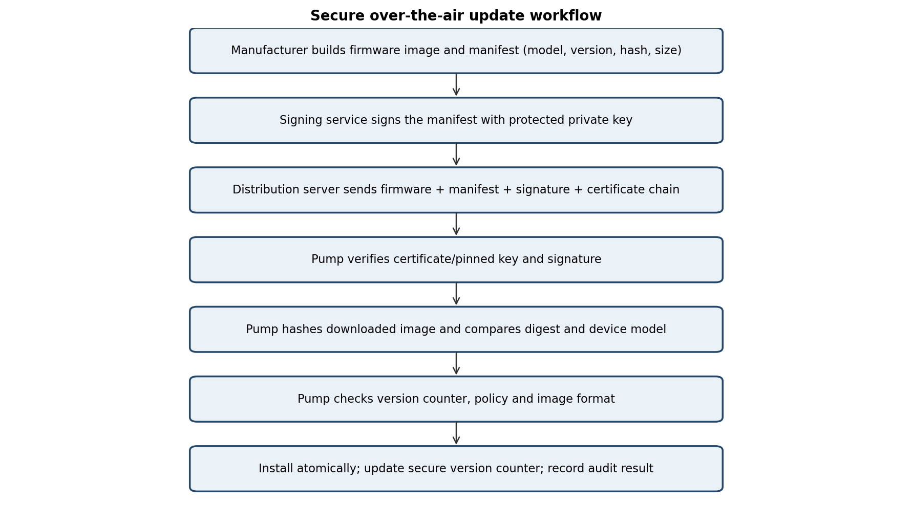

7.5 Key and certificate management
- Manufacturer signing private key: keep in a hardware security module (HSM), restrict access by role and require dual control for release signing.
- Pump trust material: store the manufacturer root public key or a carefully managed pinned public key in protected bootloader/secure storage.
- Certificate lifecycle: issue constrained code-signing certificates, monitor expiry, rotate keys before expiry and revoke compromised certificates.
- Key rotation: support signed trust-store updates and an overlap period for old and new authorized keys.
- Revocation while offline: use short-lived signing certificates where practical, signed revocation/deny lists and a defined maximum offline acceptance window. A pump cannot learn about a newly revoked key while completely disconnected.
- Anti-rollback: store the highest accepted firmware security version in tamper-resistant monotonic storage; do not rely only on a wall clock.

7.6 Signing and verification pseudocode
SIGN_UPDATE(firmware, model, version):
digest = SHA256(firmware)
manifest = encode(model, version, len(firmware), digest,
release_id, minimum_bootloader_version)
signature = SIGN(private_signing_key, manifest)
timestamp_token = obtain_trusted_timestamp(signature)
return firmware, manifest, signature, certificate_chain, timestamp_token

VERIFY_UPDATE(package, device):
parse firmware, manifest, signature, certificate_chain
if manifest.model != device.model: REJECT
if manifest.version <= secure_counter: REJECT
if manifest.size != length(firmware): REJECT
validate signing certificate or pinned key and allowed code-signing use
check certificate validity and revocation according to offline policy
if VERIFY(public_key, manifest, signature) is false: REJECT
if SHA256(firmware) != manifest.digest: REJECT
if manifest.minimum_bootloader_version > device.bootloader_version: REJECT
verify timestamp evidence and release policy where available
write image to inactive slot and verify installed image
atomically mark slot active and advance secure_counter
log release_id, digest, result and device identity
ACCEPT

7.7 Offline operation and unreliable clocks
The pump should not depend on a live server for every signature check. It can verify the signature and digest offline using a stored trust anchor. Because the local clock may be wrong, certificate-time checks should use a secure real-time clock when available, trusted timestamp evidence, or a carefully bounded offline policy. A secure monotonic counter is more reliable than wall-clock time for anti-rollback. If revocation freshness cannot be established, the device should follow a documented risk policy rather than silently assuming the certificate is safe.

7.8 Validation test cases
Test case | Expected result | Reason
Valid firmware, manifest and signature | ACCEPT | All identity, integrity and policy checks pass.
Modified firmware image | REJECT | SHA-256 digest mismatch.
Modified signature | REJECT | Public-key signature verification fails.
Older valid signed version | REJECT | Version is not greater than secure counter.
Expired/revoked signing certificate | REJECT or policy hold | Certificate status/time policy fails when reliable status is available.
Wrong manufacturer's key | REJECT | Key is not anchored to trusted manufacturer identity.
Wrong device model | REJECT | Manifest target does not match pump.
Compromised signing private key | Potentially ACCEPT until detected | Attacker can create signatures; revoke key, rotate trust and investigate.

7.9 Baseline comparison and cost
Feature | Bare SHA-256 published beside file | Proposed signed-manifest design
Detect accidental corruption | Yes, if expected digest is trusted. | Yes.
Detect attacker changing file and digest together | No. | Yes, unless signing key or trust anchor is compromised.
Authenticate manufacturer | No. | Yes, through signature and certificate/pinned key.
Non-repudiation support | No. | Potentially, with exclusive key control, timestamp and audit evidence.
Rollback prevention | No. | Yes, using secure monotonic version counter.
Offline verification | Yes, if digest known. | Yes, if trust material and required policy data are stored.
Added cost | Very low. | Signature verification, certificate storage, secure counter, key governance and audit metadata.

Verification cost is approximately one image hash plus one public-key signature verification and certificate-chain checks per update. Hashing is linear in firmware size; signature verification cost is largely independent of firmware size. The manifest and certificate chain add a small amount of metadata compared with the firmware image.

7.10 Residual risks and final evaluation
No design removes all risk. A compromised manufacturer signing key can authorize malicious firmware. A compromised root trust anchor can undermine certificate validation. A hardware or bootloader vulnerability can bypass verification. An offline device may not learn about a new revocation immediately. Supply-chain compromise, implementation bugs, physical attacks and incorrect recovery procedures remain possible. Mitigations include HSM-backed keys, dual approval, secure boot, staged rollout, independent firmware review, rapid key rotation, secure recovery images and incident-response drills.
The final design uses digital signatures and SHA-256 for firmware distribution because public-key verification works across many devices without sharing a manufacturer secret with every pump. HMAC is suitable for internal message integrity between parties sharing a secret, while Kerberos or mutually authenticated TLS can authenticate hospital service sessions. A signature is preferred over a bare hash for public update authenticity and supports stronger non-repudiation evidence than a shared-secret MAC.

OVERALL CONCLUSION
The seven investigations show that integrity, authentication and non-repudiation are related but different security goals. A cryptographic hash detects changes only when the expected digest is trusted. HMAC provides integrity and authentication to parties sharing a secret but cannot distinguish which party created a tag. Digital signatures support public verification and non-repudiation when private-key control, identity proofing, timestamps and audit evidence are reliable. X.509 provides a scalable identity-to-key binding through certificate paths, while Kerberos provides efficient ticket-based authentication for managed networks. For medical-device firmware, a signed manifest, strong hash, trusted key hierarchy, anti-rollback counter and carefully designed offline policy form a suitable integrated approach.

REFERENCES
- [1] NIST. (2015). Secure Hash Standard (SHS), FIPS PUB 180-4. National Institute of Standards and Technology.
- [2] NIST. (2008). The Keyed-Hash Message Authentication Code (HMAC), FIPS PUB 198-1.
- [3] NIST. (2023). Digital Signature Standard (DSS), FIPS PUB 186-5.
- [4] NIST. (2020). Recommendation for Key Management: Part 1 – General, SP 800-57 Part 1 Rev. 5.
- [5] IETF. (2008). Internet X.509 Public Key Infrastructure Certificate and CRL Profile, RFC 5280.
- [6] IETF. (2010). The Kerberos Network Authentication Service (V5), RFC 4120.
- [7] IETF. (2013). Online Certificate Status Protocol (OCSP), RFC 6960.
- [8] IETF. (2016). Internet X.509 Public Key Infrastructure: Certificate Management Protocol (CMP), RFC 4210.
- [9] Menezes, A. J., van Oorschot, P. C., & Vanstone, S. A. (1996). Handbook of Applied Cryptography. CRC Press.
- [10] Katz, J., & Lindell, Y. (2020). Introduction to Modern Cryptography (3rd ed.). CRC Press.

APPENDIX A – REPRODUCIBLE PYTHON DEMONSTRATIONS
The following compact script demonstrates a hash digest, HMAC verification and avalanche bit counting. It is intended for classroom testing and uses Python's standard library.
import hashlib, hmac

message = b"SIMATS cryptography assignment"
key = b"replace-with-a-random-secret-key"

# Fixed-length SHA-256 digest
digest = hashlib.sha256(message).hexdigest()
print("SHA-256:", digest)

# HMAC authentication
tag = hmac.new(key, message, hashlib.sha256).hexdigest()
print("HMAC:", tag)
print("Valid:", hmac.compare_digest(
tag, hmac.new(key, message, hashlib.sha256).hexdigest()))

# Tamper detection
tampered = message + b"!"
tampered_tag = hmac.new(key, tampered, hashlib.sha256).hexdigest()
print("Tampered accepted:",
hmac.compare_digest(tag, tampered_tag))

# Avalanche bit count
m2 = bytearray(message)
m2[0] ^= 1
d1 = int.from_bytes(hashlib.sha256(message).digest(), "big")
d2 = int.from_bytes(hashlib.sha256(m2).digest(), "big")
print("Changed output bits:", (d1 ^ d2).bit_count())

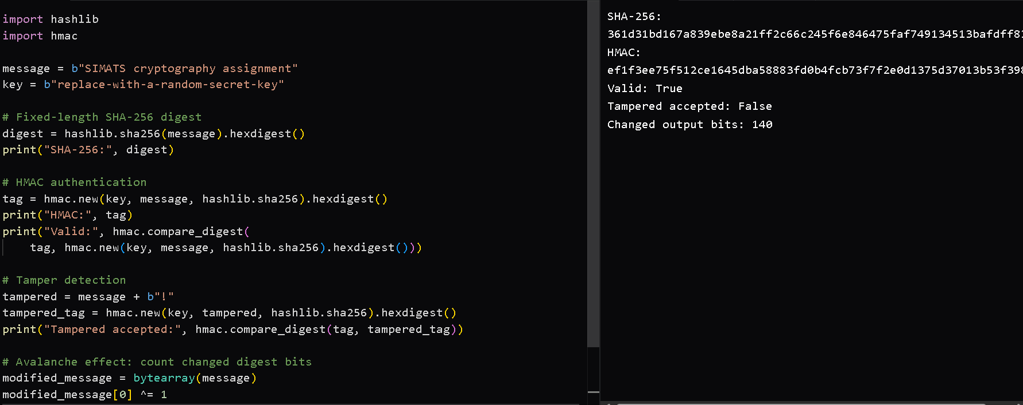

APPENDIX B – EXPERIMENTAL RECORD SHEETS
Record actual outputs after executing the supplied programs. Do not report illustrative values as measured observations.
Experiment | Input / parameter | Measured value | Observation
Avalanche | 16-byte messages; 100 trials | ________ | Compare with 128-bit ideal mean.
Avalanche | 128-byte messages; 100 trials | ________ | Compare with 128-bit ideal mean.
Avalanche | 1,024-byte messages; 100 trials | ________ | Compare with 128-bit ideal mean.
Birthday collision | k=16; 3 trials | ________ | Compare with ≈256 scale.
Birthday collision | k=20; 3 trials | ________ | Compare with ≈1,024 scale.
Birthday collision | k=24; 3 trials | ________ | Compare with ≈4,096 scale.
Birthday collision | k=28; 3 trials | ________ | Compare with ≈16,384 scale.
Birthday collision | k=32; 3 trials | ________ | Compare with ≈65,536 scale.

