SIMATS ENGINEERING
PROGRAMMING IN JAVA
ASSIGNMENT 2 – CO2
Strings, Collections Framework, hash Code–equals Contract, Generics, Comparable and Comparator
Item | Details
Student Name | Archana V
Register Number | 192521420
Course Code | CSA0905
Nature of Assignment | Individual (Total Marks: 50)
GitHub Repository | https://github.com/192521420simats-lab/CSA0905---JAVA
Submission Date | 15/11/26

Q1 – Building Text Under Load: String, StringBuilder or String Buffer?

1.1 Problem and aim
A railway e-ticket is built by joining many fields (PNR, names, coach, berth, fare, journey details). The existing code uses the + operator in a loop. I want to find out whether the choice between String, StringBuilder and String Buffer really matters or whether the difference is negligible.

1.2 Prediction before implementation
Reason (immutability and object creation). A String object can never be changed. The statement s = s + field therefore does not add to s; it allocates a brand-new String, copies all the old characters and then the new field into it, and leaves the old String as garbage. For a ticket with n fields, the i-th step copies about i x L characters (L = average field length), so the total copied is L x (1 + 2 + ... + n) = L x n(n+1)/2, which is O(n²), and n intermediate String objects are created. StringBuilder keeps one mutable character array that doubles when full, so every field is copied once (amortised O(1) per append) and only the final toString() creates a String. StringBuffer is the same class with every method synchronized, so on one thread I expect only a small extra cost for taking an uncontended lock.
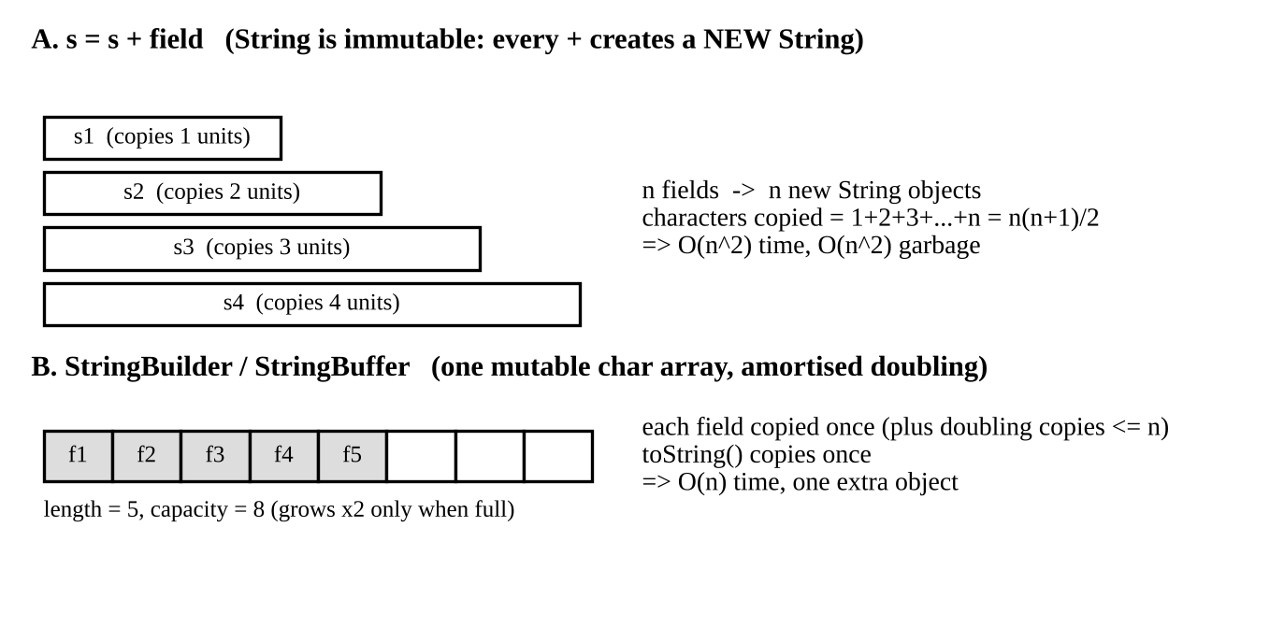
Figure 1: Why repeated + is quadratic while StringBuilder is linear
Workload | Prediction
Short ticket (few fields) | All three about the same; the difference is negligible because n is tiny.
Many tickets, 50 fields each | String + several times slower and allocates several times more memory; StringBuilder and String Buffer close to each other.
Very long ticket (2,000 fields) | String + dramatically slower (quadratic growth); StringBuilder and String Buffer still linear.

1.3 Design of the three workloads
Workload | Tickets | Fields per ticket | Purpose
W1 | 1 (repeated 1,000 times and divided) | 10 | Short ticket, should show no difference
W2 | 10,000 | 50 | Realistic busy booking counter (given in the assignment)
W3 (my own) | 200 | 2,000 | Group/bulk booking with a very long itinerary, to expose O(n²)

1.4 Implementation
The three approaches (the alternatives String.join, StringJoiner and String.format were implemented in the same program for the later analysis):
static String viaPlus(int n) { // String (immutable)
String s = "";
for (int i = 0; i < n; i++) s = s + fields[i] + "|";
return s;
}
static String viaBuilder(int n) { // StringBuilder (not synchronized)
StringBuilder sb = new StringBuilder();
for (int i = 0; i < n; i++) sb.append(fields[i]).append('|');
return sb.toString();
}
static String viaBuffer(int n) { // StringBuffer (synchronized)
StringBuffer sb = new StringBuffer();
for (int i = 0; i < n; i++) sb.append(fields[i]).append('|');
return sb.toString();
}

Measurement method: 20,000 warm-up calls, then 7 repeated runs per workload (10 for W1), System.gc() before each run, time with System.nanoTime(), allocated bytes with ThreadMXBean. The number of intermediate Strings is estimated from the code: one new String per loop step for +, and one (the final toString()) for the builders.

1.5 Measured results
W1 – one ticket, 10 fields (per ticket)
Approach | Time per ticket | Memory allocated | Intermediate Strings (est.)
String + | about 0.2 microseconds | about 1 KB | 10 (9 are garbage)
StringBuilder | about 0.1 microseconds | about 1 KB | 1
StringBuffer | about 0.2 microseconds | about 1 KB | 1
String.join / StringJoiner | 0.2 to 0.3 microseconds | below 1 KB | 1
String.format | about 2.2 microseconds | about 2 KB | 1 plus Formatter objects

W2 – 10,000 tickets x 50 fields
Approach | Total time (ms) | Memory allocated (MB) | Intermediate Strings (est.) | Time vs StringBuilder
String + | 21.36 | 186.5 | 500,000 (490,000 garbage) | 2.8 x slower
StringBuilder | 7.70 | 30.1 | 10,000 | 1.0 x
StringBuffer | 7.75 | 30.2 | 10,000 | 1.0 x
String.join | 5.03 | 18.2 | 10,000 | 0.65 x
StringJoiner | 4.53 | 12.2 | 10,000 | 0.59 x
String.format | 24.34 | 80.6 | 10,000 + Formatter objects | 3.2 x slower

W3 – 200 tickets x 2,000 fields
Approach | Total time (ms) | Memory allocated (MB) | Intermediate Strings (est.) | Time vs StringBuilder
String + | 395.11 | 5,796.4 | 400,000 (399,800 garbage) | 84 x slower
StringBuilder | 4.70 | 20.0 | 200 | 1.0 x
StringBuffer | 5.66 | 20.0 | 200 | 1.2 x
String.join | 3.64 | 14.9 | 200 | 0.8 x
StringJoiner | 4.37 | 9.0 | 200 | 0.9 x
String.format | 20.45 | 57.2 | 200 + Formatter objects | 4.4 x slower

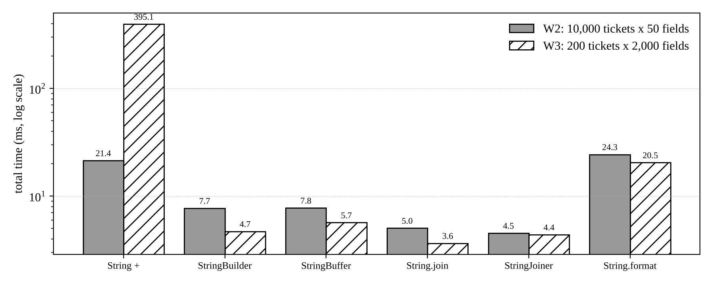
Figure 2: Total time for W2 and W3 (logarithmic scale)
To confirm the quadratic behaviour I also timed a single ticket with n from 100 to 5,000 fields:
n (fields) | String + time (ms) | StringBuilder time (ms) | String + memory (KB) | StringBuilder memory (KB)
100 | 0.0079 | 0.0017 | 72 | 6
400 | 0.0699 | 0.0049 | 1,154 | 24
1,600 | 1.2640 | 0.0218 | 18,840 | 96
3,200 | 6.4251 | 0.0295 | 77,190 | 193
5,000 | 17.3957 | 0.0488 | 190,646 | 365

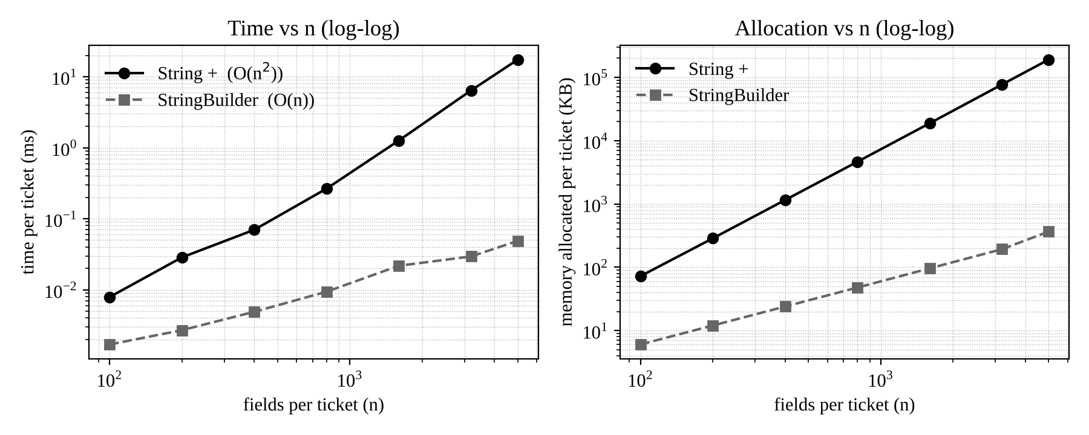
Figure 3: Time and memory per ticket against number of fields (log-log): the String + line has slope about 2, StringBuilder about 1
Reading the table: when n doubles from 1,600 to 3,200, the memory used by String + grows about 4.1 times (18,840 KB to 77,190 KB), which is the signature of O(n²); the StringBuilder memory grows only 2 times (96 KB to 193 KB), which is O(n).

1.6 Prediction compared with observation
Prediction | Observed | Verdict
W1: no real difference | All within 0.1 to 0.3 microseconds; String.format was about 10 x slower but still only 2 microseconds. | Correct (format cost was a small surprise: it parses the format string every call)
W2: + several times slower, more memory | 2.8 x slower and 6.2 x more memory than StringBuilder. | Correct
W3: dramatic slowdown | 84 x slower and 290 x more memory. Check by arithmetic: L = 15.7 bytes, n = 2,000: L x n(n+1)/2 = 31.4 MB per ticket, x 200 tickets = about 6,000 MB. Measured 5,796 MB (within 5 percent). | Correct, and the memory figure matches the O(n²) formula
StringBuffer slightly slower than StringBuilder | Equal in W2 (7.75 vs 7.70 ms), 20 percent slower in W3 (5.66 vs 4.70 ms). | Mostly correct; uncontended locking is almost free on modern JVMs

1.7 Design decision for the multithreaded booking server
Per-ticket text: StringBuilder. The builder is created inside the method, used by one thread and converted to a String before it leaves the method (it is thread-confined). Synchronisation would be pure overhead, so StringBuilder is correct and fastest.
Shared booking log: a thread-safe class is required. To check what happens if the shared log uses StringBuilder, I started 8 threads, each appending 400,000 times to one shared object, and repeated this 5 times. Expected final length 3,200,000.
RUN 1 expected=3200000 StringBuilder=3200000 StringBuffer=3200000
RUN 2 expected=3200000 StringBuilder=2894476 StringBuffer=3200000
(one thread also died with ArrayIndexOutOfBoundsException inside StringBuilder.append)
RUN 3 expected=3200000 StringBuilder=3200000 StringBuffer=3200000
RUN 4 expected=3200000 StringBuilder=3200000 StringBuffer=3200000
RUN 5 expected=3200000 StringBuilder=3200000 StringBuffer=3200000

In run 2 the shared StringBuilder lost 305,524 characters and one thread crashed, while StringBuffer was exact in all runs. A data race is non-deterministic (4 of 5 runs looked fine), which is exactly why it is dangerous: testing once proves nothing. My recommendation is therefore: StringBuilder for each ticket, StringBuffer for the shared log. One more refinement: StringBuffer makes each single call atomic, but a log entry made of several appends (time, PNR, message) can still be interleaved between threads. The better practice is to build the complete log line in a local StringBuilder and then add it to the shared log with one call (or put it in a ConcurrentLinkedQueue or a logging framework).

1.8 Alternative concept and complexity analysis
If String.join(), StringJoiner or String.format() were used instead of StringBuilder:
String t1 = String.join("|", fieldArray) + "|"; // one pass: total length computed first
StringJoiner j = new StringJoiner("|", "", "|"); // collects pieces, joins once
for (String f : fieldArray) j.add(f); String t2 = j.toString();
String t3 = String.format("%s|%s|%s|...", (Object[]) fieldArray); // parses a format string

Method | Time for n fields (L = field length) | Extra space | Remarks
Repeated + | O(n² x L): L(1+2+...+n) characters copied | O(n² x L) garbage in total; only 2 strings alive at a time, so peak is O(n x L) | n new String objects; GC pressure
StringBuilder | O(n x L): each field copied once, doubling copies add at most 2 x total | Array up to 2 x final length, plus one final String | Best general-purpose choice
String.join | O(n x L): total length computed first, single copy | Exact size, no doubling waste | Fastest when all fields are already in an array/list
StringJoiner | O(n x L) | Holds the pieces, then one result | Handy for delimiter, prefix, suffix
String.format | O(n x L) but with a large constant | Formatter and many temporary objects | Readable but slowest (3 to 4 x in my test)

Q2 – When Is Array List an Appropriate Engineering Choice? (4 Marks)

2.1 Experiment design
I compared Array List and LinkedList for the five playlist operations, each on lists of 10,000, 100,000 and 500,000 songs (Integer elements stand in for songs). Each figure is the average of 5 runs on a freshly built list. The number of operations was fixed so that the result shows growth with size:
Operation | Experiment
Add at end | 20,000 calls of add(e)
Insert / remove at front | 2,000 calls of add(0, e) and remove(0)
Insert / remove in middle | 2,000 calls of add(size/2, e) and remove(size/2)
Access k-th element | 2,000 calls of get(random index)
Iterate whole list | one for-each pass over all elements

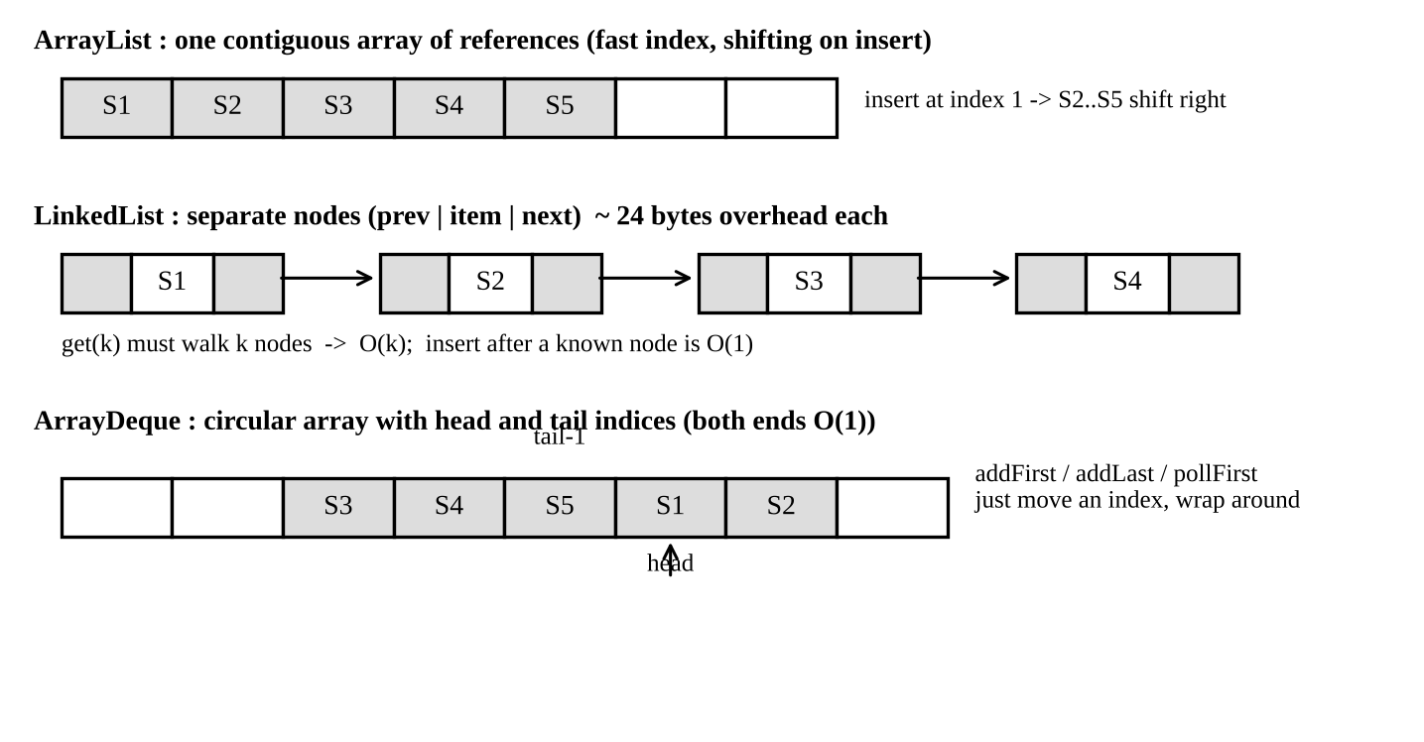
Figure 4: Memory layout of Array List, LinkedList and Array Deque
Prediction. Array List stores references in a contiguous array: get(k) is O(1), insertion or removal at index i moves (size - i) elements, so front and middle edits are O(n), appending is amortised O(1). LinkedList edits a known node in O(1) but must walk to the index first, so get(k) and middle insertion are O(n), and every element costs an extra node object.

2.2 Results (time in ms)
Operation | Size | ArrayList | LinkedList | Faster
Add at end (20,000) | 10,000 | 1.314 | 1.193 | similar
 | 100,000 | 2.090 | 0.425 | LinkedList
 | 500,000 | 8.294 | 0.200 | LinkedList (ArrayList pays for array resizing)
Insert at front (2,000) | 10,000 | 1.706 | 1.548 | similar
 | 100,000 | 16.084 | 0.077 | LinkedList (200 x)
 | 500,000 | 104.087 | 0.068 | LinkedList (1,500 x)
Remove at front (2,000) | 100,000 | 16.170 | 0.053 | LinkedList
 | 500,000 | 96.806 | 0.097 | LinkedList
Insert in middle (2,000) | 10,000 | 0.378 | 22.201 | ArrayList (59 x)
 | 100,000 | 8.165 | 281.198 | ArrayList (34 x)
 | 500,000 | 39.166 | 1751.885 | ArrayList (45 x)
Remove from middle (2,000) | 100,000 | 7.056 | 201.903 | ArrayList (29 x)
 | 500,000 | 39.601 | 2070.079 | ArrayList (52 x)
Get k-th (2,000) | 10,000 | 0.543 | 8.937 | ArrayList
 | 100,000 | 0.209 | 122.290 | ArrayList (585 x)
 | 500,000 | 0.415 | 1281.971 | ArrayList (3,000 x)
Iterate whole list | 100,000 | 2.343 | 0.763 | similar (both O(n))
 | 500,000 | 2.762 | 4.892 | ArrayList (cache friendly)

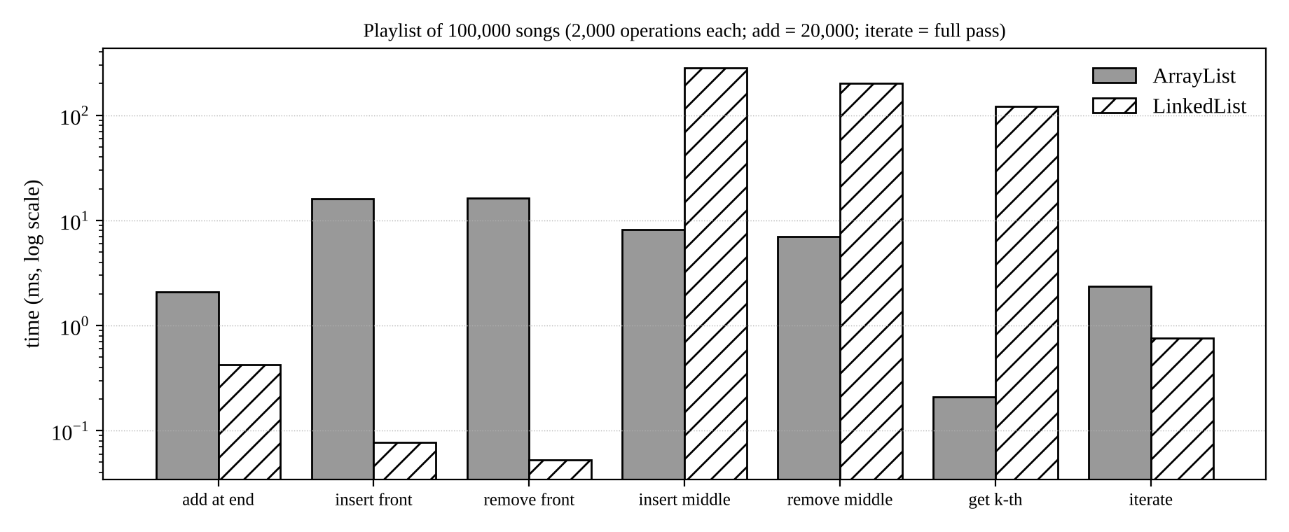
Figure 5: ArrayList against LinkedList at 100,000 songs (logarithmic time axis)
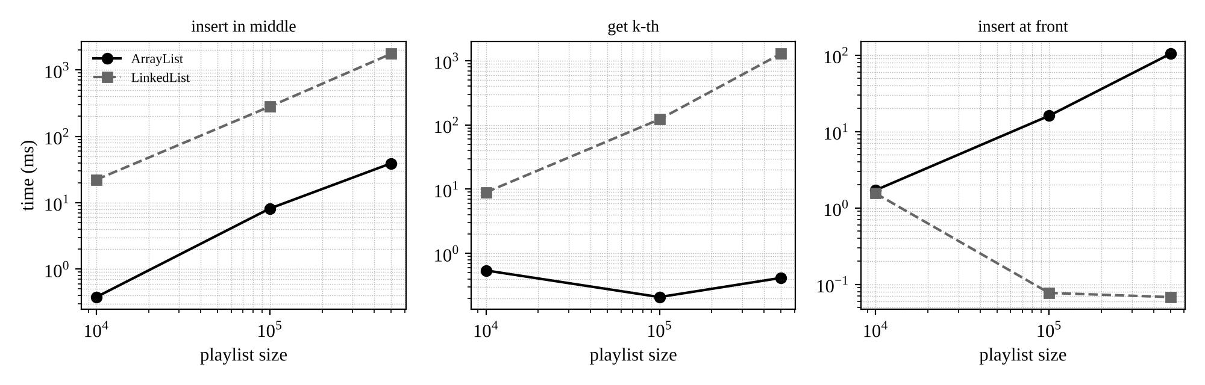
Figure 6: Growth with playlist size for three operations (log-log)
Observations. (1) The front-insertion cost of ArrayList grows in proportion to the size (16 ms to 104 ms, about 6.5 times, when the size grows 5 times), which confirms that it is at least linear, O(n). (2) LinkedList is faster at the ends but is 30 to 50 times slower for middle insertion, because the O(1) pointer change comes after an O(n) walk of cache-unfriendly nodes. (3) get(k) on LinkedList becomes unusable (1.3 seconds for 2,000 reads at 500,000 songs). (4) Very small values (below 1 ms) such as the 10,000-size rows are affected by JIT warm-up, so I use the 100,000 and 500,000 rows for conclusions.

2.3 Answer: when is ArrayList reasonable, and when would I stop recommending it?
- Reasonable: the playlist is read far more often than it is edited, songs are mostly appended, the user jumps to the k-th song (O(1) for ArrayList), and the playlist is of normal size. At 10,000 songs a front insertion costs about 0.85 microseconds and a middle insertion about 0.19 microseconds, which no user can notice. Real playlists seldom exceed a few thousand songs.
- Stop recommending: when the list is very large (about 100,000 songs or more) and front or middle insertions and removals are frequent. At 100,000 songs a front insertion costs 8 microseconds, at 500,000 songs 52 microseconds, and the cost keeps rising linearly. The boundary from my data is therefore roughly (list size x edits per second) becoming large, for example 100,000 songs with thousands of front edits per second.
- LinkedList is not the cure for middle edits (it was 30 to 50 times worse) and destroys get(k). It only wins for repeated end/front operations or when edits are done through an iterator that is already positioned.

2.4 Changed condition: the "Up Next" queue
Now songs are added at both ends and removed from the front. Index access is not needed, which removes the main reason for ArrayList. I ran 20,000 mixed operations (one third each addFirst, addLast, pollFirst) on a queue that already held n songs:
Initial size n | ArrayList (ms) | LinkedList (ms) | ArrayDeque (ms)
10,000 | 12.18 | 3.78 | 2.97
100,000 | 138.34 | 2.14 | 10.14
500,000 | 665.45 | 53.40 | 20.35

ArrayList is clearly wrong here (O(n) shifting for every front operation: 665 ms). LinkedList and ArrayDeque are both O(1) at both ends, and their differences are within the run-to-run noise of garbage collection at these sizes. I therefore recommend ArrayDeque for Up Next: it is a circular array, so there is no node object per song (less memory and garbage), it is cache friendly, and it was fastest at the largest size. The main playlist stays an ArrayList.

2.5 Alternative concept and complexity analysis
Operation | ArrayList | LinkedList | ArrayDeque
Add at end | O(1) amortised | O(1) | O(1) amortised
Insert at front | O(n) | O(1) | O(1) amortised
Insert in middle | O(n) (shift) | O(n) (walk) + O(1) link | not supported
Get k-th | O(1) | O(n) | not supported
Iterate | O(n), fastest in practice | O(n) | O(n)
Space per element | one 4-byte slot (compressed references), 4 to 6 bytes with spare capacity | one node: about 24 bytes (header + prev + next + item); I measured about 20 bytes per element in addition to the song object | one slot, 4 to 8 bytes (array up to 2 x size)

Plain array with manual shifting. The solution would be to keep an array and an int size, and to write the shifting loop myself:
int[] a = new int[capacity]; int size = 0;
void insert(int pos, int value) {
if (size == a.length) a = Arrays.copyOf(a, size * 2); // manual growth
for (int j = size; j > pos; j--) a[j] = a[j - 1]; // manual shifting, O(n)
a[pos] = value; size++;
}

The complexity is the same as ArrayList (insert O(n), get O(1), add at end amortised O(1)) but the constant is worse: 2,000 middle insertions took 2.88 ms, 31.95 ms and 139.65 ms for the three sizes, against 0.38, 8.17 and 39.17 ms for ArrayList, which uses the native System.arraycopy. In addition, the programmer must handle growth, bounds and generics. A plain array is useful only for a fixed-size list of primitives; in all other cases ArrayList is the better engineering choice.

Q3 – Engineer the hashCode–equals Contract (6 Marks)

3.1 The three designed tests, with prediction before execution
Test | Scans | Predicted size and reason
T1 (looks correct) | Three different students: 192311001, 192311002, 192311003 | 3. All students are different, so no duplicate exists; the missing hashCode() cannot cause an error.
T2 (exposes duplicates) | 192311001 scanned twice (two objects) and 192311002 once, class without hashCode() | 2 is what we want, but I predict 3. Without hashCode() the inherited identity hash is used, so the two equal objects get different hash codes, go to different buckets, and equals() is never asked.
T3 (my own: key changed after insertion) | One object added, then its regNo is changed, then contains() is called | contains() will return false although the object is in the set, and adding it again will make size 2, because the hash code changed and the object is searched for in the wrong bucket.
T4 (my own: TreeSet with a comparator inconsistent with equals) | 3 different students, comparator looks only at the length of the text | 2. TreeSet uses compare() == 0 as equality, not equals(), so two different students count as the same.

3.2 Observed results
=== Test 1: all scans are DIFFERENT students ===
Predicted 3, observed 3
=== Test 2: same student scanned at 2 gates (no hashCode) ===
a.equals(b) = true
a.hashCode() = 658909832, b.hashCode() = 1704237553
Predicted 2 (wanted), observed 3
contains(new BadStudent(192311002)) = false <- even a plain lookup fails
=== Test 2b: same scans after TODO 1 ===
Unique students: 2
=== Test 3: key changed after insertion ===
before change: contains = true, size = 1
after change : contains(m) = false, size = 1, iterating still finds it: true
add(m) again -> size = 2 (same object stored twice)
=== Test 4: TreeSet, inconsistent comparator ===
3 different students but comparator looks only at text length: size = 2

Test | Predicted | Observed | Match
T1 | 3 | 3 | Yes
T2 | 3 | 3 (wanted 2) | Yes
T3 | contains false, size 2 after re-add | contains false, size 2 after re-add | Yes
T4 | 2 | 2 | Yes

3.3 Inquiry
Why the duplicates appear
The contract says: if a.equals(b) is true then a.hashCode() == b.hashCode(). The junior developer overrode equals() (same regNo means same student) but not hashCode(), so Object.hashCode() (based on identity) is used. Two objects with the same regNo are equal but have different hash codes (658909832 and 1704237553 in my run). HashSet looks only in the bucket of the new hash code, never meets the earlier object, and never calls equals(). Test 1 worked only because there were no duplicates to find, so "appears to work" proves nothing.
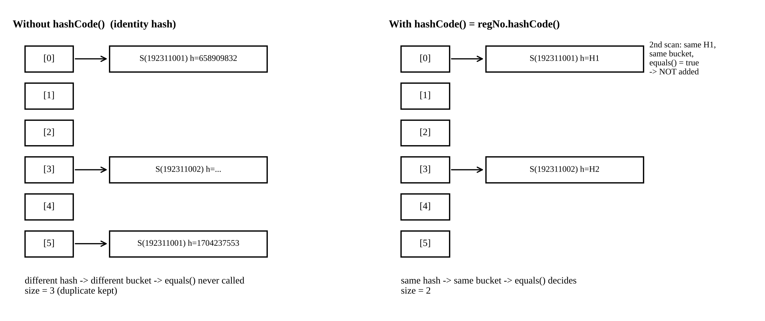
Figure 7: How HashSet places the same student twice without hashCode(), and once with it
How HashSet uses hashCode() and equals() to locate an element
- Step 1: call hashCode() and spread the bits (h XOR h >>> 16). Step 2: bucket index = (table length - 1) AND hash. Step 3: in that bucket, compare the stored full hash first and, only if it is equal, call == or equals(). Step 4: if one matches the element is a duplicate; otherwise it is added to the bucket (a linked list, converted to a tree when a bucket has 8 or more entries).
- So hashCode() chooses where to look and equals() decides whether what was found is the same element. Both must agree on what "same" means.
What happens when a field used in hashCode() is changed after insertion
The object stays in the bucket calculated from the old hash code. After the change, contains() calculates a new hash, looks in a different bucket and answers false (Test 3), remove() fails to remove it, and add() inserts a second copy. The element can only be seen by iteration. The rule is: never change fields used in equals() and hashCode() while the object is in a hash-based collection; make those fields private final.
How to correct the Student class and how to verify the correction
class Student {
private final String regNo; // final: cannot change after insertion
private final String name;
Student(String regNo, String name) { this.regNo = regNo; this.name = name; }
@Override public boolean equals(Object o) {
if (this == o) return true;
if (!(o instanceof Student)) return false;
return regNo.equals(((Student) o).regNo);
}
@Override public int hashCode() { return regNo.hashCode(); } // same field as equals()
@Override public String toString() { return regNo + " " + name; }
}

Verification: (1) a test that equal objects give equal hash codes; (2) a HashSet test with duplicates must show size 2 (Test 2b gave 2); (3) contains() on a new equal object must return true; (4) because regNo is final, Test 3 is no longer possible. The hashCode uses exactly the fields used by equals() (only regNo), so the name is deliberately left out.

3.4 Complete the Code (TODO 1)
The given Attendance program was first run without TODO 1 and then after adding the hashCode() method. Only the TODO line was replaced.
BEFORE TODO 1: Unique students: 3
AFTER TODO 1: Unique students: 2 (matches the expected output)

Explanation of the difference: before TODO 1 the two scans of Arun were equal but had different identity hash codes, so both were stored (3). After TODO 1 both have the hash code of the String "192311001", land in the same bucket, and equals() recognises the duplicate (2). Note that the output before TODO 1 is 3 only because two different objects almost never get the same 32-bit identity hash, so the failure is almost certain but not guaranteed by the language.

3.5 Alternative concept and complexity analysis
// (a) HashMap keyed by regNo - does not depend on Student.equals/hashCode
Map<String, Student> byReg = new HashMap<>();
byReg.putIfAbsent(s.regNo(), s); // keeps the first scan, ignores repeats

// (b) TreeSet with a Comparator on regNo - does not need hashCode at all
Set<Student> t = new TreeSet<>(Comparator.comparing(Student::regNo));
t.add(s); // duplicate = compare() returns 0

Structure | Time per scan | Space for n unique students | Remarks
HashSet<Student> | O(1) average, O(n) worst (O(log n) with treeified buckets) | about 32 bytes per entry (HashMap.Node) plus table slot, O(n) | Needs a correct hashCode()
HashMap<String, Student> | O(1) average | same as above plus the key reference (already inside Student) | Uses String's well-tested hashCode; also allows lookup by regNo
TreeSet<Student> with comparator | O(log n) (log2 of 50,000 is about 16 comparisons) | about 40 bytes per entry (key, left, right, parent, colour), O(n) | Sorted output; consistent comparator needed

Measured: 200,000 scans from about 50,000 distinct students (average of 10 runs): HashSet 18.5 ms, HashMap 19.1 ms, TreeSet 285.6 ms (49,094 distinct found in the test data). The TreeSet figure is exaggerated because my comparator used toString(), which creates a new String on each of the 16 comparisons; a comparator on regNo directly would be faster, but it would still need O(log n) comparisons against O(1) hashing.
Conclusion for Q3: hash-based collections are only as correct as the equals()/hashCode() pair; the safest design uses an immutable key (regNo) either inside a Student that implements both methods consistently or directly as the HashMap key.

Q4 – Choosing a Map for a Pharmacy Inventory (6 Marks)

4.1 Design reasoning before implementation
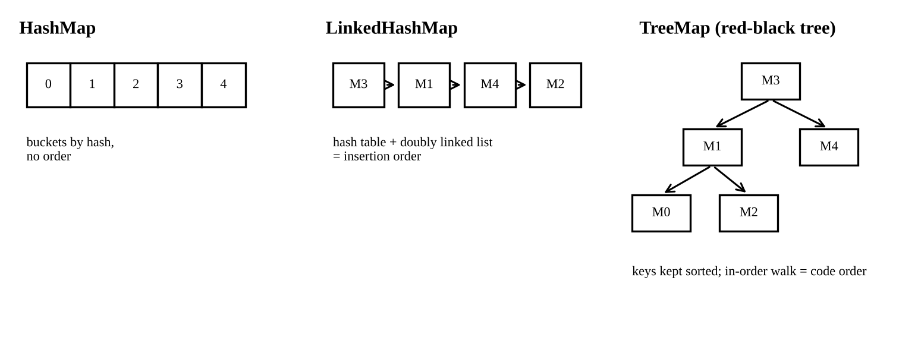
Figure 8: Internal structure of the three maps
Map | put | get | Iteration | Order produced | Naturally gives report
HashMap | O(1) average | O(1) average | O(n + capacity) | none (by hash) | Neither
TreeMap | O(log n) | O(log n) | O(n) | sorted by key | Code-order report
LinkedHashMap | O(1) average | O(1) average | O(n) | insertion order | Order-added report

Extra work if the "wrong" map is chosen. With HashMap or LinkedHashMap the code-order report needs a copy of the keys and a sort every evening: O(n log n) time and O(n) extra space. With HashMap or TreeMap the order-added report is impossible, because the order of insertion is not stored; a separate list of codes would have to be kept in step with every put (O(n) space, and the risk that the two structures disagree).

4.2 Implementation and test design
Medicine objects (code, name, stock) were inserted in a shuffled order so that insertion order is different from code order. The three maps and a fourth candidate (sorted array with binarySearch, used in 4.5) were tested with 1,000, 10,000, 100,000 and 500,000 medicines. For each size I recorded the time to insert all medicines, the time for 100,000 random lookups, the time to produce each report, and whether the output order was right. Each value is an average of 7 runs after warm-up.
Map<String, Medicine> m = new LinkedHashMap<>(); // or HashMap / TreeMap
for (Medicine x : stock) m.put(x.code, x); // build
for (String c : queries) total += m.get(c).stock; // 100,000 lookups
List<String> codeOrder = new ArrayList<>(m.keySet()); // report 1 (code order)
Collections.sort(codeOrder); // extra work unless TreeMap
List<String> addedOrder = new ArrayList<>(m.keySet()); // report 2 (only correct for LinkedHashMap)

4.3 Measured results (time in ms)
Medicines | Map | Build (put all) | 100,000 lookups | Code-order report | Order-added report
1,000 | HashMap | 0.07 | 1.62 | 0.17 (copy + sort) | not possible
 | TreeMap | 0.20 | 14.05 | 0.04 (already sorted) | not possible
 | LinkedHashMap | 0.06 | 1.72 | 0.22 (copy + sort) | 0.008 (already in order)
10,000 | HashMap | 1.32 | 5.01 | 1.71 (copy + sort) | not possible
 | TreeMap | 4.88 | 36.03 | 0.32 | not possible
 | LinkedHashMap | 1.20 | 3.80 | 3.41 (copy + sort) | 0.17
100,000 | HashMap | 17.65 | 8.11 | 29.2 (copy + sort) | not possible
 | TreeMap | 116.80 | 113.31 | 11.4 | not possible
 | LinkedHashMap | 95.62 | 7.27 | 64.0 (copy + sort) | 7.4
500,000 | HashMap | 321.86 | 19.22 | 230.0 (copy + sort) | not possible
 | TreeMap | 996.01 | 175.76 | 144.5 | not possible
 | LinkedHashMap | 384.96 | 14.84 | 433.3 (copy + sort) | 46.1

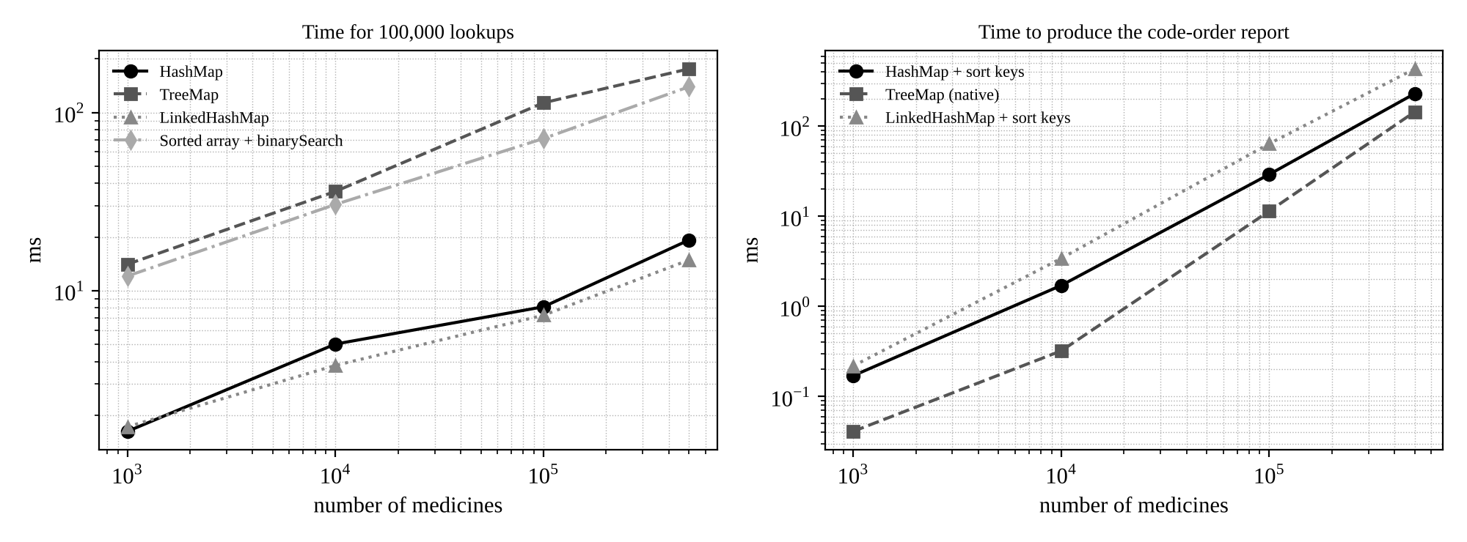
Figure 9: Lookup time and code-order report time against number of medicines (log-log)
Order check: the TreeMap output was in code order for every size; the LinkedHashMap output matched the order of arrival; the HashMap output matched neither without extra work. Per lookup at 500,000 medicines: HashMap 0.19 microseconds, LinkedHashMap 0.15 microseconds, TreeMap 1.76 microseconds.

4.4 Scalability inquiry
Acceptable response time. A pharmacist sees a screen as instant if the whole action takes below about 100 ms. I allow the stock lookup at most 1 percent of that, so one lookup should take at most 1 ms, and as an internal target at most 10 microseconds so that hundreds of lookups per hour never matter. All three maps satisfy this at every size I tested (the worst, TreeMap with 500,000 medicines, needs 1.76 microseconds).
Map I would deploy: LinkedHashMap. Its lookup is as fast as HashMap (O(1)), the order-added report comes for free, and the code-order report costs one sort in the evening (about 64 ms for 100,000 medicines), which is run once a day and is therefore insignificant. If the code-order report had to be produced often (for example live on screen), TreeMap would be better, because it needs 11 ms against 64 ms at 100,000 items, at the price of about 15 x slower lookups at that size.
Where the remaining cost comes from. For the hash maps the remaining cost is not the algorithm but memory: computing String.hashCode() (cached after the first call), then one cache miss to read the table slot and another to read the Node and key for equals(). This is why the cost per lookup rises slowly from 0.016 to 0.19 microseconds as the table outgrows the CPU cache. For TreeMap it is about log2(n) = 19 String comparisons, each following a pointer to a different memory location. For the build phase most time goes to creating Medicine and Node objects and to rehashing when the table grows.
Why Hashtable is not preferred in new code. Hashtable is a legacy class from Java 1.0: every method is synchronized on one lock, so threads block each other even for reads, it forbids null keys and values, its iteration order is unspecified and its iterators are not designed like the modern Map views. For single-threaded use HashMap is faster; for multithreaded use ConcurrentHashMap (fine-grained locking, no lock for reads) or Collections.synchronizedMap are the recommended replacements.

4.5 Alternative concept and complexity analysis
The inventory could be kept in two parallel arrays (String[] codes sorted, Medicine[] items) and searched with Arrays.binarySearch(codes, code); the index found is used to read items[index].
Operation | Sorted array + binarySearch | HashMap | TreeMap
Lookup | O(log n); measured 139 ms for 100,000 lookups at 500,000 items | O(1) average; 19 ms | O(log n); 176 ms
Insertion of one medicine | O(n): binary search to find the place, then shift the tail with System.arraycopy; measured about 20 to 27 microseconds per insertion at 100,000 to 500,000 items | O(1) average | O(log n)
Code-order report | O(n): the array is already in order (no sort) | O(n log n) sort | O(n)
Order-added report | not available | not available | not available
Space | about 8 bytes per medicine (two reference slots), the most compact | about 32 bytes node + table slot | about 40 bytes per entry
Building from scratch | O(n log n) (sort once) | O(n) | O(n log n)

The sorted array is the most memory-efficient and gives the code-order report without any sorting, so it is a good choice for a stock list that is loaded once and changes rarely. Because the pharmacy adds and removes medicines during the day, the O(n) insertion makes it less suitable than a map. Conclusion for Q4: LinkedHashMap, with a daily sort for the code-order report.

Q5 – Derive a Generic Ranking Component from a Principle (7 Marks)

5.1 Design derived from the principle
The principle: a comparison is correct only if it is consistent, meaning transitive (A above B and B above C imply A above C) and equal items compare as equal. In Java this is the contract of compare(): sgn(compare(a,b)) = -sgn(compare(b,a)), transitivity, and compare(a,b) == 0 implies the same sign against every other element. Everything below is chosen to make this contract easy to satisfy.
Comparable or Comparator?
A class can have only one compareTo(), i.e. one "natural" order, and it is then fixed inside Team. A team has several legitimate orders (league table, alphabetical list, by goal difference), and the same component must also rank players, colleges and quiz teams with different rules. I therefore chose separate Comparator objects: Team stays a plain data class, each ranking rule is a small independent object, and rules can be changed or combined without touching Team. Comparable is appropriate only if one order is clearly the single natural order of the type.
Multi-field comparison
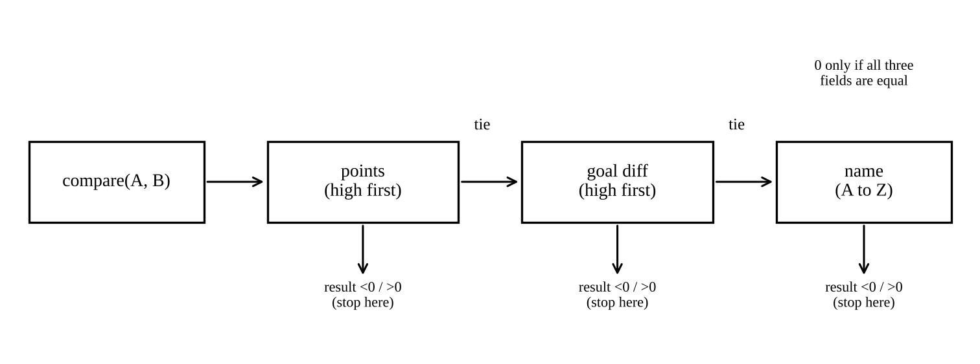
Figure 10: The comparator chain: the next field is examined only when the earlier one is tied
Comparator.comparingInt(points).reversed() gives high points first; thenComparing(...) is used only when the result is 0; the second key is again reversed (high goal difference first); the last key is the name in natural A to Z order. Because the last key (name) is unique, two different teams never compare as equal, so the ranking is fully deterministic.
Generic class and bounded types
Leaderboard<T> takes a Comparator<? super T>. The wildcard "? super T" (consumer super) means a comparator for T or for any parent of T can be used, for example a Comparator<Object> or a Comparator<Person> for ranking Teams or Players. No bound on T is needed because the ordering is supplied from outside. If a board should rank only self-comparable types, a bounded type can be used instead: class NaturalBoard<T extends Comparable<? super T>>, which accepts any T that can compare itself (for example the Comparable version of Team below). A bound is useful there, since the compiler then rejects types that cannot be ranked.
Where is List<? extends T> useful?
In addAll(List<? extends T> more) (producer extends). A Leaderboard<Team> can then accept a List<Team> or a List<ChampionTeam> where ChampionTeam extends Team. Without the wildcard, List<ChampionTeam> would not be accepted, because generics are invariant. The wildcard is read-only, which is exactly what addAll needs.

5.2 Complete the Code (TODO 1 and TODO 2)
class Leaderboard<T> {
private final List<T> items = new ArrayList<>();
private final Comparator<? super T> order;
Leaderboard(Comparator<? super T> order) { this.order = order; }
void add(T item) { items.add(item); }
void addAll(List<? extends T> more) { items.addAll(more); } // wildcard use
List<T> ranking() {
List<T> copy = new ArrayList<>(items); // TODO 1: new copy, items is not modified
copy.sort(order);
return copy;
}
}

// TODO 2 (inside main):
Comparator<Team> byRank = Comparator.comparingInt((Team t) -> t.points).reversed()
.thenComparing(Comparator.comparingInt((Team t) -> t.goalDiff).reversed())
.thenComparing(t -> t.name);

[Eagles(9,6), Bisons(9,4), Panthers(9,4), Cobras(6,1)] (matches the expected output)

Why is Bisons above Panthers? Both have 9 points and a goal difference of 4, so the first two keys are tied (compare returns 0 each time). The third key decides: "Bisons" comes before "Panthers" alphabetically, because B comes before P.
Note on the thenComparing call for goal difference: writing .thenComparing(...).reversed() at the end would reverse the whole chain including points; the reversal is therefore applied to the individual key, using a typed lambda (Team t) so that the compiler can infer the type.

5.3 Testing the design
Data set 1 (several ties at each level): 9 teams with ties on points (7, 5 and 9 points), on points and goal difference, and on all but name.
Data set 1 : [Hotel(9,0), India(9,0), Bravo(7,5), Alpha(7,3), Charlie(7,3), Delta(7,3),
Echo(5,5), Foxtrot(5,5), Golf(5,2)]
After addAll (Lions(9,6) and Wolves(3,-2) added through List<? extends T>):
[Eagles(9,6), Lions(9,6), Bisons(9,4), Panthers(9,4), Cobras(6,1), Wolves(3,-2)]

Check by hand: the 9-point teams come first; among the 7-point teams Bravo (+5) comes before the +3 teams, which are then alphabetical (Alpha, Charlie, Delta); Echo and Foxtrot are tied on 5 points and +5, so the name decides; Golf has +2. The output agrees with the hand ranking.
Data set 2 (designed to break faulty comparators). Three faulty comparators were tried:
Comparator<Team> subtract = (x, y) -> y.points - x.points; // faulty 1: subtraction
Comparator<Team> noTie = Comparator.comparingInt((Team t) -> t.points).reversed();
// faulty 2: no tie-breakers
Comparator<Team> fuzzy = (x, y) -> Math.abs(x.points - y.points) <= 2 ? 0
: Integer.compare(y.points, x.points); // faulty 3: close = equal

Teams with points 2147483642, -2000000000, 1500000000, -1500000000
Correct comparator : [A(2147483642), C(1500000000), D(-1500000000), B(-2000000000)]
Subtraction comparator: [D(-1500000000), B(-2000000000), A(2147483642), C(1500000000)] WRONG
compare(A,B) = 147483654 (A has more points, so it must be negative)

Ignoring tie-breakers, input order Zed,Amy,Max: [Zed(9,1), Amy(9,4), Max(9,4)]
Ignoring tie-breakers, input order Max,Amy,Zed: [Max(9,4), Amy(9,4), Zed(9,1)]
Correct comparator, both inputs : [Amy(9,4), Max(9,4), Zed(9,1)] (same both times)

Fuzzy: P~Q = 0, Q~R = 0, but P vs R = 1 -> equality is not transitive
Fuzzy sort on 5,000 teams threw: Comparison method violates its general contract!

- Subtraction: y.points - x.points overflows when the difference exceeds 2,147,483,647 (here 2,147,483,642 - (-2,000,000,000) wraps to a number of the wrong sign), so a team with more points is ranked below one with fewer. It works on small test data and silently fails on large values. Integer.compare avoids this.
- Ignoring a tie-breaker: teams that tie are left in input order, since the sort is stable, so the published ranking depends on the order in which results were entered. The result is not wrong in the points, but it is not a function of the data.
- "Close means equal": P equals Q and Q equals R, but P differs from R, so equality is not transitive and the sort may crash or give an arbitrary order. TimSort detected the violation and threw an exception.

5.4 Correctness inquiry: why my comparator satisfies the principle
Let each team be mapped to the key triple k(t) = (-points, -goalDiff, name). My comparator is exactly the lexicographic comparison of these triples, where every component is compared by a consistent total order (Integer.compare is a total order on ints; String.compareTo is a total order on strings; negation reverses a total order but keeps it total).
- Antisymmetry: if compare(A,B) < 0, the first component in which A and B differ makes A smaller; looking from B, the same component makes B larger, so compare(B,A) > 0.
- Transitivity: suppose A < B and B < C. Let i be the first component where A and B differ and j the first where B and C differ. Take m = min(i, j). For all components before m the three values are equal. At component m: if i < j then A_m < B_m = C_m; if j < i then A_m = B_m < C_m; if i = j then A_m < B_m < C_m, and < on a single component is transitive. In every case the first component where A and C differ is m, and A_m < C_m, hence A < C.
- Equal items compare as equal: compare(A,B) = 0 only if all three components are equal, and equal keys then give the same result against every other team (the comparison depends on the key only), so equality is transitive too (an equivalence relation).
- No overflow, no state: only Integer.compare and String.compareTo are used, so there is no subtraction overflow, and the comparator reads only final fields, so its answer never changes while sorting.
This reasoning holds for any data, which is why it is stronger than "the output looked right" for the test data.

5.5 Alternative concept and complexity analysis
// (a) Comparable inside the class: one fixed natural order
class RankedTeam implements Comparable<RankedTeam> {
public int compareTo(RankedTeam o) {
int c = Integer.compare(o.points, points);
if (c != 0) return c;
c = Integer.compare(o.goalDiff, goalDiff);
return c != 0 ? c : name.compareTo(o.name);
}
}
Collections.sort(list);

// (b) Three stable sorts: least important key first, most important key last
list.sort(Comparator.comparing((Team t) -> t.name));
list.sort(Comparator.comparingInt((Team t) -> t.goalDiff).reversed());
list.sort(Comparator.comparingInt((Team t) -> t.points).reversed());

Approach | Number of sorts | Time | Extra space | Measured, 200,000 teams (ms) | Reuse for players/colleges
Comparator chain | 1 | O(n log n) | O(n) merge buffer of TimSort; comparator objects O(1) | 157.5 | Easiest: write a new comparator, class untouched
Comparable | 1 | O(n log n) | O(n) | 160.1 | Harder: each class has one order, rule is inside the class
Three stable sorts | 3 | 3 x O(n log n), still O(n log n) but about 3 x the constant | O(n) buffer allocated three times | 238.3 | Easy to get wrong: order of the sorts must be exactly reversed; relies on stability

The three-sort version gave exactly the same order as the comparator chain in my test, but cost about 1.5 times as much (not the full 3 times, because the later sorts see data that has many equal keys, which TimSort handles quickly). The Comparator chain is the best for reuse because the sorting rule is data (an object) that can be passed to a generic Leaderboard<T>, stored, reversed and combined, whereas the other two embed the rule in code or in the class.

Q6 – Priority, Order and Fairness in a Queue (8 Marks)

6.1 Design
- Why a plain Queue is not enough: a Queue (LinkedList or ArrayDeque) serves patients strictly in order of arrival (FIFO). A critical patient (severity 1) who arrives behind twenty minor cases would wait for all of them, which violates the rule "most severe first".
- PriorityQueue with a Comparator: PriorityQueue is a binary min-heap; poll() always returns the smallest element according to the comparator. The comparator compares severity first (1 is smallest and so served first).
- Preserving arrival order among equal severities: PriorityQueue is not stable, so for equal keys it may return elements in any order. I therefore give every patient a unique, increasing arrival number from a counter and use it as the second key. Two patients are never fully tied, and for equal severity the smaller arrival number (earlier arrival) is served first.
- Removing and displaying: next() calls poll() (remove the head in O(log n)); to display the waiting list I copy the queue into a new PriorityQueue (or an array) and poll the copy, so the real queue is untouched. peek() shows only who is next.

6.2 Complete the Code (TODO 1)
// TODO 1: lowest severity first; for equal severity the earliest arrival first
private final PriorityQueue<Patient> queue = new PriorityQueue<>(
Comparator.comparingInt((Patient p) -> p.severity)
.thenComparingLong(p -> p.arrival));

Meena(S1) Kumar(S1) Lata(S2) Ravi(S3) John(S3) Asha(S5) (matches the expected output)

How the counter keeps equal severities in arrival order. counter++ gives every patient a different number that rises with time: Ravi 0, Meena 1, John 2, Asha 3, Kumar 4, Lata 5. Meena (1) and Kumar (4) both have severity 1; the comparator finds the severities equal and compares arrival, so Meena (1) is before Kumar (4). In the same way Ravi (0) is before John (2) at severity 3. Without the counter the heap could output Kumar before Meena.

6.3 Correctness check on a hand-solved instance
Eight patients arrive in this order: P1(S4), P2(S2), P3(S5), P4(S1), P5(S2), P6(S1), P7(S3), P8(S2). Hand solution: severity 1 first, in arrival order: P4, P6; severity 2: P2, P5, P8; severity 3: P7; severity 4: P1; severity 5: P3.
Arrival order : [P1(S4), P2(S2), P3(S5), P4(S1), P5(S2), P6(S1), P7(S3), P8(S2)]
pq.toString() : [P4(S1), P2(S2), P6(S1), P8(S2), P5(S2), P3(S5), P7(S3), P1(S4)] <- NOT treatment order
poll() order : [P4(S1), P6(S1), P2(S2), P5(S2), P8(S2), P7(S3), P1(S4), P3(S5)]
Hand answer : [P4(S1), P6(S1), P2(S2), P5(S2), P8(S2), P7(S3), P1(S4), P3(S5)] (identical)

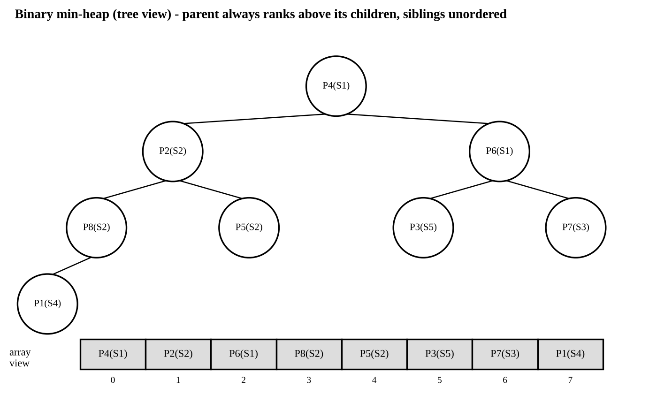
Figure 11: The same eight patients inside the heap: tree view and the array that toString() prints
Why printing the PriorityQueue does not show the treatment order. The heap guarantees only that every parent ranks before its two children (indices 2i+1 and 2i+2); the two children are in no order. toString() simply walks the underlying array from index 0 to 7. In the figure P2(S2) is at index 1, before P6(S1) at index 2, although P6 must be treated first. Only the head (index 0) is guaranteed to be the next patient; the correct order appears only by polling repeatedly.

6.4 Growth investigation
Prediction. add (offer) places the patient at the end of the array and sifts it up: O(log n) in the worst case but about O(1) on average for random severities (a new element usually moves up only a level or two). poll() takes the root, moves the last element to the root and sifts it down: always O(log n) (two comparisons per level). I therefore predict that add will almost not grow with n, poll will grow slowly (roughly with log n, plus cache effects when the array becomes large), and that neither will ever be linear.
Patients in queue (n) | add (ns per operation) | poll (ns per operation) | log2(n)
1,000 | 27.2 | 112.4 | 10
10,000 | 26.7 | 151.6 | 13
100,000 | 38.6 | 350.4 | 17
1,000,000 | 122.4 | 482.4 | 20

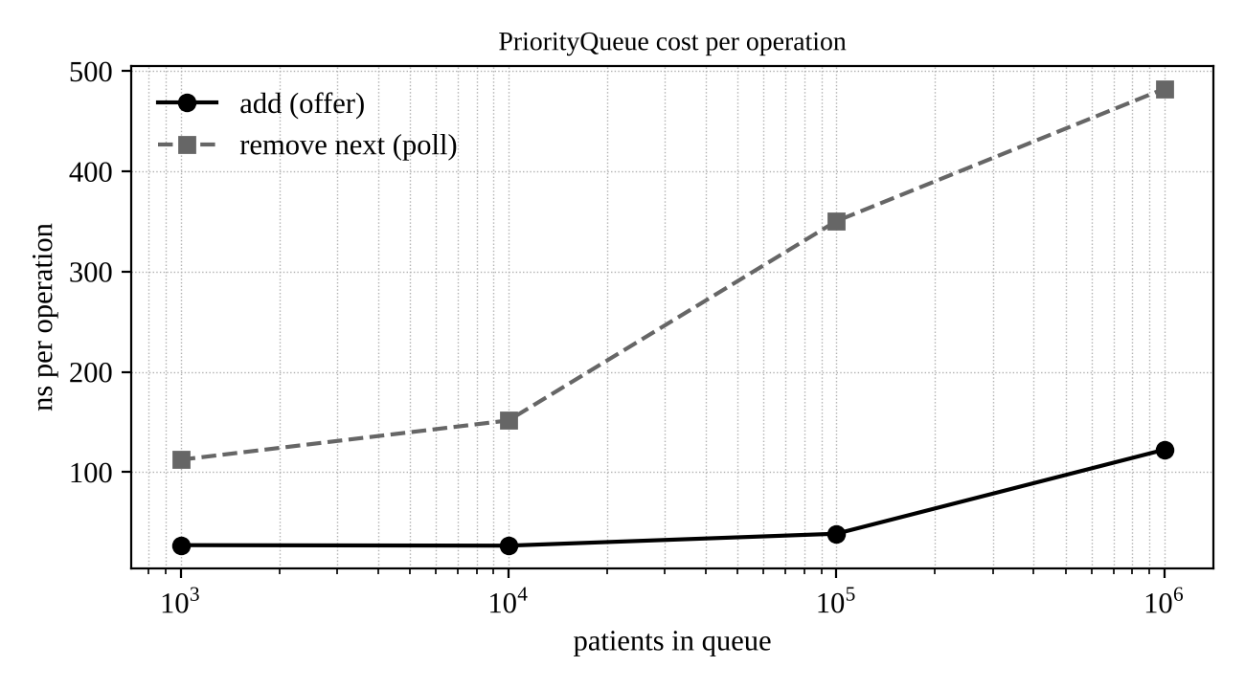
Figure 12: Cost per operation against queue size (horizontal axis logarithmic)
The prediction is supported: when n grows 1,000 times, add grows 4.5 times and poll 4.3 times (log2(n) doubles from 10 to 20); a linear cost would have grown 1,000 times. The jump of add at 1,000,000 is caused by memory (cache misses and array copying), not by the algorithm.

6.5 Inquiry: starvation and a fair rule
Why a severity-5 patient may wait indefinitely. poll() always returns the smallest key. If patients of severity 1 or 2 keep arriving at least as fast as the doctor can treat them, a severity-5 patient never reaches the head of the queue. Simulation: one severity-5 patient (Asha) arrives at time 0; every minute 3 new severity-1/2 patients arrive and one patient is treated.
strict priority : Asha seen at tick NEVER within 3000, waiting queue size 6001
aging key (W=50) : Asha seen at tick 515, waiting queue size 1031

Fair rule (aging). Instead of promoting waiting patients one by one (which means an O(n) pass and rebuilding the heap), I keep the heap and change the key so that waiting time is built in: priority key = arrival time + W x (severity - 1). A lower key is served first. One severity level is worth W minutes of waiting. A severity-5 patient arriving at time t has the key t + 4W, so any patient who arrives after t + 4W has a larger key and cannot overtake. The waiting time of every patient is therefore bounded, while within W minutes a more severe patient still goes first.
final long W = 50; // one severity level = 50 time units of waiting (to be fixed by the hospital)
Comparator<Patient> fair = Comparator
.comparingLong((Patient p) -> p.arrival + W * (p.severity - 1))
.thenComparingLong(p -> p.arrival);
PriorityQueue<Patient> queue = new PriorityQueue<>(fair);

The key never changes after insertion, so the heap invariant is never disturbed, and each operation stays O(log n). The trade-off is medical: with aging, a newly arrived critical patient may queue behind an older minor patient who has waited more than about W x (severity difference). W must therefore be chosen by clinicians, and severity-1 patients can be exempted by giving them their own absolute priority.

6.6 Alternative designs and complexity analysis
Sorted LinkedList: keep the list in order and insert each new patient at the correct position (linear scan); the next patient is the first node. Array of five FIFO queues: one ArrayDeque per severity; admit adds at the tail of the queue of that severity; serve takes from the first non-empty queue starting at severity 1.
Design | Admit | Serve next | Space | Measured admit time, n = 100,000
PriorityQueue (heap) | O(log n) | O(log n) | O(n) (array of references) | 3.44 ms
Sorted LinkedList | O(n) (scan to position) | O(1) | O(n), about 24 bytes per node | 38,814.8 ms (38.8 seconds)
5 FIFO queues | O(1) | O(1) (at most 5 checks, a constant) | O(n) plus 5 queue headers | 0.71 ms

n | PQ admit / serve (ms) | Sorted LinkedList admit / serve (ms) | 5 FIFO queues admit / serve (ms)
1,000 | 0.04 / 0.14 | 0.70 / 0.00 | 0.01 / 0.00
10,000 | 0.30 / 2.58 | 145.82 / 0.05 | 0.07 / 0.03
100,000 | 3.44 / 32.06 | 38,814.80 / 1.90 | 0.71 / 0.87

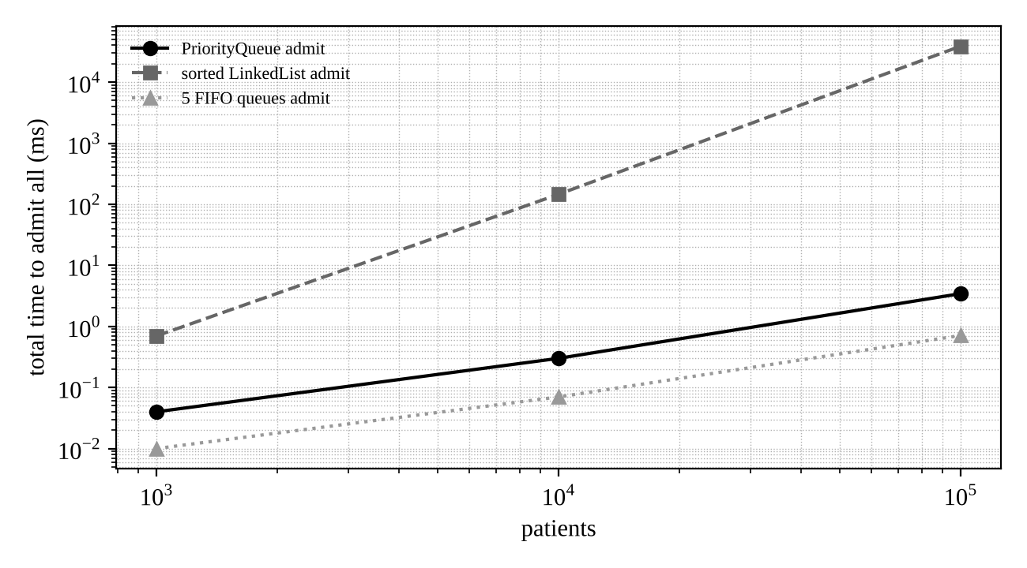
Figure 13: Total time to admit n patients in the three designs (log-log)
The sorted LinkedList becomes impractical: going from 10,000 to 100,000 patients multiplied the admit time by 266, more than the 100 x expected from O(n²), because the long list also stops fitting in the CPU cache. The five FIFO queues are the fastest, because the number of priority levels is a small fixed constant, but they cannot express aging (the aging key needs a continuous scale) or a rule that is later changed to many levels. The PriorityQueue is only a little slower and is the general design, so I keep it.

6.7 Deployment decision
Yes, the design can serve a city hospital receiving 5,000 patients a day. 5,000 per day is about 3.5 arrivals per minute, or perhaps 10 to 15 per minute at the busiest time. My measurement shows that adding and removing a patient costs well under one microsecond even with a million patients in the queue; a hospital queue will never hold more than a few hundred. The heap can therefore handle millions of times the load; the real bottleneck is the number of doctors. The points I would still address in the real deployment are: PriorityQueue is not thread-safe (use PriorityBlockingQueue or one synchronised wrapper if several reception desks add patients simultaneously); the queue lives in memory, so patients must be stored in a database or log to survive a restart; and the aging constant W and the severity rules need clinical approval.

Q7 – Day-4 Design Challenge: Diagnose, Redesign and Validate (13 Marks)
Selected solution: Q2, the playlist stored in an ArrayList. From my Q2 evidence this solution has a clear limitation as the list size grows and the usage pattern shifts to many insertions and removals in the middle of a long playlist. I will not simply swap it for another collection; the Q2 results already show that LinkedList is worse (30 to 50 times slower for middle edits and 3,000 times slower for get(k)). I will first understand why the time is spent and then design a structure for the actual usage pattern.

A. Diagnose the bottleneck (2 Marks)
Question | Finding from my evidence
Where is most of the time spent? | In moving array elements, not in the insertion itself. 2,000 middle insertions took 0.38 ms (10,000 songs), 8.17 ms (100,000) and 39.17 ms (500,000): 0.19, 4.1 and 19.6 microseconds per edit. At 500,000 songs one edit shifts about 250,000 references.
Which operation grows with the data? | add(index, e) and remove(index). Time per edit grows at least in proportion to the list size (the size grows 50 times from 10,000 to 500,000 songs; the time per edit grew about 100 times, because the large array also no longer fits in the CPU cache). Append, get(k) and iteration do not show this growth.
Is work repeated unnecessarily? | Yes. A listener edits near one position (adding songs after the song just added, removing songs next to each other), but every edit shifts the entire tail of the array behind that position again. Almost the same block of memory is moved thousands of times, although the elements between consecutive edit positions hardly change place. There is no re-sorting, re-creating of strings or linear searching in this case.
Which characteristic of the class causes it? | ArrayList keeps all elements packed contiguously and keeps all free space at the end. An edit at index i must therefore move (size - i) elements, and the position of the previous edit is forgotten, so the cost depends on the distance to the end of the list, not on the distance from the previous edit.

B. Design objective (2 Marks)
For a playlist of 1,000,000 songs and 20,000 edits made at a drifting cursor position (90 percent of edits within 20 positions of the previous one, 10 percent jumps to a random place):
- reduce the number of elements moved by at least 10 times compared with ArrayList, and the editing time by at least 10 times;
- keep get(k) O(1) and iteration O(n);
- preserve correctness: the content after any sequence of edits must be identical to ArrayList's;
- keep memory within 2 times of ArrayList.

C. Design of the revised solution (4 Marks)
Idea: keep the free space where the editing happens. Instead of packing all free space at the end, the array keeps one empty region, the gap, at the cursor. Elements before the gap stay at the start of the array, elements after the gap are stored at the end of the array. This structure is known as a gap buffer, as used inside text editors.
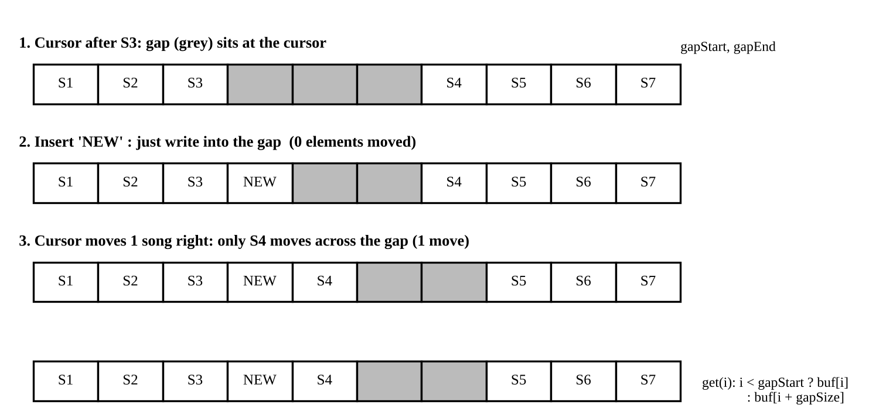
Figure 14: Gap list: inserting at the cursor costs no element movement; moving the cursor moves only the elements it passes
class GapList<E> {
Object[] buf; int gapStart, gapEnd; // gap is the free area [gapStart, gapEnd)
int size() { return buf.length - (gapEnd - gapStart); }
E get(int i) { return (E) buf[i < gapStart ? i : i + (gapEnd - gapStart)]; } // O(1)

void add(int idx, E e) { ensureGap(); moveGap(idx); buf[gapStart++] = e; } // write into the gap
E remove(int idx) { moveGap(idx); E e = (E) buf[gapEnd]; buf[gapEnd++] = null; return e; }

void moveGap(int idx) { // cost = distance between old and new cursor
if (idx < gapStart) { // shift (idx..gapStart) to the right end of the gap
int len = gapStart - idx; arraycopy(buf, idx, buf, gapEnd - len, len);
gapStart = idx; gapEnd -= len;
} else if (idx > gapStart) { // shift elements after the gap to the left
int len = idx - gapStart; arraycopy(buf, gapEnd, buf, gapStart, len);
gapStart += len; gapEnd += len;
}
}
void ensureGap() { if gap is empty: allocate array of double size, copy both halves, re-open gap }
}

Design question | Answer
What was changed? | ArrayList (free space always at the end) replaced by a gap buffer (free space at the cursor) that I wrote myself on a plain array.
Which property is exploited? | Locality of edits: the next edit is usually close to the previous one. The cost of an edit becomes proportional to the distance from the previous edit, not to the distance from the end of the list.
Which operations are avoided or reduced? | Shifting the whole tail for every edit. Edits at the cursor move 0 elements; edits within 20 positions move at most 20.
Additional memory or preprocessing? | The gap (free slots). When the gap is full the array doubles, so at most 2 x the elements are allocated (ArrayList grows by 1.5 x, so its worst case is lower). No preprocessing; the first cursor movement creates the gap.
New trade-offs? | (1) A jump to a distant position still costs O(distance), so purely random edits improve little. (2) get(k) has one extra comparison. (3) Not thread-safe, not part of the Java library, so it must be tested and maintained. (4) Index semantic must be the same as List, so I kept add(int, E), remove(int) and get(int).

D. Prediction before implementing (1 Mark)
Moves for ArrayList: an edit at a uniformly random position moves about n/2 elements on average, which at n = 1,000,000 means about 500,000 moves per edit and 10 x 10⁹ moves for 20,000 edits. For the gap list: 90 percent of edits move at most about 20 elements (negligible) and 10 percent jump to a random position, whose expected distance from the previous position is n/3. So the expected moves per edit are about 0.1 x n/3 = n/30, which is 15 times fewer than n/2. Prediction: with local edits the element moves fall about 15 times and the time should fall by roughly the same order (10 times or more) at 1,000,000 songs, with a smaller improvement at 100,000 and little at 10,000 (where ArrayList is already fast). With purely random edits I expect almost no improvement (n/3 against n/2, at most 1.5 times), because the gap has to travel as far as the elements would shift.

E. Implementation and validation (2 Marks)
Both structures were run on the same position sequence (same random seed), 20,000 alternating inserts and removes, 5 repetitions averaged. The elements moved were counted with a counter, not estimated. Before timing, a correctness test applied 200,000 random edits to both structures and compared every element ("Correctness check passed: GapList == ArrayList").
Songs | Edit pattern | ArrayList time (ms) | GapList time (ms) | Speed-up | Moved: ArrayList | Moved: GapList
10,000 | local | 3.41 | 0.93 | 3.7 x | 100,653,854 | 6,882,745
100,000 | local | 66.33 | 7.48 | 8.9 x | 982,249,967 | 66,244,622
1,000,000 | local | 1,122.83 | 94.83 | 11.8 x | 10,289,982,482 | 682,407,632
10,000 | random | 3.15 | 4.89 | 0.6 x (slower) | 99,663,836 | 66,287,135
100,000 | random | 85.36 | 76.24 | 1.1 x | 993,512,009 | 666,245,029
1,000,000 | random | 1,244.10 | 939.57 | 1.3 x | 10,007,453,545 | 6,706,137,096

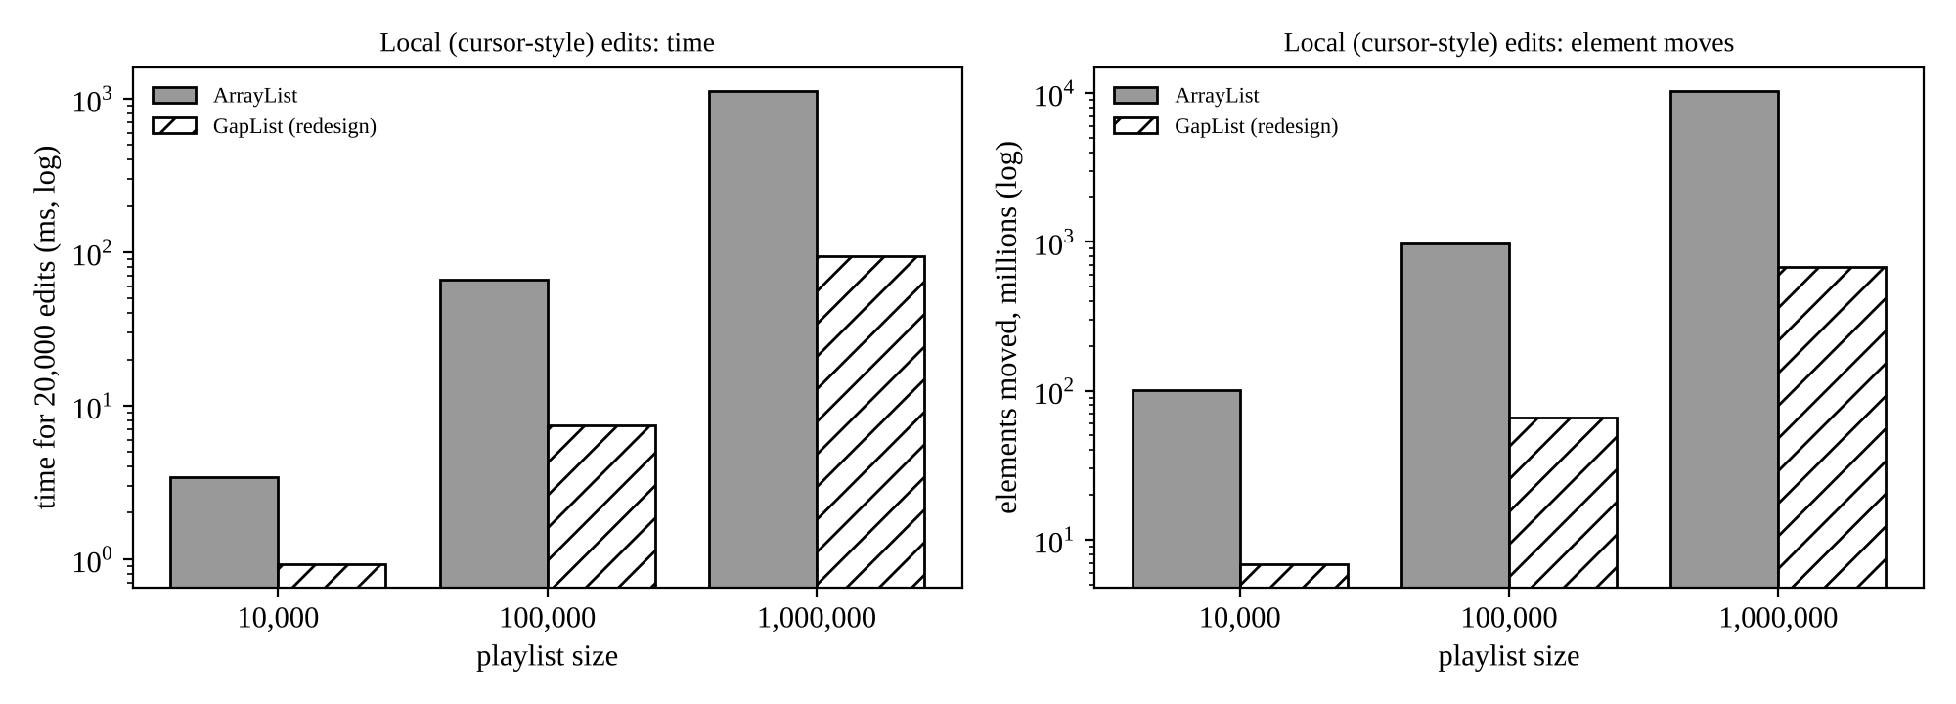
Figure 15: Local edits: time and elements moved, ArrayList against the redesigned gap list (log scale)
Cost of the extra comparison in get(k): 2,000,000 random reads were timed on both structures; the difference was at most about 7 nanoseconds per read in either direction, which is inside measurement noise.

F. Defend the final design (2 Marks)
- Was the prediction supported? Yes. The predicted reduction of moves for local edits was 15 times and the observed reduction at 1,000,000 songs was 15.1 times (10.29 x 10⁹ against 0.68 x 10⁹). For random edits I predicted at most 1.5 times and observed 1.5 times in moves (10.0 against 6.7 x 10⁹) and 1.3 times in time.
- Magnitude of improvement: 11.8 times faster at 1,000,000 songs, 8.9 times at 100,000 and 3.7 times at 10,000. The objective of 10 times was therefore met at 1,000,000 songs, just missed at 100,000 (8.9) and not reached at 10,000. The time gain is slightly below the gain in moves because the timing includes loop, boxing and allocation costs that are the same for both, and System.arraycopy is a very fast native operation.
- New costs and trade-offs: up to 2 times memory for the gap (ArrayList wastes up to 1.5 times), extra code to test and maintain, no benefit for random edits, and at 10,000 songs with random edits it was even slower (4.89 against 3.15 ms) because the gap moves for every edit while ArrayList shifts only half the array on average.
- When the original is still preferable: for normal playlists (up to about 10,000 songs the original costs 0.17 microseconds per edit, which nobody can notice); for lists that are mostly read or appended to; for random edit positions; and whenever the standard, well-tested and thread-compatible library class is more valuable than a speed-up that nobody needs. The Up Next queue from Q2 remains an ArrayDeque, which already gives O(1) at both ends.
Final engineering conclusion. The bottleneck was the position of the free space, not the choice between "array" and "linked". By moving the free space to the cursor, the redesign exploits the locality of real editing and reduces the work by the predicted factor for large playlists. It should be adopted only if the application really holds very large playlists that are edited interactively; otherwise Array List remains the right choice.

