Experiment No.: 13
Title
Sum of Integers from 1 to N using Prolog

Aim
To write a Prolog program to find the sum of integers from 1 to N using recursion.

Apparatus / Software Required
- Computer or Laptop
- SWI-Prolog
- Any Text Editor (Notepad / VS Code)
- Windows Operating System

Procedure
- Open the SWI-Prolog console.
- Open a text editor (e.g., Notepad) and create a new file.
- Save the file with a .pl extension, for example lab18.pl.
- Define a recursive predicate sum_to_n/2 with a base case for 0 and a recursive case that adds N to the sum of 1 to N-1.
- Add an initialization directive to call the main predicate automatically on consult.
- In the main predicate, prompt the user to enter a number and read the input.
- Call sum_to_n/2 with the entered number to compute the sum.
- Display the result using format/2.
- Load the file in SWI-Prolog using the consult predicate.
- Test the program, verify the output, and close the program.

Program
sum_to_n(0, 0) :- !.
sum_to_n(N, Sum) :-
N > 0,
N1 is N - 1,
sum_to_n(N1, Sum1),
Sum is Sum1 + N.

:- initialization(main).

main :-
write('Enter a number: '),
read_line_to_string(user_input, Line),
number_string(N, Line),
sum_to_n(N, Sum),
format('Sum from 1 to ~w is ~w~n', [N, Sum]).

Sample Output
Solution:
Enter a number: 2
Sum from 1 to 2 is 3

Output:

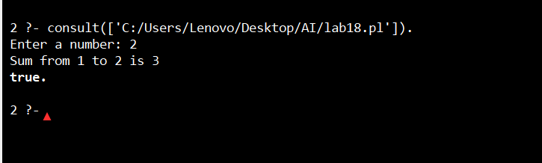

Result
Thus, the Prolog program to find the sum of integers from 1 to N was executed successfully, and the output was verified for different input values.

