Experiment No.: 19
Title
Simple Database of NAME and DOB using Prolog

Aim
To write a Prolog program to create and display a simple database storing NAME and DOB using facts.

Apparatus / Software Required
- Computer or Laptop
- SWI-Prolog
- Any Text Editor (Notepad / VS Code)
- Windows Operating System

Procedure
- Open the SWI-Prolog console.
- Open a text editor (e.g., Notepad) and create a new file.
- Save the file with a .pl extension, for example lab19.pl.
- Define a set of facts person(Name, DOB) to represent the database, one fact per record.
- Add an initialization directive to call the main predicate automatically on consult.
- In the main predicate, print a heading for the database contents.
- Use forall/2 with the person/2 facts to iterate through every record.
- Display each record's Name and DOB using format/2.
- Load the file in SWI-Prolog using the consult predicate.
- Test the program, verify the output, and close the program.

Program
% Database facts: person(Name, DateOfBirth)

person('John', '1995-05-14').
person('Mary', '1998-11-23').
person('Alex', '2000-02-09').
person('Sophia', '1997-07-30').

:- initialization(main).

main :-
write('---- Database Contents ----'), nl,
forall(person(Name, DOB),
format('Name: ~w, DOB: ~w~n', [Name, DOB])).

Sample Output
Solution:
---- Database Contents ----
Name: John, DOB: 1995-05-14
Name: Mary, DOB: 1998-11-23
Name: Alex, DOB: 2000-02-09
Name: Sophia, DOB: 1997-07-30

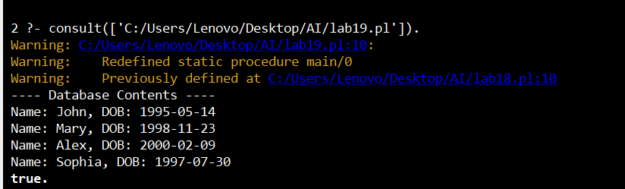

Result
Thus, the Prolog program to create and display a simple database of NAME and DOB was executed successfully, and the output was verified.

