Experiment No.: 20
Title
Student, Teacher, and SubCode Database using Prolog

Aim
To write a Prolog program to create and display a database of students, teachers, and their subject codes using facts.

Apparatus / Software Required
- Computer or Laptop
- SWI-Prolog
- Any Text Editor (Notepad / VS Code)
- Windows Operating System

Procedure
- Open the SWI-Prolog console.
- Open a text editor (e.g., Notepad) and create a new file.
- Save the file with a .pl extension, for example lab20.pl.
- Define a set of facts student(Name, SubCode) to represent students and the subject they study.
- Define a set of facts teacher(Name, SubCode) to represent teachers and the subject they teach.
- Add an initialization directive to call the main predicate automatically on consult.
- In the main predicate, print a heading for the students section.
- Use forall/2 with the student/2 facts to display every student's Name and SubCode.
- Use forall/2 with the teacher/2 facts to display every teacher's Name and SubCode.
- Load the file in SWI-Prolog using the consult predicate, test the program, and verify the output.

Program
% Database facts
% student(StudentName, SubCode).
% teacher(TeacherName, SubCode).

student('John', 'CSA17').
student('Mary', 'CSA17').
student('Alex', 'CSA18').
student('Sophia', 'CSA19').

teacher('Dr. Kumar', 'CSA17').
teacher('Dr. Priya', 'CSA18').
teacher('Dr. Ravi', 'CSA19').

:- initialization(main).

main :-
write('---- Students ----'), nl,
forall(student(Name, Sub),
format('Student: ~w, SubCode: ~w~n', [Name, Sub])),
nl,
write('---- Teachers ----'), nl,
forall(teacher(Name, Sub),
format('Teacher: ~w, SubCode: ~w~n', [Name, Sub])).

Sample Output
Solution:
---- Students ----
Student: John, SubCode: CSA17
Student: Mary, SubCode: CSA17
Student: Alex, SubCode: CSA18
Student: Sophia, SubCode: CSA19

---- Teachers ----
Teacher: Dr. Kumar, SubCode: CSA17
Teacher: Dr. Priya, SubCode: CSA18
Teacher: Dr. Ravi, SubCode: CSA19

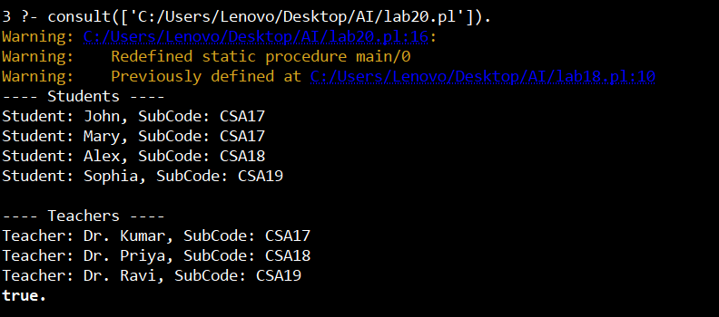

Result
Thus, the Prolog program to create and display a database of students, teachers, and subject codes was executed successfully, and the output was verified.

