Experiment No.: 21
Title
Planets Database using Prolog

Aim
To write a Prolog program to create and display a database of planets with their position and distance from the sun using facts.

Apparatus / Software Required
- Computer or Laptop
- SWI-Prolog
- Any Text Editor (Notepad / VS Code)
- Windows Operating System

Procedure
- Open the SWI-Prolog console.
- Open a text editor (e.g., Notepad) and create a new file.
- Save the file with a .pl extension, for example lab21.pl.
- Define a set of facts planet(Name, Position, DistanceFromSun) to represent the planets database.
- Add an initialization directive to call the main predicate automatically on consult.
- In the main predicate, print a heading for the planets database.
- Use forall/2 with the planet/3 facts to iterate through every record.
- Display each planet's Name, Position, and Distance from the Sun using format/2.
- Load the file in SWI-Prolog using the consult predicate.
- Test the program, verify the output, and close the program.

Program
% Database facts
% planet(Name, Position, DistanceFromSunMillionKm).

planet('Mercury', 1, 57.9).
planet('Venus', 2, 108.2).
planet('Earth', 3, 149.6).
planet('Mars', 4, 227.9).
planet('Jupiter', 5, 778.3).
planet('Saturn', 6, 1427.0).
planet('Uranus', 7, 2871.0).
planet('Neptune', 8, 4497.1).

:- initialization(main).

main :-
write('---- Planets Database ----'), nl,
forall(planet(Name, Pos, Dist),
format('Planet: ~w, Position: ~w, Distance from Sun: ~w million km~n', [Name, Pos, Dist])).

Sample Output
Solution:
---- Planets Database ----
Planet: Mercury, Position: 1, Distance from Sun: 57.9 million km
Planet: Venus, Position: 2, Distance from Sun: 108.2 million km
Planet: Earth, Position: 3, Distance from Sun: 149.6 million km
Planet: Mars, Position: 4, Distance from Sun: 227.9 million km
Planet: Jupiter, Position: 5, Distance from Sun: 778.3 million km
Planet: Saturn, Position: 6, Distance from Sun: 1427.0 million km
Planet: Uranus, Position: 7, Distance from Sun: 2871.0 million km
Planet: Neptune, Position: 8, Distance from Sun: 4497.1 million km
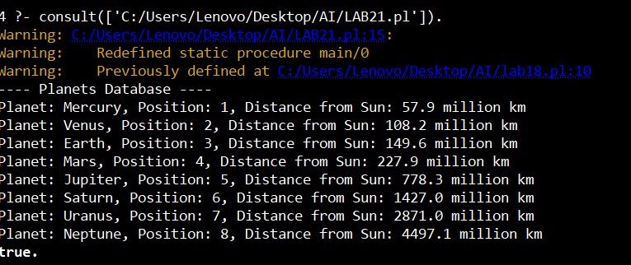

Result
Thus, the Prolog program to create and display a database of planets was executed successfully, and the output was verified.

