NAME: MOHAMMED AFFAN M
REG NO: 192572169
Experiment-33
Number of Vowels in a Word
Aim:-
To write a Prolog program to find the number of vowels present in a given word.
Algorithm:-
1. Start the program.
2. Define a fact vowel(X) for each vowel letter a, e, i, o, u.
3. Define count_vowels([],0) as the base case for an empty list of characters.
4. Define the recursive clause: if the head of the list is a vowel, add 1 to the count of the rest; otherwise the count equals the count of the rest.
5. Convert the input word (atom) into a list of characters, then call count_vowels/2 on it.
6. Display the total number of vowels. Stop the program.

Program (Prolog):-
vowel(a). vowel(e). vowel(i). vowel(o). vowel(u).

count_vowels([],0).
count_vowels([H|T],Count):-
vowel(H), !,
count_vowels(T,C1),
Count is C1+1.
count_vowels([_|T],Count):-
count_vowels(T,Count).

:- initialization(main).
main:-
Word = prolog,
atom_chars(Word, Chars),
count_vowels(Chars, N),
format('Number of vowels in ~w = ~w~n',[Word,N]).

Output:-
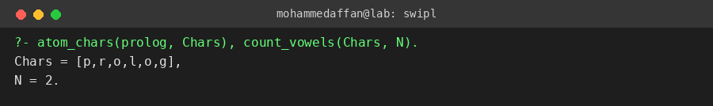

Result:-
Hence the Prolog program has been executed and the output has been verified.

