Fundamentals of Data Science - Lab Manual
Question 1
Average score per subject using NumPy
AIM:
To use NumPy arrays to calculate the average score of each subject and to identify the subject with the highest average score for a 4 x 4 student marks matrix.
ALGORITHM:
Step 1: Start the program and import the NumPy library.
Step 2: Create the 4 x 4 array student_scores (rows = students, columns = Math, Science, English, History).
Step 3: Calculate the column-wise mean using np.mean(student_scores, axis=0) to get the average of each subject.
Step 4: Find the index of the largest average using np.argmax().
Step 5: Use that index to pick the subject name from the subjects list.
Step 6: Display the average marks, the subject with the highest average and its average value.
Step 7: Stop the program.
PROGRAM:
import numpy as np

# rows = students, columns = Math, Science, English, History
student_scores = np.array([[80, 85, 90, 78],
[90, 80, 85, 82],
[85, 90, 80, 81],
[80, 85, 90, 80]])
subjects = ["Math", "Science", "English", "History"]

# average of each subject (column-wise mean)
avg_marks = np.mean(student_scores, axis=0)

# subject with the highest average
best = np.argmax(avg_marks)

print("Average marks:", avg_marks)
print("Highest average subject:", subjects[best])
print("Highest average:", avg_marks[best])
INPUT:
student_scores - 4 x 4 NumPy array (marks of each student):
Student | Math | Science | English | History
Student 1 | 80 | 85 | 90 | 78
Student 2 | 90 | 80 | 85 | 82
Student 3 | 85 | 90 | 80 | 81
Student 4 | 80 | 85 | 90 | 80

OUTPUT:
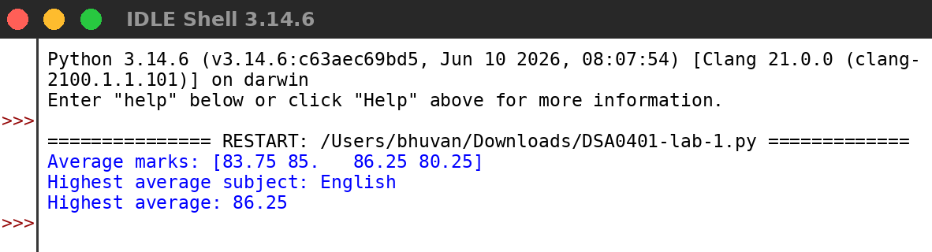
RESULT:
Thus the program was written and executed successfully and the output was verified.

