Fundamentals of Data Science - Lab Manual
Question 2
Average price of products sold
AIM:
To use NumPy to find the average price of all the products sold in the past month from a 3 x 3 sales matrix.
ALGORITHM:
Step 1: Start the program and import NumPy.
Step 2: Create a 3 x 3 array in which each row represents the sales of a different product.
Step 3: Calculate the average of each row (product) using mean(axis=1).
Step 4: Calculate the overall average of the whole matrix using np.mean().
Step 5: Display the results.
Step 6: Stop the program.
PROGRAM:
import numpy as np

# each row = one product, each column = price recorded in a different week
sales = np.array([[120, 150, 130],
[200, 220, 210],
[ 90, 100, 110]])

print("Sales matrix:")
print(sales)
print("Average price of each product:", np.round(sales.mean(axis=1), 2))
print("Average price of all products sold:", np.mean(sales))
INPUT:
sales - 3 x 3 NumPy array (each row is one product):
Product | Week 1 | Week 2 | Week 3
Product 1 | 120 | 150 | 130
Product 2 | 200 | 220 | 210
Product 3 | 90 | 100 | 110

OUTPUT:
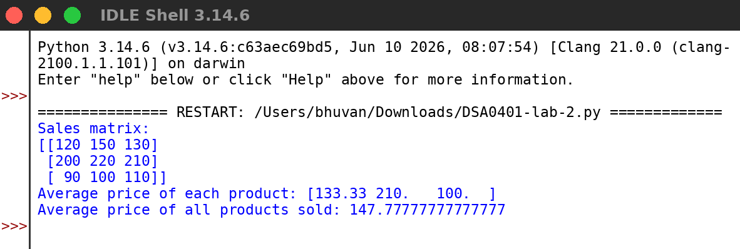
RESULT:
Thus the program was written and executed successfully and the output was verified.

