Fundamentals of Data Science - Lab Manual
Question 3
Average sale price of houses with more than four bedrooms
AIM:
To use NumPy arrays and Boolean masking to find the average sale price of houses having more than four bedrooms.
ALGORITHM:
Step 1: Start the program and import NumPy.
Step 2: Load houses.csv into the NumPy array house_data using np.loadtxt (skip the header row).
Step 3: Separate the bedrooms column (column 0) and the sale price column (column 2).
Step 4: Create a Boolean mask bedrooms > 4.
Step 5: Apply the mask on the price column and calculate the mean.
Step 6: Display the number of such houses, their prices and the average price.
Step 7: Stop the program.
PROGRAM:
import numpy as np

# columns: 0 = bedrooms, 1 = square footage, 2 = sale price
house_data = np.loadtxt("houses.csv", delimiter=",", skiprows=1)

bedrooms = house_data[:, 0]
price = house_data[:, 2]

mask = bedrooms > 4 # houses with more than four bedrooms

print("Number of houses with more than 4 bedrooms:", mask.sum())
print("Sale prices of those houses:", price[mask])
print("Average sale price:", price[mask].mean())
INPUT:
File: houses.csv (12 rows)
bedrooms | sqft | price
2 | 1100 | 185000
3 | 1500 | 240000
5 | 2800 | 455000
4 | 2000 | 330000
6 | 3400 | 560000
3 | 1650 | 255000
5 | 2650 | 430000
2 | 950 | 160000
4 | 2200 | 350000
5 | 3000 | 480000
6 | 3600 | 590000
1 | 700 | 120000

OUTPUT:
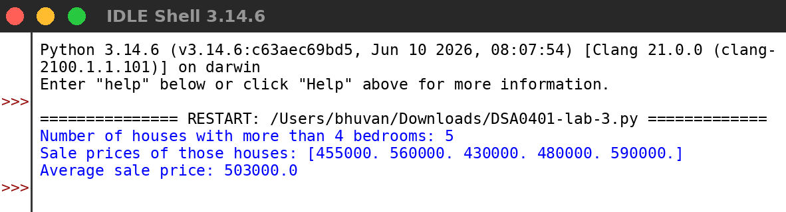
RESULT:
Thus the program was written and executed successfully and the output was verified.

