Fundamentals of Data Science - Lab Manual
Question 12
Temperature line plot and rainfall scatter plot
AIM:
To develop a Python program that draws (1) a line plot of the monthly temperature and (2) a scatter plot of the monthly rainfall of a city.
ALGORITHM:
Step 1: Start the program and import matplotlib.pyplot.
Step 2: Store the 12 month names, the average monthly temperature and the monthly rainfall in lists.
Step 3: Line plot: plot temperature against month with markers, title, labels and grid; show the plot.
Step 4: Scatter plot: plot rainfall against month with title and labels; show the plot.
Step 5: Stop the program.
PROGRAM:
import matplotlib.pyplot as plt

months = ["Jan", "Feb", "Mar", "Apr", "May", "Jun",
"Jul", "Aug", "Sep", "Oct", "Nov", "Dec"]
temperature = [25.5, 26.8, 28.9, 31.0, 33.2, 33.8,
32.5, 31.4, 30.8, 28.9, 26.6, 25.4] # degree Celsius
rainfall = [24, 8, 12, 25, 52, 53, 83, 124, 118, 267, 309, 139] # mm

# 1. Line plot of temperature
plt.figure(figsize=(8, 4.5))
plt.plot(months, temperature, marker="o", color="orangered")
plt.title("Monthly Temperature - Line Plot")
plt.xlabel("Month")
plt.ylabel("Temperature (deg C)")
plt.grid(True)
plt.show()

# 2. Scatter plot of rainfall
plt.figure(figsize=(8, 4.5))
plt.scatter(months, rainfall, color="royalblue", s=60)
plt.title("Monthly Rainfall - Scatter Plot")
plt.xlabel("Month")
plt.ylabel("Rainfall (mm)")
plt.show()
INPUT:
Month | Jan | Feb | Mar | Apr | May | Jun
Temperature (deg C) | 25.5 | 26.8 | 28.9 | 31.0 | 33.2 | 33.8
Rainfall (mm) | 24 | 8 | 12 | 25 | 52 | 53

Month | Jul | Aug | Sep | Oct | Nov | Dec
Temperature (deg C) | 32.5 | 31.4 | 30.8 | 28.9 | 26.6 | 25.4
Rainfall (mm) | 83 | 124 | 118 | 267 | 309 | 139

OUTPUT:
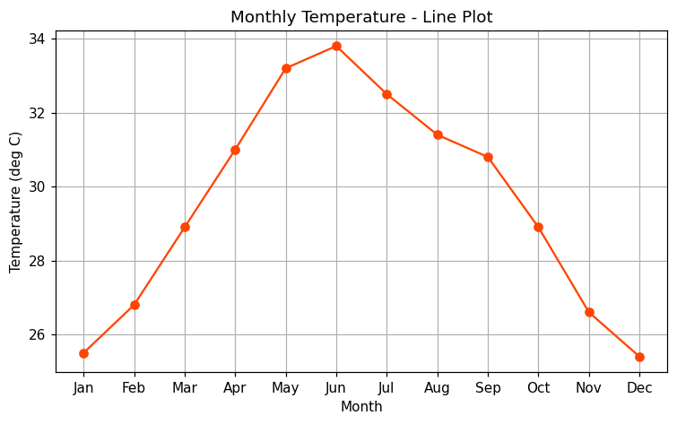
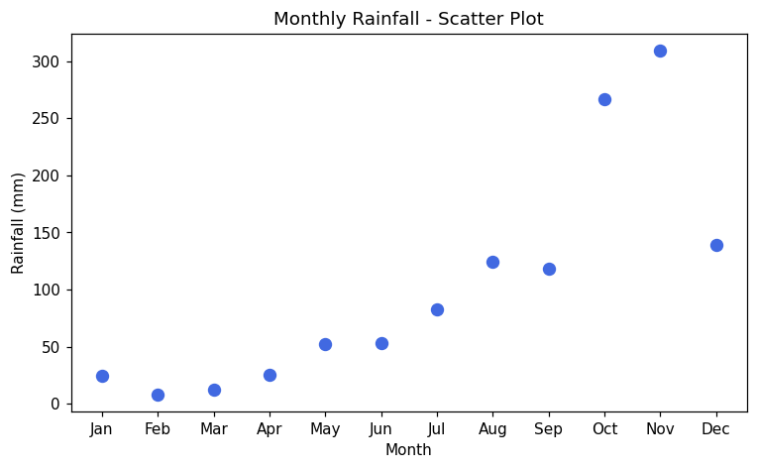
RESULT:
Thus the program was written and executed successfully and the output was verified.

