Fundamentals of Data Science - Lab Manual
Question 13
Word frequency distribution of a text document
AIM:
To develop a Python program that reads a text document, processes the text and generates the frequency distribution of the words.
ALGORITHM:
Step 1: Start the program and import re and Counter from collections.
Step 2: Open sample_text.txt and read the whole text.
Step 3: Convert the text to lower case and extract the words using a regular expression (this removes punctuation).
Step 4: Count the occurrences of every word using Counter.
Step 5: Display the total number of words, the number of unique words and the frequency of each word in descending order.
Step 6: Stop the program.
PROGRAM:
import re
from collections import Counter

with open("sample_text.txt", "r") as file:
text = file.read()

words = re.findall(r"[a-z']+", text.lower()) # lower case + remove punctuation
freq = Counter(words) # frequency distribution

print("Total words :", len(words))
print("Unique words :", len(freq))
print("\nWord Frequency")
print("-" * 24)
for word, count in freq.most_common():
print(f"{word:<15}{count}")
INPUT:
File: sample_text.txt
Data science is the study of data. Data scientists collect data, clean data and
analyze data to find useful patterns. Python is a popular language for data
science because Python has simple syntax and powerful libraries. Libraries like
NumPy and Pandas make data analysis easy, and Matplotlib helps to visualize
data. Good data leads to good decisions.
OUTPUT:
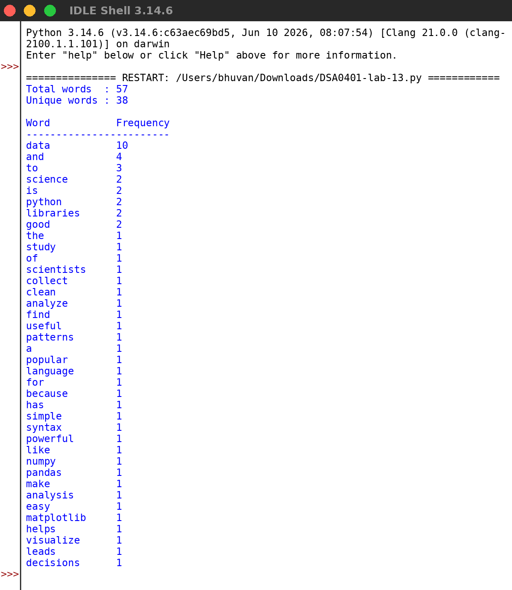
RESULT:
Thus the program was written and executed successfully and the output was verified.

