Fundamentals of Data Science - Lab Manual
Question 14
Frequency distribution of customer ages
AIM:
To find the frequency distribution of the ages of the customers who made a purchase in the past month using Pandas.
ALGORITHM:
Step 1: Start the program and import Pandas and Matplotlib.
Step 2: Create the DataFrame of customers who purchased in the past month (customer ID and age).
Step 3: Use value_counts() and sort_index() to get the frequency of every age.
Step 4: Group the ages into class intervals with pd.cut() and count each group.
Step 5: Display both frequency tables and draw a bar chart of the age frequencies.
Step 6: Stop the program.
PROGRAM:
import pandas as pd
import matplotlib.pyplot as plt

ages = [22, 33, 30, 25, 21, 31, 25, 33, 25, 30, 22, 28, 21, 32, 21, 31,
32, 27, 32, 29, 33, 31, 34, 21, 20, 30, 31, 31, 33, 26]
sales = pd.DataFrame({"customer_id": range(1, len(ages) + 1), "age": ages})

# frequency of every age
age_freq = sales["age"].value_counts().sort_index()
print("Frequency distribution of ages")
print(age_freq)

# frequency of age groups
groups = pd.cut(sales["age"], bins=[19, 24, 29, 35],
labels=["20-24", "25-29", "30-35"])
print("\nFrequency distribution of age groups")
print(groups.value_counts().sort_index())

age_freq.plot(kind="bar", color="teal", figsize=(8, 4))
plt.title("Frequency Distribution of Customer Ages")
plt.xlabel("Age")
plt.ylabel("Number of customers")
plt.show()
INPUT:
Ages of 30 customers who made a purchase in the past month: 22, 33, 30, 25, 21, 31, 25, 33, 25, 30, 22, 28, 21, 32, 21, 31, 32, 27, 32, 29, 33, 31, 34, 21, 20, 30, 31, 31, 33, 26
OUTPUT:
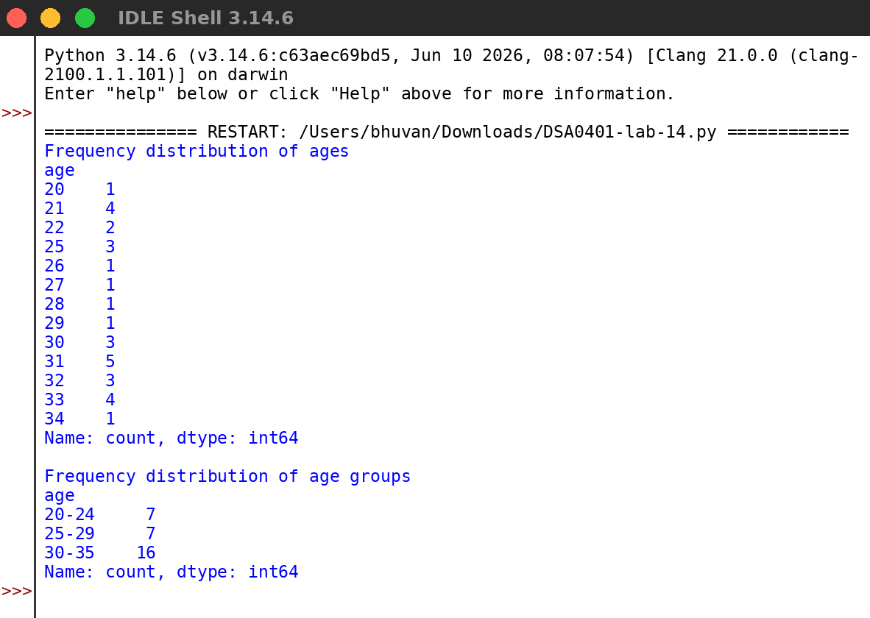
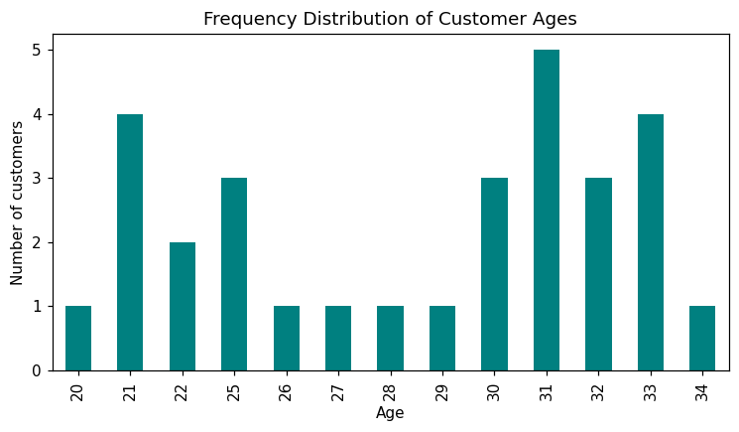
RESULT:
Thus the program was written and executed successfully and the output was verified.

