Fundamentals of Data Science - Lab Manual
Question 15
Frequency distribution of likes on posts
AIM:
To develop a Python program that calculates the frequency distribution of the number of likes received by the posts of a social media platform.
ALGORITHM:
Step 1: Start the program and import Pandas and Matplotlib.
Step 2: Create the DataFrame with the post ID and the number of likes of each post.
Step 3: Define the class intervals (0-9, 10-19, ..., 50-59) and assign every post to an interval using pd.cut().
Step 4: Count the posts in each interval with value_counts() to get the frequency distribution.
Step 5: Display the table and plot it as a bar chart.
Step 6: Stop the program.
PROGRAM:
import pandas as pd
import matplotlib.pyplot as plt

likes = [55, 41, 42, 48, 14, 20, 12, 2, 26, 34, 58, 8, 58, 43, 27, 20, 41,
27, 16, 58, 12, 46, 5, 50, 8, 33, 31, 56, 53, 1]
posts = pd.DataFrame({"post_id": range(1, len(likes) + 1), "likes": likes})

bins = [-1, 9, 19, 29, 39, 49, 59]
labels = ["0-9", "10-19", "20-29", "30-39", "40-49", "50-59"]
posts["likes_range"] = pd.cut(posts["likes"], bins=bins, labels=labels)

freq = posts["likes_range"].value_counts().sort_index()
print("Frequency distribution of likes")
print(freq)

freq.plot(kind="bar", color="darkorange", figsize=(7, 4))
plt.title("Frequency Distribution of Likes")
plt.xlabel("Number of likes")
plt.ylabel("Number of posts")
plt.xticks(rotation=0)
plt.show()
INPUT:
Likes received by 30 posts: 55, 41, 42, 48, 14, 20, 12, 2, 26, 34, 58, 8, 58, 43, 27, 20, 41, 27, 16, 58, 12, 46, 5, 50, 8, 33, 31, 56, 53, 1
OUTPUT:
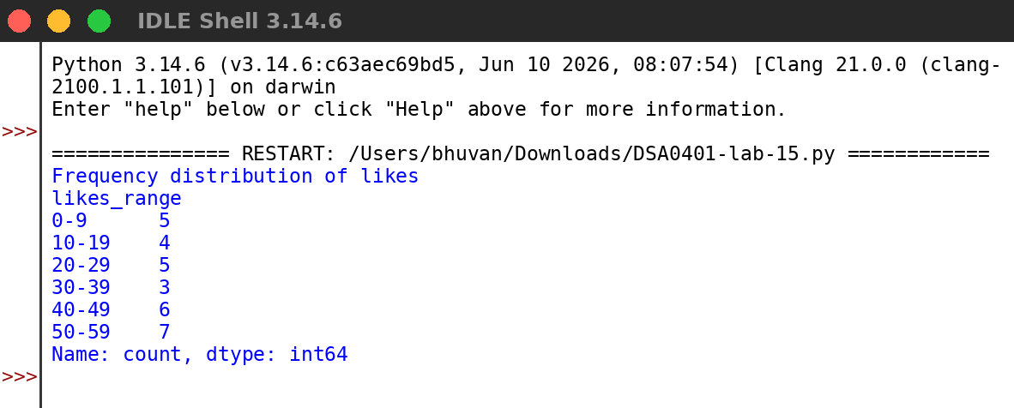
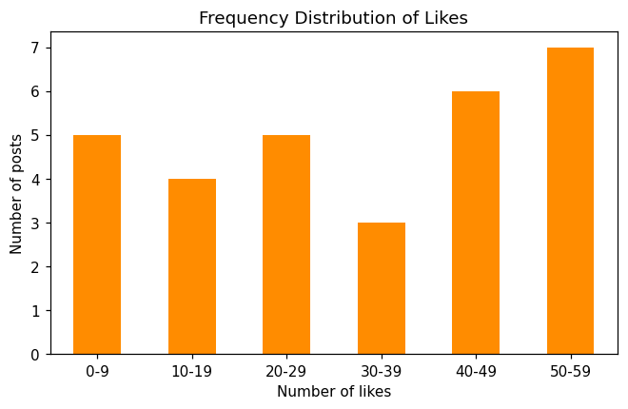
RESULT:
Thus the program was written and executed successfully and the output was verified.

