Fundamentals of Data Science - Lab Manual
Question 16
Word frequency in customer reviews
AIM:
To develop a Python program to calculate the frequency distribution of words in a customer reviews dataset.
ALGORITHM:
Step 1: Start the program and import Pandas, re and Counter.
Step 2: Read the dataset reviews.csv into a DataFrame.
Step 3: Join all the reviews into one string, convert it to lower case and extract the words (punctuation is removed).
Step 4: Count the frequency of each word using Counter.
Step 5: Convert the result into a DataFrame and display the 15 most frequent words.
Step 6: Stop the program.
PROGRAM:
import pandas as pd
import re
from collections import Counter

reviews = pd.read_csv("reviews.csv")

text = " ".join(reviews["review"]).lower()
words = re.findall(r"[a-z]+", text)

freq = Counter(words)

freq_df = pd.DataFrame(freq.most_common(15), columns=["word", "frequency"])
print("Total words :", len(words))
print("Unique words:", len(freq))
print("\nTop 15 most frequent words")
print(freq_df)
INPUT:
File: reviews.csv (8 rows)
review
Great product, works perfectly and the battery life is great.
Good quality but the delivery was late.
Very poor quality, stopped working after a week.
Excellent product, good value for money.
The battery life is poor and the charger is slow.
Great value, fast delivery and good packaging.
Not good, the product quality is poor.
Works great, I love the quality of this product.

OUTPUT:
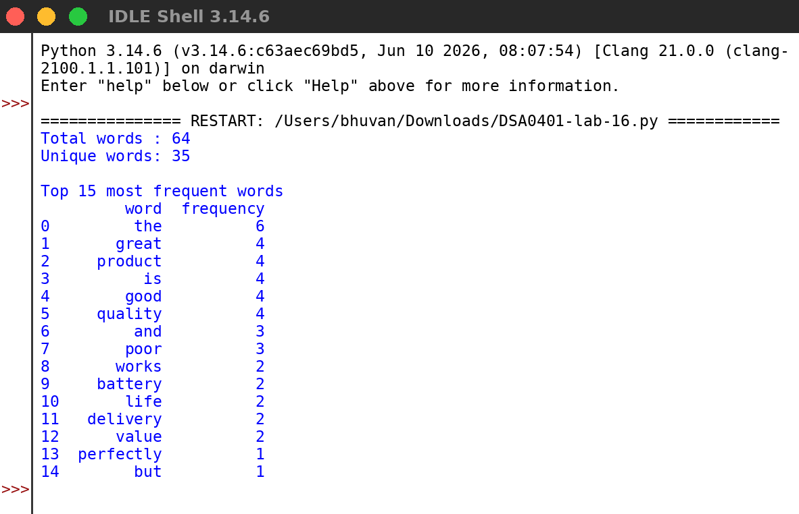
RESULT:
Thus the program was written and executed successfully and the output was verified.

