Fundamentals of Data Science - Lab Manual
Question 17
Top N words in customer feedback with bar graph
AIM:
To develop a Python program that loads customer feedback from a CSV file, pre-processes the text, finds the frequency distribution of words, displays the top N words (N given by the user) and plots them as a bar graph.
ALGORITHM:
Step 1: Start the program and import Pandas, re, string, Counter and Matplotlib.
Step 2: Load data.csv (column "feedback") into a DataFrame.
Step 3: Pre-process every comment: convert to lower case, remove punctuation and remove the stop words.
Step 4: Collect all remaining words and compute their frequency distribution with Counter.
Step 5: Read N from the user and display the N most frequent words with their frequencies.
Step 6: Plot a bar graph of the top N words and their frequencies.
Step 7: Stop the program.
PROGRAM:
import pandas as pd
import string
from collections import Counter
import matplotlib.pyplot as plt

stop_words = {"the", "and", "is", "are", "was", "were", "a", "an", "of", "to", "in",
"i", "am", "it", "this", "that", "but", "for", "with", "very", "not"}

data = pd.read_csv("data.csv")

# pre-processing: lower case, remove punctuation, remove stop words
words = []
for comment in data["feedback"]:
comment = comment.lower().translate(str.maketrans("", "", string.punctuation))
words += [w for w in comment.split() if w not in stop_words]

freq = Counter(words)

n = int(input("Enter the value of N: "))
top_n = freq.most_common(n)

print(f"\nTop {n} most frequent words")
for word, count in top_n:
print(f"{word:<12}{count}")

labels = [w for w, c in top_n]
counts = [c for w, c in top_n]
plt.figure(figsize=(7, 4))
plt.bar(labels, counts, color="steelblue")
plt.title(f"Top {n} Most Frequent Words in Customer Feedback")
plt.xlabel("Word")
plt.ylabel("Frequency")
plt.show()
INPUT:
File: data.csv (10 rows)
feedback
The delivery was very fast and the product is excellent!
Product quality is poor, and the delivery is late.
Excellent service, the support team is very helpful.
I am not happy, the product stopped working in a week.
Fast delivery, good product, and excellent packaging.
The support team was slow, but the product is good.
Very helpful support and fast delivery!
Poor packaging and late delivery, not happy.
Good product and excellent quality, I am very happy.
The quality is excellent and the price is good.

Values entered by the user at run time:
Prompt | Value entered
Enter the value of N | 5

OUTPUT:
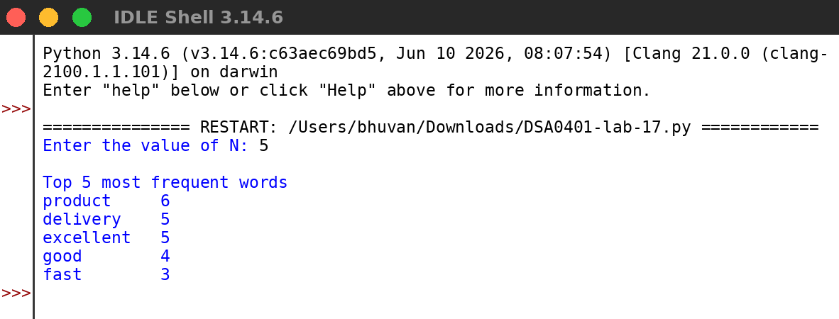
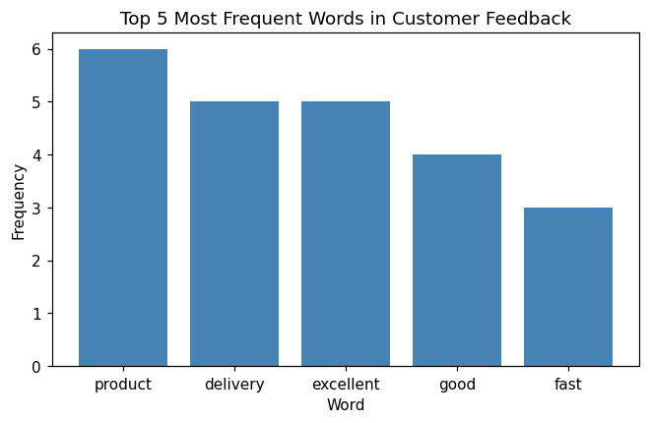
RESULT:
Thus the program was written and executed successfully and the output was verified.

