Fundamentals of Data Science - Lab Manual
Question 18
Age and body fat: statistics, box plots, scatter and q-q plot
AIM:
To calculate the mean, median and standard deviation of age and %fat using Pandas and to draw the box plots, a scatter plot and a q-q plot for the two variables.
ALGORITHM:
Step 1: Start the program and import Pandas, NumPy and Matplotlib.
Step 2: Create a DataFrame with the age and %fat values of the 18 adults.
Step 3: Calculate the mean, median and standard deviation using mean(), median() and std().
Step 4: Draw the box plots of age and %fat.
Step 5: Draw the scatter plot of age (x-axis) versus %fat (y-axis).
Step 6: Draw the q-q plot by plotting the quantiles of age against the quantiles of %fat, with the y = x reference line.
Step 7: Stop the program.
PROGRAM:
import pandas as pd
import numpy as np
import matplotlib.pyplot as plt

df = pd.DataFrame({
"age": [23, 23, 27, 27, 39, 41, 47, 49, 50,
52, 54, 54, 56, 57, 58, 58, 60, 61],
"%fat": [9.5, 26.5, 7.8, 17.8, 31.4, 25.9, 27.4, 27.2, 31.2,
34.6, 42.5, 28.8, 33.4, 30.2, 34.1, 32.9, 41.2, 35.7]})

stats = pd.DataFrame({"mean": df.mean(), "median": df.median(), "std": df.std()})
print(stats.round(2))

# box plots
fig, ax = plt.subplots(1, 2, figsize=(8, 4.5))
ax[0].boxplot(df["age"]); ax[0].set_title("Box plot of age")
ax[1].boxplot(df["%fat"]); ax[1].set_title("Box plot of %fat")
plt.show()

# scatter plot
plt.figure(figsize=(6, 4.5))
plt.scatter(df["age"], df["%fat"], color="crimson")
plt.title("Scatter plot of age and %fat")
plt.xlabel("age"); plt.ylabel("%fat")
plt.grid(True)
plt.show()

# q-q plot (quantiles of age vs quantiles of %fat)
q = np.linspace(1, 99, 50)
age_q = np.percentile(df["age"], q)
fat_q = np.percentile(df["%fat"], q)
plt.figure(figsize=(6, 4.5))
plt.scatter(age_q, fat_q, color="navy")
lo, hi = min(age_q.min(), fat_q.min()), max(age_q.max(), fat_q.max())
plt.plot([lo, hi], [lo, hi], "r--", label="y = x")
plt.title("q-q plot of age and %fat")
plt.xlabel("age quantiles"); plt.ylabel("%fat quantiles")
plt.legend()
plt.show()
INPUT:
age | 23 | 23 | 27 | 27 | 39 | 41 | 47 | 49 | 50
%fat | 9.5 | 26.5 | 7.8 | 17.8 | 31.4 | 25.9 | 27.4 | 27.2 | 31.2

age | 52 | 54 | 54 | 56 | 57 | 58 | 58 | 60 | 61
%fat | 34.6 | 42.5 | 28.8 | 33.4 | 30.2 | 34.1 | 32.9 | 41.2 | 35.7

OUTPUT:
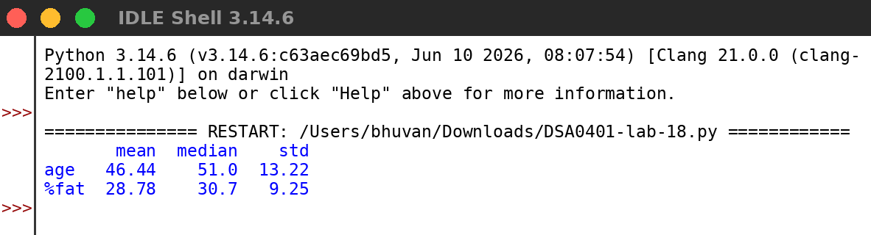
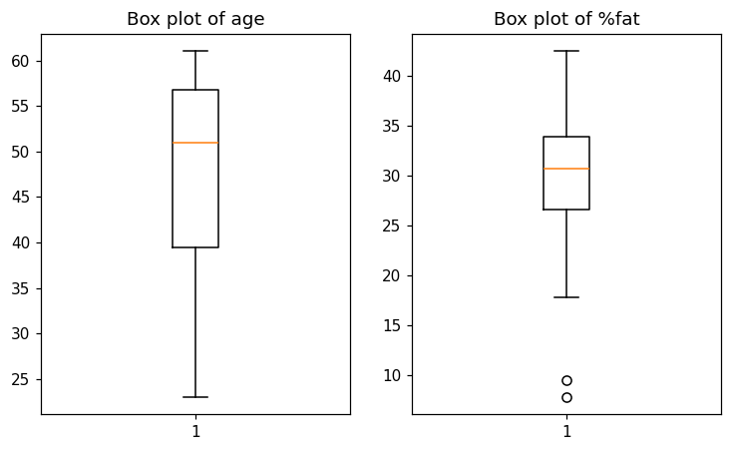
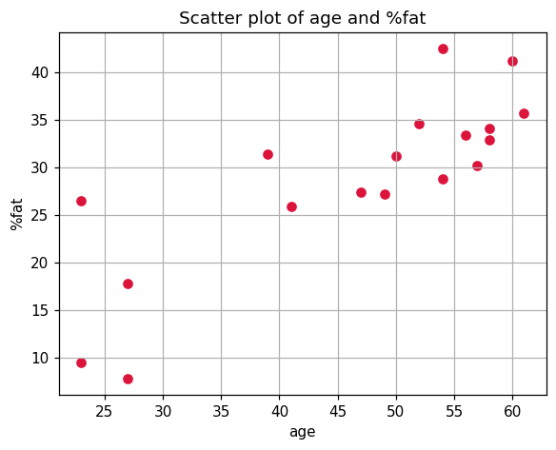
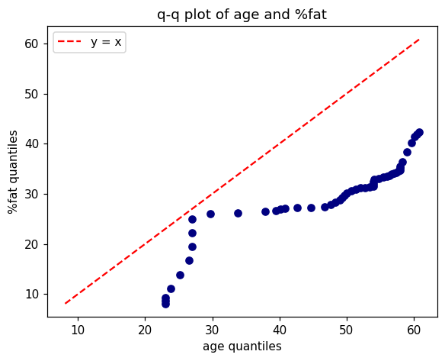
RESULT:
Thus the program was written and executed successfully and the output was verified.

