Fundamentals of Data Science - Lab Manual
Question 19
95% confidence interval of mean reduction in blood pressure
AIM:
To calculate the 95% confidence interval for the mean reduction in blood pressure for the patients who received the new drug and for the patients who received the placebo.
ALGORITHM:
Step 1: Start the program and import NumPy and scipy.stats.
Step 2: Store the reduction in blood pressure (mmHg) of the 25 drug patients and the 25 placebo patients.
Step 3: Calculate the sample mean and the standard error of the mean (sem) of each group.
Step 4: Use the t-distribution with n - 1 degrees of freedom: stats.t.interval(0.95, n-1, loc=mean, scale=sem).
Step 5: Display the mean and the 95% confidence interval of both groups.
Step 6: Stop the program.
PROGRAM:
import numpy as np
from scipy import stats

# reduction in blood pressure (mmHg), 25 patients in each group
drug = [10.5, 16.0, 13.7, 9.5, 14.7, 6.2, 14.4, 9.8, 14.5, 13.8, 8.9,
14.1, 13.4, 9.4, 20.0, 15.2, 7.3, 8.0, 13.3, 13.2, 9.1, 16.9,
12.4, 8.5, 10.5]
placebo = [3.5, -0.7, 1.5, -1.4, 3.1, 5.8, 0.1, 5.0, 0.5, 3.5, 2.5, 0.4,
2.4, 0.3, 4.9, 4.1, 7.6, -0.4, 7.3, 3.8, 5.2, 3.4, 8.6, 8.2,
7.2]

def confidence_interval(data, confidence=0.95):
data = np.array(data)
mean = data.mean()
sem = stats.sem(data) # standard error of the mean
low, high = stats.t.interval(confidence, len(data) - 1, loc=mean, scale=sem)
return mean, low, high

for name, group in (("Drug", drug), ("Placebo", placebo)):
mean, low, high = confidence_interval(group)
print(f"{name:<8} mean reduction = {mean:.2f} mmHg")
print(f"{name:<8} 95% CI = ({low:.2f}, {high:.2f})\n")
INPUT:
Reduction in blood pressure (mmHg) - Drug group (n = 25): 10.5, 16.0, 13.7, 9.5, 14.7, 6.2, 14.4, 9.8, 14.5, 13.8, 8.9, 14.1, 13.4, 9.4, 20.0, 15.2, 7.3, 8.0, 13.3, 13.2, 9.1, 16.9, 12.4, 8.5, 10.5
Reduction in blood pressure (mmHg) - Placebo group (n = 25): 3.5, -0.7, 1.5, -1.4, 3.1, 5.8, 0.1, 5.0, 0.5, 3.5, 2.5, 0.4, 2.4, 0.3, 4.9, 4.1, 7.6, -0.4, 7.3, 3.8, 5.2, 3.4, 8.6, 8.2, 7.2
OUTPUT:
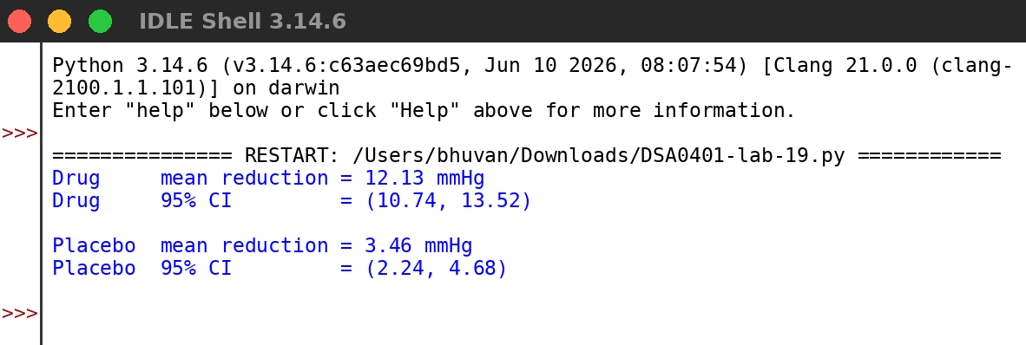
RESULT:
Thus the program was written and executed successfully and the output was verified.

