Fundamentals of Data Science - Lab Manual
Question 20
A/B test - significance of difference in conversion rates
AIM:
To test whether there is a statistically significant difference in the mean conversion rates of website design A and website design B using an independent two-sample t-test.
ALGORITHM:
Step 1: Start the program and import NumPy and scipy.stats.
Step 2: Store the conversion rates (%) of design A and design B (30 observations each).
Step 3: State the hypotheses: H0 - the mean conversion rates are equal; H1 - they are different. Take the level of significance alpha = 0.05.
Step 4: Calculate the t-statistic and the p-value with stats.ttest_ind(A, B, equal_var=False).
Step 5: If p-value < alpha reject H0, otherwise fail to reject H0.
Step 6: Display the means, t-statistic, p-value and the conclusion.
Step 7: Stop the program.
PROGRAM:
import numpy as np
from scipy import stats

# conversion rate (%) of 30 visitor batches for each design
design_a = [9.4, 12.2, 12.5, 10.6, 10.7, 9.1, 8.4, 8.4, 8.2, 11.7, 9.9,
10.2, 8.8, 8.0, 7.8, 8.5, 11.1, 10.0, 9.2, 9.6, 7.4, 12.2,
7.8, 10.1, 13.8, 5.4, 7.5, 8.7, 10.2, 6.9]
design_b = [10.8, 11.1, 11.5, 6.9, 12.4, 14.1, 12.0, 9.9, 10.1, 6.4, 12.1,
13.9, 12.4, 5.8, 10.4, 11.0, 10.3, 13.1, 8.1, 9.9, 12.3, 13.0,
11.5, 13.1, 12.1, 9.3, 13.5, 10.3, 8.3, 12.0]

alpha = 0.05
t_stat, p_value = stats.ttest_ind(design_a, design_b, equal_var=False)

print(f"Mean conversion rate of design A: {np.mean(design_a):.2f}%")
print(f"Mean conversion rate of design B: {np.mean(design_b):.2f}%")
print(f"t-statistic: {t_stat:.4f}")
print(f"p-value : {p_value:.4f}")

if p_value < alpha:
print("Reject H0: there IS a statistically significant difference.")
else:
print("Fail to reject H0: there is NO statistically significant difference.")
INPUT:
Conversion rate (%) - Design A (n = 30): 9.4, 12.2, 12.5, 10.6, 10.7, 9.1, 8.4, 8.4, 8.2, 11.7, 9.9, 10.2, 8.8, 8.0, 7.8, 8.5, 11.1, 10.0, 9.2, 9.6, 7.4, 12.2, 7.8, 10.1, 13.8, 5.4, 7.5, 8.7, 10.2, 6.9
Conversion rate (%) - Design B (n = 30): 10.8, 11.1, 11.5, 6.9, 12.4, 14.1, 12.0, 9.9, 10.1, 6.4, 12.1, 13.9, 12.4, 5.8, 10.4, 11.0, 10.3, 13.1, 8.1, 9.9, 12.3, 13.0, 11.5, 13.1, 12.1, 9.3, 13.5, 10.3, 8.3, 12.0
OUTPUT:
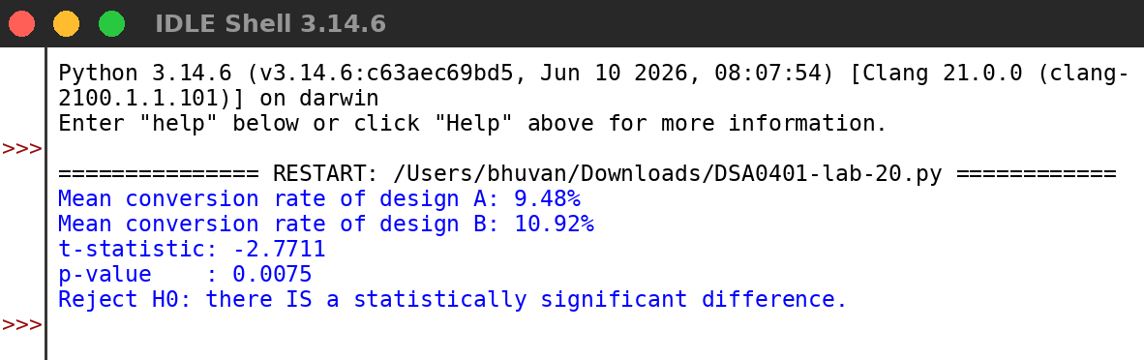
RESULT:
Thus the program was written and executed successfully and the output was verified.

