Fundamentals of Data Science - Lab Manual
Question 21
Point estimation and confidence interval of rare element concentration
AIM:
To write a Python program that estimates the average concentration of a rare element using a random sample, and calculates the confidence interval for the population mean for the sample size, confidence level and precision given by the user.
ALGORITHM:
Step 1: Start the program and import NumPy, Pandas and scipy.stats.
Step 2: Read the measurements from rare_elements.csv.
Step 3: Read the sample size, the confidence level (%) and the desired precision (margin of error) from the user.
Step 4: Draw a random sample of the given size using NumPy.
Step 5: Point estimate = sample mean; calculate the sample standard deviation and the standard error s / sqrt(n).
Step 6: Find the critical value t from the t-distribution and compute margin of error = t x standard error.
Step 7: Confidence interval = mean +/- margin of error.
Step 8: Compare the margin of error with the desired precision; if it is larger, compute the sample size required.
Step 9: Display the results and stop.
PROGRAM:
import numpy as np
import pandas as pd
from scipy import stats

data = pd.read_csv("rare_elements.csv")["concentration"].to_numpy()

n = int(input("Enter the sample size: "))
conf = float(input("Enter the confidence level in % (e.g. 95): ")) / 100
precision = float(input("Enter the desired precision (margin of error in ppm): "))

rng = np.random.default_rng(1)
sample = rng.choice(data, size=n, replace=False) # random sample

mean = sample.mean() # point estimate
s = sample.std(ddof=1)
std_error = s / np.sqrt(n)
t_crit = stats.t.ppf((1 + conf) / 2, df=n - 1)
margin = t_crit * std_error
lower, upper = mean - margin, mean + margin

print(f"\nPoint estimate of the mean concentration : {mean:.3f} ppm")
print(f"Sample standard deviation : {s:.3f}")
print(f"Margin of error : {margin:.3f} ppm")
label = f"Confidence interval ({conf*100:.0f}%)"
print(f"{label:<41}: ({lower:.3f}, {upper:.3f})")

if margin <= precision:
print("The desired precision has been achieved.")
else:
required = int(np.ceil((t_crit * s / precision) ** 2))
print(f"Desired precision NOT achieved. Sample size needed is about {required}.")
INPUT:
File: rare_elements.csv (first 12 of 100 rows shown)
concentration
13.25
15.67
8.75
16.04
12.4
10.82
10.81
10.23
12.03
14.25
13.73
13.84

Values entered by the user at run time:
Prompt | Value entered
Enter the sample size | 30
Enter the confidence level in % (e.g. 95) | 95
Enter the desired precision (margin of error in ppm) | 0.5

OUTPUT:
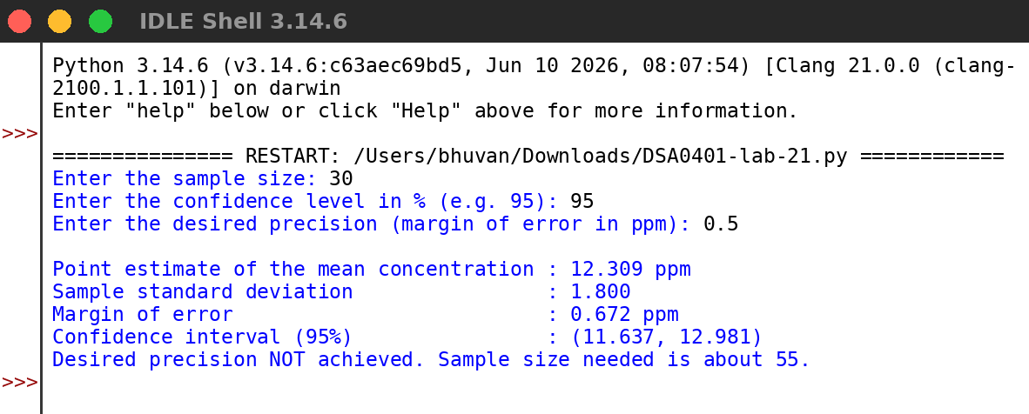
RESULT:
Thus the program was written and executed successfully and the output was verified.

