Fundamentals of Data Science - Lab Manual
Question 22
Confidence interval of the mean customer rating
AIM:
To use the Pandas library to calculate the 95% confidence interval for the true population mean rating and the customer satisfaction level of a product category.
ALGORITHM:
Step 1: Start the program and import Pandas and scipy.stats.
Step 2: Read customer_reviews.csv into a DataFrame.
Step 3: Calculate the sample mean, standard deviation and standard error (sem) of the rating column using Pandas.
Step 4: Use the t-distribution (n - 1 degrees of freedom) to calculate the 95% confidence interval.
Step 5: Calculate the customer satisfaction level as the percentage of ratings that are 4 or 5.
Step 6: Display the results and stop.
PROGRAM:
import pandas as pd
from scipy import stats

reviews = pd.read_csv("customer_reviews.csv")
ratings = reviews["rating"]

n = ratings.count()
mean = ratings.mean()
std = ratings.std()
sem = ratings.sem() # standard error of the mean

low, high = stats.t.interval(0.95, n - 1, loc=mean, scale=sem)
satisfaction = (ratings >= 4).mean() * 100

print("Number of reviews :", n)
print(f"Average rating : {mean:.3f}")
print(f"Standard deviation : {std:.3f}")
print(f"95% confidence interval : ({low:.3f}, {high:.3f})")
print(f"Customer satisfaction : {satisfaction:.1f}% gave 4 or 5 stars")
INPUT:
File: customer_reviews.csv (first 12 of 40 rows shown)
product | rating
Product 1 | 4
Product 2 | 3
Product 3 | 2
Product 4 | 5
Product 5 | 4
Product 1 | 5
Product 2 | 5
Product 3 | 5
Product 4 | 2
Product 5 | 4
Product 1 | 4
Product 2 | 2

OUTPUT:
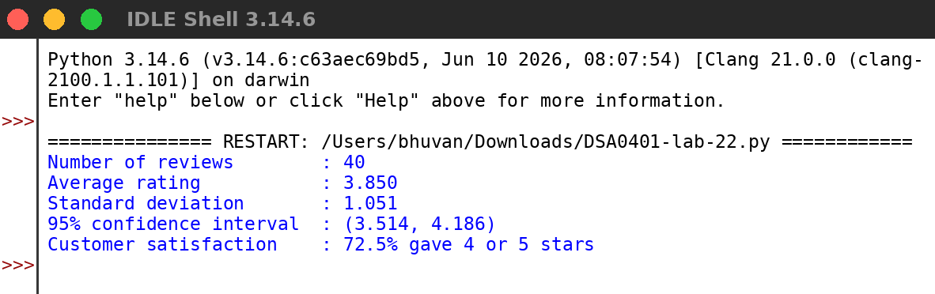
RESULT:
Thus the program was written and executed successfully and the output was verified.

